NASM Nutritional Coach

**Scope of practice 8**

The Healthcare Continuum 10

**Expectations of the Nutrition Coach 13**

The parameters of an NASM Nutrition Coach 14

Providing healthy eating guidelines 16

Provide behavioural change tactics and motivation 17

Assess 17

Food journals 17

Nutrient trackers 18

Educate 18

Implement 19

Disordered eating 21

Chronic disease and dysfunction 22

Psychological disorders 23

Change in health status 23

**The business scope for the Nutrition Coach 24**

**Science and Evidence-Based practice 26**

The scientific method 27

Hypothesis testing 28

The accumulation of evidence 30

The hierarchy of evidence 30

Non-peer-reviewed media 30

Peer-reviewed editorials and expert opinions 32

Observational research 32

Randomised Control Trials 33

Systematic reviews and Meta-Analyses of RCTs 34

Basic scientific principles 35

Types of scientific research 38

Strengths and limitations of major types of research 40

Strengths and limitations of observational designs 40

Evaluating sources of information 41

Peer-reviewed scientific journals 41

Types of peer-reviewed journal articles 41

High-Quality, non-peer reviewed sources of information 43

Questionable or poor, non-peer reviewed sources of information 43

Evaluating source quality 43

**Scientific consensus: How the scientific community changes 45**

Science: shades of grey, not black and white 45

Scientific conclusions 46

**Food preference and influences 47**

Defining health and disease 47

Disease 48

Wellness 50

The role of diet in chronic disease 52

Obesity 52

Heart disease 53

Cancer 53

Diabetes 54

Food choices 54

Socio-cultural factors 54

Economic status 56

Geographical and seasonal availability 57

Biological influences 58

Sensory stimuli 59

**Energy balance and metabolism 60**

Thermodynamics 62

Maintaining energy balance 63

Components of energy out 65

Resting Metabolic Rate 66

Thermic Effect of Food 67

Thermic Effect of Activity 67

Non-Exercise Activity Thermogenesis 67

Sleep 69

Hormones 71

Components of Energy In 72

Appetite 72

Environmental factors 75

Psychological factors 77

Individual variation 78

Food processing 79

Metabolic Energy Systems 80

Energy transfer 81

ATP-PC system 81

Anaerobic (Glycolytic) energy system 82

Aerobic energy system 84

**Protein 87**

Protein structure 87

Amino acids 87

Protein synthesis 91

Protein digestion and absorption 92

Protein function 94

Protein dietary needs 98

Dietary reference intakes 99

Protein quality 102

Protein timing 104

**Carbohydrates 107**

Carbohydrate structure 108

Monosaccharides 109

Disaccharides 110

Oligosaccharides 111

Polysaccharides 112

Summary of carbohydrate classifications 119

Carbohydrate roles within the body 120

Hormonal regulation of glucose 125

Glycaemic index 128

Current versus recommended intakes 131

Carbohydrate myths 139

**Fats 139**

Structure of lipids 140

Functions of lipids 145

Function of dietary fats 145

Dietary essential fatty acid recommendations 146

Function of fat within the body 149

Digestion and absorption 150

The mouth and stomach 150

The small intestine 151

Transport and storage of lipids 152

Transport of lipids 152

Fat metabolism and storage 155

Dietary fat recommendations and programming 156

Dietary fat and saturated fat recommendations 156

Translating recommendations into food choices 157

Programming 161

**Alcohol 163**

Alcohol structure and functions 163

Alcohol absorption 164

Metabolism of ethanol 167

The dietary impact of alcohol 169

Alcohol intake guidelines 170

Alcohol and body composition 173

Monitoring alcohol use 174

The physiological and health effects of alcohol 175

Effects on the central nervous system 176

Effects on the cardiovascular system 177

Effects on immune and hormonal function 178

Alcohol myths and hot topics 179

**Micronutrients 183**

Water-soluble vitamins 184

Vitamin B1 (Thiamine) 185

Vitamin B2 (Riboflavin) 186

Vitamin B3 (Niacin) 187

Vitamin B5 (Pantothenic Acid) 188

Vitamin B6 189

Vitamin B7 190

Vitamin B12 191

Folic acid (Folate) 192

Vitamin C 194

Choline 195

Fat-soluble vitamins 197

Vitamin A 198

Vitamin D 200

Vitamin E 201

Vitamin K 201

Common food sources of vitamins 202

Minerals 203

Calcium 204

Chromium 205

Copper 206

Fluoride 206

Iodine 207

Iron 207

Magnesium 210

Mercury 211

Phosphorus 212

Potassium 212

Selenium 212

Sodium 213

Zinc 214

Common food sources of minerals 215

Applying knowledge of minerals to the real world 216

Micronutrient application 217

Total daily requirements 219

Micronutrient programming 221

Supplementation 224

**Hydration 228**

The physiology of hydration 230

Effects of dehydration 234

Sweating 235

How does dehydration influence performance? 236

Developing hydration strategies 238

Sweat-loss assessment 240

Pre-exercise hydration status assessment 246

**Nutrient timing 254**

Timing of nutrients 256

Nutrient timing applications: endurance vs. strength-based activity 257

Myths and hot topics 262

**Supplements 270**

Guidelines for supplement selection 273

Dietary patterns to optimise health 277

Multivitamin and mineral supplements 278

Supplements for muscle gain and recovery 280

Essential Amino Acids 288

Supplements for fat loss 291

Stimulants 292

Starch / fat blockers and other common weight loss ingredients 298

Meal-replacement formulas 299

Performance-enhancing supplements 300

Creatine Monohydrate 301

**Psychology of weight control and behaviour change 305**

Psychology of body image and low self-esteem 316

The profile of a weight loss client 319

Barriers to diet and exercise 323

Eating behaviour 328

Disordered eating 328

**Coaching and communication 333**

**Motivational interviewing 352**

Motivational foundations 356

Motivational interviewing strategies 367

Stages of change and motivational interviewing 372

**Goal setting 377**

Goal-setting principles 385

**Dietary assessment and body composition testing 397**

**Monitoring Body Composition 424**

Methods of assessing body composition 425

Choosing the best methods for your clients 434

Interpreting Changes in body composition and tracking progress 435

**Food labels and portion sizes 439**

Supplement Facts Labels 455

Portion sizes 462

Portion sizing in the UK and EU 468

**Helping clients navigate the real world 471**

Meal Prep Guidelines 492

Healthy snacking 497

Navigating diets 505

**Nutrition hot topics and controversies 527**

Genetically Modified Organisms 540

**Managing weight loss plateaus and maintaining weight loss 564**

**Programming: putting it all together 585**

Body weight planner 596

Welcome to NASM's Nutrition Certification course! You’re embarking on an exciting adventure toward enhancing your career and discovering methods for helping clients. Our ever-changing world comes with a whole host of health and fitness challenges. As rates of obesity and chronic health conditions continue to climb, the demand for qualified health and fitness professionals rises. The role of a Nutrition Coach is in high demand as people look for ways to improve their health, lose weight, and stay motivated to do it.

NASM's Nutrition Certification enables you to provide evidence-based guidance to those seeking to improve body composition, athletic performance, and health. By successfully completing this program, you will have the knowledge and abilities to leverage nutrition education to increase your client's success, reduce turnover, and maximize adherence. Held to the highest standard of research-based theory and practice, this program teaches you how to provide nutrition coaching to a variety of clients with differing goals. Your knowledge and skill base will be updated to remain current and focused on delivering the gold standard of client care in the nonclinical sphere.

Successful completion of your NASM Nutrition Certification will allow you to enhance your career with crucial nutritional information and, more importantly, motivate and drive your clients to success with behavioral techniques. So, what exactly does a Nutrition Coach do? See Infographic: Profile of a Nutrition Coach for more information.

As a Nutrition Coach, you’ll do the following:

* Have an actionable, proven method for helping clients reach their personal health and wellness goals with your professional guidance.
* Leverage nutrition education to increase client success, reduce turnover, and maximize adherence.
* Work with face-to-face or online clients.

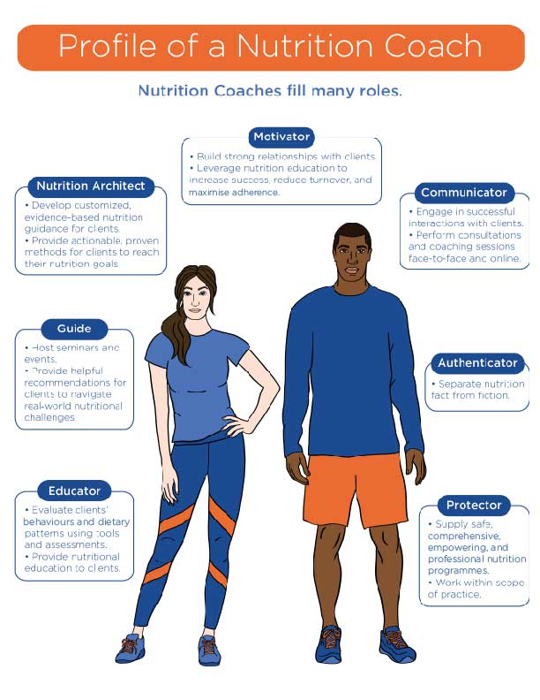

**Infographic** Profile of a Nutrition Coach

# Scope of practice

Those who work in the health and fitness profession are fortunate to work in a field that can positively affect the lives of many. There are a variety of behaviours that will contribute to a sound mind and body, but for some, nutrition and healthy eating can be the most confusing. A Nutrition Coach is an integral part of health and fitness and understanding the professional scope of practice is critical.

Critical!

For fitness professionals working in Australia, it is essential to follow the AusREPs Scope of Practice along with the Nutrition Coach Scope of Practice outlined here in this course. Additionally, working as a Nutrition Coach in Australia requires adherence to the Australian Nutrition Guidelines in addition to the recommendations outlined in this course for the USA and the UK.

Click the following links to learn more:

[Scope of Practice for AusREP](https://fitness.org.au/articles/policies-guidelines/scope-of-practice-for-ausreps/4/38/20)

[Australian Nutrition Guidelines](https://fitness.org.au/articles/policies-guidelines/nutrition-advice-within-scope-of-practice-for-ausreps/4/1356/20)

However, no matter where in the world Nutrition Coaches are working, the important thing to remember is that their job is to educate and empower clients to make their own nutritional decisions, not prescribe specific nutrition plans for them.

The healthcare system is comprised of various overlapping and complementary disciplines. For example, the physical therapist will work in conjunction with the orthopaedic surgeon to facilitate maximum recovery of their shared patient, with boundaries that must be acknowledged and adhered to for ethical and legal reasons. The Scope of Practice defines the limitations and boundaries of certain medical interventions that a person can perform. This applies to clinical, licenced professionals as well as those who are not.

Licenced healthcare providers have a range of responsibilities and licensing requirements established by their governing bodies (e.g., specific area of practice or professional board). Scope of practice can also include acceptable caseloads, practice guidelines and recommendations for referral to another professional.

There are clearly defined boundaries between the services of a certified Nutrition Coach and a Registered Dietitian Nutritionist (RDN). An RDN has earned at least a Bachelor’s degree from an accredited college or university, had their course work approved by the Academy of Nutrition and Dietetics' Accreditation Council for Education in Nutrition and Dietetics (ACEND), fulfilled hundreds of hours of supervised dietetic services in a variety of professional settings, and passed a national exam provided by the Commission on Dietetics and Registration (CDR). Many areas also require separate licensure above and beyond the RDN credential, though each has their own requirements. Once an individual earns the RDN credential, they are required to earn additional approved credits to maintain it. Beyond the designation, RDNs can also pursue further education and specialise in dietetics related to paediatrics, people with diabetes or sports dietetics, each with specific requirements and exams.

There are several other licenced healthcare professionals who commonly provide nutritional advice: Medical Doctors (MD), Certified Diabetes Educators (CDE), Advanced Registered Nurse Practitioners (ARNP), Physician Assistants (PA) and Doctors of Pharmacy (PharmD)*.* The educational requirements are robust and regular continuing education is required to maintain licensure. Licenced practitioners can legally provide nutrition guidance and information as well as providing specific meal plans in accordance with specific diseases and conditions, but the RDN is the only healthcare professional with many years of specific nutrition education as part of the curriculum. MDs, for example, in traditional medical schools, often receive as little as one or two nutrition classes during their medical programme.

Rules and regulations vary by nation and then by state in relation to who can perform the duties of a nutritionist and to what extent. It is the responsibility of each practitioner to research local guidelines and consult with a legal representative regarding any professional limitations before practising. Mandates range from "no legal opposition for individuals performing nutritional counselling" to a person "cannot legally perform specific nutritional counselling unless licenced as a Registered Dietitian Nutritionist" (NutritionEd.org). The Nutrition Coach should not only be concerned with the legal ramifications of working outside of his or her scope of practice, but should also consider the ethical and practical grounds for maintaining these boundaries. It is not only unethical but could be *dangerous* if a lesser-trained, unlicensed nutritionist provided misguided information or gave dietary advice they were unqualified to give. A Nutrition Coach must also recognise when the needs of a client are beyond their experience and knowledge scope.

Helpful Hint

Keep in mind that all apples are fruits, but not all fruits are apples. So it can be said that all Registered Dietitians are nutritionists, but not all nutritionists are Registered Dietitians.

Critical!

It is not only unethical but potentially *dangerous* if a lesser-trained, unlicensed nutritionist provides misguided information or gives dietary advice they are not qualified to give. Referring to a more-experienced and qualified practitioner is the mark of a professional who understands that the client is of utmost importance.

Getting Technical

Licensed vs. Certified

Healthcare providers are governed by the Health and Care Professions Council in the United Kingdom. In most cases, there are educational and experience requirements followed by a standardised test delivered by the professional governing board for that area or region. Licensed healthcare providers include doctors, nurses, physical therapists, paramedics, psychologists, and registered dietitian nutritionists. The medical insurance industry will impose limitations on insurance reimbursement eligibility and, in most cases, will require a licensed provider for reimbursement of nutrition or dietetic services.

A certified professional is someone who has attended a live course or studied a curriculum and then passed a standardised test, demonstrating sufficient knowledge of the subject matter. The certification may or may not have prerequisites (i.e. prior course work or life experience). The certifying authority (e.g. NASM) should dictate the scope of practice, but, ultimately, the region will limit the occupational reach.

Nutritionist is a generic term for someone who provides nutritional advice or counselling. A nutritionist is not necessarily a licensed health care professional and certainly should not portray themselves as such. Nutritionists may be found working in public health organisations, schools, health and fitness centres, weight loss clinics or in a private practice. Many states leave it up to the consumer to do their due diligence and investigate where this person received training and what credentials makes him or her qualified to provide nutritional advice.

## The Healthcare Continuum

As healthcare costs escalate, emphasis on preventive care has become a priority. Personal trainers and other fitness professionals are being welcomed into the healthcare system and are becoming an asset in the healthcare continuum (Figure: Healthcare Continuum).



**Figure** Healthcare Continuum

The healthcare system incorporates the following disciplines:

* Hospitals, emergency clinics and trauma centres
* Ambulatory care centres, including personal physicians and specialists
* Therapists, including physical therapists, cardiac rehab professionals, massage therapists and bariatric specialists
* Ancillary facilities, including dentists and ophthalmologists
* Behavioural health specialties, including psychiatrists, psychologists, addictions specialists and social workers
* Alternative medicine practitioners (licensed), including chiropractors, acupuncture physicians and massage therapists
* Long-term care, including home health and hospice
* Health and fitness specialties, including personal trainers, performance specialists, Nutrition Coaches and group exercise instructors.

As preventive health becomes a priority, a Nutrition Coach can provide a valuable service in the mission to keep constituents healthy while avoiding chronic disease and disability. Many larger hospital systems are placing an emphasis on wellness and are providing affordable services to assist with further care and guidance. These wellness centers employ certified personal trainers, corrective exercise specialists, and professionals who can provide nutrition support. These professionals can have regular access to clients via frequent visits, e-mail correspondence, texting or phone calls, as well informally through social media. The regular interaction can facilitate consistency in behavioural change and help the client stay on course. The facility itself will also identify scope of practice of its non-licensed professionals.

There are many opportunities for a Nutrition Coach to work with any number of allied health professionals that are part of the continuum of care. Most healthcare providers have little training or experience in the field of nutrition; for this reason, the Nutrition Coach can become an asset for many of these professionals.

Access the Infographic: Adjacent Careers for additional information.

Helpful Hint

The term *patient* is used within the healthcare setting and is not a common term used by a non-licensed Nutrition Coach. In this case, the term *client* is more appropriate. For example, when having a conversation with a referring physician, it is fitting to say “your patient" or "my client”.

Client confidentiality is of paramount importance. Anyone working in healthcare should be familiar with client or patient confidentiality guidelines for their area. A Nutrition Coach should not discuss personal client-related issues with any other person without the expressed written consent of the individual. If peer opinions are needed, it would be appropriate to omit the client's name or any distinguishing features, before discussing behavioural tactics with a co-worker to help the client. Furthermore, it has become common for coaches to post before-and-after pictures to promote personal achievements, but the client must be informed and provide written consent to any personal photos or metrics. This also holds true for any people in the background of a photo.

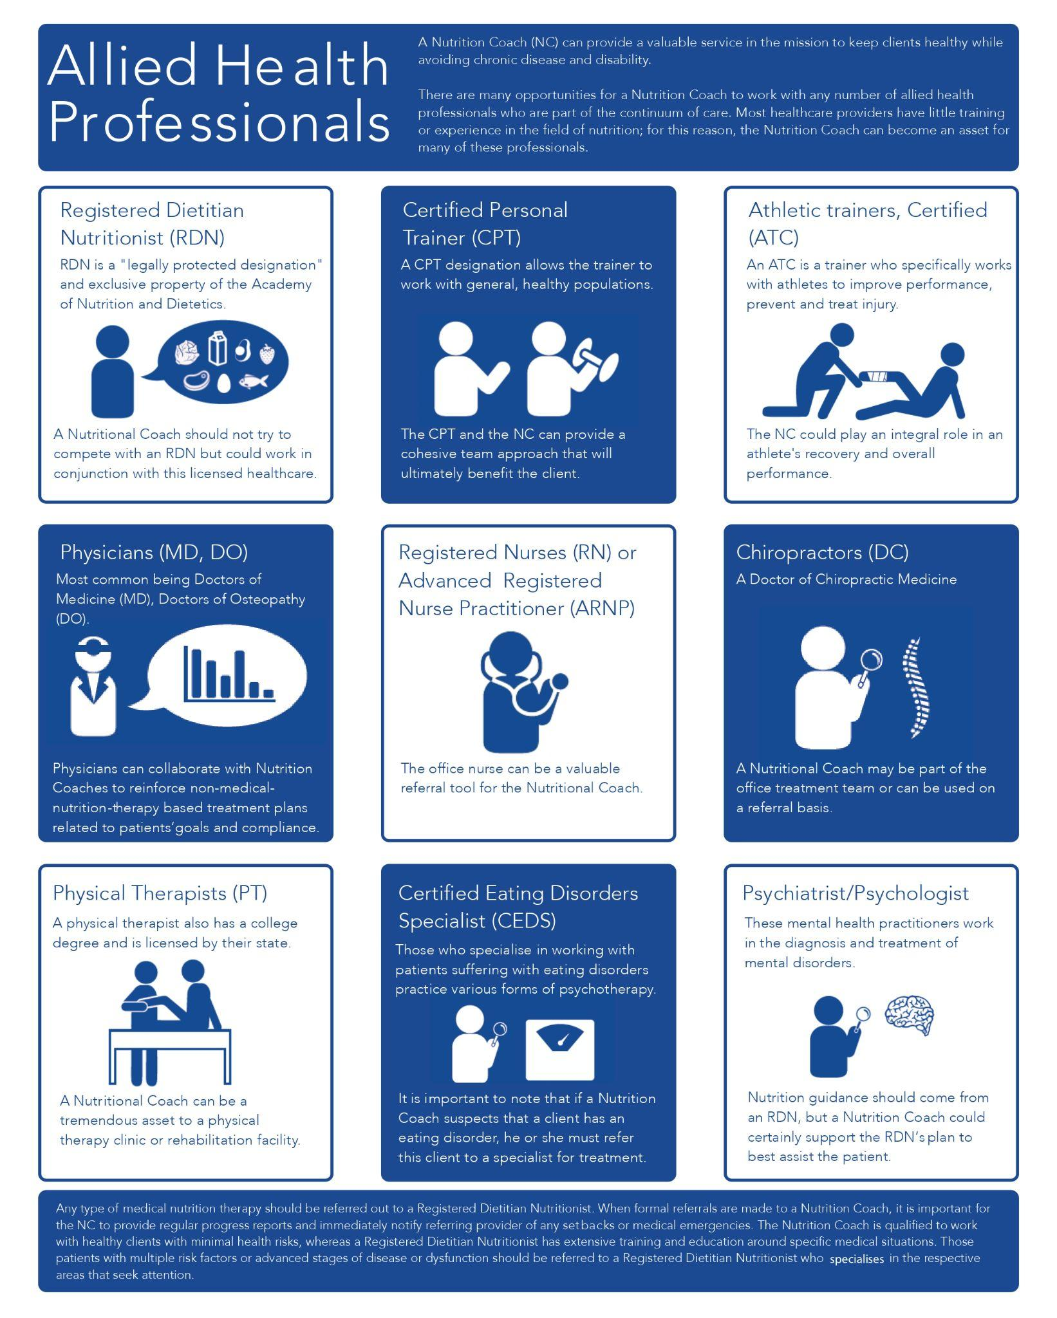

# Expectations of the Nutrition Coach

Critical!

For more information on specific state mandates in the USA visit:

<http://www.nutritionadvocacy.org/laws-state>

A Nutrition Coach has demonstrated a working knowledge necessary for providing basic nutrition education and coaching services. Each country or region has its own standards that dictate the necessary requirements for licensed nutritionists and RDNs. Region mandates range from virtually no requirements to dictating that only licensed professionals with a related degree and licensure in dietetics and nutrition can serve as a nutritionist. Each public or private agency, healthcare provider, and insurance reimbursement system will have their own set of standards and requirements for the working nutritionist. It is the responsibility of the Nutrition Coach to fully understand the requirements.

## The parameters of an NASM Nutrition Coach

In many cases, there are clearly defined boundaries between a registered dietitian nutritionist and a Nutrition Coach, as well as other limitations imposed on the Nutrition Coach. It is important to know these boundaries and then work within the guidelines to positively affect the wellbeing of each client. Table: Limits on Scope of Practice provides examples of common boundaries between an RD and a Nutrition Coach.

Limits on the Scope of Practice

| **The Nutrition Coach CANNOT** | **The Nutrition Coach CAN** |
| --- | --- |
| Provide *specific* meal plans and daily menus.  Prescribe *specific* supplements or recommend vitamins and/or mineral dosages.  Suggest drastic caloric restriction.  Promote fasting, detoxification, or other extreme nutritional practices.  Prescribe diets that omit or severely restrict certain food groups.  In anyway, go against recommendations of licensed healthcare professionals.  Provide detailed nutritional plans for athletes who participate in extreme training programs (i.e., Ironman triathletes or ultra-marathoners).  Prescribe dietary plans for those with chronic health conditions (i.e., diabetes or heart disease).  Provide nutrition therapy to treat or prevent disease.  Provide exercise prescriptions or detailed programming (unless already certified as a personal trainer). | Evaluate current eating plans and provide general guidance.  Recommend the client discuss supplement use with their personal registered dietitian nutritionist, physician, or pharmacist.  Promote caloric guidelines outlined by the USDA's MyPlate, the United Kingdom’s Eatwell Guide, or other acceptable entities.  Recommend gradual dietary modifications and consistent dietary practices.  Discuss the importance of a balanced intake of macronutrients.  Refer back to the client's personal healthcare provider when necessary.  Offer nutritional guidelines for anyone wanting to participate in typical athletic pursuits (i.e., masters swimming or a 10K run).  Provide guidance for healthy populations.  Offer advice on eating behaviors and/or macronutrients that are known to reduce the risk of disease or slow disease progression.  Offer exercise and physical activity guidelines. |

*Table created through comparative analysis of scope of practice and duties for RDNs (Academy of Nutrition and Dietetics, 2018).

While the licensed healthcare professional can focus on the specifics of dietary intake, the Nutrition Coach should focus on general practices, including behaviours that contribute to different dietary choices. It is important to conduct a thorough assessment of each client. The initial screening step will identify any client who may be beyond the expertise level of the Nutrition Coach or who should be referred to a licensed healthcare provider. The assessments will also help gain a better understanding of the client’s personal history and help provide next steps to support the client. They will not and cannot treat disease, but the Nutrition Coach can facilitate and support dietary guidelines provided by professional organisations.

## Providing healthy eating guidelines

The scope of a Nutrition Coach is divided into two main components: *Nutrition Guidance* and *Behavioural Change and Motivation*. Nutrition coaches should not provide specific meal plans, but they can provide guidance on how to incorporate balanced eating. There are several resources available to provide current dietary guidelines, most of which are free to the public. Most countries have government agencies responsible for disseminating practical information on dietary guidelines and nutrition intake. Educational entities, like colleges and universities, are also a good resource (look for websites ending in .edu).

Well known not-for-profit organisations may also have nutritional resources for both the lay person and medical professional (look for websites ending in .org). The Nutrition Coach should carefully scrutinise information coming from popular health and fitness magazines, for-profit entities with a financial stake in the research, or nutritional content from celebrities with no formal education in nutrition or preventive health.

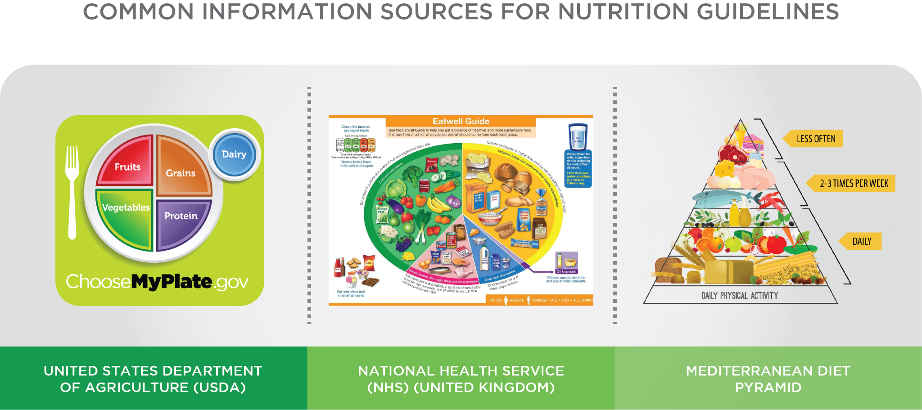

## Provide behavioural change tactics and motivation

Many clients who hire a certified Nutrition Coach may be aware of the types of food they should be eating, but they may need support on the behavioural side of nutrition (i.e. putting what they may know into practice). In addition to providing tactics for success, the Nutrition Coach can also hold the client accountable for their actions. The coach can also provide external motivation to support the various behaviours discussed and agreed on with the client.

In addition to providing guidance on food intake and balanced nutrition, the Nutrition Coach can help facilitate an action plan for the client. A thorough assessment will help start this process. Using the information gained from the assessments, the coach can then decide on the next best steps. It is important to spend some quality time educating the client so they understand the *why* of the process.

### Assess

The assessment might incorporate written questionnaires (Health History Questionnaire), a verbal interview, as well as a body composition assessment if appropriate. A thorough assessment can also help rule out any client who has issues that are beyond the scope of practice (e.g. recent CAD, diabetes, pregnancy, cancer, etc.).

A few examples of key items to cover could include questions around the following:

* Client nutritional goals
* Personal stumbling blocks
* Food aversions, preferences, known allergies, etc.
* Hydration
* Food triggers
* Exercise habits
* Daily activity patterns

The physical assessment is another important tool used by the Nutrition Coach. Common assessments include the following:

* Height
* Weight
* Body composition
* Anthropometric measures of girth (arm, neck, chest, waist, hip, thigh and calf).

#### Food journals

To gain a more detailed understanding of the client's food habits, it is recommended that the formal assessment be followed up with a 3- to 5-day food journal (written or shared online if the client may use an online tracking service, such as My Fitness Pal). This is especially valuable when the client has a weight-loss goal. Research shows there is a significant correlation between dietary self-monitoring and weight loss (Burke, Wang, & Sevick, 2011). Overall weight lost is actually greater in those who journal when compared to those who do not record food intake (Carels, Young, Clayton, Spencer, & Hobbs, 2008).

While self-monitoring is certainly not a perfect tool, at this point, it is the best available and it can provide insight into some of the daily habits, food intake, and associated behaviors (Figure: Example Food Journal).

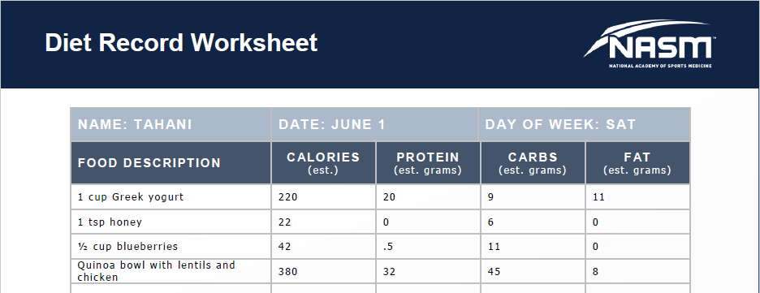

**Figure** Example Food Journal

#### Nutrient trackers

For those who want a more detailed assessment of overall nutritional intake, there are also many online applications a client can use to log their food, as mentioned above. These apps provide nutritional intake, in detail, for macronutrients and micronutrients. This type of nutritional evaluation would be very tedious to do manually; therefore, an online programme is more fitting.

The coach and the client can use the information gathered from the food journal and online applications to provide a solid foundation. The client may discover many things on their own, but with the help of their Nutrition Coach, they can develop a strategy for improvement, focusing on quality and quantity of food as well as any behaviours that will bring the client closer to their goal(s).

### Educate

The role of the Nutrition Coach is to provide general advice on what constitutes a healthy diet according to current and scientific evidence. Together, the client and the Nutrition Coach can develop a plan that will meet the goals of the client while allowing for individual preferences. It is the responsibility of the Nutrition Coach to educate the client on acceptable nutrition practices and behaviours. Research also demonstrates that adults will learn better if the coach follows principles of adult learning (Knowles, Swanson, & Holton, 2011).

Information should be:

* Highly relevant. For example, discussions on meal prep for a family would not be relevant if the client is single and lives alone.
* Based on prior experience. The client who has had countless attempts at weight loss can relate to weight loss strategies, especially if he or she is open to options and has bought into trying new things.
* Practical. The single parent with a full-time job and three children, who have a plethora of after-school activities, may not have time to prep food for an hour every day.
* Perceived to be important. If a client just lost a partner to a heart attack, the client may likely be very interested in heart-healthy foods.

Many clients who seek the expertise of a Nutrition Coach are willing to invest time and financial resources to achieve personal health and fitness goals. Clients are often confused by the barrage of information coming through media channels daily. Much of the information is not only confusing but conflicting. For this reason, it is the responsibility of the Nutrition Coach to be very knowledgeable in sound dietary practices as well as to stay up-to-date on the most popular diets to help the client sort through the (mis)information.

Coach's Corner

Working with the client to allow for setbacks and developing strategies to overcome any obstacles can be very powerful. For example, what are some success strategies if a client’s boss loves to bring in homemade baked goods every Monday to show her team how much she cares? How would the client react to unhealthy food options at a concession stand? What can be done to overcome late night cravings? These are all challenges that the coach can assist with in navigating. Developing an action plan must also work within the client's schedule and account for any budgetary constraints. The weekday plan may look different than the weekend plan. The summer plan may look different than the holiday plan. There are certainly a myriad of questions. The job of a qualified Nutrition Coach can be to support the client with potential setbacks.

### Implement

Exercise should also play an important role in the quest to achieve a healthy body weight. It is beyond the scope of practice for a Nutrition Coach to provide specific exercise programmes for their client unless they are certified as a personal trainer or other allied health professional with the proper education and training. Additionally, there are certain sports that rely on extremes in dieting – body building for competition, wrestling, endurance training – but these athletes should train under a coach who is well-versed in the extremes of diets required to excel in their sport. If a client has specific questions about exercise or is not sure exactly how to design an exercise programme, the Nutrition Coach can refer the client to a Certified Personal Trainer.

Food for Thought

One good resource for the Nutrition Coach who works with weight-loss clients is a Certified Personal Trainer. For every pound lost, up to 25% of each pound can come from lean tissue (Varady, 2011). To preserve muscle tissue, resistance training is recommended. An NASM-CPT can provide a solid conditioning programme that will help conserve or build lean muscle tissue.

Critical!

As a Nutrition Coach, there are dietary strategies and tactics that can be employed to enhance a person's physique, but in some cases, the client may need to revisit their aspirations. Extreme diets and extreme workouts cannot be maintained indefinitely, so it is important to have an open and honest conversation with the client who may have unrealistic expectations. If a Nutrition Coach finds that a client is very preoccupied with body image and is considering extreme measures to enhance their physique, it would be prudent to refer the client to an RDN who specialises in disordered eating. Body dysmorphic disorder is a true medical condition that affects both men and women. For example, a person may feel their physique is too small and may go to extreme measures to build muscle and create definition. In this case, the Nutrition Coach should discontinue further sessions until they are evaluated by a healthcare professional.

Coach's Corner

Many personal trainers will seek out certification and training programmes to expand the repertoire of services offered to their clients. Nutrition Coaching can be a significant part of the solutions offered to help clients reach their health and fitness goals. For example, a personal trainer can offer a comprehensive training package that incorporates personal training as well as nutritional guidance. In some cases, the client may be confident in their exercise programme but only needs a comprehensive nutritional plan. Depending on the region of residency/practice, scope of practice for a Nutrition Coach may be specifically defined. For example, in a region where there are strict licensing guidelines for nutritionists and dieticians, the personal trainer cannot represent him or herself as a licensed nutritional professional and must avoid providing services that are strictly reserved for the RDN in their area. Areas with strict regulatory standards are very protective of the licensed RDNs and have the authority to pursue legal actions toward any person crossing that regulatory line.

The Nutrition Coach can provide a valuable service to the client who needs dietary assistance. Providing both nutrition support and behavioural change strategies can help many clients achieve their health and fitness goals. The role of the Nutrition Coach is to provide the best and safest course of action and recognise when the client’s needs are outside their scope of practice. If a client is not making progress toward their established goals, a referral to a registered dietician or other licensed healthcare professional is warranted.

If the athlete notices an unexplained decline in performance, unexplained fatigue or experiences a change in health status (i.e. chronic pain or discomfort), a referral is warranted. Also, if the client becomes pregnant, the Nutrition Coach should recommend a visit to an obstetrician (OB-MD), who can better provide the nutritional guidance she needs for herself and her growing foetus. If the obstetrician has agreed to the client–coach relationship, a written referral should be obtained with an outline of specific dietary guidelines and weight-gain parameters. The same would be true for the post-partum client who wants to lose weight but is still lactating. The Nutrition Coach should refer to the client's obstetrician.

## Disordered eating

It is not within the scope of a Nutrition Coach to diagnose or assist a client with disordered eating. Typically, there are warning signs that demonstrate that the client needs help. The coach may recognise a drastic change in weight, but the client may also confide certain behaviours (i.e. forced vomiting after a meal or use of laxatives to enhance weight loss). In this case, it is prudent to suggest a referral to a professional who specialises in eating disorders. An eating disorder is a multi-faceted condition that can lead to permanent health problems or even death if not treated appropriately.

Try This

Quick Assessment of an Eating Disorder

The SCOFF Questionnaire

It is not within the scope of practice for a Nutrition Coach to diagnose any condition, but it is important for the coach to understand behaviours that may indicate that an eating disorder exists. The SCOFF Questionnaire is a basic yet reliable set of five questions (Morgan, Reid & Lasey, 1999):

The SCOFF Questions

* Do you make yourself Sick because you feel uncomfortably full?
* Do you worry that you have lost Control over how much you eat?
* Have you recently lost more than One stone (14 lbs = 6 kg) in a 3-month period?
* Do you believe yourself to be Fat when others say you are too thin?
* Would you say that Food dominates your life?

The Nutrition Coach could informally work these questions into conversation, but not necessarily as part of a formal eating disorder assessment. A score of two or more indicates a likelihood of anorexia nervosa or bulimia.

## Chronic disease and dysfunction

There is no doubt that proper nutrition can optimise health and well-being. It is also evident that particular foods can actually reduce the risk of certain diseases. The Nutrition Coach can use the public information provided by reputable organizations like those listed in the Table: Chronic Disease Organisations and Resources to help guide the client to make better food choices.

For clients with pre-existing conditions like heart disease, cancer or diabetes, it is not within the scope of practice to provide specific dietary guidelines to treat any disease or dysfunction. Those with pre-existing conditions will need detailed guidance on topics like food intake, timing of meals and food interactions as they relate to their medications. The client may also have specific questions related to supplements and over-the-counter medications that only an RDN would be qualified to address.

Chronic Disease Organizations and Resources

| **Resource** | **Web Link** |
| --- | --- |
| American Heart Association | [www.heart.org](http://www.heart.org/) |
| American Cancer Society | [www.cancer.org](http://www.cancer.org/) |
| American Diabetes Association | [www.Diabetes.org](http://www.diabetes.org/) |
| Association of European Cancer Leagues | [www.EuropeanCancerLeagues.org](http://www.europeancancerleagues.org/) |
| British Nutrition Foundation | [www.Nutrition.org.UK](http://www.nutrition.org.uk/) |
| European Association for the Study of Diabetes | [www.EASD.org](http://www.easd.org/) |
| European Heart Association | [www.heartassociation.eu](http://www.heartassociation.eu/) |
| World Health Organization | [www.WHO.int/nutrition](http://www.who.int/nutrition) |

Coach's Corner

One of the conditions that can be hard to control is Type 2 diabetes (T2DM). The client has to closely manage timing of meals, count out and space carbohydrates, and perform frequent blood glucose monitoring. Initially, the person will meet with their personal physician or an endocrinologist, an RDN and a certified diabetes educator (CDE). After the initial consultations and proven ability to regulate blood glucose levels, the person will be responsible for self-monitoring. This is where the Nutrition Coach can be of great service in conjunction with the licensed healthcare provider.

Most patients who have T2DM can see significant improvements in their health status by incorporating a programme of regular exercise and weight loss. Significant improvements in health status can be achieved with weight loss of as little as 5 to 10% of their body weight. It is also important for the coach to be aware of any signs and symptoms of hypoglycaemia (significant hunger, dizziness, lethargy, sweating, loss of energy, headaches and extreme thirst). As with any change in health status, it is important to report this issue to the client’s personal physician who may want to re-evaluate medication dosages.

## Psychological disorders

One of the benefits of working as a Nutrition Coach is the regular interaction with clients and witnessing the positive changes that occur over time. The frequency of coaching may also allow the client to gain personal trust. Once personal trust is gained, the client may feel a certain comfort level with the coach and may divulge personal issues.

However, caution is advised if these issues are related to psychological problems, like debilitating anxiety or panic attacks, addiction, drug or alcohol dependence, depression, or thoughts of suicide. In any of these cases, or others that are well outside the scope discussed, it is imperative that the Nutrition Coach recognises the severity of the situation and refers the client to a specialist. If the client has mentioned thoughts of suicide, an immediate call to emergency services is warranted. Call emergency services and do not allow the client to leave the premises, if possible.

## Change in health status

There are significant opportunities for a Nutrition Coach to work with healthy populations. It is important to note that if any client has a change in health status, shows an unexplained drop or increase in weight or shows signs or symptoms of a psychological disorder, the coach must not only recommend that his or her client consult with a professional, but also refuse further sessions until cleared by a licensed healthcare provider. Table: Common Reasons for Referral offers common reasons for referral.

Common Reasons for Referral

| **Reason for Referral** | **Referral Specialist** |
| --- | --- |
| Lack of progress toward weight loss or weight gain goals | RDN or personal physician |
| Decline in athletic performance | RDN who specializes in sports dietetics (CSSD credential) or personal physician |
| Change in health status: onset of CAD signs/symptoms, trouble regulating blood glucose levels, issues with shortness of breath, chronic pain or fatigue, etc. | Personal physician or Emergency Services (911) if life-threatening |
| Pregnancy or lactating mother | Personal physician and/or obstetrician |
| Extreme preoccupation with weight loss or weight gain | Psychiatrist, psychologist, eating disorder specialist, or RDN |
| Signs or symptoms of depression, anxiety, panic attacks, or more extreme mental health issues | Psychiatrist, psychologist, or Emergency Services (911) if life-threatening |
| Client with well-regulated chronic condition now wants to participate in athletic competition or extreme sports (i.e., a person with diabetes who wants to do an Ironman triathlon) | RDN, CSSD, or physician specialist (i.e., endocrinologist for the triathlete with diabetes) |
| Change in gastrointestinal status (i.e., frequent diarrhea, constipation, gastric reflux, or irritable bowel) | Personal physician or gastroenterologist |
| Client with a chronic condition considering adding supplements to existing medications (i.e., herbs, homeopathy, etc.) | Personal pharmacist, physician, RDN, or alternative health practitioner (licensed by the region) |

# The business scope for the Nutrition Coach

Before opening a business devoted to Nutrition Coaching, it is essential to check with local and region-specific laws that govern a nutritionist. Each area has its own set of regulatory standards that dictate scope of practice. It would be prudent to consult with an attorney who specialises in labour law and is aware of business practices and regulations within his or her region or country. Any prospective business owner needs to consult with an attorney, accountant or small business council to ensure a legitimate business practice. Any marketing content must portray an accurate representation of the scope of practice and the credentials of the Nutrition Coach.

Another aspect in the scope of daily work for the Nutrition Coach is the administrative side of coaching. Before meeting with the first client, it is important to establish a set of written policies and procedures. Items to consider include the following:

* Client Information Forms, including confidentiality documents
* Assessment forms, including a Health History Questionnaire and a Dietary Assessment
* Evaluation forms that would include client measurement data (height, weight, BMI, anthropometric measurements and body composition)
* Basic and advanced educational handouts that are goal-specific (i.e., Hydration 101, Eating the Rainbow, Quality Snacks, etc.) provided in paper or electronic versions
* List of appropriate books, magazines or online content for the clients to read
* Personal online content or regular newsletters that represent the vision and character of the business owner
* List of human resources for referral: Licensed Healthcare Professionals (RDN, MD or mental health experts) and fitness experts (personal trainer or running shoe experts)
* List of community resources: healthy restaurants, healthy grocery store options, cooking classes/demonstrations and quick-prep dinner-in-a-box solutions
* Marketing assets including flyers, business cards, digital advertisements, social media pages and websites

Client confidentiality should be included in the policies and procedures. Any personal information should be kept in a locked or secure area where it can be safely stored, out of reach from any unauthorised people. Nutrition coaches should check with their national and local healthcare agencies for the specific regulations to which they must adhere for healthcare record compliance and confidentiality.

One of the benefits of working as a Nutrition Coach is the regular interaction with clients and witnessing positive changes: weight loss or gain, improved energy or athletic performance and more confidence in making better nutritional choices. The populations that need guidance are vast. A Nutrition Coach can create a referral network by aligning with healthcare professionals, personal trainers, mental health professionals or even family and friends. It is important to define specific services and understand the scope of practice while complying with the professional boundaries established by the governing body or region. The Nutrition Coach must also understand when the needs of the client exceed their capabilities and know when it is appropriate to refer their client to a licensed healthcare professional.

Clients may enlist the help of a Nutrition Coach because they felt the professional guidance and support would make a difference in reaching their goals. As a coach, the primary roles are to educate, motivate, provide accountability, reinforce positive behavioural change, and provide caution when a client is getting off track. Frequent reminders of milestone achievements along with objective assessments of progress can help keep the client motivated to succeed. The ultimate goal is to provide lasting behaviours that will establish healthy patterns of eating.

In this chapter, you learned about:

* The role of a Nutrition Coach.
* Which agency regulates Registered Dieticians.
* The use of the SCOFF questionnaire.
* Professional expectations for Nutrition Coaches.
* Scope of practice for the nutrition professional.
* Related nutrition professions and the expectations and limitations of each.
* When to refer clients to another professional.

# Science and Evidence-Based practice

To consider how science fits into the scope of evidence-based practice, it is important to first understand what it means. The National Academy of Sciences (2008) defines it as “the use of evidence to construct testable explanation and prediction of natural phenomena, as well as the knowledge generated through this process.” Merriam-Webster's Learners' Dictionary (2018) defines it as “knowledge about or study of the natural world based on facts learned through experiments and observation.”

Science encompasses both a body of knowledge and the process used to obtain that knowledge. To simplify things, science is a method of attempting to arrive at objective truths. For example, a scientist may observe that people tend to spontaneously lose weight on low carbohydrate diets. The scientist formulates a potential explanation (a hypothesis); perhaps, the explanation is that people eat less due to appetite suppression. The scientist designs experiments to test the idea that appetite suppression is responsible for the weight loss. If the experiments fail to support that idea, then the scientist may need to change the explanation. If the experiments do support the idea, then appetite suppression becomes a working model to explain the weight loss. As more supporting experiments are performed, they help to form a body of knowledge on the impacts of low carbohydrate diets on appetite and weight loss. This process is an example of the scientific method.

There is a distinction between science and research. Science is a philosophy and process to investigate the natural world. In this sense, science is the best tool available for arriving at objective truths. Research is the way that people try to carry out the principles of science. Because humans perform research, studies can have inherent bias and error. Thus, research is imperfect and incomplete. Research is an ongoing process because people study one thing at a time.

When considering how science fits into evidence-based practice, it is important to understand the meaning of the term. Evidence-based practice consists of three components:

1. The weight of the evidence from scientific research. The findings of scientific studies represent a body of knowledge that can be applied to practice. It is important to consider the weight of the evidence because some studies may contradict each other. The weight of the evidence is where most of the research is pointing.
2. Field observations. Field observations are things that professionals in the industry notice with their clientele. Scientists may have yet to study these observations. There are limitations to field observations. They represent knowledge that has been obtained in an uncontrolled setting and are subject to a variety of biases and errors. Nevertheless, they are a valuable component of evidence-based practice; they can help fill in the gaps that exist in scientific knowledge.
3. Individual client needs and preferences. Science cannot give the perfect programme for a client, but it can give guidelines. However, even if a programme is scientifically sound, it is useless if the person cannot stick with it. For example, say that science says both Programme A and Programme B work, but Programme A works better. If a client cannot stick with Programme A, but can stick with Programme B, then *Programme B is better for the client*. Also, it is important to pay attention to individual responses. For example, say a client’s calorie intake is set at 2500 per day. This is estimated to allow the client to lose 0.5 kg (1.1 lbs) per week. However, after a few weeks, the client complains of feeling overly full, and has not lost any weight. These are signs that the calorie intake is too high and needs adjustment.

## The scientific method

The scientific method is the heart of the process of science. View Infographic: The Scientific Method to learn more about it.

Try This

Think of a scientific hypothesis. It could be your own or one that is currently being studied. What sort of predictions could you make from this hypothesis? How would you go about trying to test those predictions?

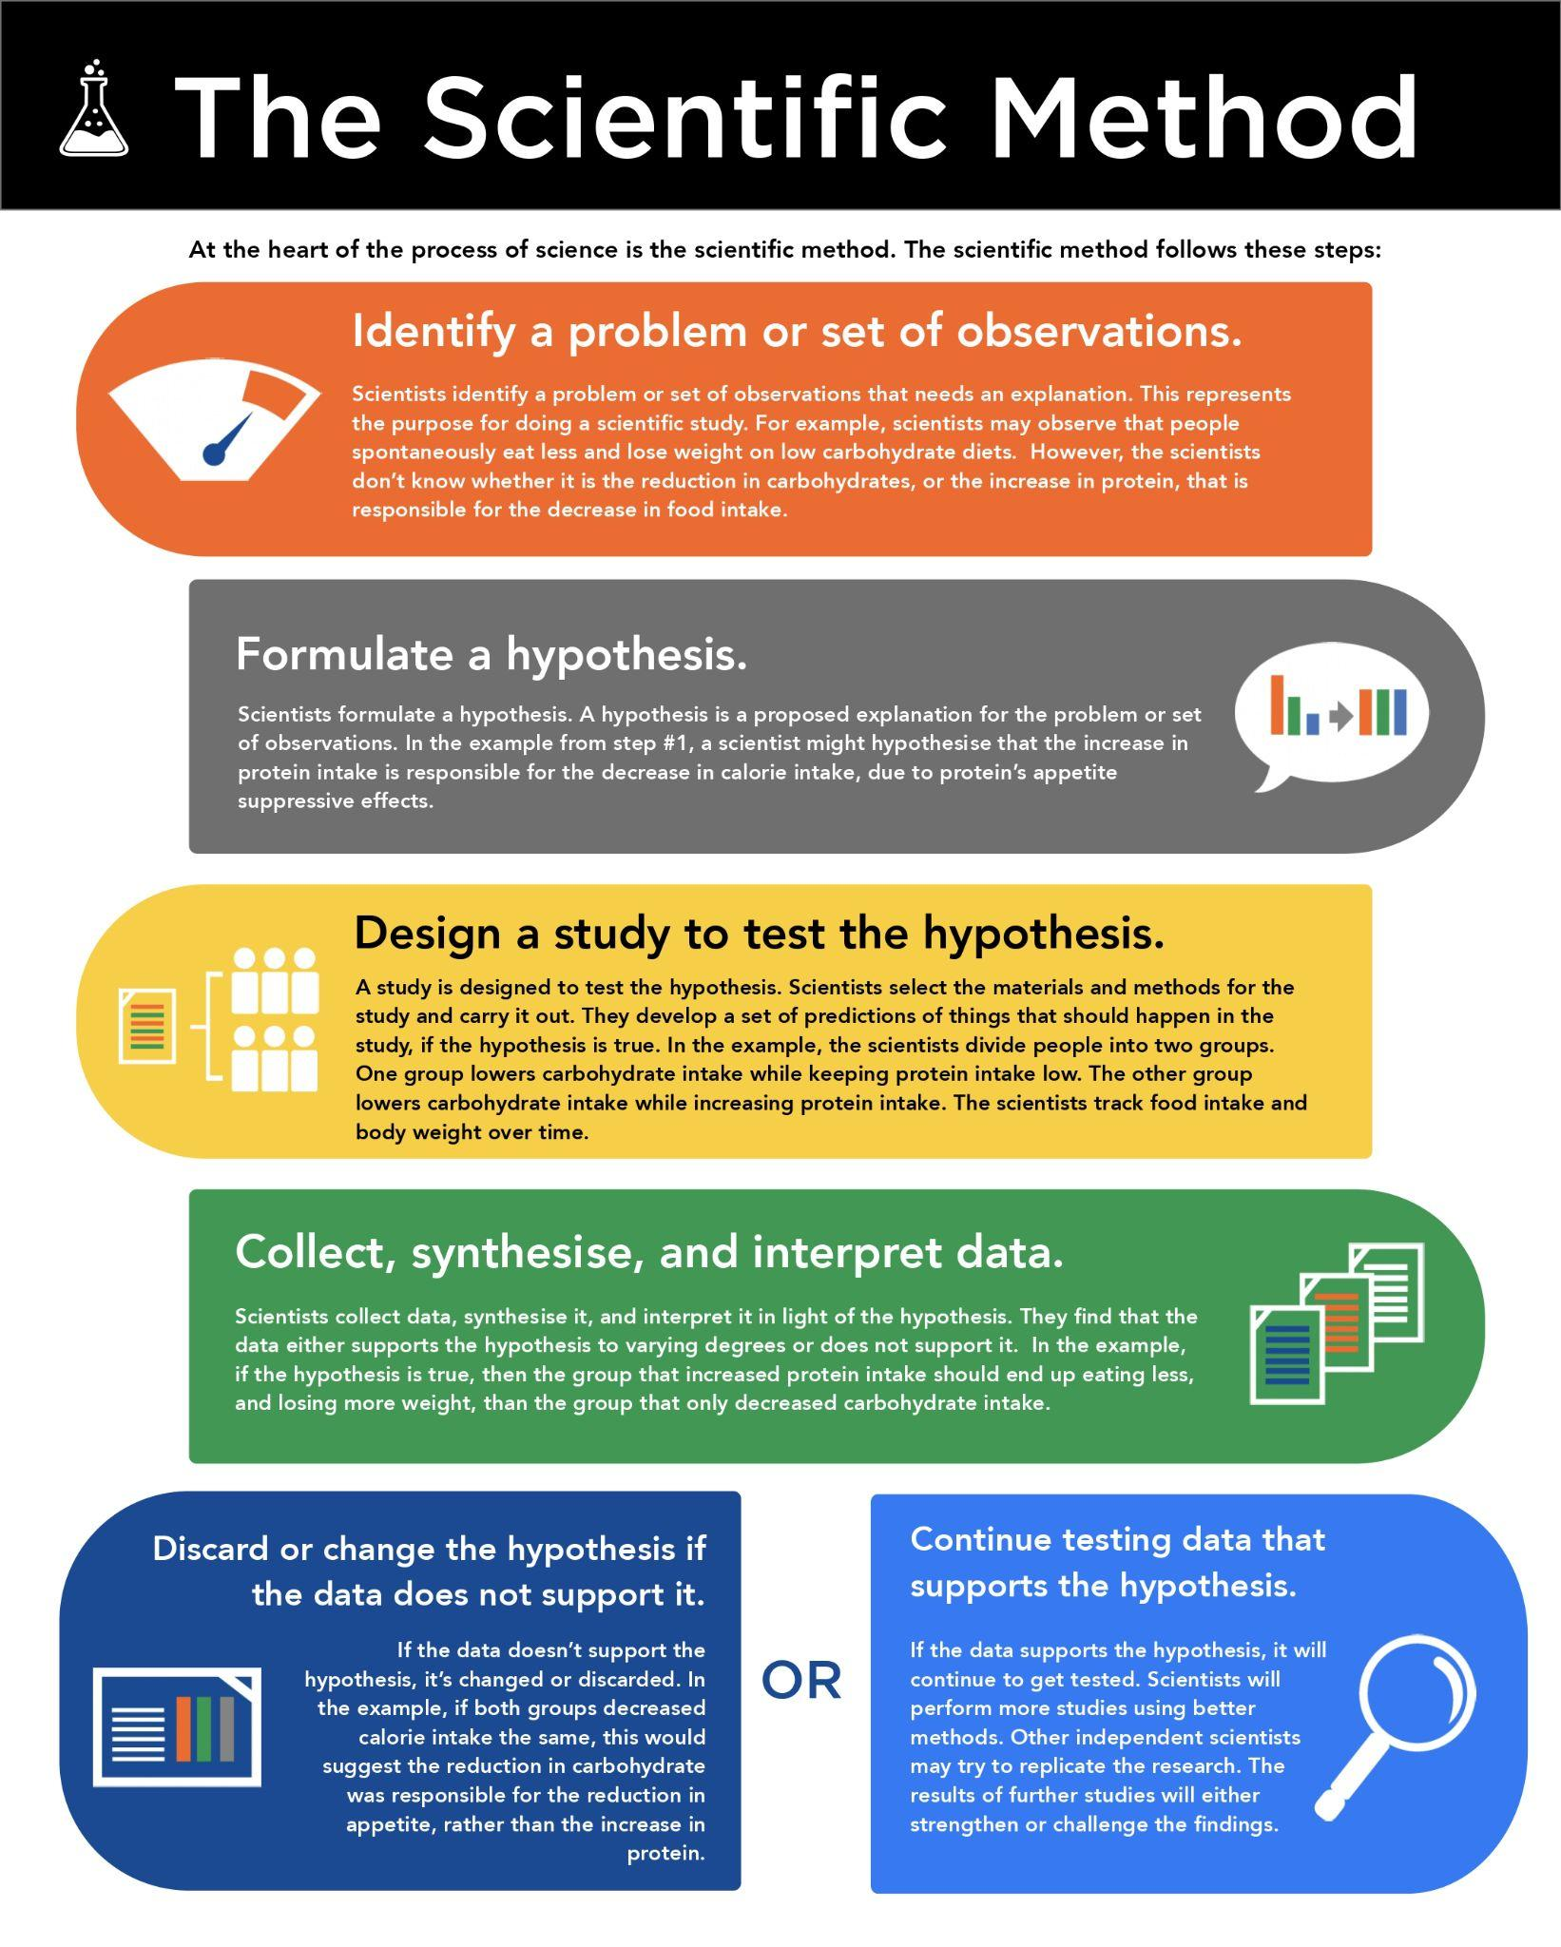

## Hypothesis testing

A large part of science involves hypothesis testing. Scientific studies are the primary way to do this. One common misconception is that studies prove something to be true. However, this is not how hypothesis testing works. Scientists do not prove something to be true. Rather, they engage in a process of narrowing what is most likely be true, *by showing what is not true* (Popper, 2002).

When scientists formulate a hypothesis, they develop a set of predictions from that hypothesis. Predictions are things that should be true if the hypothesis is true. Scientists test these predictions by doing experiments and gathering data. If the predictions are shown to be false, scientists need to modify the hypothesis or replace it (Figure: Hypothesis Testing).

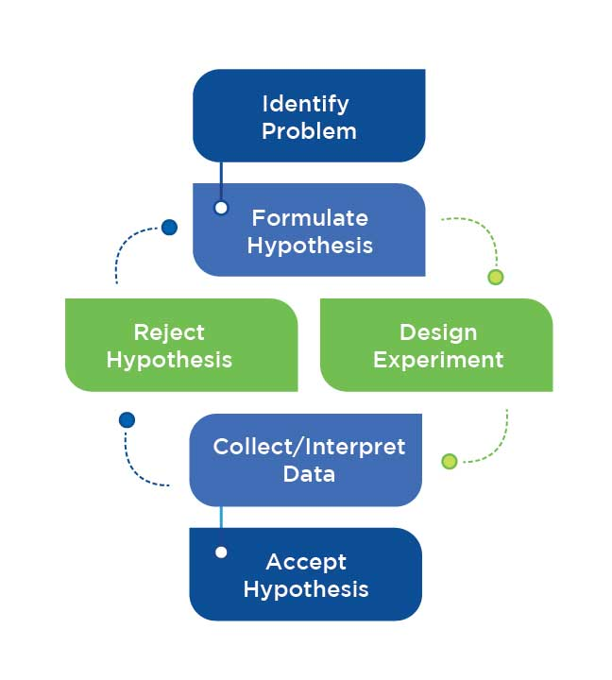

## The accumulation of evidence

As scientists develop and test hypotheses, they discard the failures and keep the ones most likely to be true. The phrase “most likely to be true” is used because science is based on probabilities. The evidence to support a hypothesis accumulates over time. The more evidence that exists to support it, the more likely the hypothesis is to be true. A scientific theory is a hypothesis, or set of hypotheses, for which a large body of high-quality evidence has been accumulated; it has withstood rigorous scrutiny through repeated testing.

Because science is based on probabilities and the accumulation of evidence, its conclusions are always tentative. There is no such thing as 100% certainty. Rather, there is a degree of certainty based on how much evidence exists. Some conclusions may be highly certain due to the vast amount of supporting evidence. Other conclusions may be highly uncertain because evidence is limited.

## The hierarchy of evidence

Some evidence carries more weight than other evidence. The following reverse pyramid shows where evidence exists on this hierarchy. The quality of evidence increases as one moves from bottom to top. See Infographic: Hierarchy of Evidence for more information and a decision tree for evaluating sources.

## Non-peer-reviewed media

Non-peer-reviewed media, including news reports, documentaries, television shows and magazines, represent the lowest quality of evidence. It can be plagued with bias, inaccuracies and misinformation. It is generally not reviewed for quality by other scientists (peer-reviewed). Anecdote and tradition form the lowest level of evidence. "It worked for me.” is an anecdote. Tradition refers to things like “Everyone does it this way.” or “Athletes have always eaten like this.” While these are forms of evidence, they are classed as low-quality. There are too many unknowns and uncontrolled variables. For example, if a supplement worked for someone, this is not evidence that the supplement, per se, was responsible. The psychological expectation that the supplement would work may have resulted in the person training harder and paying more attention to their diet.

Critical!

Non-peer-reviewed media (news reports, documentaries, television shows and magazines) can be plagued with bias, inaccuracies and misinformation. These should not be held in the same esteem as peer-reviewed sources.

Food for Thought

Be careful with media reports on scientific studies. The media tends to report on observational or lower-quality studies (Selvaraj, Borkar, & Prasad, 2014). They also tend to oversimplify or distort the results to make for catchy headlines.

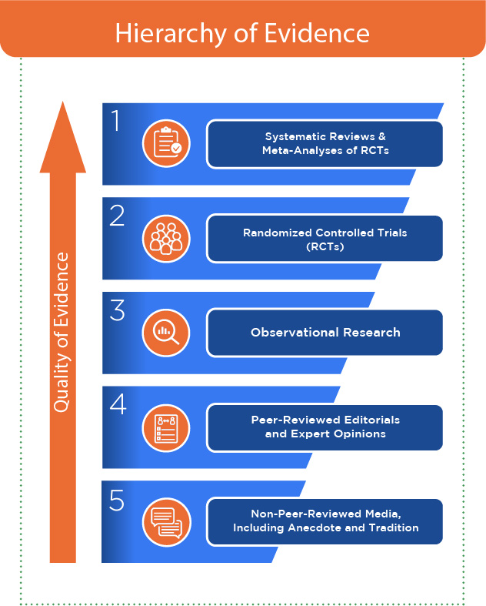

## Peer-reviewed editorials and expert opinions

A peer-reviewed editorial is an opinion piece in a scientific journal. While it has gone through peer review and may be based on scientific evidence, it is still an opinion piece. Expert opinion represents the stance of scientists who have extensively studied a topic. Experts can help summarise existing scientific knowledge and how it is applied. Nevertheless, it is still opinion and falls lower on the hierarchy compared to peer-reviewed primary research.

## Observational research

Scientists observe people in their free-living environment, collect data on them and look for relationships between variables. An example would be where scientists take 10,000 people, assess their dietary habits and body weight and follow up 10 years later. They may look at how many people had heart attacks during the 10-year period. They will see if heart attacks are related to diet, while controlling for body weight. This is of higher quality than anecdote or tradition because the data was systematically gathered from large numbers of people, analysed and sent through the process of peer-review. However, this research can only establish correlations; it cannot establish cause and effect.

Helpful Hint

Observational research can only show correlations. Correlation does not equal causation. For example, ice cream intake goes up in the summer. There is a higher incidence of broken bones in the summer. There is a correlation between eating ice cream and breaking bones. This does not mean that eating ice cream causes weak bones.

For example, scientists might show that higher fat intake is related to heart attack risk. However, that does not mean higher fat intake caused the heart attacks. Since health variables (like diet and exercise) tend to cluster together, there may be other factors causing the relationship. While scientists try to control confounding variables, they cannot account for all of them (Figure: Confounding Variables). Also, this research sometimes relies on self-report. For example, people may self-report their diets, but self-report can be inaccurate.

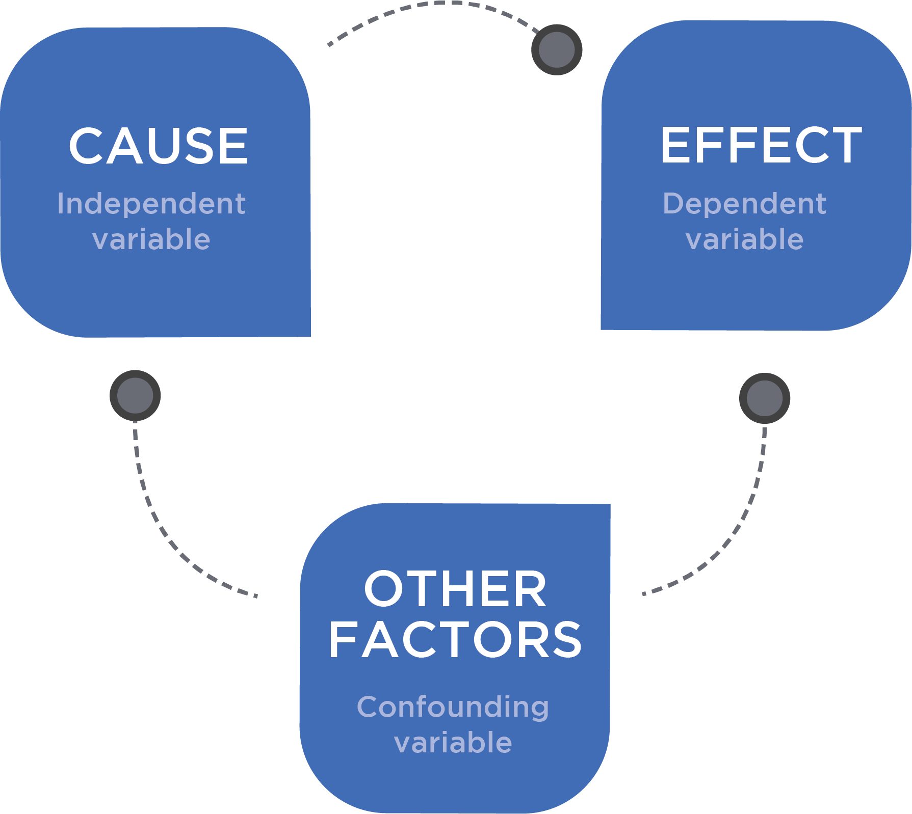

**Figure** Confounding Variables

Getting Technical

Many nutrition observational studies rely on self-report of dietary intake. This can range from 24-hour recalls (where subjects try to recall what they ate over the past day), to food frequency questionnaires (where subjects list the frequency with which they consume various food categories), to food records (where subjects record what they eat). All of these techniques can be inaccurate and introduce bias in a study. This can make it challenging to separate the effects of certain nutritional factors from other nutritional factors or health-related behaviours.

## Randomised Control Trials

In a randomised control trial (RCT) scientists divide people into two or more groups in a random fashion. The scientists keep everything the same between the groups except for one variable. This variable is the independent variable. Scientists manipulate the independent variable in one or more groups and see how the groups respond. One group may not receive a treatment or may get a fake treatment (also known as a sham or placebo); this group is the control group (Figure: RCT Design).

An example is where scientists looked at the effects of creatine supplementation on muscular strength (Kaviani, Abassi, & Chilibeck, 2018). The scientists randomly assigned men to a creatine or placebo group. The men weight trained for 8 weeks while taking the supplement or placebo. Before and after the study, the scientists measured strength. The changes in strength were greater in the creatine group. The scientists concluded creatine causes greater increases in strength compared to a placebo.

RCTs have an advantage over observational research because they can establish cause and effect. They also allow greater control over confounding variables. However, RCTs do have limitations. For example, some may be limited in the number of subjects. Also, environments may be so highly controlled that results might not apply to the general population. These limitations can limit the external validity (or generalisability) of the study.

Food for Thought

Animal studies are also a form of RCT. They have an advantage over human studies in that scientists have more control. This allows them to do a better job of isolating variables of interest. However, these studies can be limited in generalisability. Animal physiology, while similar to humans, is not the same. For example, rodents have a much greater capacity to convert carbs to fat; this means that high- versus low-carb studies in rodents are not necessarily applicable to people.

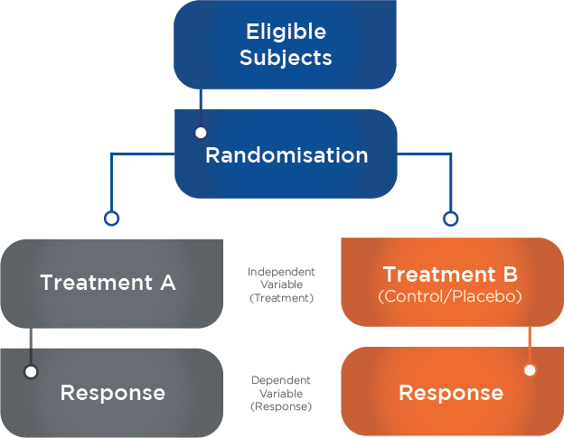

## Systematic reviews and Meta-Analyses of RCTs

The following reviews give information regarding the weight of the evidence.

A systematic review is where scientists gather all research on a topic and evaluate it based on predefined criteria and rules. This is why it is called systematic; the review was done in a systematic rather than haphazard fashion. Contrast that with a narrative review, where research may be gathered in a more informal fashion and the interpretation of the evidence may be subject to the bias of the author(s). A systematic review tries to minimise bias by following established guidelines.

Getting Technical

A systematic review is more quantitative in nature compared to a narrative review, which is more qualitative. For example, one systematic review looked at the relationship between diet and depression (Lassale et al., 2018). The researchers searched the medical literature according to predefined criteria, and gathered 41 studies that fit those criteria. They analysed the relationships between markers of diet quality and incidence of depression. They quantified the amount by which a higher-quality diet is associated with lower depression risk.

A meta-analysis is a statistical analysis of RCTs. It is a study of studies. Scientists gather RCTs that fit predefined criteria. They run statistics on the group of studies to gain an idea of where the overall weight of evidence lies.

Systematic reviews and meta-analyses represent the highest evidence level because they give the consensus on the best research. One meta-analysis gathered 32 studies that compared low-carbohydrate to high-carbohydrate diets under tightly controlled conditions (Hall & Guo, 2017). It showed high-carbohydrate diets resulted in greater fat loss, but by a clinically insignificant amount (16 grams per day, which is the equivalent of about one piece of fruit or a slice of bread). Thus, there is little difference in fat loss when comparing low-carbohydrate to high-carbohydrate diets under calorie-controlled conditions.

While systematic reviews and meta-analyses represent the highest evidence level, they do have limitations. Flaws in study selection or analysis can impact results. For example, if the analysis includes poorly designed studies, it may make the conclusions unreliable.

## Basic scientific principles

Science is a philosophy and a process. It is an approach to gathering knowledge about the natural world. There are characteristics to this approach that contrast it with an unscientific approach to gathering knowledge (Table: Scientific vs. Unscientific).

Helpful Hint

Science is an approach to gathering knowledge about the natural world.

Scientific vs. Unscientific

| **Descriptor** | **Scientific** | **Unscientific** |
| --- | --- | --- |
| Approach to gathering knowledge | Empirical | Emotion, intuition, or gut feelings |
| Attitude | Critical and questioning | Uncritical and unquestioning |
| Method of observation | Controlled | Uncontrolled |
| Method of reporting | Unbiased | Biased |
| Concepts | Clearly defined | Ambiguous |
| Instruments | Accurate and precise | Significant measurement error |
| Measurements | Reliable and repeatable | Unreliable and inconsistent |
| Testability | Falsifiable | Unfalsifiable |

The scientific approach is empirical. Knowledge grows as scientists collect data and study it in a systematic and objective manner. Contrast that with the unscientific approach to gathering knowledge, which relies on emotion, intuition, and gut feelings. It is highly subjective and vulnerable to bias and error.

The general attitude of science is critical and questioning. Scientists review and scrutinize studies and data. Independent scientists try to replicate findings. Limitations of data are addressed. Scientists ask “Where is the evidence for this?” in response to assertions. Contrast that with the unscientific approach, which is uncritical and unquestioning. Assertions are uncritically accepted, especially if they coincide with preformed beliefs.

The method of making observations or performing interventions in science is controlled. Scientists gather data in a systematic fashion. They perform experiments to isolate a variable of interest, while controlling for other variables. The unscientific approach is uncontrolled. Since variables cannot be isolated, it may not be possible to ascertain whether an intervention works or why it works. For example, a person may switch to a different diet and observe that mental alertness improves. However, the person also embarked on an exercise program and learned some new relaxation techniques. Thus, it is impossible to know the true cause of the person’s improvement.

The method of scientific reporting is unbiased. Scientific findings go through peer review and are reported in journals. Customs and rules determine how outcomes are reported. Reporting is biased in an unscientific approach. It can be subject to the whims, biases, and interpretations of the people doing the reporting. There are no systematic methods or peer-review processes.

Concepts in science are clearly defined. Concepts in an unscientific approach are ambiguous and ill-defined.

Scientific instruments are accurate and precise. They measure what is intended to be measured. The inherent error in measurement tools is known. For example, doubly labeled water is a technique to measure energy expenditure in free-living people. The error rates are low and known (about ±5%). Contrast that with instruments that are used in an unscientific approach. The instruments may have significant error of unknown quantities and may not even measure as intended. For example, there are many phone apps that are supposed to assess energy expenditure, but they are often not validated or tested. In fact, there have only been a few studies that have examined the accuracy of phone apps to assess energy expenditure (Johnson, Turek, Dornfeld, Drews, & Hansen, 2016).

Helpful Hint

Most tools available to the average person (rather than scientists) to measure things like energy expenditure or body composition are very imprecise. Also, even if a technique shows reasonable accuracy when measuring the average of groups of people, it does not mean it shows reasonable accuracy in individuals. For example, one study showed that a phone app had high error rates when assessing energy expenditure in individuals (Johnson, Turek, Dornfeld, Drews, & Hansen, 2016). Use caution when interpreting the results of these tools.

Measurements in science are reliable and repeatable and performed in an objective fashion. Measurement reliability refers to the consistency of a measure. A scientist should get similar results when something is measured under the same conditions; sometimes this is called test–retest reliability. Measurements should be close in value on repeated measurements in succession by the same person. There are objective criteria for how measurements are made. For example, waist circumference will have landmarks that guide an individual as to the appropriate way to perform the measurement. Contrast that with unscientific ways of performing measurements. They are unreliable and unrepeatable and performed in a highly subjective manner with little or no criteria to guide measurement.

Food for Thought

Replication is an important concept in science. For a scientific finding to be true, independent scientists should be able to reproduced it. For example, one lab has produced extremely positive results on the supplement HMB (Wilson, et al., 2014). However, other scientists have been unable to reproduce these results (Teixeira et al., 2018). This means that the positive results are not reliable.

As discussed earlier, science involves the process of hypothesis testing. Because every hypothesis is testable, it is subject to falsification. The process of falsification allows scientists to narrow down what is true, by proving what is not true. This is in stark contrast to the unfalsifiable hypothesis, which is a claim that is not testable. For example, the claim that a giant ape-like creature (Bigfoot or Sasquatch) roams the forests of the Pacific Northwest is unfalsifiable; it is impossible to disprove. This is because, if it does not exist, no evidence will be found. If it is pointed out that there is insufficient evidence for the existence, believers will claim they are good at hiding and forests are too vast to find them. Extra-Sensory Perception (ESP) is something that scientists have failed to demonstrate in dozens and dozens of experiments. However, ESP believers will respond by saying the skeptical thoughts of the scientists are blocking ESP transmission. The hypothesis that ESP exists becomes unfalsifiable, since, with every single failed experiment, believers will have some sort of reason why the experiment failed to support its existence.

Try This

Do you believe most nutrition-related hypotheses are testable? Can you think of an unfalsifiable hypothesis that you or your clients may have encountered?

## Types of scientific research

Some types of scientific research were covered in the section on the hierarchy of evidence. This section will expand on those types of research as well as provide other types. See Infographics: Types of Scientific Research (A and B) for an overview.

Getting Technical

While RCTs represent the gold standard of research, they can vary in quality. Some studies may be poorly designed or executed. For example, a research study from Italy supposedly showed aspartame to be carcinogenic in rodents (Soffritti, Belpoggi, Tibaldi, Esposti, & Lauriola, 2007). The research had numerous flaws and was heavily criticized by numerous scientific organizations, including the European Food Safety Authority (EFSA) and the Food and Drug Administration (FDA) (European Food Safety Authority, 2006). For example, the control rodents had very high cancer rates and independent scientists requested to reanalyze the data as a quality-control check, but the organization that produced the study refused.

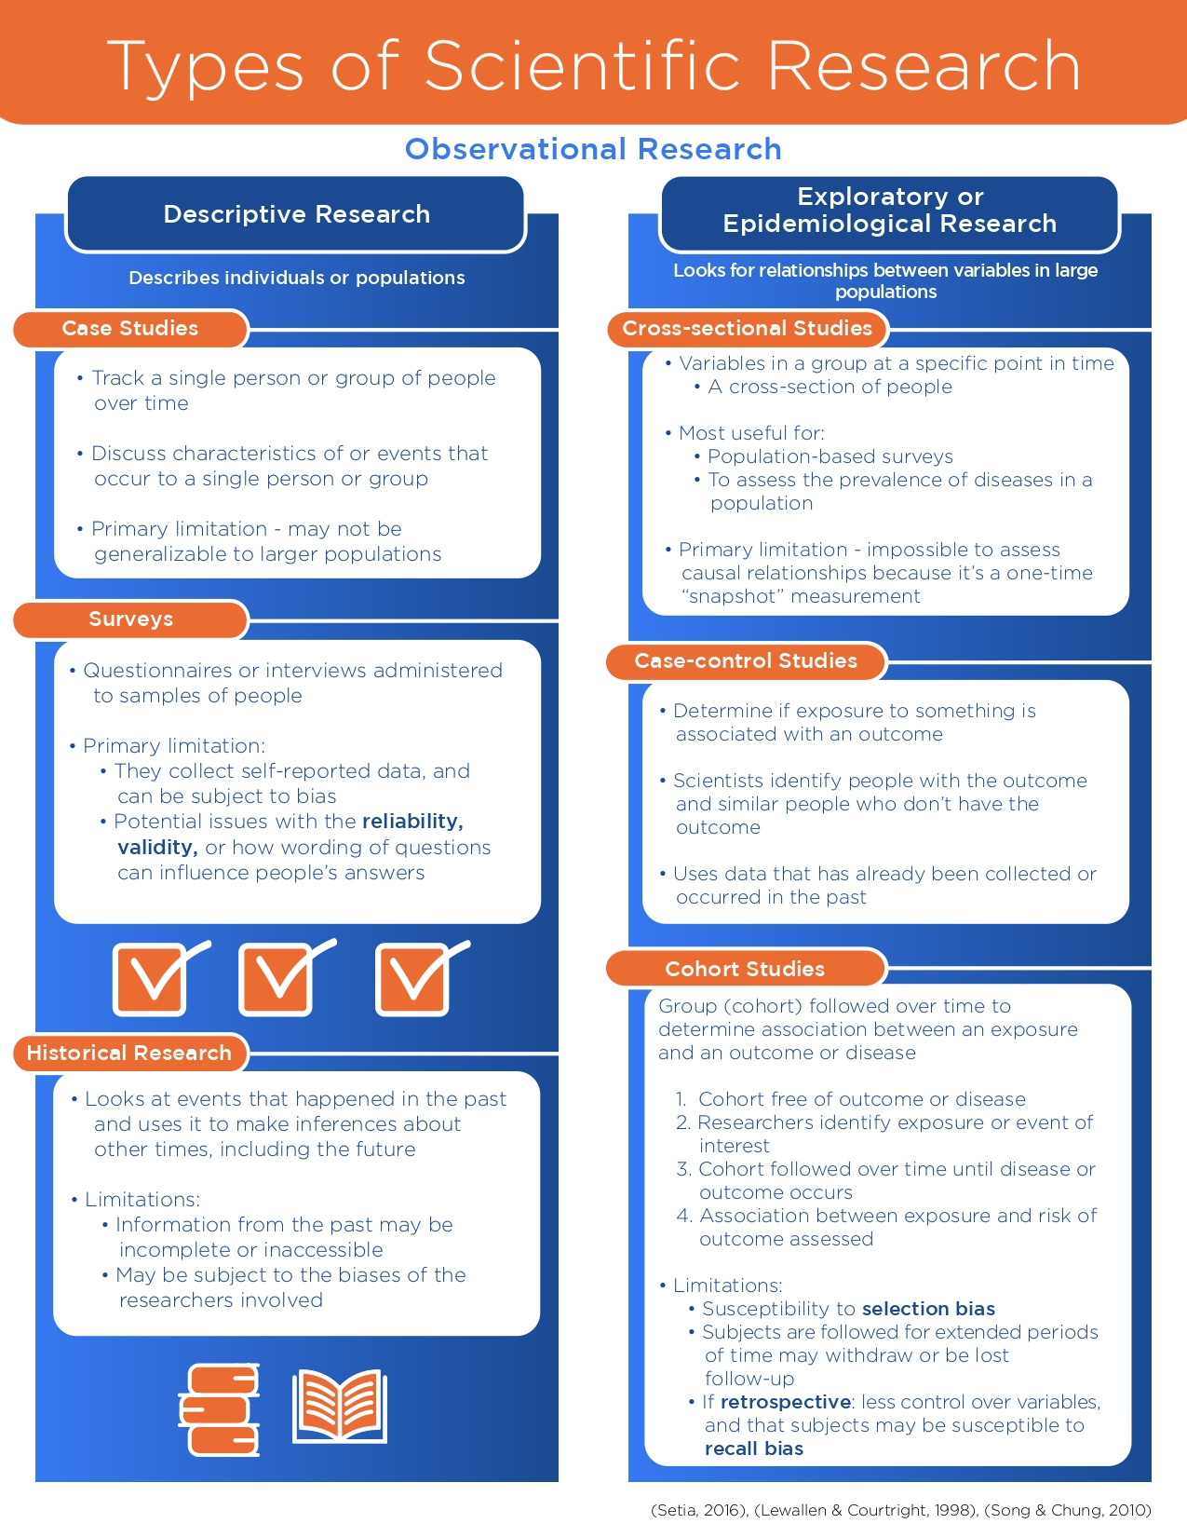

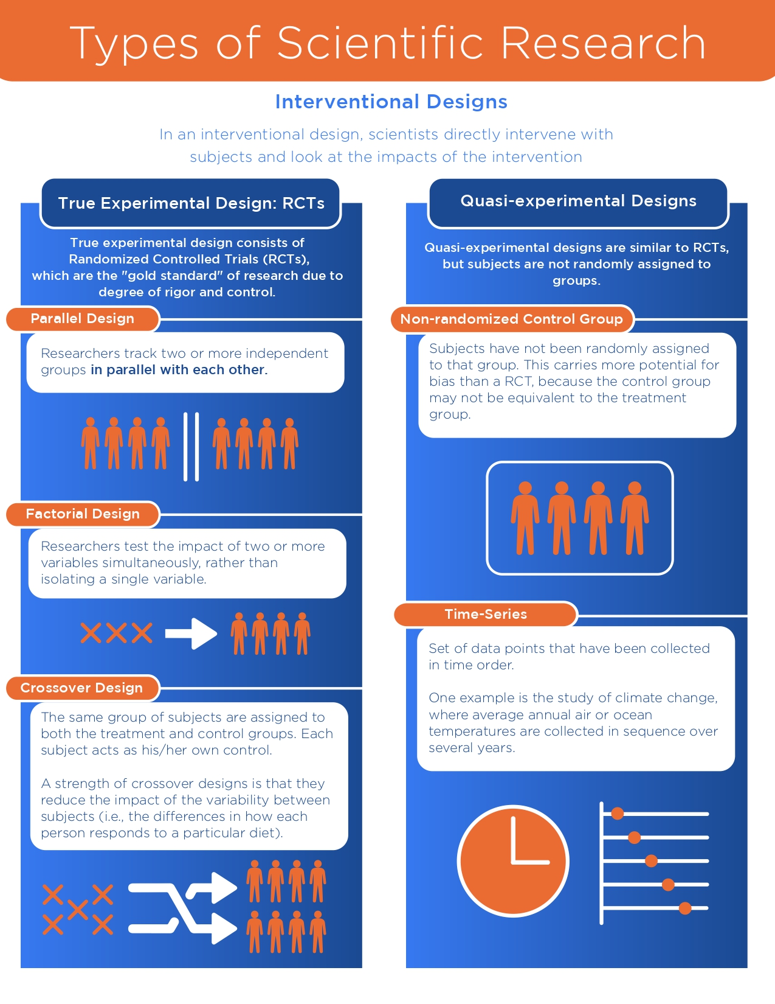

## Strengths and limitations of major types of research

While science represents the best tool to understand the natural world, it is not without limitations. The various types of studies each have unique limitations.

### Strengths and limitations of observational designs

Observational studies allow for the examination of large populations over long periods of time. They also help examine potential associations that occur over long periods of time, such as the association between diet quality and cancer risk. Finally, they allow for the generation of hypotheses that can be further studied in RCTs. Despite these strengths, observational studies cannot establish cause and effect. In other words, correlation does not equal causation. The lack of control of variables increases the chance of false associations. For example, while an observational study might show an association between a dietary component and cancer, it is possible that other dietary or physical activity factors may be responsible, since health-related behaviors tend to cluster together. While scientists try to control for some of these confounders with statistics, it is impossible to control for everything.

Some observed associations may be due to reverse causality. For example, in some observational studies, the use of non-nutritive sweeteners is correlated with obesity (Fowler et al., 2008). However, RCTs have shown non-nutritive sweeteners aid with weight control (Peters et al., 2014). This indicates that the observed association between non-nutritive sweeteners and obesity is due to obese individuals being more likely to use non-nutritive sweeteners as an aid for weight loss, rather than non-nutritive sweeteners causing obesity.

## Evaluating sources of information

Not all sources of scientific information are created equal. The best sources of information come from the place where studies are published: peer-reviewed scientific journals.

### Peer-reviewed scientific journals

Scientific journals are publications that compile research papers, editorials, and other academic writings related to a topic. With direct regard to research papers, for them to be published in peer-reviewed journals, they must go through peer review (Figure: Peer Review).

#### Types of peer-reviewed journal articles

There are several different types of articles in peer-reviewed journals and not all are studies:

* Position stands and scientific consensus statements. Position stands and scientific consensus statements are thorough and valuable summations of the state of the evidence on various topics. They are usually written by large teams of scientists.
* Systematic reviews and meta-analyses. These were covered in the section on the hierarchy of evidence. A systematic review is where scientists review all of the literature on a topic in a systematic fashion to assess weight of the evidence. A meta-analysis is where a group of studies are statistically analyzed to determine the weight of the evidence. These types of papers provide valuable overviews of the state of the evidence where position stands fall short.
* Individual studies. The majority of articles in peer-reviewed journals consist of individual studies.
* Narrative reviews. In a narrative review, research is gathered in a more informal fashion compared to a systematic review and the authors give their assessment and interpretation of the overall weight of the evidence.

Critical!

Peer review means other independent scientists critically evaluate the study before it is published. After reviewing the study, the scientists will respond to the journal publisher with their recommendations. These recommendations range from acceptance, to a request to make revisions (to improve the paper before it is published), to rejection. While peer review is not without flaws (for example, reviewers can have their own biases), it is an important form of quality control. Non-peer-reviewed literature is a minefield because it spans from well-supported articles to articles with minimal scientific support. Peer review raises the barrier of entry into journals that professionals rely upon for evidence-based data and discourse.

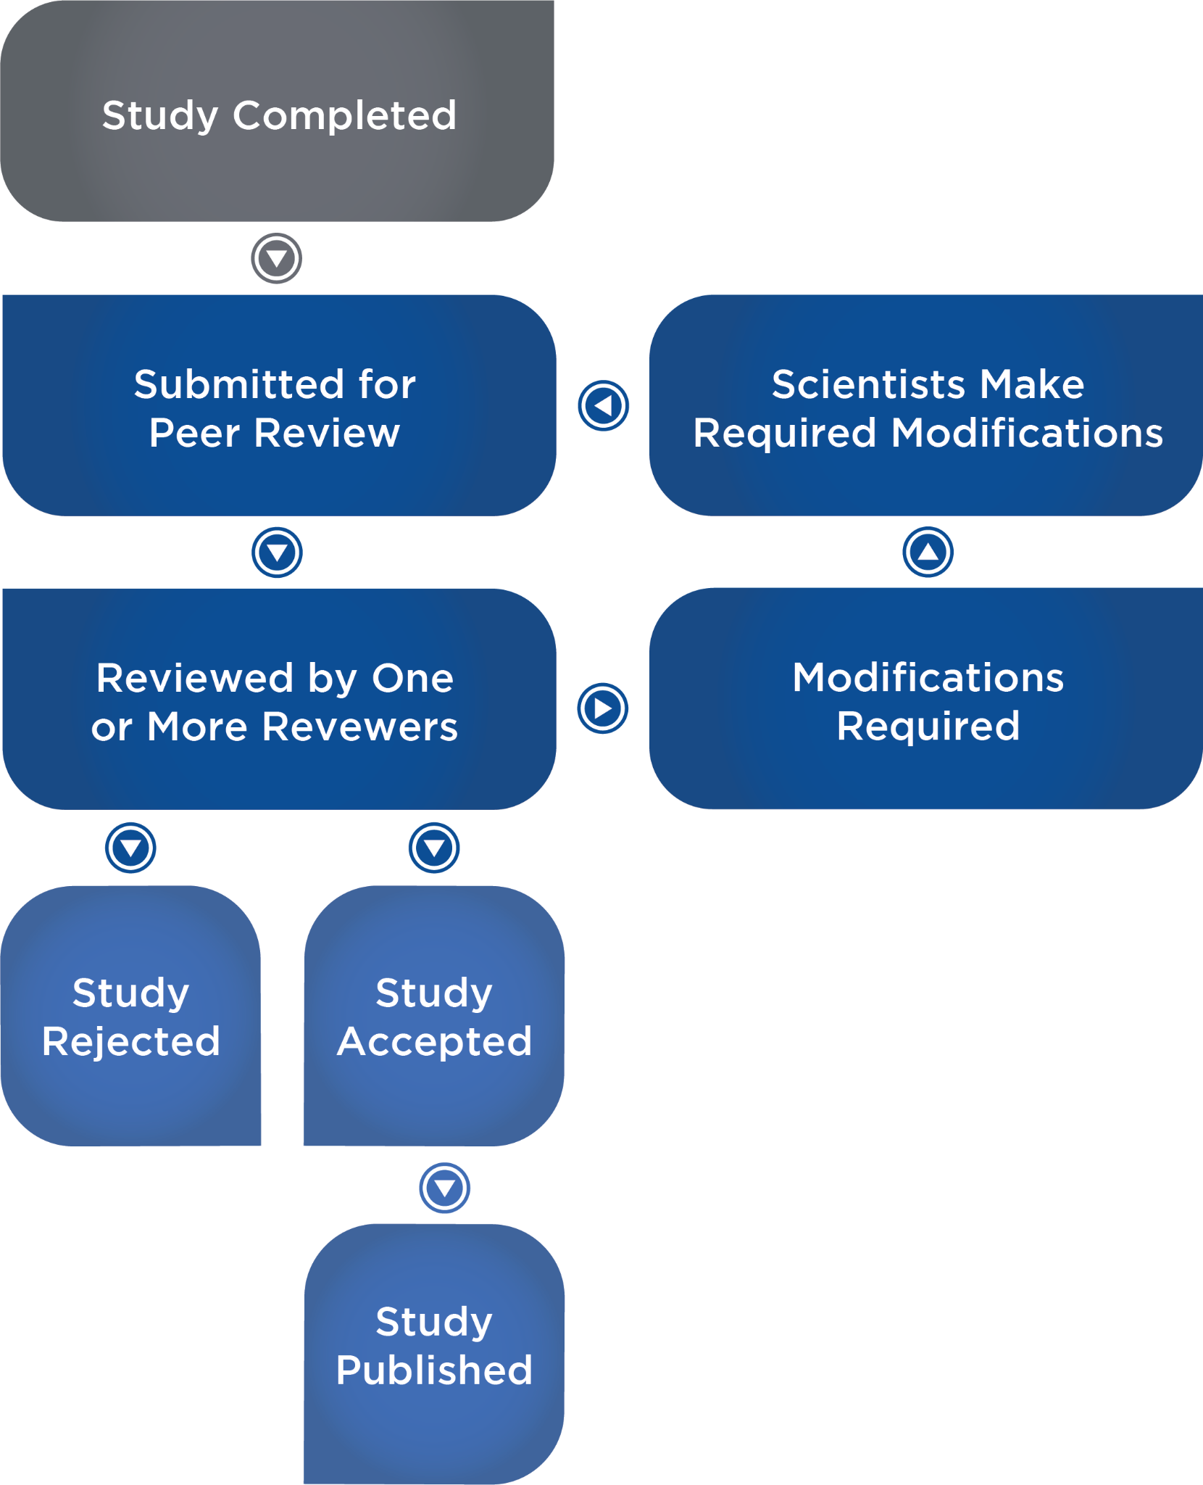

## High-Quality, non-peer reviewed sources of information

While peer-reviewed studies and scientific journals represent the highest quality sources of scientific information, there are other good sources that do not have a formal peer-review process. While they have a higher risk of bias and error, they can still serve as excellent sources of scientific information. These include the following:

* Recently published academic textbooks
* University public health websites (e.g., Harvard School of Public Health)
* Academy of Nutrition and Dietetics website (<https://www.eatright.org/>)
* U.S. government health websites (e.g., Centers for Disease Control and Prevention)
* International health websites (e.g., Eat Well Guide or World Health Organization)
* Conference presentations by primary researchers without a brand or ideology to defend or product or supplement to promote
* Podcast interviews with primary researchers

### Questionable or poor, non-peer reviewed sources of information

Caution is warranted when obtaining information from these sources:

* Popular media. This includes television and radio shows (whose main objective is ratings and advertising revenues, not scientific accuracy) and most popular diet and health books.
* Anecdotes and testimonials. Anecdotes are at the bottom of the hierarchy of evidence and can be unreliable.
* Advertisements of products or special methods and protocols
* Most blogs (and their comment sections)

## Evaluating source quality

When in doubt, refer to Infographic: Evaluating Source Quality to assess a resource.

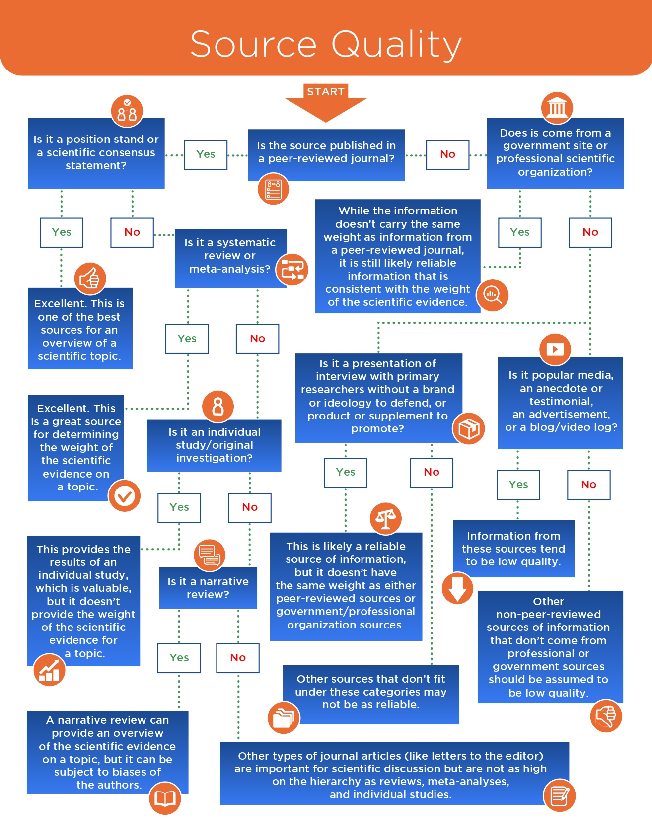

# Scientific consensus: How the scientific community changes

Science is a process of accumulating evidence and examining the weight of that evidence. Sometimes studies will contradict each other and that is a natural part of the process. As mentioned earlier, many conclusions in science are tentative and based on the best evidence available for the time. However, as time moves on and as scientists accumulate more evidence, newer evidence can sometimes overturn older evidence. This makes changing the scientific consensus slow and illuminates why there is often a lag between the scientific literature and public health recommendations. Public health recommendations may state *X*, but evidence in the scientific literature is slowly favoring *Y*. Eventually, the *X* in the public health recommendations will be replaced with *Y*.

One example of this involves butter versus margarine. Several decades ago, as evidence accumulated that the saturated fat in butter may be related to heart disease risk, scientists recommended that people switch to lower-fat margarine. However, evidence began to accumulate that the trans fats in margarine were worse than saturated fat in regards to heart disease risk. Based on this newer evidence, scientists revised their recommendations to continue to limit butter, but also eliminate margarine and trans fats.

## Science: shades of grey, not black and white

As discussed previously, conclusions in science are tentative and based on degrees of certainty according to the weight of the evidence. Thus, science can rarely give black or white answers. Rather, it provides answers in shades of grey. The more evidence there is for a particular proposition, the darker the shade of grey will be. Thus, there are vast amounts of nuances and caveats when it comes to scientific conclusions.

It is also important to realise that the science of nutrition is an inherently complex topic. Thus, knowledge of the human body and how it interacts with various agents of nature (including nutrition, supplementation and exercise) will always be incomplete. The uncertainty of science is, in fact, a strength; it forces individuals to be open-minded toward adjusting current opinions based on the weight of the evolving evidence.

The concepts that nothing is 100% certain in science and that conclusions are tentative based on the weight of the evidence can be described in Lyttleton’s (1977) bead model of truth (Figure: Bead Model of Truth). In this model, there is a bead on a horizontal wire that can move left or right. On the far left is 0, which is no evidence or complete disbelief. On the far right is 1, which is 100% certainty.

If it is unlikely for a certain proposition to be true, the bead will be closer to 0. If evidence accumulates that a certain proposition is true, it will move closer to 1. However, it will not reach the far extreme of either side because there is never 100% certainty in science. For example, the evidence is overwhelming that low-density lipoprotein (LDL) plays a causal role in heart disease (Werner & Laufs, 2015). However, due to the inherent limitations of research, scientists will never be able to claim with 100% certainty that LDL causes heart disease.

### Scientific conclusions

There is a lot of nuance when it comes to scientific conclusions and context matters. One example is how people want to label sugar as good or bad (usually the latter). However, good and bad foods do not exist; rather, food quality exists on a continuum. Regarding sugar, it is not a harmful substance on its own and one component of it (glucose) is necessary for life. Also, when consumed as part of a calorie-controlled diet, it does not cause adverse health effects or fat gain. However, when added sugar is used to enhance the palatability and energy density of foods, it makes them easy to overeat. This can lead to increased calorie intake and fat gain.

Conclusions in science are not 100% certain; the degree of certainty can be evaluated using the hierarchy of evidence. Also, understanding of various topics differs in terms of the degrees of certainty. Some topics are more difficult and logistically challenging to study than others and there will be more uncertainty and lighter shades of grey. Here are some examples of some very grey areas in nutrition, where conclusions remain uncertain due to the challenges in studying the topics:

* The interaction between the size of meals and meal frequency on body composition in resistance-training individuals
* The impacts of linear versus cyclical carbohydrate intake on body composition under different conditions (like training, hypo versus hypercaloric or energy balance)
* The impacts of changes to the gut microbiome on energy balance or body composition, and whether changes in the microbiome cause the changes in body composition or vice versa.

The study of disease endpoints, like cardiovascular disease, can also contain fair amounts of uncertainty and nuance. It is difficult and expensive to perform very long-term (over many years) clinical trials looking at disease endpoints (like mortality). Thus, scientists sometimes rely on surrogate markers correlated with the disease endpoint (like blood lipids).

Food for Thought

The phrase “cherry-picking” refers to the tendency for people to select individual studies or pieces of data that support their viewpoint, while ignoring the weight of the evidence. For example, if 9 studies show *X*, and one study shows *Y*, it could be considered “cherry-picking” if you focus on the one study that shows *Y*. The media tends to overly focus on the results of individual studies without regard to the overall weight of the evidence.

Science represents both knowledge of our natural world and the process for obtaining that knowledge. The scientific method is the process through which data is gathered and analysed, predictions are made and hypotheses are tested. Science works on the accumulation of evidence and conclusions are tentative and based on the weight of that evidence. Quality of evidence lies on a hierarchy, with low-quality evidence (like anecdote) at the bottom and high-quality evidence (systematic reviews and meta-analyses) at the top. Scientific research is made up of both observational and interventional designs. Each have their own strengths and limitations.

It is important to evaluate sources of information regarding quality and risk of bias. Research published in peer-reviewed journals represent the highest level of quality. Finally, while science can help guide decisions regarding clients and programming, it must be balanced with practical experience and the needs and preferences of the individual.

In this chapter, you learned about:

* The importance of evidence-based practice.
* Different research design methodologies (e.g. meta-analyses, cross-sectional studies, crossover designs and randomised control trials).
* The scientific method.
* Reliable and credible sources of information such as peer-reviewed journals.

Coach's Corner

Science cannot provide specific recommendations on how to programme for a client. It can only provide general guidelines. For example, science may provide guidance as to the appropriate energy intake to achieve weight loss, but this guidance is based on averages of many people. The needs of an individual may vary from the average and estimated calorie intake may not work for that individual. It is up to the coach to take those guidelines and design a customised programme for a client. Using a scientific approach to understanding information, vetting information and critically appraising information can help a coach more efficiently arrive at truths regarding general guidelines.

# Food preference and influences

## Defining health and disease

The World Health Organisation (WHO) is the international public health agency of the United Nations focused on the development and promotion of international public health and wellbeing efforts. Essentially, the WHO can be thought of as the “world’s public health department”.

The WHO defines health as

A state of complete physical, mental, and social wellbeing and not merely the absence of disease or infirmity.

Health is not a condition that is static, but rather an ever-changing condition due to the human body’s continual need to make adjustments to internal and external situations, changing environments, and pathologies. The human body is uniquely designed to respond to stressors and, if necessary, make changes to maintain optimal health and physiological functioning. This is called **homeostasis**. The term *health* refers to the objective state in which the body is functioning, ranging from a high level (optimal well-being), to moderate compromise (transition zone), to a state of poor health (Figure: The Spectrum of Health) (Khalsa, 2017). A state of poor health often accounts for multiple physical and mental pathologies, which may or may not be preventable or recoverable.

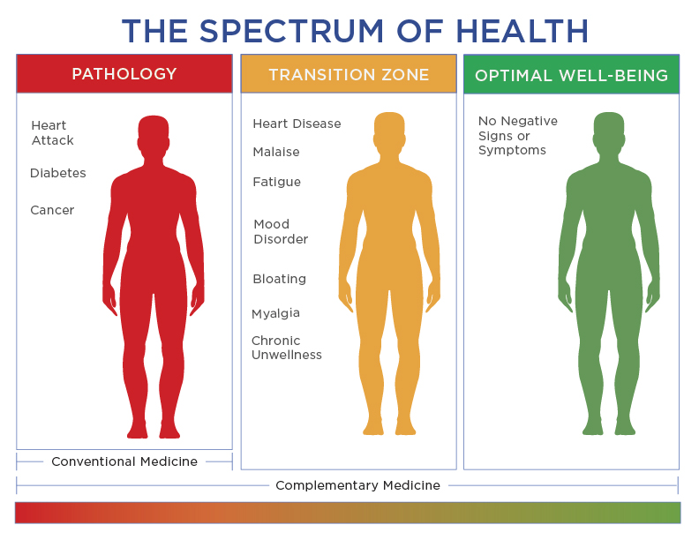

### Disease

The logical definition of disease would seemingly just be the opposite of health, but it is not quite that simple. A general definition of disease includes any abnormal condition that negatively affects the structure or function of a part of the body. Diseases can affect one area of the body or they can be systemic, affecting every part of the body (e.g. various forms of cancer). Diseases may be caused by external conditions or internal problems and are further classified by their specific signs and symptoms. The classification of disease is typically broken down further into two categories: noncommunicable and communicable disease*.*

The term noncommunicable disease (NCD) is more commonly referred to as *chronic disease* and is defined by the WHO (2018) as “diseases that tend to be of long duration and are the result of a combination of genetic, physiological, environmental and behavioural factors. The main types of NCDs are cardiovascular diseases (like heart attacks and stroke), cancers, chronic respiratory diseases (such as chronic obstructive pulmonary disease and asthma), and diabetes.”

Communicable diseases are defined as an infectious disease that is passed from person to person through direct contact with an infected individual. Communicable diseases include life-threatening viruses such as Zika and Ebola, seasonal influenza viruses (flu and colds) or Lyme disease. Most communicable diseases are preventable through proper hygiene, vaccinations and taking necessary precautions. If exposure is suspected and symptoms of an infection develop, medical attention should be sought immediately.

Food for Thought

Noncommunicable diseases, or NCDs, are by far the leading cause of death in the world, representing 71% of all annual deaths. NCDs kill more than 41 million people each year. Some 85% of all NCD deaths occur in low- and middle-income countries (WHO, 2018).

The leading causes of death in the world today are mostly chronic diseases and conditions. Coronary artery disease, a specific type of heart disease, is the leading cause of death in both men and women (Figure: Leading Causes of Death) (CDC, 2013). While preventative efforts and the availability of better treatments have lowered the rates of death from NCDs in the past few decades, the fact remains that coronary artery disease, along with numerous other chronic diseases, is highly preventable. Thus, the top two preventable causes can be contributed to cigarette smoking, physical inactivity, and/or poor diet (Figure: Preventable Causes of Death) (Mokdad, 2004).

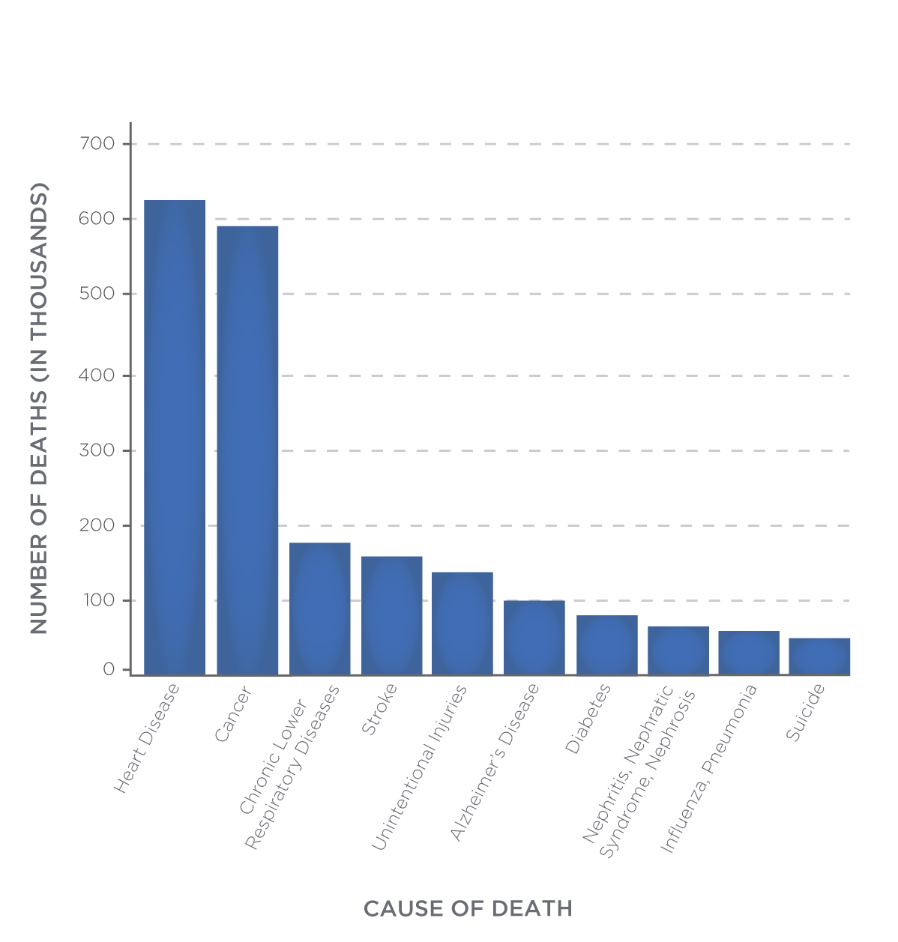 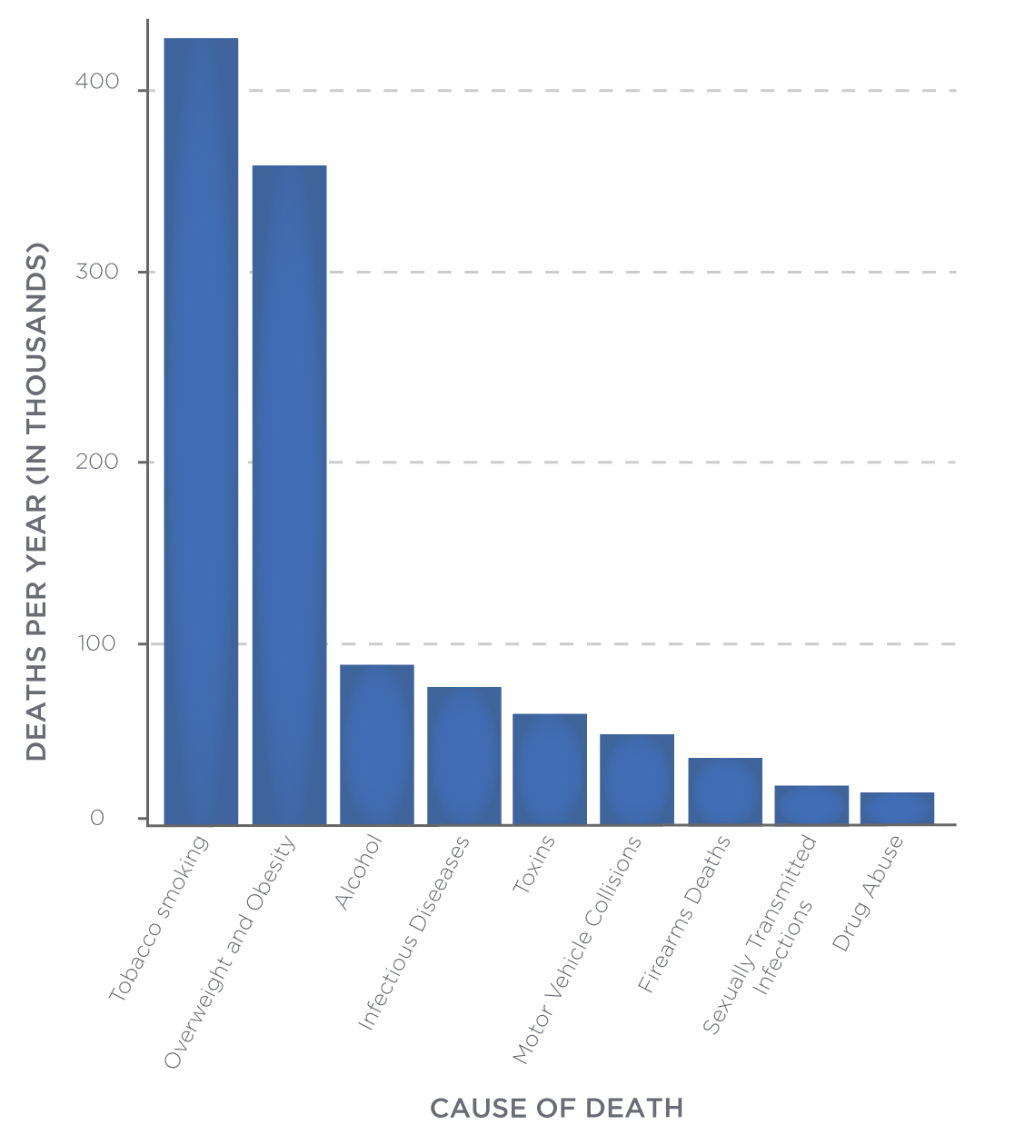

### Wellness

Wellness encompasses numerous components of life that dynamically lead to a better state of health and wellbeing. The National Wellness Institute (2018) addresses six dimensions of wellness in their definition:

The six dimensions of wellness are emotional, occupational, physical, social, intellectual, and spiritual. Addressing all six dimensions of wellness in our lives builds a holistic sense of wellness and fulfilment.

Wellness is a fluid process, whereas health is often viewed in objective terms of good or bad. Health is a state of being, underscored by the absence or presence of chronic conditions and disease. Wellness, on the other hand, exists on a more dynamic continuum (Figure: The Illness–Wellness Continuum) (Travis & Ryan, 2004). A person’s health refers to their objective states of physical, mental and social well-being, whereas wellness encompasses the lifestyle practices aimed to enhance those objective states. Wellness views health from a holistic perspective (mind, body, and spirit).

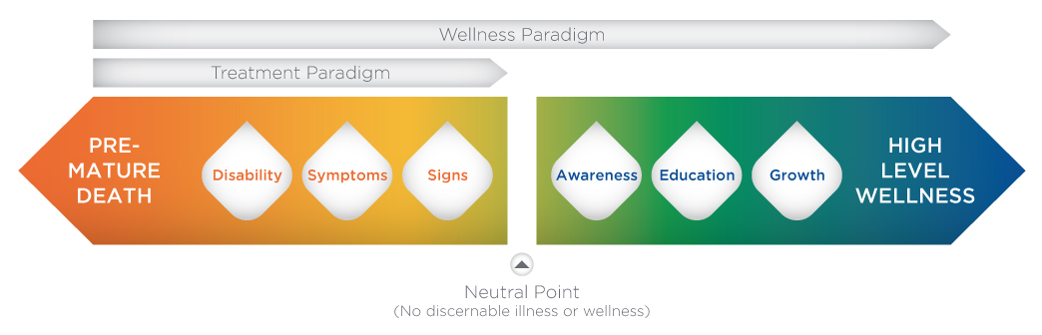

**Emotional wellness** inspires a sense of inner calm, relaxation and inner strength. Emotional wellness practices remind us to stay positive, smile, be mindful, learn from mistakes, ask for help from others and remember that life is full of ups and downs. Both positive and negative emotions affect how we respond and adapt to our surroundings. This is especially true in relation to eating habits and maintaining a healthy relationship with food.

**Occupational wellness** encourages us to carefully consider our career and employment opportunities throughout our lifetime. Personal satisfaction and senses of purpose and value are factors that lead to a high level of occupational wellness. And while “work is just work” for a large segment of the population, enhancing occupational wellness does not necessarily require monetary compensation. Taking time to explore volunteer opportunities that allow people to focus on tasks and skills they enjoy will lead to a greater sense of fulfilment and increase to overall occupational wellness.

**Physical wellness** encompasses a sense of respect and responsibility for taking care of our bodies, promoting a desired sense of optimal health and physical functioning across the lifespan. Overall physical wellness encourages the balance of physical activity, exercise, rest and relaxation, nutrition, mental health, and well-being. Maintaining an optimal level of physical wellness directly leads to better health.

**Social wellness** refers to our ability to form and maintain relationships with others. Isolation can lead to negative emotions, whereas a robust social network helps develop a positive outlook on life, especially when life is challenging. Learning to build healthy, nurturing, and supportive relationships with others leads to a high degree of social wellness. Improving social wellness is one of the best ways to also improve emotional wellness.

**Intellectual wellness** encourages people to never stop learning and engaging in creative and mentally stimulating activities across the lifespan. It means participating in activities that expand knowledge and skills across academic, cultural, community and personal pursuits. Intellectual wellness fosters a greater sense of fulfilment and helps improve both emotional and occupational wellness for a more balanced life.

**Spiritual wellness** is often one of the least understood wellness components. Most people immediately equate it with religion; however, aligning to a specific religious practice is only one means of finding an improved sense of spiritual wellness. Being spiritual simply means having personal faith in something that deepens feelings of belonging and peace with oneself and the world. A person’s spiritual wellness can be defined in terms of religious faith, personal values, ethical/moral beliefs or simply a general acceptance of an underlying mind-body-spirit connection. At its core, it helps create a greater sense of meaning and purpose in life and enhances all other dimensions of wellness.

## The role of diet in chronic disease

The association between diet and disease has been investigated and reported for thousands of years. The Greek physician and 'father of modern medicine', Hippocrates (460–370 BC), was perhaps one of the first scientists to recognise the connection between diet and health:

If we could give every individual the right amount of nourishment and exercise, not too little and not too much, we would have found the safest way to health.

Let food be thy medicine and medicine be thy food.

The association between diet and health is well-supported by research. While ample scientific literature explores many aspects of the relationship between diet and health, Nutrition Coaches should be concerned with how diet relates to the most common chronic disease conditions in the United Kingdom and worldwide.

### Obesity

According to the Centers for Disease Control (CDC), 40% of American adults were obese in 2016; this represents 93.3 million adults (Hales, 2017). Furthermore, obesity-related conditions including heart disease, stroke, Type 2 diabetes, and certain types of cancer, are the leading causes of preventable, premature death (National Heart, Lung, and Blood Institute, 2013). The link between diet and obesity is studied by looking at the dietary patterns (including total caloric intake and diet quality) and biometrics of large groups of people, and then determining if any associations exist (Min, 2017). In the past several decades, the relationship between dietary patterns and overweight/obesity has been widely researched and reported (Mu, Xu, Wu & Bai, 2017):

* There is a direct association between diet, obesity, body fat, and body mass index (BMI).
* Studies support a balanced diet that is associated with lower rates of being overweight or obese.
* The risk of developing obesity (and its associated chronic conditions) is the highest in those that eat a diet high in saturated fat and total calories (referred to as a Western pattern diet).
* Higher total caloric intake each day paired with low energy expenditure is directly associated with a higher incidence of being overweight or obese.
* A change in dietary habits can play a significant role in reversing obesity.

Overall, every person should be following a balanced dietary pattern to keep a healthy body mass and reduce the risk of being overweight or obese.

Coach's Corner

Tips for a Health-Supporting Diet

* Choose a diet that is low in saturated fat and aims to remove all trans fats.
* Follow guidelines specifically for health conditions; for example, guidelines set by the American Heart Association or the World Health Organisation.
* Choose beverages and foods that are low in added sugar.
* Eat plenty of fresh fruit and vegetables.
* Reduce intake of fatty meats, processed foods and foods with high salt content.
* If you drink alcohol, do so in moderation.

### Heart disease

Diet is considered an independent modifiable risk factor for coronary artery disease, generally referred to as heart disease. By changing your diet, an individual can change their risk of developing heart disease. The higher a diet is in saturated fat and cholesterol, the higher the risk of developing heart disease, independent of all other risk factors (Nettleton, 2017). Conversely, there is a strong correlation between reduced risk of developing heart disease and choosing a diet low in saturated fat, high in fibre, low in salt and sugar and high in plant foods (Mente, 2009). Additional risk factors for heart disease include obesity, high blood pressure and uncontrolled diabetes. The Mayo Clinic (2018) offers the following heart-healthy dietary recommendations:

* Control portion size.
* Eat more fruits and vegetables.
* Eat more whole grains.
* Limit unhealthy fats (no more than 5 to 6% of total calories from saturated fat and NO trans fat); monounsaturated fats (olive oil) are preferred.
* Choose low-fat protein sources such as fish, legumes, lean meat and low-fat dairy products.
* Reduce sodium intake (no more than 1500 mg of sodium per day).
* Plan and create menus ahead of time.
* Treat oneself on occasion.

### Cancer

Decades of research have shown that diet can directly affect cancer risk (Song, 2016). Highly processed foods, red meat and salt-preserved foods have been shown to increase the risk of developing cancer. A health-supporting diet including fresh fruits, vegetables,and foods high in fibre has been shown to reduce the risk of cancer.

There are a variety of factors that increase one’s risk for developing cancer, including genetics and the environment; however, these factors typically only amount to less than 30% of a person's lifetime risk of getting cancer. The majority of steps to prevent cancer are controllable, including diet. The following dietary habits have been associated with a lower incidence of cancer rates (Miller, 1990):

* Eating foods high in antioxidants (foods that are bright in colours, such as dark green, orange, purple and red fruits and vegetable such as spinach, carrots and tomatoes).
* Eating low glycaemic index (GI) foods – Consuming foods with a high GI is associated with a significantly greater risk of certain types of cancer.
* Increasing dietary calcium intake – There is strong evidence to suggest that higher calcium intake can help reduce the risk of cancer.
* Maintaining a low BMI – A higher body mass index increases the risk of developing some of the most common cancers.

### Diabetes

The link between Type 2 diabetes and diet is very strong (Sami, 2017). In fact, probably the strongest risk factor for Type 2 diabetes is obesity, which is also strongly correlated with dietary habits. Dietary habits and sedentary lifestyles are major risk factors for the rapidly increasing rates of Type 2 diabetes among developing countries. In particular, rapid and significant weight gain and the consumption of high amounts of added sugar in food and drinks are major factors in developing Type 2 diabetes. A diet low in added sugar and total calories is highly recommended for preventing Type 2 diabetes (Gray, 2015).

## Food choices

The development of food choice behaviours is a complex process. It evolves over time and is impacted by biological and genetic origins as well as social, economic and personal experiences and choices. The ability to experience flavour likely begins in the womb and continues to change and adapt as the child grows and develops. Research has suggested that children are hard-wired to prefer certain tastes, associating sweet tastes as good and bitter tastes as bad (Ventura, 2013). Children’s preference for sweet tastes is thought to be associated with an attraction to breast milk to accelerate early growth and development. Children then naturally reject bitter tastes as an instinctive measure to protect against ingesting poisons. Further adoption of taste and food preferences are shaped by socio-cultural, age, economic, geographical and biological factors.

### Socio-cultural factors

Socio-cultural food choices play a significant role in the development of food preferences across the lifespan. For some cultures, the preparation, serving, and consumption of food is a complex social and personal experience. From growing and harvesting food to preparing and celebrating meals together, food preferences and behaviours are learned early on and persist throughout life (Smith, 2016). For others, food choices and dietary behaviours have little social context; instead, it is just a means of eating for survival. Both positive and negative social influences can be linked to emotional eating and may lead to eating disorders and obesity (Bongers & Jansen, 2016).

Cultural influences can have both a significant impact on health, nutrition and long-term health risks. Income inequality, limited access to healthy foods, exercise habits and rapidly changing cultural shifts due to increased globalization can all have an impact of diet choices and both short- and long-term health outcomes. Diets that stress lower-saturated fat foods and more fresh fruits and vegetables have proven advantages, but may, in fact, be limited in some cultures due to cultural preferences, social class and income inequality.

Religion also influences food selection. For example, Seventh Day Adventists promote a vegan diet, while traditional Catholics are often avoid meat on Fridays. Some other examples of the diversity of religions’ food preferences include the following:

* Muslims who typically eat Halal (religiously lawful) foods, consisting of fruit, vegetables, eggs and meat farmed, slaughtered and prepared under strict criteria.
* Hindus who are primarily lacto-vegetarian (avoiding most meat and eggs).
* Sikhs who are also primarily vegetarian.
* Jews who often follow Kosher dietary practices that are similar to Halal traditions.

Some of the most common examples of social food preferences and behaviors occur during the holidays. Meals during holidays like American Thanksgiving, for example, are focused more on the social experience rather than the health effects of the meal itself. The average American consumes around 3,000 calories on Thanksgiving for just for dinner alone. After accounting for breakfast, snacks, drinks, dessert, and appetizers, the total calorie count for the day can easily exceed 5,000 calories or more! For most people, it is not at all common to regularly consume 5,000 calories of high-fat, high-sugar foods; however, in specific cultural situations, it can be normal and needs to be considered as part of a more holistic nutritional strategy.

How and where you were raised plays a significant role in food preferences, whether you recognise it or not. Athletes may also have unique dietary practices within the culture of their sport. For example, team meals the night before a competition help to build team unity and cohesion. And some families enjoy nearly all of their meals together, which helps to build the strength and unity of the family unit as well.

As we age, our dietary habits may change. As metabolisms slow and less energy is expended over the course of the day, we tend to need fewer calories to survive (Figure: Change in Metabolic Rate With Age) (Shimokata, 1993). The secret to maintaining a healthy weight as we age is to eat a health-supporting diet throughout the lifespan and respond and adapt to change. Unfortunately, too few people have acquired this skill.

A poor diet is common among older people, mostly due to changing economic and social conditions, such as the loss of a spouse. In general, people tend to eat less as they get older (Figure: Change in Caloric Intake With Age) (Weindruch & Sohal, 1997). However, even with slower metabolisms in later stages of life, it is still important for everyone to eat a balanced diet that includes all necessary vitamins and minerals for the appropriate life stage. For example, studies have shown that older adults tend to have lower dietary intake of certain vitamins and minerals, like calcium, iron, zinc, B vitamins and vitamin E, which could accelerate diet-related illnesses or health problems (Drewnowski & Shultz, 2001).

Various physiological changes, including the emptying of the stomach, altered hormonal responses, slowing metabolism, changes to taste and smell and lower physical activity all impact our food preferences later in life. Older adults should be encouraged to consume less energy-dense sweets and fast foods and choose a diet high in whole grains, lean protein, healthy fats, vegetables and fruits. Other factors, such as marital status, income, education and socio-economic status, likely play a role in changes to food preferences and food selection as people get older (Weindruch & Sohal, 1997).

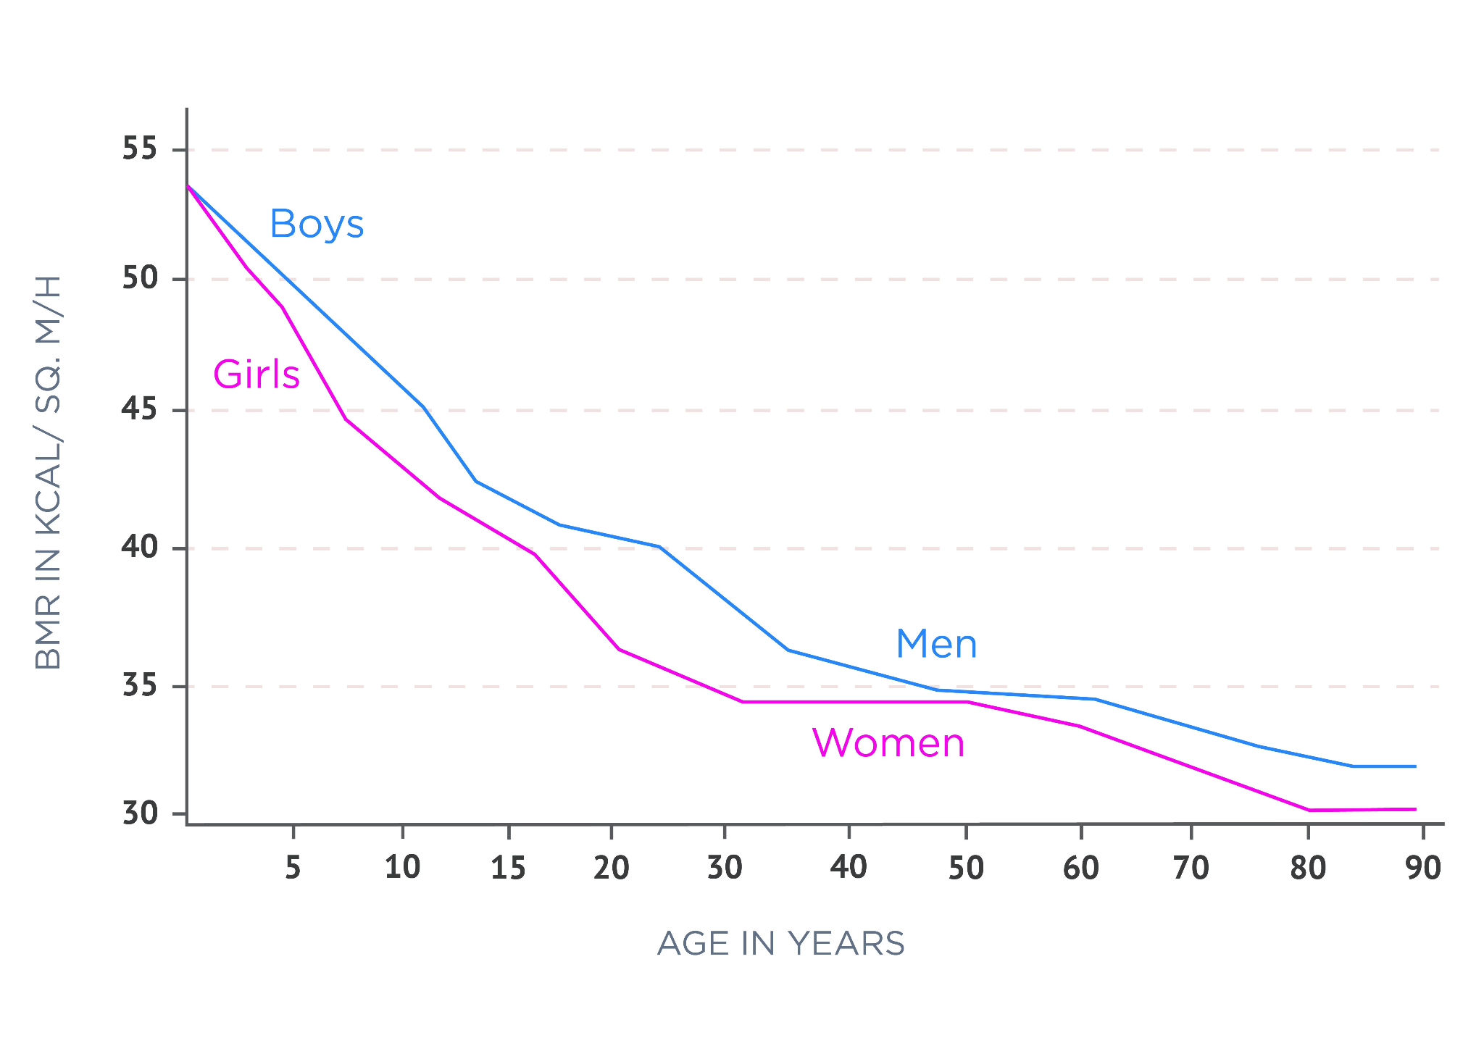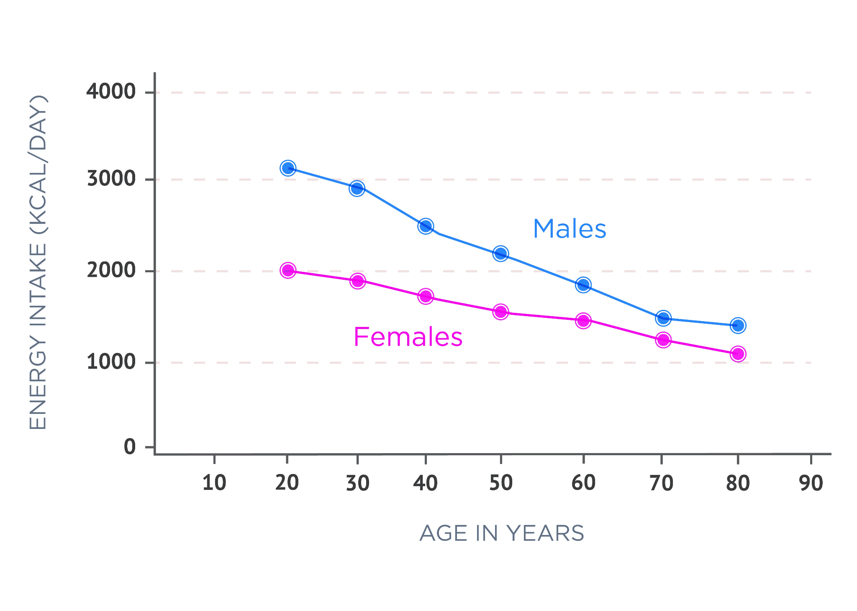

### Economic status

Of all the variables contributing to food choices, economic status likely plays an important role (European Food Information Council, 2004). A significant amount of research has been published exploring the economic and political forces behind how food is sold and consumed. Unfortunately, economics is directly tied to food choices (De Irala-Estevez, 2000). Individuals living in poverty generally develop poor eating habits simply out of a need to survive. High-calorie, highly processed foods are cheap and widely available, and often the availability of grocery stores in economically depressed areas is limited (Figure: Convenience Store). These areas are known as food deserts. The access to fresh, inexpensive foods in highly impoverished neighbourhoods is nearly non-existent and a continually growing problem in the United States. By comparison, wealthier communities will have access to a wide range of supermarket and speciality store options, making it much easier for people to optomize their nutrition (Figure: Suburban Supermarket).

There is a direct correlation between lower socio-economic status and increased risk of the development of chronic diseases such as obesity, heart disease and diabetes (Cockerham, Hamby & Oates, 2017). A lack of financial resources leads to greater food insecurity, which typically results in both short-term and long-term effects on the health and well-being of children and adults across the lifespan.

Both physiological and psychological systems regulate hunger and, ultimately, food choices. Increased economic freedom does not always relate to healthier food choices either. Wealth does not guarantee good health nor any better food choices than low-income populations. However, wealth does allow for better access to healthier and more secure food choices; of course, it is up to the individual to determine how they spend their resources.

### Geographical and seasonal availability

Geography and seasonal availability of foods can play a significant role in food selection as well. The farther someone lives from the farms that make their food, the more work it takes to get it to their table. And, as seasons change, so do our cravings.

Fortunately, because of the global economy, most foods are available year-round, though maybe just not locally sourced. Availability of certain foods, especially fresh foods, is dependent on a complex infrastructure of farmers, shippers and retail establishments. This complex logistical system is changing and improving rapidly in the face of modern technology.

For example, many grocery companies now offer app-based ordering and home delivery services. However, historically, studies have shown a correlation between access to healthful food and various geographical locations (The Food Trust, 2010).

We also tend to prefer certain foods over others based on the season. Weather and seasonal influences can impact why we desire certain foods, like hot chocolate in the winter and ice-cold lemonade in the summer. Studies have also shown that certain foods such as soups, vegetables and dark leafy greens are preferred in winter months, while citrus fruits and colourful vegetables are preferred in warmer months (Slavin & Lloyd, 2012).

### Biological influences

Food choices and preferences are also highly dependent on your individual complex biological structure. Hunger, appetite and taste are central driving forces that regulate food choices; however, these factors are regulated by complex biological, neuro-chemical and physiological mechanisms.

Biological determinants such as hunger, appetite, taste, allergies and intolerances to foods may influence food choices and result in the inclusion or exclusion of certain foods (e.g. celiac disease, nut or shellfish allergy, lactose intolerance, etc.). We need energy to survive, and thus our hunger and satiety responses are powerful signals for us to consume and store food. The type of food consumed also influences hunger and satiety. For example, complex carbohydrates, proteins and fats all have different satiety signalling strengths.

Satiety is a multi-factor theory. For example, consuming high portions of protein and complex carbohydrates tends to inspire high-satiety responses, whereas fat has the lowest satiety-signal response (Chambers, McCrickerd & Yeomans, 2015). Food satiety signalling is complex and influenced by cognitive, sensory and physiological responses. Satiety is induced via a number of mechanisms (Figure: Satiety Signalling Response) (Blundell et al., 2012). These include gastric distension, the gut hormone CCK and the energy density of food consumed. This means that most people end up eating larger portions of high-fat, calorically dense food before the brain and stomach connect to signal that enough calories have been consumed. Foods high in protein and fibre tend to have stronger satiety sensations, making them highly beneficial for balanced weight management.

Other factors altering the satiety-signal response include palatability and pace of eating (Ishii, 2003). Palatability is related to the pleasure someone experiences when eating a particular food. Palatability can be influenced by the taste, smell, texture and appearance of foods, and acts as a powerful determinant of food choices, hunger and satiety (Ishii, 2003). The development of satiety-enhancing foods that are palatable involves an integrative approach between various food-related disciplines, ranging from human biology and physiology to food consumer sciences.

As far as the pace of eating is concerned, slower paced eating is associated with improved satiety and gut hormone responses in normal-weight participants; when comparing the effect of slow and rapid eating patterns on hunger, fullness, glucose, insulin and the appetite-related gut hormones in overweight and obese participants with Type 2 diabetes mellitus, slower-paced eating increased fullness and decreased hunger in all three groups (Angelopoulos, 2014). With that in mind, slow-paced eating can be a beneficial intervention in the fight to curb the obesity and diabetes epidemic by first increasing the sensation of fullness.

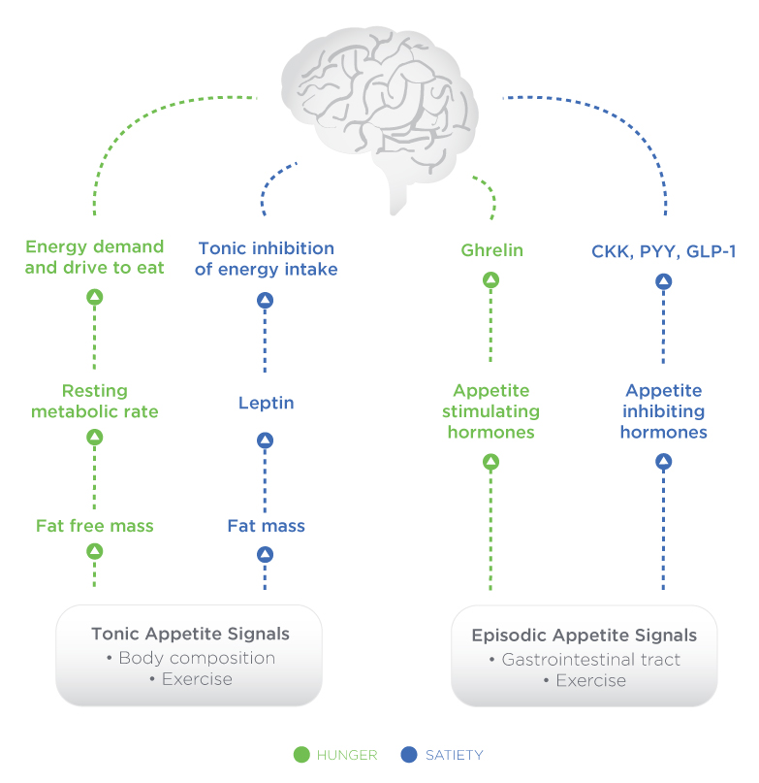

### Sensory stimuli

Appetite can be triggered by thoughts, emotions, mood, sight, smell, and proximity of food (McCrickerd & Forde, 2016). The sensory experience of eating adds an important determinant of food intake. Location, taste, texture, smells, and past experiences all play a role in when, how much and how often selected foods are consumed (McCrickerd & Forde, 2016). The pleasure of past experiences when eating, combined with visual and auditory cues, can be a powerful driving force for hunger and food choices. Marketing companies are keenly aware that visual cues are powerful reinforces of food choices, which is why so many resources are dedicated to food advertising efforts (Epstein, Leddy, Temple & Faith, 2007).

Low energy stores, a low blood sugar level and an empty, growling stomach are also powerful forces that stimulate hunger (Wright, 2008). Going grocery shopping or out to eat should be planned around having adequate energy balance in order to make healthy food choices that are not heavily driven by those sensory stimuli (Wright, 2008). Sensory nutritional science helps with assessing the longer‐term impact of food selection and consumption and with weight management. Nutrition Coaches play an important role in educating clients in how to be aware of food stimuli cues and how to develop coping skills when faced with unhealthy food temptations.

# Energy balance and metabolism

Metabolism refers to the chemical processes within a living organism that provide energy. Metabolism is one of the key features that distinguishes life from non-life. Metabolism provides the constant supply of energy that is required to sustain human life, whether at rest, during physical activity or during recovery. While most people might believe that energy comes from the food we eat, the primary source of energy to sustain life on Earth comes from the sun.

The sun provides an abundant source of solar energy, which is converted into chemical energy through a process known as photosynthesis. Energy from the sun is ultimately stored in chemical bonds, initially in plants. This energy is then transferred through the food chain, from plants to mammals. It is then used for a variety of things: locomotion, maintaining body temperature or cellular functions, or it can be lost as heat to the environment.

The primary molecules that store energy in chemical bonds and are transferred to a useable energy currency, ATP, are carbohydrates and fats, as well as protein. Specifically among plants, carbohydrates including glucose (sugar), starches, and non-digestible cellulose are a vital source of energy for living organisms. Carbohydrates can be broken down and converted into energy for immediate use as glucose or stored for later use in the form of glycogen (Tapley, 2018). Other organisms use carbohydrates, fats, and proteins more readily for fuel. A constant supply of energy is critical for the survival of all living organisms. For this reason, energy is in a constant state of production, utilisation, and recycling.

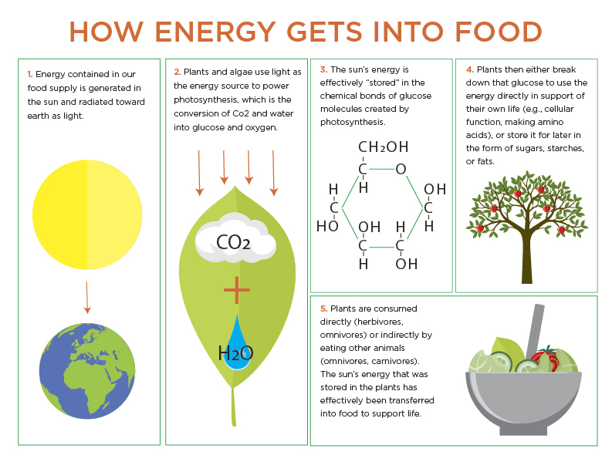

**Figure** Photosynthesis

Adenosine triphosphate (ATP) is a chemical compound that provides energy to drive muscle contraction, transmission of nerve impulses and the vast majority of chemical reactions that facilitate human life. ATP consists of an adenosine molecule bonded to three phosphate groups and is present in all living tissue (Kornberg, 2018). The breakage of one phosphate linkage (to form adenosine diphosphate or ADP) provides free energy to fuel physiological processes (Figure: ATP to ADP Reaction).

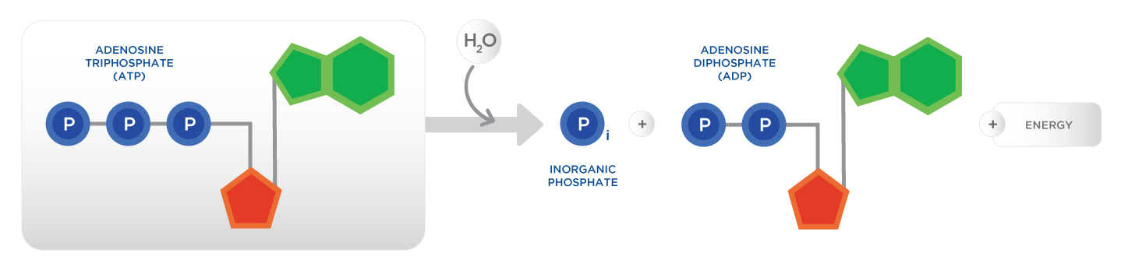

**Total Daily Energy Expenditure** (TDEE) is the estimated calorie needs per day, by age, sex and physical activity level. The total number of calories a person needs each day varies depending on a number of factors, including the person's age, sex, height, weight, and level of physical activity, thermic effect of feeding (TEF), resting metabolic rate (RMR), and non-exercise activity thermogenesis (NEAT). The basic energy need of an average human being (TDEE) is approximately 2000 calories per day, depending on age, sex, and physical activity, as well as other factors (U.S. Department of Health and Human Services, 2015). The term *calorie* can be related to the amount of energy a food can provide to the body when broken down (Szalay, 2015).

In order to survive as well as engage in physical activity, the human body needs a constant supply of energy to maintain vital organ function and to supply sufficient energy beyond that stored—to move (work and activity). The total number of calories from the food we eat and drink is based on a variety of individual needs and requirements. Energy balance is an important concept when it comes to human nutrition for both health and performance.

The concept of **energy balance** essentially follows the notion that energy intake should be matched to energy expenditure, or there will be changes to the mass (i.e. the weight of the system). Energy balance, as it relates to fitness and nutrition, is a result of thermodynamics, specifically the first Law of Thermodynamics, which states that all energy taken into the body is accounted for; it is either utilised directly, stored, or transformed to kinetic energy or heat. The balance of energy consumed is compared to the total amount of energy expended (TDEE).

## Thermodynamics

Thermodynamics describes the relationship between heat and energy (mechanical, electrical or chemical) and how these are converted into one another. Thermodynamics explains how energy is transferred from one place to another and from one form to another (e.g. chemical to mechanical) (Lumen Boundless Chemistry, 2018).

Human metabolism is the conversion of food into heat, work and stored energy. Put simply, calories (stored energy in food) are consumed, the food is broken down into smaller components and the stored chemical energy in food is used to maintain life and perform movement. Some of the energy is also lost to the environment (Lumen Boundless Chemistry, 2018).

Food for Thought

A boiling tea kettle represents energy in motion. The water in the kettle is turning to water vapour because heat energy is being transferred from the stove to the kettle. As the entire system gets hotter, work is done and steam is released during the evaporation of the water.

There are four laws of thermodynamics. This chapter focuses primarily on the *First Law of Thermodynamics.* The First Law of Thermodynamics, also referred to as the law of conservation of energy, states that energy can be transformed from one form to another, but cannot be created nor destroyed (The LibreText Project, 2018). This is one of the fundamental laws of physics. There is no evidence that this can be violated in any system. To place this in the context of humans and nutrition, if an individual consumes 2,500 calories those 2,500 calories will be accounted for one way or another. They are either used to produce energy, used to sustain life, given off as heat, or stored for later use (Figure: Calories In vs Calories Out).

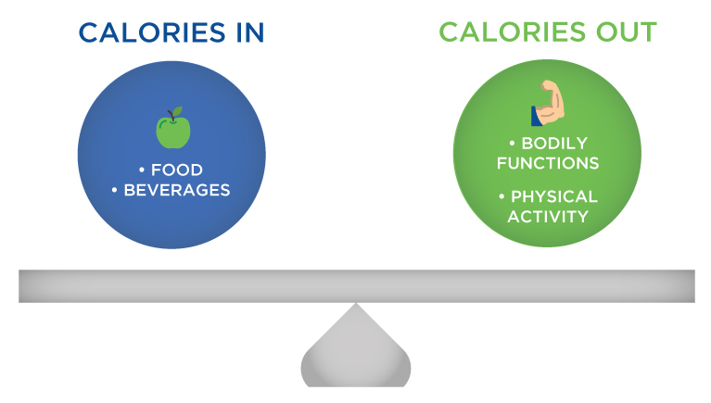

Energy can either be stored for later (potential) or used for work (kinetic). For example, the food we eat contains potential energy in the form of chemical bonds. Potential energy can also be found within the bonds of molecules stored in various forms throughout the human body, such as adipose tissue or glycogen in liver and skeletal muscle. The ability to perform human movement requires a constant supply of energy and the process of generating kinetic energy from sources of potential energy is referred to as metabolism (Poehlman, 1989). Since only a limited amount of potential energy can be stored for later use, the human body needs a constant supply of food to produce energy for survival (basal metabolic functions) and physical activity (any form of movement, as well as exercise). Metabolism includes a series of connected pathways. These pathways are often grouped as either aerobic (with oxygen) or anaerobic (without oxygen).

### Maintaining energy balance

Energy balance is the balance of calories consumed through eating and drinking minus the calories burned during the digestion and processing of food (TEF), non-exercise activity thermogenesis (NEAT) and calories burned during exercise and physical activity (TEA). *Energy In* represents energy intake (total calories consumed) in a given period of time. *Energy Out* represents the energy expended (calories burned) through the digestion and processing of food and energy expended during activity or other forms of non-exercising movement. Learning how to modulate energy balance, plan and manage periods of negative energy balance to lose weight, plan and manage periods of positive energy balance following illness or injury to gain weight and plan for long-term energy maintenance are all highly important for a Nutrition Coach.

Fundamentally, energy balance comes down to a singular idea: all calories must be accounted for through the principle of thermodynamics. When an individual consumes more calories than they expend, this is energy stored (as fatty acids, muscle tissue, bone tissue, organs, etc.). When an individual expends more calories than they consume, energy is lost (as carbon dioxide, fatty acids, muscle tissue, bone tissue, etc.). While is it impractical to account for all facets of energy balance on a daily basis, it is important to understand the various influences that regulate energy balance (Figure: Factors Influencing Energy Balance).

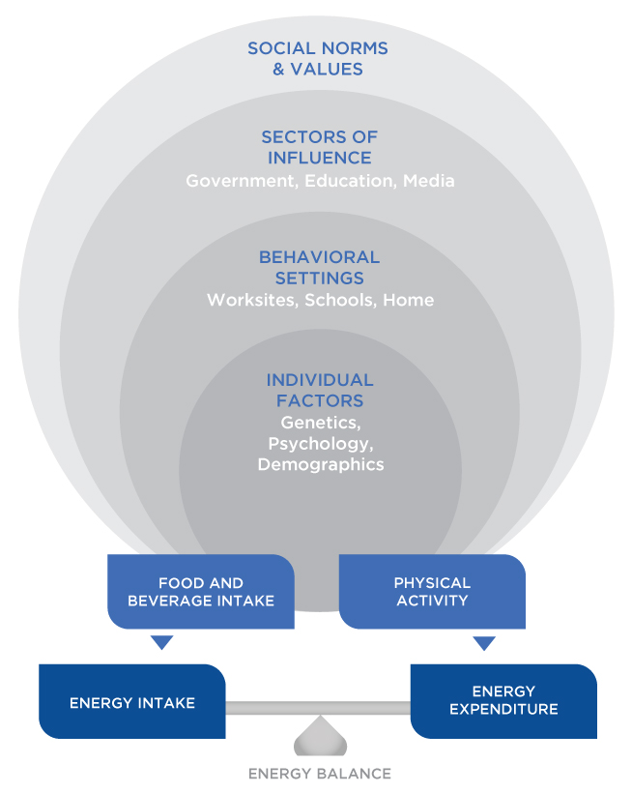

At the most fundamental level, the rise in rates of being overweight and obesity is the result of energy balance favouring an energy surplus—energy intake is greater than energy expenditure. Most data indicates that this net energy surplus is the result of both increased caloric intake as well as a decrease in caloric expenditure. In addition to excessive caloric consumption, a global reduction in physical activity, including occupational work, home/domestic work, travel, and increased sedentary activities has risen significantly in recent years, contributing to marked inequality in energy balance (Ng & Popkin, 2012).

As the graph below shows, the availability of an endless supply of cheap caloric dense foods, minus mean energy expenditure, has risen dramatically and will likely continue to increase over time. Changes in agricultural and food manufacturing and distribution practices have dramatically increased the world's capacity to provide a diversity of foods with less seasonal dependence. Globally, food consumption per person has risen almost 400 kcal per person per day from 2411 to 2789 kcal per person per day between 1969/1971 and 1999/2001 (Kearney, 2010).

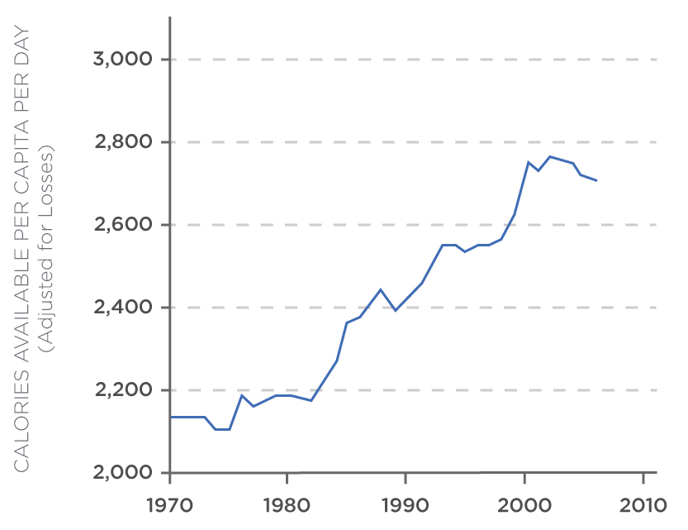

## Components of energy out

Energy out, or energy expenditure, refers to the use of calories after they have been consumed. There are four components of energy expenditure (Poehlman, 1989):

1. Resting Metabolic Rate (RMR)
2. The Thermic Effect of Feeding (TEF)
3. The Thermic Effect of Activity (TEA)
4. Non-Exercising Activity Thermogenesis (NEAT)

The majority of energy consumed is used for fuel to support and maintain normal body functions, like temperature regulation. The rest is used to digest food and support movement for exercise and leisure activities (Poehlman, 1989).

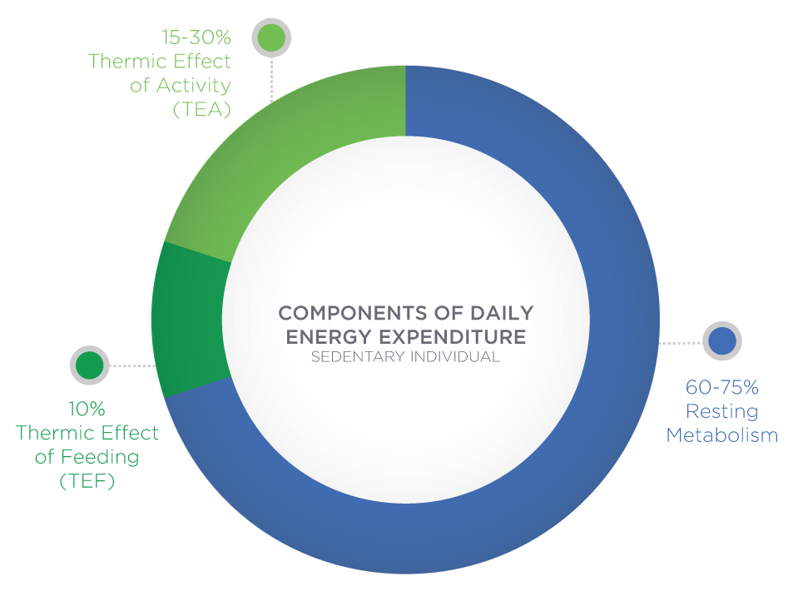

### Resting Metabolic Rate

Resting metabolic rate (RMR) refers to the total number of calories burned when the body is completely at rest. Resting metabolism is sometimes called basal metabolism (Mullur, Liu & Brent, 2014). RMR supports breathing, circulating blood, organ functions, and basic neurological functions. Some people have very-high resting metabolisms while others struggle with very-low resting metabolisms. High resting metabolic rates may be due in part to a high level of lean body mass (muscle), high production of thyroid hormones, or a variety of other factors. A low thyroid production (hypothyroidism), a high percentage of body fat and low level of lean body mass may all contribute to a low resting metabolic rate (Mullur, Liu & Brent, 2014).

RMR is proportional to lean body mass and decreases approximately 0.01 kcal\min for each 1% increase in body fatness. RMR also declines with age: 2% and 3% per decade for men and women, respectively, due to a loss in lean body mass (McMurrary, Soares, Caspersen & McCurdy, 2014). Prolonged dieting and repeated bouts of weight cycling (weight loss followed by weight gain) may lead to short-term and possibly long-term regulation of RMR, although the research is inconclusive at this point. Frequent weight loss and weight gain (weight cycling) does not appear to have a long-term effect on RMR in college-aged wrestlers (Schmidt, Corrigan & Melby, 1993). Short-term, especially in weight loss studies utilising diet only, RMR is suppressed and not consistently related to weight maintenance or weight gain long-term (Froidevaux, Schutz, Christin & Jequier, 1993).

In a follow up study, individuals experienced significant weight loss and a subsequent reduction in RMR. Six years later, their mean RMR remained unchanged following the initial weight loss, despite the majority of subjects regaining a significant amount of their weight (Fothergill, Guo et al., 2016). The short-term and long-term impact of RMR is compounded by numerous factors and requires further research to help identify best practices for weight loss and maintenance.

### Thermic Effect of Food

The thermic effect of food (TEF) represents the increase in energy expenditure after consuming a meal. This accounts for the energy required to digest food in order to prepare it for further energy extraction in the body. Approximately 10% of daily energy expenditure is accounted for by the process of consuming, digesting and utilising food (Kelly & Jones, 2013). Simple carbohydrates and fats have relatively lower thermic effects of energy compared to protein. Research has shown that eating higher protein meals has a higher thermic response than high-carbohydrate meals (Ravn et al., 2013).

### Thermic Effect of Activity

The thermic effect of activity (TEA) accounts for the most variability of daily energy expenditure. Spontaneous physical activity and planned sustained exercise can account for up to 15 to 30% of daily energy expenditure (Westerterp, 2013). TEA includes energy expenditure due to physical work, muscular activity, as well as planned and structured exercise. Regular and sustained physical activity, both acute and chronic, helps to maintain a healthy body weight and raise RMR.

Food for Thought

Although protein has a higher TEF than carbohydrates and fats, TEF is not the only factor influencing the rate or total amount of weight loss possible by any one person. For example, the influence of TEA and NEAT has a greater impact on energy balance than TEF. Everyone needs to navigate their own individual diet and find what works best for them.

A general approach when considering food selection is balance, eating nutritious foods that include all three macronutrients, resulting in a health-supporting diet. Unless directed by a physician, avoid diets that restrict or completely eliminate a macronutrient, because our bodies need and work best when it has them all. Diets that eliminate or restrict a macronutrient are often unsuccessful.

#### Non-Exercise Activity Thermogenesis

A more specific component of TEA is referred to as NEAT, or non-exercise activity thermogenesis. NEAT is the energy expended for everything we do that is not sleeping, eating or exercising. It is the energy we consume during daily activities, including walking at work, typing, walking to and from meetings and fidgeting. Daily NEAT is any physical activity that may increase metabolic rate, even for a brief period of time, that is not part of structured exercise.

Although all of the factors that tend to influence (stimulate or inhibit) NEAT are not completely understood, the more active your lifestyle, the higher your NEAT will be and the better your energy balance. NEAT could be a critical component in how we maintain body weight and/or develop obesity or lose weight (Levine, 2002). Additional spontaneous and planned activities, such as bike commuting to work, taking the stairs, standing versus sitting and taking walking breaks can all be beneficial.

For various reasons, most adults are not participating in regular bouts of intermittent or sustained physical activity sufficient to produce short- and/or long-term health-related benefits. The importance of NEAT as a component of daily energy expenditure is becoming increasingly studied, validated, and recommended. Because the majority of individuals are not engaging in regular and sustained bouts of moderate- to vigorous-intensity exercise, the promotion of NEAT activities could result in up to an extra 2000 kcal of expenditure per day beyond the basal metabolic rate, depending on body weight and level of activity (Villablanca et al., 2015). Suggesting additional NEAT activities for clients during their leisure and occupational activities could be an important factor in achieving and maintaining a long-term negative energy balance (Table: Activities to Promote NEAT).

Activities to Promote NEAT

| Do additional tasks around the house |
| --- |
| Play with the your kids |
| Take quick 10-minute walks every 2 hours |
| Have walking meetings instead of sitting in a conference room |
| Use a stand-up desk or sit on an exercise ball |
| Get a pedometer or smartwatch and challenge yourself to add more steps or activity points each day |
| Pace and fidget more |
| Take the stairs whenever available |
| Adopt a more active lifestyle instead of being sedentary in free time |
| Walk or cycle instead of driving |
| Use manual tools and utensils instead of powered labor-saving versions |

Food for Thought

A global increase in sedentary lifestyle and its corresponding link to growing rates of obesity, diabetes and other chronic diseases is highly prevalent. Unfortunately, participation in, or adherence to, daily physical activity and exercise is not improving.

* Less than 5% of adults participate in 30 minutes of physical activity each day (US Department of Agriculture)
* Only one in three adults receives the recommended amount of physical activity each week (US Department of Health and Human Services)
* Only 35 to 44% of adults 75 years or older are physically active, and 28 to 34% of adults ages 65 to 74 are physically active (Centers for Disease Control and Prevention)
* More than 80% of adults do not meet the guidelines for both aerobic and muscle-strengthening activities, and more than 80% of adolescents do not do enough aerobic physical activity to meet the guidelines for youths (US Department of Health and Human Services).

Coach’s Corner

Metabolic Equivalent (MET)

One MET is often used to describe RMR and energy expenditure. One Metabolic Equivalent (MET) = 3.5 ml O2 / Kg/min. METs can be used to prescribe exercise training intensities. For example, 2.5 METs is the amount of energy used to walk leisurely, while brisk walking elicits a 5 MET level when walking at a 6 kph pace.

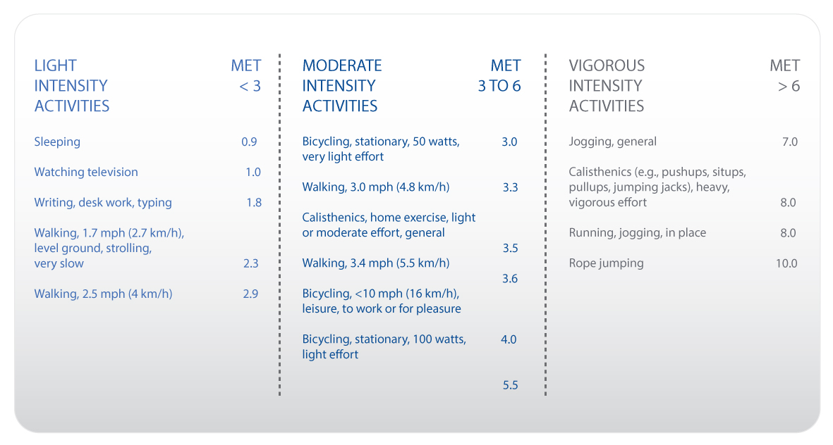

### Sleep

The effect of sleep deprivation or restriction on energy metabolism and weight gain is not well understood, but it is thought that inadequate sleep (rest) may result in a reduced RMR and an increase in energy intake above normal levels the following day. This is because RMR is a significant contributor to overall energy expenditure and any decrease in RMR in conjunction with increased food intake could lead to a positive energy balance and weight gain. Both increased caloric intake and poor food choices (high-fat and sugar-dense foods) are frequently reported following sleep restriction (Shechter et al., 2014).

During normal sleep patterns, metabolic rate reduces by around 15% and reaches a minimum in the morning in a standard circadian pattern, or REM sleep patterns (Goldberg, Prentice, Davies & Murgatroyd, 1988). Research has also shown that compromised sleeping patterns and sleeping 5 or less hours per night is associated with 3.7-fold greater odds of obesity among men, and a 2.3-fold increase among women compared to those sleeping 7 to 8 hours per night (Patel et al., 2008).

The associated mechanisms between short sleep patterns and increased risk for obesity are still being studied, but include changes in hormonal response, appetite, food choices and RMR. In one study, healthy adults had their RMR measured after sleep deprivation (4 h sleep/night for 5 nights) followed by 1 night with 12 h recovery sleep (10 h sleep/night). RMR decreased after sleep restriction by 2.6% and returned to baseline levels after recovery sleep. No changes in resting metabolic rate were observed in control subjects (Spaeth, Dinges, & Goel, 2015).

Getting Technical

Sleep Deprivation and Weight Gain

A recent study in the *European Journal of Clinical Nutrition* found that people who do not get enough sleep consumed extra calories the following day (Khatib, Harding, Darzi, & Pot, 2017). The researchers looked at the differences between sleeping only 3.5 to 5.5 hours per night to those who got 7 to 12 hours per night. They found that the sleep-deprived group consumed an average of 385 extra calories per day! This suggests that proper sleep plays a key role in maintaining energy balance.

Effects of Sleep Deprivation:

* An increase in insulin resistance at a cellular-signalling level and increased glucose, insulin and cortisol
* Sleep-deprived individuals consume more calories from fatty foods versus protein
* Sleep-deprived people may also experience a decrease in plasma leptin and an increase in ghrelin, which increase hunger and appetite
* Even a single night of total sleep deprivation can influence energy expenditure and metabolism.

### Hormones

Hormones play an important role in regulating metabolism. Hormones are the chemical messengers helping the different parts of your body communicate with each other. They are transported in the blood to specific cells or tissues to help regulate body functions. Three common hormones that affect Energy Out are thyroid hormone, cortisol and testosterone.

**Thyroid Hormones**

Thyroid hormones (TH) help regulate metabolism and also control essential steps involved in growth and development. Thyroid hormones stimulate metabolism through increased oxygen consumption and rates of ATP breakdown (Villanueva, Alva-Sánchez, & Pacheco-Rosado, 2013). Thyroid hormones stimulate both lipogenesis and lipolysis; although, when TH levels are elevated, fat loss is enhanced (Oppenheimer, Schwartz, Lane, & Thompson, 1991). Thyroid hormones are important in the relation and control of energy balance by regulating energy storage and expenditure. Thyroid hormones stimulate almost all aspects of carbohydrate metabolism, including increasing insulin-dependent entry of glucose into cells and glycogenolysis to break down glycogen for energy during exercise and recovery (Hearris, Hammond, Fell, & Morton, 2018).

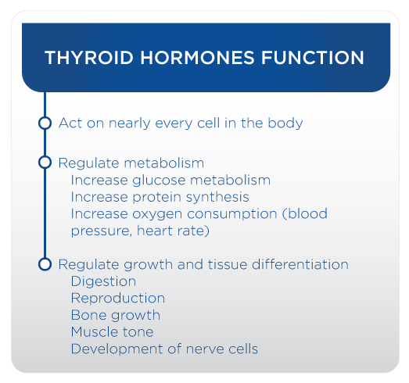

Hyperthyroidism, or excess TH, creates a condition characterised by increased resting energy expenditure, weight loss, reduced cholesterol levels, increased lipolysis and gluconeogenesis (Mullur, Liu & Brent, 2014). Hypothyroidism, or a reduction in TH levels, is characterised by reduced resting energy expenditure, weight gain, increased cholesterol levels, reduced lipolysis, and reduced gluconeogenesis (McAninch & Bianco, 2016).

**Cortisol**

Cortisol is produced by the adrenal glands and is released in response to stress. The adrenal glands produce several hormones, including adrenaline, aldosterone and cortisol. Cortisol is within a class of hormones called glucocorticoids (Sargis, 2018). Cortisol works to quickly increase blood glucose levels and works against insulin to try and keep glucose levels elevated by stimulating a process called gluconeogenesis. Cortisol is released during periods of stress and leads to an increase in heart rate, blood pressure and elevated glucose levels.

**Testosterone**

Testosterone is a hormone that plays a key role in carbohydrate, fat and protein metabolism. It has a major influence on body-fat composition and muscle mass in men. Testosterone deficiency is associated with an increased fat mass (central adiposity in particular), reduced insulin sensitivity and impaired glucose tolerance, which may be related to diabetes and risk for heart disease (Kelly & Jones, 2013). Testosterone helps control pathways involved in glycolysis, glycogen synthesis and lipid and cholesterol metabolism (Kelly & Jones, 2013). The effects of testosterone differ in the major tissues involved in insulin action, which include liver, muscle and fat, suggesting a complex regulatory influence on metabolism.

## Components of Energy In

Historically, energy balance has been discussed in the simple terms of calories in versus calories out. However, the reality is not so simple. While no living being is exempt to the Law of Thermodynamics, there are still many additional factors that will affect what food is chosen, when it is eaten and how it is digested in each person’s body. This makes the Energy In part of the equation more complex than counting calories. Appetite, environmental factors, psychological factors, individual variation, and food processing will all impact Energy In differently for every individual.

### Appetite

There are a variety of factors that influence appetite:

* Food in the stomach
* Leptin and ghrelin production
* Social factors
* Activity level

Gastric juices, enzymes and other hormones all play a role in the desire to eat, with social factors also playing a vital role in appetite and energy intake (Schultes, 2003; Institute of Medicine, 2004). Physical activity, and a lack thereof, also plays a role in appetite. For some, physical activities too close to eating a meal can be an appetite stimulant and, for others, a suppressant (Broom, 2008).

A variety of hormonal factors also regulate appetite. Hormones act on specific centres in the brain that affect the sensations of hunger and fullness or satiety (Ahima & Antwi, 2008). Some individuals may have genetic abnormalities that lead to disruption in the cells being targeted by specific hormones. If a hormone is unable to function properly, the signal to stop eating may be diminished, leading to excessive weight gain (Austin & Marks, 2009). The control of appetite is closely regulated by specific hormones, including leptin, CCK, ghrelin and PPY. A deficiency in hormone production or function can have a potentially detrimental impact on energy metabolism (Mullur, Liu, & Brent, 2014).

***Leptin*** is a hormone produced by adipose cells that decreases appetite when released. Leptin sends a signal to the brain signalling that enough food has been consumed and appetite should be inhibited. Leptin is supposed to tell the brain that we have reached a state of desired caloric intake and how many calories are stored (Klok, Jakobsdottir, & Dent 2007).

Low leptin levels induce appetite and suppress energy expenditure, thyroid and reproductive hormones, and immunity (Ahima, 1996). Larger bodies (e.g. those with higher BMI) will have larger quantities of leptin. This indicates that leptin resistance may play some role in common obesity. Furthermore, some research has suggested that some individuals may have dysregulated leptin signalling as bodyweight decreases during a weight-loss regimen. This can lead to bouncing back with excessive appetite that can lead to a return in weight gain (Ahima, 2008).

***Ghrelin*** is a hormone that is produced and released primarily by the stomach, with small amounts also released by the small intestine, pancreas and brain. Ghrelin has the opposite effect of leptin, and thus is referred to as the hunger hormone because it stimulates appetite, increases food intake and promotes fat storage. Ghrelin stimulates fat deposition and growth hormone release, leading to increased hunger and fat storage (Klok, Jakobsdottir, & Dent, 2007) (Figure: How Ghrelin and Leptin Work in the Body).

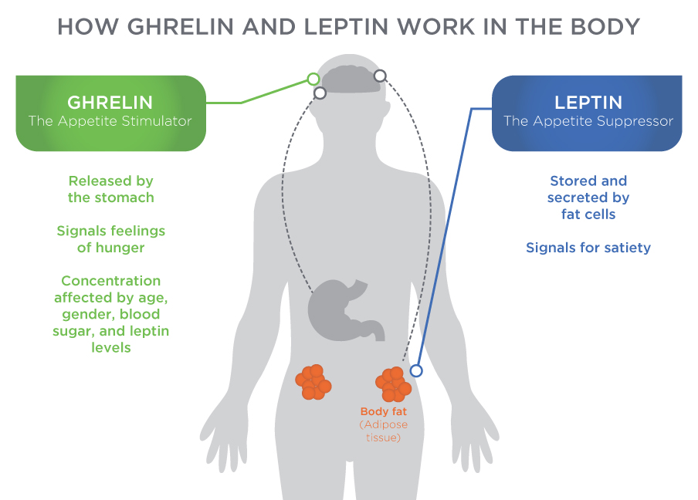

***CCK*** *(Cholecystokinin)* is a hormone released in the gastrointestinal system and is responsible for stimulating the digestion of fat and protein (Sekiguchi, 2016). CCK is secreted by cells of the upper small intestine. CCK is released when amino acids or fatty acids enter into the stomach or beginning of the small intestines. CCK stimulates the gallbladder to contract and release stored bile into the intestine to help break down fat and protein.

***NPY*** *(Neuropeptide Y)* is a neuropeptide hormone linked to the autonomic nervous system. Neuropeptides are small protein-like molecules used by neurons to communicate with each other (Beck, 2006). Neuropeptide molecules influence the activity of the brain and the body in specific ways. NPY is a specialised hormone produced in a part of the brain called the hypothalamus. NPY helps stimulate the sympathetic nervous system, which stimulates appetite and fat storage (Beck, 2006).

***Insulin*** is a hormone produced by the pancreas that is released when blood glucose levels are high, promoting the uptake of glucose for fuel or storage as glycogen. Insulin helps keep blood-sugar levels from getting too high, also referred to as hyperglycaemia. Insulin increases glucose uptake in peripheral tissue (e.g., skeletal muscle) while also decreasing the production of glucose by the liver (Figure: Insulin and Glucose).

***Glucagon***is a hormone that is released when blood sugars decrease below a certain threshold. It stimulates the breakdown of stored glucose (glycogen) in the liver, releasing additional glucose into the bloodstream for fuel.

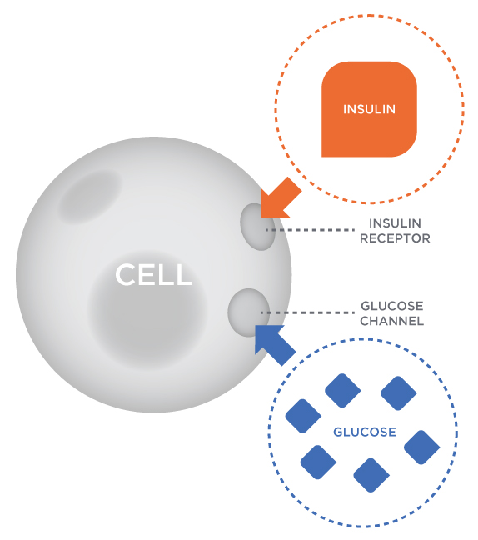

### Environmental factors

Food intake is controlled by a number of biological and external factors, including cultural and psychological influences, social-economic background, education, past experiences, portion size, and food palatability (Faith & Kral, 2006). Busy work and personal schedules can lead to poor food choices and eating behaviours, potentially leading to obesity or other nutritional disorders (Escoto, 2012). For many, healthy meal planning gets deprioritised and replaced with quick-and-easy meals, which are often unhealthy. Access to affordable healthy food choices influences the quality and amount of calories consumed, as well as overall health outcomes (Darmon, 2015). Some environmental factors are set, such as where one lives and works, which may prevent them from having flexible choices.

Any type of disturbance to this system can affect energy balance and cause changes in weight, through, most commonly, weight gain. A sudden change in jobs or income can have a significant impact on food choices. Changes in relationships or social structure can substantially influence eating behaviours. Changes in the environment can also have a positive influence on eating and activity behaviors.

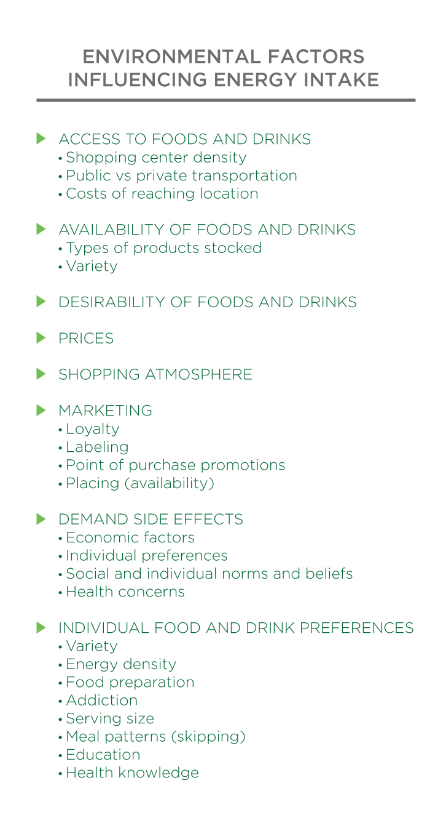

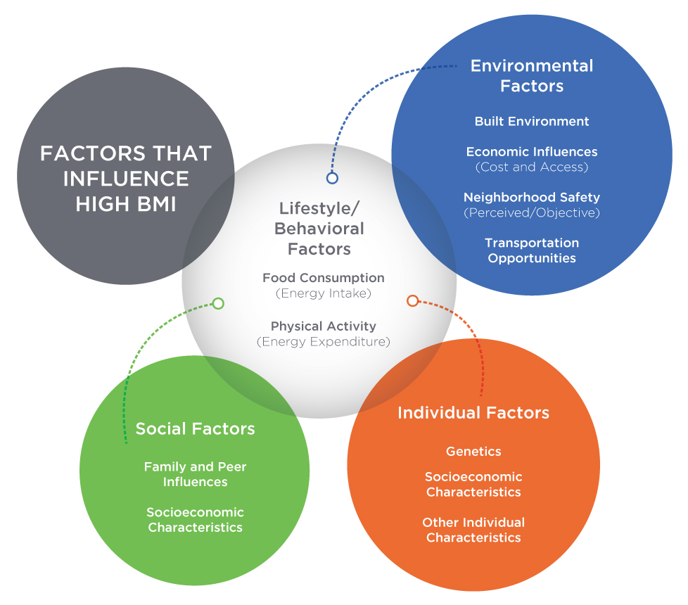

### Psychological factors

Psychological distress may alter eating behaviors, resulting in the intake of energy-dense diets (Grossniklaus, Dunbar, Tohill, Gary, Higgins, & Frediani, 2010). Diets composed of high-energy foods may increase the risk of overweight and obesity (Grossniklaus et al., 2010). Dieting, or the pressure to diet, can lead to significant psychological stress and disordered eating. There is a difference between physiological eating (hunger) and psychological eating (eating for pleasure or to ease pain/suffering) (Singh, 2014).

Coaches Corner

Practicing Mindful Eating

* Eat when hungry: no matter how powerless you feel over food and your feelings, it is possible to make a positive change
* Do not let emotions control eating: you can find healthier ways to deal with your emotions, learn to eat mindfully instead of mindlessly, regain control of your weight, and finally, put a stop to emotional eating
* Engage all six senses: as you serve and eat your meal, notice the sounds, colours, smells and textures, as well as your mind’s response to them, not just the taste
* Modest portions: moderation is an essential component of mindful eating
* Savor small bites: enjoy each bite
* Eat slow: eating slowly may help you notice when you are feeling pleasantly satisfied so that you can stop before you have eaten too much
* Chew thoroughly: take time to chew each bite thoroughly
* Do not skip meals: skipping meals can make it harder to make mindful choices.

Emotional eating (or stress eating) is using food to make yourself feel better—eating to satisfy emotional needs rather than to satisfy physical hunger. Using food occasionally as a pick-me-up, a reward, or to celebrate is not necessarily a bad thing. Only when eating becomes a primary emotional coping mechanism should there be a concern. Emotional hunger cannot be filled with food. Eating may feel good at the moment, but the feelings that triggered the eating are still there and worse feelings and emotions quickly follow because of the guilt from added calories just consumed.

### Individual variation

There is tremendous variation in rates of energy expenditure (RER, TEF, TEA, and NEAT) for all individuals. Some individuals that have a high RMR tend to eat a diet that stimulates TEF, are very active, and have a higher NEAT component of TEA that likely causes them to burn calories at a faster rate than others.

In addition to the individual variances in energy expenditure, there are different rates of absorption of nutrients from food across individuals as well. For example, if two people consume the exact same food, the total number of calories extracted and the total amount of nutrients extracted can vary. Some foods require significant enzymes to break them down, which may or may not be present in the digestive tract of all individuals. Some individuals have certain food allergies, such as Celiac disease, which is an autoimmune disorder that leads to damage in the small intestine when gluten products are consumed, drastically reducing their ability to digest, process, and absorb macro- and micronutrients.

The bacterial cells in the human gastrointestinal tract (GIT) influence the rate of digestion and metabolism. Imbalance of the normal gut microbes can cause gastrointestinal conditions such as inflammatory bowel disease (IBD) and irritable bowel syndrome (IBS). Knowledge about all of the mechanisms that impact appetite, food selection, and how your body processes and burns food is important to help regulate optimal metabolism and weight management. However, remember to always refer to a medical doctor if a disease or syndrome is suspected.

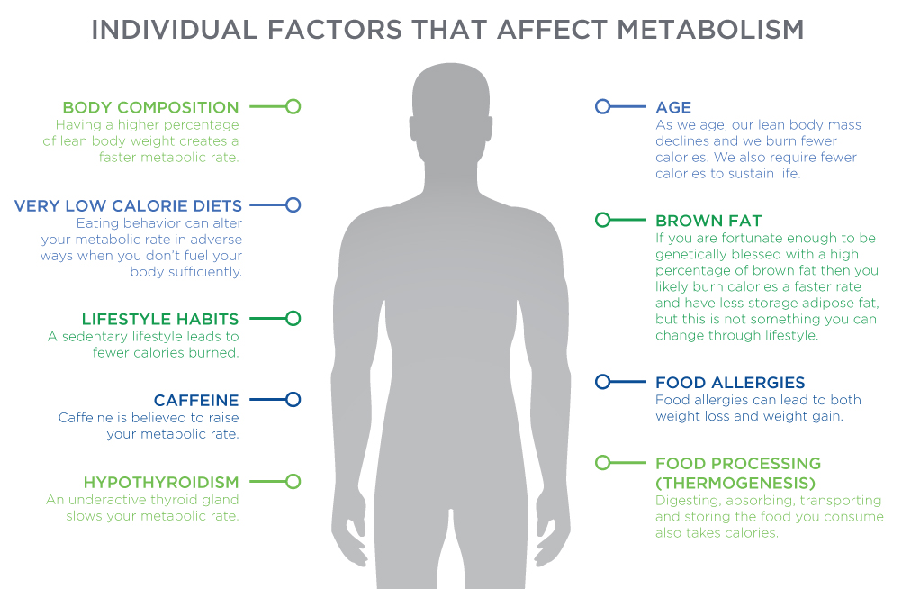

### Food processing

Food processing is defined as any procedure that alters food from its natural state, such as freezing, drying, milling, canning, mixing, or adding salt, sugar, fat, or additives (Poti, Mendez, Ng, & Popkin, 2015). Food processing changes the physical and chemical nature of the food we eat. Some foods are considered highly processed while others minimally processed. The U.S. government’s definition of *processed food* includes a diverse array of foods ranging from frozen vegetables, dried fruit, and canned beans, to whole-wheat bread, breakfast cereals, prepared meals, sweets, and soft drinks (Poti, Mendez, Ng, & Popkin, 2015). It is important to understand how food processing can both positively and negatively impact health, nutrition, and overall well-being.

The processing of food can make it safer, tastier, more stable, easier to transport, etc. The long-term and wide-ranging benefits of food processing (e.g., increasing overall food supply) likely outweigh the detrimental effects of food processing (over consumption of calories). However, the consequences of food processing should be understood and weighed accordingly regarding their impact on nutrition and health. The degree of food processing and digestion impacts nutrient availability, digestive processes, and the TEF.

For example, eating 100 grams of peanuts versus 100 grams of peanut butter will result in differences in caloric density and energy absorbed. Peanuts require chewing and, even afterwards, are still in a more nutrient-dense state when they enter the stomach and intestines. Peanut butter has been ground to a less-solid state, making it require less digestive effort than when peanuts are eaten whole. Food processing can alter the nature of proteins and thus present challenges to the way the body responds to the type of food processed. Eating a piece of fresh fruit vs. dried fruit or fruit juice will impact the body differently. None of this is to say the processing of foods or ingredients is inherently bad. It is simply to highlight that the state of processing may change how the food is digested and absorbed by the body.

## Metabolic Energy Systems

The human body needs energy to function (stay alive) and to fuel physical activity. Energy comes from the food we eat: carbohydrates, protein, and fats. Complex organic food molecules such as sugars, fats, and proteins are rich sources of energy for cells. This is because much of the energy used to form these molecules is stored within the chemical bonds that hold them together. Through a series of chemical reactions in which electrons are transferred from one molecule to another, the composition and energy content of both the donor and acceptor molecules are changed.

Carbohydrates are broken down to glucose and converted into energy (ATP) for immediate use, stored for later use in the form of glycogen, or converted to body fat. Fats and protein can also be broken down and used to make ATP in more complex metabolic pathways. The body does store a minimal amount of ATP within the muscles, but the majority is metabolised from the foods we eat.

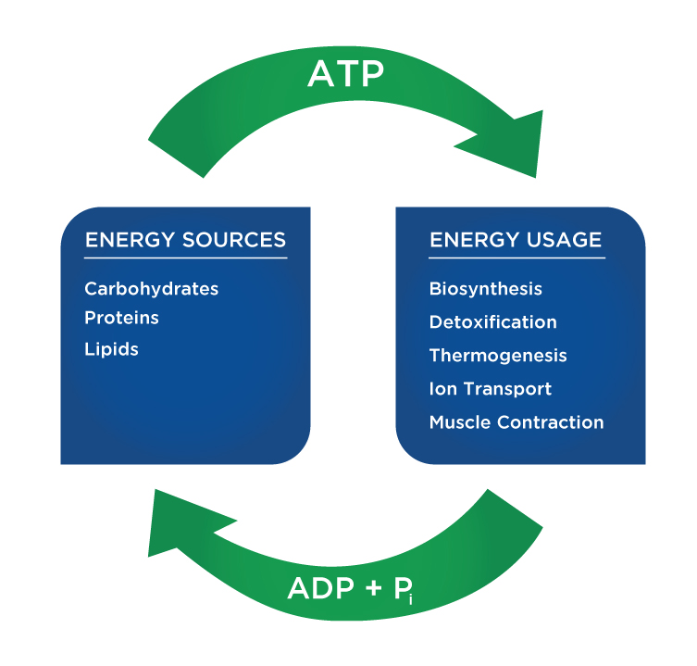

### Energy transfer

Food is made up of carbohydrates, fats, and proteins, and these nutrients are broken down into their simplest forms (glucose, fatty acids, and amino acids) during digestion. Once these nutrients are broken down, they are transported through the blood to either be used in a metabolic pathway or stored for later use. Before the food we consume can be utilised to produce work for exercise, it needs to be transformed into the primary energy source for the body: ATP. Carbohydrates, proteins, and fats need to be metabolized to create ATP from ADP (adenosine diphosphate) and free phosphate molecules. The bonds within ATP (between an adenosine molecule and three phosphate molecules) are high-energy bonds, meaning that when one is broken by enzyme reactions, forming ADP and a free phosphate molecule again, it releases usable energy for the body. And the cycle continues to sustain life.

There are three primary energy systems. Understanding how the human body produces energy for sport and exercise is important for Nutrition Coaches, personal trainers, coaches, and other fitness professionals. Each system is constantly being used, but each plays a different role depending on the availability of energy and the specific demands being placed on them. Each system has unique aspects in how they utilise fuel, replenish ATP, affect metabolism and performance, and gain or lose lean body mass.

Food for Thought

The human body can only store approximately 80 to 100 grams of ATP, which is only enough energy for a few seconds of high-intensity activity.

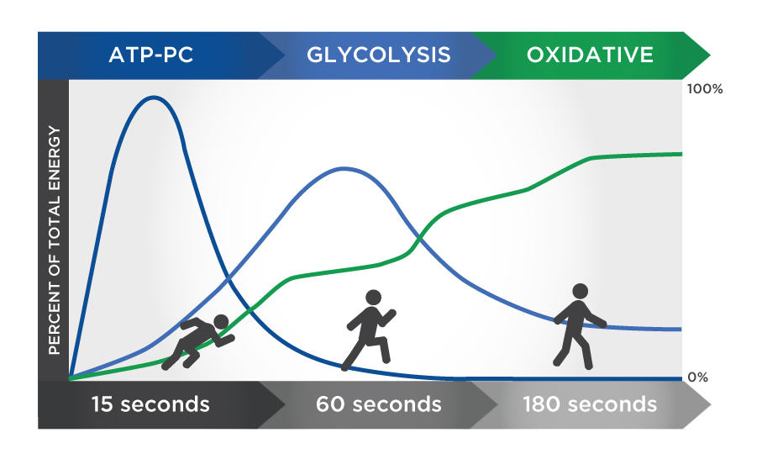

### ATP-PC system

The first pathway is called the ATP-PC system or the phosphagen system. ATP-PC stands for adenosine triphosphate-phosphocreatine. This metabolic pathway uses the energy released from the breakdown of phosphocreatine (also called creatine phosphate) for an immediate source of energy and then uses the phosphate molecule to produce more ATP. Phosphocreatine (PC) is a chemical compound stored in the muscles in limited supply. The ATP-PC system is the quickest way to resynthesise ATP, but because PC is limited, it can only resynthesise ATP for very brief periods (seconds).

In this system, the synthesis of ATP comes solely from stored PC. Because no oxygen is used, it is referred to as an anaerobic (without oxygen) pathway. During the first few seconds of exercise, regardless of intensity, the ATP-PC system is relied on almost exclusively, with energy coming from the breakdown of the ATP stores within the muscles.

These ATP stores last only a few seconds; after which, the breakdown of PC provides energy for another 5 to 15 seconds of activity. The combined energy stored in ATP in the muscle along with the ATP resynthesised for the breakdown of PC can sustain high-intensity exercise for up to 10 to 15 seconds. If activity continues beyond this immediate period, the body must rely on other energy systems to produce ATP as the limited stores of both ATP and PC will be exhausted and will need time to replenish.

Summary of ATP-PC (phosphocreatine) System:

* It is the primary energy system used for all-out exercise.
* It can last up to about 10 seconds.
* A limited amount of PC is stored in skeletal muscle.
* Fatigue happens very quickly with this system.
* Creatine kinase is the enzyme that breaks down phosphocreatine (PC) into creatine and an inorganic phosphate (Pi).
* The energy released in the breakdown of PC allows ADP and Pi to form more ATP.
* PC stores are replenished after about 2 minutes of rest.
* If activity continues at a high intensity, other energy systems will be called on.

### Anaerobic (Glycolytic) energy system

The anaerobic (glycolytic) system provides energy for medium to high-intensity bursts of activity that last from 10 seconds to 2 minutes. Glycolysis means the breakdown (-lysis) of glucose through a series of enzymatic reactions. Glycolysis uses glucose in the blood or glycogen to form ATP rapidly without oxygen. If glucose is used, two ATPs are generated. If glycogen is used, three ATPs are formed. The anaerobic glycolytic system and the ATP-PC system provide energy for high-intensity levels, but only for a brief period (several minutes). Because this system does not rely on oxygen for fuel, it is referred to as anaerobic (without oxygen).

The primary difference between the ATP-PC system and the anaerobic glycolytic system is that glycolysis provides a rapid supply of ATP for up to 2 minutes, compared to only seconds for the ATP-PC system. When glucose is broken down during this process, two ATP are produced for each molecule of glucose. Anaerobic glycolysis involves the breakdown of glucose to lactate when limited amounts of oxygen are available (anaerobic). Anaerobic glycolysis is the dominant energy system during short, intense exercise, providing energy for a period ranging from 10 seconds to 2 minutes.

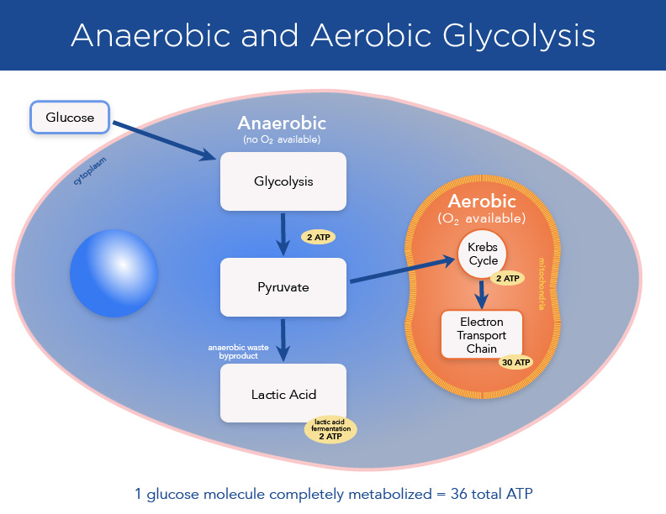

**End products of glycolysis**

The end product of glycolysis is pyruvate. Pyruvate is either transported and used to support further energy production in the Krebs cycle or converted into lactic acid (lactate + hydrogen ion). If lactic acid becomes the end product, it is called anaerobic glycolysis. If pyruvate is used further in the Krebs cycle, it becomes part of aerobic glycolysis or aerobic respiration. The availability of the oxygen determines the fate of the end product for glycolysis. Anaerobic glycolysis provides ATP for up to 2 to 3 minutes of exercise. If exercise continues beyond, either the intensity of exercise would need to be decreased or aerobic systems would need to be recruited to supply ATP.

During short bouts of high-intensity exercise (anaerobic metabolism), pyruvate will be converted to lactate. Lactate is an energy substrate that is used to support metabolism during high-intensity exercise. Lactic acid and lactate are not interchangeable terms. Lactic acid is quickly buffered to lactate. Neither lactic acid nor lactate is a primary cause of muscle soreness.

Getting Technical

The Fate of Lactic Acid

Pyruvate and hydrogen ions can accumulate rapidly during high-intensity exercise. Muscle performance can decline if a muscle cell becomes too acidic and it is not buffered quickly enough. Lactate is formed when one molecule of pyruvate attaches to two hydrogen ions. The lactate is then quickly removed from the muscle cell, protecting the cell from becoming too acidic so exercise can continue for a little longer. The conversion of pyruvate to lactate prevents the muscle from becoming too acidic. Lactate can also be carried back to the liver and converted back into pyruvate and/or glucose for further glycolysis and energy production via the aerobic energy system.

### Aerobic energy system

The aerobic system is the most utilised of the three. It provides energy for low-intensity activities that last anywhere from 2 minutes to a few hours. Unlike the other two systems, the aerobic system requires oxygen and takes much longer to overload. Sports and activities that use continuous sustained efforts such as long-distance swimming, running, and cycling rely on the aerobic system. In reality, most sports use a variety of energy systems. The energy system that is most prevalent in a given sport dictates the training intent.

The fuel used for aerobic activities comes from a combination of fat and carbohydrates. As the intensity increases, more carbohydrates are used than fat. As you approach maximum effort, your body will be utilising primarily carbohydrates to fuel performance. During short duration, high-intensity exercise (100 m sprint), energy is provided by stored ATP and CP. As the distance or time of the exercise continues, aerobic respiration, or oxidative phosphorylation, becomes the dominant energy system. When the duration of exercise is long, such as during a marathon, ATP is generated more slowly from high-capacity stores.

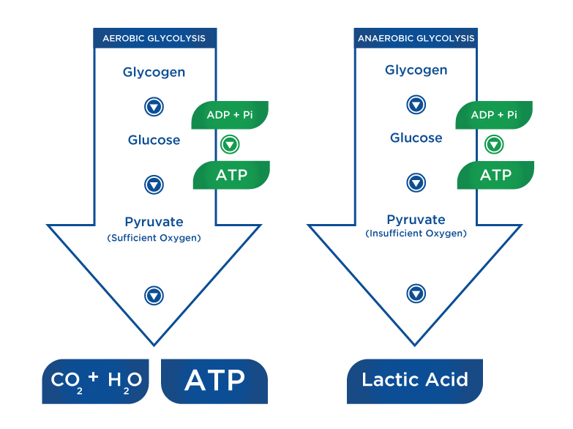

Getting Technical

Respiratory Exchange Ratio

The respiratory exchange ratio (RER) is the ratio between the amount of carbon dioxide (CO2) produced in metabolism and oxygen (O2) used. An RER is about 0.8 at rest, representing a mixed diet. Calculation of RER is commonly measured during a VO2 max test. An RER of 0.70 indicates that fat is the predominant fuel source. An RER of 0.85 suggests a mix of fat and carbohydrates. A value of 1.00 or above is indicative of carbohydrates being the predominant fuel source.

When enough oxygen is present, especially during low-intensity exercise, glucose is broken down, completely avoiding the build-up of lactic acid. The result is that there are more ATP molecules per glucose molecule: around 36 ATP molecules per glucose molecule, instead of the two from anaerobic glycolysis. The aerobic system also relies on some fatty acids for energy production. More fat is used in lower-intensity; but, at higher levels of exercise intensity, fatty acids cannot be utilised quickly enough to supply the phosphates needed to create ATP. Only muscle glycogen can meet the need.

**The Krebs Cycle and Electron Transport Chain**

The aerobic system also includes the Krebs cycle and the electron transport chain. Both use blood glucose, glycogen, plasma-free fatty acids, or intramuscular triglycerides as fuels to resynthesise ATP in the mitochondria. Glucose and glycogen are first metabolised through glycolysis with the result being pyruvate. Pyruvate is used to form acetyl-CoA, which enters the Krebs cycle. The electrons produced in the Krebs cycle are then transported through the electron transport chain where ATP and water are produced. Complete oxidation of glucose via glycolysis, the Krebs cycle, and the electron transport chain produces around 36 molecules of ATP for every molecule of glucose broken down.

Ultimately, more ATP is produced through this pathway than through the other two; however, it takes more steps and it takes longer. Pyruvate, which is produced through glycolysis, undergoes a long trip through the Krebs cycle to convert several enzymes that have lost an electron back into their original state. It is in the electron transport chain where these coenzymes undergo oxidation to convert ADP back into ATP. It is only in this pathway that fat can be used for energy.



**Fat oxidation**

Breaking down fat for energy is also a long process (called beta-oxidation), which does not directly produce ATP. When fat is broken down into free fatty acids and glycerol (lipolysis), the free fatty acids are transported into the mitochondria where the carbon atoms are used to produce acetyl-CoA in a process called beta-oxidation. The oxidation of free fatty acids yields more ATP molecules than the oxidation of glucose or glycogen. While one molecule of glucose yields around 36 ATP through a full cycle of metabolic reactions, fatty acids yield much more. For example, one molecule of palmitic free fatty acid can produce 129 ATP.

**Summary**

The human body is governed by the same immutable laws that govern the rest of the universe. The First Law of Thermodynamics indicates that neither mass nor energy can be created or destroyed. As such, changes in human mass or energy fall under the principle of energy balance: Energy In versus Energy Out. Humans take in energy in the form of food and expend it through supporting activity and bodily functions. Additionally, depending on which macronutrient is consumed and the intensity of activity, ATP is generated in a variety of ways.

Understanding the components of energy balance and the various metabolic pathways to ATP production are paramount for the Nutrition Coach. Through the manipulation of the components of Energy In and Energy Out, Nutrition Coaches can help clients fuel for activity to better manage body weight and optimise athletic performance.

In this chapter, you learned about:

* How the study of thermodynamics (specifically, the First Law of Thermodynamics) governs body composition and energy balance.
* The role hormones play in maintaining energy balance.
* The components of Energy In.
* The components of Energy Out.
* The ATP-PC energy system.
* The anaerobic (glycolytic) energy system.
* The aerobic energy system.
* Energy system utilisation based on the intensity of activity.

# Protein

Protein is one of the most discussed topics in sports nutrition, and for good reason. It is the second-most abundant molecule in fat-free bodily tissues (water being the most abundant). It plays a pivotal role in exercise recovery and it is involved in nearly all bodily functions and processes. Proteins are responsible for many functions throughout the body, including acid-base balance, energy production, cell signalling, and nutrient transport. For these reasons and many more, protein is an essential dietary nutrient for healthy living.

## Protein structure

Similar to other organic molecules, protein is made from the elements carbon, hydrogen and oxygen. However, protein is unique from the nutrients carbohydrate and fat because it is composed of nitrogen, as well. The elements carbon (C), hydrogen (H), oxygen (O) and nitrogen (N) combine to form the building blocks of protein, which are known as amino acids.

### Amino acids

All proteins are composed of amino acids. There are hundreds of amino acids in nature, yet there are just 20 amino acids that the human body requires to perform its various functions. Amino acid structure and arrangement has five components: a central carbon, a carboxyl group (organic acid – COOH), a hydrogen, an amino group (NH2), and a side chain (R group). The side chain is what makes each individual amino acid unique, and, therefore, it is different between every amino acid. For example, glycine only has a single hydrogen in the side-chain position, while leucine’s side chain is a more complex carbon and hydrogen structure (Figure: Structure of Amino Acids). Nutrition Coaches must know whether an amino acid is nonessential, conditionally essential, or essential in the human diet.

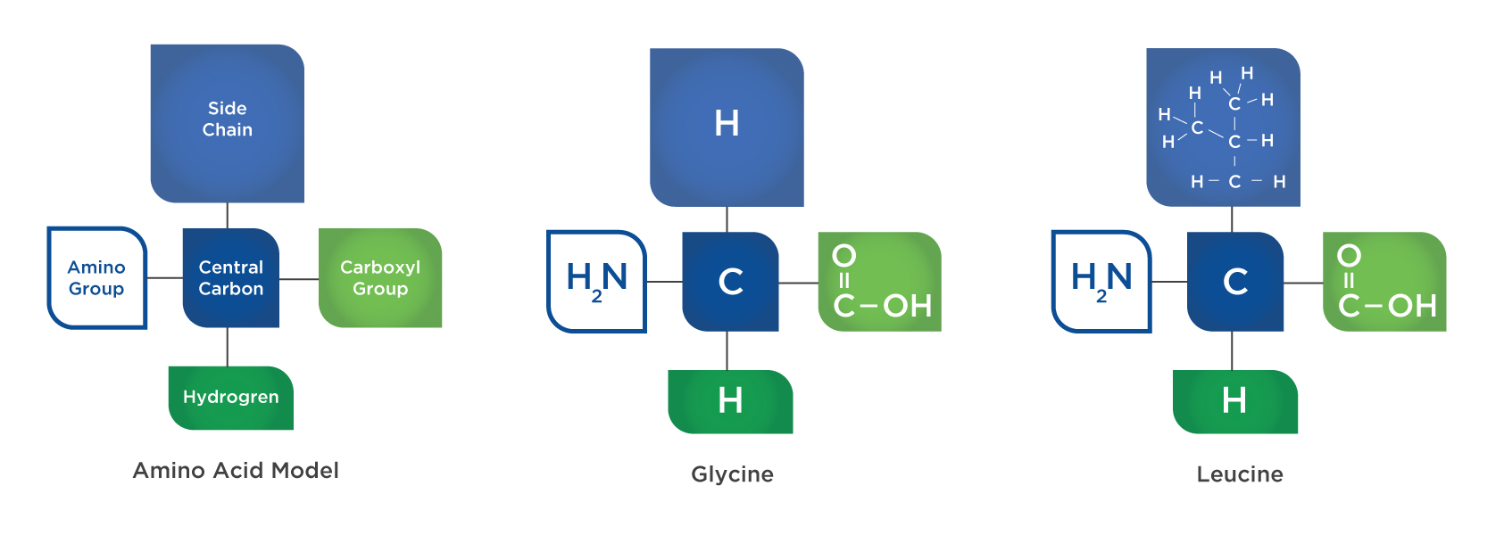

Essential amino acids (EAA) must be consumed in the diet because they are necessary for bodily functions and cannot be synthesized within the body. There are nine EAAs, which include three branched chain amino acids (Table: Amino Acid Types ). There are also six conditionally essential amino acids. Unlike EAAs, conditionally essential amino acids are considered nonessential under normal circumstances and can be synthesised in the body; however, under certain physiological conditions, requirements can outweigh their availability or rate of synthesis, making them essential for some individuals. When this occurs, the conditionally essential amino acid must be obtained in the diet. Healthy adults typically do not need to be concerned about consuming enough conditionally essential amino acids, as they only become essential during infancy, injury, disease or trauma. Nonessential amino acids can be synthesised in the body from other amino acids, typically the EAAs, so they do not need to be consumed in the diet.

Amino Acid Types

| **Nonessential Amino Acids** | **Conditionally Essential Amino Acids** | **Essential Amino Acids** |
| --- | --- | --- |
| Alanine  Asparagine  Aspartic acid  Glutamic acid  Serine | Arginine  Cysteine  Glutamine  Glycine  Proline  Tyrosine | Histidine  Lysine  Methionine  Phenylalanine  Threonine  Tryptophan    Branched Chain Amino Acids  Isoleucine  Leucine  Valine |

Helpful Hint

A classic mnemonic to remember the EAAs is PVT TIM HALL (which borrows arginine, a conditionally essential amino acid, for the “A.”)

* Phenylalanine
* Valine
* Threonine
* Tryptophan
* Isoleucine
* Methionine
* Histidine
* Arginine*
* Lysine
* Leucine

Critical!

Because the conditionally essential amino acids so rarely become essential for individuals, which amino acids to classify as conditionally essential remains a debated topic. For example, some experts advocate that serine be added to the list of conditionally essential amino acids, while others argue that amino acids only become conditionally essential in the presence of disease. Clients should always be referred to their primary care doctor to have bloodwork analysed if any concerns regarding amino acid deficiency exist.

Another classification system for amino acids is based on their potential to become glucose or ketones for use in energy metabolism. These are known as glucogenic or ketogenic amino acids (Table: Glucogenic vs. Ketogenic Amino Acids). While amino acids should not be relied on for optimal energy production, they can be broken down preferentially over fatty acids in times of negative energy balance when more intense activity needs to be sustained and carbohydrate availability is insufficient. Glucogenic amino acids can have their carbon backbone converted to glucose by the process of gluconeogenesis, or they can be converted to an intermediate compound that may enter the Krebs cycle directly. Ketogenic amino acids may become acetoacetate (a ketone body) or acetyl-CoA prior to entering the Krebs cycle for the generation of ATP. Some amino acids will always be specifically glucogenic or ketogenic, while others can be both glucogenic and ketogenic, with the outcome depending on which stage of metabolism they enter.

Glucogenic vs. Ketogenic Amino Acids

| **Glucogenic** | **Ketogenic** | **Glucogenic or Ketogenic** |
| --- | --- | --- |
| Alanine  Asparagine  Aspartic acid  Cysteine  Valine  Glutamic acid  Glutamine  Glycine  Proline  Serine  Arginine  Histidine  Methionine | Leucine  Lysine | Tyrosine  Isoleucine  Tryptophan  Phenylalanine  Threonine |

### Protein synthesis

When proteins are consumed, they must first be broken down into amino acids by digestion to be absorbed in the intestines. From there, they can be transported to peripheral tissues and recombined to form new proteins such as collagen, myosin, and hemoglobin. Protein synthesis is the process by which amino acids are joined together to form proteins, such as lean tissues, like muscle.

The amino acids bond together by a chemical reaction called dehydration synthesis (Figure: Dehydration Synthesis and Hydrolysis). In a dehydration synthesis reaction, a hydrogen from one amino acid and a hydroxyl group (OH) from a second amino acid are removed and joined together by a peptide bond to form the newly synthesised molecule and the byproduct of water (H2O). It is called dehydration synthesis because a water molecule is removed, thus de*hydrating* the molecule. The opposite process is known as hydrolysis, which occurs during digestion when proteins are broken down to amino acids.

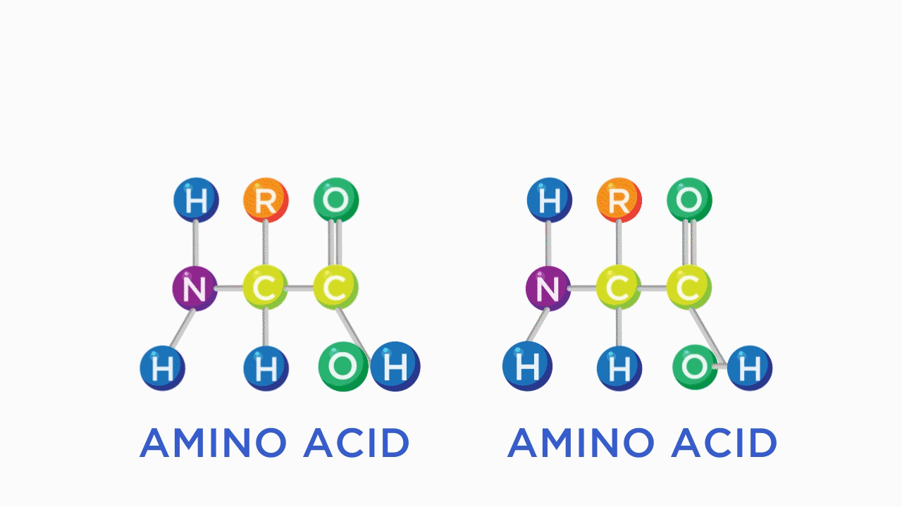

When two amino acids are joined, it is known as a dipeptide. When three amino acids are joined, it is known as a tripeptide. When between four and nine amino acids join it is called an oligopeptide, and chains of 10 or more amino acids are called polypeptides. Bodily proteins are most often formed by at least 50 amino acids. The human body is in a constant state of both protein synthesis (anabolic) *and* protein breakdown (catabolic). When an individual is gaining muscle mass, their rate of muscle protein synthesis is greater than their body’s rate of muscle protein breakdown. Conversely, someone who becomes inactive for an extended period of time will have greater rates of muscle protein breakdown as the body returns to equilibrium.

Getting Technical

Muscle proteins vary in size, shape, and function. The three major muscle proteins are myosin, actin, and titin, which all contain different amino acid compositions (Figure: Actin, Myosin, and Titin). Titin has about 30,000 amino acids, myosin has about 6,000 amino acids, and actin has about 400 amino acids. Myosin uses energy from ATP to grab actin and flex in unison with many other myosin proteins to produce a muscle contraction. Titin helps provide a muscle’s elasticity so it can return to its resting length following muscle contractions. It is so large because it stretches over the whole muscle cell, whereas myosin and actin go about halfway. Myosin is much larger than actin due to its more complex function.

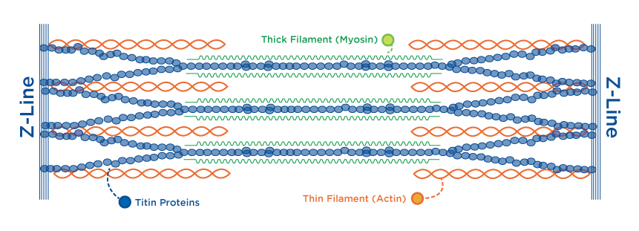

## Protein digestion and absorption

The first step in protein breakdown is denaturation, changing the shape of a protein but not its primary structure. Denaturation occurs in response to many factors such as temperature, pH, and enzymes, all of which are at work during protein digestion and absorption. For most protein-dense foods, this process begins with cooking the food. The applied heat denatures proteins, which must occur within the body eventually, either by mastication (chewing) or in the acidic environment of the stomach. Even cutting food up into smaller pieces is, in a way, facilitating digestive processes by reducing the amount of necessary mastication. Unlike with carbohydrates and fats, enzymes for protein in the saliva are relatively inactive and do little to aid in digestion.

Try This

When you want to see protein denaturation in action, fry an egg! When the clear egg white heats up and turns opaque as it cooks, you are witnessing protein denaturation. Protein denaturation does not make the protein within the food useless, as is often suggested. Many forms of cooking jumpstart the process of breaking down proteins and facilitating more efficient digestion.

However, chewing food causes the stomach wall to release gastrin in anticipation of the digestion process. In turn, gastrin causes the release of hydrochloric acid and the hormone pepsinogen in the stomach. When pepsinogen contacts the hydrochloric acid, it releases the active enzyme pepsin. Together, hydrochloric acid and pepsin begin the enzymatic breakdown of protein in the stomach. Hydrochloric acid denatures the protein and pepsin begins breaking the very long polypeptide chains into smaller peptide chains (hydrolysis reaction). Those smaller peptide chains then move to the small intestine for the next step in digestion.

As the food passes from the stomach into the duodenum of the small intestine, the intestinal cells release the hormones secretin and cholecystokinin. Secretin mostly acts as a regulator of digestion, reducing acid release to help restore pH when eating ceases. Cholecystokinin acts on the pancreas, which releases the protease enzymes trypsin, chymotrypsin, carboxypeptidase, and elastase into the small intestine. The protease enzymes continue to break down peptide chains into even shorter peptides. Finally, peptidases and aminopeptidases reduce the size to single amino acids and dipeptides, which can then be absorbed from the small intestine into the hepatic portal vein, carrying them to the liver.

Within the liver, amino acids may be used for protein synthesis, broken down into urea (urine waste), converted to carbohydrate or fat (gluconeogenesis or ketogenesis), metabolized for energy, or released into the peripheral blood stream for use throughout the body. While the maximum amount of protein that can be absorbed in one meal is yet to be determined, about 85% of plant protein and 95% of animal protein is absorbed and very little protein is found in excrement (Young & Pellett, 1994). Any remaining proteins and peptides that make it past the small intestine and into the large intestine (colon) are fermented by bacteria and secreted as waste (Infographic: Protein Digestion and Absorption).

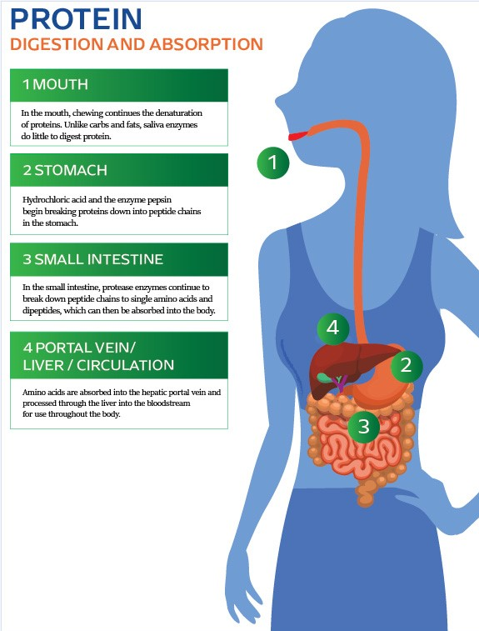

## Protein function

While fats and carbohydrates may be thought of as energy macronutrients, protein is more of a structural and functional macronutrient, forming bodily structures and serving many necessary bodily functions. Although it is possible for protein to be metabolized for energy, this only occurs when there is an abundance of protein in the diet and/or when there is not enough carbohydrate to support normal energy production (negative energy balance). Protein and amino acids are primarily used to create bodily tissues; to form enzymes and cellular transporters, as cell signals; to maintain fluid balance; to buffer acids and bases (pH balance), in the production of hormones and neurotransmitters; and in the immune system.

**Bodily tissues**

Most bodily protein is located within the musculoskeletal system. However, keep in mind there is no true storage depot for protein like there is for carbohydrates (glycogen stored in muscle tissue and the liver) or fats (adipose tissue, i.e., body fat). Rather, proteins make up the physical structure of the muscles and bones. This is why amino acids are not considered a primary source of energy because the only way to supply them (aside from eating) is by breaking down non-fat bodily tissues.

Along with the mineral calcium, bones are formed from very strong collagen proteins, which are also found in the skin, tendons, ligaments, and joints. Collagen’s molecular structure is a triple helix, which gives it great tensile strength (Figure: The Structure of Collagen). Collagen protein’s function is to provide structural integrity. The reason collagen is so effective at being strong and flexible is because it is formed from many small amino acids (glycine, proline, and hydroxyproline), which can move around without breaking their bonds. Usually found alongside collagen is elastin protein, which provides elasticity so tissues can bend but not break. Muscle proteins myosin, actin, and titin are another large repository for body proteins that enable movement. Finally, keratin is another tough protein found in human hair and fingernails.

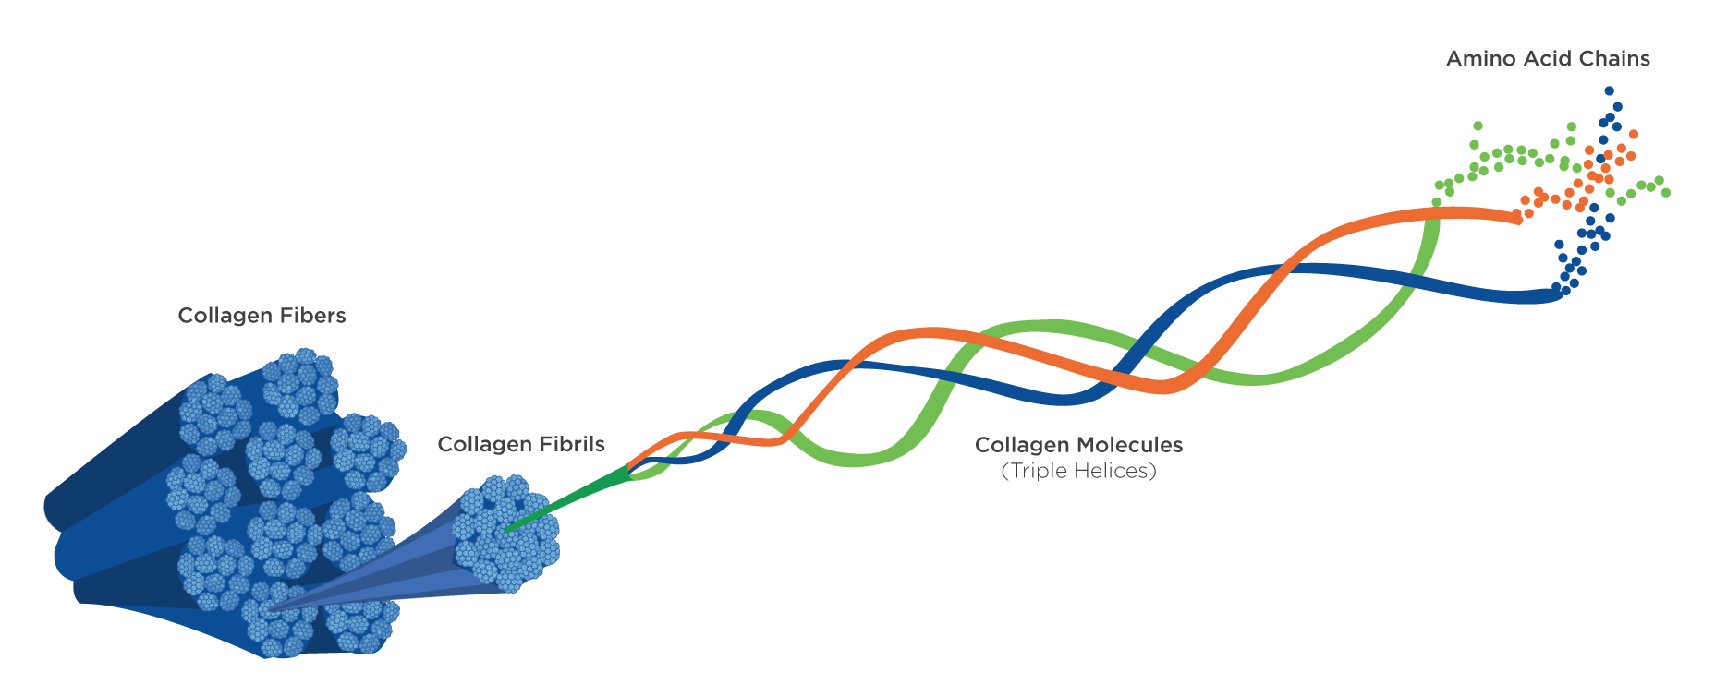

**Enzymes and cellular transporters**

Nearly all enzymes are made from protein. Enzymes are catalysts for chemical reactions and are critical for carrying out many functions within the body, especially in digestion and metabolism. Enzymes are present in saliva, stomach and intestinal fluids, blood, and throughout the cells of the body. For example, pyruvate dehydrogenase is an enzyme involved in the metabolism of glucose. It converts the end product of anaerobic glycolysis, pyruvate, to acetyl-CoA for use in the Krebs cycle within the mitochondria. Without pyruvate dehydrogenase, the energy that humans are able to generate from a glucose molecule would be severely limited.

Cellular transporters are similar to enzymes. However, instead of catalyzing a reaction, they are more like doorways in cell membranes. One of the most discussed transporters in biology is the sodium–potassium pump (Lee, 2018; Skou, 1989). The sodium–potassium pump actively (using ATP) transports potassium into the cell and sodium out of the cell to create a gradient that the cell can use for other transporters and electrical signaling. This protein-based cellular transporter is, in essence, what allows these electrolytes to do their job within the cells, maintaining the pathway by which the nervous system sends its electrical signals for muscles to contract. Other cellular transporters work passively (without ATP) to allow nutrients to cross cellular membranes.

Proteins are also critical for transporting a wide range of nutrients throughout the body. For example, hemoglobin is a protein in red blood cells that binds to and transports both oxygen and the metabolic waste product of carbon dioxide. Another example is lipoproteins, which are molecules that make the transport of lipids (fats) throughout the body possible. The most well-known example of this is cholesterol. The lipoproteins have historically received negative attention for their role in cardiovascular health (or risk), yet they perform an essential bodily function by moving lipids between the liver, adipose tissue, and other tissues or organs so they may be metabolized or stored.

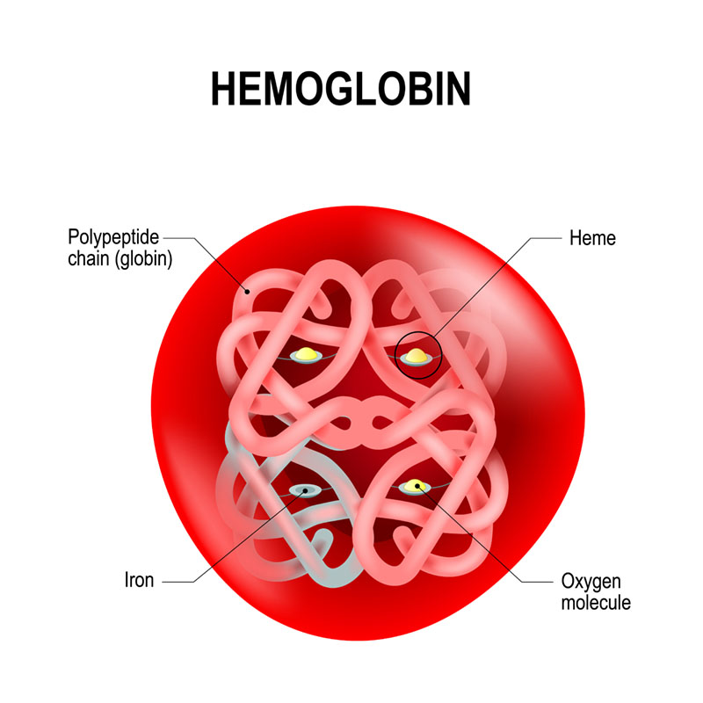

**Cell signaling**

The concentration of individual amino acids can be interpreted by the nervous system as a signal to perform certain functions. For example, an increase in the amino acid leucine has been shown to signal muscle cells to begin synthesizing new proteins when the other necessary amino acids are present. Leucine in isolation will not build muscle, but supplementing leucine into an otherwise high-protein diet can help enhance muscle hypertrophy (Atherton et al., 2017; Devries et al., 2018; Dijk et al., 2018; Garlick, 2005; Jackman et al., 2017; Norton & Layman, 2006; Norton et al., 2010; Norton, Wilson, Layman, Moulton, & Garlick, 2012; Tang, Moore, Kujbida, Tarnopolsky, & Phillips, 2009; Wilson et al., 2011; Wolfe, 2017). Not only can proteins and amino acids be signals themselves, but they often form the cellular receptors and sensors, as well. These receptors can respond to many different stimuli outside the cell and relay a message inside the cell.

**Fluid balance**

Proteins help maintain fluid balance on the cellular level as part of their role as transporters across cell membranes, allowing water to move between the cells and the blood. Fluid balance is also managed by the protein albumin, the most abundant protein in blood plasma. Albumin is present in the blood but much less abundant within soft tissue. This creates a concentration gradient that helps pull excess fluid from bodily tissues back into the bloodstream by osmosis.

**pH balance**

Proteins and amino acids help regulate the body’s acid–base balance by binding to free hydroxyl groups or hydrogen ions in the blood to help maintain a neutral pH. Hemoglobin is one of the most well-known proteins that assist with this. As a side effect of its role in binding to carbon dioxide to transport it out of the body as waste, it prevents the CO2 from forming carbonic acid and lowering blood pH. The protein’s presence within the blood, cell, and other fluids provide over half of the buffering power in the body ([Bian, Rong, & Chang, 2011](https://nasmu.nasm.org/pluginfile.php/791769/mod_scorm/content/8/#_ENREF_4)).

Food For Thought

Can amino acids prevent someone from *staying alkaline*? The short answer is no. Amino acids contain both alkaline (basic) and acidic functional groups. With few exceptions, like the stomach, the body is already slightly alkaline with a blood pH of about 7.4 and amino acids are a major factor in maintaining the slightly alkaline pH.

**Hormones and neurotransmitters**

Many hormones are derived from amino acids, which are known as peptide hormones. For example, human growth hormone (produced in the pituitary gland) contains 191 amino acids. Other examples of peptide hormones can be found throughout the body, such as insulin (produced in the pancreas), gastrin (produced in the stomach), and leptin (produced within adipose tissue).

Peptide hormones often also act as neurotransmitters. While similar to hormones, in that they serve as chemical messengers throughout the body, they are classified differently. Neurotransmitters are part of the nervous system, while hormones are part of the endocrine system. A single peptide hormone can belong to either system depending on how it is behaving. For example, oxytocin is a small peptide hormone that can also function as a neurotransmitter. As a hormone, for example, oxytocin acts within the mammary glands to signal the release of breast milk after giving birth. As a neurotransmitter, oxytocin acts on the prefrontal cortex to stimulate feelings of social connection and sexual attraction, giving rise to its nickname as the love hormone (even though its function in this capacity is within the central nervous system as a neurotransmitter and not the endocrine system as a hormone). Other peptides that function as neurotransmitters include epinephrine, glutamate, dopamine, serotonin, and histamine.

**Immune system**

Like red blood cells with hemoglobin, white blood cells also require protein to become functional. The white blood cells themselves also use proteins to fight infection and disease. In response to an infection, the white blood cell produces antibodies, which are proteins, to protect the body from sickness and disease while leaving friendly microbes and bacteria alone.

Getting Technical

Having adequate dietary protein can help prevent sickness and infection. A study conducted on trained cyclists undergoing 2 weeks of high-volume, high-intensity training and divided into either a high-protein treatment (3 grams per kilogram bodyweight) or a normal-protein treatment (1.5 grams per kilogram bodyweight) found that the increased training volume bogged down the immune system. During the normal protein treatment, cyclists reported more symptoms of upper-respiratory tract infection than during the high-protein treatment, and having greater protein intake maintained better white blood cell function (Witard et al., 2014).

## Protein dietary needs

Obtaining adequate protein in the diet is essential for athletes and non-athletes alike. For non-athletes, dietary protein is required for the myriad of health functions previously discussed. For active exercisers and athletes, additional protein intake is required for the repair and recovery of muscle tissue, as well. Depending on the goals of the active individual, they may need more protein in their diet than the average sedentary person.

**USDA Dietary Guidelines for Americans 2015-2020**

The dietary guidelines for Americans are revised every 5 years and are also on par with most other guidelines from governing bodies around the world. Table: Recommended Protein Rich Food Servings is adapted from the *USDA Guidelines for Healthy Americans* to show the recommended servings of protein-rich foods based on total daily calorie consumption (USDA, 2015). Specific recommendations for protein are not provided in units, such as grams per kilogram body weight, or as a percent of calories. However, extrapolation suggests this to be approximately 85 to 90 grams of protein per 2,000 calories per day, or 17 to 18% of total calories when including protein from all sources. The guidelines adjust total calorie intake based on sex and activity level. However, they take an average of height and weight for each age–sex group, making them inaccurate for many individuals. Therefore, the guidelines also do not modify protein intake based on individual need. The only scenarios in which protein recommendations change are with different calorie levels ([USDA, 2015](https://nasmu.nasm.org/pluginfile.php/791769/mod_scorm/content/8/#_2et92p0)).

Recommended Protein-Rich Food Servings

| **Food Group** | **Calorie Level** | | | | | | | | |
| --- | --- | --- | --- | --- | --- | --- | --- | --- | --- |
| **1600** | **1800** | **2000** | **2200** | **2400** | **2600** | **2800** | **3000** | **3200** |
| Dairy (cup-eq/day) | 3 | 3 | 3 | 3 | 3 | 3 | 3 | 3 | 3 |
| Seafood (oz-eq/week) | 8 | 8 | 8 | 9 | 10 | 10 | 10 | 10 | 10 |
| Meats (oz-eq/week) | 23 | 23 | 26 | 28 | 31 | 31 | 33 | 33 | 33 |
| Nuts, seeds, and soy (oz-eq/week) | 4 | 4 | 5 | 5 | 5 | 5 | 6 | 6 | 6 |

### Dietary reference intakes

The dietary reference intakes (DRI) are established by the Food and Nutrition Board of the Institute of Medicine (Trumbo et al., 2005). They establish the recommended dietary allowance (RDA) for protein, last revised in 2005. The RDA for protein is 46 grams (1.6 ounces) per day for women and 56 grams (2.0 ounces) per day for men. The specific quantities were determined based on providing 0.8 grams of protein per kilogram (0.013 ounces of protein per pound) of body weight per day. The amounts appear to be dramatically less than those of the USDA guidelines, and, therefore, it is important to understand the definition of RDA and the right amount to meet the needs of almost all (97 to 98%) individuals in a group. In this case, sedentary men and women with a body weight of 70 kilograms (154 pounds) and 58 kilograms (128 pounds) were used as a reference, respectively. Meeting needs is a necessary function of eating, but it does not consider if exceeding needs may be better. As may be apparent, more specific and individualised protein recommendations are necessary when working with clients.

The USDA and RDA recommendations are comparable to recommendations around the world. The UK’s *Eatwell Guide* and Australia’s *Guide to Healthy Eating* are visual guides akin to the USDA’s *My Plate*, which recommend that about 20 to 25% of a day’s nutrition comes from high-protein sources, including an emphasis on fish as a protein source (USDA, 2016; Public Health England, 2016; AGDH, 2015). More specific recommended protein intakes, such as the reference intake values of the EU, dentify 50 grams of protein daily, much like the RDA of 46 to 56 grams (Authority, 2017).

Try This

Calculate your own daily protein needs according to the RDA of 0.8 grams of protein per kilogram of bodyweight. To do this, simply multiply your weight in kilograms by 0.8 to get your total recommended amount of protein for 1 day. If you typically weigh yourself in pounds, divide that scale weight by 2.2 to convert it to kilograms first.

The USDA and Institute of Medicine recommendations are based on the scientific literature, of course. However, the USDA guidelines are mostly based on epidemiological data, and the Institute of Medicine recommendations are based largely on nitrogen balance studies. Furthermore, the RDA is seeking to meet general needs to avoid adverse health effects; they do not address what may be needed for the most optimal health, performance or body composition. There are many subtopics related to protein needs, but the most important to consider is total daily protein intake.

**Total daily protein requirements**

The total daily protein requirement depends largely on the body size, activity level or sport, and body composition goals of the individual. Therefore, it is best to recommend total daily protein intakes on a gram of protein per kilogram of bodyweight basis (Table: Protein Needs by Activity Level). In general, individuals need between 0.8 to 2.2 grams of protein per kilogram of bodyweight per day. Inactive persons require less protein than active persons, and those exercising with greater duration or intensity will require more protein than those exercising with less duration or intensity. Additionally, more protein is required to recover from strength training than from cardiovascular training.

The recommendation of 0.8 grams of protein per kilogram (0.013 ounces of protein per pound) body weight is a daily minimum *need* that may be as high as 1.2 grams of protein per kilogram (0.019 ounces of protein per pound) of body weight in non-exercising persons based on new evidence (Trumbo et al., 2005; Pencharz et al., 2016). Exceeding the proposed dietary protein need poses few, if any, negative consequences. Consuming up to 2.2 grams of protein per kilogram of body weight is an acceptable goal, even for sedentary persons, and it is likely that a greater percentage of calories coming from protein will facilitate health goals (Pencharz et al., 2016).

Protein Needs by Activity Level

| **Activity Level** | **Type of Exercise** | **Protein Needs (g/kg body weight)** |
| --- | --- | --- |
| None | N/A | 0.8 to 1.2 |
| Light to Moderate | Cardiovascular  Resistance | 1.2 to 1.6  1.5 to 2.0 |
| Moderate to Vigourous | Cardiovascular  Resistance | 1.5 to 2.0  1.7 to 2.2 |

Getting Technical

Recent developments in the methods used to determine protein needs suggest that recommendations have been underestimated by about 30 to 50% (Bandegan, Courtney-Martin, Rafii, Pencharz, & Lemon, 2017; Elango, Humayun, Ball, & Pencharz, 2010; Kato, Suzuki, Bannai, & Moore, 2016; Pencharz, Elango, & Wolfe, 2016).

Moreover, research on the effects of very high protein intake (3.0 to 4.4 grams per kilogram) on body composition indicate that individuals overeating protein will not experience an increase in body fat mass over time (Antonio et al., 2015; Antonio et al., 2014; Claesson et al., 2009). Therefore, it is typically more prudent to make general recommendations of consuming more protein than to recommend less protein within the specified ranges, particularly when the client desires to increase lean muscle mass or maintain muscle mass while decreasing fat mass.

Critical!

Remember to always teach protein recommendations broadly so that clients can make their own nutritional decisions for themselves.

When working in Australia, always refer to the [ADG Eat for Health Calculators](https://www.eatforhealth.gov.au/eat-health-calculators) to assist with the understanding of macronutrient breakdowns.

Individuals who are seeking weight loss often lose muscle mass and fat mass concurrently and in relatively equal proportions, with typical calorie restricted diets. Maintaining as much muscle mass as possible while dieting can be achieved with greater protein intake (at least 1.8 to 2.2 grams per kilogram) and regular resistance training. Several research studies have verified that simultaneous loss of fat and maintenance of lean body mass is possible (Demling & DeSanti, 2000; Josse, Atkinson, Tarnopolsky, & Phillips, 2011). This requires careful consideration of calorie and protein intake and alignment with a well-designed resistance training program. Those beginning a fat-loss program with a more athletic and muscular physique may be able to lose fat mass with more normal caloric intakes.

Incorporating high-protein snacks, whether they are advertised as such or not, may be an effective strategy as part of a weight-loss plan. Do not be fooled, though; calories are the most important factor in weight loss, gain, and maintenance. Having a snack such as a low-carb, low-fat protein bar can certainly help with weight loss by curbing appetite between meals. However, products that simply add protein into a snack that otherwise has the nutrition profile of a chocolate bar (high sugar/high fat) can be counterproductive to someone who is trying to lose body fat.

Coach's Corner

Another special consideration for adjusting protein intake is for ageing adults. They are less responsive to dietary protein for the purposes of maintaining or increasing lean muscle (anabolic resistance). This is especially true for the older adult who is also physically inactive. It may be more appropriate to recommend that individuals 65 years of age and older consume at least 0.9 to 1.6 grams of protein per kilogram of bodyweight ([Rafii et al., 2016](https://nasmu.nasm.org/pluginfile.php/791769/mod_scorm/content/8/#_qsh70q)).

Coach's Corner

Athletes who are training with unusually high volume or intensity for a brief period of time, such as during a training camp, may have even greater protein needs than under normal training circumstances. During this time, it is appropriate to consider increasing protein intake in proportion to the increase in calorie intake as needed to meet the energy demands of the activity. For example, a 60-kilogram athlete training for a triathlon may regularly train for 12 hours per week, consume upwards of 3,500 calories or more per day, and eat around 120 grams of protein per day.

Critical!

It is important to understand the difference between minimum needs and optimal amounts of protein, including the differences between government recommendations and suggestions from the scientific literature. Know how recommendations change based on activity type and volume.

### Protein quality

The second-most important factor in meeting protein requirements is the type of protein that is consumed. Protein quality refers to the number of essential amino acids contained within, and the digestibility of, a protein-containing food. Protein quality also refers to the completeness of a protein. A complete protein is a food source that contains all of the essential amino acids in appropriate quantities. In general, animal proteins are complete proteins and plant proteins are incomplete proteins, with the exception of soy, which is also a complete protein.

Vegetarians and vegans often do not consume complete proteins, and, therefore, need to be conscious of consuming a variety of protein sources to meet essential amino acid (EAA) needs. A common example of mixed protein sources are rice and beans. Rice proteins are poor sources of lysine, but they are rich in cysteine and methionine. Beans have enough lysine, but they are poor sources of methionine and cysteine. Thus, they can be combined to form a complete protein in a single meal. Because of this, they are called complementary proteins. In general, people following a vegetarian or vegan diet may pair grains or nuts/seeds with legumes to obtain sufficient EAAs.

Other examples of complementary proteins include wheat/peanut butter, pasta/peas, and lentils/almonds. Complementary protein sources may also simply be consumed in different meals on the same day, as sufficient total daily EAA intake can still be achieved even if the individual amino acids are consumed across meals over a 24-hour period. That being said, it is always important to encourage clients to eat from a variety of protein sources, regardless of the dietary approach they may be following.

**Special Consideration-Leucine**

Protein quality assessment may be taken one step further when working with athletes or recreationally active individuals. The amino acid leucine is a primary factor for increasing muscle protein synthesis to facilitate muscle recovery and growth. Of all the amino acids present in a protein, leucine is the only one that is independently capable of enhancing muscle anabolism. However, it is important to understand that leucine is operating as a signal and *all* of the amino acids are still necessary to form proteins. Therefore, a protein’s quality may be evaluated based on its leucine content when muscle mass maintenance or growth is a primary goal.

Leucine is capable of enhancing muscle protein synthesis signalling for a period of about 3 hours after ingestion, and the *optimal* dose to maximise protein synthesis is 0.05 grams of leucine per kilogram of body weight (Norton & Wilson, 2009). The leucine content of various protein sources is provided in Table: Leucine Content of Protein Sources.

Leucine Content of Protein Sources

| **Protein Source** | **Percent of Protein as Leucine** | **Grams of Leucine per Standard Serving** |
| --- | --- | --- |
| Ground Beef (85:15) | 7.8% | 1.2 |
| Chicken Breast | 7.5% | 2.0 |
| Egg (whole – large) | 8.6% | 0.54 |
| Fish (salmon – wild) | 8.1% | 1.8 |
| Milk (2%) | 9.5% | 0.77 |
| Pork Loin | 8.5% | 1.9 |
| Soy Supplement | 8.4% | 2.1 |
| Whey Supplement | 10.5% | 2.6 |
| Casein Supplement | 9.2% | 2.3 |

### Protein timing

Most individuals do not need to concern themselves with the concept of protein timing as they will naturally consume adequate protein by eating balanced meals for breakfast, lunch, and dinner. However, small improvements in long-term physiological adaptations to exercise may be obtained from strategic timing of protein ingestion throughout the day, as well as before, during, and after training. Such strategies should be reserved for thoroughly dedicated individuals (i.e., athletes), as current scientific progress only supports the strategies in theory (Mori, 2014).

For example, a study comparing the rates of muscle protein synthesis over a 12-hour period found that four servings of 20 grams of whey protein was superior to the timing strategies of two servings of 40 grams of whey protein and eight servings of 10 grams of whey protein equally spaced over the 12-hour period (Areta et al., 2013). This is due, in part, to a protein threshold in combination with the kinetics of nutrition and protein synthesis. Ten grams (0.35 ounces) of protein was not enough to stimulate protein synthesis––participants never crossed the threshold. However, they did with 20 grams (0.7 ounces) and 40 grams (1.4 ounces); and with 20 grams (0.7 ounces), they crossed the threshold more frequently, once every 3 hours compared to once every 6 hours. Three hours seems to be about as long as an anabolic signal from a high-protein meal lasts (Wilson et al., 2011).

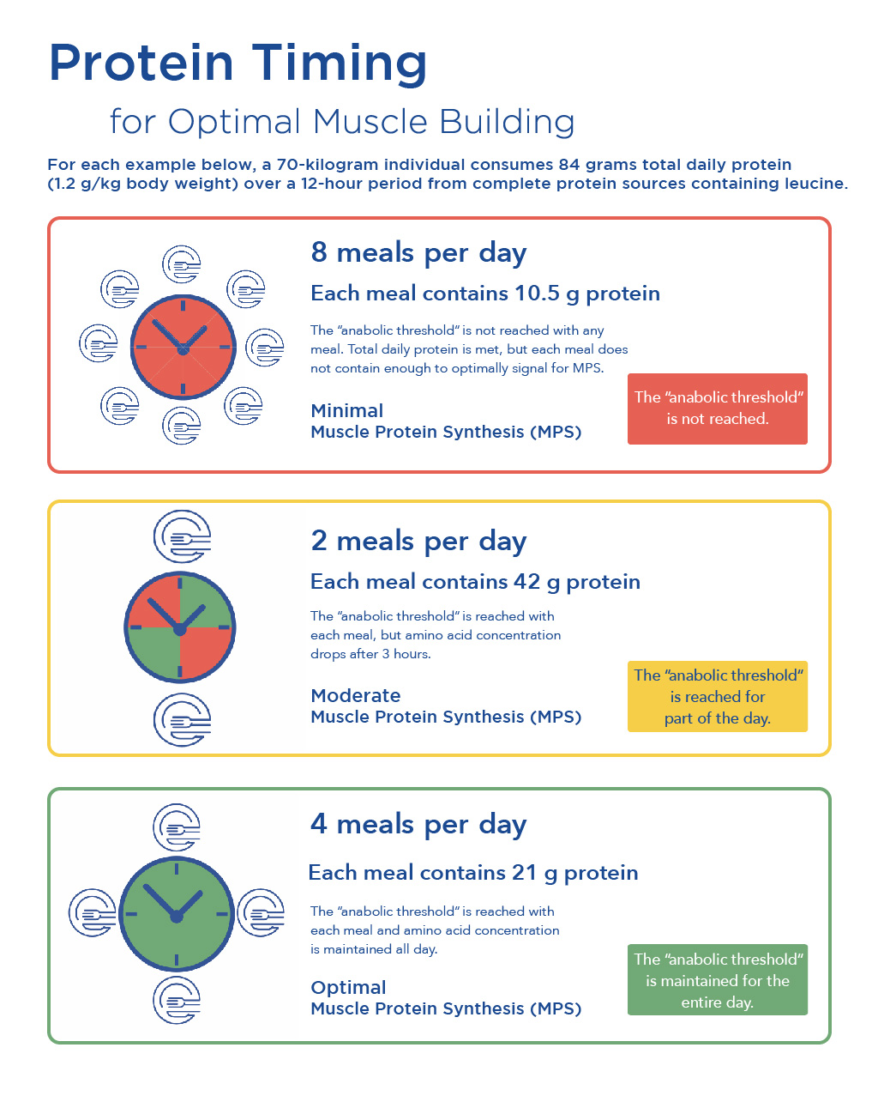

In another study design, participants ingested equal amounts of protein during each of three meals (about 30 grams / 1.06 ounces each), or they consumed protein in a skewed distribution, during which about 10 to 15 grams (0.35 to 0.53 ounces) were consumed with breakfast and lunch and about 65 grams (2.3 ounces) were consumed with dinner, but the total amount of protein was still the same. Those with an even protein distribution had 25% greater rates of muscle protein synthesis throughout the day (Mamerow et al., 2014). Such protein timing strategies may also be useful for long-term improvements in overall body composition in overweight or obese individuals. Termed *proteinpacing* by Arciero and colleagues (2016), the strategy consists of six meals per day with 30% of daily calories from protein compared to standard recommendations of three meals per day with 15% of daily calories from protein. Protein pacing enhances total, visceral, and abdominal fat loss and muscle mass maintenance during 3 months of calorie restriction and 9 months of maintenance.

Therefore, 24-hour net muscle protein synthesis may be optimal if stimulated with dietary protein (containing leucine) every 3 hours (Figure: Protein Timing). This notion was further solidified in a 2018 review on the topic of how protein should be distributed throughout the day for muscle gain, arriving at two key points: every meal should contain *at least* 0.4 grams of protein per kilogram of body weight and *at least* four meals should be consumed throughout the day (Schoenfeld & Aragon, 2018).

Consuming protein prior to exercise may attenuate rates of muscle catabolism (Bird, Tarpenning & Marino, 2006; Tipton et al., 2007; Tipton et al., 2001). However, pre- and intra-workout protein consumption are typically not emphasised if the individual has eaten a meal 1 to 3 hours prior to training. Protein consumption during exercise may be of some importance for very-long training sessions or athletic competitions (e.g., races lasting longer than 3 to 4 hours). Consuming small quantities of protein or amino acids during endurance events can limit muscle breakdown, serve as an alternative fuel substrate, and reduce muscle soreness (Bird et al., 2006; Greer, Woodard, White, Arguello, & Haymes, 2007). A beverage containing 1 to 2% protein is sufficient for intra-workout endurance purposes (Koopman et al., 2004; Saunders, 2007).

Post-workout protein consumption with carbohydrates in a 3:1 or 4:1 ratio of carbohydrates to protein can accelerate the replenishment of muscle glycogen (Ivy et al., 2002; Morifuji, Kanda, Koga, Kawanaka & Higuchi, 2010; Tarnopolsky et al., 1997; Van Loon, Saris, Kruijshoop & Wagenmakers, 2000). This is of relevance for endurance athletes who train the same muscle groups during each training session (e.g., marathon runners), athletes with multiple training sessions per day, and for multi-day competitions. Although commonplace in popular culture, post-workout protein consumption for the purposes of increasing muscle is actually of less importance.

Several investigations have observed increased rates of muscle protein synthesis when consuming protein 1 to 2 hours after resistance training; however, only a few studies have found that muscle gain is enhanced over time when protein is consumed post-workout and total daily protein intake is controlled. A meta-analysis of 20 studies for muscle growth and 23 studies for muscle strength found no statistically significant effect of post-workout protein consumption when total daily protein intake is equal (Schoenfeld, Aragon, & Krieger, 2013).

However, if the post-workout protein consumption increases the total protein intake for the day, muscle growth may be enhanced. In practical terms, this means that most individuals do not need to be concerned about consuming protein shortly after performing resistance exercise. Instead, they should be focussed primarily on total daily protein intake.

"Although commonplace in popular culture, post-workout protein consumption for the purposes of increasing muscle is actually of less importance."

Getting Technical

Statistical significance does not mean practical relevance. Post-workout protein consumption may not yield such a robust effect that the statistics will support its practice, but consuming protein after resistance exercise may still lead to a net-positive gain in muscle mass over time that may be considered relevant to an individual. Furthermore, while applied observations of muscle size or strength do not firmly support the practice of post-workout protein shakes, mechanistic research (examining rates of muscle protein synthesis) provides further insight. For resistance training novices, post-workout protein may not affect muscle protein synthesis, yet in resistance trained individuals, post-workout protein does further enhance rates of muscle protein synthesis. Thus, the recommendation to consume protein after training can be reserved for more well-trained individuals (Damas et al., 2016; Mori, 2014).

**Protein myths and hot topics**

As with many other topics in nutrition, protein is subjected to a number of myths. In most cases, research is insufficient to provide a clear answer one way or another, or research may have recently become sufficient, but adoption of the new idea is slow. Myths are the result of conjecture. However, there is substantial scientific data available to help us address some of the more common protein myths.

# Carbohydrates

Carbohydrates are often referred to as sugars and starches, or as simple and complex carbohydrates. Examples of starches include grains, corn, rice, barley, vegetables, beans, and wheat, whereas examples of sugars include sweets (candy), sugar (cane sugar), fruit, and milk (Table: Carbohydrates). Except for lactose (milk sugar) and glycogen (the storage form of carbohydrates in the body), all carbohydrates are plant-derived. Collectively, they are considered the body’s primary fuel source, yet are often labelled as the cause of weight gain. Carbohydrates frequently take a back seat to protein following exercise by those who fail to recognise the importance of this nutrient. Blame for these belief systems can be attributed to misinformation or even misunderstandings.

Although carbohydrates are not considered essential for survival, considering how the body can synthesise the amounts of glucose needed to survive from non-carbohydrate sources, they are generally needed in specific quantities to optimise health and performance. Subsequently, it is important for nutrition coaches to understand the importance of carbohydrates and how they function within the body.

Carbohydrates

| **Type** | **Examples** |
| --- | --- |
| Starches | Grains, corn, rice, barley, vegetables, beans, and wheat |
| Sugars | Sweets (candy), sugar (cane sugar), fruit, and milk |

This chapter will detail the chemical structure and organisation of carbohydrates, their key functions, their digestive and absorptive process, other important physiological functions, and carbohydrate intakes and recommendations. Furthermore, the discussion will include applications into programming, while also shedding light on various myths and topics surrounding this macronutrient.

## Carbohydrate structure

Although the terms starches and sugars may resonate with the public, practitioners often refer to carbohydrates by their scientific classifications: monosaccharides or single sugar units, disaccharides or paired sugar units, and polysaccharides, which represent longer sugar unit chains. It is the monosaccharides and disaccharides that are collectively known as simple sugars to many.

A smaller subgroup, called oligosaccharides, also exists, containing 3 to 10 sugar units. Polysaccharides and oligosaccharides are known as complex carbohydrates. As humans, we consume all these different forms of carbohydrates. However, our digestive process breaks down our digestible complex carbohydrates to their building blocks: the monosaccharides that are then absorbed into the body (Figure: Breakdown of Carbohydrates). Once absorbed, carbohydrates can be used immediately as a source of fuel or can be stored as glycogen in specific cells. In fact, the largest storage depots for carbohydrates (glycogen) are the muscle and liver cells.



### Monosaccharides

This group of carbohydrates represents single-sugar units and the only absorbable form of carbohydrates. Glucose (sometimes also referred to as dextrin or dextrose), fructose, and galactose represent the three nutritionally important monosaccharides to humans. They are each composed of carbon, hydrogen, and oxygen (Figure: Molecular Structure of Monosaccharides; Glucose, Galactose and Fructose). Subsequently, they are called hydrocarbons and they have the same molecular structure of C6H12O6. Although assembled with the same number of elements, the orientation of these elements within the molecule renders them uniquely different. Notice the difference in the molecular structure of fructose in comparison to glucose and galactose, which are both similar. This difference helps explain why fructose and glucose are absorbed and function differently in the body. While glucose and fructose are found in many food sources, galactose is only present in dairy products, forming part of the milk-sugar lactose.

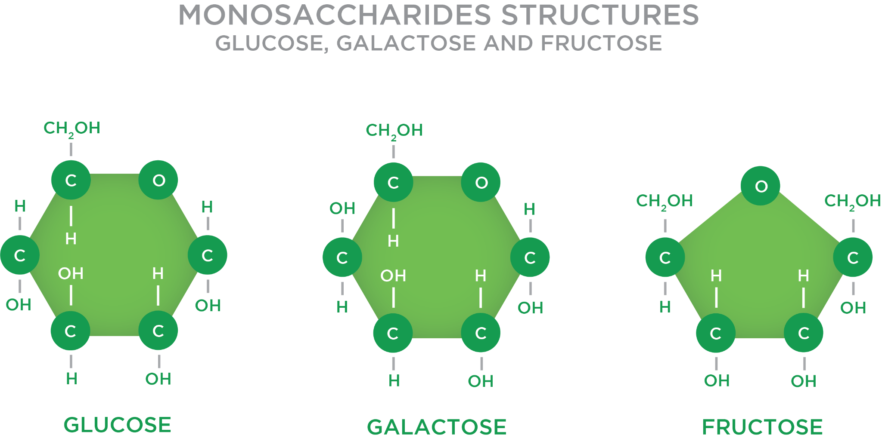

Food for Thought

Carbohydrates contain the elements carbon, hydrogen, and oxygen. Hydrogen and oxygen form water (H2O), hence the term *hydrate*, which then combines with the carbon atoms (or, if viewed differently, the water molecule hydrates the carbon).

### Disaccharides

Like monosaccharides, disaccharides are also categorised as simple sugars. However, disaccharides are comprised of three nutritionally important molecules: sucrose, lactose, and maltose (Figure: Structure of Disaccharides; Sucrose, Maltose, and Lactose).

* Sucrose is comprised of one glucose molecule joined with one fructose molecule. Examples include cane sugar, brown sugar, and date sugar. Sucrose contributes as a primary sugar in most fruits.
* Lactose is comprised of one glucose molecule joined with one galactose molecule. It is only found in dairy products.
* Maltose is comprised of two glucose molecules. Examples include corn syrup, brown rice syrup, and black treacle.

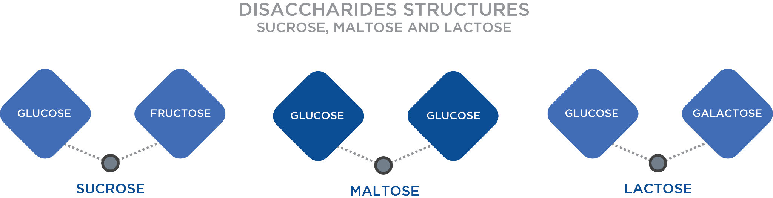

**Added sugars**

Naturally occurring sugars, such as those found in fruit or milk, are generally considered healthier options because the foods that contain natural sugars also include other important nutrients like vitamins and fibre. Added sugars are those not naturally occurring in food groups and include syrups and other caloric sweeteners found in sweets and sweetened beverages (soft drinks). Added sugars are sugars that are added to foods or food products, not sugars that are naturally contained in the food.

Added sugars include regular (cane) sugar, brown sugar, coconut nectar, date sugar, turbinado, raw sugar cane, and many other aliases for sugar itself (Smith et al., 2018). All added sugars, regardless of their source, are either monosaccharides or disaccharides that contain glucose, fructose, or galactose (Table: Added Sugars).

Added Sugars

| Raw, brown, and white sugar (sucrose)  Corn sweetener and syrups  Malt syrup  Turbinado sugar  Rice syrup  Date sugar  Glucose  Fructose  Lactose  Maltose | Honey  High fructose corn syrup  Invert sugar  Trehalose  Maple sugar or syrup  Caramel  Agave sugar  Dextrose  Dextrin  Molasses |
| --- | --- |

Critical!

Elevated levels of insulin in circulation may desensitise the body’s insulin receptors embedded within the membranes of a cell. This can advance the likelihood of developing insulin resistance, which reduces the body’s effectiveness of moving glucose out of the blood and into cells. In turn, this might increase the potential for moving toward the onset of conditions that lead to diabetes and prediabetes (early-stage diabetes) (American Heart Association, 2016). Effective ways to preserve insulin sensitivity include managing sugar and total carbohydrate intakes and remaining physically active. A regular regimen of activity helps resensitise these insulin receptors.

### Oligosaccharides

This small and less-frequently discussed group of polymer saccharides falls under the label of complex carbohydrates, but generally contains between only 3 and 10 sugar units. These partially-digestible polymers are found in legumes (e.g., peas, lentils, or beans) and plant sources; contain glucose, fructose, and/or galactose; and are touted for health-promoting benefits (Bernadot, 2012). Oligosaccharides are largely resistant to digestion because the human digestive tract lacks the necessary enzymes that can chemically break down many of these structures. This allows them to pass to the large intestine where intestinal bacteria act on them.

In fact, certain enzymes derived from intestinal bacteria may produce oligosaccharides from ingested starches and sugars. They essentially serve as food for our large intestinal bacteria and are also referred to as prebiotics. This category includes fructo-oligosaccharides (FOS), galacto-oligosaccharides (GOS) and inulin, which is extracted from chicory root (Table: Oligosaccharides). Sources of FOS include Jerusalem artichoke, leeks, onions, and asparagus, while examples of GOS are soybeans and human breast milk, which can support a healthy immune system in infants. Raffinose, stachyose, and verbascose, all found in beans, peas, and other vegetable sources, contain these three monosaccharides in the chemical structure.

Oligosaccharides

| **Category** | **Examples** |
| --- | --- |
| Fructo-oligosaccharides | Jerusalem artichoke, leeks, onions, and asparagus |
| Galacto-oligosaccharides | Soybeans and human breast milk |
| Inulin | Chicory root, sugar beets, leeks, asparagus, and banana |

### Polysaccharides

Polysaccharides are also complex carbohydrates and comprise starches, fibres and glycogen. Each contain long-chain glucose structures of more than 10 units, but they can be as large as several thousand units (e.g., glycogen molecule). Polysaccharide chains are arranged as straight-chain structures called amylose, branched-chain structures called amylopectin, and as a block structure called fibre (Figure: Polysaccharide Structures of Amylose, Amylopectin, and Fibre). Both amylose and amylopectin are digestible and make up approximately 20% and 80% of the digestible starches found in vegetables, grains, pasta, rice, and beans, respectively (Smith et al., 2018). Because enzymes digest from open ends of a structure, amylopectin will digest to the absorbable monosaccharide form of glucose faster than amylose. This raises the question to the implications of complex carbohydrates containing more amylopectin versus amylose.

Greater levels of amylopectin result in a faster and a greater spike in blood sugar than a similar compound with more amylose. Not only does this have repercussions with respect to changes in blood sugar, but it explains why not all complex carbohydrates rate low on the glycaemic index (GI). This concept is discussed in greater detail later in this chapter. Interestingly, because fiber has no open ends, it cannot be digested in the human intestine by digestive enzymes.

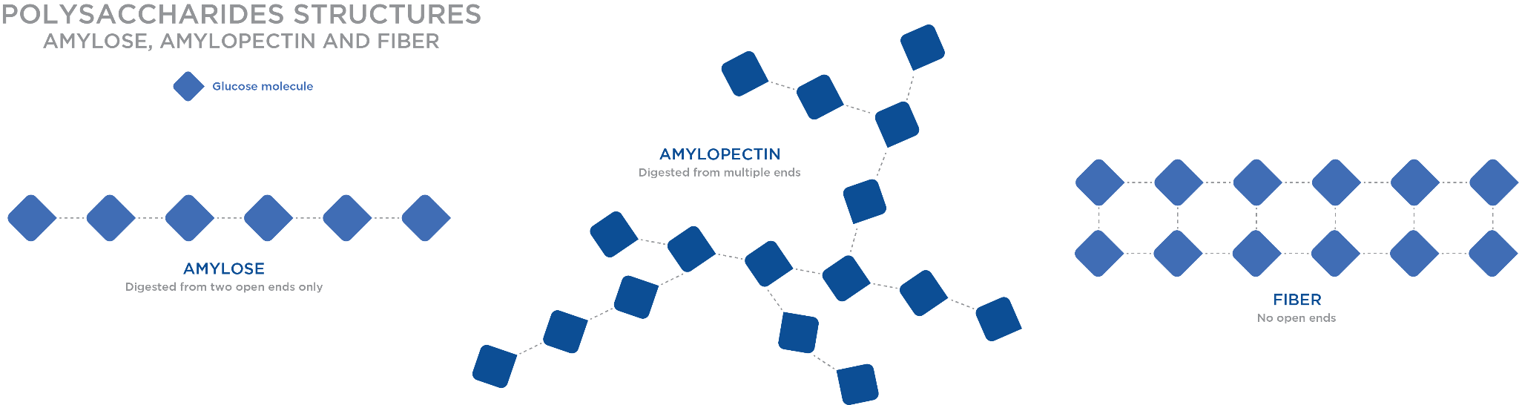

**Fibre**

Although fibre represents most of the indigestible portions of plant food, it is not a single compound. It is a group of compounds that share similar characteristics and are generally classified as either soluble or insoluble. Examples of soluble fibre include pectins, gums and mucilages that originate from the inside of the plant cell. They are called soluble because they either dissolve or swell when placed in water and most can be digested by the bacteria living within the large intestine. Therefore, they are also sometimes called fermentable.

Soluble fibres are found in oat bran, oatmeal, beans, fruits (e.g., apples or pears) and vegetables (e.g., artichoke, leeks, or sweet potatoes), as well as in many commercial products like salad dressings, jams, and jellies. They offer several benefits that include the following (Smith et al., 2018):

* Weight loss — It can delay gastric emptying (from the stomach) and it promotes an overall feeling of fullness, thereby potentially reducing caloric intake.
* Reducing risk for cardiovascular disease — It can bind to cholesterol particles. It can prevent its absorption and help remove this compound from the body.
* Bowel movement and intestinal health — It attracts water and it promotes bulk to the stool, which can safeguard against constipation.
* Diabetes protection — This carbohydrate is not absorbed. It can, therefore, reduce potential blood sugar spikes.
* Improved absorption of foods — It slows the movement of food through the small intestine. It can enhance nutrient absorption.

Insoluble fibre (water insoluble) forms the structural parts of plants and include compounds like cellulose, hemicellulose and lignin, and is often found in the outermost portion of grains, vegetables, fruits and seeds (e.g. whole-grain wheat, celery, brown rice, quinoa, apple peels or broccoli). They are called insoluble or non-fermentable because they do not dissolve in water and are not easily digested by intestinal bacteria. When many of these compounds have their outermost portions removed, this is what produces a processed starch (e.g., whole-wheat kernel to white bread or brown rice to white rice).

Like the soluble fibres, insoluble fibre also provides many health benefits that include the following (Smith et al., 2018):

* Digestive health — It adds bulk and draws water into the GI tract. It improves regularity in the large intestine to avoid constipation and other bowel-related health problems (e.g. haemorrhoids).
* Reduces risk of cancer—It improves movement through the large intestine. It reduces the risk of colon cancer and other large intestinal diseases (e.g. diverticulosis).
* Weight loss — By delaying gastric emptying (from the stomach), it promotes an overall feeling of fullness, reducing caloric intake.

If a food is listed as a good source of fibre, it may contain insoluble fibre, soluble fibre, or both. See Table: Soluble and Insoluble Fibres for examples of soluble and insoluble fibre foods sources and potential health benefits.

Soluble and Insoluble Fibres

| **Fibre Type** | **Food Sources** | **Health Benefits** |
| --- | --- | --- |
| Soluble | Oat bran  Oatmeal  Beans  Apples  Pears  Certain vegetables (e.g., artichoke, leeks, or sweet potatoes) | Lower total LDL cholesterol (may decrease risk of heart disease)  Possible weight loss  Improved bowel movement and intestinal health  Potential diabetes protection  Improved food absorption |
| Insoluble | Whole-grain wheat  Celery  Brown rice  Quinoa  Apple peels  Broccoli | Enhanced digestive health  Reduced risk of cancer  Possible weight loss |

Getting Technical

In their natural growing state, whole grains consist of the entire seed, known as a kernel. The kernel consists of three parts: the bran, germ, and endosperm. The bran is the outermost layer of the kernel and is designed to protect the kernel from the environment. It contains B vitamins, antioxidants, and fibre. The germ is the embryo of the kernel and contains B vitamins, minerals, some protein, and healthy fats. The endosperm is the largest portion of the kernel. It contains starchy carbohydrates, some protein, and small amounts of vitamins and minerals. During most refining processes, the bran and germ are removed from the kernel. As such, much of the fibre and nutrients are lost. Examples of this process including removing the outer layer of a whole-grain kernel to convert brown rice to white rice.

Functional fibre is a compound derived from isolated, indigestible carbohydrates to supposedly provide some of the physiological benefits that naturally occurring fibres provide to humans. These commercially available and man-made compounds like polydextrose and inulin are popular in many foods, but whether they offer the same health-promoting benefits as natural fibre remains to be determined.

Despite the many benefits associated with fibre intake, the current intake of fibre in the US population falls short of the recommended intake discussed later in this chapter. Figure: Fibre Intake of the US Population illustrates the current intake, which averages around 18 grams per day for men and 15 grams per day for women (WWEAI, NHANES 2009–2010). In the United States, it is recommended that women consume a daily intake of 25 grams of fibre, whereas men should consume 38 grams.

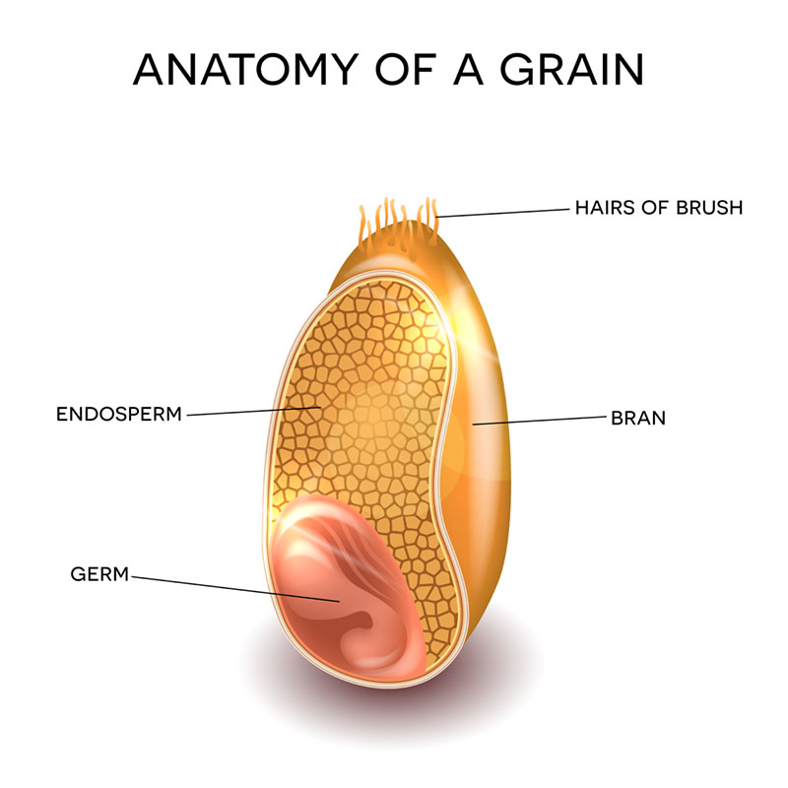

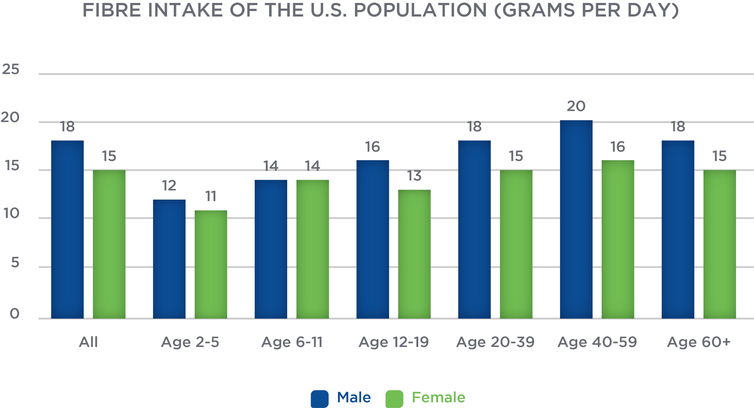

Table: Good Food Sources of Fibre provides a brief list of good food sources of fibre that individuals can consider for increasing overall fibre intake (USDA, 2014).

Good Food Sources of Fibre

| **Food Source** | **Standard Portion Size** | **Dietary Fibre (grams)** |
| --- | --- | --- |
| High fibre bran ready-to-eat cereal | ⅓ to ¾ cup | 9.1 to 14.3 grams |
| Navy beans | ½ cup | 9.6 grams |
| Split peas (cooked) | ½ cup | 8.1 grams |
| Lentils (cooked) | ½ cup | 7.8 grams |
| Pinto beans (cooked) | ½ cup | 7.7 grams |
| Wheat bran flakes, ready-to-eat cereal | ¾ cup | 4.9 to 5.5 grams |
| Pear (raw) | 1 medium-sized | 5.5 grams |
| Baked beans (canned, plain) | ½ cup | 5.2 grams |
| Avocado | ½ cup | 5.0 grams |
| Apple (with skin) | 1 medium-sized | 4.4 grams |
| Raspberries, blackberries | ½ cup | 3.8 to 4.0 grams |
| Prunes (stewed) | ½ cup | 3.8 grams |
| Almonds | 1 ounce | 3.5 grams |
| Banana | 1 medium-sized | 3.1 grams |
| Winter squash (cooked) | ½ cup | 2.9 grams |
| Peanuts (oil roasted) | 1 ounce | 2.7 grams |
| Quinoa (cooked) | ½ cup | 2.6 grams |

**Glycogen**

Glycogen is the storage molecule of glucose in animals, similar to how starch is the storage form of carbohydrates in plants. It is a large molecule with a pinwheel orientation centered around a protein core (glycogenin), and it can range from 100 to over 30,000 glucose units (Figure: The Molecular Structure of Glycogen). It is important to note that there is no fructose in glycogen; only glucose molecules are used to form glycogen. It has a highly branched structure, which allows enzymes to rapidly break the molecule apart as needed during glycogenolysis.The formation of glycogen (glycogenesis) occurs under action of glycogen synthase, an enzyme that is most active immediately after meals and after exercise.

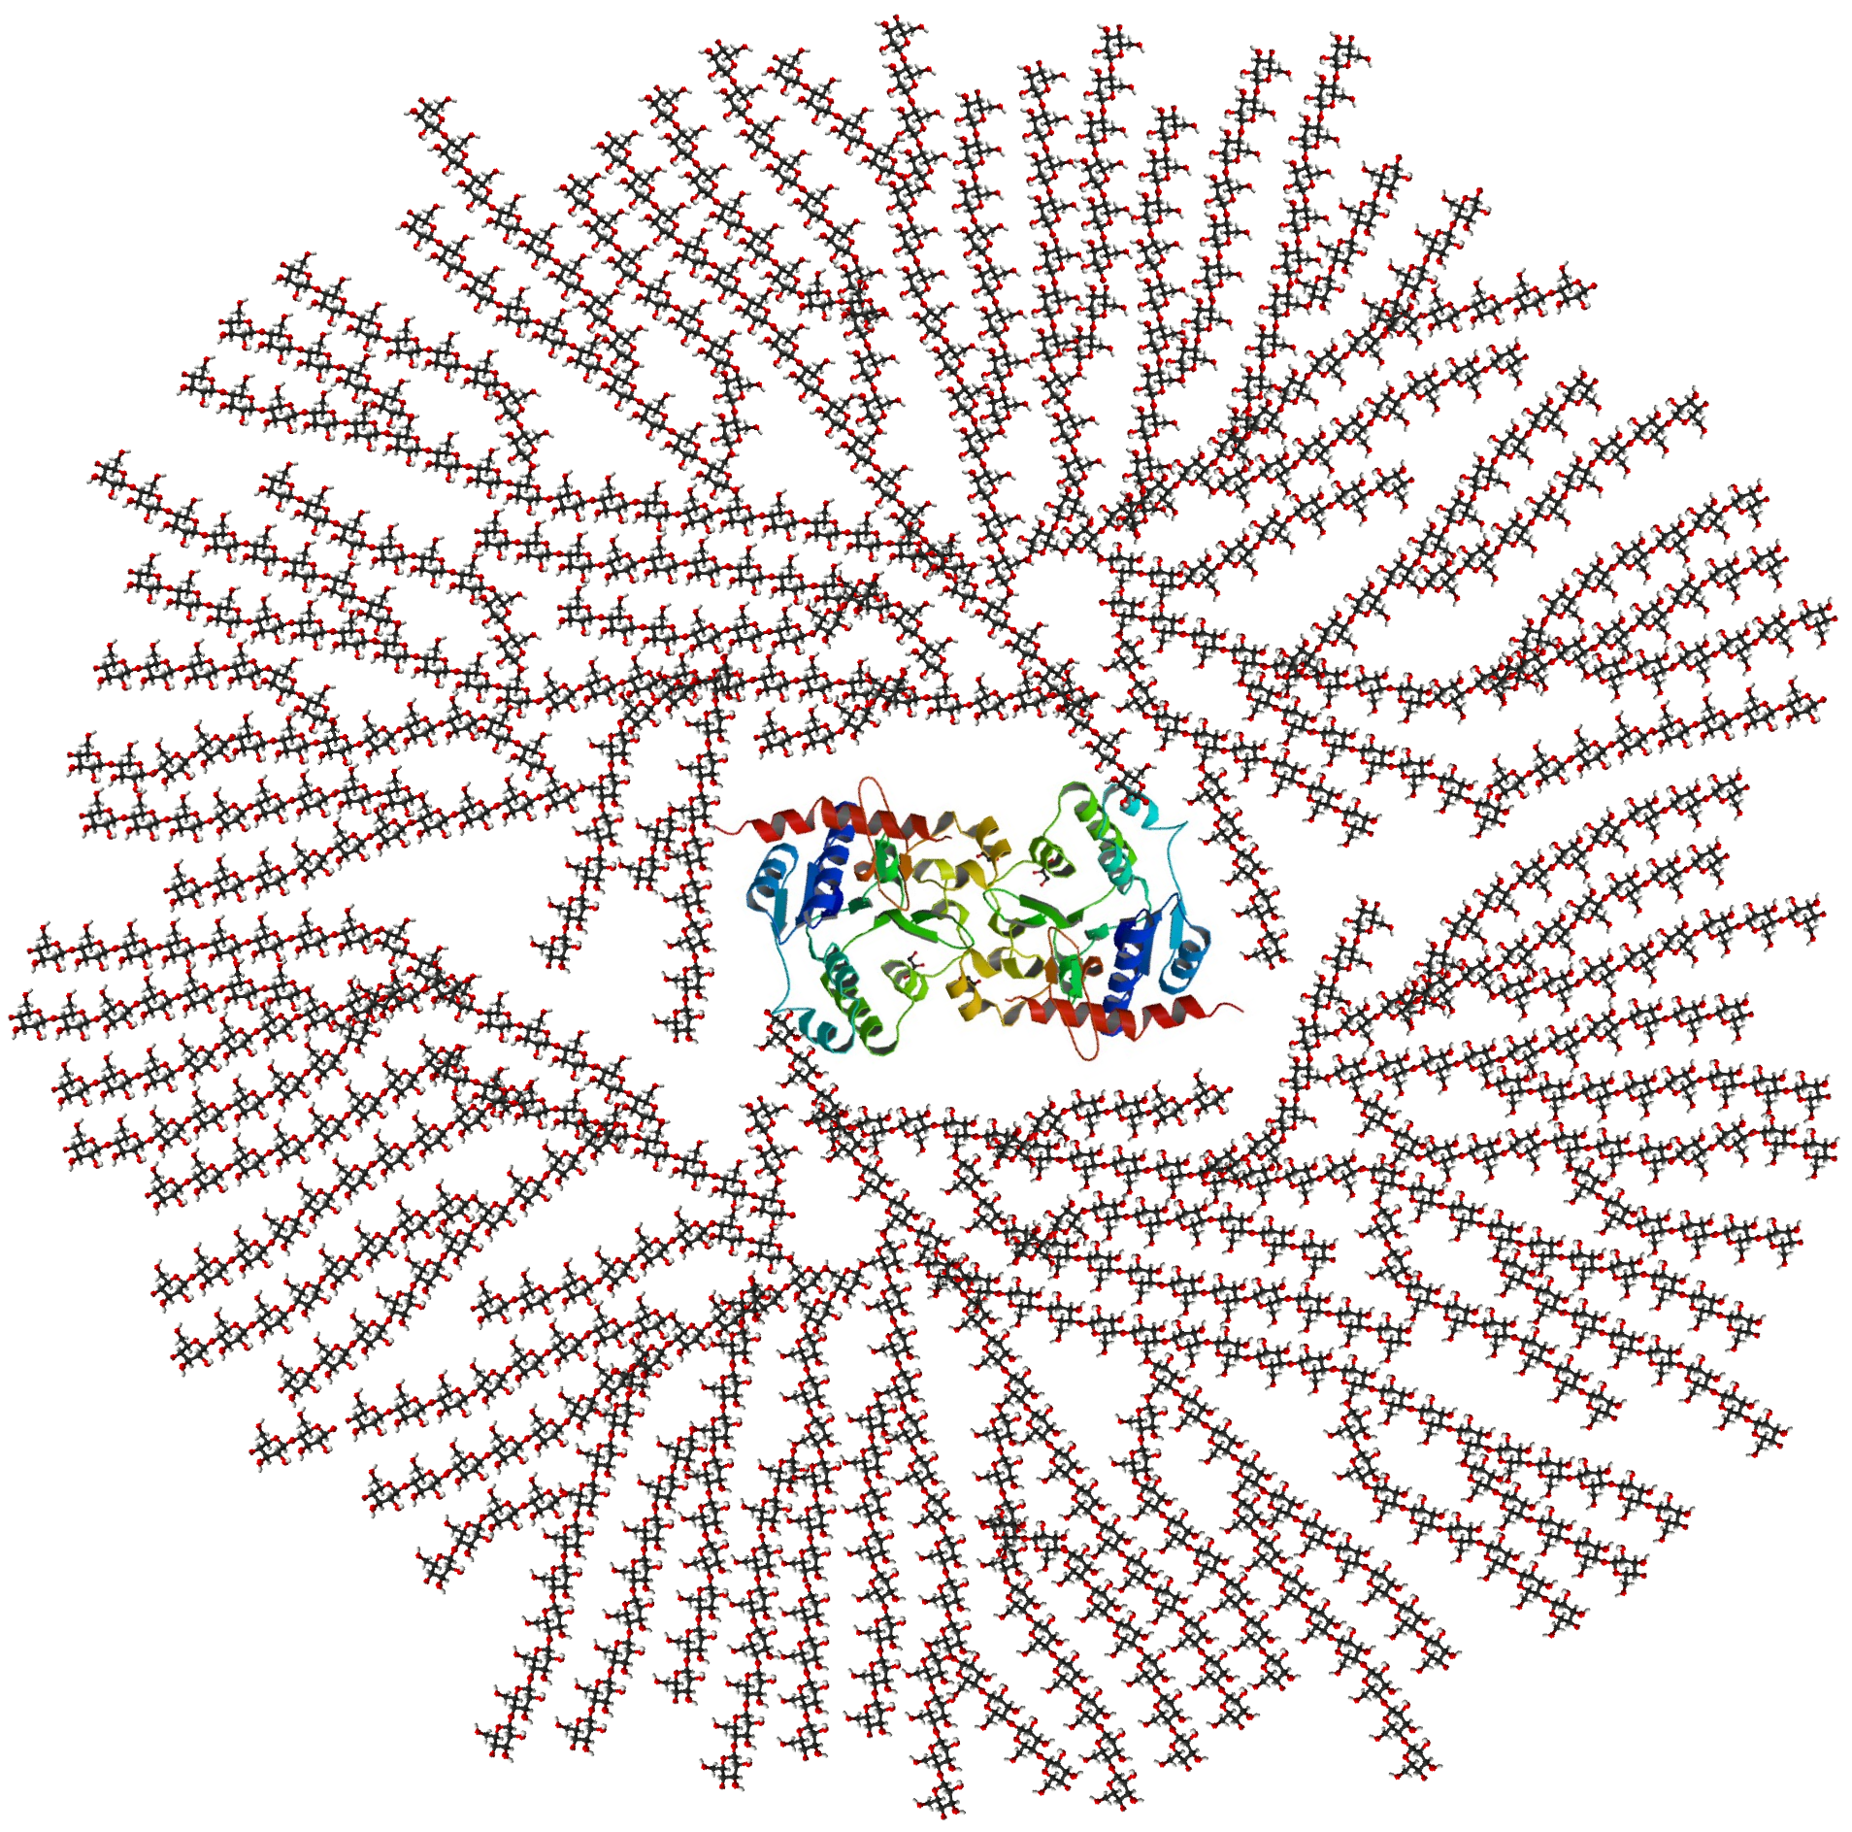

Food for Thought

Although muscle tissue contains significantly more stored glycogen than the liver, this glycogen is not available to help preserve blood glucose during times when blood sugar levels decrease. This is because muscles cells, unlike liver cells, lack a specific enzyme called glucose 6-phosphatase, which helps create a free glucose molecule from glucose 6-phosphate, a compound that is formed when stored glycogen is broken down for energy (Buczkowska & Dworzecki, 2003).

Carbohydrates are found in three distinct locations within the body. A small amount of glucose located in the blood is needed for distribution to all parts of the body (e.g., brain and central nervous system, which both prefer glucose as a fuel). A moderate amount of glycogen is stored in the liver, which is needed to preserve blood sugar. Lastly, large quantities of glycogen are stored in muscle tissue, which serve to fuel muscular work. What about the heart and other organs? An important distinguishing factor between liver and muscle glycogen is the fact that the liver is the only organ that can release glucose into the blood. Once glycogen is formed in a muscle cell, it is trapped and cannot be released into circulation. This concept has important implication in normal metabolism, fasting states, and during exercise.

Normal carbohydrate storage in muscle cells is approximately 15 grams per kilogram (6.8 g/lb.) of muscle tissue (Jensen et al., 2011). Considering how muscle comprises approximately 30% of a woman's mass and close to 40% of a man's mass, this averages somewhere between 250 and 600 grams (1,000 to 2,400 kcal) in muscle tissue (Janssen et al., 2000). Liver cells store approximately 50 grams per kilogram (22.7g/lb.) of tissue, and, considering how the liver weighs approximately 1.5 to 2.5 kg, this totals about 75 to 125 grams (300 to 500 kcal) (Jensen et al., 2011).

By comparison, blood glucose stores are small, ranging between 3 to 5 grams in a small adult, to about 10 to 15 grams in a very-large male. The average adult stores around 2,000 to 2,500 kcal, whereas an endurance athlete can expand their storage capacity to over 3,000 kcal. It is estimated that an average adult will burn about 100 kcal/mile (1.6 km); therefore, the amount of glycogen stores in the body would cover about 20 miles (32 km). See Figure: Locations of Carbohydrates in the Body for a graphical representation of carbohydrates in the body.

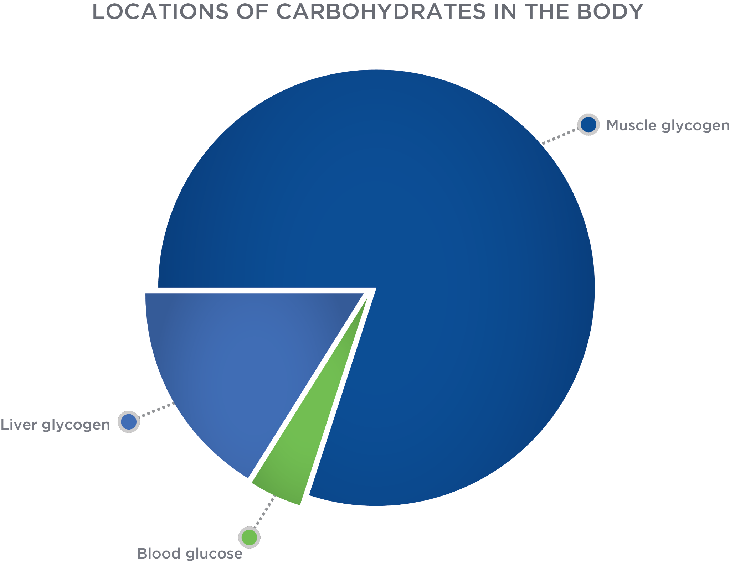

### Summary of carbohydrate classifications

Carbohydrates follow a sequential classification system derived from the number of sugar units contained within the structure or chain. Although humans may ingest a variety of different carbohydrates (e.g., starches and sugars), the digestive process breaks them down into their individual building blocks (called monosaccharides), which represent the only absorbable form of carbohydrates to the body. As a review, Figure: Overview of Carbohydrate Form and Structure summarises all the different sugar unit forms along with key characteristics of each.

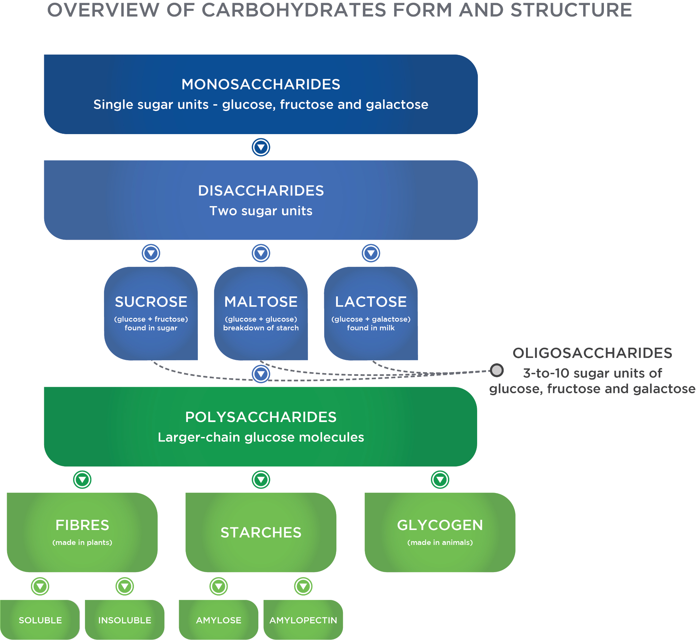

### Carbohydrate roles within the body

The primary role of dietary carbohydrates is to provide energy for the body. Any excess carbohydrates not used for immediate energy production can be stored as glycogen within the muscle and liver. Because the liver is capable of releasing glucose into circulation, it helps regulate blood glucose and insulin metabolism, which helps avoid or manage diseases like diabetes and metabolic syndrome. Should there be additional carbohydrates, it is possible for this excess (i.e. beyond what the body can store as glycogen) to be converted to fats called triglycerides. Given this effect, carbohydrates could play a minor role in indirectly regulating some fat production. Furthermore, balanced levels of glucose and insulin also assist with regulating circulating levels of other hormones like testosterone and the thyroid hormones.

“The presence of adequate amounts of carbohydrates can spare the body’s need to catabolise (break down) muscle tissue.”

The physiological pathway of fat metabolism involves a carbohydrate by-product for complete metabolism. When insufficient quantities of this specific carbohydrate byproduct exist, the partially degraded fat fragments are converted to ketones and metabolized differently. In situations of inadequate carbohydrates, the body can produce glucose from certain non-carbohydrate sources, including specific amino acids (via gluconeogenesis) that are almost exclusively derived from muscle tissue. Therefore, the presence of adequate amounts of carbohydrates can spare the body’s need to catabolise (break down) muscle tissue. The body can also make glucose from fatty acids, if needed, particularly when consuming a high-fat, very-low carbohydrate diet (Musa-Veloso et al., 2006; Beisswenger et al., 2005). Remember, the brain requires glucose to function and will ultimately do whatever is needed to function; in this case, it makes glucose from non-glucose sources.

Lastly, as mentioned earlier, soluble and insoluble fibres provide many health benefits ranging from enhanced rates of weight loss and reduced cholesterol, to enhanced digestive health and reduced risks of developing cancer (Dahl et al., 2017).

**Carbohydrate digestion and absorption**

Carbohydrate digestion begins in the mouth because of salivary amylase, an enzyme released by the salivary glands. Salivary amylase starts the digestive process by cleaving large-chain polysaccharides into smaller segments. The physical process of chewing food and adding fluid volume (i.e., saliva) to solid food facilitates digestion by increasing its surface area. In simpler terms, an individual’s own saliva along with chewing helps break down carbohydrates. It also facilities the action of swallowing food to pass it to the stomach. This small, rounded mass of food that is swallowed is known as bolus.

In the stomach, food mixes with gastric juices and the high acidity of stomach contents continue the digestive process. However, on leaving the stomach and entering the duodenum of the small intestine, this chyme is neutralised by sodium bicarbonate released from the pancreas, so that pancreatic amylase can continue the digestion of carbohydrates in the jejunum (Infographic: Carbohydrate Digestion and Absorption).

In the jejunum, the digestible carbohydrates are further broken down to disaccharide and monosaccharide forms, which then move to the latter portion of the small intestine, the ileum, where most carbohydrates absorption occurs. While the monosaccharides are in their absorbable form, the disaccharides still need to undergo further digestion to single sugar units, which takes place within the brush border of the intestinal wall. The walls of the small intestine contain many finger-like projections called villi, each with even smaller projections called microvilli that collectively increase the region’s surface area to enhance nutrient absorption. The absorptive cells within the brush border release specific enzymes to digest any remaining disaccharides to their monosaccharide form.

Getting Technical

Some individuals are lactose intolerant, implying that they are unable to digest lactose, or milk sugar, due to a lactase deficiency or insufficiency. Because of the body’s inability to digest lactose, the intestinal bacteria digest this carbohydrate, resulting in bloating, diarrhoea, gas, nausea, and pain in the abdomen. A primary cause of lactose intolerance is genetic inheritance. Certain ethnicities such as non-Hispanic Blacks, Native Americans, Asians, and Hispanics/Latinos are more prone to this condition than Caucasians. In some individuals, the small intestine begins to make less lactase after infancy and continues to decrease with age, a condition called lactase non-persistence. Symptoms associated with this lactose intolerance may not begin until later in childhood, the teenage years, or even until adulthood (National Institute of Diabetes and Digestive and Kidney Diseases, 2018). Individuals who are lactose intolerant can opt to avoid dairy products, consume lactose-free dairy products, or take a tablet containing the lactase enzyme before ingesting any dairy.

Once all digestion is complete, the monosaccharides are then absorbed by the absorptive cells into the intestinal wall. Glucose and galactose, however, are absorbed via a different process than fructose. This process results in glucose and galactose being absorbed into the body at a faster rate than fructose.

Once absorbed, all monosaccharides enter the hepatic portal vein for transportation to the liver. Priority number one for carbohydrates is to serve as an immediate fuel, so glucose or fructose can be used by the liver or pass into circulation for delivery to any target cell. Because galactose only contributes marginally to overall carbohydrate intake, it will not be discussed. Glucose feeds directly into the energy pathways, while only about 35 to 45% of the absorbed fructose is oxidised in the energy pathways (Sun & Empie, 2012).

When the immediate fuel needs are met, priority two for the surplus of carbohydrates (i.e., glucose or fructose) is to replenish liver and muscle glycogen. Glucose molecules combine to build larger glycogen chains, whereas approximately 40 to 50% of the fructose taken into the cell becomes converted to glucose for glycogen synthesis. Interestingly, while the body’s absorbed fructose is either oxidised or converted to glucose, the balance is converted to either lactate (about 30%) or to triglycerides (fats) (<1%). While the conversion to triglycerides is small, it has raised health concerns, especially with the liver. A prevailing belief involving fructose accumulation in the liver is its conversion to fat that becomes stored within this organ. A significant collection of fats in the liver can damage liver cells, much like what happens with the disease cirrhosis.

This disease is called non-alcoholic fatty liver disease (NAFLD), a condition demonstrating greater significance in inactive people who consume large amounts of fructose (and overall energy) in their diet (Chowdhury et al., 2016). Livesey and Taylor (2008) examined the level of fructose required to cause issues with the liver, including fat deposition. Fructose intakes need to be consumed in quantities over 100 grams (3.5 ounces) a day for there to be any measurable detriment to human health. In juxtaposition to this, the average American consumes roughly 55 grams (1.94 ounces) of fructose per day, so just under half of what is considered a problematic intake. So, all the data points toward excess energy intake, not fructose per se, are the leading cause of NAFLD.

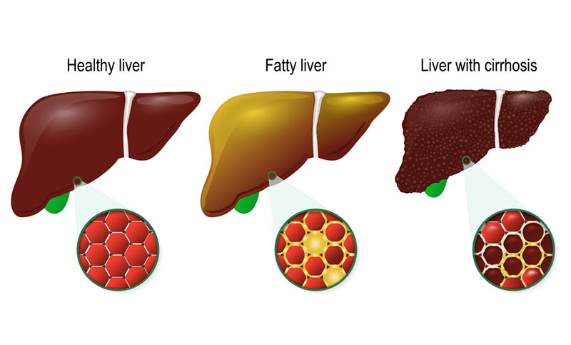

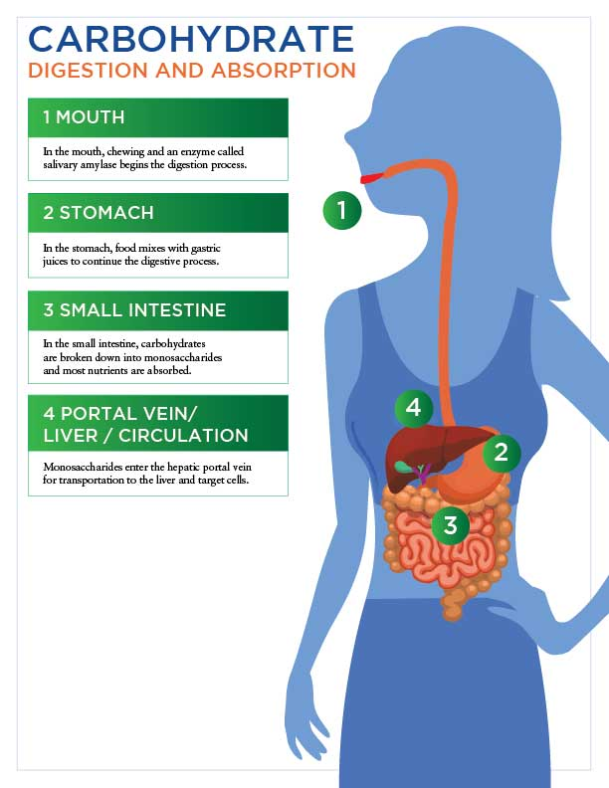

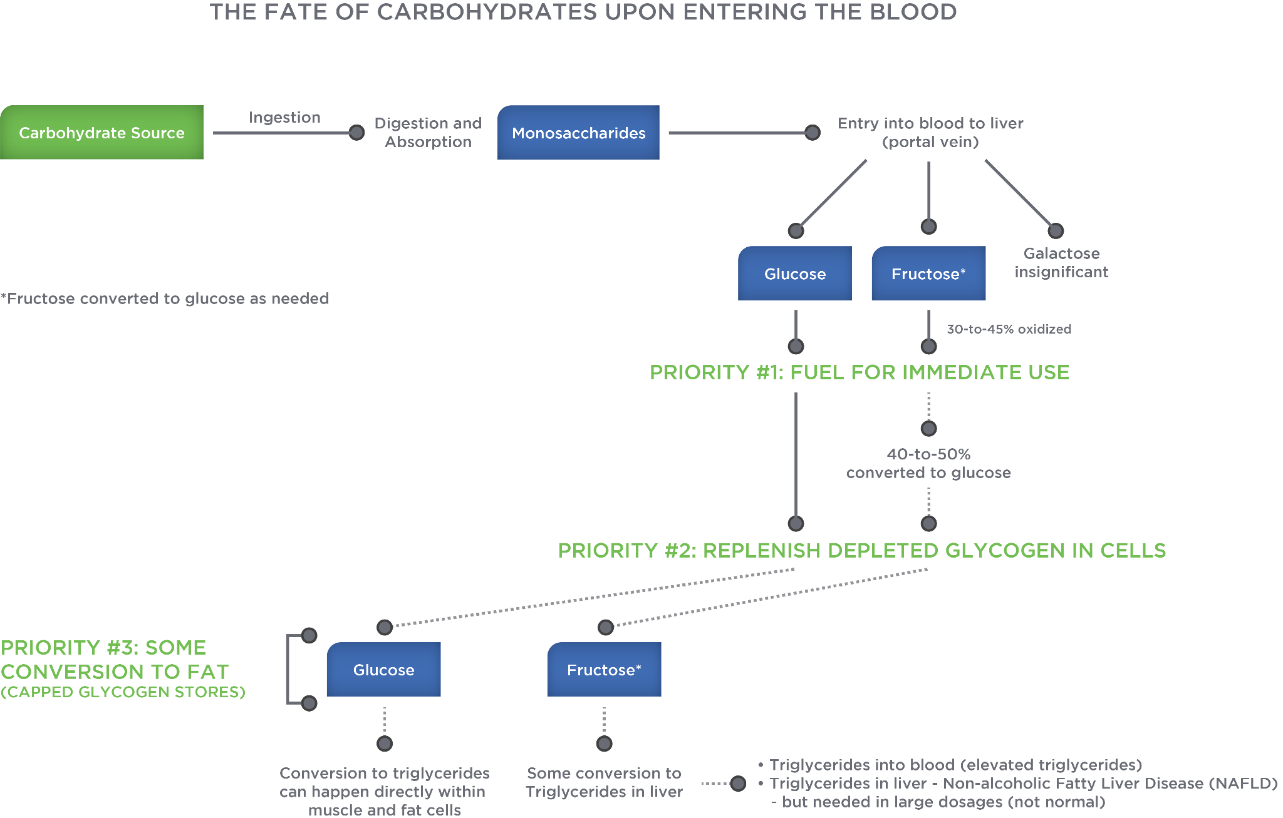

### Hormonal regulation of glucose

Two primary hormones, insulin and glucagon, are responsible for preserving blood glucose.

* Insulin is a hormone released from the pancreas. Although insulin has many important physiological roles in the body with respect to carbohydrates, it serves to lower blood sugar levels and prevent hyperglycaemia by facilitating glucose uptake into the liver, muscle and fat cells (for lipogenesis or fat building). In other words, insulin escorts glucose in the blood to the liver, muscle, and fat cells. In the liver cell, it inhibits the release of glucose into circulation. In cells, it promotes glycogenesis and inhibits gluconeogenesis. It is also involved in amino acids and fatty acid uptake into cells.
* Glucagon is a hormone also released from the pancreas. Its functions are essentially the opposite of insulin. It serves to raise blood sugar levels during periods of hypoglycaemia by facilitating glucose release from the liver into circulation. In other words, glucagon is the hormone responsible for telling the liver to release glucose into the bloodstream. It promotes glycogenolysis and gluconeogenesis, and it also inhibits lipogenesis.

**At rest**

The mechanism by which insulin works to move glucose into a cell involves a secondary messenger because insulin cannot physically enter a cell. Insulin is protein based and cell membranes are fat-based, essentially repelling anything that is water soluble, like protein. Therefore, insulin, acting like a key, binds to specialised receptors, acting like locks that are embedded within the cell membrane. This hormone-receptor complex activates pathways inside the cell (i.e., secondary messengers) that open special channels to allow for the entry of glucose into the cell. This functionality, however, is largely dependent on the availability of adequate amounts of insulin and the sensitivity of the receptors to recognise insulin.

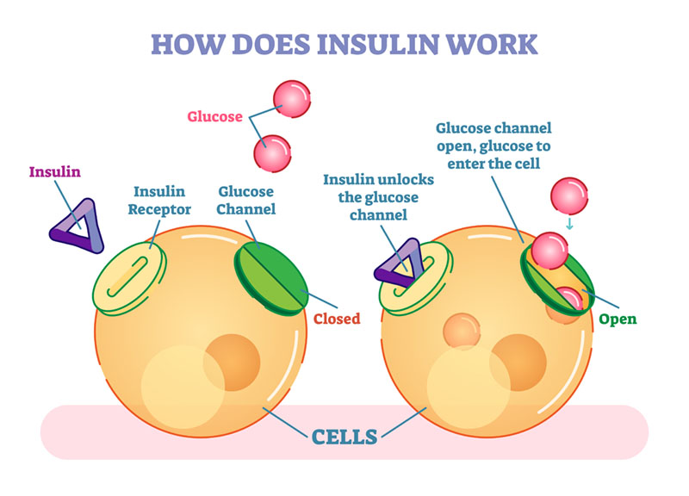

In a healthy body, glucose in circulation enters the pancreas and stimulates those beta-cells to release insulin. Once in circulation, insulin will push excess glucose into cells and restore normal blood sugar levels. The liver (primarily) and kidneys collectively start to absorb insulin out of circulation and break it down to stop blood sugar levels from dropping too low. Anytime an individual enters states of hypoglycaemia, glucagon is released from the pancreas and travels to the liver, where it releases stored glycogen to restore normal blood sugar levels (Katch et al., 2015).

Insulin production is dependent on the biological status of those beta-cells in the pancreas. In some individuals, these cells may stop producing insulin, perhaps due to some genetic variant or an autoimmune response. In this case, the individual relies on exogenous insulin from a pump or injection, and is diagnosed with Type 1 diabetes. Insulin’s ability to function at the cellular level depends on the receptors ability to recognise the hormone (i.e., receptor sensitivity). A physically inactive lifestyle, coupled with overconsumption of energy (e.g., too many calories), can ultimately decrease receptor sensitivity to insulin, leading to insulin resistance, and, ultimately, Type 2 diabetes. In fact, Type 2 diabetes represents about 90% of all diabetes cases throughout the world.

Two of the most important therapeutic modalities for Type 2 diabetics are weight loss, if necessary, and regular participation in physical activity because it resensitises the cell receptors. In fact, weight loss equivalent to 10% of overall body weight is enough to substantially reduce the risk of developing Type 2 diabetes, and among people with Type 2 diabetes, similar weight loss dramatically improves the disease.

**During exercise**

During exercise, hormonal regulation of blood sugar becomes a little more complex. The presence of exercising hormones like norepinephrine and epinephrine (adrenaline) in circulation bind to receptors in the pancreas to inhibit much of the production of insulin. This occurs because exercise is a catabolic event that relies on the release of stored energy to use for work, and insulin is an anabolic hormone that normally functions to build energy stores and prevents their breakdown or release. In other words, exercise and circulating insulin are not events that can or should happen simultaneously.

Getting Technical

If insulin is suppressed during exercise, yet needed to move glucose into cells, then why do individuals ingest carbohydrates (e.g., drinks or food) during exercise?

As discussed, certain cells like muscle, liver, and fat cells rely on that insulin-mediated glucose uptake (IMGU) pathway for moving nutrients into the cell during resting conditions, but when insulin production and release is suppressed (i.e., during exercise), these cells rely on a second, non-insulin mediated glucose uptake (NIMGU) pathway to help move glucose into the cell. During exercise, this pathway can increase glucose uptake rates into the cell significantly (i.e., more than the IMGU pathway), which can lower blood sugar levels if it is not carefully managed.

During exercise, epinephrine, norepinephrine and glucagon levels all increase to stimulate glycogenolysis and glucose release from the liver into the blood. But accelerated glucose uptake into muscle cells can pose a major problem if blood glucose levels drop too much. Remember, red blood cells can only use glucose as a fuel and they rely exclusively on blood glucose as that fuel. Cortisol is tasked with preserving both blood sugar and liver glycogen, considering how the liver is the only organ that can release glucose into circulation. Under scenarios of prolonged exercise, glycogen depletion, or carbohydrate or caloric restriction, cortisol levels elevate to preserve liver glycogen, which, in turn, preserves blood sugar. Cortisol stimulates lipolysis to slow carbohydrate utilisation rates, but it also strives to produce much-needed glucose via gluconeogenesis. It derives its substrate for conversion from various sources, but primarily from amino acids that originated as muscle tissue, or from protein food sources, if they are ingested around the same time the glucose manufacture occurs (e.g., during exercise) (Kenney et al., 2015).

### Glycaemic index

It was previously discussed how excessive energy intake can elevate insulin, which can desensitise insulin receptors embedded within the cell membranes, and how this advances the potential for insulin resistance, pre-diabetes, or perhaps even Type 2 diabetes. But, do all carbohydrates exact the same toll on the body by virtue of their insulin response? The answer is no. To help understand the uniquely different effects of each carbohydrate source, one needs to understand the concept of glycaemic index.

The glycaemic index (GI score) is a relative ranking of a food’s effect on blood glucose (blood sugar) 2 hours after the consumption of that food. The scoring index assigns a value of 100 to represent glucose, the reference food for this ranking system. A score of 50 would essentially reflect a food that elevates blood sugar at half the rate of glucose. Low GI foods are classified as foods with scores under 55, medium GI foods are classified as foods with scores between 56 and 69, and high GI foods are classified as foods with scores above 69 (Pennington & Sprungen, 2009).

There are some key observations to note:

* Not all simple sugars have high GI scores (e.g. fructose or sucrose). Fructose is absorbed more slowly and needs conversion to glucose in the liver. This subsequently lowers its GI score.
* Not all complex carbohydrates have low GI scores (e.g. instant rice, instant mashed potatoes or cornflakes). Removing fibre can increase a food’s GI score.

Glycaemic Index Scores of Common Carbohydrate Foods

| **Food** | **GI Score** | **Food** | **GI Score** |
| --- | --- | --- | --- |
| Glucose | 100 | Hamburger bun | 61 |
| Baguette (white, plain) | 95 | Raisin Bran® cereal | 61 |
| Hard Candy | 90–100 | Sweet potato | 60 |
| Baby carrots | 92 | Honey | 55 |
| Rice (instant) | 91 | Snickers® Bar | 55 |
| Gatorade® (U.S. formula) | 89 | Oatmeal (steel cut) | 55 |
| Potato (instant, mashed) | 87 | Tortilla (corn) | 52 |
| Pretzels | 83 | Quinoa | 53 |
| White potato (boiled) | 82 | Orange juice, Oranges | 50 |
| Cornflakes cereal | 81 | Brown rice (steamed) | 50–55 |
| Oatmeal (instant) | 79 | Banana | 30–55 |
| Donut (plain) | 75 | Carrots | 47 |
| French fries | 75 | Sponge cake (plain) | 46 |
| Graham crackers | 74 | Chicken nuggets (frozen) | 46 |
| Soda crackers | 74 | Peach | 42 |
| Cream of Wheat® (instant) | 74 | Spaghetti | 42 |
| Corn chips | 72 | Apple juice | 41 |
| White rice (boiled) | 72 | Baked beans | 40 |
| Saltine crackers | 70 | Strawberries | 40 |
| White bread | 70 | Apple | 36 |
| Watermelon | 70-80 | Kidney beans | 34 |
| Bread (whole wheat) | 69 | Milk (all varieties) | 31 |
| Special K® cereal (U.S. formula) | 69 | Tortilla (wheat) | 30 |
| Popcorn (microwave) | 65 | Grapefruit | 25 |
| Sucrose (sugar) | 65 | Fructose | 18 |
| Macaroni and cheese | 64 | Peanuts | 13 |
| White rice | 64 | Agave | 11 |
| Raisins | 64 | Hummus | 6 |
| Cola | 63 | Sugar alcohols (non-caloric sweetener) | 3 |

As illustrated, the GI score ranking is not as simple as distinguishing simple from complex carbohydrates. Many factors can affect a food’s GI score. Examples include the following:

* Monosaccharide form — glucose versus fructose
* Polysaccharide form — amylopectin versus amylose
* Food form (liquid versus solid) — Foods leaving the stomach generally have a semi-liquid, gooey consistency (e.g. like cream of wheat). Solid foods will, therefore, remain in the stomach longer until they reach that consistency. However, semi-liquid (smoothies or pulp) or liquid forms of food (juicing) empty the stomach much faster.
* Degree of processing and cooking — This alters GI scores in both directions. Separating nutrients from fibre during cooking (boiling) can raise GI scores while making starch more resistant via repeated heating or cooking can lower GI scores (e.g., reheating pizza where it becomes rubber-like).
* Presence of other nutrients (e.g. fibre, protein or fats) — This slows gastric emptying and digestion, which lower the food’s GI score.
* Human variability in digestion and absorption

All being said, there are many limitations to implementing GI in practice because most people rarely eat many of these foods alone and instead enjoy a mixed meal (e.g., peanut on bread or milk with oats). Furthermore, considering how GI demonstrates varied responses among people, and how it has limited clinical applicability as a stand-alone score for a single food, it should be used with caution.

Another consideration overlooked with GI scores relates to the quantity of a carbohydrate food consumed, which can influence blood sugar responses. While GI scores rank the effect of a carbohydrate sample on raising blood glucose, glycaemic load (GL) also considers the quantity of the food consumed. Because both GI and the amount of the carbohydrates consumed influence overall blood sugar responses, consideration of their collective impact should theoretically provide a better estimate of how much insulin might be needed to correct a blood sugar response.

As an example, examine baby carrots, which have a GI score of approximately 92 versus corn which has a GI score of approximately 60. If examined alone, logic dictates that carrots would require more insulin to correct. However, if only six grams of carrots were eaten, but 20 grams of corn was eaten, the amount of insulin needed for corn might be greater. A method for calculating GL exists, but there is no universal consensus among experts on the validity and significance of calculating numerical GL scores.

Recent evidence has also come out to suggest that both the GI and GL may not be overly reliable. In a recent study, it was demonstrated that each person has a substantially different response to the same foods. For example, in this study, giving two different people a slice of bread yielded completely different glycaemic responses. One person had a very large spike in blood glucose, while the other person had virtually no spike in blood glucose. The same thing occurred when they fed different people ice cream (Zeevi et al., 2015). This suggests that while GI and GL may help us better understand foods, they may not be overly robust tools to use for every client.

### Current versus recommended intakes

The recommended dietary allowance (RDA) for carbohydrates for adults aged 19 years and older is set at 130 grams per day (U.S. Department of Health and Human Services, U.S. Department of Agriculture, 2015). Generally, this is considered the minimum amount needed to maintain normal metabolism and utilisation of fuels. However, the Acceptable Macronutrient Distribution Range (AMDR) for carbohydrates is set at 45 to 65% of the total caloric intake daily, which might be at least double the RDA.

This means that if a person was consuming 2,400 calories daily, carbohydrates should represent 1,080 to 1,560 calories of that total (45 to 65%). Considering how four calories equals one gram of carbohydrates, this would amount to 270 to 390 grams a day, values that far exceed the minimal RDA. This demonstrates the confusion with having and following multiple guidelines, because 130 grams and over 270 grams represent a significant differential in calories.

**Current intakes**

Although the average intake of carbohydrates in the American diet represents approximately 47.4% and 49.6% of total calories for men and women, respectively (U.S. Department of Health and Human Services, 2017), it is the absolute or total amount of food ingested that is too high, representing a surplus of calories in our diets. One could also argue that perhaps the choice of carbohydrates many consume are less than desirable. One major concern is the excessive amount of sugar consumed, which is approximated by the United States Department of Agriculture (USDA) to be between 150 to 170 pounds of refined sugars per adult per year, an estimate that has increased by 39% since 1950. This is equivalent to approximately 1,800 cans of 12 oz. (355 mL) of soft drink per year. In fact, the United States consumes more sugar than any other country in the world. The largest sources of sugar intake represent those found in beverages, excluding milk and juices, and snacks and sweets (Figure: Sources of Sugar Intake in U.S. Diet) (U.S. Department of Health and Human Services, 2017).

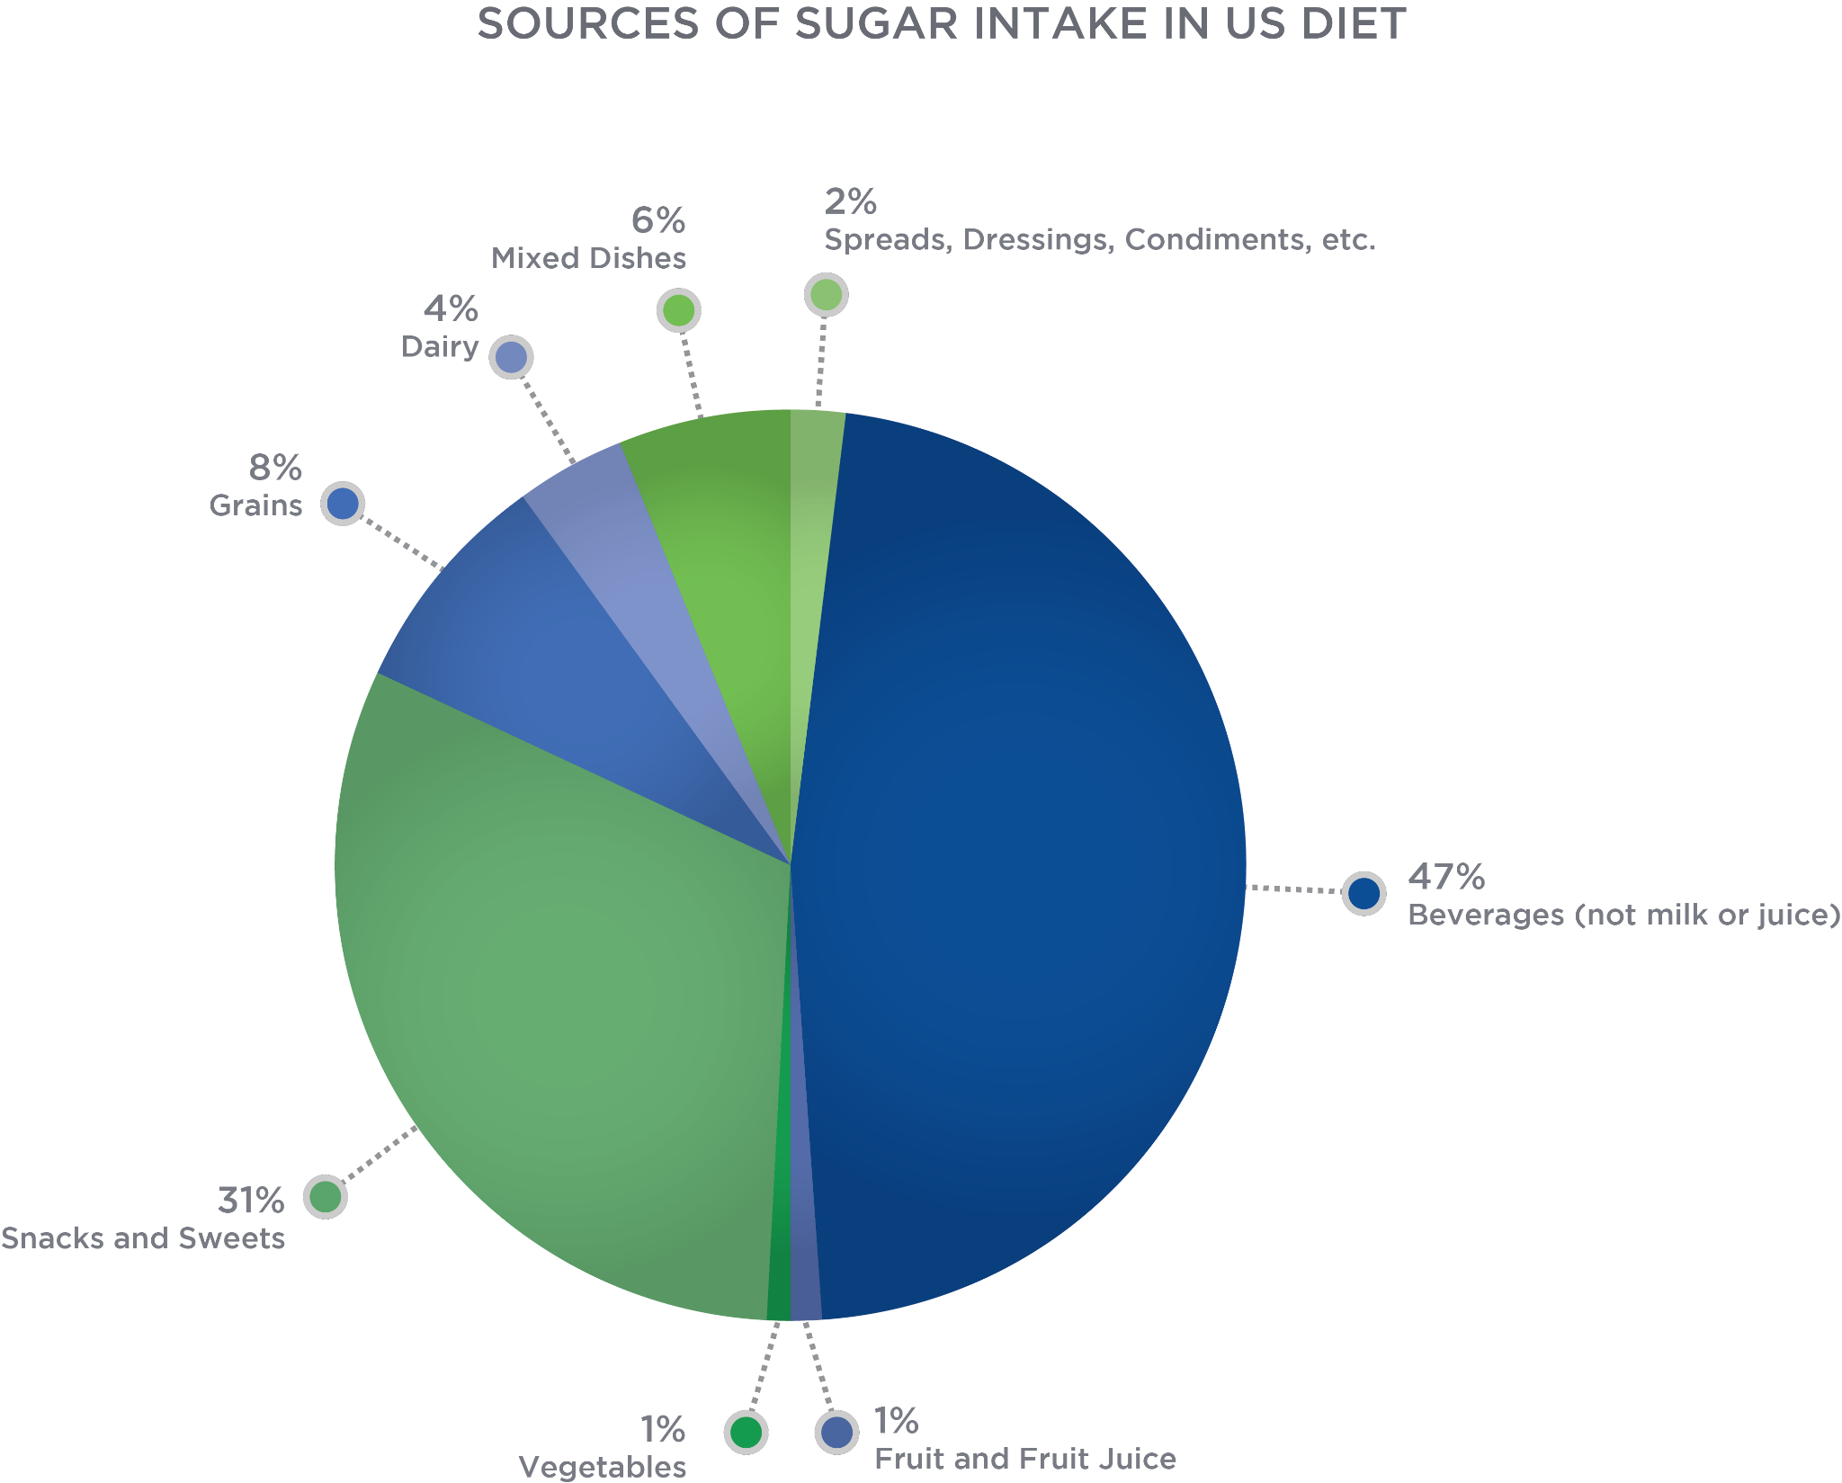

When examining sugar intake and the current dietary guidelines, it is important to first distinguish total sugar from added sugar. Added sugars represent all sugars derived from food sources that *exclude* those sugars found naturally in fruits and dairy. Although these naturally occurring sugars represent healthier options given the presence of the other nutrients (e.g., vitamins and minerals), excessive intake of these foods can also increase the risk for diabetes in the same manner as added sugars (Imamura et al., 2015).

As illustrated in the Table: Sugar Consumption in the United States, the overall goal for healthy eating is to reduce the total percentage of added sugars from 13% to under 10% of total caloric intake (i.e. no more than 12 added teaspoons) (U.S. Department of Health and Human Services, U.S. Department of Agriculture, 2015). The American Heart Association (AHA) and Center for Science in the Public Interest (CSPI) make more conservative recommendations, suggesting the following:

* AHA – limit of 6 added teaspoons (women) and 9 added teaspoons (men) (AHA, 2016)
* CSPI – limit 100 kcal or 6 ½ teaspoons (women) and 150 kcal or 9 ½ teaspoons (men) (CSPI, 2015)

Sugar Consumption in the United States

|  | **Current Intake** | **Recommended Intake** |
| --- | --- | --- |
| Added Sugar Intake | 13% of total caloric intake  (22 to 28 teaspoons per day) | < 10% of total caloric intake  (≤ 12 teaspoons of added sugar) |

Source: Johnson et al., 2009

The World Health Organisation (WHO) issued a guideline in 2015 recommending that adults and children reduce their daily intake of added sugar to under 10% of total kcal. WHO also suggested that additional benefits are attained by further reducing that intake to under 5% or about 25 grams / 0.88 ounces (6 teaspoons).

The following tables list the quantities of sugar between various beverages and juices; between juices, blended fruits, and juicing; and between sweets and food bars. Consider how similar the quantities of sugar between each are, although perceptions of one versus the other are hugely different (i.e., healthy versus unhealthy). Furthermore, examine the caloric density differences between a 12-ounce serving of fresh juice, blended fruit, and juicing. Juicing simply adds a greater density of sugar because of the quantity of fruits and/or vegetables needed to make juice (1 piece of fruit = 4 oz of juice or about 120 mL) eliminates the fibre.

Quantities of Sugar in Common Beverages

| **12 oz. (355 mL) Serving** | **Kcal** | **Sugar** |
| --- | --- | --- |
| Coke® | 140 | 39g |
| Pepsi® | 150 | 41g |
| Minute Maid® (apple juice) | 170 | 39g |

Sugar and Calorie Density of Juices

| **12 oz. (355 mL) Serving** | **Kcal** | **Sugar** |
| --- | --- | --- |
| Fresh Juice (with pulp) | 180 | 45g |
| Blended Juice | 215 | 54g |
| Juicer | 250 | 64g |

Quantities of Added Sugar in Candy and Food Bars

|  | **Kcal** | **Sugar** |
| --- | --- | --- |
| Starburst® | 240 | 33g |
| Snickers® | 250 | 27g |
| Luna® (lemon) | 190 | 9g |
| Clif® Bar | 250 | 22g |
| Bloks® Chews | 200 (6) | 24g |
| Clif Shot® Gel | 200 (2 x 1.2 oz.) | 24g |

**Current recommendations**

To recap, the current recommended dietary allowance (RDA) for carbohydrates for adults aged 19 years and older is set at 130 grams per day. According to the Acceptable Macronutrient Distribution Range, developed by the Institute of Medicine, the contribution of carbohydrates should equal 45 to 65% of the total caloric intake. Added sugars should represent less than 10% of total caloric intake, which is equivalent to no more than 12 added teaspoons of sugar daily.

The typical western diet is generally low in fibre, likely due to the limited amount of fruit and vegetables in the diet and the amount of processed starches consumed. U.S adults average between 12 to 18 grams of total fibre per day, falling short of the recommended 28 grams per day for women and 35 grams per day for men. A summary of many of these recommendations are outlined in Table: Current Carbohydrate Recommendations.

Current Carbohydrate Recommendations

| **Organization** | **Recommendations** |
| --- | --- |
| United States Department of Agriculture (USDA) | Total carbohydrates should range between 45 and 65% of total calories.  Limit added sugar to less than 10% of total caloric intake with no more than 12 teaspoons of added sugar per day.  Fiber: 14 grams per 1,000 calories (28 grams per day for women and 35 grams per day for men) |
| World Health Organization (WHO) | Reduce free sugar daily intake under 10% of total kcal, with additional benefits attained by reducing intake to under 5% or about 25 grams (6 teaspoons). |
| American Heart Association (AHA) | Limit added sugar to 9 teaspoons (150 calories) a day for men.  Limit added sugar to 6 teaspoons (100 calories) a day for women. |
| Center for Science in the Public Interest (CPSI) | Limit added sugars to 150 calories (9 ½ teaspoons) for men.  Limit added sugars to 100 calories (6 ½ teaspoons) for women. |

The 2015–2020 dietary guidelines make recommendations for each food group based on cup or ounce equivalents. As far as first impressions go, this might seem simple and logical, but the challenge lies in recalling exactly what portion sizes from each food group qualify as ½ or 1 cup or ounce equivalents. The recommended equivalents for the carbohydrate food sources (i.e., fruits, vegetables, dairy, and grains) for adults are illustrated in the following infographics.

Try This

How would you address the following scenarios?

1. A client believes that by purchasing brown sugar rather than white sugar, she is making a healthier choice, although it is 15% more expensive.
2. She decides to substitute fruit-flavoured beverages in place of regular sodas to improve her health, although both contain about 40 grams of sugar per serving.
3. She needs to fuel her muscles as quickly as possible and is undecided between a product with high amounts of fructose versus one with high amounts of glucose. Which might replenish her energy faster?

Talking Points

1. Recall that your body does not know, nor care about the source of sugar. Brown sugar and white sugar are both added sugar.
2. Recall that while fruit juice may have small amounts of nutrition (e.g. fibre, vitamins and minerals), fruit-flavoured beverages generally do not. These products are not drastically different and there are better choices to hydrate.
3. Recall that glucose is absorbed earlier and faster into the body.

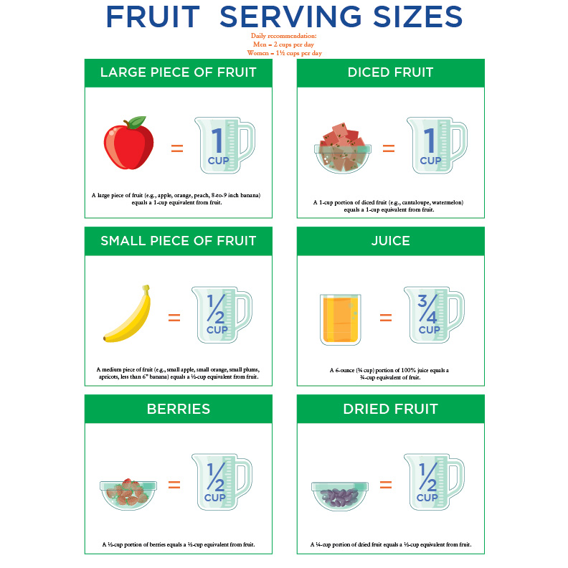

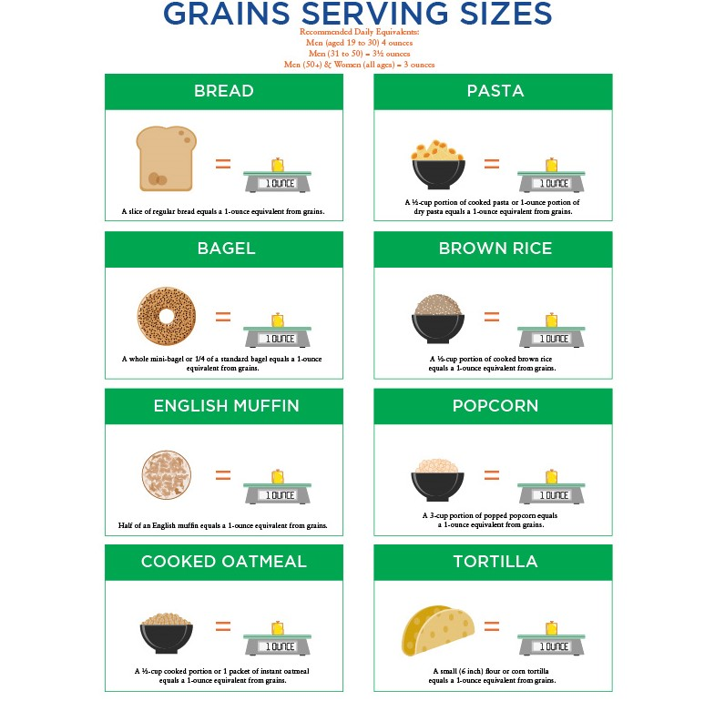

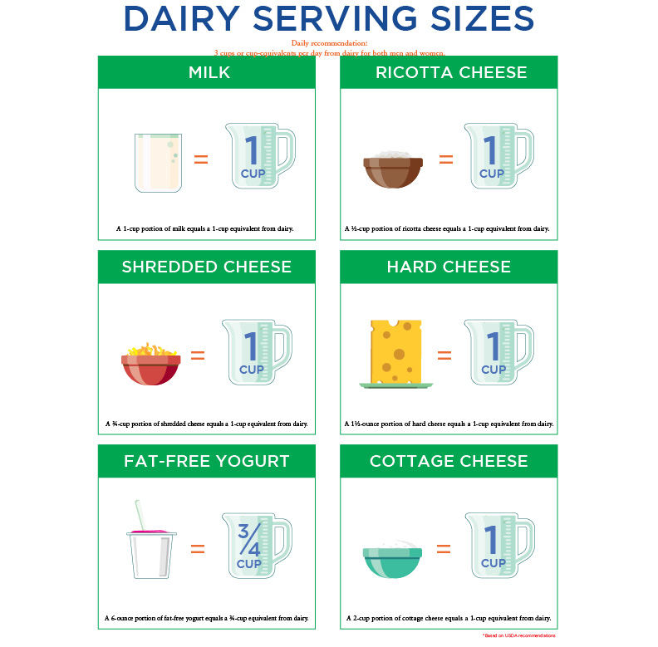

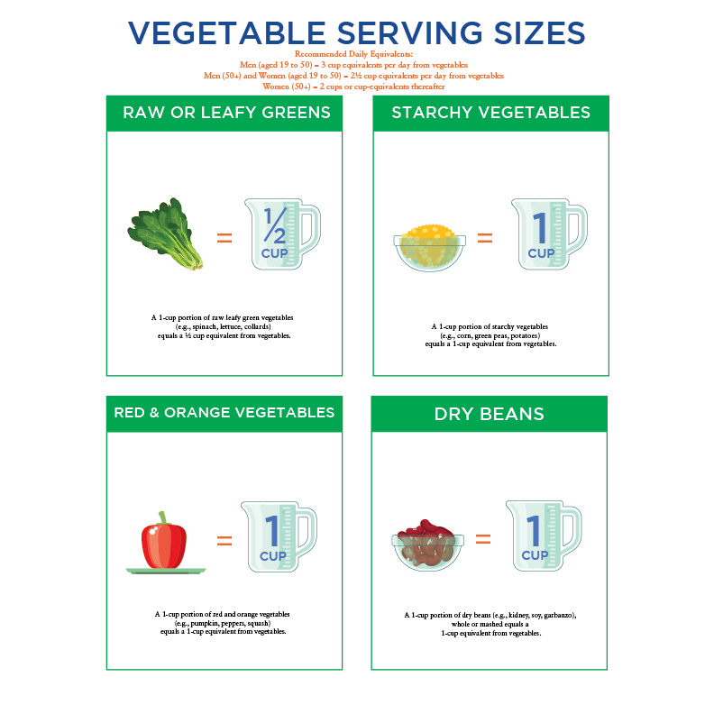

### Carbohydrate myths

The myths surrounding nutrition are endless and oftentimes complex. Although some myths may sound rational and credible, it is important to separate fact from fiction. The following video reviews some of the more mainstream myths related to carbohydrates and carbohydrate derivatives.

# Fats

Fat is one of the three macronutrients of the human diet. Dietary fat is important for our survival and has many important functions in our bodies, such as being a major source of energy, metabolising fat-soluble vitamins (A, D, E, and K), and obtaining essential fatty acids. Unlike protein and carbohydrates, fat is hydrophobic and is not soluble in water. In other words, water and oil do not mix, no matter how much you shake or stir these two substances.

Another difference between the macronutrients is that carbohydrates and protein contain 4 kcals/gram (0.14 kcals/ounce), whereas fat contains 9 kcals/gram (0.32 kcals/ounce). The fact that fat has over twice as many calories per gram than protein and carbohydrates has made it the targeted nutrient for weight loss and reducing cardiovascular disease (CVD). While overconsumption of the high-energy density of fat can lead to weight problems and cardiovascular disease, consuming the recommended amount of dietary fat, as well as eating heart-healthy fats and oils, is important for promoting overall health and well-being.

## Structure of lipids

Lipids consist of repeating units of fatty acids, which are comprised of hydrogen, carbons, and oxygen. There are a number of types of lipids, each important in various functions in the body. These include simple lipids such as fatty acids, compound lipids such as phospholipids, and derived lipids such as cholesterol.

**Simple lipids**

Fatty acids are the building blocks of fats. They are comprised of long hydrocarbon chains. At one end of the hydrocarbon chain is a carboxyl group (COOH). This carboxyl group is what makes a fatty acid an acid (carboxylic acid). Fatty acids are categorised into saturated fatty acids or unsaturated fatty acids (Figure: Chemical Structure of Saturated Fatty Acid and Unsaturated Fatty Acid).

Food for Thought

Have you ever kept a cube of butter on the counter (at room temperature) for a few hours? When you come back it is still a cube shape, not melted.

Saturated fatty acids have single bonds between the carbon atoms and are saturated with hydrogen atoms. It is the hydrogenation of the carbon atoms that makes these fats stable, giving them a long shelf life. Saturated fats, such as butter, are usually solid or semi-solid at room temperature. Saturated fatty acids are found mostly in animal products: cheese, beef, pork, chicken, butter, full fat dairy and egg yolks. There are also a few unique plant sources of saturated fatty acids such as chocolate and cocoa butter, coconut, and palm kernel oils. See Table: Examples of Foods Containing Saturated Fats for examples of foods high in saturated fat.

Examples of Foods Containing Saturated Fats

| **Food Categories** | **Examples** |
| --- | --- |
| Dairy | * Regular cheese * Dairy desserts * Whole and 2% milk * Coffee creamer and cream * Mixed dishes made with dairy such as pasta and cream sauce or pizza |
| Animal Proteins | * Chicken and chicken mixed dishes * Sausage, franks, bacon, and ribs * Beef and beef-mixed dishes |
| Grains | * Grain-based desserts (cakes, pastries, or biscuits) |
| Fats and Oils | * Lard * Palm oil * Coconut oil * Margarine * Butter |

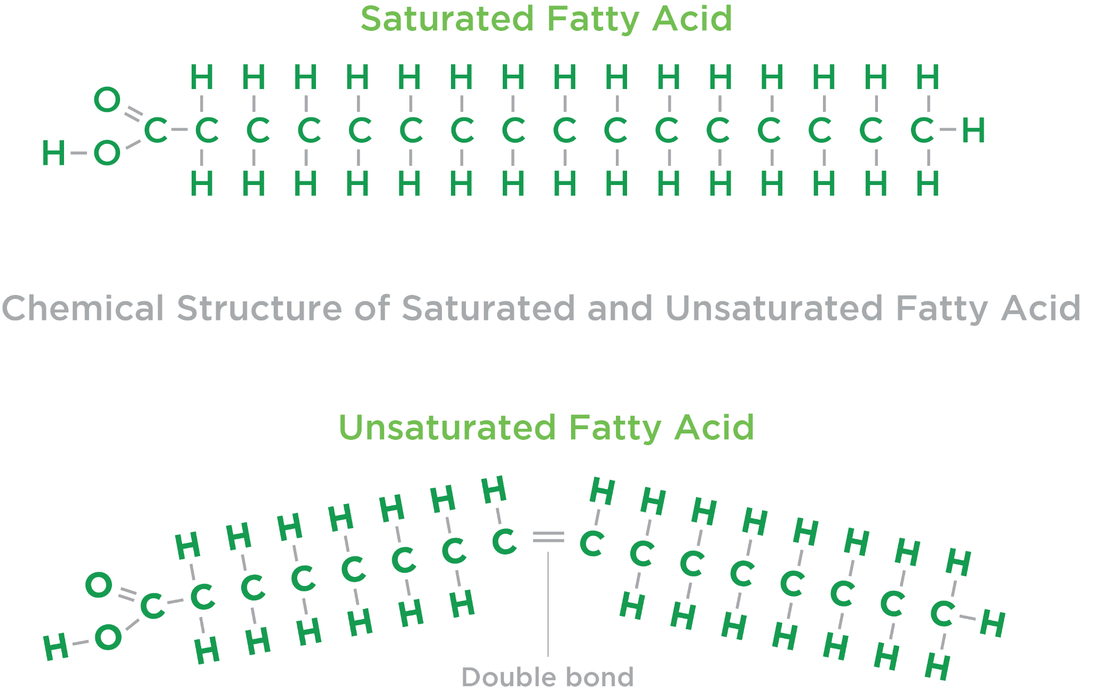

Unsaturated fatty acids contain one (monounsaturated) or more (polyunsaturated) double bonds between the carbon atoms. Unsaturated fatty acids are normally liquid at room temperature, found primarily in plant sources, and are relatively unstable. This instability makes unsaturated fatty acids more prone to oxidative damage compared to saturated fatty acids, which gives them a shorter shelf life. Unsaturated fatty acids can be categorised into monounsaturated fatty acids (MUFAs) and polyunsaturated fatty acids (PUFAs).

Foods that are excellent sources of MUFAs include olive oil; nuts such as almonds, cashews, and pecans; canola oil; avocados; olives; and nut butters like peanut or almond butter, for example. MUFAs are an important part of a heart-healthy diet, such as with the Mediterranean diet, for example. Polyunsaturated fats are also a central part of a heart-healthy diet.

Good sources of PUFAs include walnuts, sunflower seeds, flax oil, or salmon and corn, soybean, and safflower oil. Research has shown that substituting these fats for saturated or trans fats or refined carbohydrates can significantly decrease a person’s risk of cardiovascular disease (Liu et al., 2017; Hopper et al., 2015; Sacks et al., 2017). Another fatty acid category is trans fat or trans-fatty acid. Trans fat is the resulting fat from taking an oil and forcing hydrogen into it so it becomes saturated—an example of hydrogenation. The primary source of trans fat is partially hydrogenated oils (PHOs) such as margarine and vegetable shortening, as well as fried foods such as French fries, doughnuts, fried chicken, baked goods, snacks, and non-dairy coffee whitener. These fats adversely affect a range of CVD risk factors, including raising low-density lipoproteins (LDLs) and triglycerides, lowering high-density lipoproteins (HDL), increasing inflammation, and promoting endothelial dysfunction (Micha & Mosaffarian, 2008). In 2015, this type of fat was determined to not be Generally Recognised as Safe (GRAS) by the FDA (Food and Drug Administration, 2018).

Most dietary fat is comprised of triglycerides. The chemical structure of triglycerides is a glycerol backbone with three fatty acids (Figure: Triglyceride Chemical Structure). In addition to triglycerides being the main chemical form for most fat in the food supply, it is also the main component of adipose tissue (body fat)in our bodies. This layer of fat under the skin insulates the body from extreme temperature changes, acts as a cushion around our internal organs to protect against mechanical trauma, and is storage for vitamins A, D, E, and K.

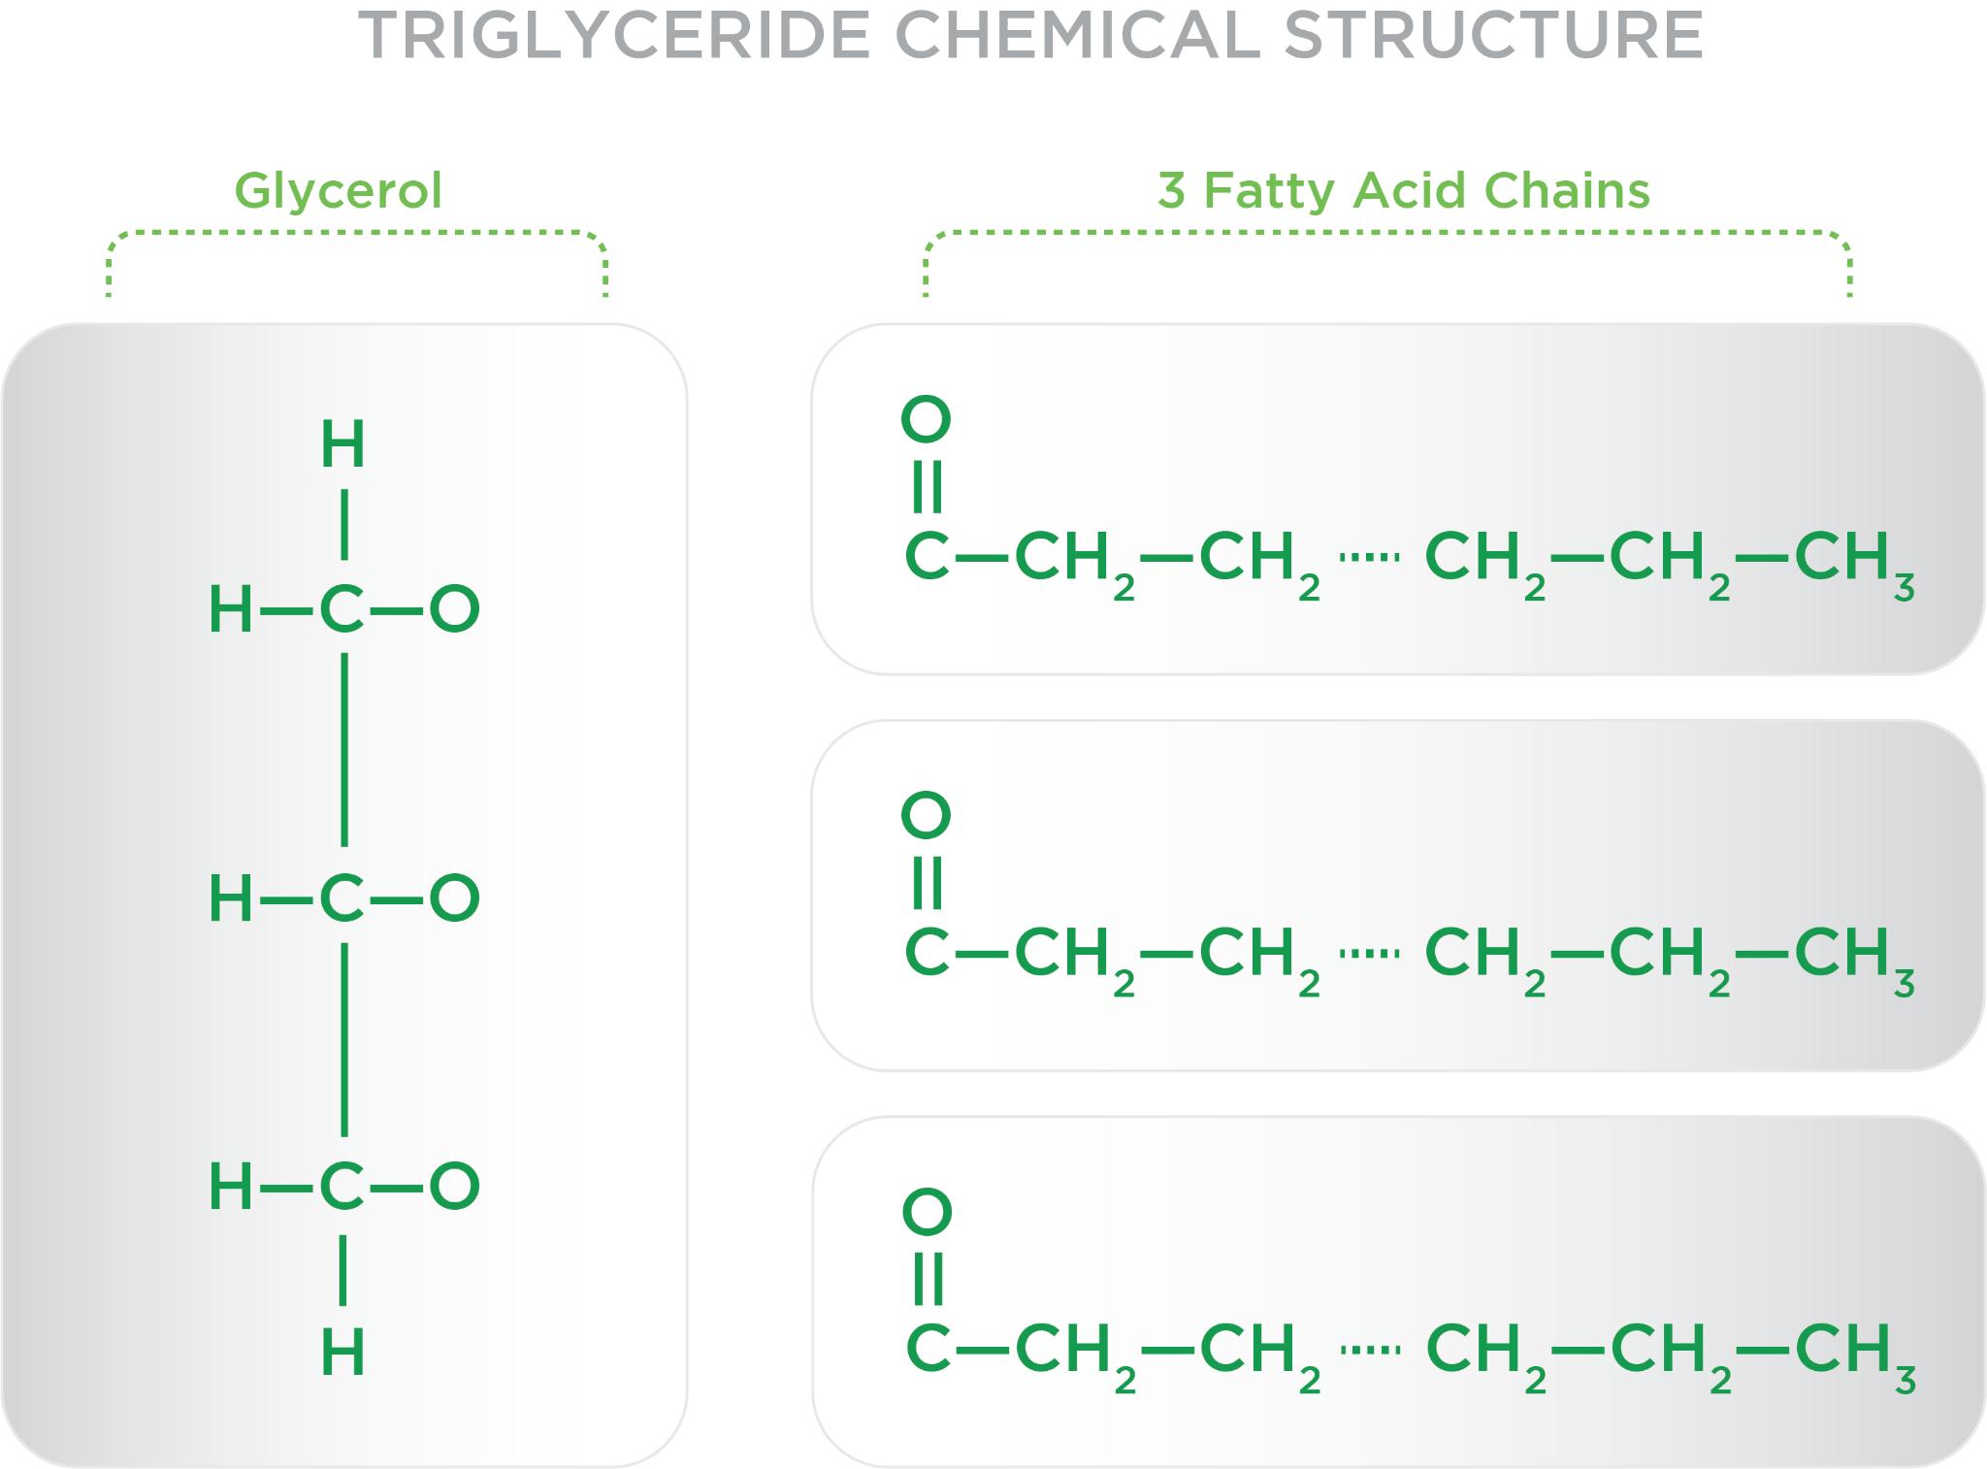

In addition, triglycerides are involved in the transportation of fats in the bloodstream. Triglycerides get into our bloodstream in two ways: they come directly from the fats or from the carbohydrates we eat.

Helpful Hint

This material can be intimidating, but it does not have to be. The following are some word tricks, visualisations, and other ways to remember the material in this chapter.

* Prefixes. Mono-, di-, tri- and poly- mean *one*, *two*, *three* or *many,* respectively. Therefore, when you see *mono*unsaturated fatty acid, that means there is one fatty acid per glycerol. Triglycerides are three fatty acids per glycerol.
* Fat is hydrophobic. Think *phobic*, which is defined as having an extreme fear or aversion to something. Fat has an aversion to water.
* There are compound lipids that contain hydrophobic (hates water) and hydrophilic (loves water) components. This is necessary to be able to get along with all compounds, such as fat-soluble and water-soluble vitamins, proteins, carbohydrates, and lipids when it comes to moving elements through the blood and into the cells.
* Visualise what happens when you mix oil and vinegar. They separate because oil does not want to mix with vinegar. When making salad dressing, an emulsifier, such as mustard, mayonnaise, egg yolks, or honey, is used to bind the oil and the vinegar.
* Saturated fat means there are the largest number of hydrogens per carbon and this makes the fat solid at room temperature. Think butter, cheese, or the fat around a piece of steak. Trans fat is taking oil and forcing hydrogen into it so it becomes saturated. Think shortening. Unsaturated fat means not every carbon has hydrogen. Think canola oil.
* Suffixes. Whenever you see -ase, that means it is an enzyme, like lip*ase*. A word ending in -genesis means *the formation of*, like gluco*genesis*– the creation of glucose. One ending in -lysis means *the breakdown of something*, like hydro*lysis*.
* Lipoproteins are a lipid plus protein. Are you confused about what are the good lipoproteins and what are the bad ones? Try this. You want high HDLs. These remove cholesterol to the liver. Hello liver, goodbye cells. You want low LDLs. These lipoproteins bring cholesterol to cells. Leave us alone, LDLs.
* How do you remember whether a food is low or high in a nutrient based on the percent DV? Give me five (5% or less) means a food is low in the nutrient. Think 20/20 vision for those foods that are high in a nutrient (20% or higher).

**Compound lipids**

The compound lipids include phospholipids and lipoproteins. A phospholipid is a compound lipid, meaning it is composed of at least two separate components. Phospholipids contain two fatty acids, a phosphate group and a glycerol molecule. They are the main component of the cell membrane (Figure: Structure of Phospholipid). The phosphate group head and glycerol are water soluble (hydrophilic); this means these elements do not repel water but rather mix with it. Other substances that are water soluble include salt, sugar, alcohol, and water-soluble vitamins. The fatty acid tail is water-insoluble or hydrophobic.

Lipoproteins are particles in the blood comprised of proteins, phospholipids, triglycerides and cholesterol. Lipoproteins transport triglycerides and cholesterol to and from the tissues of the body, particularly between the liver and adipose tissue.

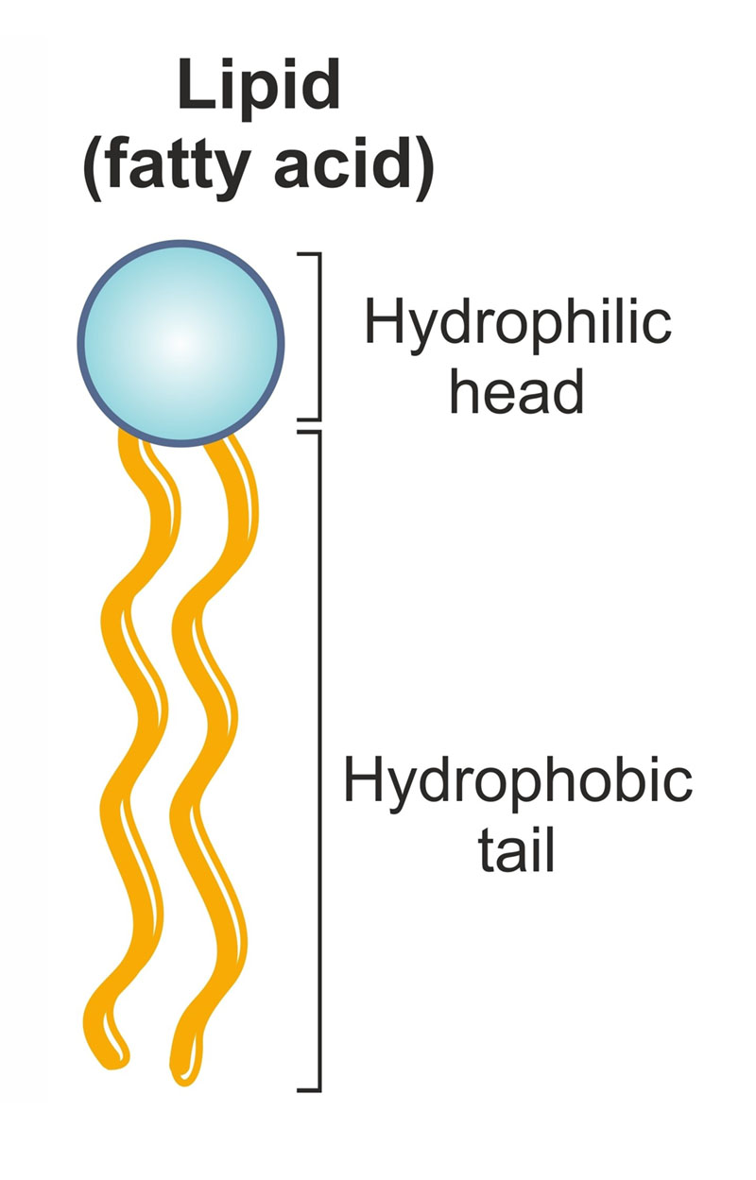

**Derived lipids**

Cholesterol helps in the production of steroid hormones as well as vitamin D. Some cholesterol is obtained from foods like eggs, cheese, and shellfish; however, most cholesterol is produced by the liver.

## Functions of lipids

Dietary fat is necessary as a source of essential fatty acids and fat-soluble vitamins. Within the body, fat has some very specific functions; being an integral part of cell membranes provides insulation and temperature regulation and is a major storage form of energy in the body.

### Function of dietary fats

From a nutritional standpoint, dietary fats are necessary as a source of energy and to obtain the essential fatty acids, Omega-3s (a-Linolenic) and Omega-6s (a-Linoleic), as well as to metabolise fat-soluble vitamins.

**Fats as major source of energy**

As mentioned before, dietary fat is the most concentrated source of energy at 9 kcals/gram, which is more than two times the number of calories in carbohydrates and protein at 4 kcals/gm. The majority of excess fat intake is stored as triglycerides. While carbohydrates are the body’s preferred fuel source during physical activity, the body’s system turns to fat stored in the adipose tissue when carbohydrates are not available.

**Fats as source of essential fatty acids**

Omega-3 and Omega-6 fatty acids are PUFAs. Alpha-linolenic acid (ALA) is mostly found in plant oils such as walnuts, flaxseeds and flaxseed oil, and chia seeds. Eicosapentaenoic acid (EPA) and docosahexaenoic acid (DHA) omega-3 fatty acids are found in cold-water fatty fish and shellfish such as salmon, mackerel, and crab. EPA and DHA are more biologically active than ALA, and, therefore, are more important for health. For instance, omega-3s, particularly EPA and DHA from fish and shellfish, may help decrease the risk of developing CVD (Harris, Miller, Tighe, Davidson, & Schaefer, 2008; U.S. Department of Health and Human Services, 2015), heart failure (Djousse, Akinkuolie, Wu, Ding, & Gaziano, 2012), coronary disease, and experiencing a fatal coronary heart disease (Del Gobbo et al., 2016). However, more research is needed to fully substantiate these claims.

The anti-inflammatory properties of omega-3s may be beneficial for those who have rheumatoid arthritis (Miles & Calder, 2012;). They are also imperative in the development of eye and brain development in a growing foetus, especially in the late stages of pregnancy (Coletta, Bell, & Roman, 2010). In addition, there is some evidence that eating high levels of omega-3s may lower levels of depression (Grosso et al., 2014), as well as research suggesting that omega-3s may be protective against Alzheimer’s disease (Huang, 2010) and dementia (Kidd, 2007).

The other essential fatty acid the body does not produce is omega-6 fatty acid (or linoleic acid). The primary sources of omega-6 fatty acids are plant oils, including soybean, safflower, and canola, as well as nuts and seeds, including pecans, walnuts, sesame seeds, and sunflower seeds. Replacing saturated fats found in meats and dairy products with these plant-based foods containing omega-6 fatty acids can be beneficial for heart health (Maki et al., 2018). However, the issue is that most of the general public's omega-6 intake comes from processed foods, such as chips, crackers, and pastries. It is important for nutrition coaches to emphasise healthier sources for omega-6 fats such as nuts, seeds, and plant oils versus processed chips, crackers, or pastries, which are typically energy dense (lots of calories), high in sugar or salt, and provide little nutritive value.

### Dietary essential fatty acid recommendations

Dietary Reference Intakes (DRIs) have been established for the essential fatty acids linolenic (omega-3s) and linoleic (omega-6s).

The adequate intake(AI) for omega-3 fatty acid is 1.6 grams and 1.1 grams per day for males and females (ages 14 to 51+ years), respectively. Consumption of EPA and DHA from food contributes a very small amount (about 40 milligrams daily or 0.04 grams / 0.0014 ounces) to total daily omega-3 intake (USDA, 2015). It is not difficult to meet this recommendation if the right foods are chosen. Yet, omega-3 supplements, comprised of usually fish oils, can be used to meet the RDIs. In fact, omega-3 supplements were the most popular supplements compared to other natural products such as probiotics, ginseng, and glucosamine, with 7.8% of U.S. adults using an omega-3 supplement in 2012 (Clark, Black, Stussman, Barnes, & Nahim, 2015).

Food for Thought

Should women, while pregnant, eat fish to get their omega-3s? The answer is yes. The recommendation is that pregnant women eat at least 8- to 12-ounces of a variety of seafood that is low in mercury. Mercury is a metal that has been found to cause birth defects. Examples of seafood with high mercury levels are: shark, swordfish, king mackerel, and tilefish. The good news is the seafood that is high in DHA and EPA, like salmon, herring, trout, and mackerel are low in mercury. A couple more tips for pregnant women is to avoid uncooked fish or shellfish, and cook seafood properly.

The jury is out regarding the benefits of omega-3 supplementation. According to the National Institutes of Health, research on omega-3 supplementation is either inconclusive or does not indicate that omega-3 supplements are beneficial. For instance, research shows that omega-3 supplements do not reduce heart disease risk; however, people who eat seafood four times per week are less likely to die of heart disease (Aung et al., 2018; Kwak et al., 2012; Rizos et al., 2012). There may be some benefits of high doses of omega-3 supplements: reducing triglyceride levels in the blood (Balk et al., 2016), as well as with DHA and EPA in relieving rheumatoid arthritis (Miles & Calder, 2012). As such, eating fish high in EPA and DHA compared to taking an omega-3 supplement may provide more significant health benefits. However, more research is needed to confirm this statement. See Table: Selected Food Sources of ALA, DHA and EPA for example foods with ALA, DHA and EPA.

Selected Food Sources of ALA, DHA, and EPA

| **Food** | **Serving Size** | **ALA DHA EPA** |
| --- | --- | --- |
| Flaxseed oil | 1 Tablespoon | 7.26 |
| Chia seeds | 1 ounce | 5.06 |
| English walnuts | 1 ounce | 2.57 |
| Flaxseed, whole | 1 Tablespoon | 2.35 |
| Salmon, Atlantic farmed, cooked | 3 ounces | 1.24 0.59 |
| Herring, Atlantic, cooked | 3 ounces | 0.94 0.77 |
| Canola oil | 1 Tablespoon | 1.28 |
| Mackerel, Atlantic, cooked | 3 ounces | 0.59 0.43 |

For omega-6s, the AI is 17 grams for men and 12 grams for women. Because omega-6 food sources are readily available, such as plant oils, including soybean, safflower, and canola, it is easy to meet the dietary recommendations. In addition, a number of processed foods have large amounts of omega-6s in them. A cup of corn chips has 14.5 grams. Regular-flavored microwave popcorn popped in oil has 22.3 grams and hard peanut granola bars contain 12.0 grams of omega-6 fatty acids.

Coach's Corner

How do vegans get EPA or DHA in their diet? While foods like chia and flax seeds have large amounts of ALA, they do not have the more biologically active versions of omega-3s: EPA and DHA. In fact, the conversion of ALA to EPA and DHA is quite small (<5%). There is evidence that seaweed is a good source of DHA, with one ounce of wakame seaweed containing 52 milligrams (0.05 grams) of DHA.

Be careful when searching for those foods high in omega-6 fatty acids. Often, these foods are in milligrams and need to be converted to grams by dividing by 1000. Good sources of omega-6s can be found in flaxseed oil and seeds, hemp seeds, acai, and nuts, including pecans, walnuts, sesame seeds, and sunflower seeds (Table: Selected Food Sources of Omega-6s).

Selected Food Sources of Omega-6s

| **Food** | **Serving Size** | **Grams Per Serving** |
| --- | --- | --- |
| Walnuts | 1 ounce | 10.7 |
| Pecans | 1 ounce | 5.8 |
| Sunflower seeds, kernels, dried | 1 ounce | 6.4 |
| Sesame seeds, whole, dried | 1 ounce | 6.0 |

Food for Thought

It has been argued that the ratio of omega-6 to omega-3 fatty acids in the Westernised diet may be involved in some chronic disease processes. Some anthropologic data suggest that tens of thousands of years ago, when humans were hunters and gatherers, the ratio of omega-6 to omega-3 was about 1. However, this is based on limited data of selective groups. Today, with traditional Western diets, the ratio of omega-6 to omega-3 fatty acids is closer to 15/1 and sometimes higher. The excessive intake of omega-6s and the very-high omega-6 to omega-3 ratio may increase the risk of many diseases such as CVD, cancer, and inflammatory and autoimmune diseases. Currently, this is a hypothesis and something to consider, but more research is needed to determine the most beneficial ratio of omega-6 to omega-3 PUFAs.

**Fats metabolise fat-soluble vitamins**

The fat-soluble vitamins, including vitamins A, D, E, and K, use fat to be absorbed and stored within the body. These essential vitamins are a vital part of the daily diet. Therefore, since fat-soluble vitamins are hydrophobic (do not like water) consuming sufficient amounts of dietary fat is necessary. In addition, fat is required to support the absorption of these vitamins in the small intestine. Finally, fat-soluble vitamins are stored in the liver or adipose tissue until they are needed by the body.

### Function of fat within the body

Beside the roles of dietary fat, body fat is important for a number of reasons, including the body’s cell membrane structure and function, as well as insulation and temperature regulation.

**Cell membrane structure and function**

Cells are encircled by a membrane. This membrane is responsible for protecting the inside of the cell and for selective permeability. Phospholipids are the main component of the cell’s membrane. These phospholipids are arranged in a phospholipid bilayer, which has the hydrophilic (water-loving) heads pointing outwards and their hydrophobic (water-repelling) fatty acid tails inward (Figure: Structure of the Cell and Phospholipid Bilayer).

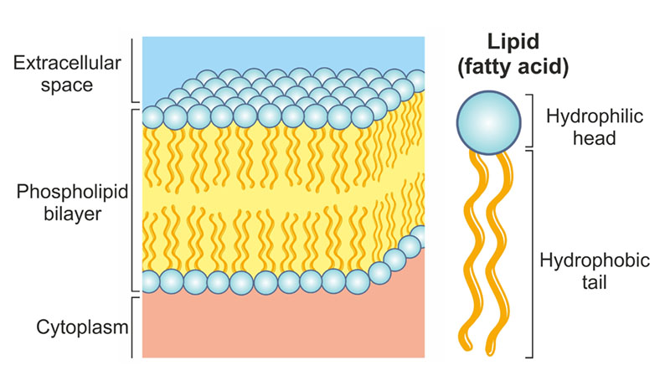

## Digestion and absorption

While most dietary fat is consumed and stored within the body in the form of triglycerides, these fats must be broken down into component parts by the process of digestion, transported into the bloodstream by the process of absorption, and delivered to the cells to either be used as energy or rebuilt into triglycerides and stored in adipocytes in the adipose tissue.

### The mouth and stomach

The first step to digestion of triglycerides begins in the mouth when fats encounter saliva. The chewing of food combined with a small amount of phospholipids, which act as an emulsifier, allow the digestive enzymes to work. The enzyme lingual lipase breaks down the triglycerides, separating fat from the water-soluble components of food, such as protein and carbohydrates. After swallowing, the fat moves to the stomach where gastric lipase begins breaking down triglycerides into diglycerides and free fatty acids. The stomach contracts and churns, further separating the fat molecules before they enter the small intestine. Note that minimal digestion of fat occurs in the mouth and stomach as compared to the small intestine.

Getting Technical

Enzymes are an integral part of the digestion process. Enzymes are proteins that speed up biochemical reactions in the body. For lipid digestion, enzymes help break down triglycerides into glycerol and fatty acids. Enzymes are identified by the suffix -ase. For instance, the first enzyme involved in digestion is the enzyme lingual lipase, which is secreted in the mouth.

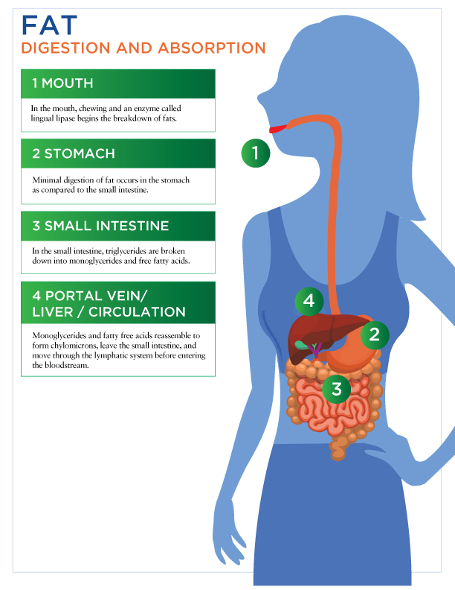

### The small intestine

In the small intestine, a small amount of bile, an emulsifier, is released, which attracts fat molecules and holds onto them while being held by the water. Next, pancreatic lipases break down triglycerides into monoglycerides and free fatty acids.

For absorption to occur, the bile salts surround the monoglycerides and free fatty acids to form micelles (Figure: Micelle). Inside of the micelle are products of lipid digestion and fat-soluble vitamins (all the water-phobic substances). On the outside of the micelle is a water-soluble lining, allowing it to travel through the bloodstream. The micelles go to the absorptive surface of the intestinal cells and release the monoglycerides, fatty acids, and fat-soluble vitamins into the digestive tract lining.

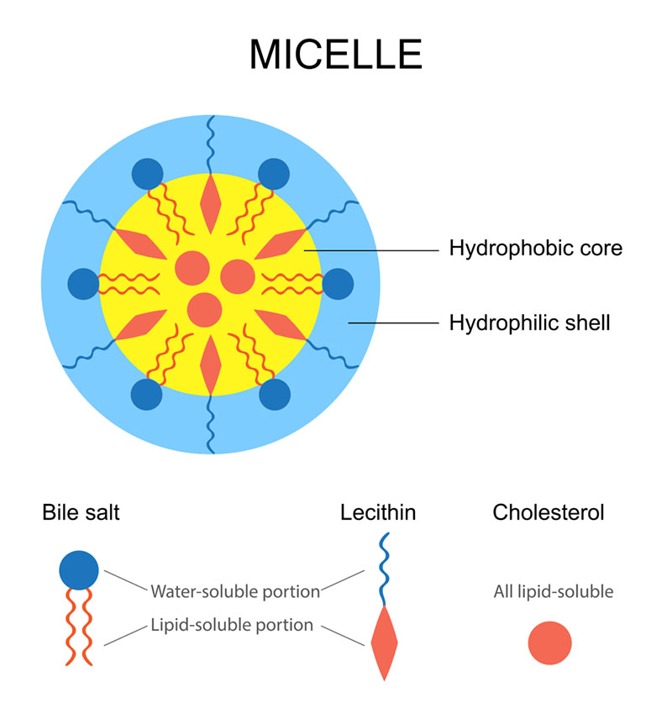

## Transport and storage of lipids

Just as lipids require special handling for digestion and absorption to occur, fats need the same kind of treatment when it comes to travelling through the bloodstream. Since fats are hydrophobic and the blood is approximately 92% water, fats (fatty acids) need a way to be transported through the blood. In other words, lipids need some way to move from the small intestine through the bloodstream to the cells of the body to be used for energy or to be stored.

### Transport of lipids

Once monoglycerides, fatty acids, and fat-soluble vitamins are released into the digestive tract lining of the small intestine, the monoglycerides and free fatty acids reassemble themselves into triglycerides. Triglycerides, cholesterol, and phospholipids, plus a protein carrier, form a lipoprotein. This large lipoprotein, called a chylomicron, enters the lymphatic system and moves toward a large vein that drains into the heart. The chylomicrons (from digestion) and very-low-density lipoproteins (VLDLs) both move through the bloodstream to deliver triglycerides to the cells of the body. Chylomicrons and VLDLs get triglycerides into the cells with the help of lipoprotein lipase, an enzyme found in the endothelium of the cells. The lipoprotein lipase binds the chylomicrons and VLDLs and triglycerides are released into the cells. Once in the cell, the lipoprotein lipase breaks down the triglycerides into fatty acids and a glycerol for the cell to use.

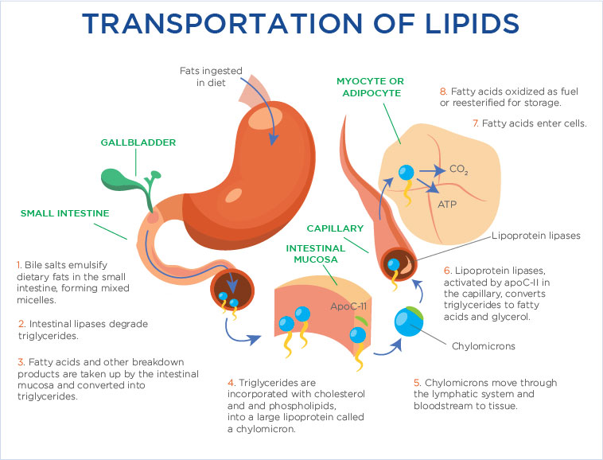

**The liver**

Besides chylomicrons and VLDLs, there are two other important lipoproteins: low-density lipoprotein (LDL) and high-density lipoprotein (HDL). As mentioned, both chylomicrons and VLDLs bring triglycerides to the cells in the body (see the pink arrows in the Figure: The Relationship Between the Liver, Lipoproteins and Cells). However, LDLs and HDLs carry cholesterol (not triglycerides). Back at the liver, the VLDLs are stripped of their triglycerides, which makes them denser (see the blue arrows in the Figure: The Relationship Between the Liver, Lipoproteins and Cells). VLDL is stripped and turns into LDL, which delivers cholesterol to the cells, which are modified and transformed into HDLs.

The function of LDL is to deliver cholesterol *to* the cells, where it can be used in cell membranes or to help in the synthesis of steroid hormones. On the other hand, HDL is responsible for retrieving excess cholesterol from the cells and bringing it *back* to the liver (see green arrows in the Figure: The Relationship Between the Liver, Lipoproteins, and Cells below). Excess cholesterol is eliminated by the liver, which secretes the cholesterol in bile (which can begin the whole process again of fat digestion and absorption in the small intestine).

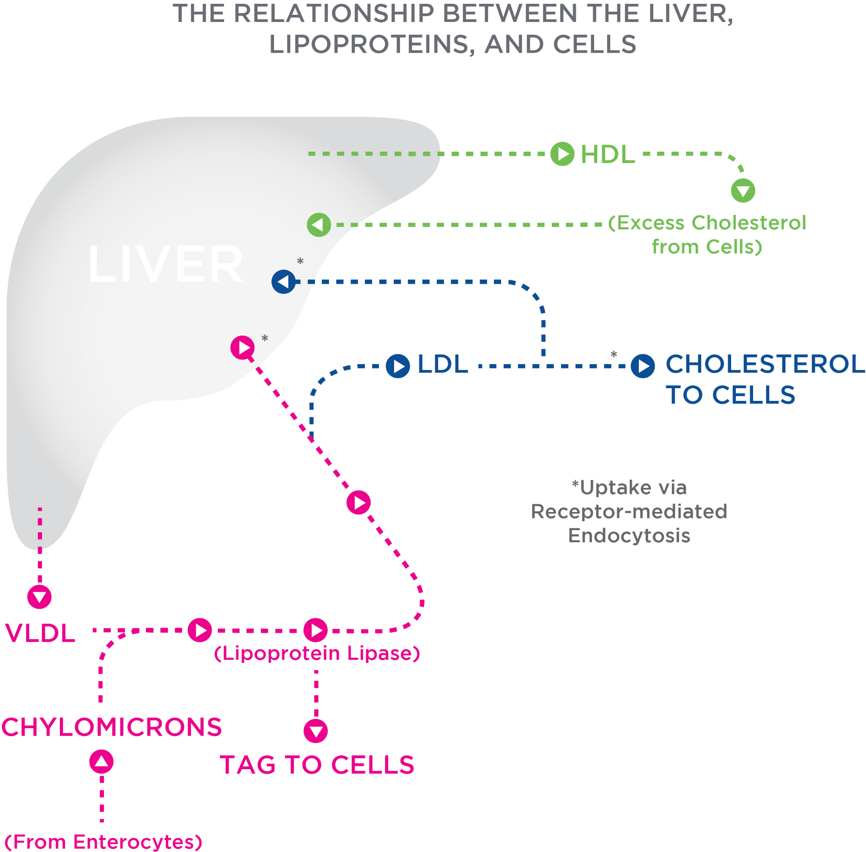

Healthy cholesterol levels are important for improving overall cardiovascular health and minimising the risk of a heart attack or stroke. Table: Recommended Cholesterol Levels contains recommendations for total cholesterol, LDL cholesterol, HDL cholesterol and triglycerides from various sources.

Recommended Cholesterol Levels

| **Test** | **Generally Desirable Level**  **(United States)** | **Generally Desirable Level**  **(UK)** | **Generally Desirable Level**  **(Australia)** | **Generally Desirable Level**  **(Canada and most of Europe)** |
| --- | --- | --- | --- | --- |
| Total cholesterol | under 200 mg/dL | under 5 mmol/L | under 4 mmol/L | under 5.2 mmol/L |
| LDL cholesterol | under 100 mg/dL | under 3 mmol/L | under 2 mmol/L | under 1.8 mmol/L |
| HDL cholesterol | over 60 mg/dL | over 1 mmol/L for males  over 1.2 mmol/L for women | over 1 mmol/L | over 1.5 mmol/L |
| Triglycerides | under 150 mg/dL | under 1.7 mmol/L | under 1.7 mmol/L | under 1.7 mmol/L |

### Fat metabolism and storage

To recount, chylomicrons and VLDLs deliver triglycerides to the cells, which, once in the cell, are broken down to fatty acids and glycerol for the cells to use. In adipose (fat) cells, the fatty acids are combined with a glycerol to become a triglyceride for storage in the adipose tissue. Once in the cell, the triglycerides go through beta-oxidation within the cells where the byproducts are glycerol and free fatty acids. However, in other cell types, particularly muscle cells, the fatty acids may be stored or made into acetyl-CoA. In the liver, acetyl-CoA is broken down into ketone bodies when rates of fatty oxidation are very high. In addition, the liver converts glycerol into glucose via gluconeogenesis (Figure: Triglyceride Utilization in the Liver, Muscles, and the Brain).

Food for Thought

In recent decades, we have gained a greater understanding of the importance of consuming an adequate amount of dietary fat (between 20% and 35%) and the benefits of consuming plant-based unsaturated fats for the reduction of CVD risk. In fact, the latest research supports the use of higher-fat diets (such as the Mediterranean-style diet) to lose weight and reduce CVD risk. Bottom line is to follow this advice:

* Avoid trans fats. These fats adversely affect a range of CVD risk factors, including raising LDLs and triglycerides, lowering HDLs, increasing inflammation, and promoting endothelial dysfunction.
* Consume 10% or less of dietary calories from saturated fat. Replace saturated fats with PUFAs.
* Focus on consuming PUFAs, including omega-3s and omega-6s food sources. Dietary PUFAs may lower serum VLDL and LDL concentrations. This is because the liver converts PUFAs into ketone bodies instead of VLDLs, which transport triglycerides to the cells.
* Reduce refined carbohydrates and added sugars.
* Reduce saturated fats and replace them with unsaturated fats

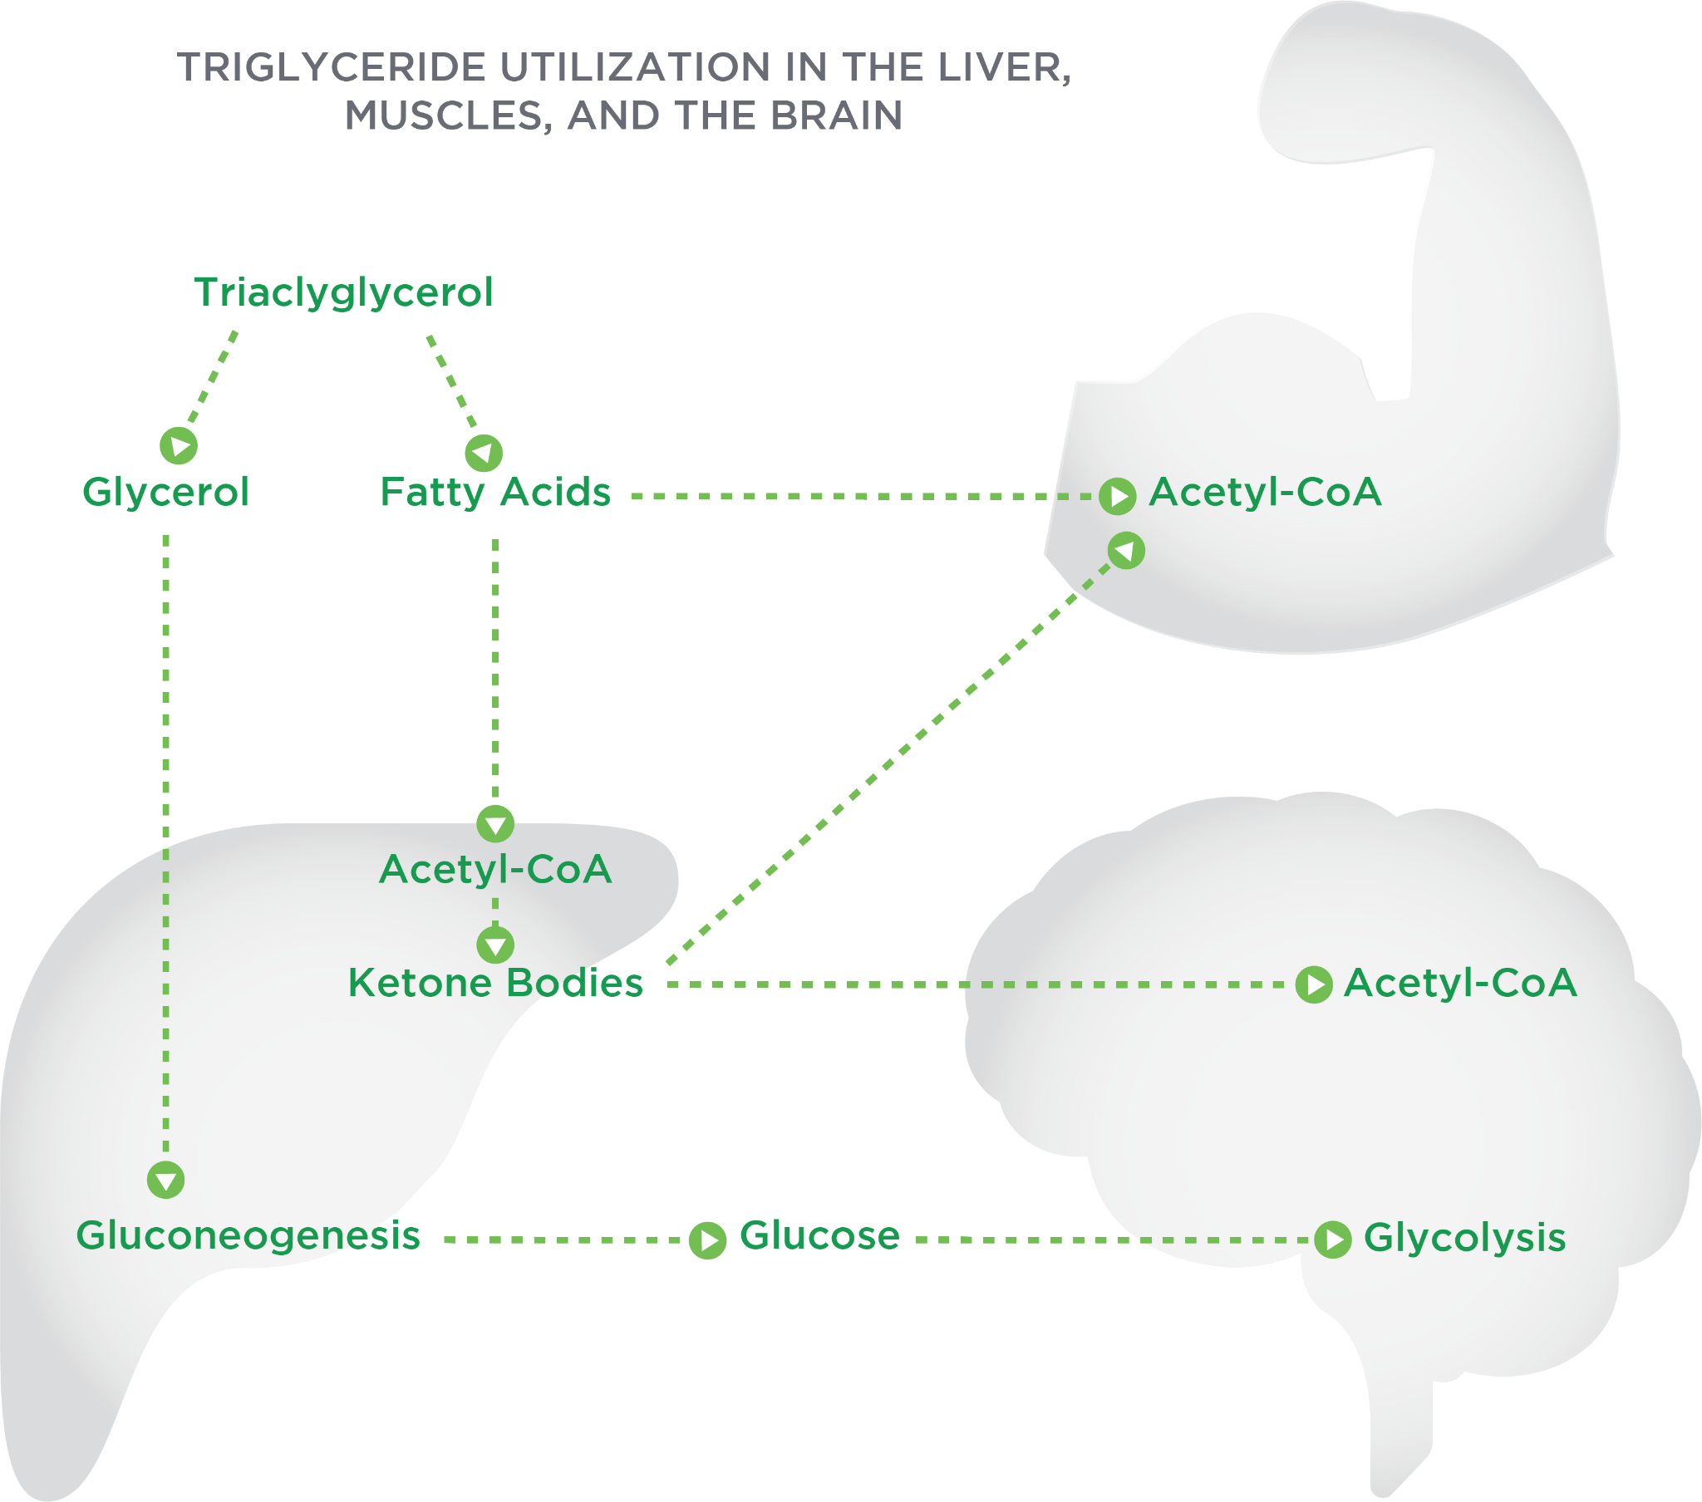

## Dietary fat recommendations and programming

Throughout this chapter, the need to consume dietary fat for various functions has been established. The Nutrition Coach needs to know what the dietary fat recommendations are and how to effectively use these recommendations to develop nutrition programming for clients.

### Dietary fat and saturated fat recommendations

There are several authoritative organisations and government agencies across the world that have developed dietary fat and saturated fat recommendations. The Institute of Medicine of the National Academies establishes nutrition guidelines based on scientific evidence for the United States and Canada. They use the Dietary Reference Intakes (DRIs) to set an acceptable macronutrient distribution range (AMDRs) for fat of between 20% to 35% of total calories per day for dietary fat (Food and Nutrition Board, 2002; Mensink & World Health Organisation, 2016). The *AustralianDietary Guidelines* also supports this dietary fat recommendation(National Health and Medical Research Council, 2013).

The British Nutrition Foundation (2018) and the Joint Food and Agriculture Organization (FAO)/World Health Organization (WHO) Expert Consultation (2010) recommend dietary fat intake to be no more than 35% and not to exceed more than 30%, respectively (British Nutrition Foundation, 2018). According to the *2015–2020 Dietary Guidelines* for *Americans,* individuals should consume less than 10% of calories from saturated fats. This recommendation is supported by the Joint FAO/WHO Expert Consultation (2010) and the *Australian Dietary Guidelines,* whereas the British Nutrition Foundation (2018) recommends that not more than 11% of calories should come from saturated fat.

Try This

Molly is on an 1800-kcals-per-day eating plan and is following recommendations from the Institute of Medicine and the *2015–2020 Dietary Guidelines for Americans*.

How many calories from fat should she be consuming? How many calories from saturated fat should Molly consume per day? How many grams of fat and saturated fat (total fat) should Molly be consuming?

Answer for total fat:

* 1800 kcals x 0.20 = 360 kcals
* 1800 kcals x 0.35 = 630 kcals
* Between 360 to 630 kcals

Answer for saturated fat:

* 1800 kcals x 0.10 = 180 kcals
* 180 kcals/9 kcals/gm = 20 grams

Answer for grams of total fat:

* 360 kcals/9 kcals/gm = 40 grams
* 630 kcals/9 kcals/gm = 70 grams
* Between 40 to 70 grams

### Translating recommendations into food choices

The Nutrition Coach needs to translate these dietary recommendations from the latest research into practical applications for the client (Table: Recommendations for Food Choices). For instance, the *Dietary Guidelines for Americans* and *Australian Dietary Guidelines* both recommend consuming a healthy, mixed eating pattern that includes a wide variety of nutrient dense foods within an appropriate calorie level.

Recommendations for Food Choices

| *Dietary Guidelines for Americans* | * A variety of vegetables from all the subgroups—dark green, red and orange, legumes (beans and peas), starchy, and other * Fruits, especially whole fruit * Fat-free or low-fat dairy, including milk, yogurt, cheese, and/or fortified soy beverages * A variety of protein foods, including seafood, lean meats and poultry, eggs, and legumes, and nuts, seeds, and soy products * Monounsaturated and polyunsaturated oils * Limiting saturated fats to 10% of total calories per day and avoiding trans fats |
| --- | --- |
| *Australian Dietary Guidelines* | * Plenty of vegetables, including different types and colors, and legumes/beans * Fruit * Grain (cereal) foods, mostly wholegrain and/or high cereal fiber varieties, such as breads, cereals, rice, pasta, noodles, polenta, couscous, oats, quinoa, and barley * Lean meats and poultry, fish, eggs, tofu, nuts and seeds, and legumes/beans * Milk, yogurt, cheese and/or their alternatives, mostly reduced fat (Reduced fat milks are not suitable for children under the age of 2 years.) * Drinking plenty of water |

*Source: U.S. Department of Health and Human Services, 2015; National Health and Medical Research Council, 2013*

Many of the dietary recommendations had specific guidelines for dietary cholesterol intake. However, with the most recent research, there is no longer a quantitative recommendation for cholesterol. Instead, the recommendation is to “eat as little dietary cholesterol as possible because foods that are high in cholesterol, such as fatty meats and high fat dairy products, are also high in saturated fats” (U.S. Department of Health and Human Services, 2015). As noted, the guidelines have shifted from focussing on a singular ingredient, cholesterol and shifted more globally to saturated fats and more specifically to limiting saturated fat to 10% to 11% of total calories per day, replacing saturated fats with unsaturated fats, and eating little to no synthetic trans fats (U.S. Department of Health and Human Services, 2015).

Critical!

Studies have found people have misinterpreted the "replace saturated fat" message and are instead replacing saturated fats with refined carbohydrates, which is not beneficial for lowering the risk of cardiovascular disease (Sacks et al., 2017).

Besides following these healthy pattern guidelines, there are other practical strategies to help clients reduce total fat and saturated fat in their diet. These include the following:

* Bake, broil or grill meats and avoid frying. Avoid crumbed meats and vegetables when possible. For instance, a 86-gram (3-ounce) boneless, skinless chicken breast has 2.9 grams (0.10 ounces) of fat, of which 0.9 grams (0.032 ounces) is saturated fat. That same chicken breast with the skin on has 7.0 grams (0.25 ounces) of fat and 1.3 grams (0.046 ounces) of saturated fat. A battered and fried chicken breast has approximately 13 grams (0.46 ounces) of fat and 2 grams (0.07 ounces) of saturated fat. While these are estimates, the point is that there are ways to prepare a food (remove skin) and cook (grill) that means less fat and saturated fat will be consumed.
* Read labels. Figure: Food Label provides an example.

Based on the food label, this 2/3 cup of food has 8 grams of fat, which is 10% Daily Value (DV). The % DV can be used as a guide to make food decisions. For instance, 5% or less of DV for a nutrient is considered low, and 20% or more of a nutrient is considered high. Therefore, in this example, dietary fat would be not be considered either low or high in % DV. For saturated fat, this food contains 1 gram or 5% of DV, which would make this a low % DV. However, % DV is based on a 2,000-calorie diet.

Try This

Assume Jane is a 38-year old client and is seeking to lose weight. She has transitioned from eating 2,000 calories per day to 1,500 calories per day. The food label image on this page indicates there is one gram (0.035 ounces) of saturated fat in the product. This equals 5% DV based on a 2,000-calorie diet. However, Jane is on a 1,500-calorie diet, not a 2,000-calorie diet. Therefore, what would be the % DV of saturated fat in this product for Jane? Remember, it is reccomended that no more than 10% of one's daily food intake come from saturated fat.

* 1500 total calories x (10%) = 150 calories from saturated fat per day (100% DV)
* 150 calories from saturated fat / 9 calories per gram = 16.6 grams of saturated fat
* 1 gram saturated fat in the product / 16.6 grams saturated fat allowed per day = 0.06 x 100 = 6%

This demonstrates how total daily calories and % DV on food labels have an inverse relationship. As daily calorie intake goes down below 2000, the % DV of a nutrient in a product will actually be higher than what is printed on a nutrition facts label. As total daily calories increase over 2000, the % DV of nutrients contained in a product will be smaller than what is printed on the label.

**Dietary essential fatty acid recommendations**

As mentioned previously in this chapter, the adequate intake (AI) for omega-3 fatty acid is 1.6 grams and 1.1 grams per day for males and females (ages 14 to 51+ years), respectively. Consumption of EPA and DHA from food contributes a very small amount, about 40 mg daily, to the total daily omega-3 intake (U.S. Department of Agriculture, 2015). Achieving this recommendation can be accomplished with smart food choices (Table: Selected Food Sources of Omega-3 Fatty Acids).

Selected Food Sources of Omega-3 Fatty Acids

| **Food** | **Serving Size** | **Grams Per Serving** |
| --- | --- | --- |
| Flaxseed oil | 1 Tablespoon | 7.26 |
| Chia seeds | 1 ounce | 5.06 |
| English walnuts | 1 ounce | 2.57 |
| Flaxseed, whole | 1 Tablespoon | 2.35 |
| Salmon, Atlantic farmed, cooked | 3 ounces | 1.83 |
| Herring, Atlantic, cooked | 3 ounces | 1.71 |
| Canola oil | 1 Tablespoon | 1.28 |
| Mackerel, Atlantic, cooked | 3 ounces | 1.02 |

For omega-6s, the AI is 17 grams for men and 12 grams for women. Because omega-6 food sources are readily available, such as in plant oils, including soybean, safflower, and canola, it is easy to meet the dietary recommendations. However, this means that several processed foods have large amounts of omega-6s in them, as well. Be careful when searching for those foods high in omega-6 fatty acids. Good sources of omega-6s, that are healthier than processed foods, can be found in flaxseed oil and seeds, hemp seeds, acai, and nuts including pecans, walnuts, sesame seeds, and sunflower seeds (Table: Selected Food Sources of Omega-6s).

Selected Food Sources of Omega-6s

| **Food** | **Serving Size** | **Grams Per Serving** |
| --- | --- | --- |
| Walnuts | 1 ounce | 10.7 |
| Pecans | 1 ounce | 5.8 |
| Sunflower seeds, kernels, dried | 1 ounce | 6.4 |
| Sesame seeds, whole, dried | 1 ounce | 6.0 |

### Programming

Based on the reading so far, it is obvious dietary fat is a vital component to our diet because of its role in important functions in our bodies. Nutrition Coaches need to find ways to incorporate healthy fat recommendations with all their clients while focussing on the individual’s goals. Table: Dietary Fat Resource is a list of common low-fat, moderate-fat and high-fat foods, and can be used as a helpful resource.

Dietary Fat Resource

| **Food Group** | **Low-Fat**  **(less than 3g fat/100g or 1.5g fat/100ml)** | **Moderate Fat**  **(3 to 17.5g fat/100g or 1.5g to 8.75 fat/100ml)** | **High Fat**  **(more than 17.5g fat/100g or 8.75g fat /100ml)** |
| --- | --- | --- | --- |
| Meat (with visible fat removed) | Chicken breast  Egg white  Turkey  Lean pork / ham | Beef extra lean  Low-fat sausage  Tofu  Whole eggs | Beef burgers  Chicken with skin  Pork belly  Salami |
| Fish | Shellfish (lobster, prawn, or shrimp)  White fish (cod or halibut) | Crab  Oily fish (salmon trout, mackerel, or sardines) | Fish in cream sauce  Fish roe |
| Fruit / Vegetables | Most fresh fruit and vegetables  Fruit juice and smoothies | Olives in brine | Avocado |
| Dairy | 1% milk  Skimmed milk  Low-fat cottage cheese  Low-fat (or fat-free) yogurt | Full cream milk  Reduced fat coconut milk  Cottage cheese  Light cream cheese  Greek yogurt | Cream  Coffee creamer  Full fat cheeses (cheddar, gouda, parmesan, blue, or mozzarella) |
| Grains / Bread | Bread (white, rolls, rye, or pita)  Rice cakes  Wheat flour | Specialty breads (focaccias, ciabatta, garlic bread, or flour tortillas)  Pizza | Croissants  Danish  Waffles  Cheese scone |

**Myths about fat**

There has been a lot of confusion around fat: whether we should go on a strict low-fat diet to lose weight to avoiding high cholesterol foods because of the potential to raise blood cholesterol. Despite advances in the scientific knowledge surrounding dietary fats, there continue to be myths and misunderstandings surrounding the topic of fat. This section will cover some of the most popular myths.

Dietary fat is one of the three macronutrients and plays several key roles in health: a source of energy, provides structure to cells, absorbs and transports nutrients, and can act as signalling molecules. Fat is energy dense, containing 9 calories per gram. Current U.S. dietary guidelines recommend that 20 to 35% of total daily calorie intake should come from fats with most of that being derived from monounsaturated and polyunsaturated fats and 10% or less coming from saturated fats. Optimal sources of fats include nuts, seeds, fish, some minimally processed oils, dairy, and cheese.

In this chapter, you learned about:

* The structure and function of fat.
* The digestion and absorption process of fat.
* Fat-soluble vitamins (A, D, E and K).
* Healthy cholesterol levels.
* The benefits of omega-3 fatty acids.
* The dangers of trans fats.
* Examples of unsaturated and saturated fats.
* Establishing fat requirements in a dietary programme.
* Key myths and hot topics related to fat.

# Alcohol

Ethyl alcohol (ethanol) is the most commonly consumed drug globally, with an estimated 1.6 gallons (6.1 L) consumed by each person (over the age of 15) each year (World Health Organisation, 2014). In the United States, an estimated 2.35 gallons (8.9 L) of pure ethanol is consumed per capita. This places the United States as the 49th highest consumer of ethanol in the world (World Health Organization, 2014). While other alcohols, such as methyl and isopropyl alcohol are commonly used in medical and industrial settings, only ethanol is tolerated, in appropriate amounts, within the body. Even in low doses, other forms of alcohol are extremely toxic and can cause severe illness and death. Ethanol is often overlooked in sports nutrition, as it is not essential for health or performance; however, given its popularity and potential for altering physiological function, an understanding of ethanol and its effects is important.

## Alcohol structure and functions

Given ethanol is produced by the fermentation of glucose, it is not surprising that the two are structurally similar, with each composed of carbon, hydrogen, and oxygen. However, while glucose has six carbons and five hydroxyl (-OH) groups, ethanol is comprised of two carbons and a single hydroxyl group (Figure: Chemical Structure of Ethanol).

Unlike carbohydrates and fat, the metabolism of ethanol is not regulated by hormones and there is no storage depot or circulating pool of ethanol in the body. Ethanol is not essential for biological function and is, therefore, perceived as a homeostatic threat (a toxin of sorts). As such, in order to remove it and its metabolites from the body, the metabolism of ethanol takes priority, above the use of other energy providing macronutrients.

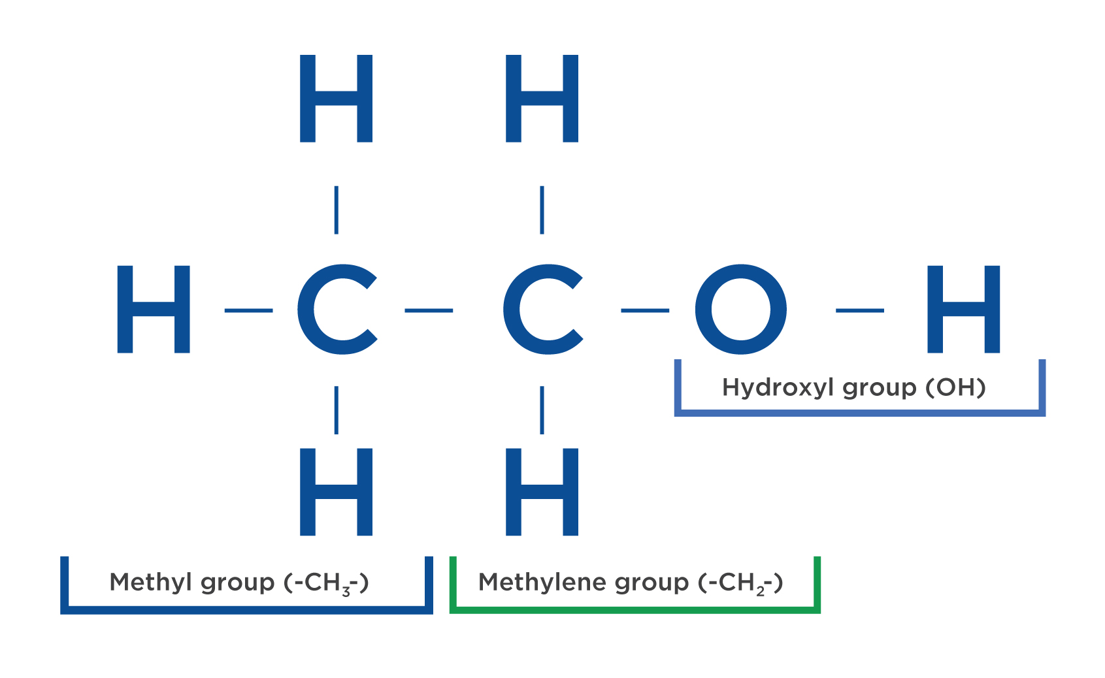

Critical!

Unlike the other macronutrients, ethanol is not required in the diet and, therefore, has no beneficial function.

Ethanol is often considered the fourth macronutrient because, when metabolised, 7.1 kcals per gram of ethanol are liberated as energy—more than carbohydrate and protein and only slightly less than fat. However, while ethanol does provide energy, it is perhaps better to think of it as a psychoactive drug, rather than a macronutrient (Lieber, 2000).

### Alcohol absorption

When an alcoholic beverage is ingested, a small amount of the ethanol in the beverage is immediately metabolised in the gastric mucosa (stomach lining) by alcohol dehydrogenase(ADH) in what is referred to as first-pass metabolism. The majority of ethanol, however, passes unaltered into the bloodstream through the stomach and small intestine by simple diffusion. Once in circulation, the water solubility of ethanol allows it to diffuse into the majority of tissues, particularly the liver, due to the flow of blood directly from the stomach. The rate of absorption and subsequent amount of alcohol circulating in the blood [i.e., blood alcohol content (BAC)] is dependent on a number of factors, including sex, body mass, the type of beverage consumed, whether the stomach is empty, and the speed at which the alcoholic beverage is consumed (Paton, 2005).

**Alcoholic beverages and food**

The adage of “never consuming alcohol on an empty stomach” has some merit, as the absence of food in the stomach is the primary determinant of how quickly ethanol will be absorbed into the bloodstream. The presence of food in the stomach, rather than the type of food, appears to be the most important factor, as no differences in absorption rates are evident between foods high in fat, protein, or carbohydrates (Ramchandani, Bosron, & Li, 2001).

While food slows the absorption of alcohol, it also increases the rate at which ethanol is metabolized, both by first-pass metabolism and metabolism in the liver, as a result of increased liver blood flow, activity of ADH, and rates of NADH, the reduced form of nicotinamide adenine dinucleotide (NAD+) re-oxidation (Ramchandani, Bosron, & Li, 2001). The coenzyme NAD+ and its reduced form, NADH, are essential in glycolysis, gluconeogenesis, fatty-acid oxidation, amino-acid oxidation and the Krebs cycle. Once formed, NADH provides the majority of electrons used for ATP production by oxidative phosphorylation within the mitochondria.

Concentrated alcoholic beverages, such as spirits, will generally produce a greater rise in BAC compared to a beverage with a lower percent of ethanol, as each drink contains more ethanol. However, this effect is influenced by the fed/fasted state. Ethanol from concentrated alcoholic beverages may be absorbed at a greater rate than dilute alcoholic beverages, such as beer, when the stomach is empty. Interestingly, the opposite is true.

Critical!

Food reduces the rate of alcohol absorption and increases the rate of metabolism, thus reducing the rate of rise in BAC. The type of beverage interacts with the fed state to alter ethanol absorption.

When food has been consumed prior to or during alcohol consumption, dilute alcoholic beverages are absorbed at a greater rate than concentrated alcoholic beverages (Roine, 2000; Roine et al., 1993). Additionally, consuming ethanol in carbonated beverages may result in a greater rate of absorption than when consuming alcohol in noncarbonated beverages (Roberts & Robinson, 2007).

**Sex and body composition**

While rates of ethanol absorption and metabolism by the liver are similar in females and males (Mumenthaler, Taylor, O'Hara, & Yesavage, 1999), a given amount of ethanol will typically result in a greater BAC in females due to several physiological differences. Firstly, since ethanol from the bloodstream diffuses down a concentration gradient into all water-containing tissues, BAC in individuals with more total body water, such as males, and those with greater amounts of lean muscle mass will be lower than those with less total body water (Figure: Male vs Female Body Water Content). When total body water is accounted for, no difference in BAC is evident between females and males (Goist & Sutker, 1985).

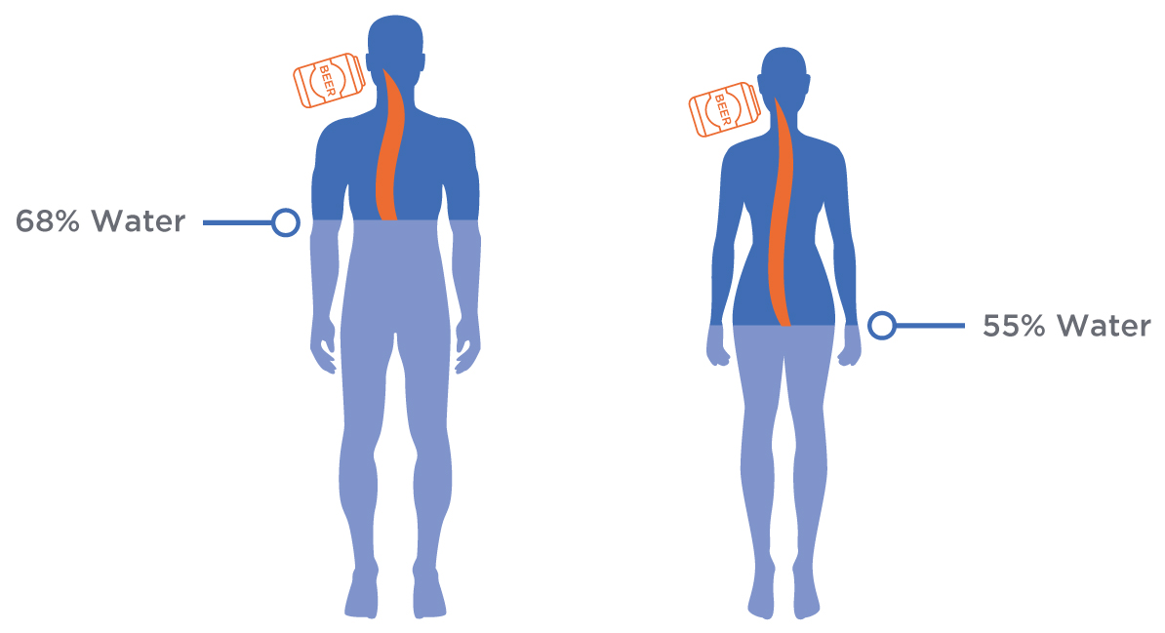

Secondly, due to differences in ADH activity in the stomach, first-pass metabolism is greater in males than females, which means less ethanol enters the bloodstream after a male consumes an alcoholic beverage (Baraona et al., 2001). Therefore, caution is needed when individuals of different body sizes, body composition, and sex are drinking together, because the rate of ethanol absorption and subsequent metabolism will not be the same for everyone.

Critical!

Differences in body size, body composition, and enzyme activity mean that females will respond very differently to males when consuming the same amount of alcohol. This needs to be considered when using standard blood alcohol content estimation tools that only compare number of drinks to bodyweight

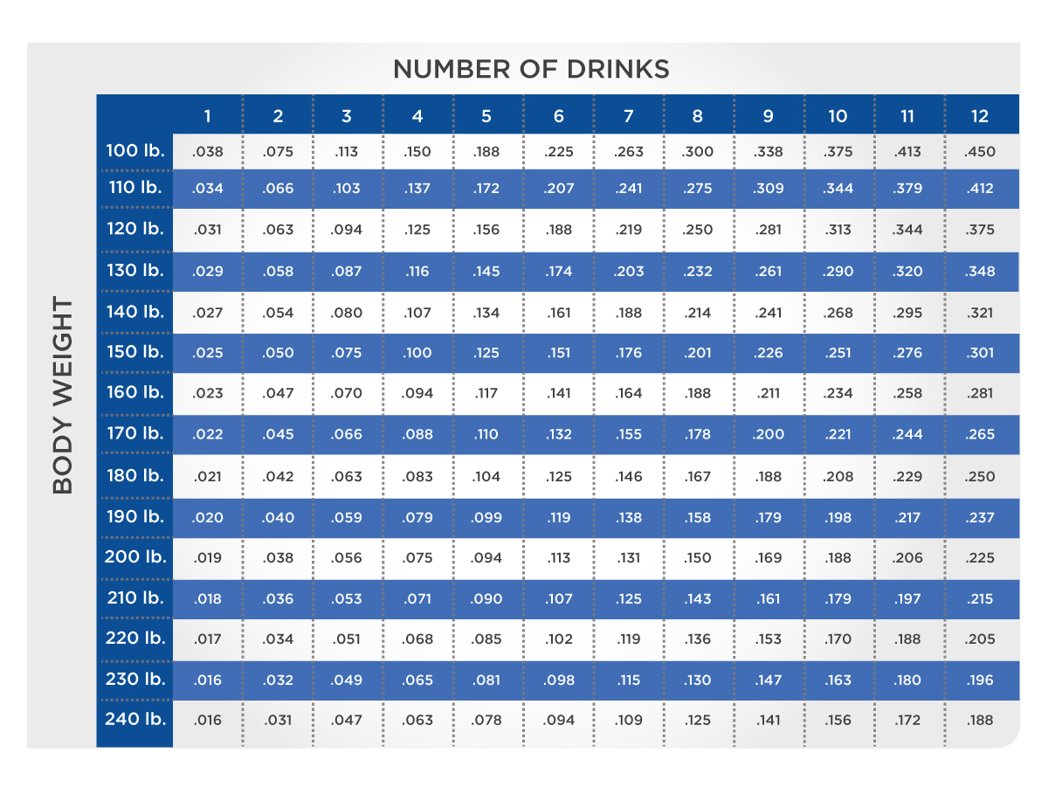

### Metabolism of ethanol

Once in circulation, 90% of ethanol is metabolised in the liver by ADH at a rate of approximately 0.25 ounces (7 grams) per hour. The other 10% is excreted through breath, sweat, and urine. As the rate of metabolism by the liver is not upregulated in response to greater circulating levels of ethanol, absorption of ethanol at a rate greater than that of ethanol metabolism will see BAC rise accordingly and intoxication will begin. Metabolism of ethanol by ADH results in the formation of acetaldehyde and NADH (Figure: Metabolism of Ethanol). Acetaldehyde is toxic, and is therefore metabolised rapidly and preferentially above other macronutrients to acetate by the mitochondrial enzyme acetaldehyde dehydrogenase (ALDH2). The majority of the acetate, which is not toxic, is released into the bloodstream, taken up by skeletal and cardiac muscle and brain cells, and subsequently converted to the Krebs cycle substrate acetyl-CoA by the enzyme acetyl-CoA synthetase. As occurs in beta-oxidation of fat, acetyl-CoA is then used in the Krebs cycle where it is eventually broken down to carbon dioxide and water via the electron transport chain.

Coach's Corner

For individuals trying to lose body fat, frequent ethanol consumption is particularly counterproductive. The acetate from ethanol metabolism provides ample acetyl-CoA to the aerobic pathways, thus reducing the body's need to utilise its own fat stores. Furthermore, by meeting energy needs with acetate, carbohydrates and fats consumed along with the alcoholic beverage will be treated like any other excess calories and be stored for later, creating a two-fold roadblock to optimal body composition management.

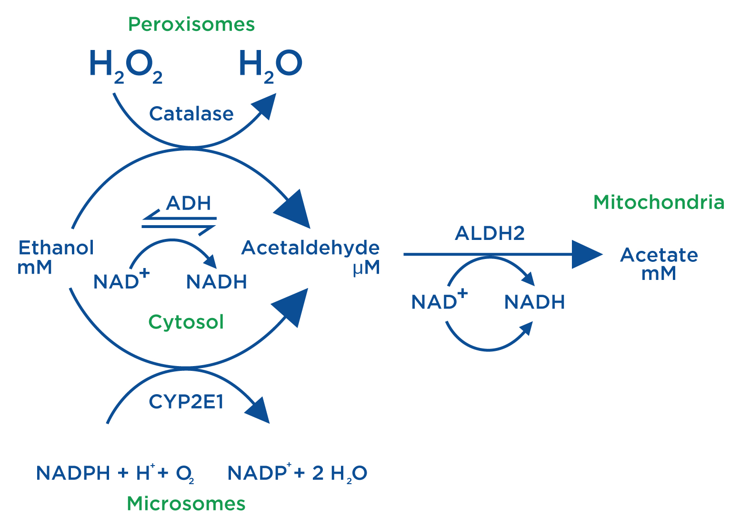

An alternative, yet complementary pathway for the metabolism of ethanol is the microsomal ethanol-oxidising system (MEOS) occurring in microsomes of the liver. This pathway is used when the ADH pathway is saturated; for example, when large amounts of ethanol are consumed and it is up-regulated by repeated heavy consumption of alcohol. It is, therefore, more active in alcoholics than in the general population. The MEOS also results in the production of acetaldehyde, which, as described previously, is converted to acetate. However, unlike the ADH reaction, the MEOS oxidises its co-factor, the reduced form of nicotinamide adenine dinucleotide phosphate (NADPH), thus altering the energy coupling of ethanol oxidation and oxidative phosphorylation, resulting in the generation of heat (Foster & Marriott, 2006).

The enzymatic activity of catalase, an enzyme that is responsible for the breakdown of hydrogen peroxide, may also contribute to the metabolism of ethanol in a small and indirect manner. Depending on the pathway used to oxidise ethanol, a maximum of 13 or 8 ATP are produced per ethanol molecule by the ADH or MEOS pathways, respectively.

The metabolism of anything more than a few grams of ethanol can result in disruption in the ratio of NADH and NAD+ within the cytosol of hepatocytes. Under normal conditions, when ethanol is absent or present in very small amounts, NADH is re-oxidised in a timely manner through the shuttling of electrons into mitochondria via the malate-aspartate and glycerophospate shuttles to maintain a low NADH to NAD+ ratio. However, when moderate to large amounts of ethanol are present, the shuttling of electrons is unable to match the production of NADH.

Critical!

Even though there are three pathways, the majority of ethanol metabolism occurs in the liver through the alcohol dehydrogenase reaction.

As many of the reactions that occur within the cytosol are close to equilibrium, this increase in NADH directly impacts dehydrogenase reactions, in particular, the lactate dehydrogenase reaction, which usually metabolises circulating lactate to produce pyruvate. Alterations in this reaction may result in elevations in circulating levels of lactate and subsequent lactic acidosis. Additionally, the reduction in concentrations of pyruvate may impact hepatic gluconeogenesis, which, under conditions of low hepatic glycogen content, may lead to severe hypoglycaemia (Lieber, 2005).

The altered NADH to NAD+ ratio also impacts a number of other metabolic processes, including a shift toward lipogenesis and hepatic fatty-acid accumulation and a shift away from fatty-acid oxidation, which is usually the main source of energy in hepatocytes. This can result in fatty liver disease (Zakhari, 2006) and, if habitual ethanol consumption is not decreased, may result in liver disease, cirrhosis, and cancer (Baan et al., 2007).

Food for Thought

Some individuals, particularly those of Asian descent, may have a deficiency in the acetaldehyde dehydrogenase enzyme. This causes an accumulation of acetaldehyde and a number of associated side effects, including acute flushing (reddening) of the skin and nausea. It is also linked with an increased risk of oesophageal cancer (Brooks, Enoch, Goldman, & Yokoyama, 2009).

## The dietary impact of alcohol

Unlike the other macronutrients, specifically programming ethanol into the diet is not necessary. However, given the popularity of alcohol as a socially acceptable, recreational drug, it is unrealistic to expect complete abstinence in the majority of the population. It is, therefore, important to take alcohol consumption into consideration when planning a healthy diet.

### Alcohol intake guidelines

The *2015–2020 Dietary Guidelines for Americans* (U.S. Department of Agriculture, 2015) recommends that if alcohol is to be consumed, it should be done so in moderation. Moderate drinking is classified as up to one standard drink per day for females and up to two standard drinks per day for males. Alcohol consumption is considered high-risk drinking for females if four or more standard drinks are consumed per day, or if eight or more standard drinks are consumed per week. For males, five or more drinks per day or 15 or more drinks per week is considered high-risk alcohol consumption. At these levels, the risk of alcohol-related harm is greatly increased (U.S. Department of Agriculture, 2015).

Of additional concern, binge drinking is classified as a single episode of drinking where more than four or five standard drinks are consumed, by females and males respectively, over a short time period. Although individuals who regularly binge drink may not necessarily exceed weekly recommendations for ethanol intake, as all ethanol may be consumed on one occasion, this behavior is associated with considerable physical, mental, and societal harm (Figure: Short-Term Health Effects of Binge Drinking; Naimi et al., 2003).

Although ethanol may be well tolerated by most of the population, at least in small to moderate amounts, females who are or may be pregnant, those under the age of 21, and those who are driving or planning to drive a motor vehicle should not consume alcohol.

Critical!

Due to the differing ethanol content of alcoholic beverages and the range of volumes that alcohol is served in, anyone consuming alcohol must be aware of how much ethanol is in each drink to ensure alcohol consumption does not reach hazardous levels. Care is needed when consuming several drinks in a single session, or when a single beverage contains more than one standard drink, so that binging on alcohol does not occur. For example, someone drinking two Long Island Iced Teas over 2 hours will actually consume 7.5 standard drinks! This is more than three times the recommended daily alcohol consumption for males and seven times the recommended amount for females and is, therefore, classified as high-risk, binge drinking behaviour.

**Defining a drink**

The ethanol content of alcoholic beverages differs greatly, ranging from beer, which is typically 4 to 5% ethanol, to spirits, which may contain over 40% ethanol. In order to quantify the amount of alcohol in a beverage and provide a way of monitoring alcohol consumption, a unit, known as a standard drink, or drink equivalent, is used. In the United States, a standard drink is any alcoholic beverage containing 0.6 ounces (14 grams) of ethanol (Figure: Common Beverages with One Standard Drink). By comparison, throughout Europe and the United Kingdom, a standard drink ranges from 8 grams to 18 grams, with the majority of countries classifying a standard drink as containing 10 grams of ethanol. As the amount of ethanol and volume of an alcoholic beverage can differ greatly, simply counting the number of drinks consumed, rather than the amount of ethanol consumed, can be misleading and result in excessive drinking (Table: One Standard Drink Around the World).

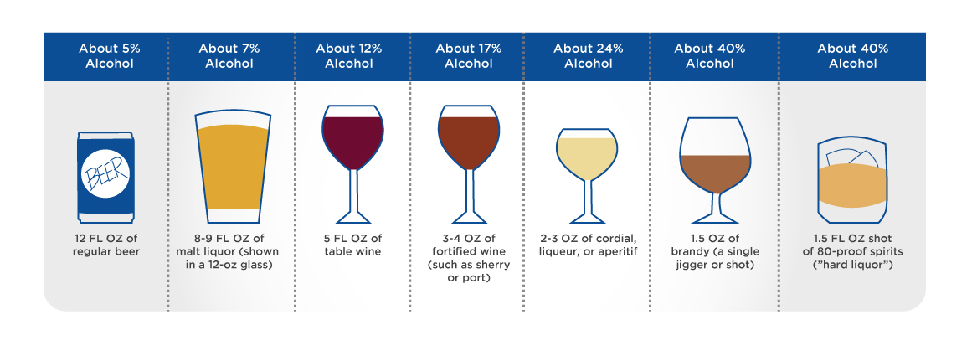

One Standard Drink Around the World

| **Country** | **Grams of Ethanol in a Standard Drink** | **Recommended Daily Alcohol Consumption** |
| --- | --- | --- |
| Argentina | 14 | Up to 20 g for males and females |
| Australia | 10 | Up to 20 g for males and females |
| Canada | 13.5 | No more than three drinks for males and two drinks for females, up to 15 drinks per week for males and 10 drinks per week for females |
| Chile | 14 | Up to 14 g for males and females |
| China | Not Classified | Up to 25 g for males and 15 g for females |
| France | 10 | Up to 20 g for males and females and no more than 100 g per week |
| Germany | Not Classified | Up to 24 g for males and 12 g for females |
| India | 8 | Up to 16 g for males and 8 g for females |
| Italy | 12 | Up to 24 g for males and 12 g for females and males aged between 18 to 21 and above 65 years |
| Japan | 20 | Up to 40 g for males and 20 g for females |
| Mexico | 13 | 13 to 26 g for males and 13 g for females |
| South Africa | Not Classified | Up to two beers or glasses of wine for males and females |
| United Kingdom | 8 | Up to 112 g per week for males and females |
| United States | 14 | Up to 28 g for males and 14 g for females |
| Visit the International Alliance for Responsible Drinking (IARD) website at [http://www.iard.org](http://www.iard.org/) for a more detailed look at each country's alcohol intake reccomendations. | | |

**Accommodating alcohol into a healthy diet**

Although many alcoholic beverages may contain some macro- and micronutrients, such as beer, which contains carbohydrates and various vitamins and minerals, and wine, which contains polyphenols, antioxidants, and flavonoids, ethanol itself has no additional nutritive value and is, therefore, considered an empty source of energy. The actual energy from ethanol in an alcoholic beverage may be relatively small (about 99.4 kcal); however, many alcoholic beverages contain considerably more energy due to the carbohydrate content of the alcohol itself (Figure: ABV and Calories in Common Drinks) and sometimes more, if a mixer was used in the beverage. This energy must be accounted for in a healthy diet, particularly as alcoholic beverages tend to be consumed in addition to a normal diet, rather than replacing energy from other sources (Yeomans, Caton, & Hetherington, 2003).

Along with solid fat and added sugars, the energy from alcoholic beverages can be considered as discretionary energy; that is, energy from these sources can be used to make up daily energy requirements once nutrient requirements are met. Based on the 2000-kcal-per-day U.S.-style eating pattern (U.S. Department of Agriculture, 2015), 270 kcal per day (14% of total energy intake) may come from discretionary food sources. If alcohol is to be consumed, then the energy from all discretionary sources should not exceed calculated discretionary calories. As such, the amount of fat and added sugar must be reduced accordingly. However, minimising discretionary calories from fat and sugar alongside alcohol consumption is often easier said than done.

Critical!

Energy from alcohol should not displace energy from other food sources that also provide macro- and micronutrients. Energy from alcohol must be accounted for when calculating energy requirements.

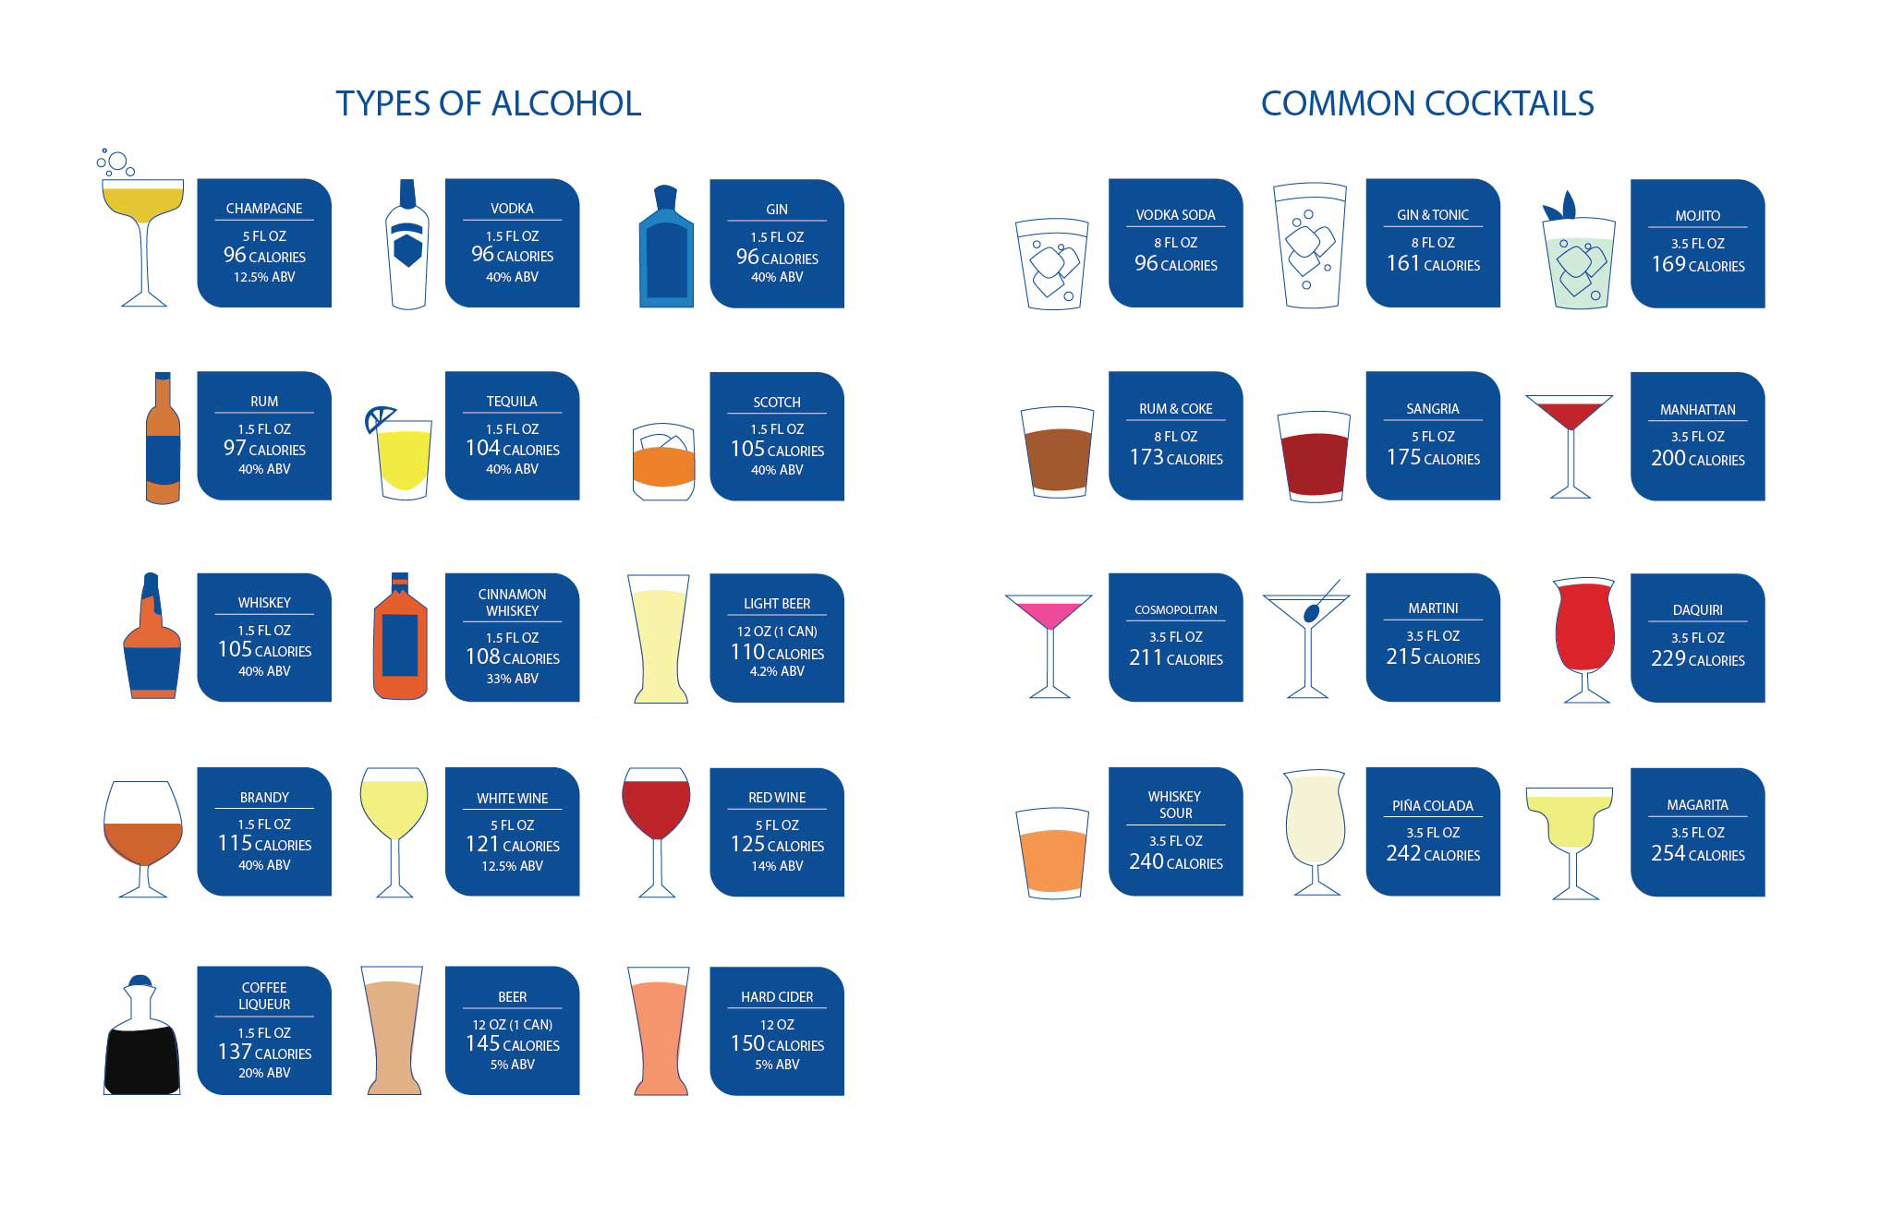

### Alcohol and body composition

According to the NCAA (2013), ethanol can influence body composition because it is stored as fat. But, is this true? The answer is not as straightforward as it seems. Like the way in which excess glucose alters whole-body fat oxidation, excess acetate, produced during the metabolism of ethanol, is transported and oxidised in peripheral tissue at the expense of normal fat oxidation. Unlike the distribution of glucose, this process does not rely on insulin. Oxidation in peripheral tissue is the fate of up to 80% of acetate, with only a small amount (<5%) being directly converted to fat (Siler, Neese, & Hellerstein, 1999).

Further compounding the issue, poor dietary choices are often made before, during, and after alcohol is consumed, leading to excess caloric intake, when both large and moderate amounts are consumed (Lloyd-Richardson, Lucero, DiBello, Jacobson, & Wing, 2008; Foster & Marriott, 2006). These factors, coupled with the fact that physical activity levels tend to decrease as habitual ethanol intake increases (Liangpunsakul, Crabb, & Qi, 2010), highlight the importance of monitoring and moderating ethanol consumption to ensure fat mass is not increased.

Interestingly, individuals who consume ethanol in moderate amounts have been shown to have less fat mass than both abstainers and heavy drinkers (Foster & Marriott, 2006). Females, in particular, appear to benefit from moderate alcohol consumption (Beardsley, 2014; Thomson et al., 2012), while waist to hip ratio, and therefore abdominal adiposity, is closely associated with ethanol consumption in males (Beardsley, 2014; Liangpunsakul et al., 2010).

When consumed regularly at high levels, ethanol may reduce lean muscle mass (alcohol myopathy) through dose-dependent reductions in testosterone (Gordon, Altman, Southren, Rubin, & Lieber, 1976), protein synthesis (Kimball & Lang, 2018), and the actions of reactive oxygen species created during MEOS (Jolley & Molina, 2017). Taken together, the metabolic disruptions and physiological alterations ethanol can cause have the potential to alter body composition; however, many of these effects are dose and sex-specific, with men who drink large amounts of ethanol likely to be affected the most.

### Monitoring alcohol use

When planning a diet, it is essential to understand the individual’s habitual dietary behaviour, including their alcohol consumption, so that all energy sources and factors that may affect overall health are considered. In order to identify an individual’s habitual alcohol consumption and risk of alcohol-related harm, the U.S Alcohol Use Disorders Identification Test (USAUDIT-C) is recommended as a first step (Higgins-Biddle & Babor, 2018). This abbreviated version of the full AUDIT (Babor, Higgins-Biddle, Saunders, & Monteiro, 2001) has been adapted to take into consideration the higher amount of ethanol in a U.S. standard drink and the U.S. low-risk drinking guidelines, which differ slightly from other countries.

Comprised of three questions, the USAUDIT-C provides an indication of whether an individual is drinking alcohol at harmful levels—above recommended guidelines. A total score of seven or more for males and five or more for females is a positive score; however, due to losses in lean body mass during old age, men over the age of 65 use the same 5 or more criteria for a positive score similar to women. The number of drinks consumed weekly can be calculated by multiplying number of drinks (Q1) and frequency of drinking (Q2). The answer to Q3 provides an indication of the frequency of binge drinking. The higher the total score from the three questions, the greater the likelihood of alcohol-related harm. If an individual has a positive score, further questioning, using the remaining seven AUDIT questions (Babor et al., 2001) is recommended in order to understand alcohol dependence and harm. Depending on the results of the full AUDIT (USAUDIT-C + AUDIT), an individual may require alcohol education, counselling, or a brief or significant intervention in order to minimise the risk of alcohol-related harm in the future.

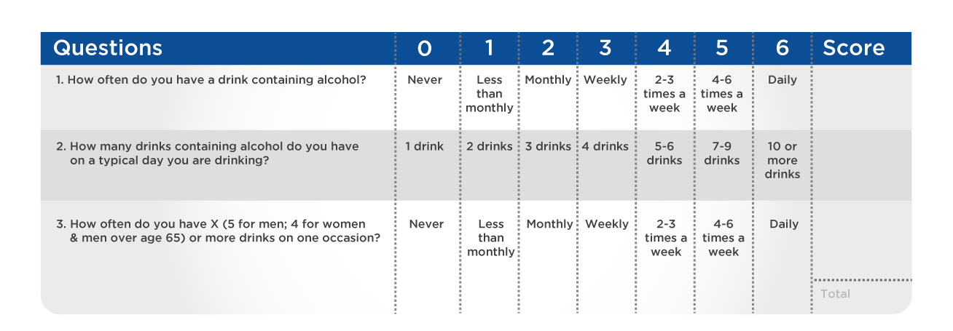

## The physiological and health effects of alcohol

The recommendation to consume ethanol in moderate amounts stems from the detrimental acute and chronic physiological effects ethanol has on the body. As a water-soluble toxic substance, ethanol and its main metabolites have the ability to affect a number of tissues in the body. These effects are both the reason individuals drink alcohol and the reason moderation is recommended (Figure: Health Effects of Alcohol).

Regular consumption of moderate to harmful levels of ethanol has been linked to an increased risk of over 200 health conditions. These include, but are not limited to, a number of cancers (including the most common forms of cancer: breast, prostate, and colorectal cancer), cardiovascular disease, neuropsychiatric conditions, gastrointestinal diseases, and diabetes mellitus (WHO, 2014). Females are particularly susceptible to ethanol-related diseases and illness; of particular concern is the increased risk of breast cancer with even moderate amounts of ethanol (Scoccianti, Lauby-Secretan, Bello, Chajes, & Romieu, 2014). Ethanol consumption contributes to over 88,000 deaths annually in the United States and over 3.3 million deaths globally (USDA, 2015; WHO, 2014).

Critical!

Although ethanol may provide some protection against some diseases, in general, there are no health benefits from drinking alcohol. Furthermore, on the gradient of “How much does this help me?” there are many other factors that play a bigger role in offering health benefits than alcohol alone.

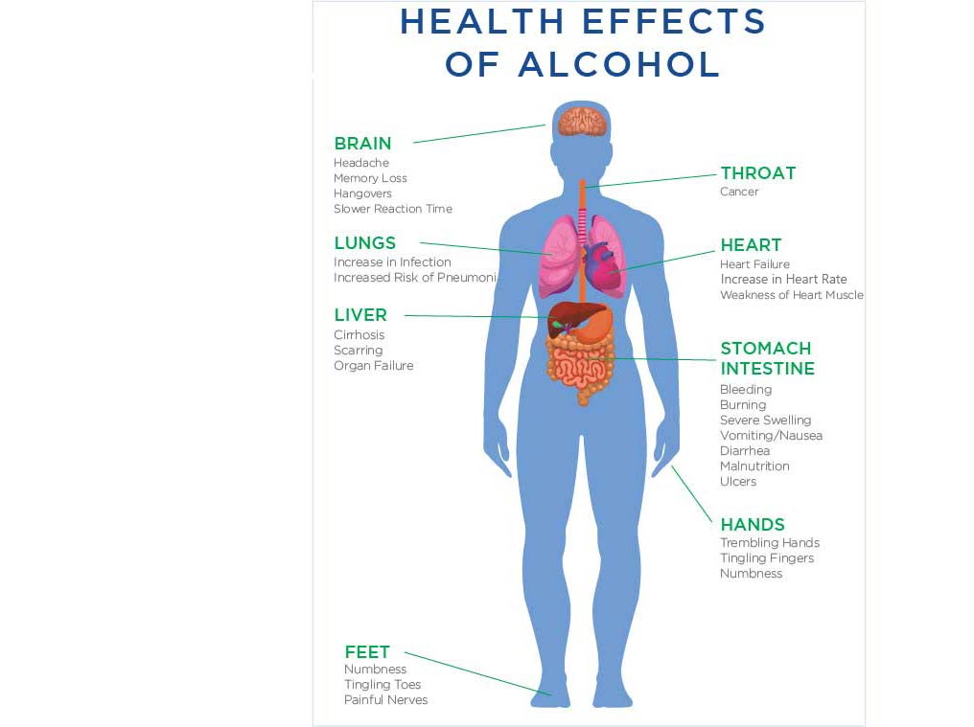

### Effects on the central nervous system

The popularity of ethanol as a legal drug is due to its depressant effects on the central nervous system (CNS) (Table: Alcohol Effects on the Nervous System). Once absorbed, ethanol (but not acetaldehyde) readily crosses the blood-brain barrier, allowing it to act at a number of locations within the CNS in a dose-dependent manner; the greater the dose the more extreme the effect (Reilly, 2002). Acute, moderate ethanol consumption will significantly alter cortical excitability and the way signals are transmitted in the CNS; these changes are responsible for many of the cognitive impairments associated with intoxication (Kähkönen, 2005; Volkow et al., 2008). Additionally, increased activity in the limbic region, through the actions of dopamine and serotonin, reinforce the pleasure associated with ethanol consumption, making it a highly addictive drug (Volkow et al., 2008).

Over time, the consumption of ethanol at harmful levels can result in significant, permanent structural and functional damage to the brain. Such damage can cause memory loss, learning difficulties, psychosis, mental confusion, and, in extreme cases, paralysis (Thomsom, Heap, & Shaw, 1994). Abstinence from ethanol and dietary supplementation with thiamine may reverse some of the structural and functional deterioration; however, for some, the damage will be irreparable (Ridley, Draper, & Withall, 2013).

Alcohol Effects on the Nervous System

| **Blood Alcohol Level (mg/100ml blood)** | **Blood Alcohol Content (BAC %)** | **Effects** |
| --- | --- | --- |
| 30 | 0.03 | Enhanced sense of well-being, retarded simple reaction time, impaired hand-eye coordination, and increased risk of having an accident |
| 60 | 0.06 | Mild loss of social inhibition, impaired judgement, and increasing cheerfulness |
| 90 | 0.09 | Marked loss of social inhibition, coordination reduced, and noticeably under the influence |
| 120 | 0.12 | Apparent clumsiness, loss of physical control, tendency towards extreme responses, and definite drunkenness noted |
| 150 | 0.15 | Erratic behavior, slurred speech, staggering gait, quarrelsomeness, and exuberance |
| 180 | 0.18 | Loss of control of voluntary activity and impaired vision |
| 400 | 0.400 | Oblivion, sleepiness, and coma |
| 500 | 0.500 | Death possible |
| 600 | 0.600 | Certain death |

### Effects on the cardiovascular system

Drinking ethanol is likely to acutely increase heart rate and, to a lesser extent, blood pressure. The increase in heart rate compensates for the well-documented decrease in left ventricle contractility that occurs when ethanol is consumed (Horwitz & Atkins, 1974) No significant changes in cardiac output are observed with moderate to high levels of alcohol consumption (Kupari, 1983). Chronic, harmful ethanol consumption is linked to an increased risk of coronary heart disease and alcoholic cardiomyopathy (Guzzo-Merello, Cobo-Marcos, Gallego-Delgado, & Garcia-Pavia, 2014).

In hot environments, ethanol-related increases in peripheral vasodilation (increased blood flow to the skin), along with increased feelings of being hot, (T. Yoda et al., 2005) can be cause for concern. Caution should also be taken when consuming ethanol in cold environments, as perceptions of cold and thermal discomfort are reduced (Tamae Yoda et al., 2008), which may lead to a greater time exposed to the cold. Both scenarios put an individual at risk of developing hypothermia.

Coach's Corner

When consuming alcohol, drink with food or on a full stomach to slow the rate of intoxication. Avoid drinking large amounts of alcohol in hot or cold environments and keep track of the number of *standard drinks* you are consuming, not simply the number of drinks.

### Effects on immune and hormonal function

Chronic alcohol use has long been associated with altered immune function, as evident in chronic alcoholics who often exhibit increased susceptibility to a range of infectious diseases (Cook, 1998). However, acute alcohol consumption may also negatively impact immune function, thus making the drinker more susceptible to infection (Greiffenstein, Mathis, Stouwe, & Molina, 2007; Szabo, 1999) and impacting recovery after illness or trauma.

Chronic alcohol use has long been associated with altered immune function, as evident in chronic alcoholics who often exhibit increased susceptibility to a range of infectious diseases (Cook, 1998). However, acute alcohol consumption may also negatively impact immune function, thus making the drinker more susceptible to infection (Greiffenstein, Mathis, Stouwe, & Molina, 2007; Szabo, 1999) and impacting recovery after illness or trauma.

Additionally, at certain doses, ethanol can alter normal hormone secretion with a reduction in testosterone in men and an increase in oestrogen in both sexes (Emanuele & Emanuele, 2001; Emanuele, Wezeman, & Emanuele, 2002). These changes may impact muscle mass, bone density, fertility, and sexual function (Emanuele & Emanuele, 2001; Van Thiel et al., 1980) and may contribute to the increased risk of breast cancer in females (Sarkola, Mäkisalo, Fukunaga, & Eriksson, 1999).

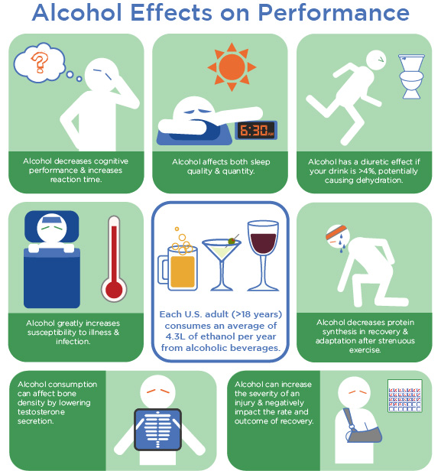

### Alcohol myths and hot topics

As with the three macronutrients (carbs, protein, and fat), the "fourth macro", alcohol, is surrounded with misinformation that can bring considerable confusion to the discussion of how it fits within a generally healthy lifestyle. The following section will address and discuss some of the more prolific myths and hot topics regarding alcoholic beverages and how they impact overall health and wellness.

**Ethanol helps protect the cardiovascular system**

Light to moderate regular ethanol consumption has been suggested, by association, to reduce total mortality and protect against cardiovascular disease and stroke (Agarwal, 2002). High in antioxidant polyphenols, red wine, in particular, has consistently been shown to improve a variety of health outcomes, including reducing the risk of cardiovascular disease, hypertension, some cancers, and diabetes. As such, daily moderate consumption (one to two standard drinks) of red wine is recommended, as part of a healthy diet (Snopek et al., 2018).

Conversely, recent studies (Knott, Coombs, Stamatakis, & Biddulph, 2015; Stockwell et al., 2016) challenge the popular view that moderate ethanol consumption may provide benefits for health. To date, the strongest evidence against ethanol’s health enhancing/protective effects comes from a study based on data analysed from 1990–2016 across 195 countries (Adhikari, 2018). Although this study identified some protective effects of ethanol against heart disease and diabetes in females, these were offset by other negative health consequences. Overall, not only did this study fail to find any ethanol-related health benefits, the authors concluded that no level of ethanol consumption was safe. Irrespective of the amount consumed, ethanol consumption appears to negatively impact health and contribute to premature death, particularly in males. These recent findings have implications for alcohol regulators as current alcohol guidelines may, in fact, overestimate how much alcohol is safe.

**Drinking ensures a good night’s sleep**

On the face of it, drinking an alcoholic beverage before bed may seem like a great way to get to sleep. After all, ethanol’s depressant effects on the CNS lead to drowsiness and reduce the time it takes to fall asleep, irrespective of how much ethanol has been consumed. However, once asleep, ethanol can disrupt normal sleep patterns so that the quality of sleep, measured by the time spent in REM and non-REM sleep and total time asleep is reduced. Non-REM deep sleep is considered as regenerative, mainly due to the release of growth hormone, and, although this type of sleep is increased when ethanol is consumed, growth hormone secretion by the pituitary gland is decreased (Roehrs & Roth, 2001).

For the athlete, reduced sleep quality and quantity as well as the associated decrease in growth hormone may have a number of implications, including suppressing immune function, impairing next-day cognitive functioning, and reducing physical performance. Additionally, a reduction in growth hormone secretion may also have implications for tissue repair, protein synthesis, and subsequent growth (Fullagar et al., 2015). For athletes who may already suffer from poor sleep quality and quantity as a result of training, competition, travel, and social factors (Drew et al., 2017; Halson et al., 2017), the consumption of ethanol in the hours prior to sleep should ideally be avoided or minimised.

**Alcohol improves athletic performance**

The use of alcohol to improve athletic performance has it foundations in ancient Greece where, as part of his diet, the great Olympic champion Milo of Croton was said to have consumed 2.6 gallons of wine a day (Harris, 1966). While this is an unlikely tale, the popularity of consuming ethanol as an ergogenic aid before and during sport and exercise continued until the middle of the 20th century. Unbeknownst to these early athletes, ethanol consumed prior to or during exercise has no performance enhancing benefits and, in fact, is more likely to be ergolytic, particularly when consumed in higher amounts.

Short duration efforts, such as sprinting and one-off, simple-strength tasks do not appear to be affected even at high BACs. However, for longer duration, aerobic exercise performance is reduced with greater effects seen as the amount of ethanol consumed increases (Barnes, 2014). Importantly, the reductions in coordination, reaction time, and decision making at even moderate BACs may reduce the ability of an athlete to execute exercise technique or other training-related motor tasks efficiently and safely. Combined, these effects strongly suggest that there is no place for ethanol consumption prior to training or exercise.

Drinking ethanol before and during exercise is rare, although not unheard of; however, drinking after exercise is a more likely scenario, with athletes more likely to binge on alcohol at higher rates than non-athletes (Sønderlund et al., 2014; Tavolacci et al., 2016; Veliz, McCabe, & Boyd, 2016). Drinking alcohol in amounts similar to those reported by athletes may negatively impair recovery from exercise-induced muscle damage in males (Barnes, Mündel, & Stannard, 2010a & 2010b), but not females (Levitt et al., 2017; McLeay, Stannard, Mundel, Foskett, & Barnes, 2017).

However, even when very-high doses of alcohol are consumed, if muscle damage is not considerable or the type of exercise performed prior to drinking is not novel, then recovery may be minimally affected (Levitt et al., 2018; Murphy, Snape, Minett, Skein, & Duffield, 2013; Prentice, Stannard, & Barnes, 2014).

Large amounts of ethanol, consumed after resistance exercise, alter hormone secretion (Vingren & Kraemer, 2006) and reduce protein synthesis (Duplanty et al., 2017; Parr et al., 2014) and inflammation, (Levitt et al., 2016) suggesting that ethanol has the potential to impair adaptation to resistance exercise. Whether this is the case is currently unknown. As with recovery from damaging exercise, similar responses to ethanol as those seen in males are not necessarily evident in females (Budnar, 2015; Duplanty et al., 2017) possibly as a result of the female sex hormone oestrogen.

Food for Thought

As a population, college athletes tend to binge on alcohol and are more at risk of alcohol-related harm than other populations in the United States (Martens, Dams-O'Connor, & Beck, 2006) and other countries (O’Brien et al., 2012; Zhou & Heim, 2014). Although drinking behaviour may differ between intramural/club athletes who regularly consume alcohol at hazardous levels and intercollegiate athletes who drink less often but consume very-large quantities when they do drink, both groups of athletes are at an increased risk. The difference in drinking behaviour between the two groups may be due to the more structured nature of intercollegiate sport and the more time intramural athletes have for socialising (Barry, Howell, Riplinger, & Piazza-Gardner, 2015; Marzell, Morrison, Mair, Moynihan, & Gruenewald, 2015). Additionally, team sport players, who have a strong athlete identity often consume alcohol in very-large, harmful amounts. The opposite is true of athletes in individual sports; the stronger their athlete identity is, the less they are likely to drink (Zhou, Heim, & O'Brien, 2015). College athletes drink alcohol as a reward for the hard work they put in during training and competition, to celebrate success (Pitts, Chow, & Donohue, 2018), and as a way to deal with sport-related stress (Martens, Pedersen, Smith, Stewart, & O'Brien, 2011). Educating college athletes about the harm, both physical and social, that alcohol can do is important. The success of such education can be helped greatly if the coach takes an appropriate attitude toward harmful drinking by showing concern for the athlete’s alcohol use and by being less permissive of this type of behaviour (Mastroleo, Marzell, Turrisi, & Borsari, 2012; Pitts, Chow, & Yang, 2018).

If ethanol is to be consumed after exercise, then, in order to ensure the effects of ethanol on recovery and subsequent performance are minimised, normal post-exercise nutritional recommendations should be followed prior to consuming alcohol. Alcohol consumption should be delayed, until foods containing carbohydrates and protein are eaten. This will ensure substrates are available for glycogen resynthesis and protein synthesis and are not replaced by energy from ethanol. Remember from earlier in the chapter, ethanol is preferentially metabolised by the body, negatively impacting repair. Although ethanol will not worsen the level of post-exercise hypohydration (Hobson & Maughan, 2010), rehydration prior to consuming large volumes of alcohol is also recommended (Evans, James, Shirreffs, & Maughan, 2017).

The main form of alcohol contained in the recreational beverages we drink is ethanol. Because ethanol is metabolised in such a unique way, it is often referred to as the fourth macronutrient. But ethanol has no nutritive value and the acetate produced when metabolising it can get in the way of the body oxidising its own fat. When used in moderation, alcohol can, in fact, have some positive benefits for an individual's overall health and wellness; however, it can quickly transition to a harmful (or even deadly) substance when consumed in excess.

Alcohol is the most widely consumed drug on Earth, so it is important for Nutrition Coaches to understand the wide range of effects is has on the body. By understanding how alcohol is absorbed and metabolised (while considering the physiological differences between males and females) Nutrition Coaches can help their clients stay on track with their health-and-wellness goals while still having a little fun on the side!

In this chapter, you learned about:

* The makeup of common alcoholic drinks.
* The chemical structure of ethanol.
* How consumed ethanol is processed and eliminated from the body.
* Ethanol absorption and metabolic differences for men and women.
* The cognitive and health impact of consuming ethanol.
* How the body uses metabolised ethanol for energy.
* Strategies for incorporating alcoholic drinks into a healthy diet.

# Micronutrients

Macronutrients and micronutrients are defined by the quantity in which they are needed in the diet. Macronutrients (i.e., protein, carbohydrates, and fat) are nutrients that are needed in large quantities, often in terms of tens to hundreds of grams per day. Conversely, micronutrients (i.e., vitamins and minerals) are nutrients that are needed in small quantities, often in terms if micrograms or milligrams. Similar to macronutrients, micronutrients can be found in animal and plant food sources as well as in supplementation.

Whereas macronutrients are the molecules used to produce structure metabolised directly for energy, micronutrients (both vitamins and minerals) are critical in maintaining the metabolic processes that produce energy. A good analogy for this is the different roles that petrol and oil play when producing energy in a car. Petrol is the main source of energy (the macronutrients) for the car and it is combusted (oxidised) to generate energy and make the engine run. The oil (micronutrients) is critical for allowing the engine to run smoothly, enabling all the parts to move (Figure: Understanding Micronutrients).

To be a little more specific, in the context of human nutrition and metabolism, micronutrients are used as coenzymes and cofactors for many of the metabolic reactions and are used quite extensively in the mitochondria to facilitate the electron transport chain. For example, vitamins B1 and B2 are required for the Krebs cycle to function properly, while minerals like iron and sulphur are critical in maintaining the function of the electron transport chain (Huskisson, Maggini, & Ruf, 2007).

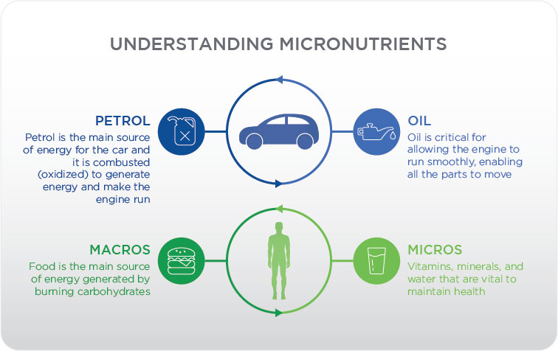

Helpful Hint

Macronutrients and micronutrients both play critical roles in metabolism, with micronutrients being crucial for facilitating energy production. A good way to think about this is that micronutrients are the oil for your car, which keeps the engine running smoothly; the macronutrients are the petrol that provide the energy.

Micronutrients are critical to maintaining robust human metabolism and overall human health. Deficiencies in micronutrients are the cause of diseases like scurvy (vitamin C deficiency), rickets (vitamin D deficiency), and blindness (vitamin A deficiency). Additionally, deficiencies in micronutrients such as magnesium can impair glucose metabolism and deficiencies in selenium can result in muscle pain and bone disorders. In developed countries, overt deficiencies in any of these micronutrients are rare; however, deficiencies still occur with alarming frequency in developed countries.

## Water-soluble vitamins

Water-soluble vitamins are defined as vitamins that can dissolve in water. Due to this ability, they are not stored in the tissue of the body but are present in the blood and other water-based fluids. Many water-soluble vitamins are essential, meaning that they must be consumed from foods or dietary supplements. They are found in both animal foods and plant foods.

Most of the water-soluble vitamins are part of the B-complex family of vitamins. Review the B-complex family in Figure: Water-Soluble Vitamins. Another water-soluble vitamin is vitamin C.

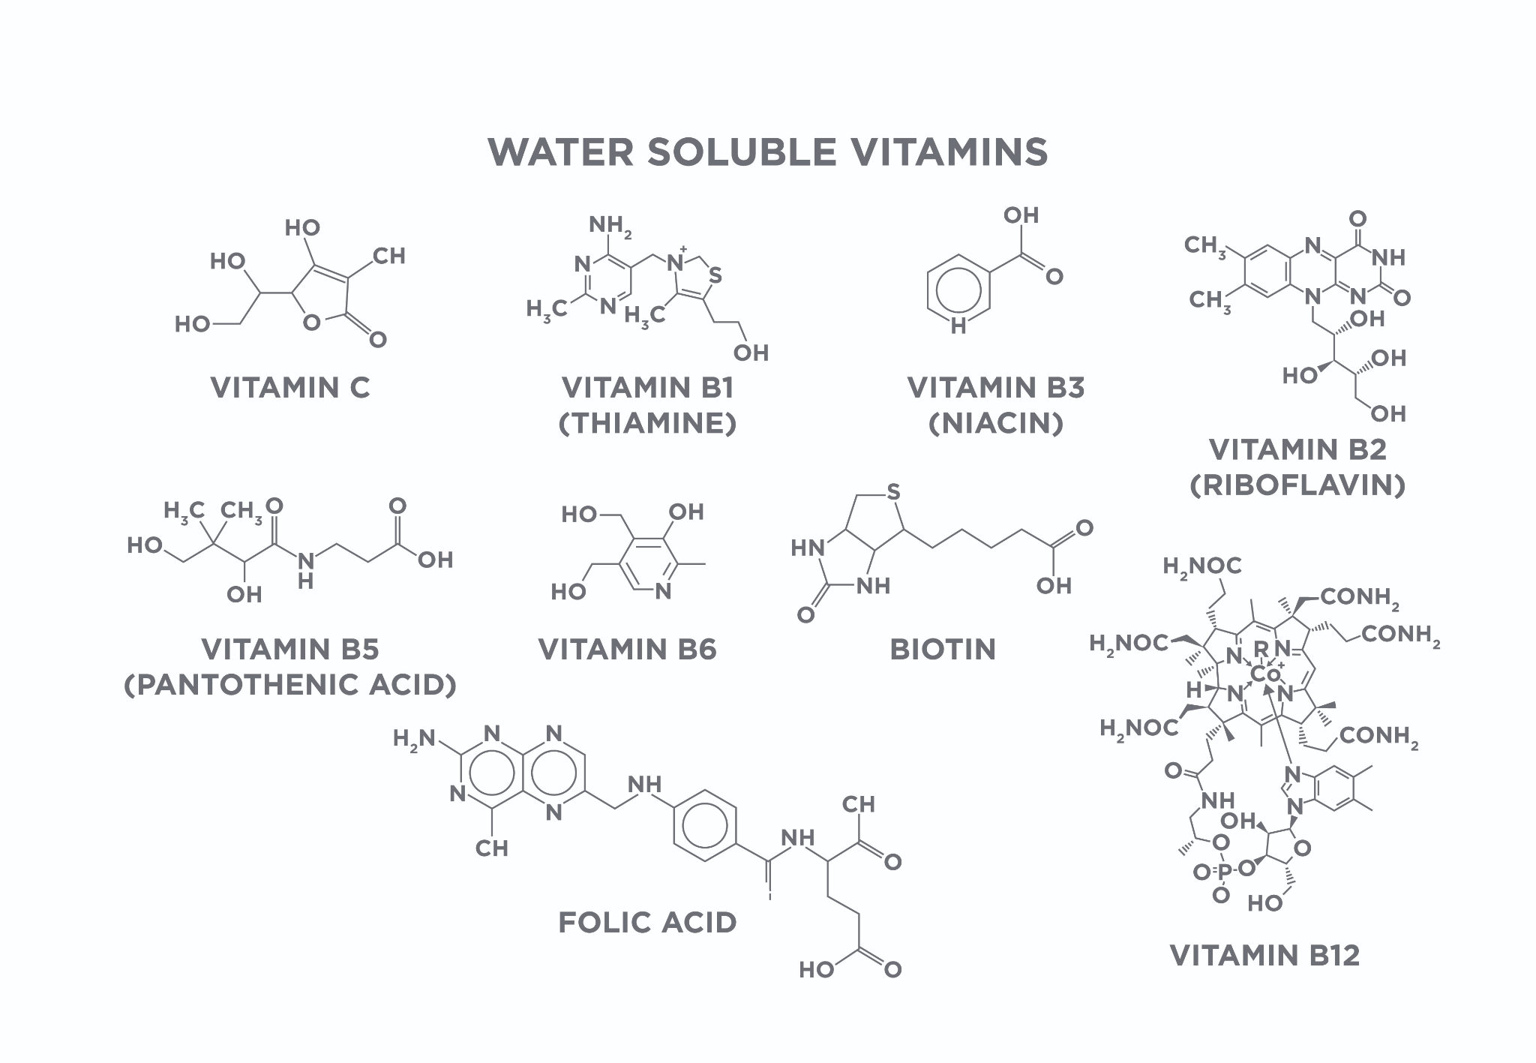

These vitamins are excreted in the urine and must be replaced daily for optimal health. Because they are not stored and easily excreted, large and/or mega doses of these vitamins are often wasteful. Much of the excess is excreted and never used by the body.

Food for Thought

Water-soluble vitamins are not stored in the tissues and excess levels are excreted. Therefore, urine becomes a vibrant, bright yellow after consumption of a large dose of vitamin B-complex vitamins, vitamin C, or a multivitamin.

### Vitamin B1 (Thiamine)

*What is it and why is it important?*

Vitamin B1, commonly referred to as thiamine, is critical in the metabolism of sugar and amino acids as well as central nervous system function. Vitamin B1 is found in high concentrations in skeletal muscle and it has been hypothesized that individuals who engage in higher levels of physical activity are more likely to have low levels of vitamin B1 and may require higher intakes of vitamin B1 or supplementation (Manore, 2000; Figure: Vitamin B1).

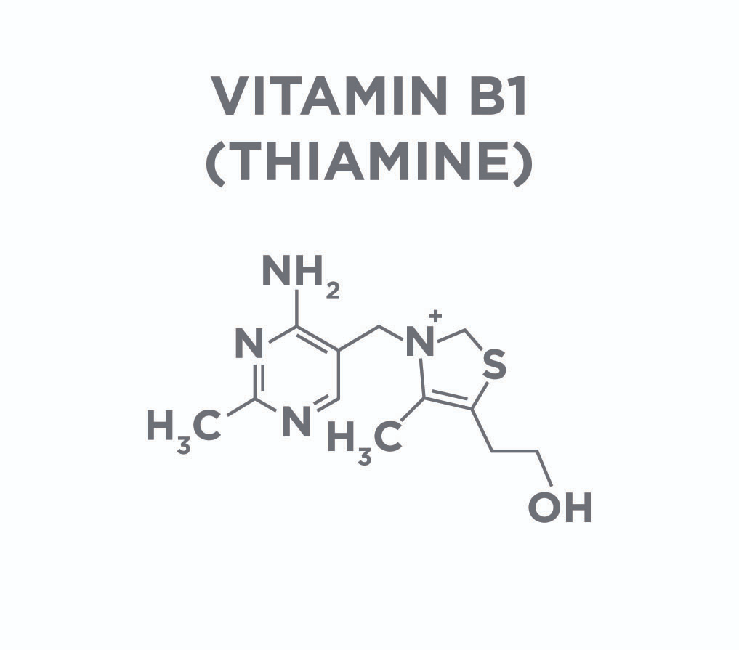

Deficiency in vitamin B1 can lead to several serious health conditions, specifically beriberi and Wernicke encephalopathy. Ensuring someone consumes an adequate amount of vitamin B1 in the diet can prevent these conditions. Research on the effect of vitamin B1 supplementation on performance in humans unfolds that, outside of preventing deficiencies, it does not help performance.

*Where is it found in foods?*

Vitamin B1 is found in fortified and enriched grains, as well as animal meats (beef, pork, and salmon). It can also be found in squash, black beans, and flax seeds.

*How do we apply this information?*

Most people who consume a well-rounded diet get enough vitamin B1 and, in almost all cases, supplementation is not necessary. However, if someone is eating a low-quality diet, limited in the foods shown in Water-Soluble Vitamins Handout, it would be important to have a person’s vitamin B1 levels assessed to ensure they are not deficient.

### Vitamin B2 (Riboflavin)

*What is it and why is it important?*

Vitamin B2, commonly referred to as riboflavin, is critical in the metabolism of proteins, carbohydrates, and fat and is a component of flavin adenine dinucleotide (FAD), an essential part of the antioxidant system in the body. Deficiencies in vitamin B2 result in dry skin, sore throats, and inflammation primarily due to its role in the antioxidant system (Figure: Redox Basis of Illness). This, however, does not mean added supplementation boosts performance. The evidence on deficiencies or inadequacies in athletic populations is equivocal.

*Where is it found in foods?*

Vitamin B2 is found in a wide range of food sources: beef, fish, pork, milk, mushrooms, peanuts, avocados, and eggs. Deficiencies are not common in the normal population because of its widespread availability in the diet (refer to the Water-Soluble Vitamins Handout on the previous page (Figure: Vitamin B2).

*How do we apply this information?*

Obtaining enough vitamin B2 to maintain health is easily achieved through a balanced diet. Similar to vitamin B1, supplementation in most cases is not necessary. Furthermore, it is not something that needs to be supplemented in athletic populations unless a medical professional has assessed the diet and diagnosed a deficiency.

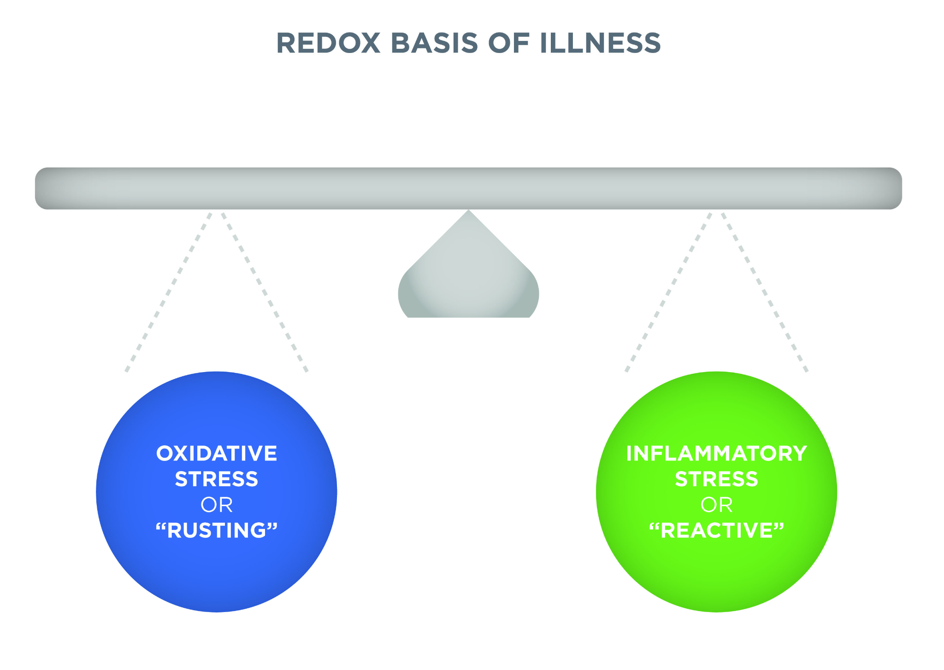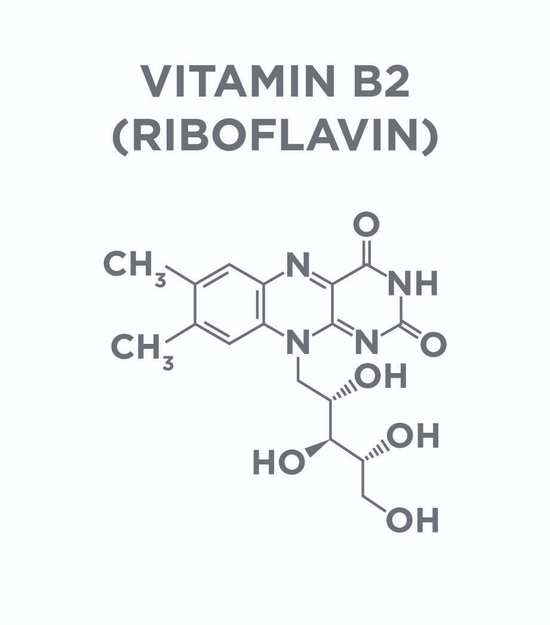

### Vitamin B3 (Niacin)

*What is it and why is it important?*

Vitamin B3, commonly referred to as niacin, shares many similarities with vitamin B2 because it is critical in the metabolism of proteins, carbohydrates, and fat. It is also a component of a dinucleotide, specifically, nicotinamide adenine dinucleotide (NAD). NAD plays a critical role in the Krebs cycle and electron transport chain and is responsible for much of the ATP production in our cells. Furthermore, NAD is involved in the production of many other macromolecules that are essential for optimal function, including cholesterol and fatty acids (Figure: Vitamin B3).

Though vitamin B3 deficiency is rare, occurrence leads to inflammation of the skin, headache, diarrhoea, memory loss, and, in severe cases, it can lead to death. There has been very little research conducted on vitamin B3 and physical performance. One study demonstrated that supplementation with vitamin B3 did not improve 10-mile run times in trained runners (Norris, Schade, & Eaton, 1978).

*Where is it found in foods?*

Vitamin B3 is found in many of the same foods with B1 and B2: beef, fish, pork, milk, mushrooms, peanuts, avocados, and eggs (refer back to the Water-Soluble Vitamins Handout). Given its abundance in many of the commonly consumed foods and it being included in enriched grains, deficiencies are rarely seen.

*How do we apply this information?*

Obtaining enough vitamin B3 to maintain health is easily achieved through a balanced diet and supplementation is not required for most people. Also, supplementation with vitamin B3 is not effective at improving athletic performance.

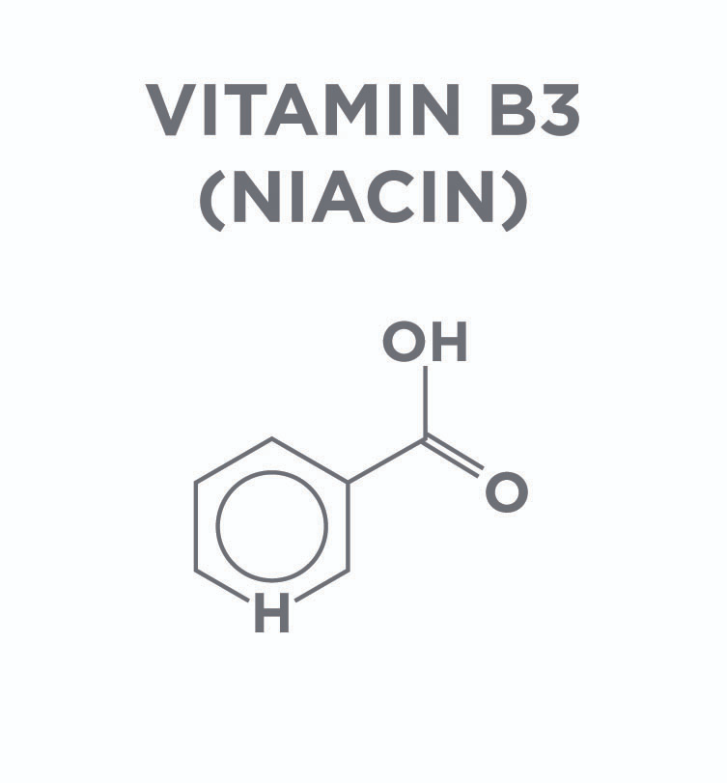

### Vitamin B5 (Pantothenic Acid)

*What is it and why is it important?*

Vitamin B5, commonly referred to as pantothenic acid, is a component to co-enzyme A (CoA). CoA serves as a molecular link between glycolysis and the Krebs cycle, which means that it is involved in the metabolism of proteins, carbohydrates, and fatty acids. Vitamin B5 also plays a fundamental role in the production of cholesterol, fatty acids, and other molecules, such as coenzyme Q10 (CoQ10) (Figure: Vitamin B5).

Vitamin B5 deficiency is quite rare and occurs in cases of severe malnutrition, so it is not a primary concern for most people. Despite it being critical in one of the key molecules in all of human metabolism, there is very little research on the effect of pantothenic acid supplementation on improving overall health or improving performance.

*Where is it found in foods?*

Vitamin B5 is found in similar foods as vitamins B1, B2, and B3. Primarily, it is found in fortified and enriched grains, fish, beef, chicken, lentils, many seeds, and even shiitake mushrooms.

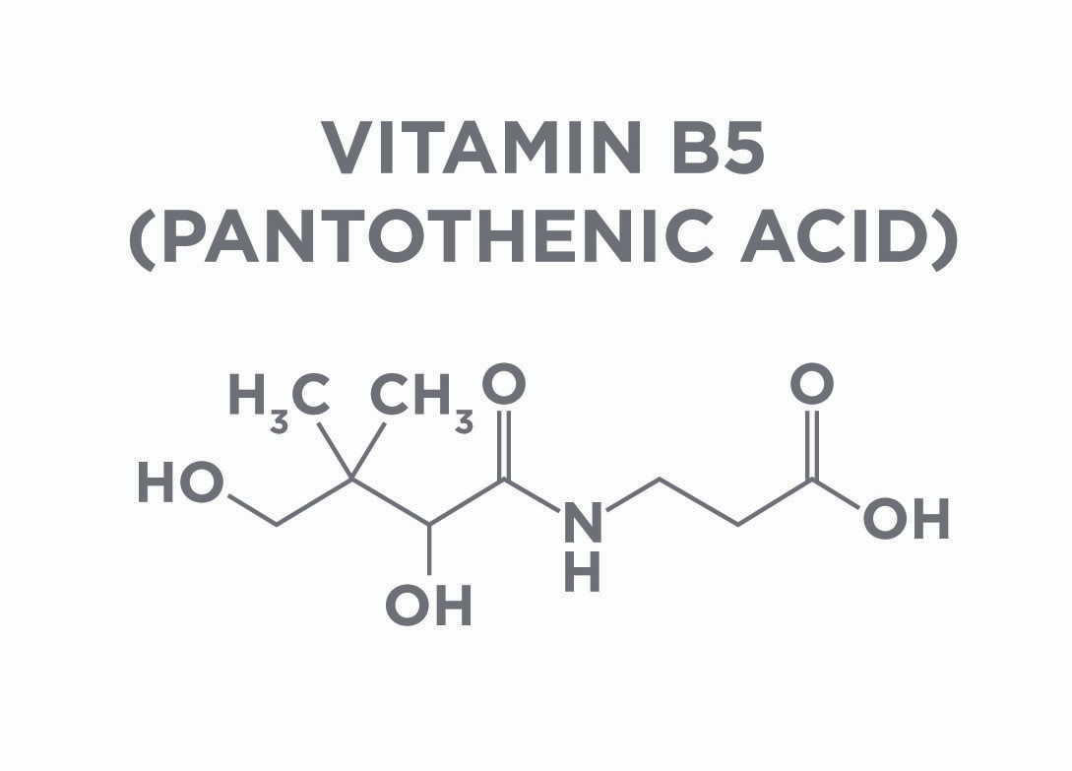

### Vitamin B6

*What is it and why is it important?*

Vitamin B6 represents a class of several related (but different) molecules, each of which are important for optimal health (“Office of Dietary Supplements - Dietary Supplement Fact Sheet: Vitamin B6,” 2018). Briefly, these molecules are pyridoxal, pyridoxine, and pyridoxamine. Several of these, specifically pyridoxal and pyridoxamine, play critical roles in metabolism.

These are involved in the breakdown of glycogen into glucose and the production of glucose and neurotransmitters. Vitamin B6 deficiency is uncommon in otherwise healthy people with one study showing inadequate levels of vitamin B6 being present in about 1.5% of the people studied (Ho, Quay, Devlin, & Lamers, 2016). However, Vitamin B6 supplementation may help reduce the risk of complications in people with diabetes (Williams et al., 2007).

Vitamin B6 also does appear to alter fuel metabolism slightly during exercise, shifting it to use more carbohydrates and less fat (Manore & Leklem, 1998; deVos, Leklem, & Campbell, 1982). However, it does not appear to either impair or improve performance (Manore & Leklem, 1988).

*Where is it found in foods?*

Vitamin B6 is found in fortified grains and in dairy along with eggs, organ meats (e.g., liver), potatoes, bananas, parsnips, and some nuts (e.g., pistachios).

*How do we apply this information?*Consuming a balanced diet that contains animal meats and is rich in fruits, vegetables, and nuts will provide adequate vitamin B6. While most people do not require supplementation, including athletes, it may be of use for people with diabetes to reduce the risk of complications.

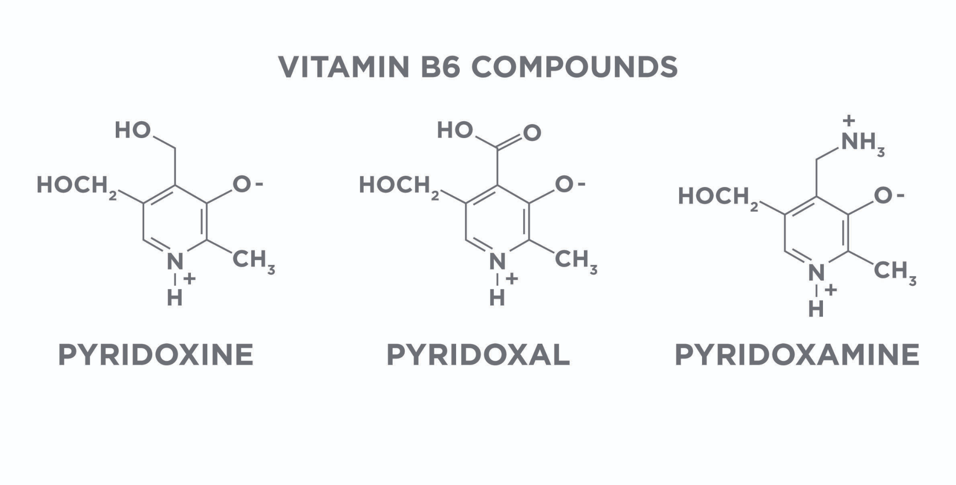

### Vitamin B7

*What is it and why is it important?*

Vitamin B7, commonly referred to as biotin and formerly referred to as vitamin H, is a cofactor in many carboxylase enzymes, which are responsible for transferring carbon dioxide molecules and the metabolism of carbohydrates, fatty acids, cholesterol, and amino acids (“Office of Dietary Supplements - Biotin,” 2018; Pacheco-Alvarez, Sergio Solórzano-Vargas, & Del Rı́o, 2002) [Figure: Vitamin B7 (Biotin)].

Biotin deficiency is rare, given that it is needed in very small quantities (about 30 µg/day), is found in many common foods, and is synthesised by gut bacteria. Biotin deficiencies can result in hair loss (alopecia), dermatitis, and issues with nails. Supplementation to correct major deficiencies have shown some benefit to these conditions. However, in otherwise healthy people, biotin supplementation does not appear to provide a measurable benefit to hair, nails, or skin. While there are robust marketing claims to support biotin supplementation as a beauty aid, and one study showing a small benefit on nail health, the cumulative scientific data do not support it (Colombo, Gerber, Bronhofer, & Floersheim, 1990).

*Where is it found in foods?*

Vitamin B7 is found in similar foods as vitamin B6: organ meats, fish, nuts and seeds, and dairy. Biotin is needed in such small quantities that a diet containing dairy, nuts, and seeds usually provides enough biotin to avoid the need for supplementation.

*How do we apply this information?*

Biotin supplementation is not necessary for most people as a well-rounded, balanced diet provides enough biotin to prevent deficiencies. Furthermore, biotin supplementation does not appear to benefit hair, skin, or nails and people should not be advised to take it for this purpose.

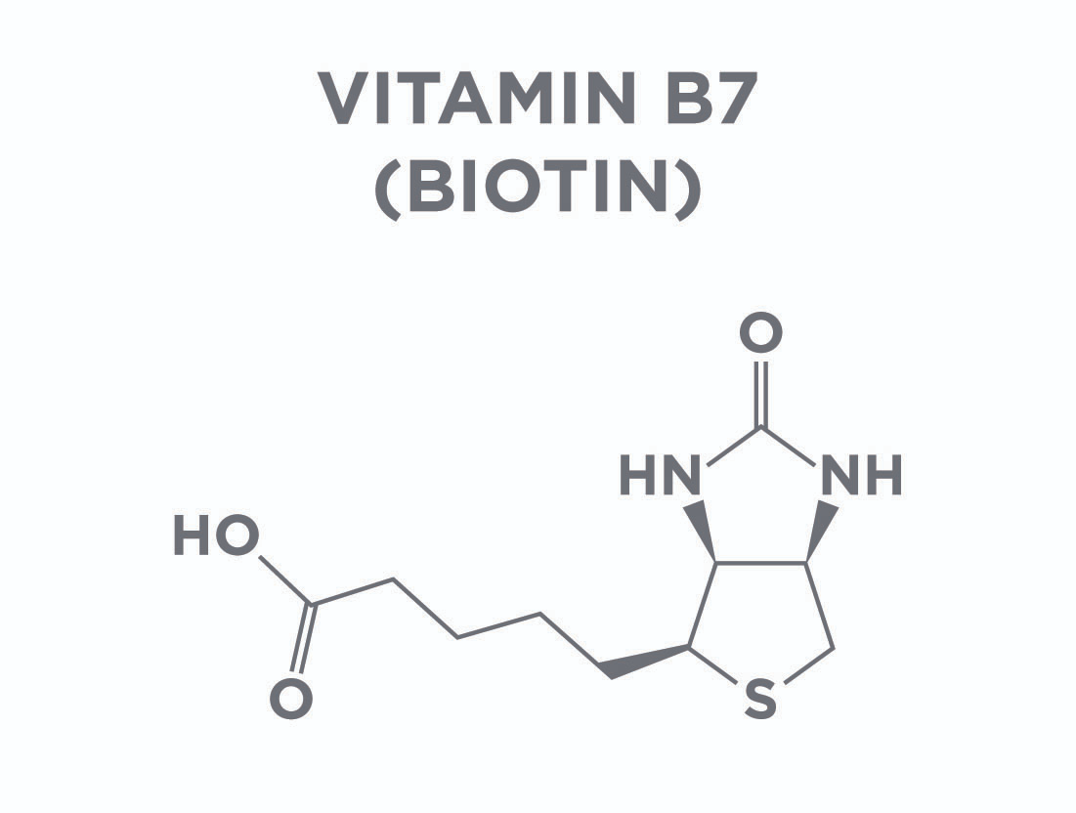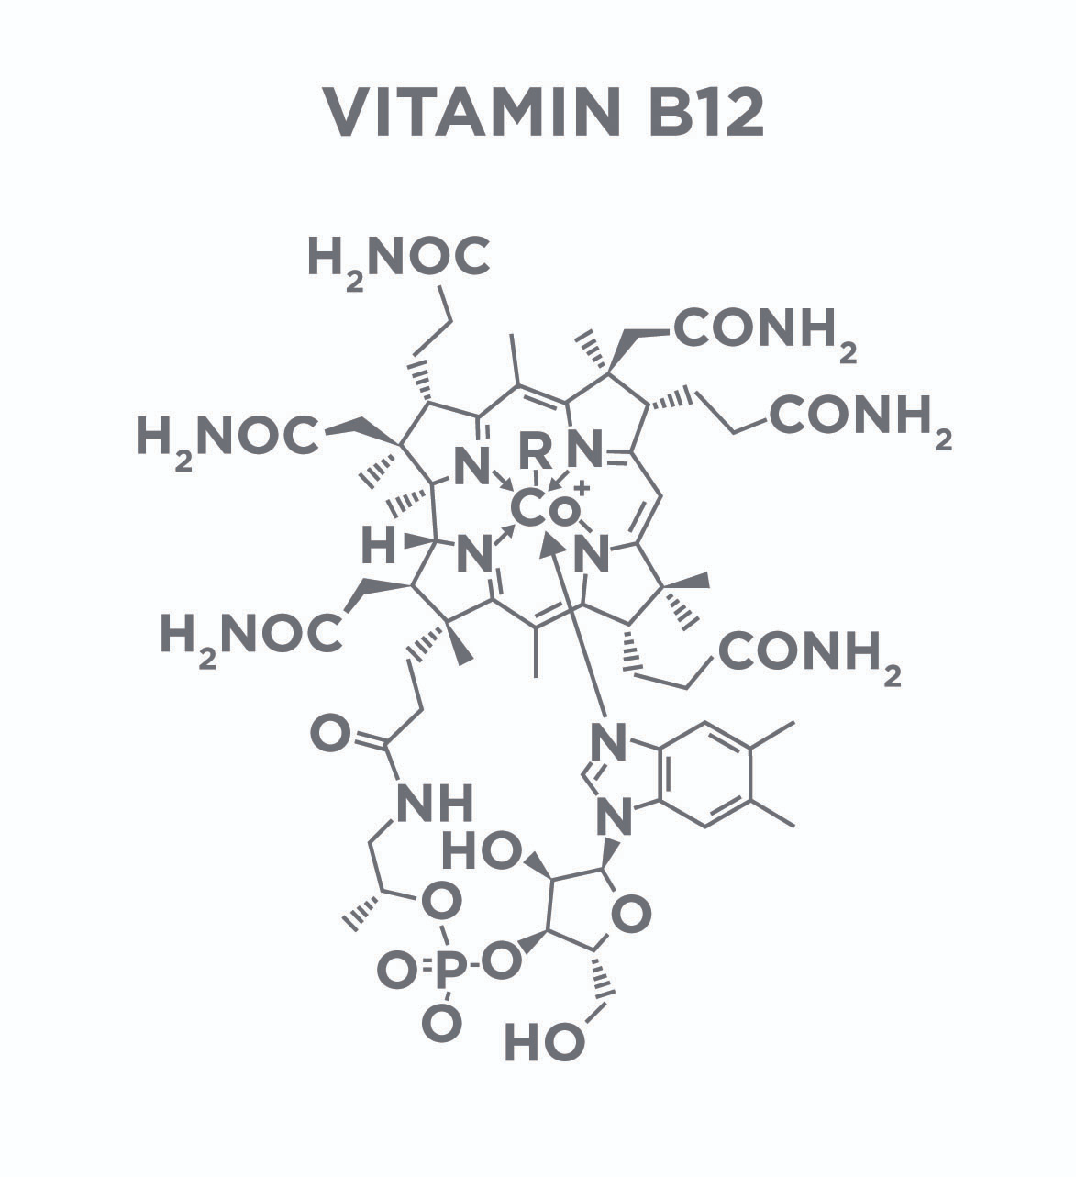

### Vitamin B12

Vitamin B12 stands out among the B-complex vitamins in that it is the largest, comes in many forms, and contains a heavy metal/mineral in its molecular structure, specifically cobalt (“Office of Dietary Supplements - Vitamin B12,” 2018). Vitamin B12 is involved in many different metabolic processes, including DNA synthesis, red blood cell production, and in maintaining proper neurological function (Figure: Vitamin B12).

In fact, vitamin B12 deficiency can lead to anaemia (Lane & Rojas-Fernandez, 2002), neurologic disorders (Lane & Rojas-Fernandez, 2002; Lindenbaum et al., 1988), and a host of other diseases and disorders. Supplementation with vitamin B12 has been shown to improve the health of infants in developing countries, where deficiency is common (Srinivasan et al., 2017; Thomas et al., 2018). While vitamin B12 supplements are often marketed as energy supplements, there is little evidence examining the effect of vitamin B12 supplementation on athletic performance.

*Where is it found in foods?*

Vitamin B12 is found in fortified grains, shellfish, fish, beef, and dairy. Vitamin B12 is not found in as many foods as the other B vitamins; subsequently, deficiency is more common with vitamin B12 than the others. Deficiency of vitamin B12 appears to vary substantially across age groups, by geographic location, and by a country’s socio-economic status. For example, vitamin B12 deficiency in children and young adults in developed nations is between <1 to 3%, while vitamin B12 deficiency has been reported at 70 to 80% in developing countries.

*How do we apply this information?*

Of all the B vitamins, vitamin B12 needs the most consideration as deficiency is more common than the other B vitamins, especially in developing countries. Deficiency is more common in people who consume a vegetarian or vegan diet and supplementation ought to be considered among vegetarians and vegans (Pawlak, Lester, & Babatunde, 2014). Furthermore, vitamin B12 status should be checked in pregnant women as vitamin B12 status may impact foetal and infant health.

### Folic acid (Folate)

*What is it and why is it important?*

Like vitamin B12, folic acid (folate) is unique among the B-vitamins; however, it plays a narrower role in human metabolism than vitamin B12. Folate helps regulate single-carbon transfers, both accepting and donating single carbons to chemical reactions (“Office of Dietary Supplements - Dietary Supplement Fact Sheet: Folate”, 2018). These single-carbon reactions are critical as they help produce red and white blood cells as well as DNA when cells make copies of themselves. Like vitamin B12, deficiencies in folate can lead to anemia [Figure: Folic Acid (Folate)].

Also, similar to vitamin B12 and the other B vitamins, deficiencies in folate are uncommon in young, otherwise healthy individuals in developed countries but are higher in lower socio-economic groups (Umesh Kapil, 2014) and in older adults (Clarke et al., 2004).

In pregnant women, folate supplementation may improve haemoglobin levels and reduce birth complications (Greenberg, Bell, Guan, & Yu, 2011). Furthermore, it may also help with recovery from depressive disorders (Godfrey et al., 1990; Taylor, Carney, Geddes, & Goodwin, 2003).

Folate supplementation has not been shown to improve athletic performance and the research surrounding the effect of folate on athletic performance is scarce (Matter et al., 1987). However, folate supplementation can be an important part of a nutritional strategy for certain populations, as mentioned. In fact, since folate fortification was mandated in grains in the late 90s or early 2000s, depending on the country, rates of neural tube defects have decreased dramatically and it is considered one of the most successful national health campaigns in history.

Folic Acid Fortification Levels

| **Levels of folic acid fortification in countries with mandatory fortification programs** | | |
| --- | --- | --- |
| Country | Fortification Level | Date of Implementation |
| United States | 140 µg/100g | 1998 |
| Canada | 150 µg/100g | 1998 |
| Costa Rica | 180 µg/100g | 1998 |
| Chile | 220 µg/100g | 2000 |
| South Africa | 150 µg/100g | 2003 |

Source: Crider, K. S., Bailey, L. B., & Berry, R. J. (2011, Mar.). Folic Acid Food Fortification—Its History, Effect, Concerns, and Future Directions. *Nutrients*, *3*(3): 370–384. doi: 10.3390/nu3030370

*Where is it found in foods?*

Folate is found in similar foods as B12: fortified grains, seafood, lean meats and poultry, eggs, legumes (beans and peas), nuts, seeds, and soy products.

*How do we apply this information?*

Folate, like vitamin B12, deserves attention and blood levels of folate should be measured routinely in specific populations: pregnant women, people with depressive disorders, and in people with a history of anaemia. Supplementation should be considered in people with low levels of folate or in people who may consume a low folate diet (e.g., vegans or vegetarians).

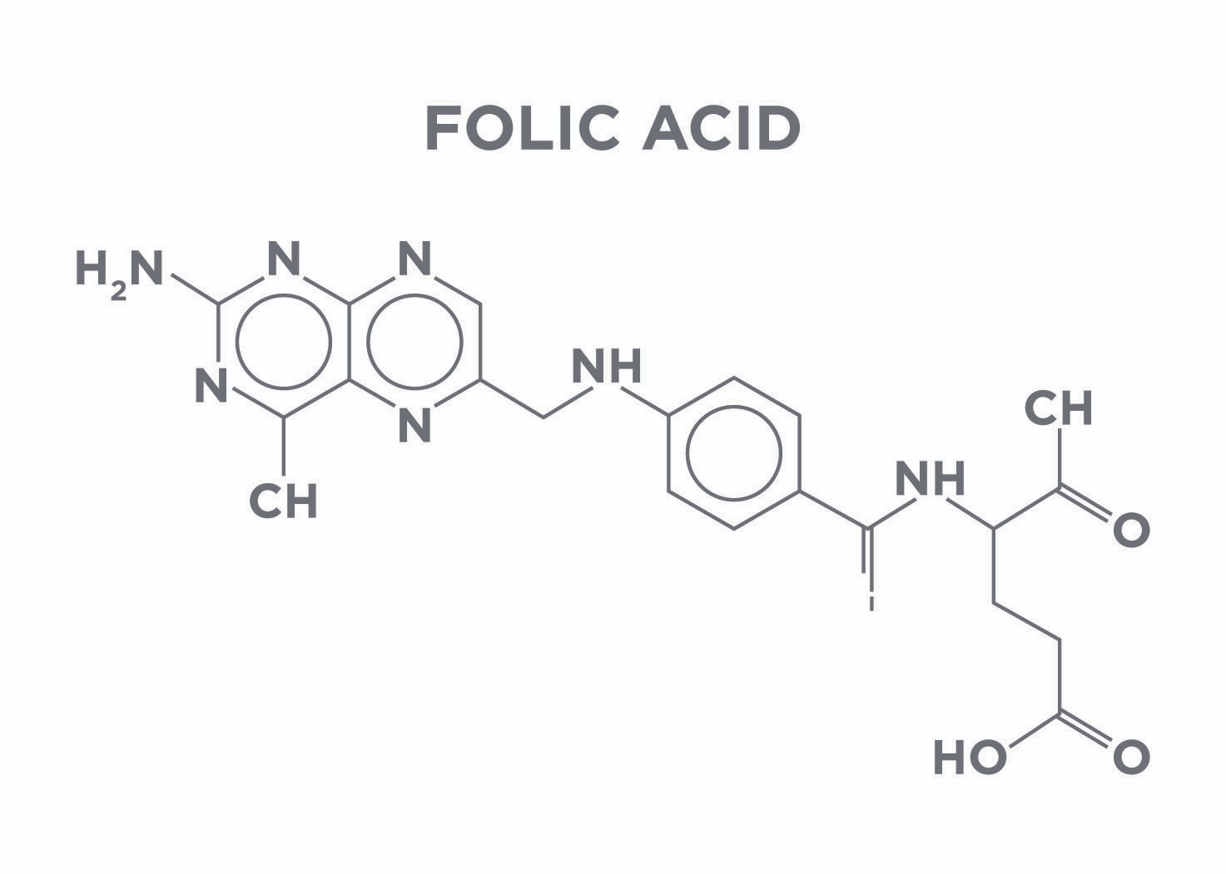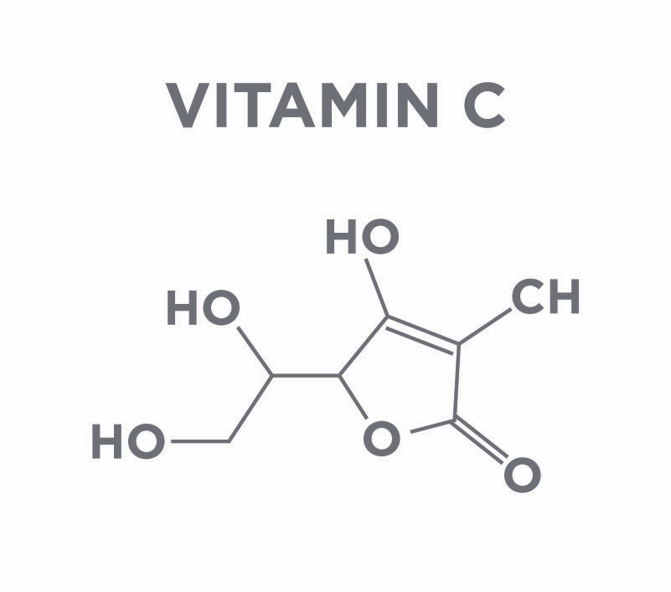

### Vitamin C

*What is it and why is it important?*

Vitamin C, commonly referred to as ascorbic acid, is one of the more robust vitamins. It plays myriad roles in the human body. Deficiencies in vitamin C can lead to diseases such as scurvy as well as less-serious conditions such as dry skin.

There has been a substantial amount of research exploring the effect of vitamin C on health. Currently, the evidence indicates that adequate amounts of vitamin C is important for maintaining your antioxidant system and minimizing disease risk (Figure: Benefits of Vitamin C). However, there are not any real benefits to vitamin C supplementation, including treating the common cold among otherwise healthy people.

Vitamin C has been quite extensively studied in athletic populations and it does appear to have some benefit. Primarily, it has been shown to reduce exercise-induced muscle damage and reduce post-exercise soreness known as delayed-onset muscle soreness (DOMS). There are also some considerations for abstaining from vitamin C supplementation as antioxidant therapy may prevent adaptation to exercise (Paulsen et al., 2014). The current status of the evidence is mixed and it is not entirely certain whether vitamin C supplementation is beneficial for exercise or detrimental and in what circumstances it might play either role (Nikolaidis, Kerksick, Lamprecht, & McAnulty, 2012).

*Where is it found in foods?*

Vitamin C is found primarily in bright coloured fruit (e.g., oranges, strawberries, guavas, or cherries), capsicums, cruciferous vegetables, dark leafy greens, and tomatoes. Due to the presence of vitamin C in a wide variety of food, deficiencies in vitamin C are uncommon. However, they do still occur in roughly 7% of the U.S. population (Schleicher, Carroll, Ford, & Lacher, 2009).

*How do we apply this information?*

It is important to consume adequate amounts of vitamin C to prevent diseases such as scurvy and to maintain the antioxidant system. This can be easily achieved by consuming several servings of fruits and vegetables daily. Supplementation is not necessary for most people consuming a balanced diet. Furthermore, vitamin C supplementation is not advised as an ergogenic aid. In fact, a large single serving of vitamin C can result in GI distress and sometimes lead to diarrhoea.

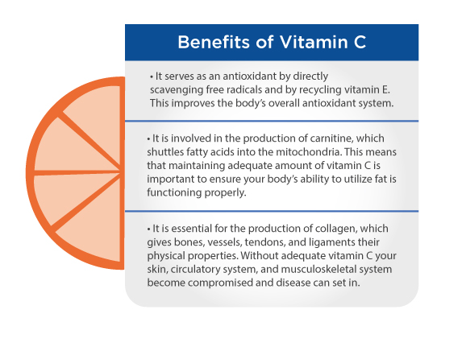

### Choline

*What is it and why is it important?*

Choline plays many important roles, but the two main roles of choline are to aid in providing structure for cell membranes and as a critical molecule for the production of the neurotransmitter acetylcholine (“Office of Dietary Supplements - Choline,” 2018). Choline also can play a role in changing how the genes are expressed by adding specific tags, methyl groups, to your DNA. This process can change whether genes are turned on or turned off. The body manufactures choline in the liver but does not make enough to cover all the choline needs of the body, meaning that choline must be consumed in the diet.

Deficiency of choline leads to organ dysfunction, primarily fatty liver and damage to muscle tissue [(Fischer et al., 2007)](https://paperpile.com/c/cZDv7y/NwwjP). Homocysteine has been hypothesised to play a role in the development of heart disease, and, as choline supplementation can lower homocysteine levels, there has been some speculation over the potential benefit of choline for reducing risk of heart disease (Olthof, Brink, Katan, & Verhoef, 2005).

Coach's Corner

It is important that people consume enough choline to prevent deficiency, but it should not be considered a supplement that prevents heart disease.

*Where is it found in foods?*

Choline is found primarily in organ meats and egg yolks. It can also be found in oysters; dark, leafy greens; cauliflower; and mushrooms.

Getting Technical

Acetylcholine is a chemical messenger that is released in muscle cells to activate muscle contraction. It is essential for all movement.

It has been hypothesised that choline supplementation might improve athletic performance by increasing how much or how long muscles can contract by increasing the amount of acetylcholine in muscle tissue. Currently, the data do not provide evidence to support the use of choline as an ergogenic aid.

*How do we apply this information?*

While choline is found in many animal and plant foods, there are some populations who are at risk for choline deficiencies, specifically vegetarians and vegans. These populations should ensure they consume choline-rich plants or consider supplementing with choline. Supplementation with choline in athletes does not appear to provide benefit and is not necessary.

Getting Technical

One double-blind study found no benefit of roughly 8.4 grams of choline citrate on a treadmill test, run time-to-exhaustion, or a squat test. A second double-blind, placebo-controlled study found no effect of 2.4 grams of choline bitrate on time to exhaustion in cyclists (Spector et al., 1995).

As a class, water-soluble vitamins are critical in the maintenance of human health. Deficiencies in these vitamins are rare and the recommended daily intake (RDI) can be achieved through a balanced diet. While deficiencies may impact athletic performance, supplementation above and beyond normal intake levels does not appear to benefit athletic performance.

In order to prevent micronutrient deficiencies for water-soluble vitamins, a person should consume a diet that includes the following:

1. Animal meats or animal by-products such as dairy or eggs
2. Green, leafy vegetables and other bright-coloured vegetables
3. A variety of nuts and seeds
4. Micronutrient-rich grains and legumes
5. Enriched or fortified grains or oils in moderate quantities

Following these basic principles can help an individual maintain adequate micronutrient status for the full spectrum of water-soluble vitamins. There are some populations that might benefit from supplementation. Vegetarians and vegans may require vitamin B12 and/or choline supplementation, depending on the makeup of their vegetarian diet.

Food for Thought

While the water-soluble class of vitamins are critical for human health, supplementation of any of them (including vitamin C) does not appear to improve performance. Furthermore, there may be some downsides to supplementing with vitamin C that need to be investigated in more detail. Most people can obtain an adequate amount of these micronutrients through a balanced diet. Individuals in lower socio-economic areas of the world, older adults, and pregnant women may require some form of supplementation or a bigger focus on ensuring they reach their daily requirements of these micronutrients. Individual needs should be discussed with a registered dietitian nutritionist or the client's own healthcare practitioner.

Critical!

If working in Australia, make sure to always refer to the [Australian Dietary Guidelines](https://fitness.org.au/articles/policies-guidelines/nutrition-advice-within-scope-of-practice-for-ausreps/4/1356/20) before educating clients on micronutrients.

## Fat-soluble vitamins

Fat-soluble vitamins are defined as those that dissolve in fats and oils (“NCI Dictionary of Cancer Terms,” 2018). Due to this ability, fat-soluble vitamins can be stored in the body’s fatty tissue. However, they must also be absorbed along with fats in the diet, meaning that they are not easily absorbed without dietary fat present in ingestion (Dawson-Hughes et al., 2015; Gijsbers, Jie, & Vermeer, 1996). Fat-soluble vitamins are found in both animal and plant foods as well as in dietary supplements.

Vitamins A, D, E, and K are the fat-soluble vitamins. Because of their solubility, they are stored in the tissues of the body and play critical roles in metabolism and proper hormonal function.

Critical!

As dietary fat assists with the absorption of fat-soluble vitamins, it is critical that people are consuming fat in their diet. Consuming fat-blocking supplements impairs the body’s ability to absorb fat-soluble vitamins (Melia, Koss-Twardy, & Zhi, 1996). Furthermore, high doses of fat-soluble vitamins consumed over long periods can lead to toxicities as they are stored in tissues.

### Vitamin A

*What is it and why is it important?*

Vitamin A is a group of compounds referred to as retinoids. The most common retinoids are retinol, retinal, and retinoic acid. Vitamin A can also be made from beta-carotene and other similar compounds known as the carotenoids, which are antioxidants. Vitamin A plays several critical roles in human health (Figure: The Role of Vitamin A). It is critical in vision, immune function, and for human development. Vitamin A deficiency is known to lead to impaired vision and even blindness and death in extreme circumstances (Table: Forms and Functions of Vitamin A). While vitamin A deficiency is rare in developed countries, it has high prevalence in developing countries.

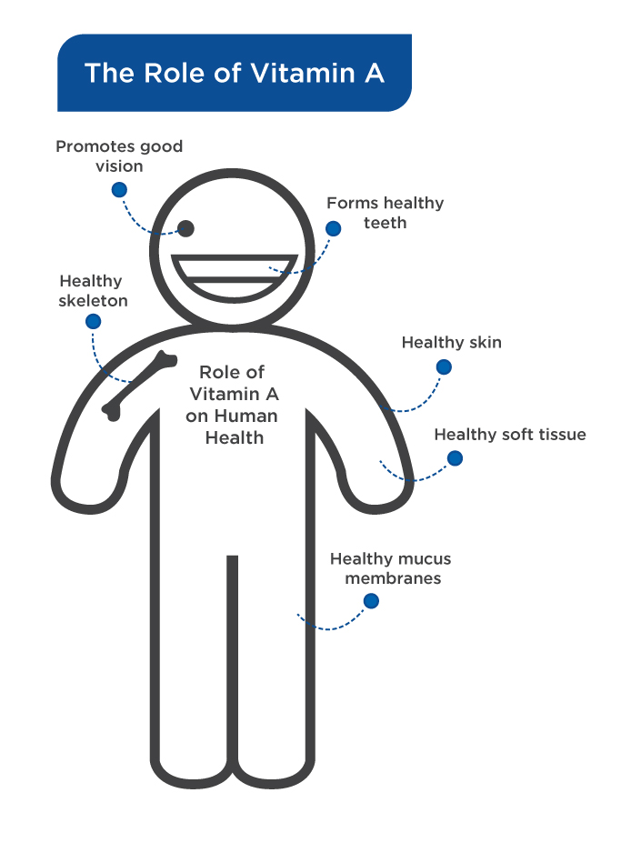

Roughly 33% of children under the age of 5 have vitamin A deficiency worldwide, with 670,000 children under 5 dying each year due to vitamin A deficiency and another 250,000 going blind (World Health Organization, 2013).

Research on vitamin A dates back to the 1940s, and, since then, there has been little evidence to indicate that vitamin A supplementation will improve one’s physical capabilities.

Forms and Functions of Vitamin A

| Chemical | Description |
| --- | --- |
| Retinol | Retinol is often referred to as vitamin A1. It is converted into retinal in the human body. |
| Retinal | Retinal is one of the other main forms of vitamin A and is converted into retinoic acid in the human body. Retinal is important as it converts light into signals that the brain turns into vision. |
| Retinoic Acid | Retinoic acid directly affects expression of genes. Retinoic acid is often used as a treatment of some skin conditions, such as acne, as it can control protein production that contributes to acne. |

*Where is it found in foods?*

Vitamin A is found primarily in fish, specifically fish oils such as cod liver oil. It is also found in butter, eggs, some cheeses, and beta-carotene-rich foods such as carrots, squash, and kale.

*How do we apply this information?*

Vitamin A is consumed in adequate quantities when following a balanced diet that includes some seafood; dairy; green, leafy vegetables; and bright-coloured vegetables. In cases where vitamin A deficiency is a concern, a registered dietitian nutritionist can help with supplementation guidelines after the adequate dietary sources are incorporated regularly.

Coach's Corner

There does not appear to be any evidence to suggest that vitamin A supplementation improves athletic performance. For example, one study performed in 1942, in which participants were purposefully brought into a state of vitamin A deficiency and then given high doses of vitamin A for 6 weeks, saw no improvement in ability to perform on an incline treadmill test.

### Vitamin D

*What is it and why is it important?*

Vitamin D has been a subject of great discussion and investigation over the last several decades. Vitamin D plays many critical roles in human health, including immune function, bone formation, and calcium metabolism. One of the more well-known diseases that arises from vitamin D deficiency is rickets, which is one of the first diseases that was tied directly to a nutrient deficiency [(](https://paperpile.com/c/cZDv7y/lfvq8)McCollum et al., 1925[)](https://paperpile.com/c/cZDv7y/lfvq8). In humans, vitamin D can be manufactured in the body through the conversion of cholesterol (7-dehydrocholesterol) to the active form of vitamin D (D3) by sunlight.

It has previously been argued there is no need for dietary vitamin D or vitamin D supplementation (Antonio et al., 2009). However, recent evidence has indicated that dietary vitamin D and supplemental vitamin D are indeed necessary for many people.

Vitamin D insufficiency and deficiency is likely the result of individuals spending the majority of their time indoors or when they are outside, wearing sunblock or clothing that blocks the majority of the skin. Living at more northern latitudes and diets low in vitamin D-rich foods also contributes to deficiency. These low levels of vitamin D may impair some aspects of performance and recovery, specifically via reducing overall aerobic metabolism, muscle repair, and bone repair. There is some evidence that correcting these deficiencies can improve aerobic performance, muscle strength, and recovery from training (Dahlquist et al., 2015; Farrokhyar et al., 2015). However, more work is needed to determine how much benefit athletes may get from vitamin D supplementation.

*Where is it found in foods?*

Vitamin D is found in many of the same foods as vitamin A: salmon, sardines, mackerel, tuna, cod-liver oil, shiitake mushrooms, fortified milk, and fortified cheese.

Food for Thought

Vitamin D was first discovered in cod liver oil and has since been identified as an essential vitamin and an important nutrient for a variety of metabolic and biological processes.

*How do we apply this information?*

Of all the micronutrients, vitamin D has the highest rate of deficiency worldwide. Specific focus should be given to this micronutrient to ensure that there are not substantial deficiencies and to encourage more vitamin D-rich foods in the diet. Encouraging clients to ask their own doctor to add vitamin D to their normal labs is a wise idea as well to assess their own status. Then, the provider can make suggestions, as needed.

### Vitamin E

*What is it and why is it important?*

Similar to vitamin A, vitamin E is a class of compounds. The most common ones are known as the tocopherols and the tocotrienols, each of which has four types: alpha, beta, gamma, and delta (Shils, Shike, Ross, Caballero, & Cousins, 2006). Vitamin E is one of the main antioxidant molecules in the body and it protects cells from oxidative damage. One the main mechanisms by which vitamin E protects cells is by reducing the oxidation of fatty acids that make up cell membranes and other critical structures within cells (Meagher, Barry, Lawson, Rokach, & FitzGerald, 2001).

Vitamin E deficiency can lead to neurological disorders that include uncontrolled movement and slurred speech. Furthermore, vitamin E supplementation has been shown to be beneficial on lipid peroxidation and measures of oxidative damage even in otherwise healthy people (Meagher, Barry, Lawson, Rokach, & FitzGerald, 2001).

*Where is it found in foods?*

Vitamin E is primarily found in nuts and seeds (e.g., almonds, sunflower seeds, wheat germ, hazelnuts, and pine nuts) as well as oils derived from them. It is also found in fish, such as salmon, as well as butter and avocado.

*How do we apply this information?*

Getting adequate levels of vitamin E can be achieved by consuming several servings of nuts and seeds per week, as well as fish or avocado. Most people do not need to supplement with vitamin E to obtain an adequate amount from their diet.

### Vitamin K

Vitamin K is the name for a family of compounds known as the phylloquinones (vitamin K1) and menaquinones (vitamin K2). Vitamin K is involved in regulating blood homeostasis by controlling clotting. It also plays critical roles in bone formation and remodelling as well as working synergistically with vitamin D. Vitamin K has some interesting properties in that vitamin K1 can be obtained in the diet from plants, whereas vitamin K2 is the product of bacterial fermentation and must either be made by the gut bacteria or consumed in supplemental form, come from some animal foods, or be derived from bacteria [(](https://paperpile.com/c/cZDv7y/4L7jf)Elder, Haytowitz, Howe, Peterson, & Booth, n.d.).

Deficiencies in vitamin K lead to bleeding disorders where people cannot stop bleeding. Additionally, vitamin K deficiency can lead to osteoporosis, which can be improved by restoring vitamin K levels (Villa, Diaz, Pizziolo, & Martino, 2017).

*Where is it found in foods?*

Vitamin K is primarily found in dark, leafy greens, such as kale, collard and mustard greens, swiss chard, mustard parsley, romaine, green-leaf lettuce, & Brussels sprouts.

*How do we apply this information?*

Vitamin K is often overlooked in peoples' diets and there should be a concerted effort to focus on vitamin K intake. This can be accomplished by consuming dark, leafy greens several times a week and/or considering supplementation.

Fat-soluble vitamins differ substantially from water-soluble vitamins in that they are stored in bodily tissue and must be consumed with dietary fat to ensure proper absorption (Figure: Fat-Soluble Vitamins). Also, unlike water-soluble vitamins, deficiencies in these vitamins appear to be more common, especially vitamin D. Because these vitamins can be stored in tissues, vitamin toxicity from high intakes is also possible and diets that are high in fat-soluble, vitamin-rich foods should be monitored. When talking to clients about their nutrition, careful attention should be given to ensuring adequate levels of fat-soluble vitamin intake through the variety of foods suggested in this chapter.

This can be achieved by doing the following:

* Consuming fatty fish at least once a week
* Consuming several servings of vitamin-rich nuts and seeds (two to three) per day
* Consuming several servings of fortified dairy products (two to three) per day

Supplementation with any vitamins and minerals should be considered if advised by a registered dietitian nutritionist who may have access to a client’s lab work and can best assess their diet. A Nutrition Coach can support the recommendations to best assist the client.

### Common food sources of vitamins

Micronutrients are core components of all the foods that we consume. They give many foods their taste and colour and should not be viewed much differently than macronutrients as they co-occur. When helping support a client with their nutrition, it is important to consider both the quantity and quality of the diet. When supporting an RDN who may have created this diet for the client, the key is to understand how best to support the client in their quest to make better food choices.

The B-complex vitamins, folate, and vitamin C are found in a wide range of food sources. Vitamins B1, B2, B3, B5, B7, B12, and folate are all found in fortified grain products such as cereals, breads, and pastas. Vitamin B2 (riboflavin) is also found in milk and most organ meats (e.g., liver and kidney) while vitamin B3 (niacin) is found in beef, fish, and poultry. Vitamin B5 (pantothenic acid) is found in beef, poultry, organ meats, and eggs, as well as oatmeal and potatoes. Folate can also be found in leafy, green vegetables while biotin is found in small quantities in some fruits and beef and in moderate amounts in liver. Vitamin C is found primarily in fruits, specifically citrus fruits; however, it can also be found in dark, leafy greens, cruciferous vegetables, and tomatoes.

Fat-soluble vitamins are found in similar food sources as the water-soluble vitamins. Vitamin A is found in dark, leafy greens and dark-coloured fruits, in high quantities in fish and liver, and in moderate quantities in milk products (e.g., milk and yogurt). Vitamin D is found in fatty fish (e.g., salmon, herring, and sardines), fish oils (e.g., cod liver oil), fortified cereal products, and fortified milk products. Vitamin E is in nuts and seeds (e.g., almonds, nuts, and sunflower seeds) and their cold-pressed oils, fruits and vegetables, and beef. Vitamin K is primarily in dark, leafy greens and some plant oils.

Food for Thought

When considering the major food sources of both water- and fat-soluble vitamins, it is abundantly clear that a diet rich in fruits; dark,-green, leafy vegetables; animal meats; and dairy will allow people to reach their micronutrient needs. Enriched and fortified grains and cereals are used to help offset diets that are missing in these food groups.

## Minerals

Minerals are naturally occurring compounds, often atomic elements, that are required for life. Similar to vitamins, minerals are not made by the body; they must be consumed in the diet or be supplemented. However, they are substantially different than vitamins because vitamins are organic while minerals are inorganic. Also, vitamins are often broken down by air, acid, or heat while minerals are not.

Most of the minerals relevant to humans are considered metals. These minerals are critical in bone structure, the antioxidant system, thyroid function, oxygen transport, and a host of other essential processes. Minerals are often overlooked in the diet, especially iodine, chromium, and copper. However, it is critical that people receive adequate mineral nutrition, which can be accomplished by consuming mineral-rich foods a few times a week.

### Calcium

The levels of calcium in the blood are very tightly controlled, with levels of calcium ranging between 8.4 to 9.5 mg/dL. Calcium plays a well-known role in the structural integrity of the skeleton; it is the critical mineral in the crystalline structure that makes up bone tissue. In addition to its structural role, calcium is also essential for skeletal muscle contraction along with other electrical signalling functions.

Calcium is an essential nutrient and must be consumed in sufficient quantities to prevent degradation of bone tissue and the development of osteoporosis. Calcium status of the body is so critical that there is an elaborate system of feedback loops that regulate calcium absorption. One way to think about calcium regulation is like a thermostat in a house: the temperature is set and a heater turns on and off to keep the temperature at that level. Calcium is controlled in a similar manner where absorption of calcium increases or decreases depending on how much the body needs (Figure: Calcium and the Body).

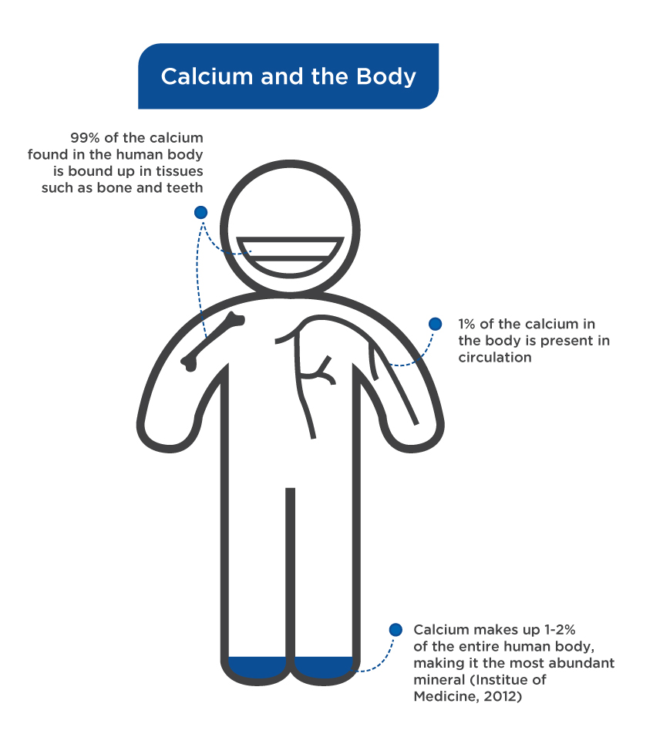

Vitamin D is involved in the active absorption of calcium from the digestive tract and absorption of calcium varies with the amount of calcium consumed. The relative amount of calcium absorption increases when calcium intake is low and decreases when calcium intake is high. For example, when calcium levels in the diets of women were decreased, the fractional proportion of calcium being absorbed increased (Dawson-Hughes, Harris, Kramich, Dallal, & Rasmussen, 1993).

### Chromium

Chromium is considered a trace element as the required intake is low (0.2 to 45 micrograms per day). There are two major forms of chromium: chromium 3+ (trivalent) and chromium 6+ (hexavalent). Chromium 3+ is the form found in food and is the biologically active form while chromium 6+ is a toxic form that results from industrial pollution (“Office of Dietary Supplements - Dietary Supplement Fact Sheet: Chromium”, 2018). Chromium deficiency is not well documented as there is no clinically defined level of deficiency and chromium is one of the most abundant minerals on earth.

Chromium has been implicated in regulating insulin signalling, with some data suggesting that it may enhance insulin sensitivity and/or decrease insulin resistance (Cefalu et al., 1999[)](https://paperpile.com/c/cZDv7y/QEEkX). Chromium works to improve insulin signalling by modulating chromodulin, a protein that augments the signalling of insulin receptors. While it is difficult to link chromium deficiency to diabetes or diseases of insulin resistance, there are several pieces of evidence to suggest that chromium, as a mineral, is likely involved to some extent in the development of diabetes (McIver, Grizales, Brownstein, & Goldfine, 2015; Rajpathak et al., 2004) (Figure: Chromium Sources).

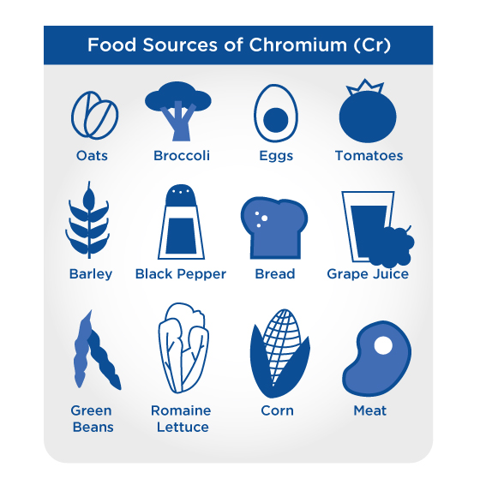

### Copper

Copper is an essential mineral and helps balance the redox system in the human body. There are several disorders that come from copper metabolism issues. For example, Menkes disease results in seizures, brain atrophy, and hypotonia and is corrected by early copper supplementation. Copper is needed in minute quantities, ranging from 600 to 700 micrograms (0.6 to 0.7 milligrams) per day. Copper deficiency is exceedingly rare in humans and, in most cases, copper is consumed in adequate quantities in most dietary patterns.

### Fluoride

Fluoride is a non-essential mineral that, when consumed in low quantities, can be considered a beneficial ingredient for preventing cavities in teeth. Fluoride is found primarily in drinking water in the United States: roughly 52% of drinking water contains 0.7 to 1.2 mg/L of fluoride (Erdman, MacDonald, & Zeisel, 2012; Spector et al., 1995). While low doses of fluoride can reduce the risk of cavities, higher doses consumed chronically (>2mg/kg) can result in mottled and pitted tooth enamel. Furthermore, ingestion of 10 to 25 mg/day for extended periods of time (7 to 20 years) can damage bones. Currently, fluoride insufficiency is uncommon in humans and, in most urban and rural places, fluoride toxicity is rare and does not need to be a cause of concern.

### Iodine

Similar to chromium, iodine is considered a trace mineral that is found in some foods and is supplemented in many others such as iodised salt (“Office of Dietary Supplements - Iodine,” 2018). The primary function of iodine in the human body is as a precursor to thyroid hormones: both T3 and T4 (Figure: Function of Iodine). Iodine deficiency varies in prevalence due to geographic location as there are varying levels of iodine in the soil throughout the world. The most prevalent complications of iodine deficiency are goitre and hypothyroidism (Zimmermann, 2009[)](https://paperpile.com/c/cZDv7y/n8uHQ).

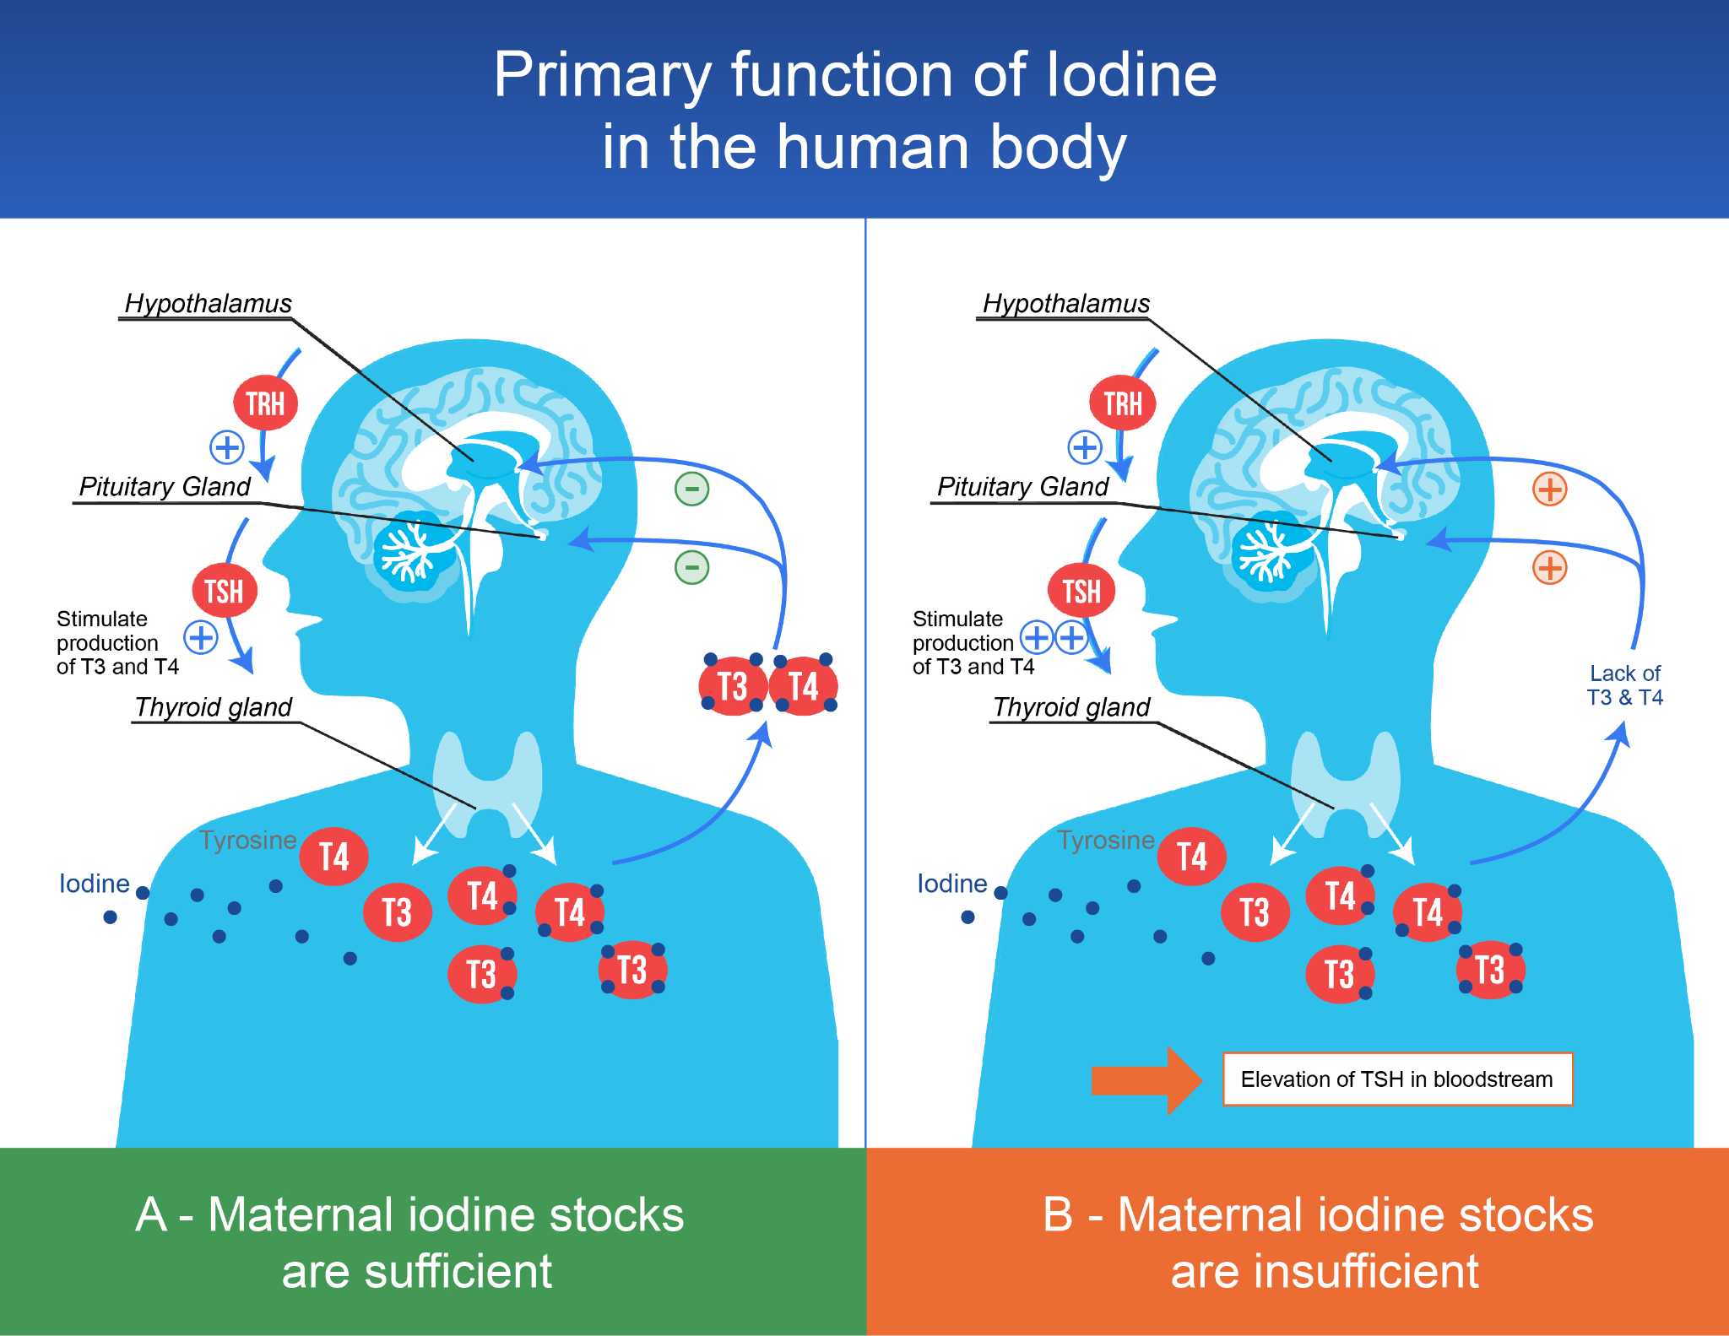

Iodine deficiency and goitre were common in the Midwest United States through the early 1920s until iodised salt was made available in 1924 (Leung, Braverman, & Pearce, 2012). Iodine is critical to maintain proper thyroid function. In people who consume low-sodium/low-salt diets, careful attention should be given to ensuring adequate iodine intake.

### Iron

Iron is central in hundreds of metabolic processes, with the storing, transporting, and delivery of oxygen via haemoglobin and myoglobin being the most important of its myriad roles. Iron is also involved in the electron transport chain and neurotransmitter production (Alberts et al., 2002; “Anaemia | National Heart, Lung, and Blood Institute (NHLBI),” n.d.).

Iron deficiency prevalence varies from 5% in North America to upwards of 60% in Africa and is responsible for roughly 50% of all cases of anaemia (Stoltzfus, 2003). Iron deficiency is the primary cause of anemia, a condition in which your body does not have enough healthy red blood cells to transport oxygen (Figure: Iron-Deficient Countries).

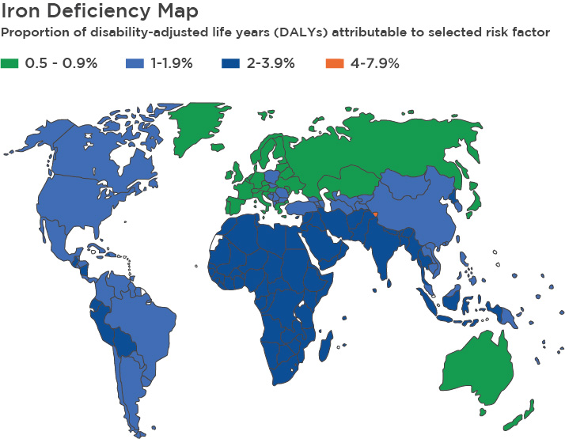

Dietary iron is found in two major forms: haem and non-haem iron. Haem iron is derived from animal sources and is primarily made of haemoglobin and myoglobin. Non-haem is obtained from plants and other iron-fortified foods. While heme iron contributes roughly 15% of the total dietary iron intake, it contributes to more than 40% of all absorbed iron (Carpenter & Mahoney, 1992) (Figure: Sources of Iron Comparison).

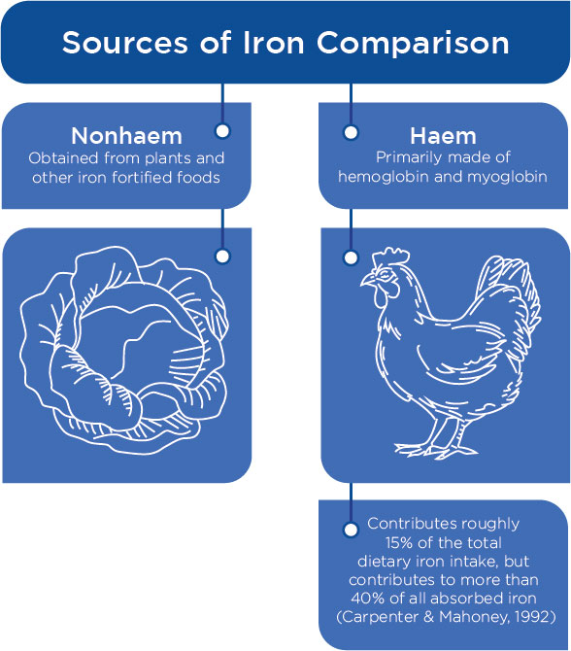

Given the substantial role that iron plays in metabolism, specifically oxygenation and aerobic metabolism, and the relatively high prevalence of iron deficiency, there has been a substantial body of research examining the effect of iron supplementation on athletic performance. Much of the literature is focused on repletion of iron in iron-deficient women.

These studies demonstrate that in iron-deficient but not anaemic women, supplementation with iron improved their ability to adapt to aerobic exercise [(](https://paperpile.com/c/cZDv7y/pghjk)Brownlie, Utermohlen, Hinton, & Haas, 2004; Brownlie, Utermohlen, Hinton, Giordano, & Haas, 2002; Brutsaert et al., 2003). This indicates that iron likely plays a role in athletic performance and athletes, especially female endurance athletes, should be tested for iron deficiency.

Coach's Corner

Research indicates that correcting iron deficiency through supplementation (and potentially dietarily through food) can improve athletic performance. This does not mean supplementation above and beyond or if one is not deficient will help improve athletic performance.

### Magnesium

Magnesium is involved in over 300 biochemical reactions that span the full spectrum of human metabolism: from digestion to nervous system activity to glucose regulation and protein synthesis (“Office of Dietary Supplements - Magnesium,” 2018). Like calcium, magnesium is found in large quantities in the human body, with roughly 20 to 30 grams found in the average adult human. It is distributed as follows: 60% is found in bone tissue, 20% in skeletal muscle, 19% in other soft tissues (e.g., heart, liver, and lungs), and less than 1% is found in extracellular fluid (Swaminathan, 2003) (Figure: Distribution of Magnesium[)](https://paperpile.com/c/cZDv7y/5Tniz).

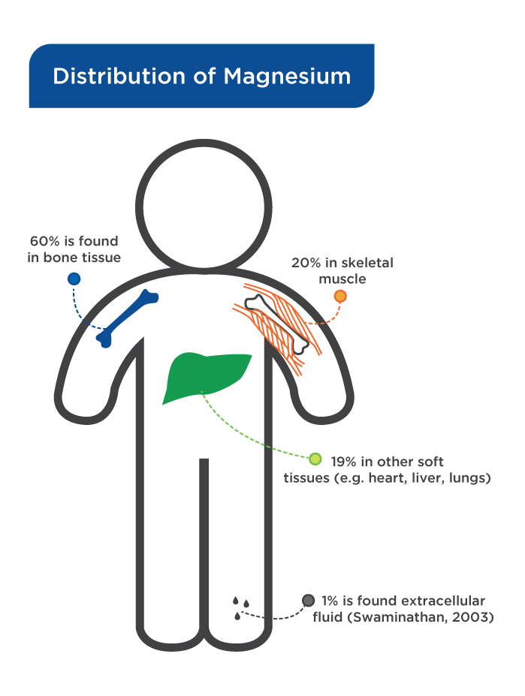

Magnesium is conjugated to ATP; most ATP in the human body is found as MgATP. It is also intimately involved in the metabolism of carbohydrates, fats, and proteins and in the ion channels that regulate calcium flux and potassium flux across membranes. Additionally, evidence over the last 20 years has highlighted the role of magnesium insulin resistance.

Magnesium is important in many chronic diseases, specifically diabetes. People with Type 2 diabetes are more likely to have lower levels of serum magnesium and supplementation with magnesium has been shown to improve glucose metabolism and markers of insulin sensitivity (Arpaci et al., 2015; Rodríguez-Morán & Guerrero-Romero, 2003).

A recent meta-analysis also showed that magnesium supplementation lowered fasting glucose, LDL-c, and triglycerides and raised HDL-c in people with Type 2 diabetes (Verma & Garg, 2017). Magnesium should be given special attention in your diet and individuals should consume magnesium-rich foods such as whole grains, cocoa, spinach, and nuts. Supplementation can also be considered in individuals with very-low levels of magnesium.

### Mercury

Mercury is a trace element that finds its way into the human diet, has no necessary function, and is highly toxic, especially during development in utero and early childhood. The maximal daily intake of mercury recommended by the World Health Organization (2017) is 2 µg/kg per day. Mercury exerts its toxic effects primarily via the displacement of selenium (Carvalho, Chew, Hashemy, Lu, & Holmgren, 2008).

The largest source of dietary mercury is from seafood, including fish and shellfish. Mercury concentrations increase the further one goes up the food chain. Fish and shellfish that consume smaller fish with mercury in their blood and tissue store more mercury per tissue volume than smaller fish. As such, fish such as sharks, swordfish and tuna have higher levels of mercury than smaller fish such as mackerel (Mahaffey, Clickner & Bodurow, 2004) (Figure: Mercury Levels in Fish).

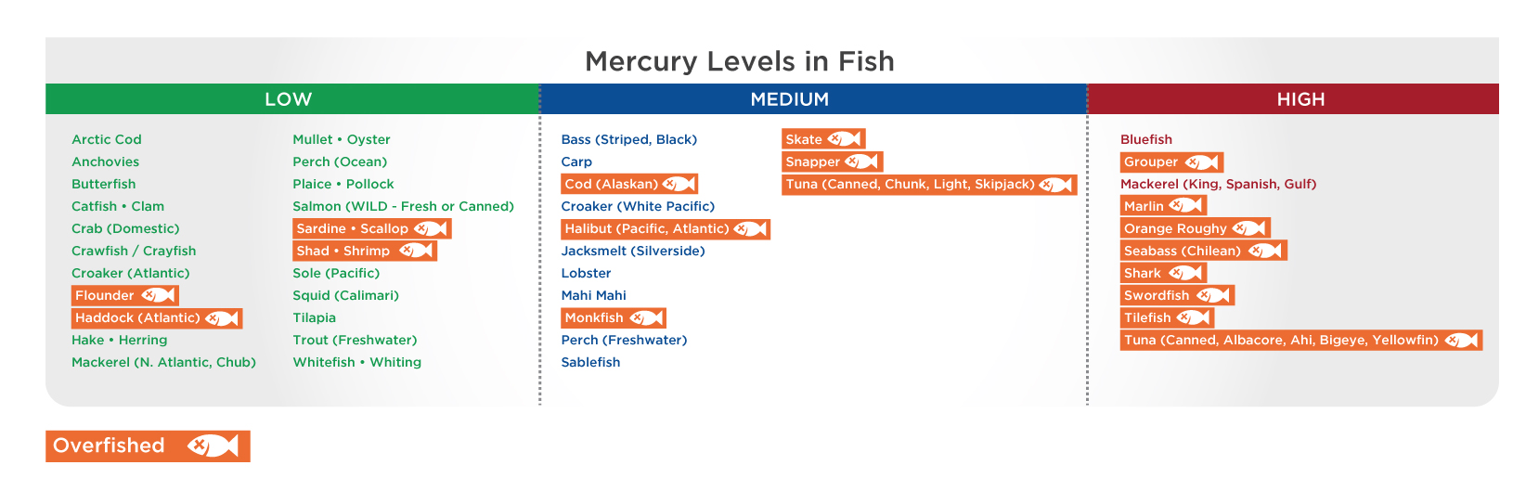

### Phosphorus

Phosphorus is found everywhere in the body and is required for energy production and maintaining cellular viability. Phosphorus is the central molecule in phosphate, which is part of adenosine triphosphate (ATP), the energy molecule that facilitates virtually every biochemical reaction. Phosphorous deficiency is exceedingly rare in the United States and does not appear to be a major concern in most health conditions (McClure, Chang, Selvin, Rebholz & Appel, 2017).

There is some evidence that excessive phosphorus intake from processed foods may increase the risk of cardiovascular disease and osteoporosis and accelerate established kidney disease; however, these data are mostly observational in the broad public, with the exception being kidney disease. In people with kidney disease, the ability to clear excess phosphorus from the body is impaired and elevated levels of phosphorus are associated with increased risk of progression to end-stage renal disease (O’Seaghdha, Hwang, Muntner, Melamed, & Fox, 2011; “Serum Phosphorus and Death or Progression to End-Stage Renal Disease in Persons Screened in the Community for Chronic Kidney Disease,” 2013; Palmer et al., 2011[)](https://paperpile.com/c/cZDv7y/5Gxqp).

Currently, there is no evidence that phosphorus supplementation improves athletic performance; it does not need to be supplemented or a major focus for performance nutrition (Jones et al., 2017).

### Potassium

Potassium is present in all tissues in the body and is required for maintaining concentration gradients, fluid volume, and cardiac rhythm (“Office of Dietary Supplements - Potassium,” 2018). Potassium is present in relatively large quantities, with roughly 140 grams residing in a grown adult. Most potassium is present inside of cells with small amounts in circulation, with the ratio of intracellular to extracellular potassium being 30:1 (Hinderling, 2016[)](https://paperpile.com/c/cZDv7y/ZNB2o).

Severe potassium deficiency, known as hypokalaemia, can be deadly and cause cardiac arrest. Similarly, hyperkalaemia can also result in cardiac arrest (Jain et al., 2012). Potassium deficiency is rare in otherwise healthy adults without established kidney disease. There has been some discussion that potassium may prevent cramps; however, this has not been supported by scientific literature.

### Selenium

Selenium is the key component of several selenoproteins that serve as antioxidants or in the regeneration of antioxidants. Specifically, thioredoxin reductase and glutathione peroxidase are selenoproteins. Mercury exerts its toxicity in the human body by displacing selenium and substantially impairing the antioxidant systems in the body. Currently, selenium deficiency is incredibly rare in developed countries, but it is projected to become a larger issue as soil becomes depleted of selenium in the coming decades (Jones et al., 2017; Palmer et al., 2011).

### Sodium

Much like potassium, sodium is present in virtually every tissue of the body and is essential for maintaining gradient balance, fluid status, and cardiac rhythm. Where sodium differs from potassium is in its location. Sodium is primarily an extracellular fluid compared to potassium which is primarily an intracellular fluid (Figure: Sodium and Body Tissue).

For comparison, the extracellular concentration of sodium is between 136 and 151 millimolar, whereas potassium is between 3.4 and 5.2 millimolar. Sodium deficiency is virtually unheard of in the developed world, with average intakes of sodium being roughly three to five times the RDA (Institute of Medicine, Board on Population Health and Public Health Practice, Food and Nutrition Board, & Committee on the Consequences of Sodium Reduction in Populations, 2013). Like the micronutrient iron, sodium is well-understood in terms of athletic performance as is the increased need for sodium among athletic populations.

The increased need is primarily due to loss of sodium through sweating (evaporative cooling). Insufficient sodium intake in athletes leads to hyponatraemia, which sets in at concentrations below 135 millimolar. Hyponatraemia can lead to malaise, nausea, cramps, headache, and slurred speech, with extreme cases leading to cardiac arrest and death. While it is well-accepted that many athletes have a higher need for sodium intake than the general population, athlete specific RDIs have not been established.

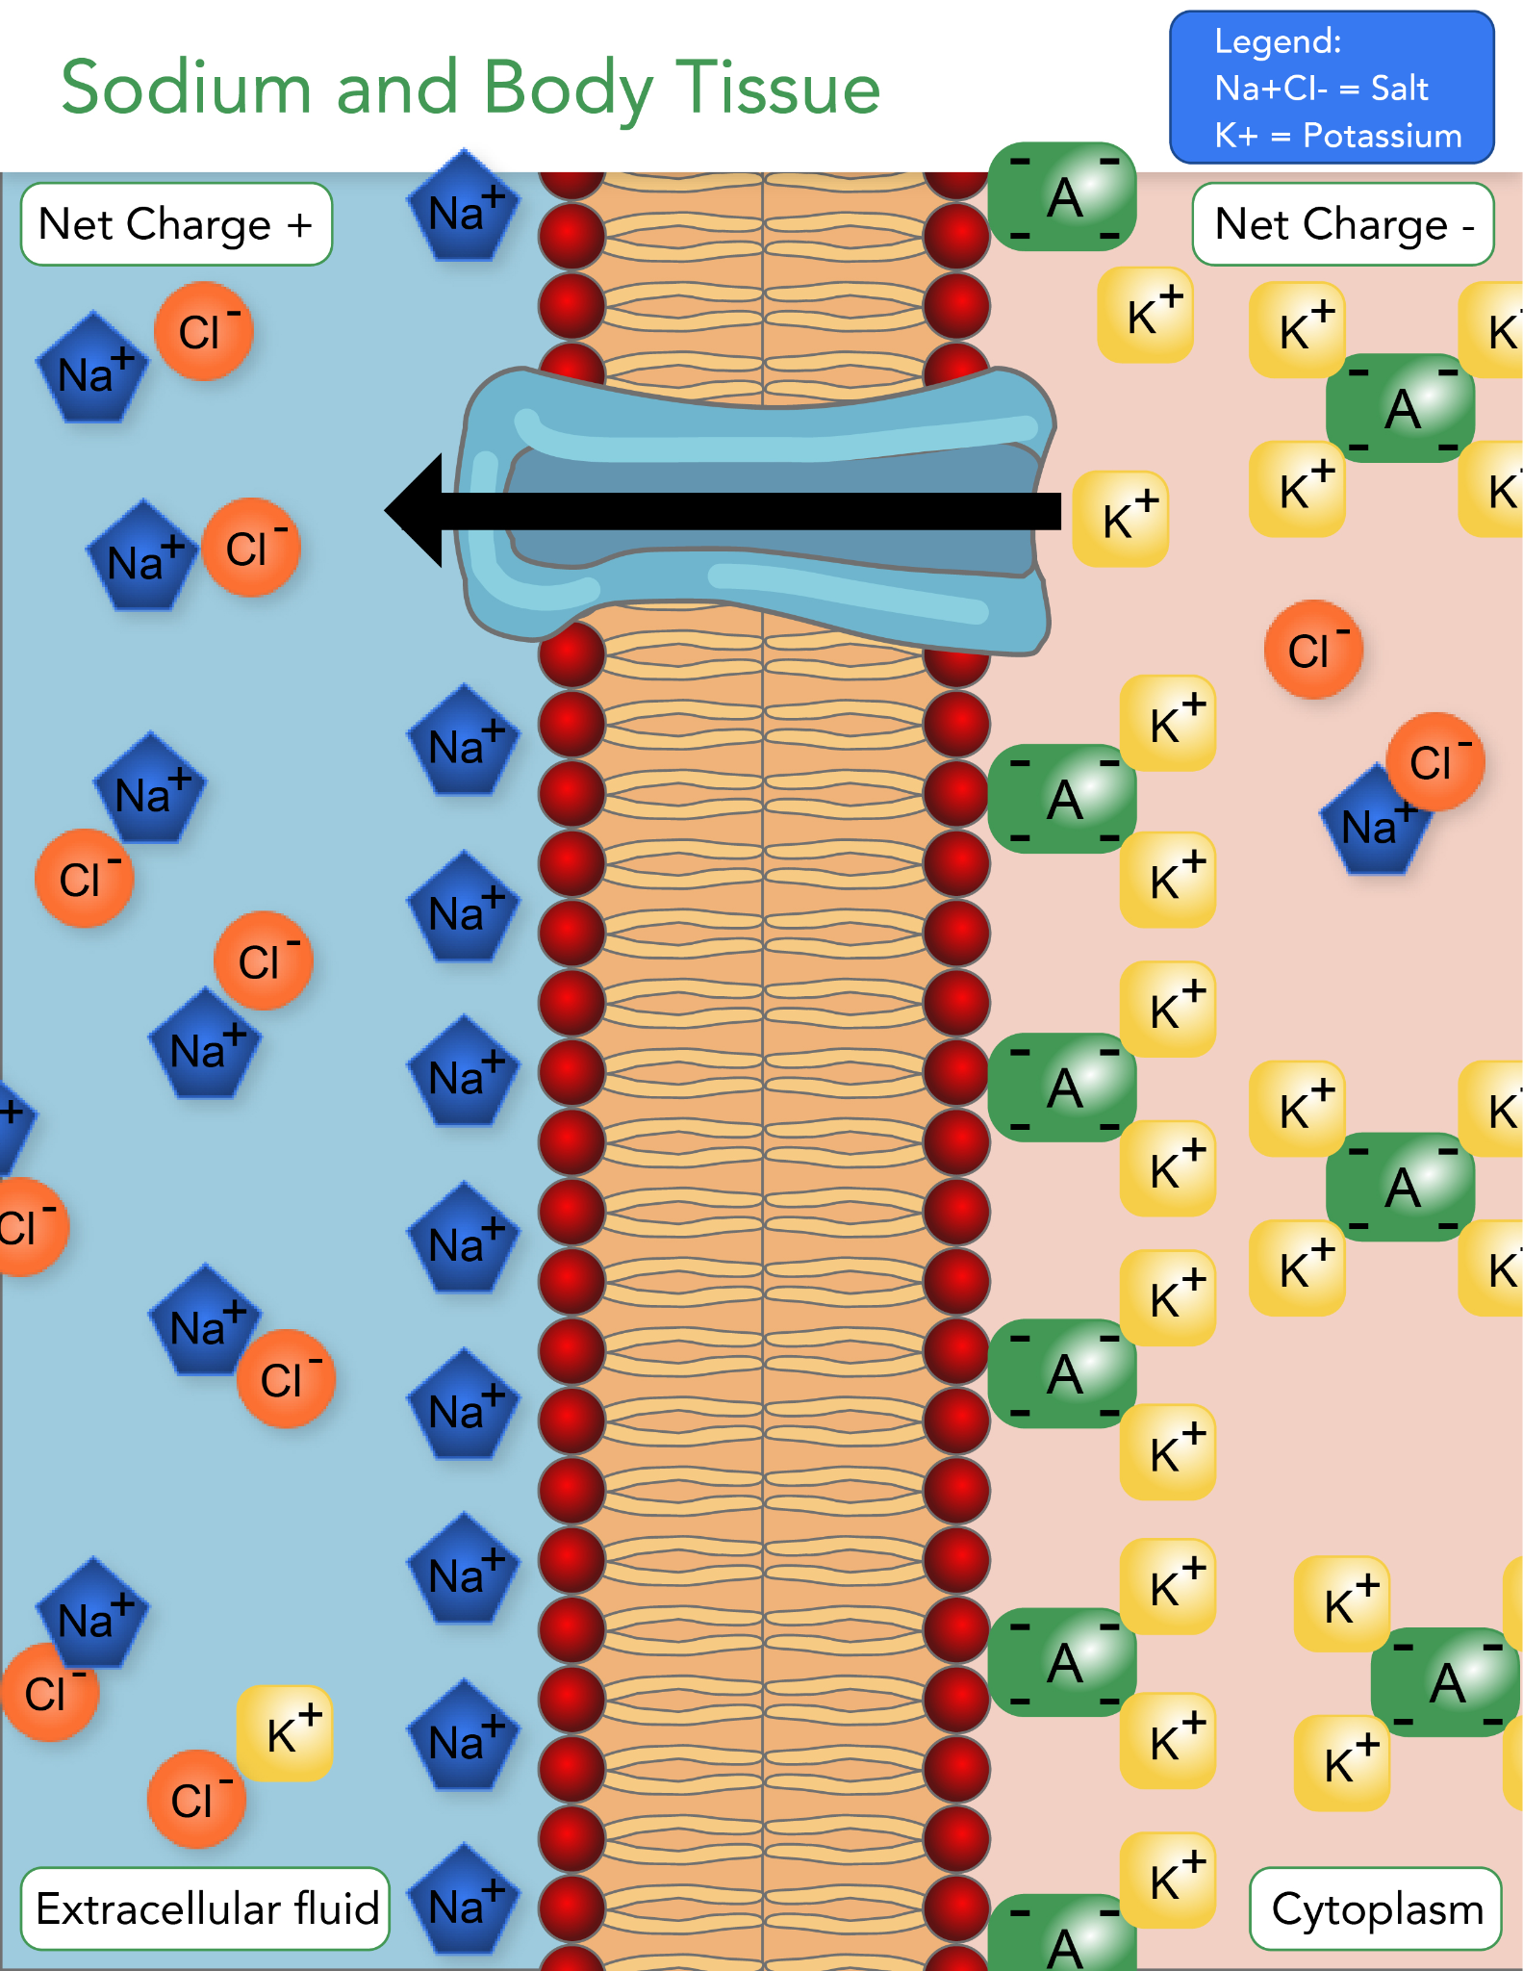

### Zinc

Zinc provides structure to cells and helps reactions occur. It is the most abundant intracellular of the trace elements and plays regulatory roles in transcription via transcription factors and stabilises nucleic acids. It is also necessary for the creation of tubulin, giving cells their internal rigid structure and allowing them to properly maintain their shape and function. Overt and severe zinc deficiencies are known to cause substantial health issues: alopecia, immune deficiencies, night blindness, delayed wound healing, and growth retardation.

Mild zinc deficiency may lead to impaired growth, which can be corrected through supplementation [(](https://paperpile.com/c/cZDv7y/nZOJa+VDYzz+SVM4d)Hambidge et al., 1979; Sur et al., 2003; Walravens, Hambidge, & Koepfer, 1989[)](https://paperpile.com/c/cZDv7y/nZOJa+VDYzz+SVM4d). Zinc deficiencies range from less than 1% to greater than 25% across the world, with the highest rates of zinc deficiency observed in Sub-Saharan Africa and South Asia [(](https://paperpile.com/c/cZDv7y/1urnv)Wessells & Brown, 2012[)](https://paperpile.com/c/cZDv7y/1urnv). There is also some evidence that high intakes of zinc, especially via supplementation, can result in copper deficiency [(](https://paperpile.com/c/cZDv7y/hSk6t+Pp090+s6n1z)Duncan, Yacoubian, Watson, & Morrison, 2015; Krotkiewski, Gudmundsson, Backström, & Mandroukas, 1982; Lukaski, Bolonchuk, Klevay, Milne, & Sandstead, 1984).

Coach's Corner

Given that zinc does not provide robust, if any, benefits on athletic performance and may result in copper deficiency, zinc supplementation for athletic performance is not recommended.

Getting Technical

In one study, supplementation with 135 milligram of zinc per day for 14 days showed a roughly 15% improvement in peak isometric torque at 180°, but not at any other angle. In a second study, where men were zinc depleted via a low-zinc diet and then repleted, repletion of zinc did not impact aerobic performance (Krotkiewski et al., 1982; Lukaski et al., 1984).

### Common food sources of minerals

Minerals are found in a wide range of foods, coming from both plant and animal sources. Minerals are found in the highest quantities in dairy (e.g., milk, yogurt, eggs, and cheese), beef, shellfish, whole grains, and dark, leafy greens (Figure: Minerals Found in Common Foods).

Food for Thought

Minerals are found in high quantity in beef, shellfish, legumes, nuts, and root vegetables grown in mineral-rich soil. Supplementation is not necessary for minerals in most populations.

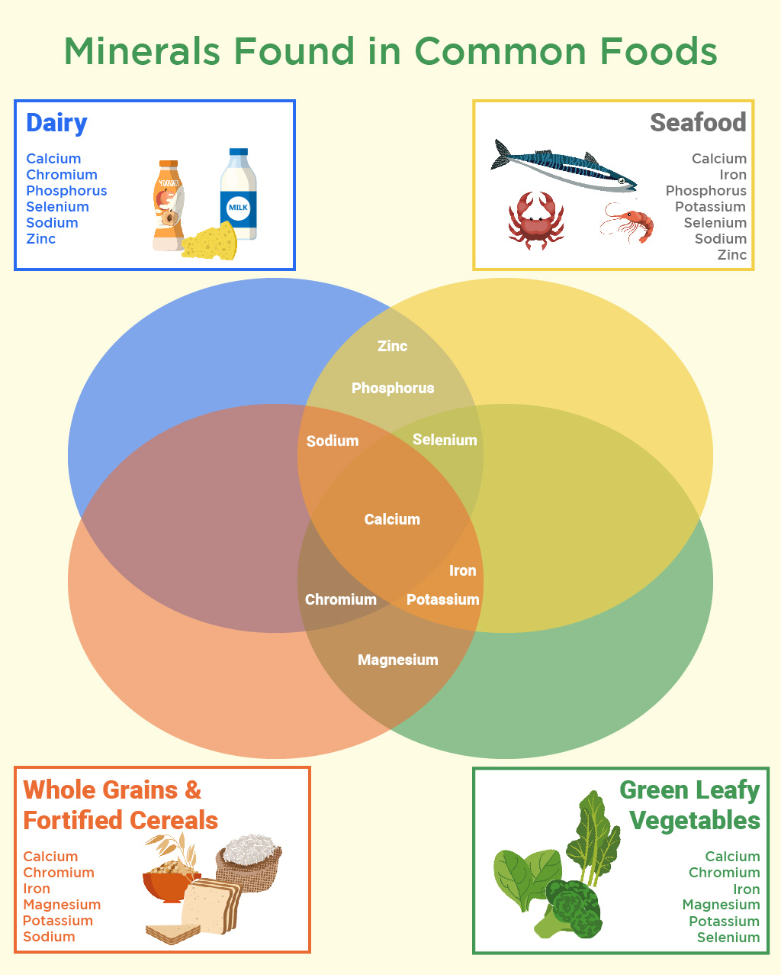

### Applying knowledge of minerals to the real world

While mineral metabolism is complex, applying this knowledge into the real world can come down to very-basic principles. Ensuring someone obtains adequate minerals in their diet falls in line with the same practical advice for ensuring adequate vitamin intake: consuming a well-balanced diet that is rich in fruits and contains some animal meats or animal by-products.

Furthermore, understanding the varying mineral profiles of different foods and eating a variety of different mineral rich foods can ensure that an individual does not miss key nutrients found in some foods and not others. There are several simple actionable steps that can be taken to help individuals obtain adequate micronutrients.

Use USDA Guideline examples to ensure adequate minerals are ingested:

* Consume three to seven servings of green, leafy vegetables per week.
* Consume fish on a weekly basis.
* Consume three to seven servings of mineral-rich tubers (e.g. potatoes and turnips) per week.
* Consume three to seven servings of legumes and/or whole grains per week.
* Consume three to seven servings of lean cuts of animal meat and/or dairy products per week.

Source: U.S. Department of Agriculture (n.d.). Vitamins and Minerals. National Agriculture Library. Retrieved from <https://www.nal.usda.gov/fnic/vitamins-and-minerals>

These approaches to consuming an adequate amount of minerals falls in line with the USDA guidelines for ensuring the adequate micronutrition discussed.

Try This

Make a list of all the foods that contain water-soluble vitamins, fat-soluble vitamins, and minerals and develop a personal shopping list of foods that are high in all micronutrients and of which foods help clients consume all of them. This can be a weekly grocery list to use with clients.

## Micronutrient application

Not all foods are created equal with regard to the availability of the nutrients contained within them. The availability of a nutrient for assimilation into the body from food is known as bioavailability. Bioavailability is defined as the fraction of the ingested nutrient that is absorbed and subsequently utilized for normal physiological functions (Fairweather-Tait & Hurrell, 1996).

Some foods make digestion and absorption of micronutrients easier than others. There are some key aspects that impact the bioavailability of a nutrient: solubility, the type of micronutrient, how it is bound up in the food, and the co-ingestion of other foods or compounds that facilitate absorption or compete with it. The bioavailability of each micronutrient appears to be affected by different factors and uniform rules do not appear to apply to each micronutrient or ever-larger classes of nutrients (Infographic: Bioavailability).

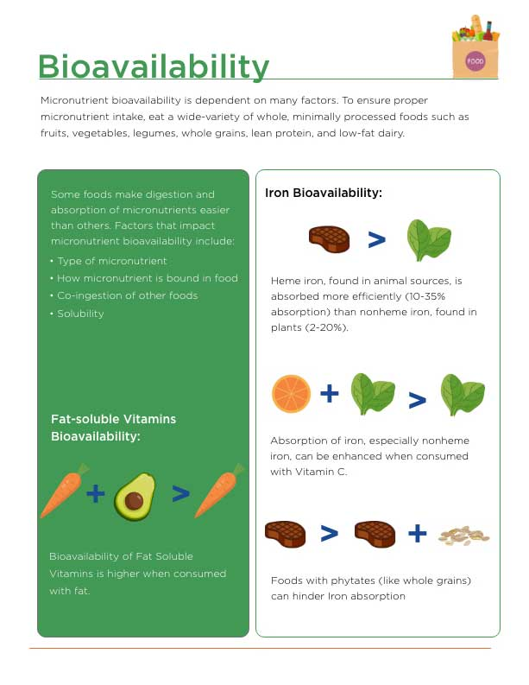

For example, the bioavailability of fat-soluble vitamins is greatly impacted by what they are consumed with. When consumed with dietary fat, their bioavailability is much higher than when consumed without fat. Conversely, the bioavailability of iron is impacted by the form of iron consumed. However, there are some factors that tend to make some micronutrients more or less bioavailable: the food source, co-ingestion with other foods/molecules, and what form the micronutrient is in or is bound to.

**Iron**

Iron can be used as a use case to highlight some of the factors that influence bioavailability. The source and form of a micronutrient impacts its bioavailability: both where it is from and what form it is found. For example, heme iron, which is found in animal sources, is absorbed more efficiently (10 to 35% absorption) when compared to nonheme iron (2 to 20% absorption), which is found in plants (Monsen, 1988[)](https://paperpile.com/c/cZDv7y/PtFL8). Even among those broader categories, there are substantially different rates of absorption. For example, in heme iron sources, about 10% of iron is absorbed from fish, while 20% is absorbed from veal muscle. In non-heme sources, roughly 2% of iron is absorbed from black beans, while 7% is absorbed from soybeans (Layrisse et al., 1969).

Absorption of iron can be enhanced by co-ingestion of vitamin C, especially non-heme iron. Conversely, absorption of iron is substantially reduced when co-ingested with phytates, which are often found in whole-grain foods such as bran (Hallberg, 1987[)](https://paperpile.com/c/cZDv7y/dlzot). While this example highlights many of the factors affecting bioavailability, it is important to note that these exact factors do not affect all foods in the same way. What impacts the bioavailability of each micronutrient needs to be assessed on a nutrient-by-nutrient level.

### Total daily requirements

The daily requirement for each micronutrient is explained by several different reference amounts that fall under the umbrella of dietary reference intakes (DRI) (Table: Reference Intake Descriptions).

Reference Intake Descriptions

| **Dietary Reference Intake Label** | **Description** |
| --- | --- |
| Estimated Average Requirement (EAR) | A nutrient intake value that is estimated to meet the requirement of half the healthy individuals in a group |
| Recommended Dietary Allowance (RDA) | The average daily dietary intake level that is sufficient to meet the nutrient requirement of nearly all (97 to 98%) healthy individuals in a group |
| Adequate Intake (AI) | A value based on observed or experimentally determined approximations of nutrient intake by a group (or groups) of healthy people – used when an RDA cannot be determined |
| Tolerable Upper Intake Level (UL) | The highest level of daily nutrient intake that is likely to pose no risk of adverse health effects to almost all individuals in the general population – As intake increases above the UL, the risk of adverse effects increases. |

Getting Technical

There is a systematic process for how each of these reference values are defined. The EAR is determined through a systematic review of the literature and uses human data and animal data to help determine an accurate EAR. The RDA is then calculated by using either two standard deviations or coefficient of variation for the EAR of 10%, which is ordinarily assumed. The AI is set when there is not enough evidence in the scientific literature to establish an EAR and is often limited to specific groups of people in which there is evidence.

[**Daily reference intakes in the general population**](http://nasmu.nasm.org/file.php/10359/pdf/Chapter_10/RDA_for_Micronutrient_Handout.pdf)

Research collated over the past several decades has illuminated RDAs for the major micronutrients present in the human diet for the general population. See Handout: Micronutrient RDA for a complete list of RDAs for the vitamins and minerals discussed and to help support your discussions with clients (“Office of Dietary Supplements - Nutrient Recommendations: Dietary Reference Intakes (DRI),” n.d.).

Critical!

It is important to remember that RDA numbers are set on normative population data and that individuals have differing requirements. These are to be used as broad guidelines and some populations may have different requirements. For example, people who are located in higher latitudes require more vitamin D from their diet than people who live closer to the equator. Do female athletes, on average, require more iron relative to their calorie intake than males? Each client is unique and has their own unique needs; however, making individual recommendations is tricky and should be done by a registered dietitian nutritionist.

[**The effect of physical activity on daily recommended Intakes**](http://nasmu.nasm.org/file.php/10359/pdf/Chapter_10/Effects_of_Physical_Activity_on_DRI_of_Micronutrients_Handout.pdf)

There are additional considerations when determining DRIs for people who undertake higher levels of physical activity: increased energy demands, larger muscle mass, increased loss of solutes due to excessive sweating, and so on. It seems clear that athletes are likely to have different daily requirements for micronutrients than non-athletic populations; however, there are some substantial limitations that prevent the development of guidelines for athletes. Namely, small sample sizes, vastly different energy requirements and micronutrient utilization, different perspiration rates and overall volume of fluid and micronutrients loss due to perspiration, and so on. As such, there is currently not enough literature basis to establish separate and individual DRIs (EAR, RDA, AI, and UL) for athletic populations.

There has not been a systematic evaluation of the literature that examines the effect of physical activity on micronutrient needs. Most evidence is in the form of examining higher-dose supplementation in micronutrient deficient athletes, which precludes us from drawing conclusions about setting distinct DRI values for highly active people; however, there is some data available that can help guide some decisions. One of the most studied micronutrients impacted by physical activity is iron. In this example, the evidence suggests that highly active people, especially long-distance runners, have an about 70% increased requirement for iron intake when compared to non-runners (Whiting & Barabash, 2006).

Use Handout: Effects of Physical Activity on Micronutrient DRI to help support the discussions you have with your clients.

Food For Thought

A lack of systematic investigations into an increased micronutrient demand in athletes does not mean the problem is nonexistent. More research is required on this topic. Individualized nutrition is a critical part to successful dietary management in athletes, part of which requires understanding micronutrient status.

### Micronutrient programming

The vast range of micronutrients, their roles in the human body, and the varying levels of requirements can make dietary recommendations for meeting micronutrient needs appear complex and daunting. However, in practice, addressing micronutrient needs can be achieved using simple approaches. This is due, in large part, to the body's regulatory mechanisms for helping clear excess nutrients, regulating absorption, and having wide ranges between meeting daily minimum requirements and upper limits of intake. Furthermore, micronutrients are present in most of the available and commonly consumed foods. This section will discuss how to apply the knowledge learned in this module to your clients and supporting their nutritional needs.

**Covering the food spectrum**

There is no singular diet or approach to eating required to achieve complete macro- and micronutrition. The human diet has evolved over millennia, continents, and myriad cultural and technological revolutions, resulting in a breadth of different dietary approaches, many of which meet modern-day nutrition guidelines. As stated by the Food and Agricultural Organization of the United Nations (2002),

Advice for a healthy diet should provide both a quantitative and qualitative description of the diet for it to be understood by individuals, who should be given information on both size and number of servings per day.

The quantitative aspects include the estimation of the amount of nutrients in foods and their bio-availability in the form they are actually consumed. The qualitative aspects relate to the biologic utilization of nutrients in the food as consumed by humans and explore the potential for interaction among nutrients.

Pragmatically speaking, achieving complete macro- and micronutrition in the developed world is best achieved by eating a well-balanced diet: several servings of fruits and vegetables, whole grains, and lean meats or fish (Table: Micronutrient Sufficient Diet Example).

This approach to eating provides adequate micronutrition for the water- and fat-soluble vitamins, along with adequate mineral micronutrition. An example of the macro- and micronutrient breakdown of this dietary pattern can be seen below.

Micronutrient Sufficient Diet Example

| Example: 2,000 kcal per day diet following USDA guidelines for meeting micronutrient needs |
| --- |
| * 4 servings of fruit per day * 2.5 cups of vegetables per day, comprising of the following:   + 3 cups of dark green vegetables per week   + 2 cups of orange vegetables per week   + 3 cups of legumes (dry beans) per week   + 3 cups of starchy vegetables per week   + 6.5 cups of other vegetables per week * 3 ounces of whole grains and 3 ounces of other grains per day * 5.5 ounces of meats, poultry, or fish per day * 3 cups of dairy (milk, cheese, or yogurt) per day * 6 teaspoons of oils per day |

In order to easily achieve complete micronutrition, it is best to avoid diets that utilize severe restriction of macronutrients (e.g., very-low-carb diets), omit entire food groups (e.g., vegan diets or the keto diet), or eat very-low energy for extended periods of time. Further, these specific protocols, or any others, should be discussed with a RDN and supported by a Nutrition Coach. While there are special considerations for unique populations, the moderate, balanced approach achieves complete macro- and micronutrition for greater than 90% of the population.

Macro- and Micronutrient Breakdown

| **Example: 2,000 kcal per day diet following USDA guidelines for meeting micronutrient needs** | |
| --- | --- |
| **Nutrient** | **USDA Food Guide (2,000 kcals)** |
| Protein, g | 91 |
| Carbohydrate, g | 271 |
| Total fat, g | 65 |
| Saturated fat, g | 17 |
| Monounsaturated fat, g | 24 |
| Polyunsaturated fat, g | 20 |
| Potassium, mg | 4,044 |
| Sodium, mg | 1,779 |
| Calcium, mg | 1,316 |
| Magnesium, mg | 380 |
| Copper, mg | 1.5 |
| Iron, mg | 18 |
| Phosphorus, mg | 1,740 |
| Zinc, mg | 14 |
| Vitamin B1, mg | 2 |
| Vitamin B2, mg | 2.8 |
| Vitamin B3, mg | 22 |
| Vitamin B6, mg | 2.4 |
| Vitamin B12, μg | 8.3 |
| Vitamin C, mg | 155 |
| Vitimain E (AT)g | 9.5 |
| Vitamin A, μg (RAE)h | 1,052 |

### Supplementation

Supplementation of vitamins and minerals should be viewed as supplements to an otherwise healthy and/or robust diet. For the most part, much of a person’s micronutrient needs (including athletes) can be met through a diet that is rich in fruits, vegetables, grains, and some animal products or animal by-products. Thus, even in societies where dietary quality may appear to be poor or with a chronic disease driven by excess consumption, these dietary patterns do appear to largely meet micronutrient levels in a robust manner.

Critical!

This type of dietary pattern is achieved quite readily by developed countries (including the United States) with deficiencies in micronutrients ranging from less than 1% for folate, vitamin E, and vitamin A, to about 10% for vitamin B6 (Centers for Disease Control and Prevention, 2014).

A recent study examining the behavior patterns of individuals who take supplements compared to those who do not found that, on average, individuals who do take supplements tend to have a 1 kg/m2 lower BMI and an overall healthier diet than people who do not consume supplements (Anders & Schroeter, 2017).

This data seems to suggest that, for most people who consume supplements, dietary supplements are likely to be function of nutrient support and not as placeholders for an otherwise nutrient-dense diet. While the general population should rely primarily on food sources for micronutrients, there are some populations in which supplementation ought to be considered in addition to a food-based diet as a standard approach. For example:

1. Aging and/or institutionalized populations benefit from vitamin D and/or calcium supplementation (Krieg et al., 1999; Meehan, 2014[)](https://paperpile.com/c/cZDv7y/ESIgz+RIjPa).
2. Individuals with celiac disease benefit from additional folate, vitamin B12, vitamin D, and calcium supplementation [(Caruso, Pallone, Stasi, Romeo, & Monteleone, 2013)](https://paperpile.com/c/cZDv7y/P6OMq), and pediatric patients with intractable epilepsy benefit when placed on a ketogenic diet (Lee, Kang, & Kim, 2016).

Again though, it is an important reminder that any diet or supplementation recommendation legally needs to come from a RDN.

**Multivitamin / Mineral vs. individual nutrients**

There are both advantages and disadvantages to taking individual nutrients as a supplement when compared to a multivitamin. Using single nutrients can impart the ability to target and correct single nutrient deficiencies quicker and more effectively. For example, an individual can correct a vitamin D deficiency much faster supplementing with higher doses of vitamin D (e.g., 1000 IU per day) than if they were consuming vitamin D at lower doses (e.g., 100 IU per day) as part of a multivitamin. Controlling the exact type, source, and dosage, is easier when using individual nutrient supplements.

**People restricting energy & other populations of concern for deficiencies**

Micronutrition often becomes compromised during periods of overall energy restriction, or in diets that restrict specific food groups or have very strict rules surrounding food choices. Long periods of caloric restriction or substantial weight loss also place people at risk for developing micronutrient deficiencies. Long periods of overall caloric restriction typically lead to less micronutrition as less overall food is being consumed. Despite the decreased intake in micronutrients from less food, the body is still using a high level of energy and requires the same amount of micronutrition.

In one study, participants who were obese with suboptimal levels of micronutrition saw further decreases in micronutrient status during a 3-month period of caloric restriction and weight loss (Damms-Machado, Weser, & Bischoff, 2013). This decrease occurred despite consuming a protein-rich formula diet containing vitamins and minerals that were designed to cover the DRI.

Coach's Corner

Micronutrient deficiencies are observed in many popular diets. For example, one study that examined micronutrient status in people following the Atkins Diet, the South Beach Diet, the Best Life Diet, and the DASH Diet found that all four diets led to nutrient deficiencies in one or more micronutrients [(Calton, 2010)](https://paperpile.com/c/cZDv7y/NQicV). The deficiencies were quite large in each diet.

The Atkins Diet was only 44% sufficient, meeting only 12 out of 27 essential micronutrients, while the Best Life Diet was 56% (15 out of 27), the DASH Dietwas 52% (14 out of 27), and the South Beach Diet was 22% sufficient (6 out of 27). Similar findings were observed in a study examining a commercial vegan diet (Eat to Live-Vegan, Aggressive Weight Loss) as well as a commercial high-animal protein, low-carbohydrate diet (Engel, Kern, Brenna, & Mitmesser, 2018[)](https://paperpile.com/c/cZDv7y/PmTqx).

There is also some concern for nutrient deficiencies among people with celiac disease. Those with celiac disease must restrict gluten-containing foods in their diet. Further, because of the nature of the disease, which affects digestion and absorption in the intestine, it can also have a negative effect on nutrient transport and absorption. In a study of newly diagnosed people with celiac disease, 87% of people had at least one nutrient that was considered deficient; 7.5% were deficient in vitamin A, 20% in vitamin B12, 67% in zinc, and roughly 46% showed decreased iron storage (van der Schueren, Berkenpas, Mulder, & van Bodegraven, 2013).

It has been argued that on removal of gluten and the healing of the villi, which restores nutrient uptake capacity, many of these deficiencies can be restored; however, supplementation of folate, vitamin B12, vitamin D, and calcium is recommended as these levels do not always get restored and restoration to normal may not be enough to address reductions in bone density that occur during the disease [(](https://paperpile.com/c/cZDv7y/P6OMq)Caruso et al., 2013). These unique dietary challenges make it even more important to collaborate with an RDN, as working with clients who have unique health situations is outside the scope of a Nutrition Coach.

Vitamins and minerals are essential nutrients the body relies on to sustain life, prevent disease, and promote overall health and well-being. The amount of micronutrients needed to optimize the former are small in comparison to its predecessor, macronutrients. Sufficient quantities can be obtained through a balanced diet that contains fruits, vegetables, nuts or seeds, animal meat, dairy, and shellfish. This includes achieving sufficient micronutrient status for the fat- and water-soluble vitamins as well as minerals.

Achieving sufficient micronutrient status can be accomplished by following basic guidelines based on the best-known available literature and current dietary recommendations from various governing bodies around the world. See Table: Micronutrient Sufficient Diet Example for an example of a typical diet that meets these guidelines.

Micronutrient Sufficient Diet Example

| Example: 2,000 kcal per day diet following USDA guidelines for meeting micronutrient needs |
| --- |
| * 4 servings of fruit per day * 2.5 cups of vegetables per day, comprised of the following:   + 3 cups of dark, green vegetables per week   + 2 cups of orange vegetables per week   + 3 cups of legumes (dry beans) per week   + 3 cups of starchy vegetables per week   + 6.5 cups of other vegetables per week * 3 ounces of whole grains and 3 ounces of other grains per day * 5.5 ounces of meats, poultry, or fish per day * 3 cups of dairy (milk, cheese, or yogurt) per day * 6 teaspoons of oils per day |

In addition to these dietary guidelines, supplementation is often viewed as an insurance policy for a diet that may not meet all of the recommendations or in special populations who suffer from nutrient deficiencies, such as in lower socio-economic countries or with individuals located at northern latitudes. Supplementation should be a targeted intervention that is utilized after a proper assessment of nutrient status is conducted. It should be used in addition to improving overall dietary habits and the inclusion of micronutrient rich foods. It should only be recommended by a RDN or an individual’s physician.

Currently, there is little evidence (outside of correcting nutrient deficiencies) that micronutrient supplementation increases athletic performance. Thus, taken together, it is understood that micronutrients are complex and essential for biochemical, physiological, and structural alterations that contribute to health and performance. However, evidence lacks in ergogenic effects outside of disease and deficiencies.

In this chapter, you learned about:

* The role of and importance of water-soluble vitamins.
* The role and importance of fat-soluble vitamins.
* Minerals required for daily function and optimal health.
* Micronutrient application.

# Hydration

Water constitutes a greater percentage of body mass than any other substance. It helps fill the spaces inside the cells, outside of the cells, and in all major vessels (Figure: The Purpose of H2O). Water is continually being formed and broken down in the major metabolic pathways of the body. Opinions concerning what (and how much) physically active individuals should drink vary greatly when coaching clients, and the advice given can be pivotal in improving performance and maintaining general health. It was not that long ago that American football coaches commonly treated players’ thirst as a sign of a lack of toughness (Dent, 1999). In contrast, a young American football player recently and tragically died from overconsumption of fluids following a routine practice.

The good news is that the overwhelming majority of clients do not need any hydration advice, because of the low volume of sweat loss experienced during typical training situations. However, there are scenarios in which hydration advice can be pivotal in helping clients optimize physical performance. This chapter will attempt to blend the basic science principles of hydration physiology and human performance with real-world application for the Nutrition Coach who is motivated to use contemporary research to develop optimal hydration strategies for a variety of physically active individuals.

Getting Technical

Hydration Strategy Guidelines

The first formal and widely disseminated guidelines for fluid intake were published by the American College of Sports Medicine (ACSM) in 1996 (Convertino et al., 1996). In the following two decades, knowledge of how water and electrolyte losses affect human performance has continued to expand. These new levels of insight have led to major revisions of the original policies created by the ACSM (Sawka et al., 2007).

Other influential organizations, such as the National Athletic Training Association (Casa et al., 2000; McDermott et al., 2017) and the International Marathon Medical Directors’ Association (Hew-Butler et al., 2005), have also created their own guidelines. Some of these guidelines present viewpoints that have considerable contrast, ranging from very-specific fluid recommendations to simply allowing thirst to dictate fluid intake (Beltrami, Hew-Butler, & Noakes, 2008; Cotter, Thornton, Lee, & Laursen, 2014; Noakes & Speedy, 2007). Making a concise and uniform hydration strategy is complicated by the nonuniformity in these guidelines and made more confusing by the discrepancies in suggestions offered by exercise science textbooks and popular, non-peer-reviewed reading sources such as fitness magazines.

Try This

How might a Nutrition Coach respond to the following situations? Record your responses now and see if they change after completing your reading about hydration.

Scenario 1: After refraining from working out for several years since high school, a friend tells you that a week of upper-body weightlifting has resulted in repeatedly dark urine color and very stiff and swollen elbow joints.

Scenario 2: A triathlete and member of your local endurance sport club has posted a picture of a very new and expensive road bike. Statements are made that the new bicycle is very light and also has five, 1-liter bottle holders!

Scenario 3: You are contacted by a NCAA Division I basketball’s strength-and-conditioning coach and told that the majority of the team frequently reports to practice with dark-colored urine and a urine-specific gravity (USG) reading above 1.020.

Scenario 4: You are training two clients. Their warm-up begins with jogging one lap around a track. After the first lap, one client exits to the infield and lies down on their back, appearing weak and breathing heavily. The other client runs to the aid of their training partner and immediately begins yelling, “We need water. She's dehydrated!”

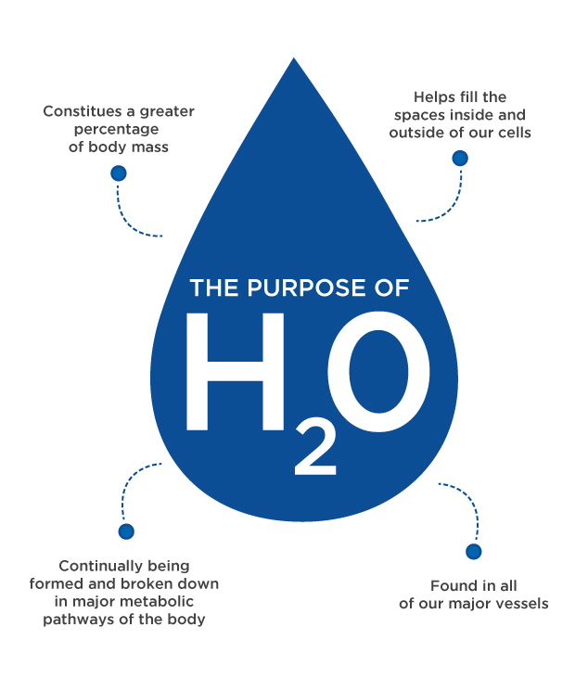

## The physiology of hydration

Water constitutes 50 to 70% of total body mass (Figure: Body Water Percentage). Under normal living conditions without heavy sweat losses from environmental or exercise stress, total body water fluctuates very little from day-to-day (Armstrong et al., 2010). Roughly 2/3 of this fluid is located inside of individual cells and is referred to as intracellular fluid (ICF). The majority of the remaining fluid can be found in the vascular system (plasma portion of blood) or in the space between cells (interstitial fluid). Collectively, the fluid found outside of cells is termed extracellular fluid (ECF) (Figure: ECF and ICF).

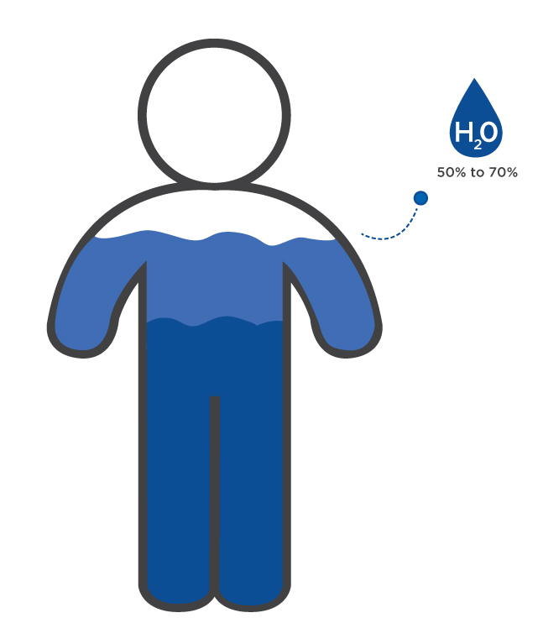 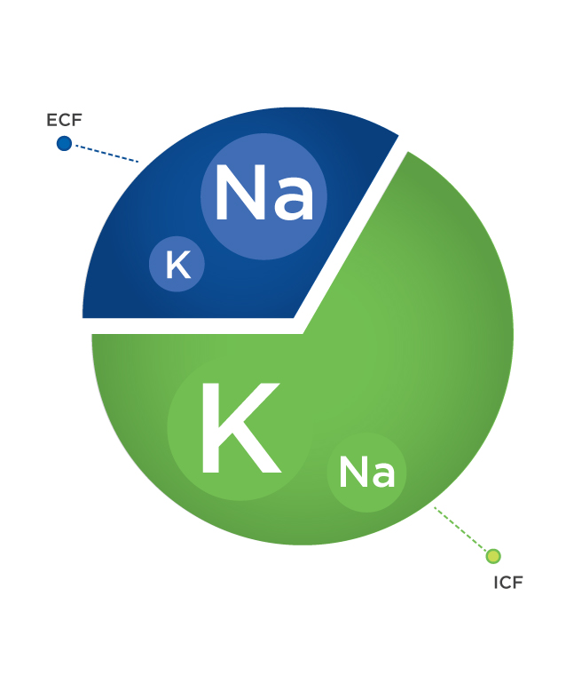

While there are many solutes (e.g., glucose and red blood cells) located within the body’s water compartments, the primary factor that determines what space body water will occupy is dependent predominantly on the concentration of two electrolytes. The first is sodium (Na+), the major ECF solute, while the second is potassium (K+), the major ICF solute.

Getting Technical

You have probably heard that electrolytes are contained in sport beverages and are important for athletic performance. But what is an electrolyte? Electrolytes are molecules that contain a negative or positive charge. Notice the plus sign after the atomic symbol for sodium and potassium in the previous paragraph. The superscript plus symbol denotes that the molecules (in this case two minerals) are positively charged, meaning that each type of atom has one more positively charged proton than negatively charged electron.

The regulatory mechanism that describes the processes that dictate total body water levels and water compartment movement in the body is called osmolality.

The majority of fluid and electrolyte shifts in the body and between compartments are caused by three primary actions provided in the Figure: Involuntary Actions That Deplete Body Water and Electrolytes.

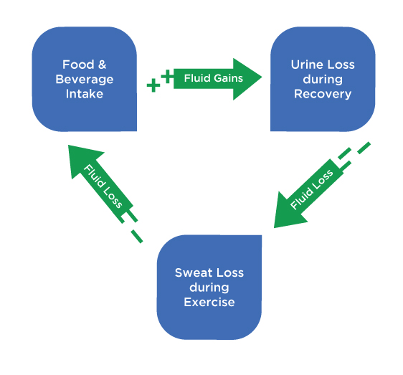

Water in the body continuously seeks to find a distribution in ICF and ECF spaces where the number of solutes in each compartment is roughly equivalent. Most solutes located in these spaces cannot freely cross the cell membrane barriers separating ECF and ICF, but water has a unique capability. With sodium being the primary ECF solute, its concentration is a primary factor in determining the amount of water that will enter a cell body (i.e., ICF) or remain in the ECF.

With an understanding of osmolality and the recognition that the only significant means to add water and electrolytes to the body is by food and beverage consumption, it is apparent that sodium intake is a pivotal dipsogenic signal when attempting to restore total body water after training.

Food for Thought

When large quantities of sodium are ingested without a similar increase in water, plasma osmolality increases and increased thirst drive follows (Johnson, 2007). Most athletes and coaches recognize that thirst is influenced by total body water. However, the most significant influence to thirst for water is regulated by ECF osmolality. Humans experiencing great total-body water losses will not naturally attempt to match sweat losses with fluid intake (Adolph, 1947). In fact, it is estimated that elite male marathoners may lose greater than 8% of their body mass due to a major sweat loss to fluid intake deficit (Beis, Wright-Whyte, Fudge, Noakes, & Pitsiladis, 2012). In contrast, it would be almost unthinkable to invite someone to partake in a salty meal or snack without a beverage also being offered. This concept is critical in understanding what Nutrition Coaches can do to optimize fluid intake between exercise (more on this later).

Thirst sensation is also related to the other two major actions that cause a loss of body water. These losses come in the form of sweating or urine production, both hypo-osmotic, which results in decreased blood pressure due to a loss in total blood volume, or hypovolemia. Sensors in the body known as baroreceptors detect these changes and can stimulate thirst drive. Under normal conditions, total-body water losses are minimal and severe thirst is not typically experienced without intake of salty foods. However, physical activity in warm environments can result in sweat rates up to and exceeding 3 liters per hour. These fluid losses do not typically result in a thirst response that matches fluid intake to sweat losses in the first few hours after exercise, which can lead to inadequate recovery fluid consumption.

Several physiological factors have been discovered that help explain this form of short-term *voluntary* (or sometimes referred to as *involuntary*) dehydration. Sweat is hypo-osmotic, and one of the major adaptations of training in a warm environment is a shift to even less salty sweat. In a seminal study, Nose, Mack, Shi, and Nadel (1988b) documented that a primary reason for the sodium-diluted sweat is that water shifts out of the ICF to the vascular ECF space. This movement of fluid from the ICF space keeps total blood volume from decreasing and serves to maintain blood pressure but also limits the increase of plasma osmolality, the major dipsogenic stimulus.

When a considerable volume of water (but less water than was lost in sweat) is consumed after dehydration, much of it remains in the ECF, further decreasing plasma osmolality-related thirst drive (Nose, Mack, Shi, & Nadel, 1988a).

Critical!

Plasma osmolality is a key driver of thirst. If you are working with athletes who need to replace large volumes of sweat lost, consuming meals or snacks with sodium will promote a natural increase in fluid intake and also aid in retention of ingested fluids.

Food for Thought

The main ingredients (water, carbohydrates, and salt) of sport beverages have remained consistent since their inception. However, the concentrations of carbohydrates and electrolytes have been reduced over the years to improve the gastric emptying rate (GER) and increase carbohydrate availability during exercise. The only situation that essentially requires sport-beverage consumption is during intense and prolonged training. Drinking sport beverages during recovery is more of a beverage preference than a necessity, as most Western diets are already rich in carbohydrates and electrolytes (i.e., salt). The caloric impact of a sports beverage should be considered when choosing recovery beverages.

Coach's Corner

Recent attempts to quantify the hydration efficiency of 13 popular beverages have led to the creation of a Beverage Hydration Index. (For more detailed information see Maughan et al., 2016.) Hydration efficiency was calculated as the volume of urine produced over a 4-hour period following ingestion of 1 liter of each beverage type. Milk bested all other common beverage types, including a sports drink, in regard to decreasing volume of urine production after fluid intake. Milk is touted as an excellent recovery beverage for a variety of factors (Pritchett & Pritchett, 2012; Shirreffs, Watson, & Maughan, 2007) and includes protein, fat, and micronutrients not included in sport beverages.

## Effects of dehydration

**Hydration and heat illness**

Regulation of body temperature during exercise is influenced by total-body water levels in multiple ways. However, it is critical to understand that hydration status alone does not determine whether a physically active individual or athlete will experience a heat-related illness or heat stroke.

Many individuals falsely assume that hydration is the key to preventing these incidents. Abstention from overexertion in hot external environmental conditions or microenvironments (e.g., very hot conditions created by working in a hazardous-materials suit despite moderate environmental conditions) is the best defence against experiencing a heat-related illness, but not even exercising or competing in cold weather can prevent all cases of heat illness (Roberts, 2006). Some heat can be dissipated from the body via movement of the blood to the skin if the external environment is cooler than the body’s internal environment (e.g. average body temperature is around 36.6 ºC (98 °F), but most gyms keep the temperature around 21 ºC (70 °F)).

Increased body water can also reduce heat generation related to elevated cardiovascular strain (i.e., higher heart rate while working at the same relative intensity) due to a less efficient venous return associated with decreased total blood volume. The majority of thermoregulation attributed to body water in hot conditions comes from the production and evaporation of sweat. Sweating provides the greatest cooling effect; however, sweating is only beneficial for cooling if it is evaporated from the skin’s surface. The transformation of sweat from a liquid to a vapour produces this cooling effect. An earlier onset of sweating and greater sweat rate are key adaptations that improve tolerance to exercise in hot environments.

### Sweating

Several elements determine sweat evaporation rate. The first is heat. Higher temperatures increase the rate of sweat evaporation. The second factor is humidity. Environments with lower humidity increase the rate of sweat evaporation, often to such a degree that people incorrectly assume they are not actually sweating in hot, arid regions on windy days. Another factor is convection. For nonaquatic activities, convection describes how air movement or lack of air movement increases or decreases sweat evaporation (Infographic: Sweat Evaporation Rate Factors).

Convection can be caused by the wind or by the client’s movement against air, which can be significant in activities like cycling, where athletes routinely propel themselves over 20 miles per hour. When cycling indoors on a trainer or spin bike or running on a treadmill, it becomes easy to notice these indoor sessions seem to result in greater sweat losses than similar efforts outdoors, even if the indoor temperatures are cooler. This misunderstanding occurs primarily due to the fact that the only areas of the body experiencing convection are the legs during spin, or the arms and legs during treadmill running. During outdoor cycling or running, the torso receives considerably more air flow and more sweat is evaporated.

Critical!

Hydration only plays a small role in heat illness or heat stroke. A variety of factors, including environmental conditions, level of exertion, training status, body composition and clothing, may explain individual bouts of heat illness. Euhydration should not be misperceived as all-encompassing protection guarding against heat-related illnesses. Remember, sweating more does not mean more caloric expenditure. Keep tabs on the thermostat and do not programme exercise in the heat for lesser fit, non-heat acclimated clients. Encourage clients to wear breathable clothing and avoid sweat suits.

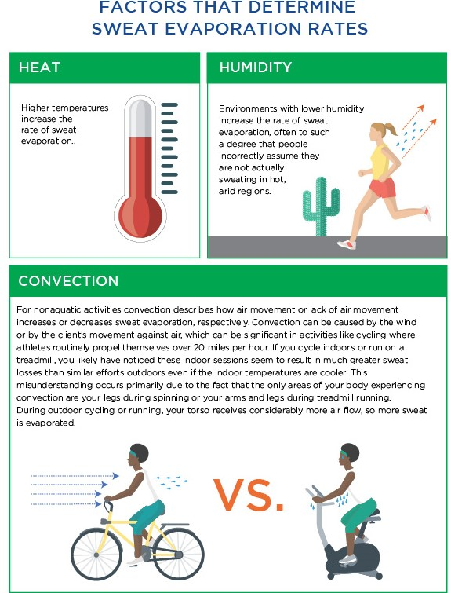

### How does dehydration influence performance?

Hydration status affects the two major influential factors concerning performance during exercise in a hot environment: cardiovascular and thermo-regulatory functions. In Figure: Hydration Status and Heart Rate, the final heart rates and core temperatures are presented from a study in which 10 men completed a 90-minute, fast-paced walk (3.5 miles/hour (5.6 km/hour) at a treadmill grade of 5% in a hot (33 °C or 91 °F) and humid environment under four hydration conditions.

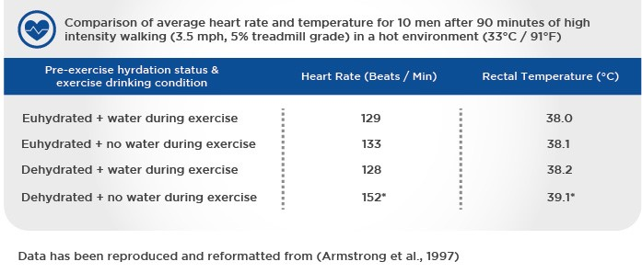

During two trials, participants began exercise euhydrated, and during two other trials, participants began exercise dehydrated. Participants were not permitted to drink at all or were allowed to drink ad libitum under each pre-exercise hydration status. Notice that only one of these conditions resulted in major upward drifts of heart rate and temperature: beginning exercise dehydrated with no access to fluids. Limiting these drifts are major goals when developing hydration strategies. It is critical to note that even when exercise was begun with severe dehydration (loss of water equal to 3% body mass — e.g. 6 pounds (2.7 kg) of water loss for a 200-pound (91 kg) client) followed by exercise inducing an additional litre of sweat loss, simply drinking to natural preferences was enough to offset the upward drifts of heart rate and rectal temperature.

It should be noted that the low relative exercise intensity and continuous opportunity to drink resulted in a nearly six-fold fluid consumption (about 1.7 litre versus 0.3 litre) versus exercise initiated in a euhydrated state. This level of fluid intake is not likely palatable during more intense training and emphasises the importance of between-training-session fluid intake. Half-marathon running studies conducted under similar hot environmental conditions from both the field (Lee, Nio, Lim, Teo & Byrne, 2010) and laboratory settings (Dion, Savoie, Asselin, Gariepy & Goulet, 2013) suggest that most endurance athletes will only replace 15 to 20% of their sweat losses during longer duration training bouts or competitions.

It is also important to note that the low-fluid replacement volumes exhibited in these two studies resulted in many participants experiencing body temperatures greater than 40 °C (104 °F), even though no runners experienced symptomatic heat-related illness.

Critical!

During activities with high thermal stress, Nutrition Coaches should offer free access to a variety of fluid types during preplanned hydration breaks and encourage clients to drink on their own because thirst dictates more fluid intake.

Coach's Corner

Before continuing, look back at your answer to Scenario 1 in the first Try This (Scenario 1 provided below).

Scenario 1: After refraining from working out for several years since high school, a friend tells you that a week of upper-body weightlifting has resulted in repeatedly dark urine colour and very stiff and swollen elbow joints.

Exertional rhabdomyolysis (ER) (often referred to as rhabdo) is a condition in which muscle cell membranes rupture and leak high amounts of proteins, such as myoglobin and creatine kinase, into the extracellular fluid after abnormally hard or new exercise routines. ER is most commonly identified by athletes producing very-dark urine. Unusual puffiness, stiff and swollen joints, and abnormal muscle soreness are also key symptoms of ER. Because the kidneys must handle the excess nitrogen/amino acids loads released from the increased circulating proteins, renal dysfunction is the primary medical concern from ER. Joint swelling is a result of widespread inflammation substrates and fluids shift into the lymphatic system, which accumulate at bends in the body such as the elbows. Clients and athletes with symptoms of ER should be advised to seek medical help immediately and discontinue training until a diagnosis and treatment (usually rest and IV fluid replacement) can be made. Dehydration is often linked as a cause of ER. It is critical to note that this is not the case; rather, the severe muscle damage is the instigator. However, like cardiovascular and thermo-regulatory drift, it is possible chronic dehydration could potentially exacerbate ER-related renal injury. For an excellent in-depth discussion on ER read (Brudvig & Fitzgerald, 2007).

## Developing hydration strategies

Dehydration for clients is often caused by excessive sweating or lack of fluid intake. However, in some cases, dehydration can also be a result of an illness (e.g. vomiting and diarrhoea) (Cheuvront & Kenefick, 2014).

Clinically, dehydration andeuhydration are not defined by total body water but by plasma osmolality or sodium concentrations.

In contrast, for both the scientific and exercise and sport communities, dehydration is often described and expressed as an acute change in total body water, not a change in osmolality.

Euhydration is also commonly defined in the laboratory based on urine solute concentration (e.g. urine-specific gravity). The lack of a single operational definition results in very different interpretations at times. For example, Volpe, Poule and Bland (2009) reported (using urinalysis techniques) that only 34% of 263 collegiate athletes were euhydrated before practice. In contrast, Hew-Butler, Eskin, Bickham, Rusnak and VanderMeulen (2018) found that out of 318 blood samples provided by collegiate athletes, not a single sample would have been classified as dehydrated based on serum sodium norms.

There are multiple reasons why dehydration is used and expressed as a change in total body water in the field versus the plasma osmolality status. Measurement of plasma osmolality or sodium concentration requires a blood draw and expensive analysers to determine a clinical definition of the hydration status. With this in consideration, almost any use of these markers to determine real-time hydration status in a gym or athletic setting is eliminated. In contrast, acute sweat losses can be simply tracked by changes in body mass, and fluid intake is easily measured.

The following section has been prepared with the limitation in mind: that hydration status measured in the clinical sense is not a likely possibility in the exercise realm and that change in total body water does not always correspond uniformly to acute osmolality or sodium concentration levels.

Getting Technical

Total body water shifts are primarily, but not only, related to sweat losses, urine voids and beverage intake. In dry climates, water loss also occurs through evaporative loss of fluids in the mouth and respiratory tract. The aerobic pathway process used to produce energy as adenosine triphosphates (ATP) also result in the formation of new water molecules in the body. Fortunately, under most conditions, these secondary factors are not robust enough to substantially alter the total-body water shift. See Maughan, Shirreffs and Leiper (2007) for a deeper look.

Developing individualized hydration plans for clients is a three-step process. The first two procedures include establishing sweat-loss volume from routine exercise sessions and determining if clients begin training in a euhydrated status. Once this information is established, fluid prescription during and between exercise bouts can be developed, if warranted.

### Sweat-loss assessment

It is possible to drive a car without a functioning fuel gauge, but you will only run into trouble if you fail to fill your petrol tank up frequently enough. This analogy is an almost perfect metaphor for describing the importance of sweat-loss assessment before developing a hydration strategy for a client. Dehydration from sweat loss rarely has severe negative effects on performance or impairs health. Trainers know this because they have survived 100s, if not 1000s, of workouts without incident. Most client's workouts will likely not produce major sweat losses (analogous to a short car trip), and those losses can be easily replaced by ad libitum fluid intake during training and recovery (analogous to frequent stops for petrol).

Sweat-loss assessment allows the Nutrition Coach to determine if their clients do indeed experience major fluid deficits and if any intervention is needed. There are two key differences with regard to hydration using the petrol gauge analogy.

1. A vehicle’s performance will not suffer simply because your gas tank is low, only when it is completely out of gas. In contrast, exercise capacity can potentially be impaired from a significant fluid deficit.
2. Overfilling the gas tank is not that big of a deal unless it spills out of the tank, which can become hazardous. Similar to this hazard, extreme overdrinking can potentially result in death.

Consider the following questions:

1. How do you know how much of a fluid deficit you will incur?
2. How do you determine the level of fluid replacement that will inhibit performance decrement?

Try This

How do you know how much of a fluid deficit your client will incur?

* To determine client sweat rate, you only need a reliable scale, preferably digital for accuracy. Always weigh twice for reliability confirmation.
  + Clients should weigh themselves in the nude in a privacy room. Sweat trapped in clothing will cause an underestimation of sweat losses.
  + Weigh before and after a workout that matches the normal intensity and the environmental conditions of the client. Sweat rates remain very stable if environmental and exercise intensity are consistent.
  + An hour of exercise creates a suitable gauge for estimating sweat losses of shorter- or longer-duration training bouts.
* It is best to avoid using the toilet, if possible, to get the most accurate sweat-loss assessment, and fluid intake must be accounted for (see the interactive sweat-loss calculator).

Helpful Hint

In the United States, body weight is usually measured in pounds and ounces, but beverages are often served in the metric unit of millilitres. If you weigh yourself in kilograms, fluid intake prescription is much easier. A litre of distilled water has a mass of 1 kilogram. Most sport bottles hold around 1 litre (1000 millilitres) of fluid. A half-litre (500 millilitres) of water is the size of a common plastic water bottle and a race aid station paper cup is usually around a quarter of a litre (250 millilitres).

Calculating Sweat Loss

| Initial weight _______________ kg  - post-weight in _______________ kg  + fluid consumption between weigh-ins _______________ kg  - urine volume _______________ kg  Sweat-loss volume _______________ kg (L) |
| --- |
| Example Problem  Joe ran for 1 hour at a pace of 8 minutes per mile in 74 °F (23 °C) weather with low humidity. His nude, pre- and post-weights were 70.0 and 68.5 kilograms, respectively. He drank 0.350 kilograms (liters) of water from his bottle. He did not use the restroom during his run.  Initial weight 70.0 kg  - post-weight in 68.5 kg  + fluid consumption between weigh-ins 0.350 kg  - urine volume 0 kg  Sweat-loss volume 1.850 kg (L) |

The American College of Sports Medicine (Sawka et al., 2007) recommends that fluid intake should not exceed sweat-loss volume and a fluid deficit should be limited to less than 2% of body mass. For a 70-kilogram (154-pound) client, this would mean that fluid intake should not allow body mass to decrease by more than 1.4 kilograms (i.e. 2% of body mass) or exceed 70 kilograms during exercise.

While this sounds ideal in theory, research examining runners (O'Neal et al., 2012; O'Neal et al., 2014; Passe, Horn & Murray, 2000; Shaver, O'Neal, Hall & Nepocatych, 2018) and team-sport athletes (Love, Baker, Healey & Black, 2018; Thigpen, Green & O'Neal, 2014) have repeatedly confirmed that athletes experiencing training bouts that cause sweat losses greater than 2% of body mass cannot accurately estimate their sweat losses.

The miscalculation of sweat losses is almost always in the direction of underestimation. There is ongoing debate concerning whether a 2% loss in body mass from dehydration is a valid indicator of performance impairment (Baker, Dougherty, Chow & Kenney, 2007; Dion et al., 2013; Sawka & Noakes, 2007). Regardless, valid fluid intake prescription can only be made if a reasonable estimation of sweat losses can be established.

Coach's Corner

Physically active individuals are not cognisant of the amount of sweat losses they incur. In fact, a survey of close to 300 long-distance runners (when asked to describe how they monitored their hydration status) found less than 3% reported weighing themselves before and after runs to determine their sweat losses (O'Neal et al., 2011). Figure: Actual vs Estimated Sweat Loss compares sweat-loss estimation averages to actual sweat-loss averages for a variety of studies that further demonstrate this point. It is evident from this figure that if athletes are attempting to drink to prevent a certain amount of fluid deficit, they are doing so with a broken petrol gauge.

The figure confirms the general trend of sweat loss underestimation across activity types, but what really matters for the Nutrition Coach is the ability to improve the performance of the individual.

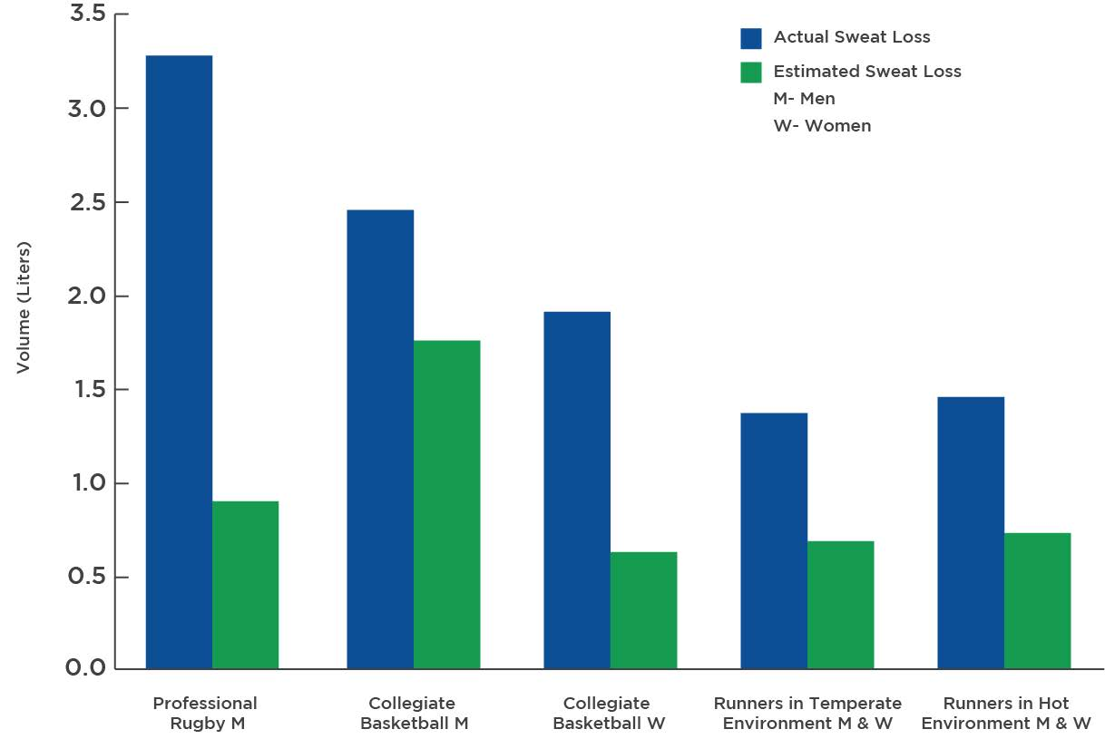

Figure: Estimated Sweat Loss vs Actual Sweat Loss provides insight when estimating sweat loss. Each dot represents an individual. The position of each dot is based on the participant’s estimated (*y* axis) and actual (*x* axis) sweat losses following a 1-hour run in the heat. A closer look reveals how much variability (0.75 to nearly 3 litres!) there is in sweat losses among individual runners. For this simple reason, it is highly inappropriate to ever suggest blanket fluid intake guidelines. Knowing the client’s expected sweat losses allows the Nutrition Coach to make informed and correct fluid-intake recommendations.

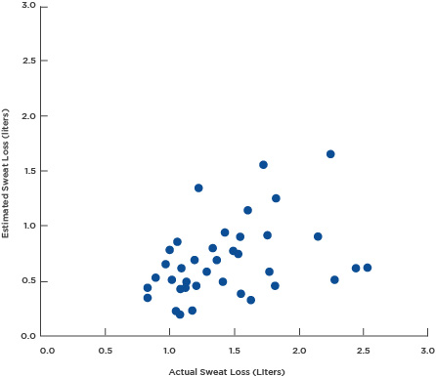

Revisit Scenario 2 below. A tri-athlete is rejoicing over a road bike that could hold an immense volume of water bottles. What if the scenarios previously described were reversed and an athlete experiencing low relative sweat losses drank under the impression that their sweat losses were much greater?

Scenario 2:

A triathlete and member of your local endurance sport club has posted a picture of a very-new and expensive road bike. Statements are made that the new bicycle is very light and also has five, 1-litre bottle holders!

Food for Thought

A convincing argument can be made that athletes should only *drink to thirst* (Hoffman, Cotter, Goulet & Laursen, 2016), and multiple hydration guidelines have been written on this premise (Hew-Butler et al., 2005; Hew-Butler et al., 2008; Hew-Butler et al., 2015). However, there are examples of individuals developing Exercise Associated Hyponatremia (EAH) that either do not follow their body’s cues to prevent over-drinking or psychological factors override physiological signals. These incidents are most likely to occur in low-intensity activities of prolonged duration such as hiking, and it possibly impacts females more commonly (Backer, Shopes, Collins & Barkan, 1999; Kenney & Chiu, 2001; O'Neal et al., 2012).

O'Neal, Poulos and Bishop (2012) examined the ad libitum fluid intake of 27 women drinking water and a variety of non-caloric sport beverages with different ingredient combinations during a 1-hour long, hot summer-time walk and 2-hour recovery period. One participant exhibited a profound concern about dehydration and researchers had to provide the participant with a urine container so she could step into the library to pee during every walking session! Table: Hydration Behaviour of an Active Female displays this woman’s data from the study.

Hydration Behavior of an Active Female

| **Comparison of hydration behavior of a physically active female with unfounded excessive concern about hydration – These values are averaged over 5 days of testing with five different beverages.** | **Outlier Participant** | **All Participants** |
| --- | --- | --- |
| Pace (km/hour) | 6.3 | 6.0 |
| Mean heart rate (beats/min) | 128 | 132 |
| Sweat loss (mL) | 590 | 526 |
| Pre-exercise USG | 1.004 | 1.016 |
| Exercise fluid consumption (mL) | 890 | 289 |
| 2-hour recovery consumption (mL) | 390 | 225 |
| Total consumption (mL) | 1280 | 514 |
| 3-hour urine voids (mL) | 1120 | 196 |

The data in this tabel was reformated from O'Neal et al, 2012.

The participant’s pace, heart rate and sweat losses were similar to the rest of the group, but her hydration behaviour was a far outlier. Her average pre-exercise USG was 12 units lower than the other 27 women, suggesting she was hyper-hydrated prior to exercise. However, her fluid consumption exceeded her peers by 250%, and her urine production was an astounding 570% greater than the other walkers as her kidneys were working aggressively to offset the excessive water load in her ECF.

If someone continues to excessively hydrate for extended periods of time during exercise, it is possible for exercise associated hyponatremia (EAH) to occur. Working knowledge of sweat rate and volume can help avoid situations of EAH in most conditions.

Getting Technical

EAH is a potentially deadly medical condition most commonly caused by fluid intake that greatly exceeds sweat loss, which dilutes ECF sodium levels. As a result, an influx of water into the ICF space can lead to cells in the brain stem rupturing, leading to a coma or death. Multiple factors can lead to exacerbated risk of EAH. During exercise, blood flow to the kidneys is greatly diminished, resulting in reduced clearing of the excess fluid. Some individuals over-aggressively hydrate before exercise and others are genetically predisposed to altered hormonal regulation that causes the body to produce less urine than it should. It is important to teach clients to listen to their own body’s cues to not drink in excess of natural thirst.

Coaches are not expected to diagnose EAH but should be aware of the signs and symptoms of EAH. Athletes experiencing EAH with severe symptoms (e.g. seizures or coma) will likely be unable to continue drinking and need to seek medical attention. However, the less-severe symptoms of EAH (such as weakness, cramping, vomiting, disorientation or confusion) may also be experienced during severe dehydration, but should still be treated medically as this is outside the scope of practice for a Nutrition Coach. When assisting someone who is showing signs of hypo- or hyperhydration, always determine the individual’s recent fluid intake. If they report drinking heavily, continued fluid consumption should be restricted. Severe thirst or lack of thirst may help indicate if an athlete is dehydrated or experiencing EAH. If EAH is expected, get the athlete to a hospital as quickly as possible, where sodium levels can be formally evaluated.

Coach's Corner

The good news is that EAH is uncommon and athletes should not have an irrational fear of EAH. There are several competition or training scenarios that are more likely to result in EAH.

* Training or competition sessions that last 4 hours or longer – caution should be given in overzealously promoting fluid consumption.
* High fluid intake during cool environmental conditions that do not result in high sweat rates
* Individuals with lower body mass that take longer to finish an event may exhibit a greater relative fluid intake to body mass ratio.

### Pre-exercise hydration status assessment

The pre-exercise hydration status of the athlete also impacts hydration recommendations. Determining pre-exercise status is complicated and each method of assessment has weaknesses (Armstrong, 2007). Measuring plasma osmolality is obviously impractical in a non-clinical setting, such as a fitness facility. On the opposite end of the spectrum, thirst sensation is easily and freely measured (Davis et al., 2014; Lopez et al., 2011; Stearns et al., 2009; Wilcoxson, Johnson, Pribyslavska, Green & O'Neal, 2017). The most popular remaining options to detect pre-exercise hydration status include changes in body mass and various forms of urinalysis.

**Thirst and body mass as indicators of hydration status**

In regard to changes in body mass to detect hydration status, it has been proposed that athletes record their morning body weight after making voids over a 3-day period and use a 1% decrease from the 3-day body-mass average as a marker of hypohydration (Cheuvront et al., 2004). However, it is unlikely establishing a 3-day baseline for body mass and checking for deviations from that body mass is commonly practised.

It may be logistically difficult to get accurate 3-day body-mass averages of clients already engaged in training. A simple body mass change from training session to training session is more likely used in the field setting, but this method also has flaws. Many training sessions are separated by unequal periods of recovery. Meal consumption and bowel movements may impact pre-exercise body mass. There is no universal guideline for what percentage of body mass should be returned before the next practice begins.

Like thirst, great sweat losses followed by unusually restrictive fluid intake during recovery will produce pronounced differences in body mass (Lopez et al., 2011; Stearns et al., 2009). However, data from studies that have induced significant sweat losses followed by less-restrictive fluid allowances suggest change in body mass may not be well representative of recovery fluid intake. Davis et al. (2014) found that the replacement of 75 versus 150% of sweat losses from a 75-minute run in the heat over a 12-hour period only produced a difference of about 0.5 kg in body mass — due to the effectiveness of the kidneys to retain fluid when intake is less than ideal but not restricted during recovery.

Under a similarly designed protocol, Wilcoxson et al. (2017) required trained runners to lose about 3% of body mass on three separate occasions followed by 1.6, 2.1, or 2.6 litres (approximately 70, 100 and 120% replacement of sweat loss) of multiple beverage types over a 12-hour recovery period. Fluid replacement at these three levels resulted in approximately 0.5, 0.9 and 1.4 litres of urine production. Because of the vast differences in urine production, the average difference in change in total body water was less than 0.2 litres!

Both of these studies controlled all food intake over the 12-hour recovery testing period and still found no clear change in body mass that differentiated between different recovery fluid replacement levels. In summary, thirst sensation and change in body mass are likely great indicators of pre-exercise hydration status if fluid intake after the previous exercise bout is highly insufficient, but diagnostic legitimacy may decrease under more ecologically valid conditions.

**Urinalysis as an indicator of hydration status**

Urine osmolality, colour and specific gravity are also used to gauge the real-time hydration status. The impracticality of using osmolality, even from urine versus blood, has already been discussed. The highly popular urine colour scale (Armstrong, 2000) was developed as an alternative to techniques that required laboratory instruments and is often found in fitness facility locker rooms. Urine colour, like thirst or the change in body mass, is excellent at distinguishing between extremes of recovery fluid intake but is not particularly sensitive to less contrasting levels of recovery fluid intake that would likely be experienced by clients (Wilcoxson et al., 2017). This may be due to the subtle differences in shading for the identifying markers in the middle of the eight-level urine color chart (Figure: Urine Chart).

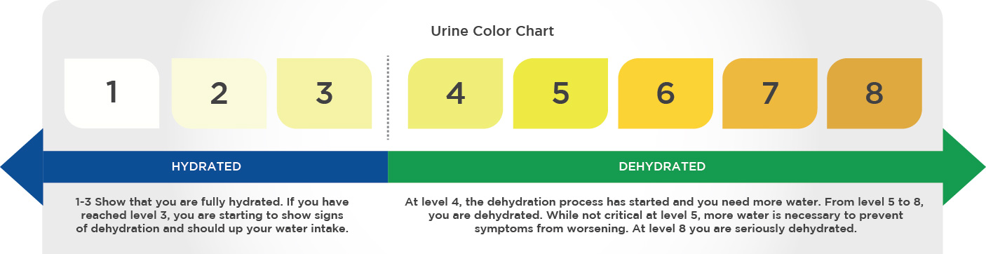

Thought must also be given to how the urine colour is measured. The chart was designed to be used after urine is collected in a clear container, but most athletes likely examine their urine after it has been diluted in toilet water.

Urine-specific gravity may be an option for Nutrition Coaches looking for a more objective way to determine if clients are adequately rehydrating between training [Figure: Urine-Specific Gravity (USG)].

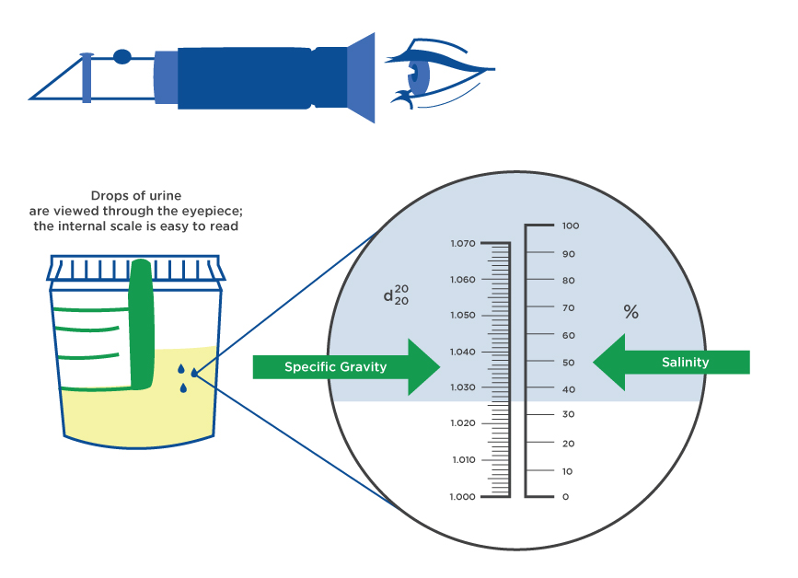

Getting Technical

Urine-specific gravity (USG) is a scale that represents the ratio by which the pathway of light is bent (or refracted) after travelling through a liquid in comparison to light passing through water that has no solute content. The picture above is a picture of a manual refractometer (purchased for <$150), which can assess USG.

A drop of urine is placed on the lens of the refractometer and a metered scale in the viewfinder is used to determine the refraction ratio.

As the kidneys attempt to conserve body water, more solutes and less water will be found in the urine. Hyperhydration results in the kidneys trying to clear excess water and the urine will be more dilute. Assessing USG is simple. Nutrition Coaches may consider adding this assessment to better serve their clients needing hydration advice.

Figure: Relationship Between Percentage of Sweat Loss Replaced and USG below presents the USG 12 hours after 60 to 90 minutes of running and the percent of sweat losses replaced during recovery.

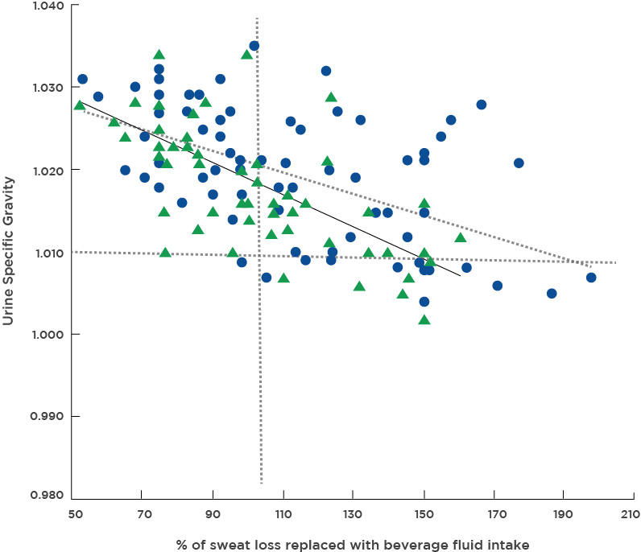

There is a strong but imperfect relationship between the fluid replacement percentage and USG, and the relationship’s strength is improved in runners that lose greater relative percentages of sweat (purple triangles). When runners lost greater than 3% of their body mass, USG correctly identified the recovery fluid intake adequacy just shy of 85% of the time. Correct identification fell to less than 70% for those individuals who sweated less.

Again, under this scenario, USG is not meant to be a substitute for a clinical hydration classification (i.e. plasma osmolality). Instead, frame it as a tool to identify clients that experience heavy sweat losses and repeatedly show up to train without adequately replacing fluids between training sessions.

Coach's Corner

Tips to Hydration Education and Recommendations

Traditionally, a USG exceeding 1.020 has been used as a dichotomous hydrated/dehydrated measure. USG may be more useful as an indicator of adequate recovery fluid consumption.

Measure USG prior to multiple training sessions to gain a global picture of the individual client’s chronic hydration behaviour. USG meeting or exceeding 1.030 likely indicates a significant failure to replace fluids, while a reading closer to 1.020 probably indicates a less-significant lack of adequate fluid replacement.

Help athletes that repeatedly exhibit USG of 1.025 or greater to assess their sweat rates in training (see the sweat-loss calculator) and prepare a plan to intentionally replace about 110 to 120% of their expected sweat losses from practice with fluids from a metered bottle.

**Fluid intake during and between training**

Before a Nutrition Coach provides any hydration recommendations to their clients, they must ask themselves if there is a genuine need for fluid intake advice. Dehydration is an easy culprit to blame when a training session or competition does not go as planned, but Nutrition Coaches should only intercede when intervention is actually needed (i.e. when sweat losses from training are great and clients fail to adequately hydrate between training bouts).

There is disagreement on the precise percent of body mass lost through sweating that leads to impaired performance (Dion, Savoie, Asselin, Gariepy & Goulet, 2013; Sawka & Noakes, 2007). Anecdotally, less-well-trained and non-heat acclimatised individuals are more likely to suffer impaired performance associated with dehydration than their more elite peers. A simple recommendation is that if fluids are freely accessible during training and sweat losses will be less than about 3% of body mass, no formal hydration advice concerning beverage consumption is needed during exercise. This covers the vast majority of training or competition circumstances.

Some clients will actively seek hydration advice. If sweat loss and pre-exercise hydration evaluations suggest no intervention is needed and this appraisal is too anti-climactic for your clients, simply encourage consumption of 500 mL of water before bed and another 500 mL of water in the 2 hours before exercise.

**Fluid intake during exercise**

For Nutrition Coaches who work with athletes, the main difference for endurance and team-sport-based athletes is that most team-sport practices and games typically have built-in periods of rest where fluid consumption can take place without difficulty. For Nutrition Coaches who work with team-sport athletes who do experience great sweat losses, it is critical that ample breaks and a variety of beverages to encourage fluid consumption are provided. Keep in mind that when provided with the opportunity to drink, most, but not all individuals will consume fluids to prevent the cardiovascular and thermo-regulatory impairment caused by dehydration (Armstrong & Maresh, 1998).

For endurance athletes, there are many options to preplan drinking opportunities: place fluids along routes, plan routes that pass convenience stores or water fountains, carrying hydration packs on their backs or bikes, place drinks on pool decks, use hand bottles, etc. Ideally, a sweat-loss assessment analysis should be incorporated before competition to determine the minimal amount of fluid that must be consumed to prevent excessive dehydration. The athlete should also practise their competitive fluid-intake routine strategy during training to determine if the fluid consumption volume or beverage type will result in gastrointestinal distress. All of these factors can also be incorporated when working with non-athlete clients to encourage day-to-day euhydration.

**Fluid intake during recovery**

Some hydration guidelines prescribe fluid intake for *before* and *after* exercise. A more global terminology of recovery hydration is preferred. The key to recovery hydration is to replace sweat-loss fluids and maximise the retention of those fluids before the next training session. ACSM guidelines (Sawka et al., 2007) suggest that when the recovery period is less than 12 hours, athletes should replace 150% of their sweat losses via beverage fluids.

The idea behind this replacement prescription is that roughly 1/3 of beverage intake will be lost through urine voids. This is entirely appropriate if sweat losses are not great. However, when sweat losses exceed 3% body mass, this volume of fluid replacement is likely unpalatable for many individuals and may produce urine volume greater than 1/3 of the beverage intake, nullifying the additional fluid consumption for many individuals (Davis et al., 2014; Wilcoxson et al., 2017).

Under the scenario that greater than 3% body-mass loss will be incurred and the recovery period will be <12 hours, it is suggested that athletes should aim for replacing at least 110 to 120% of their sweat losses with fluid intake from beverages and acquire additional fluid intake from food sources (Infographic: Fluid Prescription During Training and Recovery).

Sodium, protein and carbohydrate intake support fluid retention by decreasing the relative urine production. It is a popular belief that hunger is disguised thirst. There may be some truth that drinking before eating decreases food intake, but there is no doubt that food consumption encourages fluid consumption. Sodium-rich food items, such as mustard packets, pickle juice or pretzels, increase fluid intake and retention during recovery and are probably only truly needed during very-intense and prolonged training phases.

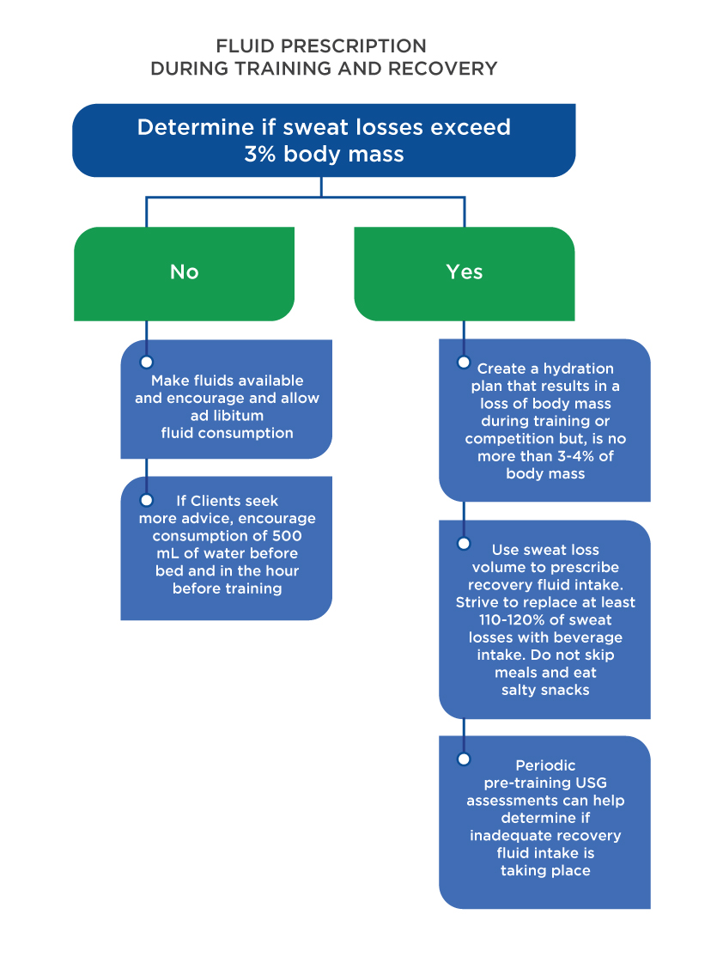

Eating meals and snacking between training is paramount to optimising recovery hydration efforts. Use the following tips to share with clients:

* Some fruits and vegetables contain up to 90% of their mass as water and also contain potassium, the key ICF electrolyte. Soups are also high in water content and generally contain ample amounts of sodium.
* Many athletes falsely assume water is the only beverage that improves hydration status. All beverages, excluding those with alcohol percentage >4% (McDermott et al., 2017), increase total body water.
* Caffeine has also been miscast as a diuretic for physically active populations, but habitual consumption of caffeine and exercise negate the diuretic effect of caffeine to benign levels (Zhang et al., 2015).
* The high sodium content of pickle juice reduces urine output. This strategy might be helpful during very-intense periods of training in the heat, but it is not likely needed if salty food is consumed at meals during recovery.

# Nutrient timing

Nutrient timing is a hot topic among fitness professionals and academicians alike. Depending on the audience, nutrient timing can elicit different thoughts as to what it truly means. Using the working definition as “the temporal positioning of nutrients throughout the day and/or relative to the exercise bout in order to maximise performance or improve body composition”, this chapter will examine different nutrients, guidelines and recommendations to best help clients reach their desired outcomes.

Fuelling strategies to enhance athletic performance and recovery are an important aspect of sports nutrition. Athletes often seek new methods to improve athletic performance and recoverability from demanding workouts or sport practices. As such, nutrition coaches should arm themselves with evidence-based information regarding fuelling strategies that maximise performance and recovery, no matter if the client is a professional athlete, a weekend warrior or someone striving to improve their health and well-being.

Macronutrients are substances required in large amounts by living organisms to survive and are the building blocks of the diet. The three macro-nutrients are carbohydrates, proteins and fats. Each macronutrient plays an important role in fuelling athletic performance and exercise.

Carbohydrates are the body’s fuel source and intake will determine the quality of energy (or, in this case, the work capacity) that is put out. Carbohydrates are broken down into glucose in the body and they help provide the energy that powers every move: from eating, breathing and thinking, to walking and running. Glucose is also the preferred energy source of our brain. Even though the brain accounts for just about 2% of total body weight, this tiny but powerful organ consumes about 20% of glucose-derived energy, making it the main consumer of glucose in the body (Erbsloh et al., 1958).

Fibre is found in carbohydrates and plays a vital role in how quickly something is digested and used as energy (Lattimer and Haub, 2010). Fibre is made up of edible parts of a plant that are resistant to digestion and absorption in the small intestine. Meals further away from activity should be higher in fibre compared to the meals or snacks closer to the activity (1 to 2 hours before) so the food has time to digest and be available for energy (Coleman, 2017).

While solid food is a great choice if time allows, for some clients or athletes, sipping a sports drink or chocolate milk on the way to the gym may be the most practical option, depending on the workout ahead. Other ideas include a piece of fruit with a bit of nut butter, yogurt or dried fruit with some nuts (about a 2:1 ratio of fruits to nuts), for example.

Protein comes from a variety of sources and does more for the body than just repair muscle. Protein is made up of amino acids and is required for many bodily functions including building and repairing tissues; providing the building blocks of bones, muscles, skin, cartilage and blood; and making enzymes and hormones. Protein is a necessary component of every cell in the body. Typically, athletes will need more than the required amount because their bodies are constantly at work building or repairing muscle (Jäger et al., 2017).

According to the Institute of Medicine, the recommended amount of protein ranges from 10 to 35% of total energy. While that is a large range, there are more specific recommendations for more- and less-active individuals. The general RDA for protein is 0.8 gram/kilogram/day. This is the minimum intake to simply prevent deficiency. Most research and protein experts have found intakes should be higher, particularly for active individuals, where most research encourages 1.2 to 1.6 gram/kilogram/day or more, depending on the individual goal(s) (Burd and Phillips, 2017).

Fat provides a concentrated source of energy to an athlete (over double what carbohydrates and protein provide, with about 9 calories per gram versus about 4 calories per gram for carbohydrates and protein). In fact, fatty acids are the most abundant source of endogenous energy in the body, due to their high energy capacity as well as the copious amount of storage in even the leanest individuals (Wolfe, 1998). Fat also plays a vital role in nutrient absorption, hormone regulation, heart health, blood pressure regulation, protection of vital organs and hair and skin health.

Fat is essential for the absorption of fat-soluble vitamins A, D, E and K. While these are all important qualities of fat, it also helps provide the feeling of fullness (satiety). This may be important in terms of educating clients on sustainable energy; however, it may also impact the immediate availability of nutrients to working muscles, depending on the type and duration of physical activity.

Fat is stored within muscles as intramuscular triglycerides and can be accessed for energy while training. However, during long-duration exercise, the body uses these triglycerides that are stored within the muscles. In long-duration sports, it is important to replenish carbohydrates, protein and fat stores, as fat plays a bigger role in continuing to perform physical activity over long-duration activities. Ultimately, the athletes who most likely need this type of replenishment are those training for longer events such as Olympic distance triathlons or longer marathons. For these athletes, it is best to refer them to a qualified sports dietitian.

## Timing of nutrients

Nutrition is a fundamental priority for athletic populations, both recreational and professional, to provide sufficient energy for working muscles, help repair bodily tissues, regulate hormones and combat fatigue. The importance of the type of food a client consumes can determine the quality of their physical and mental performance. Carbohydrates provide the most immediate energy source, protein helps build and repair muscle, and fats help to regulate hormones in addition to producing energy for extended bouts of exercise.

An adequately fuelled body can store enough glycogen to fuel up to 120 minutes of continuous exercise. Remember the discussion of nutrient metabolism and energy systems from earlier in the chapter. This is where the understanding of those systems comes into play, to understand how ATP is produced. Food containing carbohydrates consumed during exercise can delay the depletion of muscle glycogen stores (Table: Estimated Energy Stores in Humans).

Estimated Energy Stores in Humans

| **Energy Source** | **Storage Site** | **Approximate Energy (kcal)** |
| --- | --- | --- |
| ATP-PC* | Various tissues | 5 |
| Carbohydrate | Blood glucose | 80 |
| Liver glycogen | 400 |
| Muscle glycogen | 1500 |
| Fat | Serum free fatty acids | 7 |
| Serum triglycerides | 75 |
| Muscle triglycerides | 2500 |
| Adipose tissue | 80,000+ |
| Protein | Muscle protein | 30,000 |
| *ATP-PC = adenosine triphosphate phosphocreatine | | |

### Nutrient timing applications: endurance vs. strength-based activity

Carbohydrates and fat are the main substrates used by the body during an endurance activity. The intensity of the activity determines the contribution of each. Carbohydrates are the main substrate used during moderate- to high-intensity exercise, whereas fat is the predominate substrate used during lower-intensity exercise. In addition to intensity, as the exercise duration continues (prolonged bouts of exercise), fuel substrates begin to shift, moving more from carbohydrates (glycogen) to fat stores as well.

Like endurance activity, resistance-based exercise relies primarily on carbohydrates as the primary fuel source, making liver and muscle glycogen stores important for performance (Robergs et al., 1991). It is important to keep muscles fuelled and hydrated to optimise performance and support adequate recovery. The body takes time to digest foods, so total energy intake and composition should be considered in the meals leading up to exercise. During exercise (>60 mins), glycogen depletion can be delayed when exogenous glucose is present.

**Endurance exercise**

The amount of carbohydrates an endurance athlete needs varies tremendously based on their size, gender, training programme and sport (Ivy, 1991). Often, elite endurance athletes struggle to consume enough calories to balance the day-to-day energy demands. Glycogen stores are maximised with a higher carbohydrate diet and can be depleted with high-volume exercise, such as consistent endurance activity (Kerksick et al., 2017). Carbohydrates are critical for an endurance athlete and a continuous supply (8 to 12 grams/kilograms/day) is optimal (Kerksick et al., 2017). Athletes who continuously eat a carbohydrate-rich versus a higher protein- or fat-rich diet have greater muscle glycogen stores to draw from during training and racing (Ivy, 1991).

It is well-established that adequate muscle glycogen stores help delay the onset of fatigue (Impey, 2018). While research around carbohydrate timing and intake is plentiful, at this time, research is inadequate to also suggest the timing of the fat intake as it relates to exercise.

Endurance athletes should consume frequent meals and snacks throughout the day and avoid skipping meals. Good-quality carbohydrates, lean protein and healthy fats should be the focus of all meals and snacks. Active individuals training for a race of some kind (e.g. 5k or 10k) and exercising consistently for over an hour should also ensure adequate carbohydrate intake to fuel exercise and speed up recovery from training bouts (Eberle, 2014).

Fueling Strategies - Endurance Athletes

| **Pre-Exercise Meal** | | |
| --- | --- | --- |
| Timing | Composition | Hydration |
| 3 to 4 hours before exercise | High in quality carbohydrates (e.g., English muffin, pancakes, waffles, lower fiber cereal, or whole grain bread)  Lean protein (e.g., eggs, turkey, ham, roast beef, chicken, or tuna)  Low in fiber and fat | 4 hours before activity, start hydration strategies.   * Example: Drink about 20 oz water. |
| **Pre-Exercise Snack** | | |
| Timing | Composition | Hydration |
| 30 minutes to 1 hour before exercise | High in carbohydrates (e.g., chocolate milk, yogurt, fruit and nut butter, or sports drink with protein powder)  Moderate in protein  Low in fat and fiber | ​​​​​​​Continue hydrating.   * Example: Drink 5 to 10 oz of water. |
| **Peri-Exercise Meal** | | |
| Timing | Composition | Hydration |
| Carbohydrate intake should begin shortly after onset of activity, but only if the exercise session is continuous and will last more than 60 minutes. | Products providing multiple transportable carbohydrates such as sports gels, blocks, sport beans, sports drinks, fruit, or high-carbohydrate bars with little to moderate protein | Continue hydrating, which is dependent on the athlete’s sweat rate.   * Example: 0.4 to 0.8 liters per hour   Sports drinks should contain 6 to 8% carbohydrate solution.  Replace electrolytes lost with sports drinks or foods high in sodium and potassium. |
| **Post-Exercise Meal/Snack** | | |
| Timing | Composition | Hydration |
| Critical only if another exercise bout is planned within 24 hours; however, no harm in replenishment soon after exercise  2 hours after exercise (Continue meals in 2-hour intervals up to 6 hours.) | Quality carbohydrate and lean protein  Carbohydrates: 1 to 1.2 g/kg per hour for 4 to 6 hours post-exercise  Protein: 0.25 to 0.3 g/kg post-exercise | Continue hydrating.   * Example: Drink 16 to 24 oz water or sports drink for every pound lost during exercise (1.25 to 1.5 liter per kilogram of body weight lost during exercise). |

**Resistance exercise**

For a strength-training athlete, the main goals are to provide calories for daily activity and intense training and competition, and to build and repair muscle mass. Focussing on eating and hydrating often and nutrition before, after and possibly during exercise are the keys to training and performing at an optimal level and achieving specific fitness goals. While traditional resistance exercise has less of an impact on muscle glycogen concentration than exhaustive endurance exercise, studies have demonstrated that resistance exercise can significantly decrease muscle glycogen as well (Robergs, Pearson & Costill, 1991).

It is also well-established that resistance exercise stimulates muscle protein synthesis (MPS), which is further stimulated and augmented by protein ingestion (Damas, Phillips, Vechin & Ugrinowitsch, 2015). MPS is an important factor for increasing the size of muscles, known as muscle hypertrophy.

Nutrient timing is simply one part of the equation of increasing muscle mass. In fact, muscle hypertrophy cannot occur without a properly designed and simultaneous resistance-training programme. In reality, there are many factors that play a role in achieving hypertrophy and strength gains, including hormone levels, stimulating lean muscle with a properly designed resistance-training programme, and the consumption of the right fuel (total energy and protein).

Fueling Strategies - Strength Athletes

| **Pre-Exercise Meal** | | |
| --- | --- | --- |
| Timing | Composition | Hydration |
| 2 to 4 hours before exercise | High in quality carbohydrates (1 to 4 g/kg)  20 to 30 g lean protein  Lower in fiber and fat | 4 hours before activity, start hydration strategies.   * Example: Drink about 20 oz of water. |
| **Pre-Exercise Snack** | | |
| Timing | Composition | Hydration |
| 30 minutes to 2 hours before exercise | High in carbohydrates  Moderate in protein  Low in fat and fiber | Continue hydrating.   * Example: Drink 5 to 10 oz of water. |
| **Peri-Exercise** | | |
| Timing | Composition | Hydration |
| Carbohydrate intake (and possibly protein) should begin shortly after onset of activity only if exercise session lasts more than 60 minutes. | 30 to 60 g carbohydrates per hour spaced every 15 to 20 minutes for exercise lasting over an hour | Continue hydrating, which is dependent on the athlete’s sweat rate.   * Example: 0.4 to 0.8 liters per hour   Sports drinks should contain a 6 to 8% carbohydrate solution.  Replace electrolytes lost with sports drinks or foods high in sodium and potassium. |
| **Post-Exercise Meal/Snack** | | |
| Timing | Composition | Hydration |
| Critical only if exercising again within 24 hours, but not harmful to try to consume quality carbohydrates and protein soon after exercise session comes to an end and at repeated intervals (about every 4 hours), particularly when it comes to protein | Quality carbohydrates and lean protein  Carbohydrates: 1 to 1.2 g/kg for 4 to 6 hours post-exercise  Protein: 20 to 30 g (0.25 to 0.3 g/kg) consumed after exercise | Continue hydrating.   * Example: Drink 16 to 24 oz of water or sports drink for every pound lost during exercise (1.25 to 1.5 liter per kilogram of body weight lost during exercise). |

## Myths and hot topics

Nutrition brings a bevy of information, myths or otherwise. There are a variety of topics that can be explored in this section, but a few of the most common are highlighted.

**Is it possible to build muscle and lose fat simultaneously?**

For years, most experts and the associated scientific weight-loss literature advised that weight loss inevitably would lead to both fat and muscle loss, with most of the loss coming from lean tissue. On the surface, this makes sense: increasing lean body mass requires a positive energy balance, whereas a negative energy balance is needed to decrease body weight. The idea is that when a person is in an energy deficit, it makes it nearly impossible to simultaneously increase lean body mass.

However, more recently, some data has been published challenging that long-held belief. In fact, losing body fat and gaining muscle simultaneously is possible with the right diet and training program. A commonality among the studies that support this notion is the quantity (and quality) of protein in the diet. Several studies have now demonstrated that this seemingly impossible feat is truly possible (Longland et al., 2016, Pasiakos et al., 2013).

One study specifically examined three different protein intake levels during a calorie-controlled weight-loss study:

* The U.S. RDA (0.8 grams protein/kilogram body weight)
* Twice the U.S. RDA (1.6 grams protein/kilogram body weight)
* Three times the U.S. RDA (2.4 grams protein/kilogram body weight).

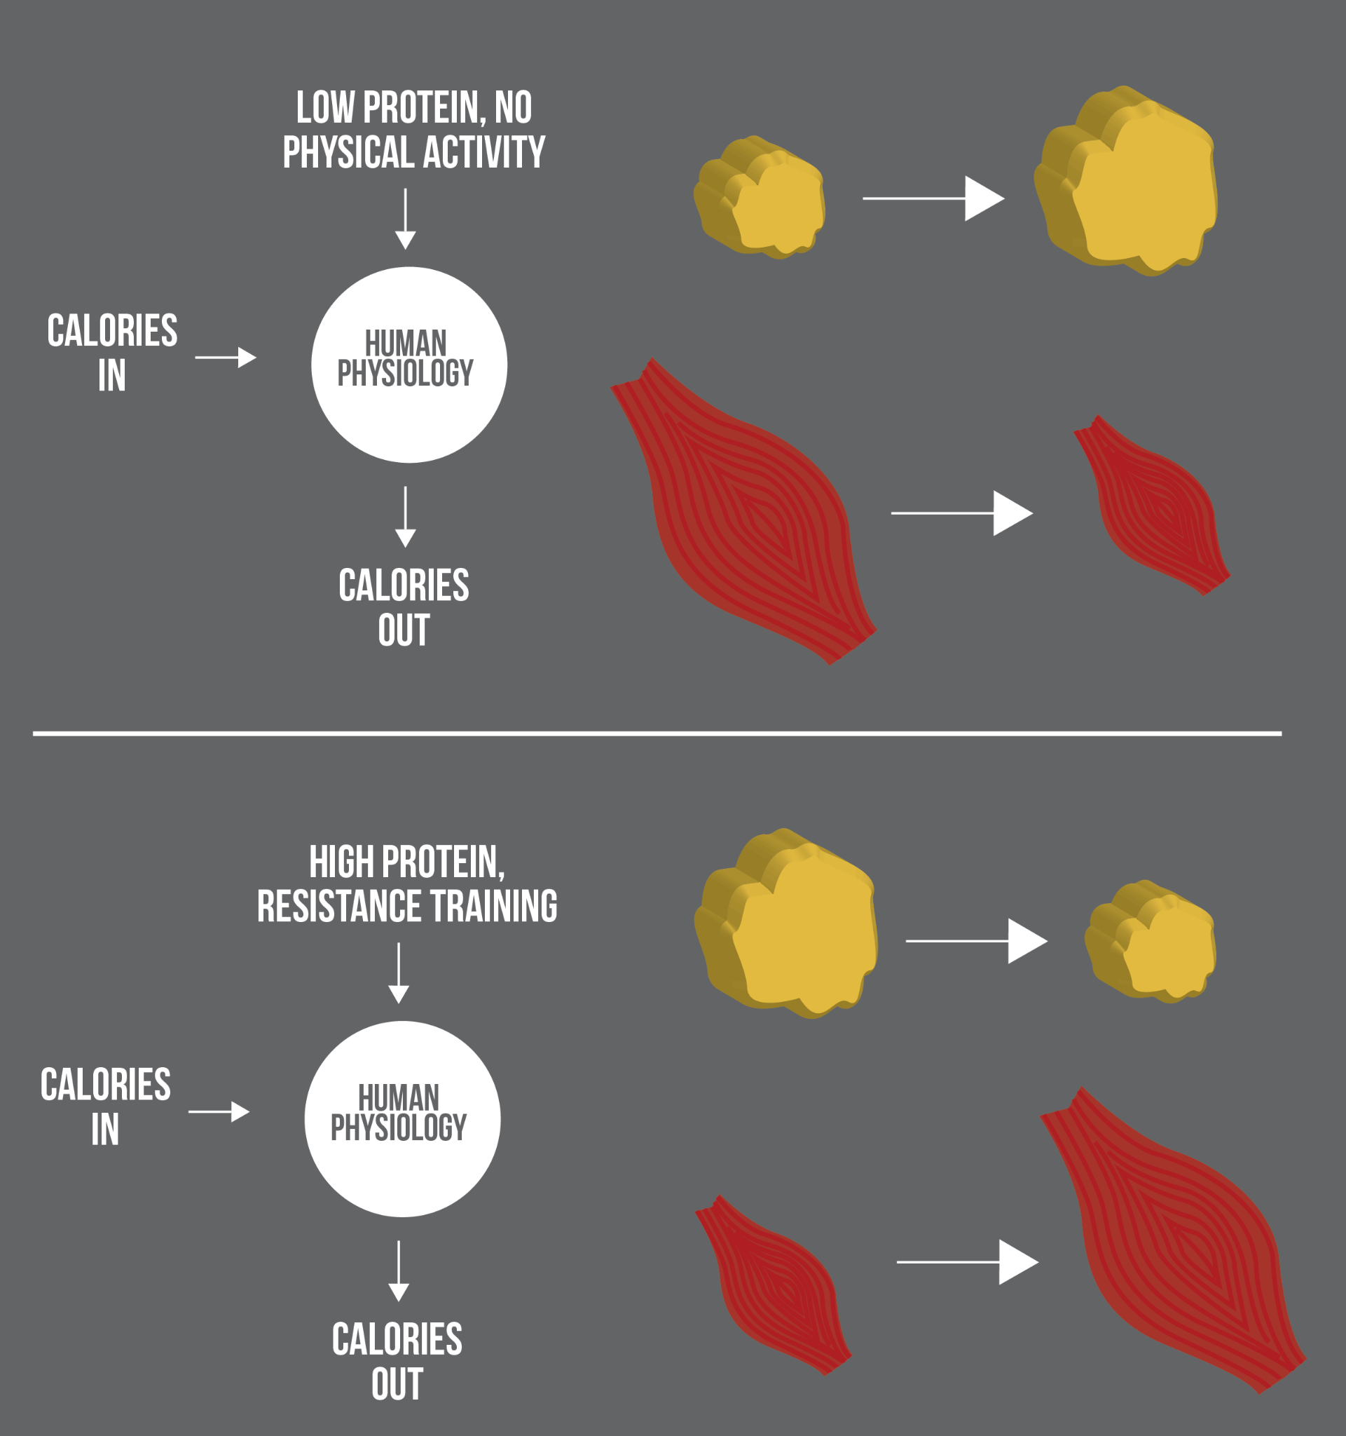

Researchers provided all meals and supervised all exercise routines among the subjects during the study. Those subjects who ate double the RDA of protein (1.6 grams protein/kilogram body weight) and exercised were able to lose fat while preserving lean tissue. Interestingly, subjects who ate 2.4 grams protein/kilogram body weight did not experience more weight loss than the group who ate 1.6 grams protein/kilogram body weight. Regardless, both higher protein groups lost more weight than the group eating at the RDA level of 0.8 grams protein/kilogram body weight.

The results of this study support others with similar findings: increasing protein intake while in a negative energy balance can help preserve muscle.

Critical!

Nutrition alone cannot build muscle. While protein is necessary for the repair and building of muscle, without a proper resistance-training program to stimulate growth, mindlessly adding protein itself is not an effective strategy for increasing lean mass.

When an athlete sets a goal to lose weight or gain muscle, encourage them to focus on this goal during their off-season. During the season, training should focus on skill sets and performance. The fueling techniques for performance are focused on fueling the activity for optimal performance and then replenishing muscle glycogen stores and facilitating muscle repair from protein consumption.

Encourage athletes trying to lose or gain weight to focus on eating a variety of foods. High-quality protein, whole grain carbohydrates, and healthy fats are essential for a weight increase or reduction plan. Table: Time Needed to Digest Macronutrients shows the general time it takes for macronutrients to digest in the body. This is important when creating a plan.

Time Needed to Digest Macronutrients

| Macronutrients | Time It Takes to Digest/Leave the Gut |
| --- | --- |
| Carbohydrates | Up to 1 to 2 Hours |
| Protein | Up to 3 to 4 Hours |
| Fat | Up to 6 Hours |

Food for Thought

Building muscle requires increased strength training and calories to aid in the replenishment and repair of muscles. Weight loss in overweight and obese persons through diet and/or exercise can offer many benefits; however, energy restriction alone typically leads primarily to weight loss from mostly lean tissue. There are some ways to preserve lean mass during caloric deficits. For example, one study found that consumption of dairy foods and dairy-derived calcium lead to greater weight loss and fat mass loss (Josse et al., 2009). In young, recreationally active men and women, this study observed an advantage of consuming low-fat milk with resistance exercise in promoting lean mass gains both acutely and over time in conjunction with fat-mass loss, despite participants being in a positive energy balance. This research shows the benefit of the types of food consumed and should be considered as a strategy for weight loss and lean-mass retention

**Carbohydrate periodization**

Carbohydrate periodization involves manipulating carbohydrate intake on a day-to-day or even a meal-to-meal basis. Low- to moderate- to high-carbohydrate meals are used to alter the availability of glucose in a proceeding training session.

Before discussing if this strategy works, it is important to quickly review the energy systems. Remember from earlier, ATP synthesis from fat metabolism is too slow to supply working muscles with the energy they need during intense exercise. Carbohydrates are the predominant fuel source for endurance activity. Romjin (1993) showed an increase in the use of carbohydrates as the intensity of exercise increased. It was also demonstrated that as exercise increased in duration, the use of carbohydrates decreased and an increase in free fatty acids was shown. The conditions of this study are important to note because the subjects were in an overnight-fasted state with no carbohydrates fed before or during exercise, which we know would favor the use of free fatty acids over muscle glycogen stores.

Food for Thought

Some clients may come to exercise in the morning on an empty stomach. They may do this for a few reasons: clients may not have enough time in the morning for a pre-workout meal, they may not be hungry, or they believe exercising on an empty stomach burns more fat. While exercising first thing in the morning on an empty stomach may, in fact, shift the body’s fuel source to primarily free fatty acids, this does not translate to fat loss or to enhanced performance. Encouraging clients to have something on the way to the gym, even if it is small like chocolate milk or a piece of fruit, may be of benefit and help them feel better during the workout and allow them to exercise at a higher intensity.

After this was discovered, other studies, including one seminal one by Goedecke (1999) investigated the use of training with low-glycogen ingestion, or a high-fat diet, in an effort to increase free fatty-acid oxidation and spare muscle glycogen to delay the onset of fatigue. In this study, the metabolic adaptations were measured in sixteen endurance-trained athletes after 15 days of a high-fat diet (69% of energy from fat) compared to a control group (30% of calories from fat). It is important to note that in this study all subjects were eating an isocaloric diet.

The researchers discovered in as little as 5 to 10 days that there was a shift from carbohydrates to fat oxidation during exercise. Remember, total glycogen in the body is limited compared to fat storage. Although this method showed an improvement in the body’s ability to oxidize free fatty acids throughout exercise, it also showed a decrease in the body’s ability to oxidize carbohydrates. This is important because without the ability to oxidize carbohydrates, the body’s ability to efficiently provide ATP decreases and performance could suffer.

This is how the concept of periodically restricting carbohydrates around training was created. More recent studies have shown that periodically completing endurance training sessions (e.g. 30–50% of training sessions) with reduced carbohydrate (CHO) availability modulates the activation of acute cell signaling pathways (73% of 11 studies), promotes training-induced oxidative adaptations of skeletal muscle (78% of 9 studies), and, in some instances, improves exercise performance (although only 37% of 11 studies demonstrated performance improvements) (Impey et al., 2018).

Now, with the scientific basis for carbohydrate periodization discussed, how might this be applied to clients? Table: Carbohydate Periodization examines a few scenarios that nutrition coaches may encounter.

Carbohydrate Periodization

| **Scenario** | **Description** |
| --- | --- |
| Fasted Training | Waking up in the morning and exercising in a fasted state – The studies on this method are still inconclusive. |
| Recover Low | This method is where a client restricts carbohydrates in the post-exercise period with the intention of enhancing pathways for fatty-acid oxidation. |
| Sleep Low, Train Low | In this method, athletes perform an evening training session, restrict carbohydrates during overnight recovery, and then complete a fasted training session the following morning. The total time with reduced muscle glycogen is between 12 to 14 hours. Using this technique for 1 to 3 weeks showed improved endurance efficiency. |
| Twice-A-Day Training | Athletes complete a morning session to deplete muscle glycogen and follow the day up with a reduced carbohydrate intake, so the second exercise session is with reduced muscle glycogen. |

**Anabolic window**

The anabolic window refers to a period of time following exercise in which nutrients such as protein and carbohydrates can be used to maximize muscle growth and glycogen replenishment. There has been much discussion surrounding this post-workout window of time and several lines of research have begun to answer a few fundamental questions:

* How long does the post-workout window last for maximizing muscle growth?
* How long does the post-workout window last for maximizing glycogen replenishment?
* How much carbohydrate and protein should be consumed during this period?

According to a study done on nutrient timing, theoretically, consuming the proper ratio of nutrients during this time not only initiates the rebuilding of damaged muscle tissue and restoration of energy reserves, but it does so in a super-compensated fashion that enhances both body composition and exercise performance (Ivy, 1991). This window of time was thought to be within 30 to 45 minutes after exercise, but up to 1 to 2 hours after is when protein synthesis happens most effectively (Ivy, 1991). Recent data, however, questions that anabolic window and suggests that the total amount of protein and carbohydrates eaten over the course of the day is more important for body composition and performance than nutrient-timing strategies specific to the workout itself (Aragon and Schoenfeld, 2013).

In this review, the authors examine the literature around this often-touted anabolic window to better provide practical strategies for the typical client. The initial thought, based on data from Ivy and colleagues, was that the suggestion to refuel immediately post-exercise was to replenish glycogen as rapidly as possible. While research has, in fact, supported the theory that glycogen repletion is maximized when carbohydrates are fed soon after a workout, the practical significance of doing so is limited to those exercising multiple times daily, usually in endurance-based sports (Jentjens & Jeukendrup, 2003). The application of this data, however, does not appear to carry over for the clientele most fitness professionals will encounter (e.g., the stay-at-home dad or busy executive simply looking to improve health or maybe lose a bit of weight).

Coach’s Corner

While research around the anabolic window has limitations and is often inconsistent, the general principle around replenishing with carbohydrates and protein remains consistent. The question of how long the anabolic window actually is still remains unclear; however, the reviewed studies show it might be longer than 30 to 45 minutes post-exercise. Apply reasonable strategies with your clients and stress a consistent healthy diet from the beginning of the day to the end.

Outside of carbohydrates and glycogen, for many years it has been encouraged to also consume protein soon after a workout has ended, to slow or prevent muscle protein breakdown. While some data does support this notion (Levenhagen et al.., 2001), other studies do not (Tipton et al., 2001). There is no clear indication of the true long-term benefits. Practically speaking, however, there are certainly no detriments either. That said, while it does not seem to be imperative to encourage clients to consume something immediately post-workout, there is certainly no harm in encouraging clients to seek out quality carbohydrates and protein around a workout.

**Breakfast: the most important meal of the day?**

*Breakfast—*the word itself means to *break* the *fast*. Breakfast is often called the “most important meal of the day,” but, in reality, all meals play important roles. Breakfast is unique in that the body is coming from a fasted state and glycogen stores are not quite optimal. It is also a bit of a dehydrated state, negatively affecting physical and mental performance. Therefore, because the body is in a fasted and dehydrated state, it is extremely important to start the day off right each morning with a quality, nutritious meal, especially when it comes to physical performance.

Research tells us breakfast consumption shows improvement in behavior, cognition, concentration, and school performance for the children (Adolphus, Lawton, & Dye, 2013). In adults, breakfast can lead to improved quality of overall diet, micronutrient intake, body weight, and other lifestyle factors (Williams, 2014). The human brain uses up to 70% of the glucose taken in to survive (and thrive). If the body is not fed in the morning, less-optimal levels of glucose are expected, and, in turn, physical and mental performance can suffer.

Just because breakfast was eaten, does not mean it is okay to skip the next meal. Consistently eating quality foods every few hours will help the body get all necessary nutrients and function properly and optimally, especially in relation to athletic performance.

Nutrient Timing Summary

|  | **Little Effect** | **May Have an Effect** | **Maximal Effect** |
| --- | --- | --- | --- |
| Carbohydrate | * Moderate intensity resistance training (< 60 minutes) in a fed state | * Exercise in a fasted state * Exercise > 60 minutes | * Continuous exercise > 60 minutes * Repeat bouts of exercise (training or competition) within 24 hours |
| Protein | * Timing around endurance exercise in a fed state | * Timing around resistance exercise in a fed state | * Timing around exercise in a fasted state or if previous meal was > 3 hours prior |

Nutrient timing is important but maybe not as important as once thought. As the level of competition, skill level and workouts increase, so may the importance of nutrient timing. In a generally active individual trying to lose, maintain or gain weight, a consistent healthy diet with sufficient carbohydrates, protein and fat is more important than the timing of the workout and meal. The timing of meals becomes more important when an individual's goal includes extreme muscle or strength gains, extreme fat loss in advanced exercisers, and continuous and exhaustive training lasting over 60 minutes or more. Competitors with multiple competitions with minimal time between require more intense timing of nutrition (Seebohar, 2011).

Other studies showed that protein, carbohydrates and creatine taken around an activity session might lead to more muscle mass and increased strength than those same nutrients eaten further away from the session (Schoenfeld et al., 2013). However, further research using the same protocol as this study failed to find a similar result. There is also a placebo factor in nutrient timing for some levels of exercise less than 60 minutes in duration. Research has led to findings around the effects of the brain sensing the presence of carbohydrates and potentially other nutritional components in the oral cavity, which can enhance perceptions of well-being and increase self-chosen work rates (Sherman et al., 1981).

The job of a research study is to help answer a very-specific question around very-specific situations while controlling as many variables as possible. More often, however, research findings open the door to asking more questions, as is the case with this very topic. All of these findings open opportunities to expand the research question. For Nutrition Coaches, using the most-current and best-available information to better help each client with their unique goals and requirements is the main goal, ultimately leading to the most success.

In this chapter, you learned about:

* The basics of metabolism.
* Nutrient-timing strategies for performance (endurance or strength).
* Nutrient-timing strategies for altering body composition.
* Key myths and hot topics related to nutrient timing.
* The role nutrient timing plays within an overall nutrition strategy.

# Supplements

The use of dietary supplements is widespread in the general population and even higher among athletes and exercisers. The ability to evaluate the validity, safety and quality of dietary supplements marketed for weight loss, muscle gain or improved athletic performance adds credibility and value to Nutrition Coaches. Given the multi-billion-dollar supplement industry, myriad products, advertisements and claims to help exercisers and athletes attain the desired results from their use, as well as an apparent lack of understanding of how supplements are regulated, there is a need for guidance grounded in science and an understanding of the marketplace.

**Prevalence of use**

The prevalence of dietary supplement use in North America is widespread, with approximately half of the general population reporting taking at least one dietary supplement, with the most commonly used supplement being a multivitamin and mineral formula (Blumberg et al., 2017). Among older adults, dietary supplement use is higher, with 63% of people over age 51 and 75% of individuals over age 71 reporting using at least one dietary supplement (Cowan et al., 2018). The majority of health club members (84%) report taking a range of products, from multivitamins to protein powders, and among adults in the United States who reported making a serious attempt at weight loss, over 1/3 have used a dietary supplement for that reason (Dickinson, Blatman, El-Dash & Franco, 2014; Morrison, Gizis & Shorter, 2004; Pillitteri et al., 2008).

A systematic review of 159 studies revealed that athletes use dietary supplements to an even greater extent, with the highest prevalence among elite athletes compared to non-elite athletes (Knapik et al., 2016). Undoubtedly, Nutrition Coaches will be asked for guidance on which, if any, dietary supplements can help support health, weight loss, muscle gain and athletic goals. Thus, having the knowledge to provide guidelines based on the body and strength of evidence related to supplements is of high value to clients, regardless of their participation in competitive sports.

It is also important to take into consideration the hierarchy of nutritional strategies for accomplishing the desired outcomes. The following model provides a contextual overview of the impact each level has on an individual’s nutritional status. Similar to Maslow’s Hierarchy of Needs (which is concerned with life as a whole), foundational nutrition strategies need to be met before giving concern to the next level.

Just like how physiological and safety needs must be met before one can focus on psychological and self-fulfillment needs in Maslow’s model (Figure: Maslow’s Hierarchy of Needs), daily energy requirements for health need to be met before undertaking more specific dietary strategies and supplementation. This can serve as a model for prioritising daily, weekly and overall dietary choices, actions and goals (1 = highest/foundational priority).

5 - Proper supplementation to support body composition, training and performance

4 - Meeting micro-nutrient needs based on nutritional gaps in the diet

3 - Tailoring carbohydrate and fat amounts and timing based on client preferences and energy needs for training and competition

2 - Meeting daily protein requirements for the desired outcomes

1 - Daily energy needs according to the client’s goal and the demands of the activity

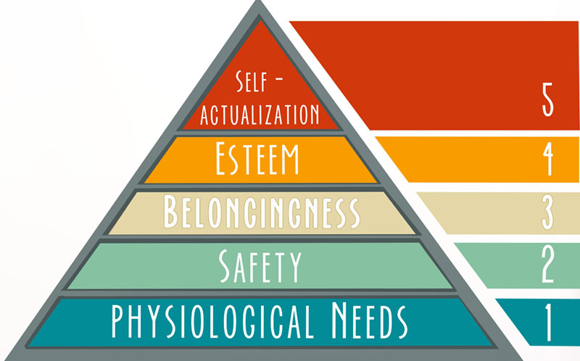

This model implies that daily energy needs, protein intake and essential nutrient requirements are of higher priority than supplements, including ergogenic aids because they have a greater impact on the individual’s body composition or performance goals compared to supplements. However, this is not to dismiss the benefits certain dietary supplements may have on health and the desired aesthetic or performance outcomes when properly selected, utilised and added to a solid nutritional foundation. Understanding the regulatory framework around dietary supplements, the related body of research on any particular ingredient of interest, and the various independent agencies that test the quality of supplements is critical for Nutrition Coaches to be able to make sound recommendations to the general population and athletes alike.

Coach's Corner

By providing an evidence-based approach to dietary supplements, including criteria for the proper selection of products, Nutrition Coaches can prevent wasteful spending, adverse health effects, inadvertent doping and subsequent suspensions from athletic competition, all while gaining the benefits certain dietary supplements have to support fitness, exercise and athletic performance goals.

Critical!

For fitness professionals working in Australia, it is essential to follow the AusREPs Scope of Practice along with the Nutrition Coach Scope of Practice outlined here in this course. Additionally, working as a Nutrition Coach in Australia requires adherence to the Australian Nutrition Guidelines in addition to the recommendations outlined in this course for the USA and the UK.

Click the following links to learn more:

[Scope of Practice for AusREP](https://fitness.org.au/articles/policies-guidelines/scope-of-practice-for-ausreps/4/38/20)

[Australian Nutrition Guidelines](https://fitness.org.au/articles/policies-guidelines/nutrition-advice-within-scope-of-practice-for-ausreps/4/1356/20)

However, no matter where in the world Nutrition Coaches are working, the important thing to remember is that their job is to educate and empower clients to make their own nutritional decisions, not prescribe specific nutrition plans for them.

The current laws governing dietary supplements should be taken into consideration for proper selection and utilisation for the general population as well as by athletes, regardless of their competitive level or professional status. In the United States, the regulation of supplements is dictated by the Dietary Supplement and Health and Education Act (DSHEA) of 1994 (U.S. Food and Drug Administration, 2018). Under the provision of the DSHEA, dietary supplements, which include herbs, botanicals, vitamins, minerals and other ingredients, are regulated as food products. In contrast, over-the-counter medication and prescription drugs are subject to premarket testing and approval by the U.S. Food and Drug Administration (FDA).

Manufacturers of dietary supplements are responsible for adopting current good manufacturing practices (cGMPs), which are standards and guidelines to ensure supplements are made properly. Manufacturers are also obligated to make accurate label claims and are prohibited from marketing supplements to prevent, treat, cure or diagnose a disease. Similar to product safety and efficacy, label claims for supplements do not have to be approved by the Federal Trade Commission (FTC) or the FDA prior to their sale and marketing. Hence, the proper testing of raw materials, manufacturing of ingredients and verification procedures for the identity, composition and purity of finished products are all the responsibility of the individual supplement producers.

To enforce these supplement manufacturing rules, as opposed to requiring testing and approval of every dietary supplement prior to sale, the FDA performs annual inspections of randomly selected manufacturing sites to assess compliance with cGMPs. In the 2016 FDA Inspection Report of nearly 500 manufacturing facilities, infractions were found at nearly 2/3 of the facilities (ConsumerLab, 2017). An average of six infractions were discovered at each facility, with the most common infractions involving the lack of processes for verifying the identity of raw ingredients and assessing the purity, identity and composition of finished products. This lack of compliance with the cGMPs by supplement manufacturers results in poor product quality, including ineffective formulas and contamination with hidden ingredients.

The FDA has the power to recall a product and does so after serious or sufficient adverse events are reported or new, unapproved ingredients are discovered. The FDA maintains an online database of over 900 supplements that have been found to be contaminated with prescription drugs and illegal substances (U.S. Food and Drug Administration, 2018). Contaminated supplements have been purported to be the cause of negative health effects in the general population and positive drug tests among athletes, resulting in their suspension from competition. However, there appears to be a general lack of awareness of the buyer-beware supplement market as a result of the DSHEA. Fortunately, there are methods and tools in place to ensure standards are being adhered to.

## Guidelines for supplement selection

An evidence-based approach to dietary supplements includes: evaluating whether a supplement is safe and effective based on the strength of the research and the population studied; the potency of the formula, including the dosages and ingredient forms; whether the ingredients are legal, and whether the finished product has undergone independent testing for the accuracy of label claims and the absence of contaminants and banned substances.

**Strength of the research**

The strength of the evidence on dietary supplements varies greatly and the body of research on safety and efficacy should be well-established to recommend usage. Credible resources include the [National Institute of Health’s Office of Dietary Supplements](https://ods.od.nih.gov/), the [Micronutrient Information Centre of the Linus Pauling Institute](https://lpi.oregonstate.edu/mic), and other reputable organisations such as the [Academy of Dietetics and Nutrition](https://www.eatrightpro.org/) and the [International Olympic Committee](https://www.olympic.org/the-ioc), all of which offer position papers on various topics related to exercise and sports nutrition, supplements and ergogenic aids.

The scientific, peer-reviewed research reviews and clinical trials available on PubMed are generally reliable resources with limitations to some studies, sometimes including a small number of participants, inadequate duration and a lack of control of influencing factors (i.e. confounding variables). Studies performed on animals without follow-up studies in humans, single studies or case studies are not considered adequate to recommend a dietary supplement. Commercials and testimonials based on anecdotal evidence are the weakest forms of evidence. The International Olympic Committee’s hierarchy of evidence for the use of dietary supplements is presented in Figure: IOC's Hierarchy of Scientific Evidence (Maughan et al., 2018).

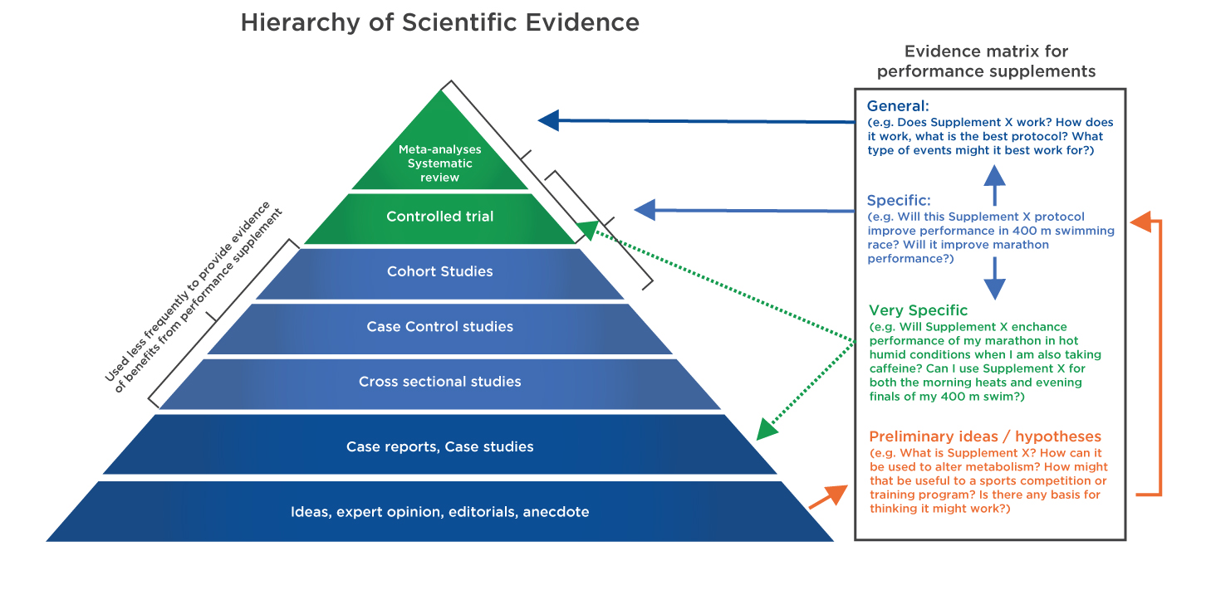

**Dosages, ingredient form and study populations**

In addition to a strong body of research, the formula of the product, including amounts and forms of the ingredients, should ideally match well-designed human clinical trials, which include a control group, randomisation of the supplement(s) and placebo, the measurement of relevant outcomes and a control for any confounding variables. Oftentimes, supplements are not marketed to the population that was studied in the research they claim supports their product. For example, a weight-loss supplement may be marketed to speed up fat burning based on a 'recent scientific study'. Further investigation reveals that the study was conducted in mice who consumed a thermogenic compound that has not been evaluated in humans. Additionally, supplement companies frequently tout some forms of ingredients to be superior to others, as is the case for creatine monohydrate, a well-researched ergogenic aid with over 1,000 studies, yet the data is lacking on other forms of creatine (e.g. creatine nitrate and creatine hydrochloride).

Another factor to note is the dose of the ingredients included in the product, which may not match the study protocols. For instance, creatine monohydrate has been shown to elevate muscular creatine stores when consumed at 3 to 5 grams a day over approximately 4 weeks; yet, a serving size might contain 1 gram of creatine. As noted, it is not required by law for supplement manufacturers to prove their products are safe or effective; however, companies are legally obligated to have scientific research that supports the safety and efficacy of their products and should be able to provide this documentation on request. Failure to do so is a red flag and should elicit an additional investigation prior to using or recommending the product.

Critical!

Elements of a well-designed clinical trial include the following:

* Human subjects
* Control groups
* Randomisation of the supplement(s) and placebo
* Measurement of relevant outcomes
* Control of confounding variables

**Independent testing**

Independent, third-party testing of products for the ingredient quality and identity, label accuracy, purity and disintegration is a voluntary step manufacturers can take to assure consumers that their product contains the listed ingredients in their respective amounts. The major companies in the United States that provide certification to verify the content of their supplements include Consumer Lab, U.S. Pharmacopeia (USP), Informed Choice, Banned Substances Control Group (BSCG), and NSF International (Table: Supplement Testing Companies). Consumer Lab’s quality evaluation requires that products from consumer channels be randomly tested once a year. Approval indicates the product was tested for ingredient identity, strength (amounts stated on the label), purity (free of specified contaminants) and disintegration (Consumer Lab, 2018).

Supplement Testing Companies

|  |  |  |  |  |
| --- | --- | --- | --- | --- |
| Consumer Lab  [consumerlab.com](http://consumerlab.com/) | U.S. Pharmacopia (USP)  [quality-supplements.org](http://quality-supplements.org/) | Banned Substances Control Group  [bscg.org](http://bscg.org/) | Informed Choice  <https://www.informed-choice.org/> | NSF International  [nsf.org](http://nsf.org/) |

USP’s Dietary Supplement Verification Program ensures the product contains the ingredients and amounts listed on the label, is free from harmful levels of specified contaminants (e.g. pesticides, heavy metals or microbes), is made in a facility that is compliant to cGMPs, and will break down in the body within a specified time. Products are also tested annually to retain the USP Verified mark (U.S. Pharmacopeia, 2018).

In addition to testing for ingredient identity and strength, testing for hidden drugs and banned substances in sports is also conducted to varying degrees and standards by BSCG’s Certified Drug-Free programme, Informed Choice’s Registration Process and NSF International’s Certified for Sport programme. These programmes may include random audits of manufacturing facilities and procedures (cGMPs) and random testing of finished products. On the successful completion of the certification process, products are permitted to include the certifier’s logo and are listed on the certifier’s website.

NSF International offers a Certification for Sport programme that includes testing for banned substances listed by various sports organisations. Major League Baseball, the National Hockey League and the Canadian Football League require members to utilise only NSF Certified-for-Sport products. Several organisations, including the National Football League, the Professional Golf Association and the Collegiate and Professional Sports Dietitians Association, recommend NSF Certified-for-Sport products. Utilising independently tested products is particularly important if you are working with athletes because they can test positive for a banned substance by using tainted supplements.

However, a critical point about third-party testing companies is they do not evaluate the efficacy of the products or truthfulness of all claims companies make about their products. Nutrition Coaches, athletes and consumers are advised to seek out additional information from credible resources, such as those previously listed, and contact companies to provide information about product efficacy, including published research related to their products. The legality of supplement ingredients for athletes in their respective sports must also be investigated. Additionally, it is prudent for individuals taking medications to consult their healthcare professional prior to consuming dietary supplements as there may be potential interactions.

Coach's Corner

Guidelines for Selecting Dietary Supplements

1. Verify the ingredients are supported with solid evidence for efficacy and safety from scientific reviews, reputable organisations and/or well-designed human studies.
2. Determine whether ingredient forms and dosages in product formulas match evidence-based recommendations.
3. Check if the product is independently tested to verify label accuracy. For athletes, third-party testing for banned substances is critical.
4. Request independent research from companies that verifies the claims for their products.

Quite frequently, supplement products cannot meet all four of these guidelines. However, one example of a supplement brand that always strives to meet these criteria for their entire product line is dotFIT. Learn more about how dotFIT supports their products with independent, third-party research by exploring their [Practitioner Dietary Supplement Reference Guide (PDSRG), 3rd Edition](https://www.dotfit.com/PDSRG-Updates).

## Dietary patterns to optimise health

Despite the recommendations to choose a wide variety of nutrient-dense foods and consume an appropriate level of calories to maintain a healthy body weight, the food choices of many Americans are in sharp contrast to the *Dietary Guidelines for Americans* (DGA), resulting in the overconsumption of calories and underconsumption of essential micro-nutrients (vitamins and minerals). The 2015–2020 DGA report identified key nutrients that are under-consumed, including vitamins A, C, D and E, choline, potassium, magnesium, iron, calcium and fibre. Adverse health effects resulting from the under-consumption of calcium, vitamin D, potassium, iron and fibre were deemed a public health concern (U.S. Department of Agriculture & Health and Human Services, 2015). Although overt micro-nutrient deficiencies are rare in the United States and other developed countries, inadequate intake appears commonly.

In addition to the key nutrients identified as of public health concern by the DGA, a dietary analysis of 70 sedentary individuals and athletes revealed insufficient intakes of 3 to 15 essential micro-nutrients in every individual diet (Misner, 2006). Males lacked 40% of the vitamins and 54.2% of minerals, and females were deficient in 29% of vitamins and 44.2% of the minerals analysed. Athletes had more micro-nutrient deficiencies than sedentary counterparts and those reducing calories to lose weight were lacking more micro-nutrients than those who did not reduce calories.

Another study, which analysed 3 days of menus from four popular diets, including the South Beach diet, Atkins for Life, the DASH diet and the Best Life diet, concluded that individuals following any of these diets were highly likely to become deficient in several micro-nutrients (Calton, 2010). Each diet failed to provide the daily recommended levels of 12 to 21 micro-nutrients and there were six micro-nutrients that were deficient in all four diets – vitamin D, vitamin E, biotin, iodine, molybdenum and chromium. Considering estimates that 1/3 of adults in the United States are on a diet at any given time, coupled with the data above, it is possible that many people are at risk of developing micro-nutrient deficiencies over time.

Coach's Corner

Data shows that many Americans under-consume key vitamins and minerals that support optimal health, including vitamins A, C, D and E, choline, potassium, magnesium, iron, calcium and fibre. Underconsumption of essential nutrients is a key public health concern.

### Multivitamin and mineral supplements

Sufficient amounts of essential micro-nutrients, such as vitamins and minerals, are required for normal growth and development, metabolism and longevity. Low consumption of micronutrients may result in negative mood, impaired focus and attention span, general fatigue and lowered capacity to fight infections; yet, these symptoms are often attributed to factors other than micronutrient intake (Dong, Xun, Pe & Qin, 2011; Huskisson, Maggini & Ruf, 2007; Yokoi & Konomi, 2017). Additionally, even when not at low levels of overt deficiency, emerging data suggests that inadequate intakes of micro-nutrients below daily recommended levels may elevate risk for chronic and age-related diseases, including eye disease, osteoporosis, cancer, heart disease and Type 2 diabetes (Ames 2006; Angelo, Drake & Frei, 2015).

The proper use of dietary supplements, particularly multivitamin and mineral formulas, has been shown to help fill common and widespread nutrient gaps (Bailey, Fulgoni, Keast & Dwyer, 2012; Blumberg et al., 2017). Blumberg et al. (2017) analysed the intake of 17 nutrients in nearly 11,000 adults in the United States from either food alone, or food and a multivitamin and mineral supplement. Higher frequency of use eliminated inadequate intakes of all the vitamins and minerals examined, with the exception of vitamin D, calcium and magnesium. Hence, the use of a daily multivitamin and mineral to avoid common insufficiencies and meet recommended intakes based on age, gender and life stage appears to be an effective nutritional strategy. Achieving daily requirements for major minerals such as calcium, magnesium, iron and other essential nutrients, such as vitamin D and the omega-3 fatty acids DHA and EPA, may require separate supplementation. Although dietary supplements do not replace a healthful diet, they can help achieve recommended intakes of essential nutrients, which may play a supportive and critical role in healthy aging.

Helpful Hint

Use the values depicted in Figure: What Your Multi Should Contain to help choose a quality multivitamin and mineral formula (adapted from Schardt, 2016).

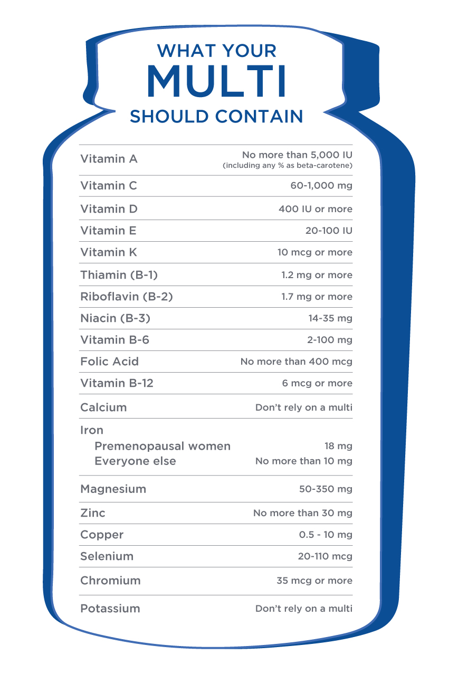

### Supplements for muscle gain and recovery

Numerous dietary supplements are made commercially available and are marketed for enhancing muscle mass, strength, weight loss, athletic performance and recovery from strenuous exercise. Other products are positioned as convenient sources of energy and protein to fuel exercise and achieve target amounts of macro- and micro-nutrients. Varying levels of evidence exist to support such claims, from anecdotal to systematic reviews of several randomised controlled trials. The data presented in this chapter is categorised as solid, moderate and weak for various ingredients purported to enhance common fitness goals and athletic performance, with a focus on the evidence and application for use for those with sufficient human data on safety and efficacy.

Athletes and avid exercisers frequently seek out methods to accelerate changes in body composition or boost training sessions and competitive events to gain a performance edge. The desire for continuous improvements in strength, physique, and performance has led to myriad supplements that tout various benefits; yet, solid evidence exists for only a few ingredients (Table: Muscle-Gain Supplements Strength of Evidence) (Kerksick et al., 2018). As such, there is general consensus that protein, creatine monohydrate and essential amino acids are supported by strong evidence for enhancing resistance-training-induced outcomes, including strength and muscle hypertrophy. The research and recommendations for use will be reviewed in this section. There is less evidence for the majority of ingredients in dietary supplements purported to enhance greater gains in muscle and improve recovery.

Muscle-Gain Supplements Strength of Evidence

| **Strong Evidence** | **Moderate / Mixed Evidence** | **Weak / Lack of Evidence** |
| --- | --- | --- |
| Protein  Creatine monohydrate  Essential amino acids | BCAAs  HMB  Phosphatidic acid | Arginine  Glutamine  ATP  Alpha-ketoglutarate  Prohormones |

**Creatine monohydrate**

Creatine monohydrate is synthesised endogenously in the liver and kidneys from amino acids and is stored primarily in muscle tissue. Its role is to regenerate intracellular ATPstores via the phosphocreatine system during high-intensity activity. Creatine can also be obtained from food, namely beef, poultry, and seafood (Table: Creatine Sources) (Tarnopolsky, 2010). Supplementation with creatine monohydrate is backed by a plethora of research studies that demonstrate its effectiveness at increasing muscular stores and enhancing muscle mass in conjunction with resistance training (Kreider et al., 2017; Kerksick et al., 2018). Greater gains in muscle tissue seem to be a result of superior training adaptations due to increased workload capacity at high intensities. When compared to controls, individuals who supplement with creatine monohydrate for 1 to 3 months have been shown to gain 1 to 2 more kilograms of mass (Volek et al., 1999; Helms, Aragon & Fitschen, 2014).

Short- and long-term studies have demonstrated the safety of creatine supplementation among healthy populations, with the only significant side effect (which is typically one of the desired side effects) being weight gain due to increases in water retention and muscle mass (Kreider et al., 1999; Kreider, 2003).

Creatine Sources

| **Source (8 oz serving)** | **Creatine Content** |
| --- | --- |
| Beef (lean) | 1.5 to 2.5 g |
| Pork | 1.5 to 2.5 g |
| Herring | 2.0 to 4.0 g |
| Salmon | 1.5 to 2.5 g |
| Milk | 0.05 g |

Typical use includes two methods that have been shown to increase muscular creatine stores by 20 to 40% (Kreider & Jung, 2011). The first method includes a loading phase lasting 5 to 7 days consuming 20 to 25 grams daily, or about 0.3 gram/kilogram of body weight in doses split throughout the day, followed by a maintenance phase that consists of consuming a daily dose of 3 to 10 grams daily, with the higher-maintenance dose likely more appropriate for individuals with greater muscle mass (Kreider et al., 2003; Kreider et al., 2017). Another method involves gradually increasing muscular stores by consuming a daily dose of 3 to 5 grams a day over 3 to 4 weeks.

The first method may result in a faster loading and more immediate performance benefit due to higher creatine stores. Co-ingesting carbohydrate (with or without protein) with creatine monohydrate increases uptake and muscular retention (Kreider et al., 2017). The duration of creatine supplementation is dependent on the individual’s desired outcome, length of high-intensity training phase, and time restrictions due to competitive events. On cessation of use, creatine stores normalise within 4 to 8 weeks (Tarnopolsky, 2010; Kreider et al., 2017).

Getting Technical

The research on creatine is extensive. Review Table: Key Research on Creatine Monohydrate for a selection of studies that produced significant results in favour of creatine supplementation.

Despite marketing claims to the contrary, other forms of creatine including creatine HCl, buffered creatine, alkalised creatine and creatine ethyl ester have not been proven to be more effective than creatine monohydrate (Spillane et al., 2009; Jager, Purpura, Shao, Inoue & Kreider, 2011). Creatine monohydrate is thought to be the most-effective dietary supplement for enhancing high-intensity training, strength and muscle mass. However, some individuals are considered non-responders and do not experience these benefits, likely due to naturally elevated muscular stores of creatine (Harris, Söderlund & Hultman, 1992).

Key Research on Creatine Monohydrate

| **Research Authors** | **Outcome Measured** | **Dosing Protocol** | **Results** |
| --- | --- | --- | --- |
| Harris et al., 1992 | Muscular creatine content of the quadriceps femoris | 5 g, 4 to 6 times/day for 4 to 10 days  N = 17; 5 females + 12 males | about 15 to 20% increase |
| Hultman et al., 1996 | Total muscular creatine stores | 5 g, 4 times/day for 6 days + 2 g/day for 30 days  3 g/day for 28 days  N = 31; males | about 20% increase in both supplementation groups compared to placebo group |
| Vandenberghe et al., 1997 | Muscular creatine stores  Strength  Fat-free mass | 5 g 4 times/day for 4 days + 5 g/day for 65 days + resistance training (10 weeks followed by detraining period)  Same protocol for placebo group  N = 19; young, sedentary females | Significant increase in phosphocreatine stores  20 to 25% increase in maximal strength  60% increase in fat-free mass |
| Volek et al., 1999 | Muscular creatine stores  Muscle fiber hypertrophy | 25 g/day for 1 week + 5 g/day for 11 weeks  Same protocol for placebo group  N = 19; resistance-trained men | 22% increase in creatine stores  6.3% increase in body mass  6.3% increase in fat-free mass  Significant increases in Type 1, 11A, and IIAB muscle fiber cross-sectional areas  Significantly greater average volume lifted in bench press in creatine group during weeks 5 through 8 |
| Kreider et al., 2003 | Creatine stores  Phosphocreatine stores | Literature review of 500 studies | Short-term supplementation of 20 g for 5 to 7 days increases total creatine by 10 to 30% and phosphocreatine by 10 to 40%. |

**Protein**

Protein provides amino acids, the building blocks of skeletal muscle, other structures, and various compounds in the body such as enzymes and hormones. Of the 20 amino acids, 9 are considered essential and must be obtained from the diet because they cannot be synthesised endogenously. Animal sources of protein provide all essential amino acids (EAAs), whereas plant sources, with the exception of soy, are limited in at least one or more essential amino acids. In general, protein sources considered to be high quality are rich in essential amino acids, are digested and absorbed well, and for exercise and athletes, are superior for supporting training outcomes such as muscle hypertrophy, fat loss and enhanced recovery.

The ingestion of high-quality protein stimulates muscle protein synthesis (MPS) and the effect is enhanced with resistance training (Jäger et al., 2017). Thus, maximally stimulating MPS may benefit those attempting to gain muscle tissue. This has been investigated extensively in humans of various ages and training experience levels. Protein intake greater than the recommended dietary allowance (RDA) of 0.8 gram/kilogram/day of body weight has been shown to help individuals performing resistance-training exercise maintain protein balance, build muscle mass and improve body composition (Aragon et al., 2017; Cintineo, Arent, Antonio & Arent, 2018; Jäger et al., 2017; Morton et al., 2018).

A systematic review of 49 randomised controlled trials with 1863 participants, who performed resistance training at least twice a week for 6 weeks or longer, revealed that protein supplementation significantly increased strength, lean body mass, and muscle size in healthy adults who were not restricting calories compared to a placebo or no supplements (Morton et al., 2018). On average, protein-supplementation-enhanced resistance training induced a lean-body-mass gain of 27% and increased the muscle fibre cross-sectional area by 38%. These increases were not further enhanced with daily protein intakes greater than 1.62 gram/kilogram of body weight (0.73 gram/pound) and were more pronounced in trained individuals. Older individuals did not appear to benefit from training-induced increases and muscle protein supplementation; however, the average dose among older subjects was 20 grams/day. It has been shown that higher dosages of up to 40 grams post-exercise are needed to achieve muscle protein synthesis rates similar to younger counterparts, likely due to the anabolic resistance among older individuals (Burd et al., 2013; Churchward-Venne, Holwerda, Phillips & van Loon, 2016; Wall et al., 2015).

The International Society of Sports Nutrition (ISSN) recommends a daily protein intake of 1.4 to 2.0 grams/kilograms of body weight to build and maintain muscle tissue for most exercisers: split evenly throughout the day, approximately every 3 to 4 hours (Jäger et al., 2017). Higher daily intakes of approximately 3.0 grams/kilograms among highly trained athletes restricting calories has been shown to preserve lean tissue and promote fat loss with no adverse health effects; however, this did not yield greater increases in lean mass compared to 2.2 grams/kilograms/day. MPS is stimulated with protein ingestion and remains elevated for 3 to 4 hours. Thus, the aim of consuming regular meals with protein is to keep the muscle synthetic response optimal and continuous throughout the day.

After resistance exercise, skeletal muscle synthetic rates remain elevated for up to 24 hours and, although the consumption of protein immediately (1 hour) after training or competition may not enhance hypertrophy if total daily intakes are met, doing so may support recovery and subsequent training and performance (Cintineo et al., 2018). Thus, the post-workout period offers an opportunity to consume a high-quality protein dose to help reach daily targets, enhance MPS and potentially benefit continuous intense training. Additionally, appetite is often diminished after intense activity and consuming a protein-rich shake may be more feasible, especially at training or competition venues.

Athletes and exercisers interested in optimising muscle protein synthesisto maximise gains in lean tissue may benefit from per-meal protein doses of 0.40 to 0.55 gram/kilogram, consumed across at least four meals to reach total daily intakes of 1.6 to 2.2 grams/kilograms (Schoenfield & Aragon, 2018). Protein sources with a full spectrum of essential amino acids and adequate amounts of leucine (1.7 to 3.5 grams per dose), the primary trigger of muscle protein synthesis, with some sources having higher amounts of leucine than others, should be selected (Table: Protein Supplement Leucine Content). Protein supplements typically contain one or more sources: milk, eggs, soy, peas or rice.

Protein Supplement Leucine Content

| **Protein Supplement Type** | **% Leucine Content** |
| --- | --- |
| Whey | 11% |
| Casein | 9.3% |
| Eggs | 8.5% |
| Soy Isolate | 8% |
| Peas | 8% |
| Wheat | 7% |
| Brown Rice Isolate | 8% |

**Whey**

Whey and casein are derived from bovine milk, comprising 20% and 80% respectively of the protein component of milk. Whey is particularly rich in EAAs (50% by weight), with the highest leucine content when compared to other animal protein sources. Due to its solubility, whey mixes easily and is digested and absorbed rapidly, rendering it a particularly popular supplement among exercisers and athletes seeking to increase or preserve muscle mass during intense training and/or dieting in preparation for competition. It is available in three main forms: concentrate, isolate and hydrolysate, all of which are widely available and marketed for inducing muscle gain.

Whey protein concentrate is the liquid fraction of milk and is typically about 80% protein with small amounts of carbohydrates, fat and lactose. It contains bioactive ingredients such as beta lactoglobulin, alpha lactalbumin and lactoferrin, which play a role in immune system function and is, therefore, less refined than the isolate form (Bell, 2000). Whey protein isolate contains a higher portion of protein by weight (90%) and is a result of additional filtration of whey concentrate, during which the bioactive compounds, fat and carbohydrates are removed. It is typically costlier than the concentrate form. Whey protein hydrolysate contains shorter amino acid chains (peptides), which are formed by adding enzymes to either whey concentrate or isolate, purportedly enhancing digestion and absorption. It is often the most expensive form of whey protein.

All forms of whey protein are rapidly digested and provide a high-quality source of protein, which can help individuals reach total-daily-protein targets and maximise muscle protein synthesis, particularly when minimising calories during weight loss or when consuming whole food sources is impractical.

**Casein protein**

Casein makes up 80% of the protein in milk. Although it is a complete protein source, it contains less leucine and is insoluble in acid, forming clots in the stomach acid, thereby leading to slower digestion and absorption. As such, casein protein supplementation has been shown to stimulate MPS to a lesser extent than whey protein supplementation and leads to lower resistance-training-induced gains in lean mass (Cribb, Williams, Carey & Hayes, 2006; Tipton et al., 2004). However, there appears to be a benefit to consuming casein protein prior to bedtime for stimulating MPS during sleeping hours. One study showed that when a pre-bedtime dose of casein protein (27.5 grams) and carbohydrate (15 grams) are combined with daytime resistance training over several weeks, muscle strength and hypertrophy are greater in healthy, young men compared to a calorie-free placebo (Snijders et al., 2015). A narrative review by Trommelen & van Loon (2016) revealed that pre-sleep protein ingestion results in adequate digestion and absorption during overnight hours, and that 40 grams of casein protein administered prior to sleep leads to greater amino acid availability and 22% higher MPS rates than a placebo among recreational athletes performing regular resistance training.

At present, the research on pre-sleep protein ingestion and its effect on MPS, strength and muscle mass has been conducted with casein. The optimal protein types and dosages have yet to be established; yet, it is clear there is potential benefit from the ingestion of protein prior to sleep for enhancing muscle protein synthesis and exercise-induced outcomes as well as reaching daily protein targets.

**Plant protein**

Plant-based protein supplements are growing in popularity and are often composed of one or more protein sources from soy, peas, rice and others. In terms of stimulating MPS, soy protein has been shown to be inferior to whey and casein due to lower leucine content, fewer essential amino acids and lower bioavailability (Tang et al., 2009). Although soy is a complete protein and fast-acting due to its rapid digestibility, its amino acids are not as bioavailable to skeletal muscle tissue compared to whey and casein protein (Devries & Phillips, 2015). Research examining the impact of plant-based proteins on muscle protein synthesis and changes in body composition has utilised primarily soy protein; thus, the data is limited (Morton et al, 2018).

In theory, a plant-based protein source rich in EAAs and leucine with high bioavailability would stimulate MPS and enhance the response to resistance exercise. A randomised controlled trial comparing two daily doses of 25 grams of supplemental pea proteins with whey protein placebo on their impact on muscle mass during 12 weeks of resistance training resulted in the whey and pea protein groups experiencing similar and significant improvements in muscle thickness compared to the placebo, demonstrating potential viability for pea protein to enhance muscle gain with additional studies needed (Babault et al., 2015).

Protein ingestion above the minimum recommended amounts (RDA) improves resistance training outcomes, including strength and greater muscle mass. Protein supplementation provides a viable means of optimising the muscle synthetic response over 24 hours with benefits appearing greater with whey and casein, which are abundant in leucine and contain the full spectrum of EAAs required to synthesise muscle tissue. Health concerns resulting from high-protein intakes, broadly defined as greater-than-minimum daily requirements of 0.8 gram/kilogram, were addressed in two 2018 systematic reviews.

Among 1358 individuals across 28 randomised, controlled trials comparing protein intakes of at least 1.5 gram/kilogram body weight or more than 100 grams per day to lower protein intakes, glomerular filtration rates did not differ between groups and do not impair kidney function in healthy individuals (Devries et al., 2018). A separate review and meta-analysis of trials and observational data had similar findings with evidence suggesting that protein intake above minimum requirements does not adversely affect blood pressure (Van Elswyk, Weatherford & McNeil, 2018). Of note is the current Acceptable Macronutrient Distribution Range (AMDR) of 10 to 35% of total daily calories from protein, which can exceed the current RDA and include previously noted optimal intakes for muscle hypertrophy.

Coach's Corner

Protein Supplementation Guidelines

* Ensure total daily intakes are met using 0.7 to 1.0 gram/pound (1.2 to 2.2 grams/kilograms). Trained athletes restricting calories may benefit from more to preserve muscle and promote fat loss.
* To maximise MPS and hypertrophy, consume four meals with 0.2 to 0.25 gram/pound (0.4 to 0.55 gram/kilogram) of body weight per meal of high-quality protein.
* There may be benefits to consuming a protein-rich meal/snack in the post-workout period, especially with heavy training volumes, multiple competitive events, or when helping to meet total daily protein targets depending on meal frequency.
* A pre-bedtime protein dose of 30 to 40 grams may help maximise MPS during sleeping hours.

### Essential Amino Acids

Essential amino acids (EAAs) provide building blocks for muscle tissue and other bodily proteins with the branched chain amino acids (BCAAs) leucine, valine, and isoleucine being the most abundant in skeletal muscle (Table: Essential Amino Acids). As previously noted, they cannot be produced in the body, and therefore, must be obtained from the diet. It is well-established that complete protein sources, which contain the greatest amounts of EAAs, are the most effective at stimulating muscle protein synthesis with a synergistic effect occurring with resistance training. Isolating EAAs from intact protein sources and delivering them in free form has also been shown to stimulate MPS. EAAs, as well as BCAAs, are commonly used supplements among those seeking improved recovery and greater gains from intense training (Tipton, Gurki, Matin & Wolfe, 1999).

Essential Amino Acids

| Leucine | Isoleucine | Valine |
| --- | --- | --- |
| Histidine | Lysine | Methionine |
| Phenylalanine | Threonine | Tryptophan |

A review of the evidence concluded that the consumption of EAAs has potential value for enhancing muscle protein synthesis when 6 to 12 grams are consumed before, after or during exercise (Kerksick et al., 2018). Borsheim, Tipton, Wolf & Wolfe (2002) showed that 6 grams of EAAs consumed as a beverage 1 and 2 hours after strenuous resistance training equally simulates muscle protein synthesis in six young (19 to 25 years), active men and women. A follow-up study conducted with six young (average age 34 years) and seven older (average age 67 years) healthy, physically active participants demonstrated that 15 grams of EAAs dissolved in a noncaloric beverage significantly increased muscle protein synthesis with no difference between age groups and independent of resistance training (Paddon-Jones et al., 2004). This is in contrast to the blunted muscle protein synthetic response to protein observed in older adults compared to younger counterparts, suggesting EAAs are an effective means to stimulate MPS and can potentially aid in preserving muscle mass and enhancing resistance training outcomes during aging.

When healthy, trained males consumed equal amounts of leucine via beverages with EAAs, BCAAs or leucine alone (during resistance exercise) greater muscle protein synthesis occurred with EAAs, indicating a synergistic effect of the complete spectrum of EAAs (Moberg et al., 2016). Furthermore, 15 grams of EAAs combined with 30 grams of carbohydrates consumed in between normal meals resulted in a greater anabolic effect than similar amounts of EAAs from a whole food source, and did not reduce the muscle synthetic response to protein-containing meals consumed throughout the day (Paddon-Jones, Sheffield-Moore, Aarsland, Wolfe & Ferrando, 2005). These findings suggest that EAAs in free form may be more readily available to elicit muscle protein synthesis than mixed meals.

Some studies have investigated the potential value of EAAs to reduce perceived muscle soreness, decrease markers of muscle damage, or help maintain force production, and thus support ongoing high-quality training sessions. A recent study demonstrated that BCAAs consumed in dosages according to LBM (0.22 gram/kilogram/day) while controlling for protein intake (1.2 gram/kilogram/day) resulted in significantly lower muscle damage, less soreness and greater force production (VanDusseldorp et al., 2018). Therefore, EAA or BCAA ingestion with adequate leucine may serve as a viable nutritional strategy to maximise MPS throughout the day among young and older individuals and may be particularly beneficial with lower protein intakes while restricting calories to promote fat loss, minimise the loss of lean tissue and support recovery from intense training.

Consuming 6 to 15 grams of essential amino acids with 1.7 to 3.5 grams of leucine may maximise MPS and reduce muscle soreness. This may be particularly helpful for those restricting calories while attempting to maintain muscle tissue and with lower protein intakes.

Essential Amino Acids (EAAs) include the branched chain amino acids (BCAAs), leucine, isoleucine and valine. Adequate leucine (1.7 to 3.5 grams) and all EAAs are required to stimulate muscle protein synthesis and build muscle tissue. If EAAs are consumed to maximise MPS, BCAAs are likely unnecessary. If the total daily protein intake is on the lower end (1.2 gram/kilogram), BCAAs may be beneficial.

**HMB (Hydroxy-Methylbutyrate)**

Hydroxy-Methylbutyrate is a byproduct of the essential branched chain amino acid, leucine, identified as the primary initiator of muscle protein synthesis. A review of the research identified modest improvements in strength and muscle gain (0.5 to 1.0 kilogram) over a period of 3 to 6 weeks of resistance training and 1.5 to 3 grams per day of calcium HMB, particularly in untrained individuals compared to those not supplementing with HMB (Kerksick et al., 2018).

Among trained individuals, it appears that the duration of supplementation may be an influencing factor on resistance training and body-composition outcomes. In a trial with 24 resistance-trained individuals randomised to either 3 grams per day of HMB free acid or a placebo for 8 weeks of progressive resistance training, followed by 2 weeks of an overreaching cycle and 2 weeks of tapered training, the supplement group significantly increased strength and lean body mass compared to the placebo (Wilson et al., 2014).

Among 24 highly trained male combat athletes (wrestlers, judokas and Brazilian jiu-jitsu practitioners), 12 weeks of supplementing with 3 grams per day of calcium HMB resulted in a significant increase in fat-free mass and significant decrease in fat mass compared to 12 weeks of placebo treatment (Durkalec-Michalski, Jeszka & Podgórski, 2017). Documented benefits of HMB supplementation on strength and muscle mass involve the ability of HMB to reduce muscle damage induced by exercise predominately in older, untrained individuals and highly trained athletes undergoing periods of extreme physical stress, such as severe caloric restriction and intense exercise (Holecek, 2017; Rowlands & Thomson, 2009).

However, a systematic review and meta-analysis of six randomised controlled trials and 193 participants on the effect of HMB supplementation on body composition and strength did not find any impact in trained and competitive athletes (Sanchez-Martinez, Santos-Lozano, Garcia-Hermoso, Sadarangani & Cristi-Montero, 2018). One review of nine randomised controlled trials with 3 grams/day of HMB free-acid supplementation with resistance training concluded HMB may reduce markers of muscle damage and enhance strength and muscle mass (Silva et al., 2017).

Another systematic review and meta-analysis of 18 studies and over 500 participants involving HMB supplementation and recovery concluded HMB improved markers of muscle damage in a time-dependent manner, with significant improvements observed with at least 6 weeks of supplementation (Rahimi, Mohammadi, Eshaghi, Askari & Miraghajani, 2018). Hence, the body of literature suggests HMB’s benefit as an anticatabolic and recovery agent with potential for counteracting muscle loss during aging (Molfino et al., 2013; Phillips, 2015; Woo, 2018). Daily doses of 3 to 6 grams are often split across the day with meals and bedtime to enhance retention, and use for up to 8 weeks appears safe (Nissen et al., 2000).

## Supplements for fat loss

With overweightness and obesity among U.S. adults and youth at an all-time high and steadily increasing (Figure: Trends in Obesity), coupled with the challenge to improve eating and exercise habits and maintain weight loss over the long haul, the desire and appeal for a product to enhance weight loss is unsurprising. One survey of 3500 U.S. adults revealed that among those making a serious attempt to lose weight, over 1/3 (33.9%) use at least one dietary supplement (Pillitteri et al., 2008). This study also revealed widespread misunderstanding regarding the regulation of dietary supplements, demonstrating that many believe the safety and efficacy of supplements are determined prior to their sale and advertising.

Widespread use and misperceptions of dietary supplement manufacturing underscores the need to guide and educate clients accordingly. Despite the plethora of weight-loss supplements in the marketplace, the abundance of strong evidence to support their use is limited. This section will review the research on popular dietary supplements marketed for weight loss and, where appropriate, their applications for use.

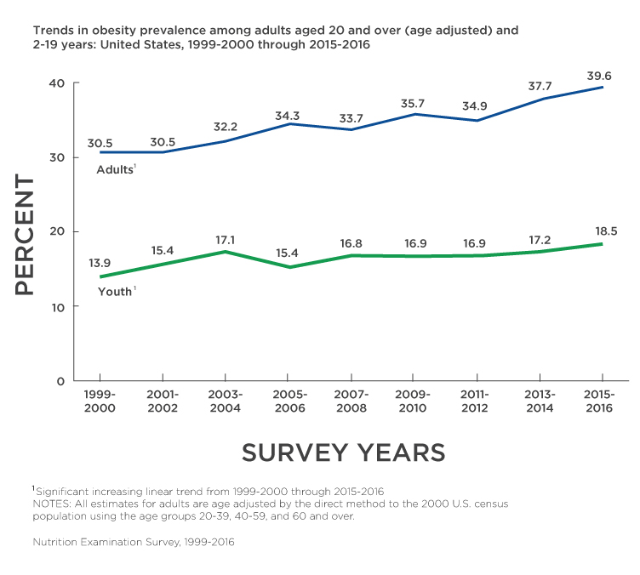

### Stimulants

Weight-loss supplements, whether in pill, capsule or powder form, often contain one or more ingredients that stimulate the nervous system and are routinely advertised as fat burners due to their impact on metabolism. Commonly used stimulants include caffeine, green tea extracts, ephedra, bitter orange and capsaicinoids and may be combined with herbs, other plant-derived ingredients, amino acids and minerals.

Herbal sources of caffeine or other stimulants may be listed as an ingredient without including the particular stimulant and the amount. Furthermore, multi-ingredient weight-loss products are abundant in the marketplace, yet are rarely tested in clinical trials, making it difficult to determine the safety and efficacy for consumers and practitioners alike.

**Caffeine**

Caffeine (1,3,7-trimethyl-xanthine) is a naturally occurring substance in coffee beans, kola nuts, guarana seeds, yerba mate and tea leaves, and it is also synthesised in a lab as caffeine anhydrous. It stimulates the nervous system and has been shown to modestly increase daily energy expenditure, decrease energy intake, reduce perceived-effort-level of exercise, and improve feelings of energy and alertness (Acheson et al., 2004; Harpaz, Tamir, Weinstein & Weinstein, 2017).

Using a moderate caffeine dose of 4 milligrams/kilograms of body weight from coffee, significant increases in resting metabolic rate (RMR) ranging from 4.9 to 12% were observed in normal-weight and obese individuals, with a greater increase occurring among normal-weight persons (Acheson et al., 1980; Bracco, Ferrarra, Arnaud, Jequier & Schutz, 1995). Similarly, a single 100-milligram dose of caffeine increased resting metabolism by 3 to 4% for 2.5 hours in lean and formerly obese participants (Dulloo et al., 1989). Over 12 hours, taking a 100-milligram dose every 2 hours increased energy expenditure by 8 to 11% in both groups. This equated to a significant daily increase of 79 calories in the formerly obese participants and 150 calories in the lean subjects. A meta-analysis of six well-designed studies revealed caffeine-only and caffeine with catechins from tea significantly increase 24-hour energy expenditure by 4.8 and 4.7%, respectively, compared to the placebo. A caffeine-catechin mixture also significantly increased fat oxidation (Hursel et al., 2011).

Caffeine appears to work synergistically with exercise to increase energy expenditure and fat oxidation and potentially decrease acute energy intake. Active healthy adults consumed a moderate dose of caffeine (3 milligrams/kilograms) 90 minutes before an hour of moderate-intensity exercise and 30 minutes post-exercise, which resulted in significantly higher energy expenditure and fat oxidation. Fewer calories were consumed 2 hours later compared to a meal consumed after an exercise bout without caffeine ingestion (Schubert et al., 2014).

Other studies have generated similar findings among sedentary women with higher dosages (5 to 10 milligrams/kilograms) consumed prior to moderate exercise, resulting in greater energy expenditure compared to exercise without caffeine (Donnelly & McNaughton, 1992; Wallman, Goh & Guelfi, 2010). Caffeine in coffee at a dosage of 6 milligrams/kilograms reduced how much overweight and obese participants consumed 3 hours later and the next day compared to water and a lower dose of caffeine (3 milligrams/kilograms). Another study found that, compared to a placebo, 300 milligrams of caffeine given 30 minutes prior to unlimited access to food reduced intake in men (by 22%) but not women (Gavrieli et al., 2013; Tremblay, Masson, Leduc, Houde & Depres, 1988).

Other research found no immediate impact of caffeinated coffee on energy intake in healthy males (Gavrieli et al., 2011). An apparent benefit to caffeine ingestion is a decreased sense of effort associated with exercise and an increase in physical performance (Harpaz et al., 2017). This has relevant practical application to exercise enjoyment and subsequent adherence, particularly during the early stages of exercise adoption and during weight- and fat-loss plateaus.

Caffeine appears to be a viable weight-loss tool; however, fat-burner supplements often include other ingredients, including green tea, capsaicin, bitter orange and ephedra (which is now banned in the United States). Green tea extracts, primarily EGCG, in combination with caffeine have been shown to increase metabolism and fat oxidation and to modestly boost weight loss and reduce waist circumference (Bérubé-Parent, Pelletier, Doré & Tremblay, 2005; Dulloo et al., 2011; Hursel et al., 2011; Phung et al., 2010) However, green-tea extracts alone do not appear to have the same impact (Janssens, Hursel & Westerterp-Plantenga, 2015; Thielecke et al., 2010).

A systematic review of 13 randomised, controlled trials analysing the effect of caffeine on weight loss determined a dose-response of caffeine on reductions in fat mass, weight and body-mass index, suggesting caffeine’s viability to aid in promoting weight and fat loss (Tabrizi et al., 2018). Overall, the research shows that caffeine in moderate doses increases energy expenditure at rest and exercise, and may decrease energy intake, and therefore, appears to serve as a safe thermogenic weight-control aid among healthy adults. See Figure: Caffeine Sources and Content for the average amounts of caffeine contained in various popular sources.

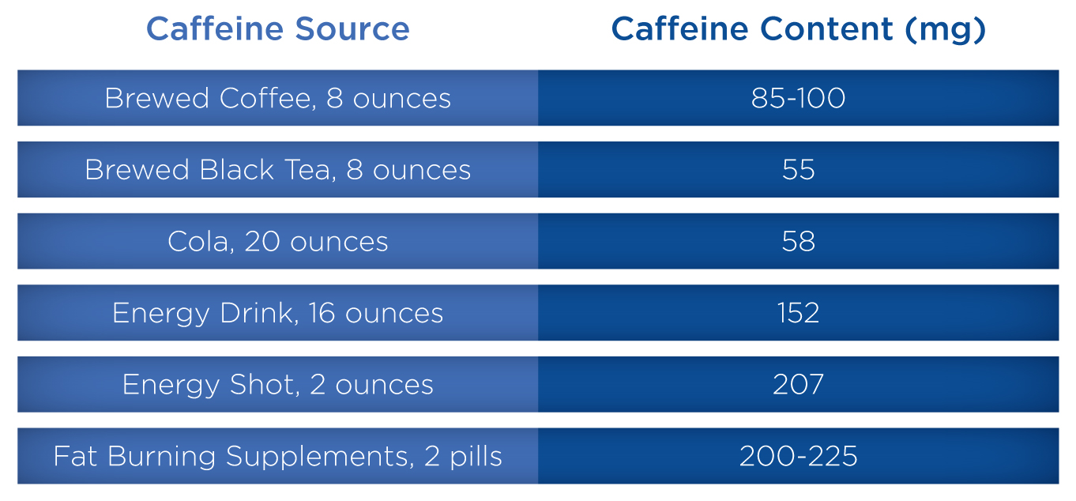

One of the common misconceptions around caffeine is the notion that caffeine use at normal and recommended intake causes dehydration; yet, this has not been proven in the research (Goldstein et al., 2010; Maughan & Griffin, 2003). A minor diuretic effect may occur at rest but does not negatively impact fluid balance during exercise. Adult intake of caffeine up to 400 to 500 milligrams per day appears safe in healthy individuals, but adverse side effects, including elevated heart rate, increased blood pressure, jitteriness, nervousness and gastrointestinal distress, may occur and are more likely at higher doses (>500 milligrams) and among novel users (European Food Safety Authority, 2015; Torpy & Livingston, 2013; U.S. FDA, 2013). Doses over 10,000 milligrams are considered fatal.

The American Medical Association recommends that teenagers limit daily intake of caffeine to 100 milligrams/day (Torpy & Livingston, 2013). Because the half-life of caffeine in healthy adults is 5 to 6 hours, increased sleep latency may occur if taken late in the day.

Combining other sources of caffeine - including energy drinks; coffee; and herbal ingredients such as ma huang (ephedra), citrus aurantium (bitter orange) or other stimulants - can exacerbate side effects and is not recommended. Side effects of stimulants associated with green tea extracts include nausea, stomach upset and increased blood pressure (Jurgens et al., 2012).

Critical!

Caffeine intake up to 400 to 500 milligrams/day appears safe in healthy adults. Higher doses and combining with other stimulants may result in adverse side effects such as jitteriness, insomnia and stomach upset. Doses over 10,000 milligrams are considered fatal.

Coach's Corner

Low to moderate doses of caffeine at 3 to 4 milligrams/kilograms of body weight, not to exceed 400 to 500 milligrams/day, modestly increases daily energy expenditure, decreases food intake and may help support healthy weight management.

**Other stimulant ingredients**

The stimulants p-synephrine, the active ingredient extracted from bitter Seville oranges (citrus aurantium), and ephedrine, derived from a native Chinese plant (ma huang), are commonly included in weight-loss supplements often in combination with caffeine or other ingredients. Ephedra was banned as an ingredient in dietary supplements in 2004 by the U.S. FDA due to safety concerns, but may still be commercially available through various websites. P-synephrine is structurally similar to ephedrine and is often marketed as an ephedra-free fat-loss aid due to its apparent stimulatory effect on the central nervous system, energy expenditure and mild suppression of appetite (Stohs, Preuss & Shara, 2012).

The safety of p-synephrine has been called into question after two small studies with 25 total participants reported increases in heart rate and blood pressure (Bui, Nguyen & Ambrose, 2006; Haller, Benowitz & Jacob, 2005). The trial conducted by Bui et al. was a randomised, crossover study with 15 healthy adults who consumed one dose of bitter orange (900 milligrams standardised to 6% synephrine) or a placebo. Conversely, a small trial with 20 healthy subjects demonstrated that a 50-milligram dose of p-synephrine increased resting metabolism by 65 calories compared to a placebo with no adverse effects on mood, heart rate or blood pressure (Stohs et al., 2011). Additionally, two larger and longer double-blind, placebo-controlled trials with healthy subjects taking 49 milligrams of p-synephrine once or twice a day alone or in combination with other herbs for 2 months observed no significant changes in heart rate, blood pressure or blood chemistry (Kaats, Miller, Preuss & Stohs, 2013; Shara, Stohs & Mukattash, 2016).

The authors of one review of over 20 published and unpublished studies with over 350 subjects taking p-synephrine in doses up to 80 milligrams/day with or without caffeine in doses of 132 to 528 milligrams/day or other ingredients for up to 12 weeks concluded that p-synephrine alone, or as part of a multi-ingredient supplement, increases energy expenditure and resting metabolic rate (Stohs, Preuss & Shara, 2012). Jung et al. (2017) studied the effects of a multi-ingredient caffeine-containing (284 milligrams) pre-workout supplement with and without 20 milligrams of p-synephrine or a placebo on exercise performance and resting energy expenditure in 75 healthy active adults. It found no adverse effects on heart rate, blood pressure, kidney function or liver enzymes relative to baseline values. Both treatment groups experienced increases in resting energy expenditure, greater readiness to exercise with no improvements in muscular endurance or anaerobic sprint capacity compared to the placebo group, and no additional benefits of p-synephrine.

A 2017 review of approximately 30 studies in over 600 normal-weight and overweight human subjects concluded that p-synephrine does not have negative effects on the cardiovascular system at daily doses up to 100 milligrams and acts as a non-stimulatory thermogenic, with no serious adverse events being directly attributable to p-synephrine; however, favourable changes in body weight have not been demonstrated (Stohs, 2017).

It is important to note that synthetic forms of p-synephrine are prohibited for use in the United States and include methylsynephrine, isopropyl-norsynephrine and t-butyl-norsynephrine, which are considered as adulterants in dietary supplements. Although the literature to date has shown small changes in energy expenditure with the bitter orange extract, p-synephrine alone, and in combination with various other ingredients, changes in body weight are less apparent and require further investigation with longer, larger-scale studies at varying doses and to discover whether meaningful weight loss can be safely achieved.

**Capsaicin**

Capsaicin is one of five naturally present capsaicinoids in red chili peppers and is purported to be a natural weight control due to its ability to stimulate thermogenesis, increase body temperature and decrease food intake (Belza & Jessen, 2005; Westerterp-Plantenga et al., 2006; Whiting, Derbyshire & Tiwari, 2012). Janssens et al. (2013) administered 2.56 milligrams of capsaicin to 15 normal-weight and overweight individuals before meals three times a day during a 25% caloric deficit and observed a significant increase in fat oxidation over a 36-hour period. Others have observed acute increases in energy expenditure between 5 and 20% with capsaicin intake, while others have not observed an effect, possibly due to varying doses, study protocol and/or small sample sizes (Saito & Yoneshiro, 2013). Additional research is required to determine whether capsaicin supplementation can result in elevated energy expenditure over extended periods.

Capsaicin’s potential as a viable weight-loss aid may be due to its effect on appetite and food intake. A small study conducted by Janssens, Hursel and Westerterp-Plantenga (2014) analysed the effect of capsaicin ingestion with meals three times a day while subjects were in energy balance and during a 25% calorie restriction. During energy balance, there were significantly greater feelings of fullness and satisfaction with capsaicin consumption and a 30% reduction during dinner. During caloric restriction, participants reported a marked decrease in the desire to eat after dinner compared to a control group, potentially mitigating the negative impact weight loss has on appetite.

A systematic review of eight randomised controlled trials on the impact of capsaicin ingestion on food intake in normal-weight and overweight adults found that a minimum dose of 2 milligrams consumed prior to meals significantly reduced intake by 74 calories compared to a placebo (Whiting, Derbyshire & Tiwari, 2014). A 12-week randomised, placebo-controlled trial with overweight individuals who supplemented with 4 milligrams of capsaicinoids daily resulted in significantly lower reported intake (257 calories/day), and those who consumed a lower daily dose (2 milligrams) experienced an improved waist-to-hip ratio compared to the placebo group. However, the 4 milligrams/day dose resulted in gastrointestinal distress in 23% of the subjects and no significant improvements in body weight were observed (Urbina et al., 2017).

A review of 20 studies involving 563 participants on the potential for capsaicin and capsaisinoids to influence body weight concluded that regular consumption significantly reduces appetite and energy intake, raises daily energy expenditure by 50 calories and significantly decreases abdominal fat, potentially leading to meaningful weight loss after 1 to 2 years of use (Whiting, Derbyshire & Tiwari, 2012).

Coach's Corner

Capsaicin may have a slight positive impact on energy expenditure, appetite and food intake when consumed in 2- to 4-milligram doses before meals.

Capsaicin ingestion prior to meals appears to have a modest impact on both sides of the energy-balance equation, potentially serving as a useful aid to help manage appetite and slightly increase daily expenditure. Capsaicin is considered safe when used in the amounts studied, with 4 milligrams/day resulting in reports of gastrointestinal distress, elevated insulin levels and lower HDL cholesterol levels among some study participants.

### Starch / fat blockers and other common weight loss ingredients

Various ingredients have been investigated for their potential to decrease absorption of macro-nutrients and their respective calorie content to promote weight loss and are routinely included in supplements as fat blockers or carbohydrate/starch neutralisers. Phaseolus vulgaris, extracted from white kidney beans, inhibits the action of the digestive enzyme amylase, thus interfering with the digestion of and absorption of carbohydrates and potentially preventing absorption (Obiro, Zhang & Jiang, 2008).

Daily dosages of Phaseolus vulgaris ranging from 500 to 3000 milligrams for up to 12 weeks have been shown to modestly enhance weight loss, albeit inconsistently. In a randomised, double-blinded, placebo-controlled trial with 60 overweight subjects, those who consumed a proprietary form (Phase 2) before a high-carbohydrate meal lost significantly more weight (6.4 lbs/2.9 kg) compared to subjects receiving the placebo (0.77 lbs/0.34 kg) after 30 days (Celleno, Tolaini, D’Amore, Perricone & Preuss, 2007).

Chitosan is another blocker supplement manufactured from shellfish. It is marketed as a fat blocker due to its ability to prevent absorption of dietary fat by binding to it in the intestinal tract (Rios-Hoya & Gutierrez-Salmean, 2016). One review of 15 trials and 1219 participants concluded that chitosan results in significantly greater weight loss of 3.7 lbs (1.68 kg) over 6 months, but many of the trials have been of poor quality (Jull et al., 2008). A 2018 meta-analysis of 14 randomised, controlled trials revealed that using chitosan (0.34 to 3.4 grams/day) for 4 to 52 weeks compared to a placebo slightly reduces body weight (weighted mean difference of 1.01 kilogram) in overweight and obese subjects (Moraru, Mincea, Frandes, Timar & Ostafe, 2018). Other commonly used ingredients in weight-loss supplements include conjugated linoleic acid (CLA), L-carnitine, chromium, green coffee bean extract and hydroxycitric acid or HCA (garcinia cambogia), all of which are either lacking in well-designed research or have shown virtually no impact on body weight (Manore, 2012).

### Meal-replacement formulas

The use of protein-rich shake formulas has been shown to be an effective strategy for reducing caloric intake and supporting weight loss and weight-loss maintenance (Heymsfield, 2010). A review of six randomized, controlled interventions on the effect of utilizing reduced isocaloric diets with one to two liquid meal replacements or regular foods for at least 12 weeks revealed that overweight or obese adults lost significantly more weight after 3 months and 1 year with no reports of adverse events and better adherence in the partial-meal replacement group (Heymsfield et al., 2003). Other work has demonstrated the use of meal replacements for up to a year to increase total protein intake and enhance weight loss and fat mass while preserving fat-free mass in obese subjects with metabolic syndrome (Chaiyasoot et al., 2018; Fletchner-Mors et al., 2010).

In a randomised trial with young, overweight men in a 40% calorie deficit combined with resistance training, high-intensity interval training, or sprint interval training 6 days a week, subjects consumed either a low-protein diet (1.2 gram/kilogram) or high-protein diet (2.4 grams/kilograms) using whey protein beverages for 4 days (Longland, Oikawa, Mitchell, Devries & Phillips, 2016). The high-protein group lost more body fat and gained significantly more lean body mass compared to the lower-protein group, which maintained lean body mass. This data and others demonstrate the value of higher protein intakes and protein-rich shakes for promoting favourable changes in body composition during weight loss.

Meal replacements appear to offer multiple benefits, including portion control and the ability to induce a calorie deficit, a method for increasing protein intake to aid in satiety along with providing structure, and convenience for weight-loss plans. The Academy of Nutrition and Dietetics identifies the use of meal replacements as an evidence-based strategy for weight loss and maintenance in overweight and obese adults (Raynor & Champagne, 2016). Additionally, meal replacements offer an opportunity to increase the diet quality of clients by adding in nutrient-rich foods such as fruits, vegetables, and calcium- and vitamin D-rich beverages.

Coach's Corner

Supplements promoted as fat burners have a limited impact on weight loss, with most ingredients lacking quality evidence. However, the use of protein-rich meal replacements one to two times/day has been shown to improve weight-loss success, body composition and maintenance of a healthy body weight.

## Performance-enhancing supplements

Dietary supplements aimed at enhancing athletic or exercise performance typically target mechanisms that are involved with inducing fatigue in the various energy systems: the phosphocreatine system and glycolysis, which are primary during high-intensity exercise of short duration or with repeated bouts of high-intensity effort over a prolonged period (i.e. team sports), and the aerobic energy system, which dominates endurance activities. Delaying or reducing fatigue in these systems can prolong maximal effort and increase time to exhaustion, thus, leading to improved measures of performance.

The ability of supplements to increase tolerance to intense training could lead to greater work capacity and improve strength, power and endurance. Performance-enhancing products are considered to be ergogenic aids and are available as liquids, powders, bars, tablets and more. A handful of ingredients have solid evidence to support their use, including creatine monohydrate, caffeine, beta alanine and sodium bicarbonate. The various mechanisms, evidence, and applications for their use will be discussed.

Many others have limited, weak, or no evidence to support use at this time, and are listed in Table: Performance Supplements Strength of Research based on several extensive reviews on dietary supplements and athletic performance, including the "IOC Consensus Statement: Dietary Supplements and High-Performance Athlete" (Maughan et al, 2018), the scholarly review “Evidence-Based Supplements for the Enhancement of Athletic Performance” published by the International Journal of Sport Nutrition and Exercise Metabolism (Peeling, Binnie, Goods, Sim & Burke, 2018), the International Society of Sports Nutrition’s "Exercise & Sports Nutrition Review Updates: Research & Recommendations" (Kerksick et al., 2018, and "The Position of the Academy of Nutrition and Dietetics, Dietitians of Canada, and the American College of Sports Medicine: Nutrition and Athletic Performance" (Thomas, Erdman & Burke, 2016). In addition to understanding the efficacy and safety of dietary supplements, Nutrition Coaches and athletes should thoroughly review the rules regarding dietary supplements and banned substances set forth by their sport’s governing body and should ensure products considered for use are independently tested for such banned substances.

| **Moderate/Mixed** | **Weak** | **Banned** |
| --- | --- | --- |
| BCAAs  Carbohydrate/Protein Shakes  Citrulline  Essential Amino Acids  Glycerol  HMB  Nitrate  Quercetin  Taurine | Arginine  Carnitine  Deer Antler Velvet  Glutamine  MCTs  Ribose | Androstenedione  Dimethylamylamine (DMAA)  1,3-dimethybutylamine (DMBA) |

### Creatine Monohydrate

Creatine monohydrate, as previously described, is supported by hundreds of studies that not only demonstrate its ability to increase strength and muscle gain but also its performance-enhancing effects for any activity during which the phosphocreatine system is heavily taxed. Hence, sports that require repeated short bursts of high-intensity activity, such as soccer, basketball, rowing, rugby, and individual sports such as tennis and sprinting, would potentially benefit from creatine (Kreider et al., 2017; Maughan et al., 2108; Peeling et al., 2018).

Kreider’s 2003 review revealed that 70% of the 300 studies on the effects of creatine supplementation on performance reported significant improvements, and none reported significant negative impacts on performance. Ergogenic findings included 5 to 15% improvement in maximal power/strength, 1 to 5% improvement in single-effort sprints and even greater benefit (5 to 15%) in repetitive sprint performance.

For example, young, trained males were randomised to consume 20 grams of creatine monohydrate for 5 days or a placebo. The creatine group experienced significant improvements in six 60-metre sprints and 100-metre sprints (Skare, Skadberg & Wisnes, 2001). Among highly trained junior swimmers with an average age of 16 years, 5 days of creatine use at 20 grams/day led to significantly reduced times in two maximal 100-meter races compared to the placebo (Juhasz, Györe, Csende, Rácz & Tihanyi, 2009). Two more recent systematic reviews on randomised, placebo-controlled trials had similar findings on strength performance. For exercises lasting less than 3 minutes with more pronounced effects in activities less than 30 seconds, creatine supplementation enhanced lower-body strength performance in over 60 studies with over 1200 participants and upper-body strength performance in over 53 studies and 1100 participants (Lanhers et al., 2015; Lanhers et al., 2017). Performance improvements in endurance exercise are not as well-supported; however, creatine may help enhance glycogen synthesis and aid in thermoregulation due to its ability to draw fluid into muscle (Cooper, Naclerio, Allgrove & Jimenez. 2012; Kreider et al., 2017).

The ability to train more intensely and with greater workloads over time enables users to improve muscular power, strength and lean mass, which has been demonstrated in males and females across a wide range of age groups, including adolescents and older adults (Kreider et al., 2017). Nine weeks of creatine supplementation and resistance training in elite football players resulted in significant differences in strength, anaerobic power and capacity, lean body mass and body weight compared to the placebo and control groups (Bemben, Bemben, Loftiss & Knehans, 2001).

A large body of work on the safety of creatine supplementation indicates that it does not result in muscle cramps, heat illness, dehydration or any other adverse health effect with daily dosages ranging from 0.3 to 0.8 gram/kilogram of body weight for up to 5 years for individuals of various ages (Schilling et al., 2001; Kreider et al., 2017). An extensive discussion on the safety of creatine and clinical applications, such as neurodegenerative diseases, ischemic heart disease and Type 2 diabetes, is presented in the International Society of Sports Nutrition’s position stand (Kreider et al., 2017).

**Caffeine**

Caffeine is often included in pre-workout type supplements in the purified, anhydrous form. In addition to caffeine’s stimulatory effect on the nervous system, it also blocks adenosine receptors, thus resulting in mental alertness and other cognitive benefits. Caffeine ingestion prior to intense exercise reduces rates of perceived exertion, lowers pain, raises endorphin release and improves fatigue resistance (Maughan et al., 2018). It has been well-studied and shown to be an effective ergogenic aid in short-term single and repeated bouts of maximal strength and power, intermittent team sports and endurance exercise (Goldstein et al., 2010; Grgic, Mikulic, Schoenfeld, Bishop & Pedisic, 2018).

Among trained cyclists, those given low (100 mg) and moderate (200 mg) dosages of caffeine consumed during exercise, time trials were completed significantly faster compared to a trial with a placebo, with the moderate dose rendering better improvements than the low dose (Talanian & Spriet, 2016). A systematic review, including 21 studies on endurance time trials ranging from 5 to 150 minutes across a variety of sports, found that 3 to 6 milligrams/kilograms of caffeine consumed before or during exercise improved performance by 3.2% on average, with a range between 0.3 to 17.3%. This range implies high variability in individual responses to caffeine and/or varying methods utilised across studies (Ganio, Klau, Casa, Armstrong & Maresh, 2009).

Among athletes who participate in team sports requiring repeated sprints over a prolonged period, 6 milligrams/kilograms of caffeine consumed an hour before exercise trials resulted in 8.5% greater work performed and 7% higher peak power compared to a placebo (Schneiker, Bishop, Dawson & Hackett, 2006). These findings were later replicated with semi-professional rugby players who consumed 300 milligrams of caffeine or a placebo prior to their trials (Wellington, Leveritt & Kelly, 2017).

A review on the impact of caffeine supplementation on resistance exercise concluded that 3 to 9 milligrams/kilograms ingested 60 minutes prior to activity improves maximal strength, power, muscular endurance and ratings of perceived exertion, with equivocal findings for pain perception and most of the research conducted among males utilising caffeine anhydrous in a pill or powdered form (Grgic et al., 2018).

The overall body of evidence points to dosages of 3 to 6 milligrams/kilograms of body weight consumed approximately an hour before resistance training or exercise with short, high-effort bursts. Lower doses during endurance activities have also been utilised successfully; the effectiveness of use diminishes over time according to some, but not others (Ganio et al., 2009; Goldstein et al., 2018). Intakes above 9 milligrams/kilograms of body weight offer no additional benefits, are likely to increase the risk of side effects, and may lead to a positive doping test by the International Olympic Committee (IOC) or National Collegiate Athletic Association (Burke, 2008).

Caffeine appears to promote urine flow, but there is no evidence that it disrupts fluid balance or causes dehydration at the recommended doses (Goldstein et al., 2010). As noted, daily intakes of over 400 to 500 milligrams may cause side effects, including irritability, nausea, insomnia and restlessness. Caffeine is contraindicated among those with heart disease, hypertension, thyroid disease and anxiety, and is not recommended during pregnancy and lactation. Individuals who are taking medication should consult with their physician for possible interactions.

Coach's Corner

Caffeine, particularly in anhydrous form, is an established ergogenic aid for strength, power, intermittent high-intensity and endurance activities using doses of 3 to 6 milligrams/kilograms of body weight consumed an hour before exercise, or lower doses of 1.5 to 3 milligrams/kilograms taken during endurance exercise.

**Beta Alanine**

Beta alanine is a nonessential amino acid naturally present in animal meats and produced in the liver. It combines with the amino acid histidine to form carnosine. It is a compound in skeletal muscle that reduces fatigue during high-intensity exercise by buffering the drop in pH due to hydrogen ions that are produced when glycogen is broken down to lactic acid. As such, increasing carnosine levels in skeletal muscle via beta alanine supplementation would benefit activity that relies on glycolysis for energy such as weight lifting, football, soccer and rowing. Daily intake of 4 to 6 grams over 4 to 10 weeks has been shown to elevate muscular carnosine levels significantly among trained athletes and untrained individuals, with wide variation in the degree of increase (Baguet et al., 2009; Harris et al., 2006; Trexler et al., 2015).

Performance improvements result from less fatigue during intense activity of short to moderate duration (1 to 4 minutes). The IOC’s recommendation is based on weight (about 65 milligrams/kilograms) to be ingested in doses of 0.8 to 1.7 grams every 3 to 4 hours for 10 to 12 weeks, noting the potential for meaningful performance benefits for continuous or intermittent activity lasting 30 seconds to 10 minutes (Maughan et al., 2018). Theoretically, supplementation would allow resistance exercise workloads to increase, leading to greater adaptations such as strength, power and lean mass gain, but this has yet to be determined. Although beta alanine appears to be safe in the recommended dosages noted for healthy individuals, reported negative side effects include skin tingling and rashes, which appear to be harmless and are minimised with divided doses (Trexler et al., 2015).

For healthy individuals who perform primarily high-intensity exercise lasting 30 seconds to 10 minutes, beta alanine supplementation may offer a performance benefit. Typical use includes a 2- to 4-week loading phase using 4 to 6 grams daily in divided doses. Skin tingling, a phenomenon known as paraesthesia, is a reported side effect and may be minimised by taking daily doses in two to three smaller servings throughout the day and may diminish with continued use.

**Sodium Bicarbonate**

Sodium bicarbonate, commonly known as baking soda, aids in buffering the acidity in the blood due to the production of hydrogen ions during sustained strenuous exercise, thereby potentially reducing fatigue and enhancing performance during short-term and intermittent strenuous exercise such as sprinting, tennis and boxing. Several short-term trials have established a modest enhancement of athletic performance (McNaughton, Gough, Deb, Bentley & Sparks, 2016). A meta-analysis of 38 studies revealed a 1.7% improvement in a 1-minute sprint performance and a 2.7% improvement in repeated sprint performance using a sodium bicarbonate dose of 0.3 gram/kilogram (Carr, Hopkinds & Gore, 2011).

The overall body of evidence indicates pre-exercise dosages ranging from 0.2 to 0.4 gram/kilogram of body weight, which equates to 3 to 5 teaspoons of baking soda approximately 1 to 2.5 hours before activity improves short-term, high-intensity exercise performance by approximately 2% with benefits diminishing beyond 10 minutes (Siegler, Marshall, Bray & Towlson, 2012; Maughan et al., 2018). Short-term use appears safe, but unpleasant taste and stomach upset are widely reported and are potentially eliminated with split doses or consumption of small amounts of carbohydrate (Carr, Hopkins & Gore, 2011). Therefore, trial experimentation during practice sessions is recommended to assess tolerance.

Sodium bicarbonate acts as a buffering agent during high-intensity training between 60 seconds and 10 minutes. Typical use includes single doses of 0.2 to 0.4 gram/kilogram body weight taken 1 to 2.5 hours before exercise, or split doses over 3 hours. GI upset is reported with use and may be alleviated with split doses and/or ingestion with carbohydrates.

# Psychology of weight control and behaviour change

Psychology is the study of the mind and behaviour. It has numerous categories in fitness-related fields such as exercise psychology, sport psychology and health psychology. It includes how the brain functions, how emotions and motivations influence behaviours, and how individuals learn and reason. There are some distinct differences between psychology and other sciences (such as biology, the study of life). In studying biology, things can be directly measured or quantified. Psychology, on the other hand, is mainly based on qualitative inquiry, which relies on being able to observe *behaviours* and assess individuals based on what is being said.

Therefore, communication is an important aspect of psychology as the right questions need to be asked, answers need to be heard, and non-verbal cues need to be observed (such as body language, tone of voice, facial expression and gestures).

While psychological variables are not tangible, there are things that *can* be firmly determined: how a situation makes someone feel or why someone is motivated to do something. In general, psychologists study the human mind and assess how different situations affect behaviours. While a psychologist holds either a Masters or Doctorate degree in Psychology along with state licensure to practice as a psychologist, there are many aspects of psychology that can be appropriately applied within the health and fitness industry by certified professionals. It is crucial to understand the scope of practice that is appropriate for a Nutrition Coach. In addition, understanding how and why people change behaviour – along with being able to recognise the signs that indicate when to refer out to a medical professional – will ensure proper care of each client.

Food for Thought

Psychology compliments behaviour change across several health and fitness areas, including exercise, eating behaviours and other health-related lifestyle adjustments. Many of the strategies used in one area can easily be applied across disciplines. For example, when it comes to changing any behaviour, there has to be motivation, education, goal-setting, adoption of new behaviours and adherence to a new lifestyle.

**Role of psychology in fitness and wellness**

Psychology plays an important role in fitness and wellness, because every behaviour happens for a reason. The role of the Nutrition Coach is not to diagnose or attempt to treat an individual, but to be an excellent communicator and disseminate correct information and provide support. This is why it is important to understand *exactly* what a client wants to achieve and why.

Nutrition Coaches can set themselves apart by consistently delivering accurate information to clients. Having knowledge is one thing, but being able to communicate that knowledge on a regular basis and know whether the message was received as intended is where an understanding of psychology can be useful. Being able to pick up on nuances during conversations, such as body language and tone, along with being a good listener will create an atmosphere where the needs of the client can be met. Additionally, understanding some basic parameters about how people can successfully change behaviours will assist Nutrition Coaches with matching the intervention to the needs of the client and providing the appropriate level of support and information. Collectively, having knowledge to share, along with being able to consistently educate clients with the information they need to successfully make a change, will yield better results.

Active listening involves practise! When talking to family, friends and co-workers, mentally prepare to listen and do not mistake hearing for listening. Try paraphrasing what the speaker has said and ask for confirmation that you have received the correct message. As you become an expert active listener, your clients will surely be impressed with your ability to really hear what they are saying.

**The desire to change**

Nutrition Coaches can help people daily, but forcing someone to change their behaviours is not a realistic outcome. The focus needs to be on influencing people to change their habits through education and proper motivation. Motivation refers to the reasons that drive a person to take actions. Nutrition Coaches need to understand that motivation can be both intrinsic and extrinsic in nature (Weinberg & Gould, 2015). Intrinsic motivation describes when people are motivated by an internal drive to be competent or successful, these people are fulfilled when they master a skill or behaviour change. They also value the learning process as they try something new. In other words, clients who are intrinsically motivated enjoy the process of the change.

Extrinsic motivation refers to being motivated by rewards and recognition. Clients who are extrinsically motivated will likely focus on the outcome of the behaviour change and look for recognition for things such as noticeable weight loss. These clients may also respond positively to a reward system, such as buying new clothes as they lose weight. These different types of motivation are not mutually exclusive, and many clients will exhibit both intrinsic and extrinsic motivation for changing a behaviour. Aside from the explicit types of motivation for why people engage in behavioural change, there are also specific motives closely related to everyday food choices: *what* people eat and *why* they eat (Renner, Sproesser, Strohbach & Schupp, 2012). For example, when researchers combined aspects of several surveys used to determine why people eat the way they do, the following comprehensive list emerged (Renner, et al., 2012) (Table: Why People Eat What They Do).

Why People Eat What They Do

| **Rationale** | **Example** |
| --- | --- |
| Liking | Because something tastes good |
| Habits | What people are accustomed to or familiar with eating |
| Need and Hunger | Needing energy or feeling hungry |
| Health | To have a balanced diet or to stay fit |
| Convenience | Because something is quick and easy |
| Pleasure | To indulge or reward oneself |
| Traditional Eating | Something a person has grown up with or food related to special occasions |
| Natural Concerns | Consuming foods that are organic or natural |
| Sociability | Spending time with others or to make social gatherings comfortable |
| Price | Because something is inexpensive or on sale |
| Visual Appeal | Attractive packaging or recognize product from an advertisement |
| Weight Control | Because something is low in calories or fat or a person is watching their weight |
| Affect Regulation | Because someone is sad, frustrated, or lonely |
| Social Norms | Because it would be impolite to not eat something |
| Social Image | Because something is trendy or others like it |

Taken collectively, motivation is a powerful tool for behavioural change. By determining what and why people eat, along with the extrinsic and/or intrinsic motives that clients may have, the Nutrition Coach can then better serve clients by properly focussing their efforts in the process of behavioural change.

The first step in this process is to clearly define the client’s goals. Next, it is important to identify all behaviours that will accomplish the goals. Finally, the client must value the potential outcomes and believe that changing their habits will accomplish their goals. One way to do this is to explain the relationship between a behaviour and a specific outcome. For example, if the goal is weight loss, explaining how reducing caloric intake daily will lead to losing weight due to the energy balance equation will show the client how the new behaviour (reducing caloric intake) will lead to the goal (weight loss). Even though someone cannot be forced to want to change, Nutrition Coaches can create *value* in adjusting behaviors and habits that will ultimately lead to success.

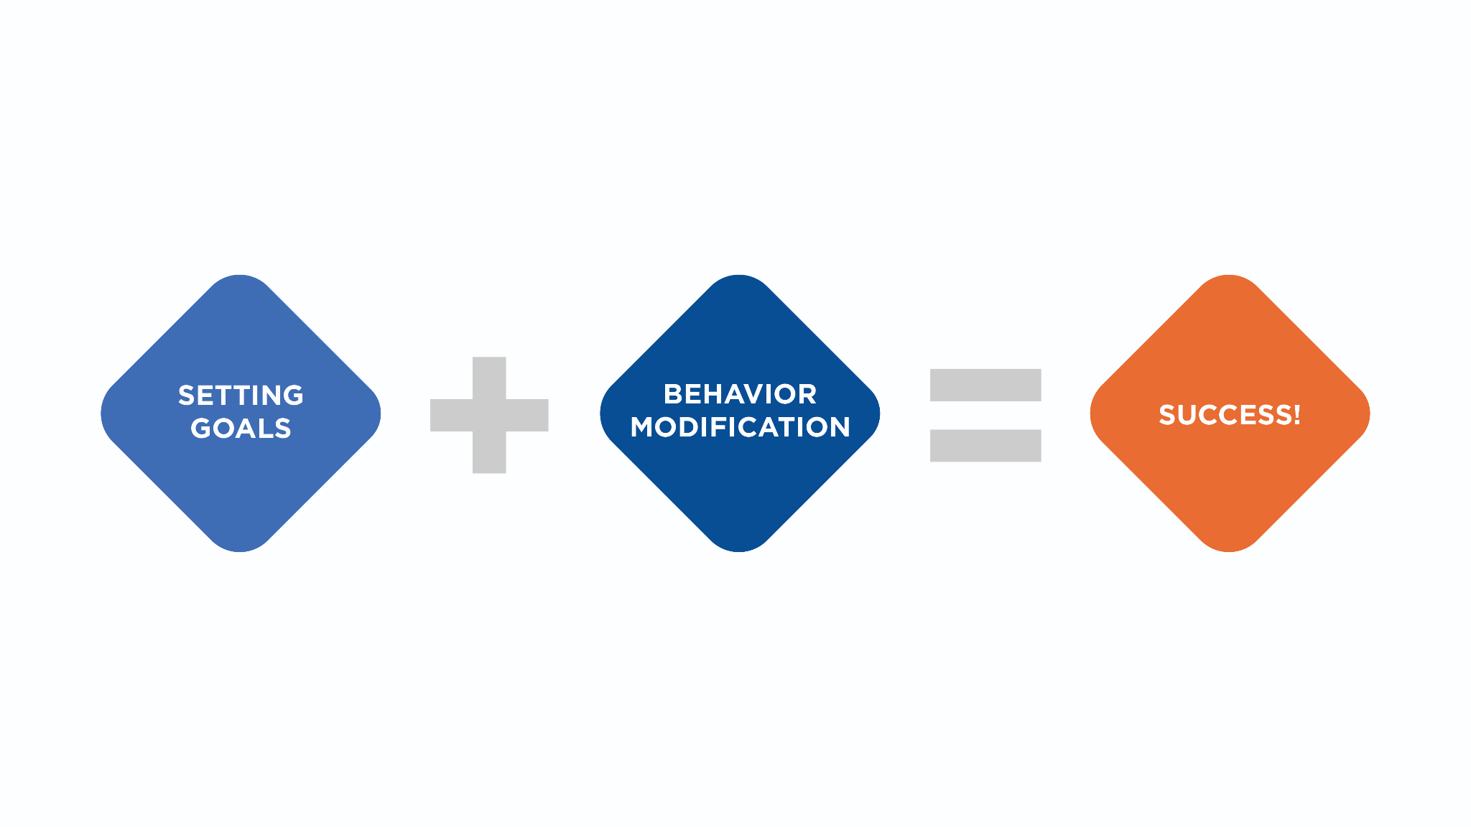

When it comes to changing eating habits, especially for individuals who have an unhealthy relationship with food, a treatment team may be the best approach. This could include a mental health professional, a medical professional, and a registered dietician, for a holistic approach where each person has a specific scope of practice. However, many clients will not have a diagnosable issue regarding food, and will benefit from receiving current and accurate information regarding diet and nutrition from a certified fitness professional. Persuading people to change is not always easy, but by helping clients find solutions to problems, remaining empathetic and being realistic, fitness professionals allow clients to decide what they are motivated to change and why.

**Communication**

Communication is very important when counselling individuals on how to change any behaviour, especially those related to improving overall health and well-being. Communication consists of delivering and receiving both verbal and non-verbal messages. One of the keys to effective communication is conveying empathy. Empathy is when someone identifies with another person’s feelings, attitudes or thoughts. A simple way to describe being empathetic is the ability to put yourself in someone else’s shoes.

Being empathetic starts with being a good listener. This is something that may not come naturally to everyone, but it is a skill that can be improved on over time. Clients need to feel that they are being heard and that their messages are being accurately received.

Empathy is a skill that includes being able to correctly interpret what people are saying, as well as what their body language is indicating. Being able to interpret messages will help the coach identify with how the client is feeling and thinking. There are several keys to being an empathetic communicator: gathering information, avoiding bias, having an appropriate level of empathy and being aware of personal actions (Lorimer, 2013).

Getting Technical

Biases are basically opinions people have that are preconceived or unreasonable, and are typically described as stereotypes. One way to avoid bias is to not make assumptions about people or situations. This goes back to gathering information before forming opinions. Providing too much empathy can be a problem when a coach loses an objective perspective on a situation.

To identify with others and show empathy, it is crucial to not be judgmental and to convey understanding. Empathy also involves being focussed on the other person, so body language and facial expressions need to be appropriate. Understanding and empathy are both important but have distinctions (Table: Conveying Empathy vs Understanding).

Conveying Empathy vs. Understanding

| **Empathy (relating to someone’s feelings)** | **Understanding (showing knowledge)** |
| --- | --- |
| *I know it’s tough making decisions at the grocery store; with so many options it can be overwhelming. I’m going to give you some hints and tips to help you make good decisions.* | *What I hear you saying is you’re not sure how to identify the healthiest options while grocery shopping. Is that correct?* |
| *I can imagine that you are very frustrated with the lack of support you're getting at home while you're trying to change your diet.* | *It sounds like you don’t have much support at home when it comes to changing your diet.* |
| *I know how you feel. My friends always pick restaurants with few options that fit my food preferences.* | *Your friends don’t seem to be helping you with your goals to change your diet.* |

Try This

Take note of personal body language by paying attention to posture, eye contact, gestures, facial expression, tone and inflection of voice, and the use of personal space. These are all powerful non-verbal aspects of communication and play a significant role in how messages are delivered and received.

Non-verbal communication is as important, if not more important, than verbal communication. Specific aspects of nonverbal communication to be aware of are posture, eye contact, gestures, facial expressions, tone of voice and body position. Much non-verbal communication is unconscious, meaning people are often unaware of the non-verbal messages they send. Nutrition Coaches should be mindful of both theirs and their client’s nonverbal communication and how they may affect the overall trainer–client relationship (Table: Nonverbal Communication).

Nonverbal Communication

| **Nonverbal Communication** | **Examples** |
| --- | --- |
| Posture | How one stands, sits, or whether arms are crossed |
| Eye contact | Making or avoiding eye contact or rolling eyes |
| Gestures | Pointing, thumbs up, large vs. subtle gestures, or nodding |
| Facial expressions | Smiling, frowning, smirking, or raising eyebrows |
| Body position | The space between people and how they are positioned |

It is important to remember that when empathy is not conveyed, whether it is due to poor nonverbal cues, inserting personal views and biases into the conversation, or not being a good listener, it all minimises what the client is saying and feeling and takes the focus away from the issue at hand. Empathy is ultimately about understanding, and *conveying* that understanding to the client. By becoming more empathetic within the trainer–client relationship, one can build trust and enhance communication, which will ultimately strengthen the relationship.

Being empathetic will enhance the relationship with the client by building trust and improving communication.

**Quality of life**

Having a good quality of life involves overall physical, mental and social well-being. It describes how happy and positive an individual is regarding each of these domains. When it comes to the lifespan, the goal is to have not only longevity, but to have high quality within those years. Physical well-being includes overall health status along with how well someone can go about their activities of daily living with adequate energy and little discomfort. Mental well-being includes aspects such as self-esteem, body image and the amount of positive versus negative feelings. Social well-being has a strong focus on personal relationships and whether or not an individual feels supported (Figure: Well-Being). Achieving a favourable quality of life should be one of the biggest selling points to initiate and continue behaviour modification.

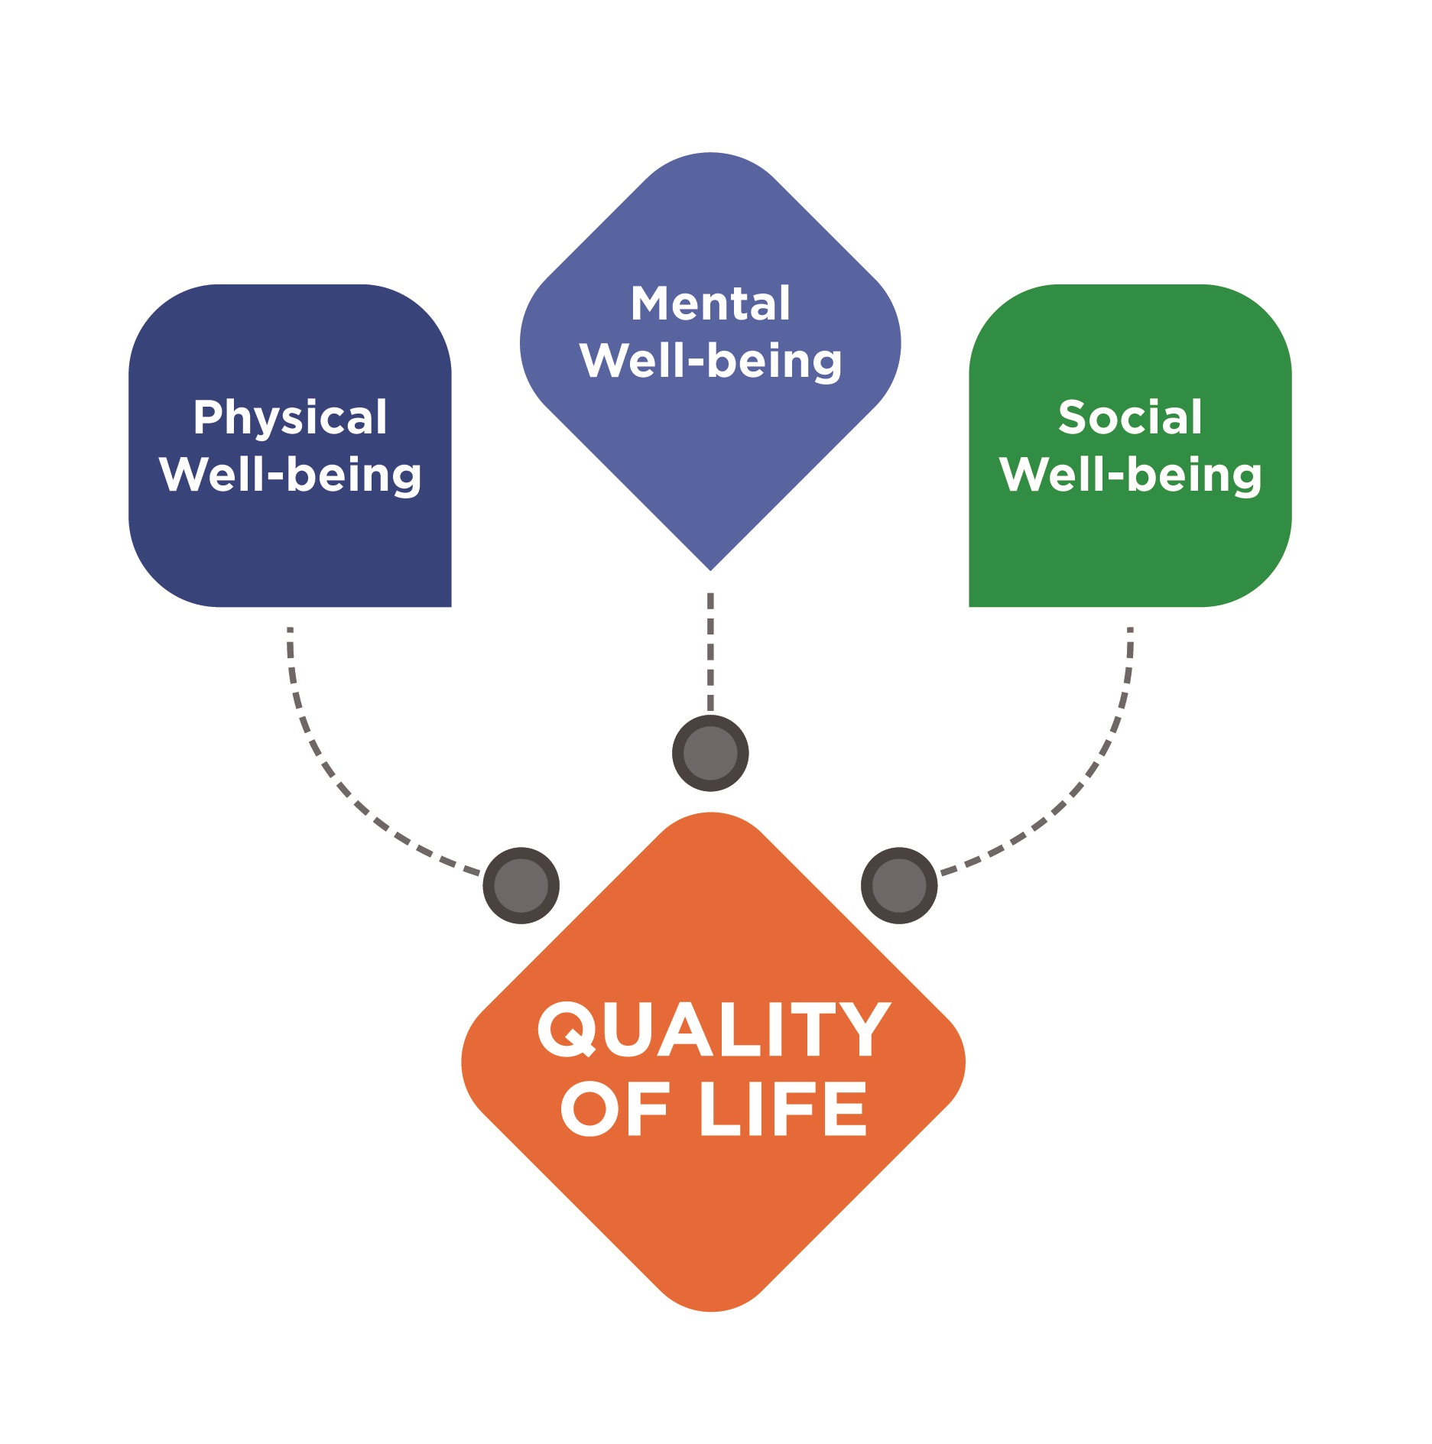

Quality of life is important to monitor as it is a way to determine if a behavioural change is effective or not. For the weight-loss client, particularly for those that are overweight and obese, quality of life tends to decrease as weight increases; therefore, the emphasis should be on educating individuals about the many aspects of their quality of life that can improve with behavioural modification. Some of the benefits of healthy eating related to quality of life are weight loss, weight control, improved physical functioning, increased energy and overall mental well-being (Govindaraju, Sahle, McCaffrey, McNeil & Owen, 2018). Being able to get in and out of a car, easily put on shoes or climb stairs without pain are all simple but, taken collectively, these improvements in physical function lead to greater independence.

Food for Thought

All aspects of quality of life can be impacted with an improved diet and regular physical activity. Educating clients about the many benefits of behavioural change may help them see the value in making substantial life changes. These benefits can include physical, mental and social enhancements, which collectively affect how someone perceives their overall quality of life.

Increasing energy and improving mental well-being will create opportunities to confidently participate in more activities such as exercise and social events. Some physiological improvements related to health include improving conditions such as heart disease, diabetes, high blood pressure and high cholesterol, as well as having better digestive health. There is also growing evidence that healthy eating can improve mood (Breymeyer, Lampe, McGregor & Neuhouser, 2016). In addition to the known physical benefits, control over eating can also lead to more fulfilling social interactions and promote a positive outlook on life, therefore affecting well-being. Quality of life is also a very subjective thing because it comes down to how a person perceives these various aspects of their life. Everyone has different expectations for how their physical, mental and social well-being should impact their day-to-day life, and certain aspects may be more important to certain individuals. For example, some people may put a larger emphasis on their social interactions over their physical function, while the opposite might be true for others. As with all aspects of behavioural modification, finding out what the client values will help shape the intervention.

**Stages of change model**

There are numerous theories and models that describe how people go about changing their behaviour. One common component among them all is that each has a focus on the outcome from changing behaviour(s) being valued by the individual. For example, if someone needs to reduce sodium intake due to a diagnosis of hypertension, then the behaviour change is lower sodium intake daily and the outcome is to have normal blood pressure. If the outcome is valued by the individual, the behavioural change is likely seen as worthwhile.

Getting Technical

The term transtheoretical, which refers to 'across theories', is sometimes used because this model is derived from several behavioural change theories. Specifically, the common use of self-efficacy and expected outcomes across theories are prominent in the Stages of Change Model.

While there are many approaches to behavioural change, one model is particularly useful for the Nutrition Coach, who will be assisting and supporting clients throughout the process. The Stages of Change Model, also called the Transtheoretical Model, has been used for decades and can be used for nearly any type of behavioral change (Figure: Stages of Change Model) (Prochaska, DiClemente & Norcross, 1992). This model consists of a systematic flow through stages in which a person can cycle when it comes to implementing lifestyle changes.

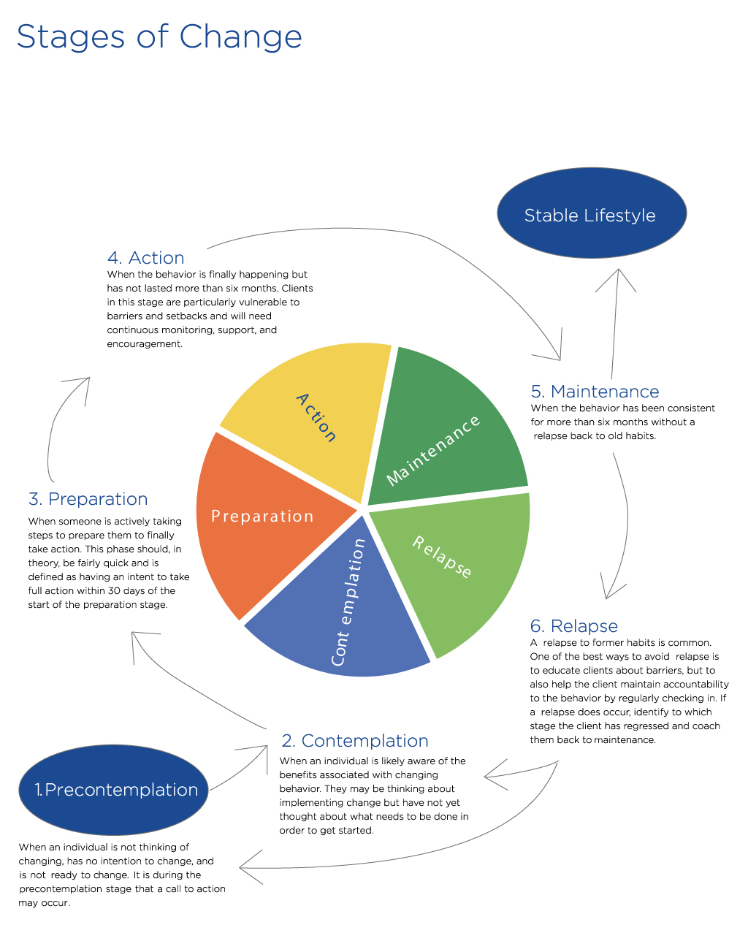

**Applying the stages of change model**

Applying the Stages of Change Model includes using specific strategies at each distinct stage. For the weight-loss client, it may also be a layered approach as opposed to an all-at-once approach. For example, the first adjustment might be reducing daily caloric intake and once that is underway, the next step might be to increase vegetable intake, then reducing sodium and so on, until all behaviours in the plan have been successfully adjusted.

During the Pre-contemplation stage, when the client is unaware of the need to change and has no intention of changing, the Nutrition Coach should focus on creating a supportive environment to start a dialogue about behavioural change. This should include discussing the many benefits of losing weight, including improved health and overall quality of life, finding out what the client knows about the process of losing weight, and discussing the negative impact that *not* changing eating behaviours will have on long-term health and quality of life.

As a client moves into the Contemplation stage there is interest in changing, but specific steps have not yet been taken. It is during this time that the Nutrition Coach should focus on helping the client determine which behaviours need to be changed and to prioritise them. This is a time to discuss motives to change and also identify potential barriers. Also, assessing things such as food preferences and current daily habits (including work schedule, eating schedule, leisure time, etc.) and understanding any past attempts at dieting. By gathering information during the Contemplation stage, a personalised approach can be designed. Throughout this stage, the Nutrition Coach should reinforce the overall benefits to changing behaviour.

In the Preparation stage, a firm plan should be established in terms of exactly how the client will change behaviours. This can include finding healthy recipes to try, creating grocery lists, and identifying lower-calorie options at favourite restaurants. Preparing for potential barriers and strategising about how to react to them when they arise is key in the Preparation stage. Additionally, it is important to help the client work with their schedule so that the time it will take to implement change is accounted for. This is also a time for small steps to be taken by the client toward the behavioural change. Because the client may not be very confident in their ability to successfully change, it is also a time to be supportive and encouraging. As the client moves into the Action stage, this is a time for accountability to the changes being implemented and also helping them overcome barriers as they are encountered. Remaining positive and supportive will help keep the client excited about the changes and the progress being made and increase their confidence.

The Maintenance stage is when the behaviour has been consistent for more than 6 months. It is an important time to address the possibility of relapses and how to avoid them. Continuing to be supportive and holding the client accountable to the behaviours will help reduce the chance of a relapse back to old habits. In the case that a relapse has occurred at any stage along the way, the Nutrition Coach should focus on why the relapse occurred and strategise with the client on how to get back on track, as there are no setbacks that cannot be overcome.

For any behavioural intervention, it is important to match the strategies being implemented to the stage the client is in for the best chance of success. Practical application of the Stages of Change Model with a personal client is meant to be a guide for how to approach working with an individual. Additionally, it is not as important for a client to know which stage they are currently in as it is for a health-and-fitness professional to understand the type of information or support that the client likely needs in each stage. Overall, the Stages of Change Model has been successfully implemented for dietary modifications such as eating less fat or eating more fruits and vegetables (Mastellos, Gunn, Felix, Car & Majeed, 2014); however, it should be noted that many more aspects of changing behaviour need to be addressed, including self-esteem, self-efficacy, overcoming barriers, overcoming poor relationships with food and other psychological and sociological triggers to eating.

Coach's Corner

When using the Stages of Change Model, start by determining which stage a person is in by first asking if he or she has ever thought about changing eating habits. If the answer is no, then the stage is Pre-contemplation, and a call to action will need to occur to move the client to Contemplation. If the answer is yes, follow up with asking if they have taken any steps toward changing. If no steps have been taken, then they are in Contemplation. If steps have been taken, determine if they are in the Preparation or Action stage. Making lifestyle changes is not black and white, and it is possible for some action to be occurring while preparation for future changes may be underway. No matter which stage a person is in, it is likely that accurate information and support are both needed by the client.

## Psychology of body image and low self-esteem

When it comes to how people perceive and judge their bodies, there are a few variables to consider: body reality, body ideal, and body image. Body reality is based on objective, measurable variables such as height, weight, body-fat percentage, and waist circumference. These variables can further be used to define health status and benchmarks can be set for optimal health.

The body ideal refers to how people think they should look and is often associated with images in the media or among peer groups. According to the National Eating Disorder Association, body image is defined as how someone sees themselves when looking in the mirror or when they picture their body in their mind (National Eating Disorder Association, 2018). Body image is not necessarily based on facts such as weight or body-fat percentage and having a negative body image can lead to depression or an obsession to obtain a perfect physique. Body image can change based on several things, including what someone sees as a normal or ideal physical appearance, the current image a person has of his or her body, and current emotions. Additionally, body image has traditionally been tied to self-esteem.

Self-esteem is how an individual views themselves with regard to their worthiness and abilities. Low self-esteem has long been thought to be a major factor in the development of disordered eating and poor body image (Zeigler-Hill & Noser, 2015). Thus, poor self-esteem and poor body image feed into each other in a negative fashion.

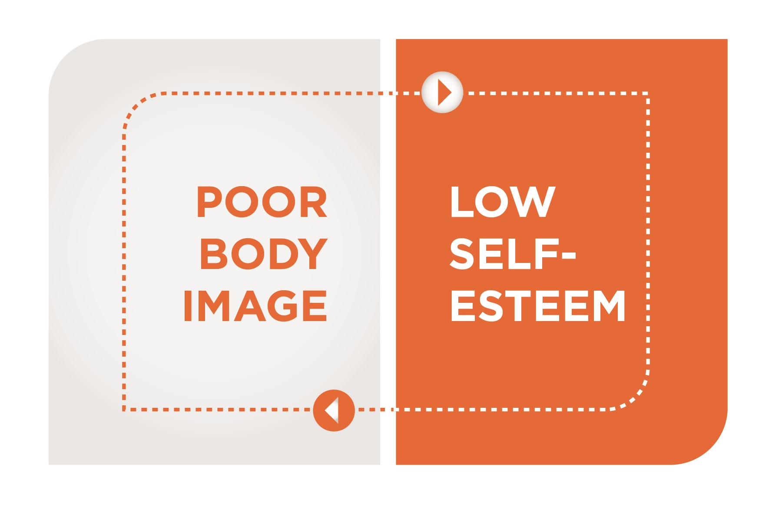

Confidence is how strongly one feels about their ability to do something, or how they feel about something such as personal physical appearance, and it ranges from low to high. In terms of healthy eating, confidence comes from believing in one’s ability to make the right decisions about food intake at home, work, social gatherings, and restaurants. Low confidence is problematic regarding eating behaviors because it can lead to making bad decisions on a daily basis. Additionally, having high levels of confidence in the absence of accurate and credible information may also lead to poor decisions. A concept that is closely related to confidence is self-efficacy. Self-efficacy is the confidence that a person has that he or she can successfully engage in the behaviors required for a certain outcome (Bandura, 1986). For example, an individual with high self-efficacy feels strongly that they can reduce calories on a daily basis to reach their goal of losing weight. Self-efficacy has a strong influence over what a person chooses to do, how much effort will be put into a given behavior, and how much a person remains committed to a behavior, especially when faced with challenges (Bandura, 1986).

The relationship between past experience and self-efficacy is thought to be reciprocal, meaning past experiences influence self-efficacy and self-efficacy influences future behavior.

Levels of self-efficacy can change based on several variables: mastery experiences, social modeling, social persuasion, and physical and emotional responses (Bandura, 1986). Mastery experiences are very influential over behaviors and refer to past experiences with a particular situation. For example, if someone had healthy eating patterns in the past, they are more likely to resume those habits because they have a reference point for success. Successful experiences, such as making good food choices, will cause self-efficacy to increase, whereas unsuccessful experiences will cause a decrease in self-efficacy.

Social modeling is often described as vicarious experiences, in which someone else successfully models a behavior. This might mean sharing meals with people who share the same opinions and values surrounding healthy eating, which could also be considered a form of social support. Social modeling can also be simply observing someone (who is viewed as similar) engaging in healthy eating behaviors. This would translate into the positive thought, “If they can do it, I can do it!” Social persuasion is different in that it will most likely be verbal encouragement either from a person with credibility or status regarding the targeted behavior or from family, friends, or co-workers. Social persuasion can be positive or negative.

Positive persuasion would include accurate information being disseminated and verbal encouragement to engage in healthy behaviors. It turns negative when things like peer pressure lead a person toward situations that will cause challenges for healthy eating, such as going to restaurants that do not have many healthy options or that have temptation items on the menu (Table: Social Persuasion).

Social Persuasion

| **Positive** | **Negative** |
| --- | --- |
| Encouraging a client to do some extra cardio following a social gathering that included indulging in extra calories. | Telling a client not to worry about skipping workouts when their schedule gets busy. |
| Telling a client about a new organic protein bar that is inexpensive and fits their food plan. | Encouraging a client to splurge on dessert so that they can stay ahead of any cravings. |
| Letting a client know you are extremely proud of their progress and to keep up the great work. | Informing a client that you are very disappointed in their lack of progress in the past few weeks. |

Physical and emotional states also have a positive or negative influence over self-efficacy (Bandura, 1986). Having cravings or needing to eat for comfort will lower self-efficacy but, as healthy eating continues and an individual feels better both physically and mentally, self-efficacy can increase. Collectively, these variables need to be considered when trying to increase the confidence someone has to consistently engage in a targeted behavior.

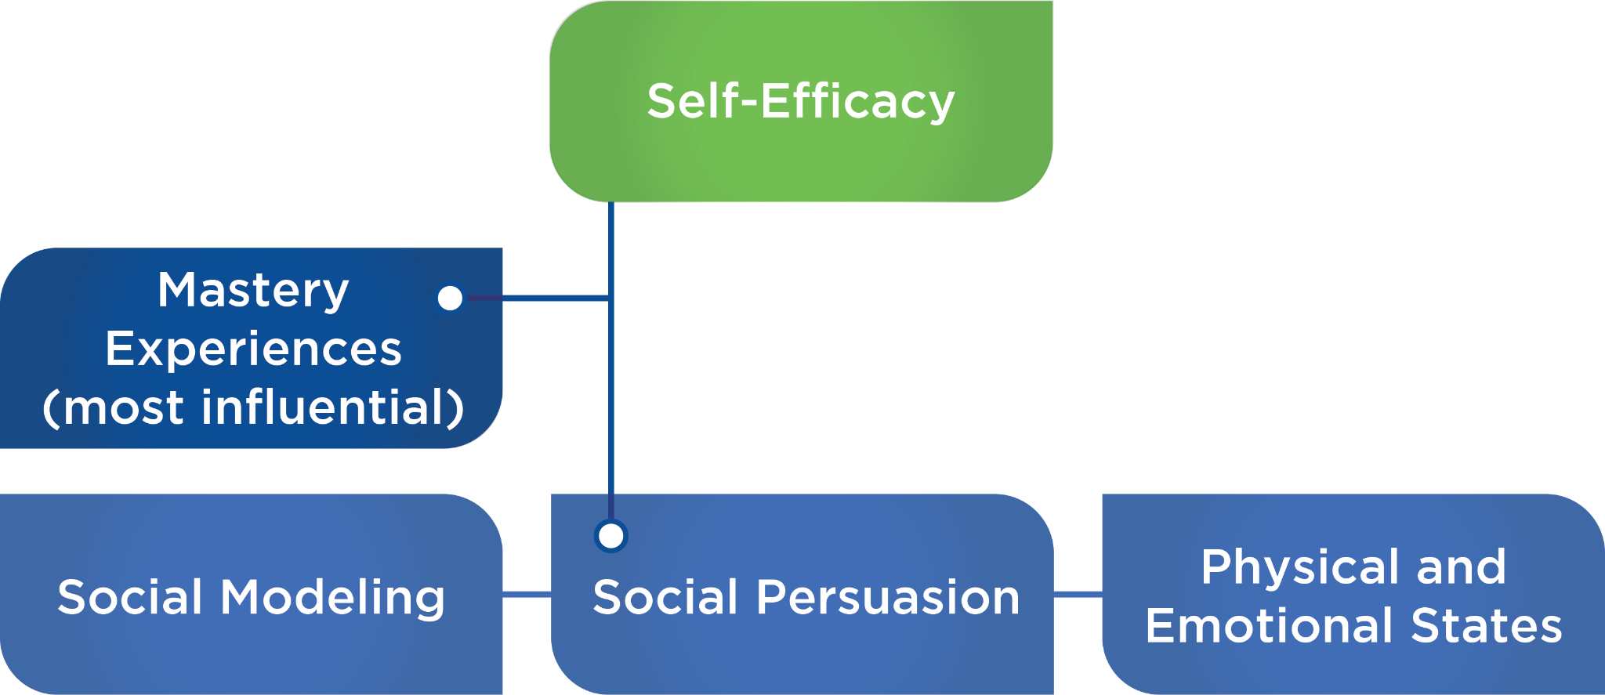

In terms of increasing self-efficacy, the health-and-fitness professional has the most influence via social persuasion. This is where encouragement, empathy, and being positive are crucial. Being an advocate for the behavioral change, being a cheerleader for the client, and providing ongoing accountability will show the client that he or she has support. When it comes to making a change regarding diet and exercise, it is possible that the only consistent support comes from the trainer or coach. Checking in frequently and coaching clients on how to navigate potentially difficult situations will allow the client to realize success and increase self-efficacy.

## The profile of a weight loss client

Nutrition Coaches will likely work with a variety of clients, including those who want to lose weight, increase muscle mass, improve athletic performance or simply eat healthier in the absence of a physical goal. Of interest is the weight-loss client, due to the magnitude of changes that need to take place for their long-term success. Weight-loss clients come from every walk of life and have varying motives and barriers in terms of reaching their goals. Thus, personal training and nutrition coaching are not one-size-fits-all professions, and care should be taken to identify which clients are a good match for the optimal results.

Creating a profile of weight-loss clients will also allow fitness professionals to remain within their scope of practice and refer out to other healthcare professionals when necessary. A client profile defines who an ideal client is and can include several variables such as demographics, attitudes, beliefs, lifestyle and personal history with weight loss. The demographics of obesity are well-documented and updated frequently, as it continues to be a major health concern for both men and women (Hales, Carroll, Fryar & Ogden, 2017). With the alarming prevalence of obesity, Nutrition Coaches need to gain a better understanding of the profile of these potential clients – each one has a unique story to tell.

Before addressing the client profile, Nutrition Coaches should identify specific populations for which they are more comfortable working with or for which they have an expertise. For example, some Nutrition Coaches may be more comfortable working with women than men, or with more specific populations such as post-partum women, individuals who have had a surgical procedure to address obesity, or individuals that have had a life-long struggle with weight. These preferences can come from having a certain expertise, or possibly from having a relatable past experience with one or more of these areas. Once potential client populations are determined, the next step is to learn about the client. It is important to determine why a client wants to lose weight and also how important it is for them to achieve that goal, as that will likely be linked to how committed they are to making the necessary lifestyle changes.

Another important aspect of creating a client profile is identifying what the motivation to change is based on. As previously noted, motives for behavioural change will vary from client to client. In addition to reasons *why* people eat what they eat, there are also specific motivating factors for losing weight. For example, in individuals who have successfully lost weight and kept it off, the motives for doing so include improving appearance, wanting to feel better about oneself, health concerns, social pressure, improved social life, feeling physically uncomfortable and improved energy (LaRose, Leahey, Hill & Wing, 2013). For example, the approach to a client who wants to lose weight for health reasons will be different than a client who is more driven by improving appearance. For those who have a motive due to health, the Health Belief Model (Figure: Health Belief Model), which involves the relationship between a health issue and whether or not to change behaviour as a means to addressing the health issue, may offer additional structure when coaching these clients (Rosenstock, 1982).

The premise of this model is that individuals who believe they are at risk for a health issue, and especially when the health issue is perceived as serious, will weigh the benefits and barriers to changing their behaviour. Perceiving potential health issues can come from having a family member or friend develop an illness, from routine screenings with a physician, or from cues to action from media campaigns. Ultimately, if a health threat is perceived, and especially if it appears severe, the benefits and barriers will be weighed. If the benefits outweigh the barriers, then behavioural modification is likely.

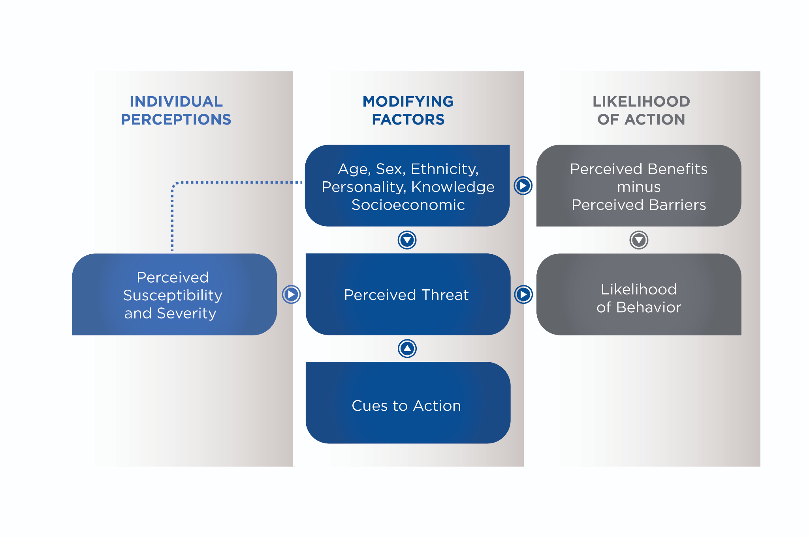

Individuals who are intrinsically motivated for health reasons will benefit from learning about the ways that improving diet and exercise can lead to a better quality of life and longevity. The health-and-fitness professional can provide education about how improving diet and adding exercise are behaviours that can be modified in an effort toward better health by highlighting the benefits they bring. Additionally, addressing barriers will also assist the client with a successful lifestyle change.

Determining *why* someone wants to lose weight may be the first step, but Nutrition Coaches must also try and understand *how* the client got to where they are and if there have been failed attempts to lose weight in the past. Failed attempts will reveal a lot about barriers they have faced and how the client reacted to challenges.

Coach's Corner

The Health Belief Model provides another tool for the Nutrition Coach when helping clients who are facing illness or are already ill. Applying the Health Belief Model includes the client having a desire to be or remain healthy and also believing that taking specific steps will improve or prevent an illness. One aspect of the Health Belief Model that distinguishes it from other models of behavioural change is the Cue to Action, which describes an event that has pushed a person toward a lifestyle adjustment. For example, if a client feels susceptible to an illness such as heart disease and also feels like this is a serious threat to overall longevity and quality of life, then they may be interested in taking action. A Nutrition Coach can provide the client with the benefits of behavioural change and then the client may perceive changing their diet as a way to improve or avoid heart disease. Further, the Nutrition Coach can help identify barriers that will be faced and also teach the client how to overcome the barriers. If a health threat exists and the benefits of changing behaviour outweigh the barriers, then change is likely.

Simply telling someone who has struggled with weight loss that they need to cut their calories and exercise more is not an effective strategy. While the advice may be technically correct, it does not actually provide the individual with concrete, actionable steps to move in the right direction.

**Real-life struggles**

When working with weight-loss clients, it is important to acknowledge the real-life struggles that people face. In addition to the everyday barriers that keep people from a healthy diet, some issues may run deeper such as food addiction or a binge eating disorder, which would require a diagnosis and subsequent treatment from a medical professional (a physician or psychiatrist). While some people legitimately have a diagnosable condition, many clients will not reach this threshold, so understanding the day-to-day struggles that people face is key to being able to help.

**Combating stigma**

Another struggle that overweight and obese people face is being stigmatised as lazy or just bad. Anti-fat bias refers to placing a negative judgment on overweight and obese individuals. This bias can stem from several beliefs, including, but not limited to the following:

* People tend to identify with groups of people they feel they are similar to; therefore, people who are within the normal-weight range may see themselves as distinctly different from overweight and obese individuals.
* Weight is controllable and fat people simply choose to not control their weight, and are therefore viewed as lazy.
* An explicit bias exists where most people, regardless of their personal shape or size, generally prefer thin people (Elran-Barak & Bar-Anan, 2018).

No matter the reason for anti-fat bias, it is associated with low self-esteem and poor body image by those who perceive it (Papadopoulos & Brennan, 2015). As a Nutrition Coach, it is important to identify and acknowledge personal biases toward potential clients as only supportive and trusting relationships will build a long-term client base. Unfortunately, a negative bias toward overweight and obese individuals does exist among fitness professionals (Robertson & Vohora, 2008). This is concerning because the people who are being called on to help this population have strong biases toward the very people who most need their help. With constant exposure to images of thin people, it is difficult to adjust the anti-fat culture. Overweight and obese people have likely dealt with anti-fat biases and will quickly determine if someone is sincere and caring or not. Having an anti-fat bias is not unusual and it does not make someone an inherently bad person, but if it goes unacknowledged, it will likely have a negative impact on retaining a long-term client base or obtaining referrals for additional business. Acknowledging possible biases toward any potential client will help to create an inclusive and supportive environment where client success remains the focus.

### Barriers to diet and exercise

Everyone faces barriers to accomplish goals, whether it is extra responsibilities at work or home, the opportunity to do something different and fun or just the lack of motivation or willpower on any given day. When there are barriers to exercise, the result is a missed workout and sedentary behaviour. In a similar fashion, when barriers are present in regard to healthy eating, the behaviour that replaces it is a higher consumption of fast foods that are calorie dense and mostly unhealthy (Pinho et al., 2018). When it comes to barriers in relation to diet and exercise, there are some common themes for both, but each has its own set of distinct challenges, as well. Some common barriers between both healthy eating and exercise are time constraints, lack of willpower, family and friends with different habits and lack of knowledge or expertise. The barriers that affect both exercise and healthy eating are particularly problematic for the weight-loss client, because they may be missing out on two important behaviors that will help them reach their goals (Table: Common Barrier Strategies).

Common Barrier Strategies

| **Common Barrier** | **Strategy to Overcome Barrier** |
| --- | --- |
| Lack of time | * Prepare larger quantities of healthy meals and snacks and store in appropriate serving sizes. * Purchase snacks in preportioned sizes. * Identifying recipes that are not time-consuming and easy to prepare. |
| Lack of willpower | * Identify the types of foods and situations that are most difficult to deal with and create plans on how to overcome the lack of willpower or minimize its effects. |
| Family and friends with different habits | * Express to friends and family what the specific goals are and how healthy eating will help achieve the goals. * Suggest social interaction that does not include food such as going for a walk. |
| Lack of knowledge or expertise | * Seek information from credible sources and ask questions when in doubt. |

Lack of time is a commonly reported barrier but everyone has the same 24 hours in a day and a behaviour must be valued if people are going to make time for it. Fitness professionals should display empathy and understanding toward their clients who cite lack of time as a barrier to participating in healthy habits. Yet, this barrier must be overcome for behavioural change to occur. It takes a dedicated amount of time to be physically active, whether that is taking 30 minutes to go for a walk or taking several short walks throughout the day, either way it takes time.

Many clients may be committed to exercising and understand that they are going to dedicate blocks of time to be active, but they may not be anticipating the time that healthy food preparation may involve. Compared to consuming fast food, it takes more time to prepare healthy meals and snacks, so it is important to counsel clients to schedule the time this takes into their daily routine. Some ways to overcome this barrier are to prepare larger quantities of healthy meals and snacks and store in appropriate serving sizes (Rolls, 2014). For example, if something like carrots is a preferred snack, immediately open the bag and divide and store in snack bags so they are ready for the week in the correct servings. This strategy works well with items that can be purchased in larger quantities if perishable items can be consumed while they are still fresh. Although not as cost-effective, many healthy snacks are available in preportioned sizes and the benefit of this packaging is both convenience and longer shelf life. Perceived lack of time is usually a time management issue and, once healthy eating is a top priority, a client will be more inclined to put food preparation before other activities.

Some barriers specific to eating healthy are having strong taste preferences, the cost of food, and portion sizes when eating out (Pinho et al., 2018). Strong taste preferences can manifest in several ways, including not liking foods like fruits and vegetables or craving sweets or fried foods. When preferences are available, it will be difficult to avoid eating unhealthy choices unless strategies are in place such as how to order a healthier version, limiting portion size or choosing a healthy alternative all together. The cost of unhealthy food is apparent in nearly every fast-food establishment with dollar menus and inexpensive add-ons, but, even at restaurants, a salad may cost as much as a burger with chips. If the burger is preferred and the cost is the same or less, then the burger may seem like the reasonable choice; however, if the client has the correct information about how that choice will affect achieving their goals, then they may be able to make a more informed decision. Finally, portion sizes are generally much larger than they need to be when eating out and value in food volume is something consumers look for.

**Social influences**

Social influences are a constant part of life and they can both help and hinder behavioural change. These influences can come from interactions with people, social norms that come from different groups and constant exposures to images and messages from the media. Social support refers to the ways in which someone is supported by others and includes emotional support as well as information or tangible items to assist with a behaviour change. It can come from family, friends, co-workers, healthcare providers or Nutrition Coaches.

Emotional support includes providing encouragement, being a good listener and being empathetic. Some examples are letting a client know that change is difficult but reinforcing that they are not alone throughout the process or asking how a client feels about the change. Informational support is like it sounds: providing someone with information that will assist them in making decisions. Informational support can be in the form of educating a client about the benefits of healthy eating, such as feeling better, increased energy and weight loss and how to be a consistently healthy eater both at and away from home or how to read food labels. Information does not have to be all positive; it can also be informing clients about the negative consequences of not changing their behaviour: overall poor quality of life, obesity, high blood pressure, high cholesterol, diabetes and heart disease, among many other conditions. Some tangible ways to provide support are offering to go grocery shopping with someone to help pick out healthy choices and hold them accountable to not purchasing unhealthy items. Or it can be finding healthy recipes and offering to help make the food. When it comes to social support, there are many ways it can be done, but the common theme is to support the behavioral modification efforts (Table: Social Support) (Hausenblas & Rhodes, 2017).

Social Support

| **Type of Social Support** | **Example** |
| --- | --- |
| Emotional support | When a client indicates that they are struggling with changing their eating habits, let them know that even though it is a difficult change, they are not alone in this process and that they will not be abandoned in this process. |
| Informational support | Explaining to a client the way that properly reducing caloric intake over time will create an energy imbalance where the result will be weight loss. |
| Tangible support | Assisting a client with finding healthy recipes that are fast and easy and then helping them to create a shopping list. |

Social networks refer to interactions with groups of people and they can occur in person or over the Internet. It will be a group that will have a common interest or connection: family and friends, co–workers or a group with a common goal or interest such as exercise, weight loss or any number of hobbies. Social networks can be helpful with behavioural change when positive behaviours are being promoted, but, unfortunately, this may not always be the case. There are groups that endorse unhealthy behaviours such as extreme food restriction. When encouraging social networks, Nutrition Coaches should help evaluate if a group is being helpful or creating barriers and challenges for a client. As long as a social network is providing accurate information, along with additional accountability to healthy behaviours and is fostering a positive environment for change to occur and for setbacks to be overcome, then participation should be encouraged.

Much like social networks, the media also influences behaviours. First, it has an overall strong influence over what people see as *normal* and these images can be misleading, especially when it comes to advertising. Research has shown that for women, media pressure in the form of advertisements, movies and magazines is the strongest predictor of body dissatisfaction (Marshall, Lengyel, & Utioh, 2012). There is also evidence that media images affect young people where social comparison to favoured characters, such as those found on television shows, has been shown to contribute to poor body image (Te'eni-Harari & Eyal, 2015). Additionally, advertisements often promise results that are very appealing such as achieving the thin ideal body and remaining youthful.

Coach's Corner

Nutrition Coaches can assist by helping clients determine if a website is helpful or not based on the reliability of the information. Some things to look for are whether or not something is being advertised and if the product is promising unrealistic results. Also, determine who is responsible for the information and if the information is relevant for the client. The source should be easy to verify with contact information available such as government or not-for-profit agencies and higher-education institutions. The goal is to guide clients through the maze of available information and steer them toward legitimate sources. Finally, the power of social media cannot be ignored. With many platforms available to socially share images and information, clients should be cautioned about the sources they may be relying on when it comes to health, fitness and nutrition.

**Willpower**

Willpower is the ability to control impulses and can be a powerful tool for the weight-loss client (Weir, 2012). Willpower is a subset of self-control and having a strong willpower to achieve positive behaviours and avoid negative behaviours will likely result in success. For example, as with a weight-loss client, lack of willpower may be over-emphasised as the underlying cause of obesity, which is strongly driven by both physiological and psychological issues. There is some disagreement about the role of willpower regarding obesity; however, willpower (or lack thereof) is certainly a barrier to healthy eating that continues to be cited over the years (de Mestral, Khalatbari-Soltani, Stringhini, & Marques-Vidal, 2017; Lappalainen et al., 1997; Pinho et al., 2018).

For the health and fitness professional, understanding that willpower may be a significant issue for some clients but minimal for others will help dictate how that client is coached. Assuming that every weight-loss client suffers from a lack of willpower is an inaccurate stigma and treating everyone the same may result in low motivation for some. However, for those who indicate they are challenged by willpower, they need to be coached regarding how to overcome the need for the instant gratification they get from eating certain foods. The biggest challenges for those who lack willpower when it comes to healthy eating are temptations. One way to combat lack of willpower is to minimise exposure to foods and situations that make it difficult to stay on track. This includes not bringing tempting foods into the house and replacing them with healthy options.

Using a rewards system may also help break bad habits. The reward needs to match the magnitude of the healthy behaviour that has earned the reward. For example, eating out at a favourite restaurant may be earned after completing a certain number of workouts in a week or a month, but having a small portion of dessert can be earned from doing an intense workout. Willpower is closely related to barriers. When something unhealthy is easier to obtain in the midst of busy schedules and life demands, then convenience will likely win (Pinho et al., 2018). Therefore, it is imperative to implement time-management strategies where healthy options are always available.

## Eating behaviour

Eating behaviors can be defined on a spectrum that ranges from positive behaviors and healthy outcomes to negative behaviors and unhealthy outcomes (Figure: Eating Behaviour Spectrum).

There is generally little concern for the eating behaviours of healthy individuals; however, when eating behaviours result in overall poor nutrition or health, it can be due to chronically under-eating or over-eating, binge eating or simply not consuming enough high-quality foods. When eating behaviours result in poor nutrition or compromised health, there is reason for concern as this may indicate a more serious problem.



### Disordered eating

Disordered eating can be any number of possible behaviors that someone engages in that do not meet the strict criteria for a diagnosed eating disorder as listed in the *Diagnostic and Statistical Manual of Mental Disorders,* 5th ed. (DSM-V)*.* Disordered eating can include behaviours such as binging, purging, food restriction, prolonged fasting and use of diet pills, diuretics and laxatives (Anderson, 2018). The underlying causes of disordered eating are complicated, but the constant exposure to ideal body images in the media is associated with an increase in symptoms along with an increase in depression and a decrease in self-esteem (Hausenblas et al., 2013). Further, the use of social-media platforms is also associated with poor body image and disordered eating, which is something to be aware of when working with clients who have demonstrated concerning behaviours (Holland & Tiggemann, 2016). A major underlying concern of disordered-eating behaviours is that they can manifest into an eating disorder, which can have serious health consequences up to and including death.

**Triggers to disordered eating**

There can be countless triggers to disordered eating that can range from the environment and situations to long-term psychological challenges. Unlike environments that may trigger eating (social situations), eating due to variables such as stress and depression may not be as easy to overcome. In these cases, food may be used as a coping mechanism that provides temporary comfort or fulfilment. Stress is something that has caused a mental or physical system to become out of balance. Most of the time, when people use the term *stress* they are referring to something that has caused a bad reaction. This is actually distress, which is when someone is experiencing something negative. Distress is a known trigger to eating and it has been demonstrated that when individuals are faced with a stressful situation, such as not being able to solve a problem, they consume more high-calorie, unhealthy foods (Zellner et al., 2006). There is also evidence that stress contributes to people eating in the absence of hunger when faced with a stressful situation (Rutters, Nieuwenhuizen, Lemmens, Born, & Westerterp-Plantenga, 2009). With strong evidence that stress plays a role in food intake, clients need to be aware of the effect that day-to-day stresses, both large and small, may have on their eating habits. Learning to recognise when stress and not hunger is leading to the desire to eat is a significant step in adjusting that habit.

Critical!

A health-and-fitness professional should never attempt to diagnose or treat a client with depression. If there is any suspicion that a client is dealing with depression, then the appropriate action is to refer them to a medical professional.

Depression is a condition that continues to be associated with emotional eating (Antoniou, Bongers, & Jansen, 2017; van Strien, Konttinen, Homberg, Engels, & Winkens, 2016). Depression is a serious medical condition that affects how a person feels. These negative feelings in turn affect how someone acts and thinks. While very treatable, the symptoms can range from mild to severe; so it is important to identify if someone is depressed as it may not always be obvious.

A diagnosis of depression may come with a negative stigma and, therefore, many people remain in denial that it could be a possible condition they are dealing with. In addition to the feelings of sadness and loss of enjoyment, it can also manifest with unhealthy eating behaviours, including both overeating and undereating (Abbate-Daga et al., 2015; Royal, Wnuk, Warwick, Hawa, & Sockalingam, 2015). When depression causes emotional eating, it will likely lead to overeating as comfort is being sought in food. However, a loss of appetite can be as concerning with food restriction leading to overall wasting of both muscle and fat tissue among other declines in health. Further, emotional eating for depressive symptoms is also associated with worse eating behaviours in overweight and obese individuals. When compared to eating due to positive emotions, overweight and obese individuals who eat due to depression also experience less well-being and more disordered eating behaviours. Therefore, eating due to depression is likely coupled with additional emotional challenges (Braden, Musher-Eizenman, Watford, & Emley, 2018).

**Eating disorders**

Individuals with eating disorders have significantly higher mortality rates with anorexia posing the greatest threat (Arcelus, Mitchell, Wales, & Nielsen, 2011). Anorexia nervosa, bulimia nervosa, and binge-eating disorder can only be diagnosed by a qualified medical professional based on the DSM-V criteria. While Nutrition Coaches are not able to diagnose an eating disorder, it is important to be aware of these diseases, what they entail, and signs to look out for so that referrals to medical professionals can be made when warranted. The DSM-V was released in 2013 with several important updates regarding eating disorders, including the addition of binge-eating disorder as a standalone condition as opposed to being a subset of bulimia (Attia et al., 2013). Additionally, there were updated criteria for diagnosing anorexia nervosa and bulimia nervosa.

Binge-eating disorder is when someone has recurring episodes of eating large amounts of food in a short period of time while feeling out of control (Attia et al., 2013). The binge eating episodes are associated with three or more of the following:

1. Eating much faster than normal
2. Eating until uncomfortably full
3. Eating large amounts of food when not hungry
4. Eating alone and feeling embarrassed
5. Feeling depressed or guilty after consumption

A diagnosis would include the behaviour occurring, on average, at least once a week over the past 3 months. Binge eating is different from overeating and the two should not be confused.

Critical!

Do not ever attempt to diagnose an eating disorder. If an eating disorder is suspected, always refer to a physician. Keep in mind that any diagnosed condition is to remain confidential should the client choose to disclose a diagnosis.

The symptoms of anorexia nervosa include intense fear of fatness, distorted body image and restriction of calories. For adults, severity of the disease is based on body-mass index, which is a height to weight ratio calculated by body weight (kilograms)/height in meters squared (m2) (Table: Anorexia Nervosa) (Attia et al., 2013).

One of the major symptoms that was removed from the diagnosis was amenorrhoea, which is lack of a menstrual cycle. This removal now allows for males, young girls and post-menopausal women to be properly diagnosed with anorexia nervosa (Attia et al., 2013).

Anorexia Nervosa

| **Severity** | **BMI (kg/m2)** |
| --- | --- |
| Mild | ≥ 17.0 |
| Moderate | 16.0 to 16.9 |
| Severe | 15.0 to 15.9 |
| Extreme | < 15.0 |

The symptoms of bulimia nervosa include recurrent episodes of binge eating followed by inappropriate compensatory behaviours, including purging, use of laxatives or diuretics, fasting or excessive exercise to avoid weight gain, with these behaviours occurring, on average, at least once a week over the past 3 months. The severity of bulimia nervosa is based on the frequency of inappropriate compensatory behaviors (Table: Bulimia Nervosa) (Attia, et al., 2013).

These disorders represent the extremes of the eating disorder spectrum, come with significant health concerns and complications and require medical attention to treat both physical and psychological disturbances.

Bulimia Nervosa

| **Severity** | **Episodes of inappropriate compensatory behaviors in a week** |
| --- | --- |
| Mild | 1 to 3 |
| Moderate | 4 to 7 |
| Severe | 8 to 13 |
| Extreme | ≥ 14 |

The DSM-V had several notable changes for classifying eating disorders. In addition to the recognition of binge-eating disorder are pica, rumination disorder, Avoidant/Restrictive Food Intake Disorder (ARFID), Other Specified Feeding or Eating Disorder (OSFED) and Unspecified Feeding or Eating Disorder (UFED). The category Eating Disorder Not Otherwise Specified (EDNOS) has been removed.

**Warning signs**

There is not a one-size-fits-all approach when it comes to the red flags of disordered eating behaviours. However, Nutrition Coaches should be aware of certain behaviors and/or physical changes that could be problematic (Table: Warning Signs).

Warning Signs

| Possible signs of when to refer to a medical professional, including but not limited to the following: |
| --- |
| * Noticeable changes in weight (increase or decrease) * Muscle weakness * Feeling dizzy on standing * Feeling cold * Dressing in loose clothing to hide weight loss * Reports of not sleeping well * Being ill more often * Becoming overly concerned about calories, carbohydrates, fats, or specific foods or food groups * Caloric restriction * Cutting out certain food groups * Having strict rules about exactly what to eat, how much to eat, and when to eat * Being obsessed with calories, body weight, or any perceived physical imperfections. |

**Modifying the eating environment**

Modifying the eating environment will be one of the most important strategies when changing behaviours. In a society that values and enjoys food, nearly every situation has the potential to involve choices about eating. By modifying how to approach the home environment, the work environment and social gatherings, clients can successfully navigate situations that were once difficult. One shift that needs to be made is from mindless eating to mindful eating habits. The home environment poses a challenge for several reasons, including no accountability for some, having a household that does not support healthy eating or a general lack of willpower. As eating environments are modified, clients need to be aware not only of what they eat, but also how much they eat as both of these factor into overall nutrition.

# Coaching and communication

Health-and-fitness coaches spend a lot of time developing their craft to build successful programming that will make a positive difference in their clients’ lives. Developing a quality programme does not guarantee programme success and, for some, it might be difficult to even define what it means for a programme to be successful. There are many factors that go into qualifying a programme as successful, including effective design, implementation and goal attainment.

It is also important to note that this definition of *success* can differ from person to person. For some, success may be based on the design of the programme itself, on the fact that it has been successful in the past or on whether client’s goals were met. Another view is to base the success of a programme on client adherence, which is an interesting notion. Does it really matter how great the programme is if no one sticks to it?

Coaches must be able to communicate information in a way that influences decision making and behaviour change.

Most coaches and trainers in the health and fitness industry have experienced situations in which thoughtful, scientifically and practically sound programmes were developed, but client adherence was low and goals were not achieved. It may be easy to place the blame on the client for not being committed or ready to make a change. While this may be true in some situations, adherence is a complex topic with many factors. When dealing with nutritional programming, it may even be more challenging to achieve than with other health behaviours.

Nutrition Coaches must work beyond the components of programme design and development and focus on how to implement a programme to maximise client adherence and success. In order to succeed at this task, high-level communication is required in which information is effectively shared, client needs and concerns are heard and solutions for success are created. In other words, the key to being an effective Nutrition Coach is not only having the knowledge needed to help others but the ability to effectively share that information with others. Coaches must be able to communicate information in a way that influences decision making and behaviour change.

Most coaches and trainers in the health and fitness industry have experienced situations in which thoughtful, scientifically and practically sound programmes were developed, but client adherence was low and goals were not achieved. It may be easy to place the blame on the client for not being committed or ready to make a change. While this may be true in some situations, adherence is a complex topic with many factors. When dealing with nutritional programming, it may even be more challenging to achieve than with other health behaviours.

Nutrition Coaches must work beyond the components of programme design and development and focus on how to implement a programme to maximise client adherence and success. In order to succeed at this task, high-level communication is required in which information is effectively shared, client needs and concerns are heard and solutions for success are created. In other words, the key to being an effective Nutrition Coach is not only having the knowledge needed to help others but the ability to effectively share that information with others. Coaches must be able to communicate information in a way that influences decision making and behaviour change.

While communication can be defined as the process of sending and receiving messages through verbal and nonverbal means, it is more powerful than the definition implies. Communication is a dynamic and complex construct that involves effectively expressing thoughts, feelings and needs while understanding the thoughts, feelings and needs of others. It is considered a soft skill and is not related to the technical training and knowledge required to be a Nutrition Coach.

Soft skills are personal attributes related to how well one works with others and can be overlooked by the more job-specific hard skills in education and career training. Soft skills, including communication, are often more difficult to learn than career-specific skills and they are starting to become more valued in the workplace. Over the years, researchers have developed theories and models to understand communication from a scientific perspective. For the Nutrition Coach, it is more important to understand the application of communication skills in their practice as communication can positively or negatively influence attitudes, motivation, expectations, emotions and behaviours, which are all powerful components in successful programme implementation (Yukelson, 2010).

Food for Thought

Identifying communication as a soft skill can suggest that it, and other soft skills, are not as important as the job-specific skills learned in school and training. However, proficiency with soft skills takes intentional work. There are professionals advocating that the word *soft* be replaced with *power* in describing these skills as they are critical to success in all fields (Agarwal, 2018).

While communication is a skill that can be learned through practice, it is a difficult one that requires constant attention and development. It starts with the Nutrition Coach making a commitment to improvement and being willing to develop self-awareness of tendencies and habits that may be preventing proper connections with clients. This can be done through self-monitoring of behaviours and attitudes when interacting with others and understanding how they may be influencing relationship quality and, ultimately, business success. It is not something that is necessarily perfected but, instead, is something that continuously needs monitoring and improving.

Instead of trying to learn each of the subskills of communication (listening, persuasion, body language, and other nonverbal cues such as word choice and writing style) one at a time, the best place to start in learning and practicing communication is to build awareness. Self-awareness refers to the Nutrition Coach’s understanding of their interaction and listening styles, confidence, and conversational habits. Understanding strengths and weaknesses is the first step in building more effective skills (Brenner, 2017).

**Nonverbal communication**

While communication is about sharing words, it is affected by more than just what is said. A well-cited study demonstrated that, in a typical conversation, only 7% of the information being shared comes from the actual words being used, while most of the message is interpreted through body language (55%), which includes eye contact and movement and tone of voice (38%) (Mehrabian, 1971). These factors are referred to as nonverbal communication, which can be defined as the exchange of information through wordless cues. As a Nutrition Coach, interactions with clients and the impact of a message are greatly influenced by a variety of nonverbal cues, including body posture, voice inflection, hand and body gestures, and eye contact.

A well-cited study demonstrated that, in a typical conversation, only 7% of the information being shared comes from the actual words being used, while most of the message is interpreted through body language (55%), which includes eye contact and movement and tone of voice (38%).

(Mehrabian, 1971)

Additionally, the physical environment plays a role in the nonverbal side of communication and should be considered. Any distractions, including clutter, noise and even air temperature, can affect the quality of the communication taking place (Stans et al., 2017). To grow and develop as a successful communicator, coaches must be aware of not only the words they are saying, but how they are communicating nonverbally. With the nature of client–coach communication being about sharing and understanding thoughts, feelings and needs, nonverbal communication becomes even more important and coaches may not get a second chance at creating impactful connections with new or potential clients.

People create first impressions on several traits, including trustworthiness and competence, which are critical for the coach–client dynamic, within 1/10 of a second and these initial judgements are not likely to change with time (Willis & Todorov, 2006). When verbal and nonverbal cues do not match, the nonverbal cues will be more received and interpreted as the meaning of the message being shared. For example, a coach notices a notification on their phone and says, “I’m listening” while quickly checking what came through. This mismatch in message leads to a lack of trust in what is being said, which would create a problematic start to a coach–client relationship.

Mismatches in verbal and nonverbal messages are often not intentional and are amplified when one is stressed, distracted or sick. Because of this, it is even more important for Nutrition Coaches to be aware of their current state and to create a clear mind and focus on the conversation at hand. There may be times (such as when the coach is stressed or distracted) that are not ideal to have a sensitive or important conversation with a client and these appointments should be scheduled with this in mind.

To better understand the influence of nonverbal communication in nutritional coaching, it is important to know and practice the key types of nonverbal communication that contribute to overall quality and effectiveness of communication. These behaviours should be practiced in casual conversations with family and friends; body postures and gestures can even be practiced in front of a mirror.

Try This

Stand in front of a full-length mirror and examine how you look in your natural stance. Then take a few minutes and stand in different positions with your arms and legs and body postures. Examine each position and think about the message you are portraying and how you feel, as well. What feels very comfortable to you may come across as lazy or disinterested to others. Practice using these different positions in your conversations and pay attention to how clients respond.

Becoming an effective communicator requires self-monitoring and awareness of habits and the impact those habits may be having on professional conversations and relationships. The goal of developing positive nonverbal cues in communication is to demonstrate confidence, care and readiness to help. Table: Effective Nonverbal Behaviour identifies common types of nonverbal communication and ideal behaviours associated with each type.

Effective Nonverbal Behaviour

| **Nonverbal Behaviour** | **Examples** | **Ideal Behaviour** |
| --- | --- | --- |
| Body Language and Posture | Slouching or leaning  Arms crossed  Sitting or standing very straight  Fidgeting | Mirror posture to other person, but work to maintain generally straight posture  Maintain open position with relaxed arms  Be still with hands on lap or table |
| Facial Expression and Eye Contact | Looking down or away  Looking around  Staring  Smile or scowl | Mirror eye behaviour of other person, but maintain steady gaze  Consider cultural differences related to eye contact  Maintain relaxed face and smile when appropriate – It will come across in the way your words sound. |
| Tone of Voice | Raising pitch at end of sentence  Speaking softly when making a request or asking difficult question | Maintain level tone across statements  Use direct language when asking questions |
| Rate and Volume of Speech | Very slow or very fast rate of speech  Speaking very softly or very loudly | Mirror speech rate of other person unless it is extreme  Establish steady rate with clearly enunciated words |

Try This

Record yourself reading an article aloud. This will give good insight into how fast or slow you talk and how easy (or difficult) your words are to hear and understand. Identify areas to change and then try again. You might be surprised by what you hear!

**Improving nonverbal communication**

When a Nutrition Coach is working with a new client, the emotions and apprehensions of the client should be considered. The client is likely anxious, excited or even sceptical about the programme and some clients may be looking for a reason why the programme will not work before it even begins. With this in mind, the coach needs to focus less on communicating programme details and more on building trust and making the client feel comfortable. One strategy that can be practiced and considered during conversation is for the coach to mirror his or her verbal and nonverbal behaviours with those of the client. These behaviours can include body posture, voice volume, eye contact and speech rate.

When a Nutrition Coach mirrors the client in conversation, comfort and security, understandings are perceived along with an opportunity for the coach to pick up on cultural differences in communication styles. Examples of cultural differences in nonverbal communication may include eye contact, gesturing, speech rate, body language and personal space. These differences may be subtle or more obvious. Building intentional focus on body language can help a coach reinforce the meaning of the words being used and also increase approachability and likability, which are both important in building a solid coach–client relationship. Simple nonverbal practices, like nodding when answering yes to a question, can demonstrate confidence and engagement.

Helpful Hint

Trying to understand all the specific cultural differences related to communication would be overwhelming and never-ending! The best approach to being sensitive and responsive to cultural differences is to pay attention to the tendencies of the client and to mirror those behaviours in speech and movement. The more interaction with a client, the better one's understanding of how to best communicate with them will become.

**Verbal communication**

The counterpart to nonverbal communication is the part of communication that uses words, both spoken and written, to convey a message. This is called verbal communication and it specifically refers to the words being used. In a coaching setting, verbal communication takes place in person, over the phone and in writing via text message and e-mail. Despite the effect of nonverbal cues on the quality and effect of conversations, it is the verbal communication that most effectively exchanges information and ideas.

Imagine removing the verbal communication component from a conversation and trying to only share ideas through nonverbal cues. Making a point, sharing an idea or teaching on a topic would be very difficult. Because the verbal component of communication is so important, the words used should be chosen carefully to maximise understanding and clarity. Just as coaches need to practice being aware of their gestures and body language, they should also develop awareness of the words they use. Words chosen should match the client or audience and serve the purpose of demonstrating knowledge, understanding and confidence.

**Word choice**

Word choice should vary depending on client age, past experience and knowledge of the topic and current emotional state. If a client is very anxious about the new programme, the words chosen should be simple and brief. Oftentimes, less information is better during initial meetings.

Working in nutrition, there are many words that may trigger an emotional response or meaning different to what the coach intended. The denotation of a word is the literal meaning of the word while the connotation of a word is the more emotional/perceived meaning. In talking about body size and weight (fitness and fatness), it is critical for Nutrition Coaches to choose words carefully so that the correct message is portrayed.

Words such as *skinny*, *fat* and *fit* have very different meanings to different people so Nutrition Coaches must choose words and terms that can be clearly defined with a minimal emotional response. Without any intention or direct implication, word choice can leave clients with the perception of being called fat or out-of-shape and Nutrition Coaches need to be aware that words trigger such responses.

Words such as *skinny*, *fat* and *fit* have very different meanings to different people so Nutrition Coaches must choose words and terms that can be clearly defined with a minimal emotional response.

Words should be chosen to create positive images and beliefs in the client’s mind and should create focus on successfully achieving goal behaviours instead of on all the things that need to be avoided. To achieve this, Nutrition Coaches should use supportive words that build efficacy in the client and demonstrate belief that the client can preserve and attain programme success. This means that the coach should choose words that focus on goal behaviours and strategies to hit those behaviours instead of focusing on all the things that should be avoided during the program (Table: Focus on Positive Goal Behaviours).

Focus on Positive Goal Behaviours

| **Goal** | **Method to Meet Goal** | **What to Focus On** |
| --- | --- | --- |
| Decrease mindless snacking | Eat filling and nutritious snacks throughout the day. | Plan ahead for the day and prepare healthy snack options in proper serving sizes that are ready to grab when needed. |
| Decrease carbohydrate consumption | Consume the proper nutrient ratio for health and energy systems. | Educate on nutrients and map out sample meals with goal ratios. |
| Decrease sugar consumption | Eat healthy and nutritious snacks and treats. | Identify snacks and drinks that should be consumed and provide ideas for healthy options to fulfill the sweet tooth. |
| Do not skip meals | Eat at least three balanced meals a day. | Help create a plan based on the client’s daily schedule that provides feasible meal options for each meal. |

**Supportive language**

Word choice should be considered in all communications to establish a supportive communication style. Supportive language is a communication approach used to develop and strengthen the coach–client relationship. It focuses on successful engagement in the programme. It is a broad concept and can include avoiding inappropriate humour, maintaining positivity and enthusiasm, sticking with the conversation until everyone is on the same page and continual affirmation of success. The goal of using supportive language is to avoid focusing the conversation on all the reasons why the client may not succeed or has not succeeded in the past but, instead, focus on a plan for present success. In order to achieve this, Nutrition Coaches should not be judgmental or come across as being self-righteous.

Supportive language is related to building efficacy and competence in programme implementation and success and gives the Nutrition Coach a focus for word choice. When practising using supportive language, Nutrition Coaches should focus on action plans designed to reach positive goals. This means that the focus should not be on the behaviours the client needs to avoid (snacking, skipping meals, etc.) but on what is trying to be achieved.

Framing the plan and the communication in a positive way allows the coach to use positive words and to naturally talk about success. Additionally, small daily successes should be acknowledged and celebrated, especially during initial programme adoption. Anything from increasing daily water intake or cleaning out a pantry to making a healthy choice at a restaurant deserves recognition and celebration. Creating a positive and supportive environment and communication style will create more positive emotions and attitudes about the programme.

**Written communication**

In written communication, which most often occurs via text message or e-mail, Nutrition Coaches should choose words carefully to ensure the clarity of the message. If the message is ambiguous, it will likely be misinterpreted as there are no nonverbal cues available to help interpret the intended meaning of the message. Written communication should be proofread before sent to double check for inconsiderate errors (e.g. recipient’s name spelled wrong) and to ensure the tone of the words appear professional but not cold or short-tempered.

Like other skills in communication, mastering written text takes focused practice and a desire to improve. Nutrition Coaches should also consider when it is more appropriate to schedule a face-to-face meeting or phone meeting versus communicating via writing. If a client sends a text message with numerous questions about a programme or concerns about the ability to follow a programme component, a phone call or meeting is going to be a better choice. If the question is simple and requires a direct response, a text message or e-mail is likely best.

**Active listening**

The best way to improve the quality of communication is to become a better listener. Just like the other aspects of communication, becoming a better and more engaged listener takes practice. The goal for Nutrition Coaches is to learn to employ active-listening skills. Active listening is the process of being fully involved in the information being shared and demonstrating this involvement by asking questions and expressing compassion. It can be fully defined as the act of mindfully hearing and attempting to comprehend the meaning of words spoken in a conversation.

Try This

Spend a few days paying attention to a variety of conversations in your life. How mindful are you in your listening? Does it differ for your conversations with family, friends, co-workers and clients? Do you find yourself multitasking and not being fully engaged? Make an effort to increase your attention to listening and practise fully comprehending what is being said. Be prepared. This is not as easy as it sounds!

Even with the best intentions, however, the benefits of active listening can be derailed by simple behaviours, including taking too many notes or being distracted by a phone, noise or messy meeting area. This shows that the nonverbal communication skills serve as identifiers for how much one is listening. Any external factor that even briefly removes the coach’s focus from the conversation will be observed and perceived as lack of interest or care.

For excited and motivated Nutrition Coaches, active listening may be more difficult to employ. The passion and excitement for using knowledge and expertise to develop and implement programming and for having answers to client questions can override the practice of being patient and listening. In active listening, the desire to share all the knowledge, experiences and details of the programme must be muted and patience must be displayed to first create the foundation in which the client feels secure and understood.

There will even be moments in conversations in which the Nutrition Coach does have an answer or input on information being shared but needs to hold that information for the appropriate time in the conversation. If the client is continually interrupted by the coach, the communication will break down and the client will ultimately stop sharing. Nutrition Coaches should be patient and intentionally listen and ask questions while giving the client the opportunity to be heard. There are several strategies to demonstrate engagement and listening while also gathering important information for programme implementation. Active listening can be improved with self-monitoring and practice. The first step in building active-listening skills should be awareness of nonverbal cues during listening.

Coach's Corner

A simple strategy to demonstrate your engagement in a conversation, without interrupting the client, is the use of simple phrases and sounds (i.e. "uh-huh" or "really?"). As the conversation progresses, ask questions and encourage the client to expand on a topic to demonstrate that you are listening and understanding and to show interest.

**Stages of listening**

Similar to other aspects of communication, listening is complex and is divided into five unique stages: receiving, understanding, remembering, evaluating and responding (DeVito, 2000). These stages of listening may happen very quickly in a short conversation or may be more drawn out in a deeper, more involved discussion.

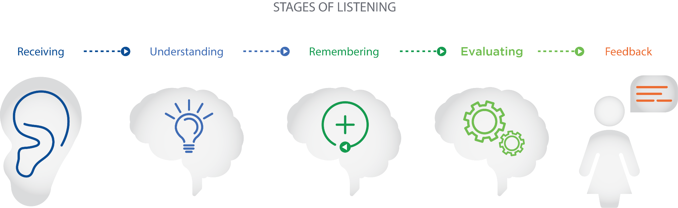

The receiving stage refers to having intentional focus on hearing what the client is sharing. This requires the Nutrition Coach to be able to filter through information and identify what is important. In this stage, the environment, as previously mentioned, can derail the communication if the client cannot be heard or if the Nutrition Coach is distracted. This interruption at the receiving stage will prevent the conversation from moving to a more meaningful level.

In the understanding stage, the Nutrition Coach begins to try and identify the meaning of what is being said. This is the stage at which the Nutrition Coach must be careful not to attach bias or assumptions to the words being used and, if the coach is unsure if they understand the intended message, questions should be asked to clarify so that the communication can advance. The goal of the understanding stage is for the Nutrition Coach to perceive the message in the manner in which it was intended.

If a Nutrition Coach is practicing effective active-listening skills, the remembering stage should be a natural flow as it relates to how much is remembered about what the client has (and is) sharing. However, if the Nutrition Coach is distracted or has not been fully attentive, then details will be forgotten and the message will be missed. In some cases, the message itself may be very complex, making it more difficult to remember. Nutrition Coaches should, again, ask questions and follow up on any parts of the conversation that are unclear.

As the conversation progresses and the information being shared by the client is understood, the Nutrition Coach will start making evaluations about the message. Coaches may start to mentally identify items that will be key to programme development, potential barriers that need to be addressed and individual differences and preferences that should be considered. During this evaluation stage, the Nutrition Coach should work to be free of bias and maintain a positive attitude about the client and the information being shared.

The final stage of listening is how the Nutrition Coach responds to the information shared. In the responding stage, the coach will provide some type of feedback regarding the information shared by the client and the conversation will progress based on the type and direction of the feedback given.

Coach's Corner

Just remember that listening is a process and you should not expect to understand everything and respond quickly. Practising patience and allowing yourself time to think about what the client is saying will lead to better understanding and, ultimately, more programme success.

**Reflection**

One way that active listening is demonstrated is through the type of feedback and input the coach provides during the conversation. The focus should remain on the client and the information, attitudes and emotions the client is sharing. Feedback and input from the coach should be carefully considered and should not change the subject of the conversation or take the focus back to the coach. Using comments to reflect on what the client is sharing is a valuable way to build understanding and demonstrate compassion and interest.

Reflection can be thought of as paraphrasing the words and emotions of the client. It does not involve asking questions but, rather, is focused on briefly restating what the client said to show listening and understanding and to allow the client to provide more clarity or information, if needed. As the conversation continues, it may be valuable for the coach to summarise what they heard to ensure understanding and to demonstrate buy-in to the client’s needs. Reflective listening is about being engaged and attentive to what the client is sharing and letting the client know that they are understood. The purpose is not to interrupt the conversation but to keep the focus on the client (Katz & McNulty, 1994).

Learning and practising reflective listening skills is worthwhile. More practice is associated with more emotion being shared and better retention of information (Rautalinko, [Lisper, &](https://www.ncbi.nlm.nih.gov/pubmed/?term=Lisper%2520HO%255BAuthor%255D&cauthor=true&cauthor_uid=17760322) Ekehammar, 2007). Nutrition Coaches should understand the value of investing time in developing reflective-listening skills and should routinely practice, even in casual conversations. Table: Types of Reflection Statements demonstrates different types of reflective statements to demonstrate reflective listening.

Types of Reflection Statements

| **Type of Reflection** | **Example Statement** |
| --- | --- |
| Acknowledgement Responses | “Go on.”  “Uh-huh.”  “Sure.” |
| Reflecting Content | “So, you are currently on a carbohydrate-restricted plan?” |
| Reflecting Feelings | “You feel disappointed that you haven’t been able to make these changes on your own.” |
| Summarizing | “You feel a little anxious about being able to stick to the plan late in the day as your evenings are really busy with family commitments, but you’re excited and looking forward to making positive changes in your life. And changing your nutrition and activity habits is a priority.” |

Developing the ability to ask quality questions is likely the most important tool to develop in becoming a better listener and overall communicator. The ultimate goal of questioning is to gain information and, depending on the type of information needed, different types of questions should be asked. Because not all questions are created equal, it is imperative to understand the effect of the question being used and the type of information that is likely to come from the question.

**Questioning**

Questioning is a powerful communication tool as it not only shows engagement but also provides an opportunity to gain a deeper understanding. Nutrition Coaches should consider the type of information needed when forming a question. If the desired response is a yes-or-no answer, then a closed-ended question is most appropriate. Closed-ended questions are simple and direct questions that can generally only be answered with a yes-or-no response.

“Do you eat meat?” “Have you tried quinoa?” and “Do you drink coffee?” are examples of closed-ended questions. When needing straightforward information on food preferences or sensitivities, a series of closed-ended questions may be appropriate.

If the goal is to trigger more conversation or a deeper level of sharing from the client, then open-ended questions are a better choice. Open-ended questions typically begin with *how*, *what*, or *why* and they create an opportunity for clients to share experiences and views. One type of open-ended questioning that is helpful for Nutrition Coaches is probing questioning. Probing questions should be used when the coach needs more detail or additional information. They are an important tool to gain needed information and develop a deeper understanding of the client. Additionally, probing questions keep the focus of the conversation on the client and their needs, experiences and preferences.

Follow-up probing questions can seek clarification on a topic: “Can you tell me more about your morning routine and why you usually skip breakfast?” Probing questions can also serve the purpose of refocusing a conversation that has gotten off track: “A few minutes ago, you mentioned how you don’t have time to eat a well-balanced lunch. Can you tell me about the food you typically choose when you are short on time?”

Another use of probing questions is to prompt the client to talk about a certain topic or to dig deeper on something that was mentioned with the goal of having the client share more about their attitudes and experiences on a topic. For example, “What do you think is the biggest barrier we need to address to ensure programme success?”

It is less important for Nutrition Coaches to worry about the specific classification of questioning being used and more important to focus on the type of information needed and how to best encourage the client to share that information. Some questions may be much broader and used to get the client to think about a topic without having to give a specific right or wrong answer.

This type of questioning is called divergent questioning and can be helpful in brainstorming and identifying preferences. This can be a great way to get the client more involved in the programme through open sharing of ideas and information. This may take shape in a conversation with a Nutrition Coach asking a client to describe the perfect meal or even programme outcome. If used appropriately, it may decrease apprehension (because it is fun) and also provide valuable insight for the coach. In other situations, more specific questions may be required to elicit a focused response.

A variety of question types should be used to gather needed information. Keep in mind that some conversations may require more questioning if the client is not very talkative. In contrast, other clients may naturally share so much information that very little questioning is required (Table: Types of Questioning).

Types of Questioning

| **Type of Question** | **Example** |
| --- | --- |
| Closed-ended | “Do you eat breakfast every morning?” |
| Open-ended | “What are your favorite foods to eat for lunches and dinners?” |
| Probing | “Tell me more about how you felt when you previously eliminated sugar from your diet?” |
| Divergent | “Imagine your perfect day. What would your meals be like and how would they make you feel?” |

Coach's Corner

It is important to find a balance of questioning with the non-talkative clients as you do not want to the conversation to turn into an interrogation. After a couple of questions with minimal responses, mix in a reflection statement to acknowledge what you have already learned about the client.

**Building rapport**

The initial goal of all coach–client communication should be to build trust and develop understanding. The knowledge of the coach and the quality of the programme are irrelevant if a stable and trusting relationship is not created. When approaching a new nutritional programme, clients will likely feel nervous, cautious and maybe even insecure. These emotions should be acknowledged and validated by the Nutrition Coach prior to programme discussion or implementation. Taking the time to develop understanding of client needs and emotions will help establish rapport with the client.

The knowledge of the coach and the quality of the programme are irrelevant if a stable and trusting relationship is not created.

Quality communication that builds rapport in the Nutrition Coach–client relationship is a very selfless and client-centred process. While the expertise of the Nutrition Coach may have initially attracted the client, it is the client-centred communication and establishment of rapport that will build adherence and success. It can be difficult for coaches to understand that a good programme alone, even if it generates results, will not keep clients coming back for more.

It takes more than a thorough, scientifically sound and well-planned programme to build adherence. Engagement in the programme needs to be a positive experience in the client’s life and there must be perceived value for starting and sticking with the programme. The commitment required to adopt and adhere to a nutritional programme should always be considered and client–coach interactions should be positive and enjoyable for both the coach and the client.

The process of establishing rapport will not be the same for all individuals. Some people require more attention, explanation and overall care than others. Nutrition Coaches need to be aware of how clients are responding to communication and when it is time to move forward or when more time is needed for rapport building.

Some clients will ask a lot of questions and want to know as many details as possible as they build trust and confidence in the coach and programme. Others will require very little additional information and be ready to get started. Coaches should be perceptive of these cues and meet client needs during rapport building. The same differences exist throughout the programme for feedback, as well. Some clients will require consistent encouragement, reaching out and positive feedback as they develop the self-efficacy that they can succeed. Creating initial success is the most important way to build efficacy so coaches should be aware of the clients who need the extra encouragement to build the belief and experience the success.

**Adherence**

Credibility and trust, which serve as the foundation of rapport, can also lead to increased client adherence. Rapport is an important determinant of adherence (Pizzari et al., 2002) and is something that not only should be addressed in the early stages of the coach–client relationship but should receive continual attention throughout the programme. Coaches should take the time to evaluate how the relationship is progressing and if open communication and trust are strengthening. It should be expected for clients to have highs and lows throughout as they experience the challenges of implementing a new nutritional programme.

Each phase of the programme will influence the coach–client relationship and Nutrition Coaches should make the time to continually evaluate how the client is feeling and what emotions they are experiencing. This evaluation should be taken with the continual evaluation of how the client is proceeding and sticking to the nutritional plan. Conversations about the parts of the plan that are more challenging or easy to implement should be discussed. For example, a client may find weekly menu planning and meal prepping to be a time saver and excellent tool to stay on track. Other clients may find this task to be overwhelming and, as a result, they have not done it since the first week.

Coach's Corner

Pay attention to all cues from your clients. If they are being quiet or short-tempered, complaining (even mildly) about programme components or even just not appearing to be having fun, take a few minutes for small talk to continue to build the relationship and trust. If someone is struggling, only talking about the programme may push them away even more. It takes some people longer than others to be on board so take the time and make the effort to build the relationship first.

How the plan is integrating into the client’s life (or in some cases disrupting) should also be addressed. Maybe having meal prep for dinners has transformed dinner for a client who has busy evenings with her children’s activities and who used to grab fast food due to lack of time to cook, while another client is struggling with the goal of taking lunch to work every day as lunch meetings at restaurants are part of his regular routine.

There is no one-size-fits-all programme and honest conversations that consider the clients experience will provide opportunities for programme modification and a long-term benefit for adherence and maintenance of a quality relationship. Failing to understand challenges and make modifications will ultimately result in clients quitting the programme all together because it does not work in their lives.

**Empathy**

An important component of establishing and maintaining rapport is for Nutrition Coaches to have the ability to express empathy in their client interactions. Empathy is the understanding of what another person is feeling and experiencing. It is a learned skill that demonstrates care, concern and genuine interest. Unlike sympathy or compassion, which refer to feeling sad or concern for someone, empathy is having the ability to take the perspective of the client and feel what they are feeling.

Because of the vulnerability related to being empathetic, it fosters a mindset that allows for better communication. When a coach is able to view the behaviour change and approach the new program from the client’s perspective, they will communicate in a way to benefit the client and all aspects of programme adoption (Watson, Steckly, & McMullen, 2014).

Being empathetic requires the Nutrition Coach to be willing to create modifications or adaptations to meet the specific client’s needs based on the perspective gained. Coaches must understand that one size does not fit all in health behaviour change programming. Trying to force a predesigned programme onto all clients will surely lead to programme failure and dropout. Being empathic allows a coach to take the core components of the programme and put them together in a way that meets the individual client's situations, needs, fears and concerns. Empathy also benefits verbal and nonverbal communication cues as it helps determine appropriate word choice and delivery style. Being empathetic, like other communication skills, requires a client-centred approach and takes practice and intentional effort.

Empathy should also be expressed for the magnitude of the challenge the client is taking on. Changing nutritional habits is not easy and should not be dismissed as so. Through communication, Nutrition Coaches should express the understanding of the commitment required to succeed in the programme. Not only will empathy improve the quality of coach–client communication, but a lack of empathy will likely lead to misunderstanding, frustration and withdrawal from the programme.

Coach's Corner

There are many ways to work on building empathy but a great tool is to get out of your usual routine and try something new and challenging. Taking on a new and difficult task will build humility and understanding and will encourage you to meet new people who are also taking on a challenge. These experiences will create a natural development of empathy, especially for those starting a new programme.

**Professional boundaries**

Nutrition Coaches need to be aware of the potential side effects of having rapport and demonstrating empathy with clients as clients will feel comfortable and open to sharing a variety of personal information. Coaches must be conscious and work at maintaining professional boundaries in their client relationships and identify when advice is being asked for on topics that are out of the Nutrition Coach’s scope of practice.

Coaches should spend time thinking about their own scope of practice (based on their education and professional training) and work to not stretch that scope with advice given or programme components implemented. This may require refocusing a conversation to topics that are related to the programme and not responding with questioning to pull a conversation further outside the professional boundaries. It will be much easier to maintain appropriate scope of practice if boundaries are set and adhered to from the start of the relationship.

Critical!

Due to the personal nature of work as a Nutrition Coach, it is likely clients will become quite comfortable around the coach. This can manifest in clients sharing personal information or wanting to forge a more personal relationship. A client’s vulnerability should be respected while still maintaining professional behaviours and setting responsible boundaries. Professional boundaries are often located within codes of conduct or employee handbooks and usually reflect guidelines for appropriate conversation and physical interaction.

**Discussing sensitive nutrition topics**

In working with clients as a Nutrition Coach, not all conversations will be straightforward and simple. In fact, coaches might often feel that many of the conversations they have are challenging and even sometimes uncomfortable. In developing and implementing nutritional programming, there is no doubt that coaches will have to address sensitive topics with clients, including body weight/composition and food sensitivity issues. In addition, there will always be clients who are only focused on the number on the scale. This is a challenge and coaches need to be prepared to identify other cues for success and be able to communicate them effectively.

Food for Thought

Between information in the media and marketing from food companies, most people have opinions about healthy foods or food to avoid. Clients are inundated with information on what they should (and should not) eat and understanding popular trends will help prepare a coach for programming and communication on these topics.

Nutrition Coaches should be willing to identify the role they play in client/programme success. Taking a piece of the responsibility can relieve stress and help clients refocus on the goals. Nutrition Coaches should emphasise their role in helping through all aspects of programme implementation. Encouraging communication, whether for clarification or just support, can make a big difference in developing the efficacy needed for programme success.

Nutrition Coaches must be willing to invest time in learning and practicing communication techniques. So much work and knowledge go into creating an effective programme that it is critical for coaches to know how to connect with people and implement the programme for optimal success. Nutritional coaching is a people business and the excitement of this field is the potential to change lives, potentially generations of lives, if healthy habits are implemented. Taking the time to self-monitor and learn about habits and tendencies will pay off tenfold in the impact through success programme outcomes.

In this chapter, you learned about:

* Verbal and nonverbal communication.
* Active listening.
* The stages of listening.
* Open-ended, closed-ended and probing questions.
* Strategies for building rapport and trust.
* Effective communication and soft skills to elicit behaviour change.
* Appropriate levels of assistance/coaching required to achieve client goals.

# Motivational interviewing

Changing eating habits is not easy. Even when change does occur, it can become easy to fall back on old habits. Over time, people who lose weight may gain that weight back (Wing & Phelan, 2005). Motivational Interviewing (MI) is a counselling style that aims to help individuals get unstuck from ambivalence and to increase personal motivation for change (Miller & Rollnick, 2004). Ambivalence occurs when clients want to change but at the same time they do not want to change. Motivational interviewing helps clients define their current and ideal selves and form a plan that moves the current self toward an ideal self. When an individual wants to change dietary behaviours to improve body composition, overall health, or athletic performance, motivational interviewing is a coaching approach that can be used to help clients change specific health behaviours.

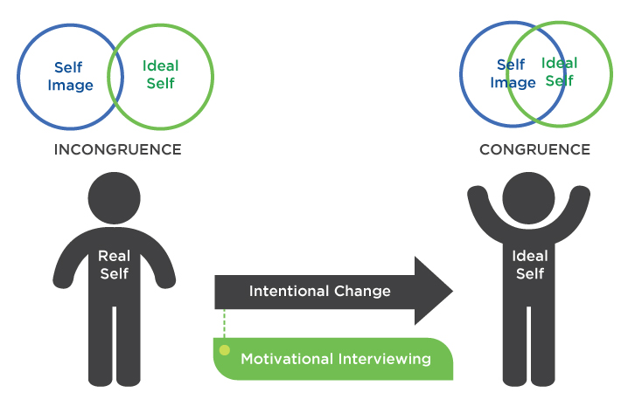

At its core, motivational interviewing is a way of being with clients. This way of being with people is non-confrontational; indeed, it is a collaborative, empathetic and goal-oriented style of communication. Effective motivational interviewing helps clients discover their own reasons for change by providing acceptance, compassion and active listening. It is important to understand why a client would want to change and why a client would feel ambivalence about change.

Helping clients change dietary behaviours, particularly for weight loss, presents a challenge. Nearly 70% of adults in the United States are obese or overweight (Ogden, Carroll, Kit, & Flegal, 2014). In an ideal situation, as soon as a person would gain 5 lbs (2.27 kg) outside of their normal range, they would engage in self-correcting behaviour. However, this often does not happen and clients find themselves off track in their health behaviours. A Nutrition Coach is uniquely poised to help clients improve their health by assisting them in modifying their dietary habits. To help clients, a Nutrition Coach should be versed in client-centred coaching styles such as motivational interviewing.

Most people know the health dangers of being overweight or eating an unhealthy diet. With available knowledge on the part of the individual who holds a weight-loss or health goal, the health-and-fitness professionals are inevitably left with one question: why, once a person knows what they should do, do they fail to enact self-correcting behaviours? The answer is that knowledge does not guarantee action.

For example, it has been stated

"social psychological models of self-regulation tend to assume that people generally have sufficient and appropriate knowledge to execute the task and focus instead on the mechanisms by which that knowledge is transformed into behaviour change, as well as why individuals who know exactly what they must do to achieve optimal health still do not do so." (Mann et al., 2016)

Once knowledge is acquired about the benefits of a certain behaviour, the client needs to contemplate the desirability and feasibility of the action. The rewards of unhealthy eating are very proximal, meaning they are immediate. The rewards of healthy eating are much more distal, meaning they are not realised until later in the future.

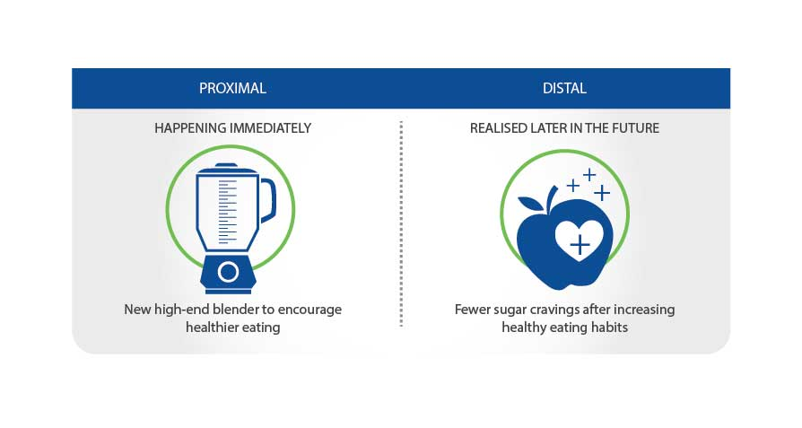

Individuals must move through two general change phases: a motivational phase and a planning phase. In the initial deliberative stages, clients create a motivational foundation for implementing change. In the implemental stage, clients plan when, where and how to act. Plans will fail to drive action if a person questions the desirability or feasibility of the chosen goal.

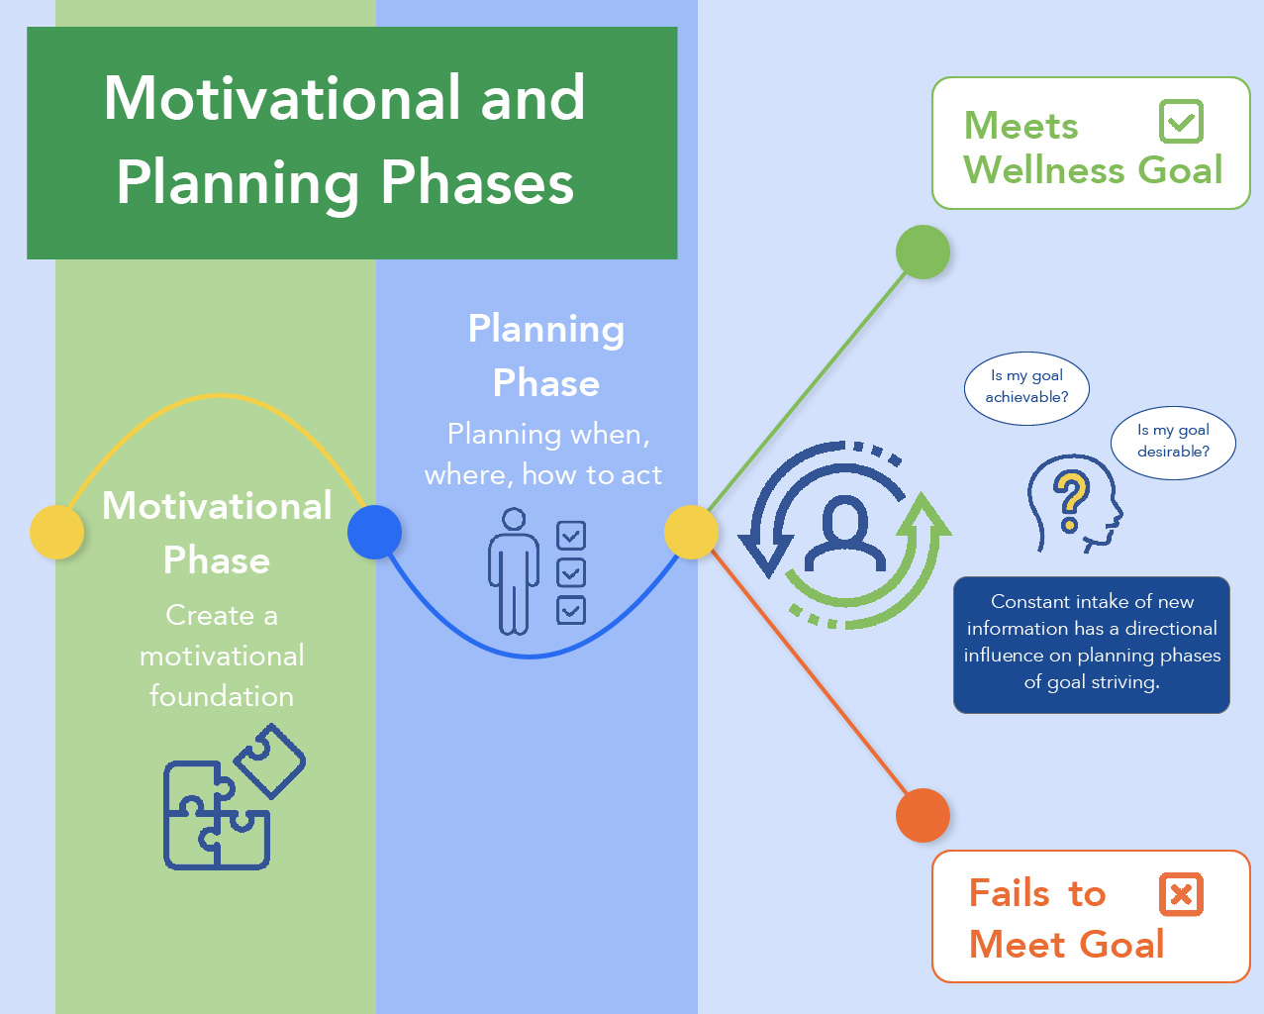

As the client makes changes and continues to strive toward a health-and-wellness goal, they will consistently take in new information about the desirability and likelihood of obtaining their goal. New information has a directional influence on the planning phases of goal striving. If a client does not believe the goal is desirable or if they believe they lack the capabilities to achieve the goal, they will fail to plan or fail to follow through on plans. Thus, it would be beneficial for an individual to base change efforts on a strong motivational foundation.

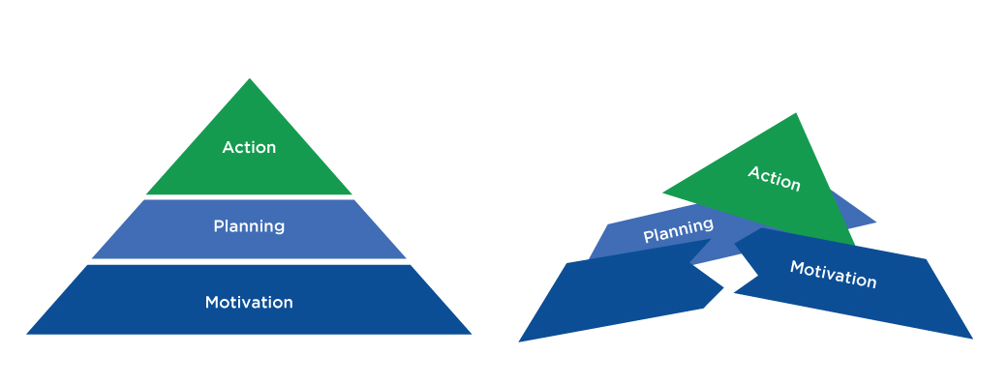

Changing dietary behaviours is a challenging but attainable goal. The client may make some changes but the weight on the scale does not change. The desirability of the goal may start to decrease in the client’s mind. Success is motivational whereas perceived failure reduces motivation. Have clients think about the best version of themselves, the person who makes healthy decisions in almost every scenario. This is the person who snacks on fruit instead of ice cream at night. Encourage them that this version of themselves exists. Hand the decision making for healthy decisions over to this version of themselves. Each time they forgo a proximal temptation, they are doing something that is going to help the future version of themselves.

Motivation has been defined as the brain processes that energise and direct behaviour (Michie, van Stalen, & West, 2011). Motivation, as energy, is subject to change. One day clients may wake up ready to exercise and eat healthy. After a stressful day at work, even the best intentions might go awry. Motivation has a direct relationship with planning as well as the execution of plans (de Vet et al., 2011; Sheeran, Webb, & Gollwitzer 2005). If clients have a strong motivational foundation, they will follow through on their plans (de Vet et al., 2011; Koestner, Otis, Powers, Pelletier, & Gagnon, 2008).



For example, if a client can strongly link their nutrition choices to valuable life outcomes, this motivation should direct planning, prioritisation and action. If a client eats healthy food because they value being in good enough shape to play with their children, they will do so for the most part regardless of barriers. The more successful they are, the more confident they will be. Motivation may become more stable and healthy behaviour will become more habitual. Think of a client’s motivational foundation as the well from where they draw this energy. Some wells may be able to hold more energy than others.

## Motivational foundations

Imagine two different clients with identical weight-loss goals. The first client wants to lose weight so that he can look better. The second client just found out that he was going to have his first child. Since college, he has gained 30 pounds (13.6 kg) and is overweight and sometimes even gets winded climbing up the stairs. The individual wants to be a father that is able to play with his children just like how his father was able to play with him. There is nothing wrong with wanting to look better, but while the goal is the same, the two clients have different motives.

Motivational interviewing is a client-centred method for enhancing intrinsic motivation to change by exploring and resolving ambivalence (Miller & Rollnick, 2004). Self-Determination Theory (SDT) is a motivational theory that is closely aligned with MI (Patrick & Williams, 2012). SDT postulates that motivation can lie anywhere on a continuum from amotivation, to extrinsic motivation, to intrinsic motivation.

Amotivation refers to lacking motivation to engage in a behaviour. Intrinsic motivation refers to participation in an activity for no external reward. It is done for the inherent pleasure and satisfaction and is considered fun and enjoyable. Extrinsic motivation occurs when the behaviour is performed for any reason external to pleasure and satisfaction. Desired extrinsic outcomes may be tangible (i.e., a reward) or intangible (i.e., to avoid feelings of guilt) (Ryan, Williams, Patrick, & Deci, 2009).

| **Motivation** | **Example** |
| --- | --- |
| Amotivation | I will not eat healthy because I do not want to eat healthy. |
| Extrinsic | I will eat healthy because, if I do not, I could face health problems. |
| Intrinsic | I will eat healthy because I really enjoy knowing that I am fueling my body with the best nutrients possible. |

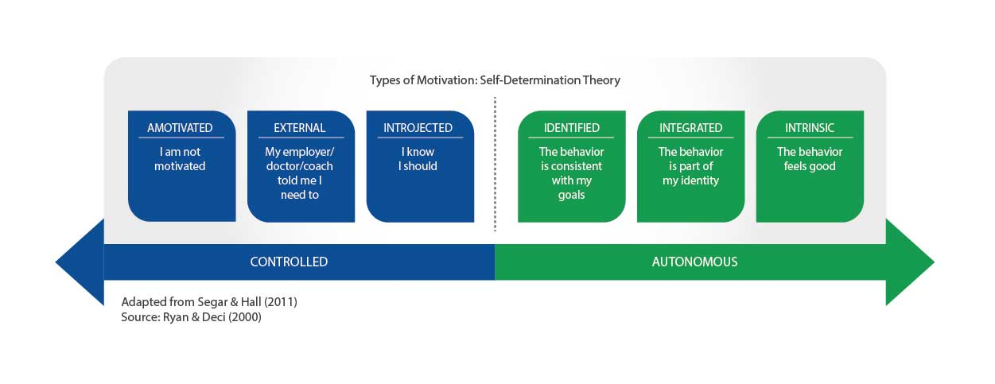

Motivational regulation varies along a continuum and is reflective of the level to which a behaviour is integrated into an individual’s values or identity (Ryan & Deci, 2017). On one end of the spectrum are non-self-determined or controlled motives and on the other end are self-determined or autonomous motives. When behaviours have been internalised and are reflective of the self, yet are still extrinsic, they are considered autonomous and extrinsically motivated. For example, when a client wants to lose weight to compete in a triathlon (a separate outcome), they are extrinsically and autonomously motivated. When regulations have not been internalised, the behaviour is considered controlled, such as when a client starts eating more fruits and vegetables to win a monetary weight-loss prize (the separate outcome) at work. If coaches can help clients connect their change efforts to valuable outcomes, the client will be more likely to adhere to the program and prioritize behavior appropriately.

| **Motives** | **Motivational Regulation** | **Example** |
| --- | --- | --- |
| Controlled Motives | External | Losing weight because there is a weight-loss challenge at work and the winning team gets a prize |
| Introjected | Losing weight because of the guilt of being overweight |
| Autonomous Motives | Identified | The client believes that achieving and maintaining a healthy weight is personally important. |
| Integrated | Losing weight because being healthy and fit is consistent with the client's other health goals (e.g., running a half marathon) |

Compared to autonomously motivated individuals, externally motivated people may deplete more willpower when they resist food temptations (Muraven, 2008). This may be because the act of eating healthy is not inherently enjoyable to them or they may not understand the link between their goals and their behaviour. If an activity is enjoyable or helps the client reach their goals, it may not drain them of any energy.

**Autonomous self-control is less-depleting**

When a person resists a temptation to be unhealthy because being healthy is valuable to the person, they may not need as much self-control compared to a person who is resisting temptation for extrinsic reasons. For example, after resisting eating cookies, participants with strong extrinsic reasons for resisting gave up on a handgrip task sooner than those with more autonomous motives for not eating the cookie. It may be the case that when forced to exert self-control individuals deplete more energy than when they have the freedom to exert self-control (Muraven, 2008).

**Why are you healthy?**

Think about the health decisions you make on a regular basis. When you did food prep on Sunday, did you do it because it was inherently enjoyable or because the outcome was valuable to you? When faced with the decision to eat broccoli or macaroni and cheese at a restaurant, why did you choose the broccoli? Did you enjoy the taste more or is it because healthy eating is part of your identity? Think about where your behaviours fit in the motivational regulation continuum.

**Different types of behaviour regulations**

There are different types of extrinsic behavioural regulations. These regulations differ in the extent to which they are autonomous. The behavioural regulations are external, introjected, identified or integrated (Ryan & Deci, 2002). External regulation occurs when a client is engaging in a behaviour to satisfy external demands such as reward attainment or punishment avoidance. Introjected regulation involves behaviours that have been partially internalised. These behaviours are performed to avoid guilt, attain ego enhancements or to enhance self-esteem. Identified regulation occurs when the behaviour is valued and is personally important but not entirely congruent with the client’s sense of self. Lastly, integrated regulation occurs when behaviours are congruent with values, goals and needs. This type of regulation is comparable to intrinsic motivation; however, it is still considered extrinsic because the behaviour is done to achieve an outcome other than interest and enjoyment. For example, a client may value being healthy and understand that eating vegetables helps with this but may still not find the act of eating vegetables intrinsically pleasing. Ryan and Deci (2002) state that "to integrate the regulation of a behaviour, people must grasp its meaning for themselves personally, and they must synthesise that meaning with other aspects of their psychic makeup." If a health coach can help a client do this, they may help them grasp the personal relevance of change and anchor their behaviour change efforts to a stronger motivational regulation.

If a client can discover autonomous motives to drive behaviour, they may be more likely to change (Ryan & Deci, 2017). Once a client’s values are discovered, they can address whether their current behaviours are in congruence with their value structure. If a client can recognise discrepancies between their current choices and their goals or values, motivation for change will increase (Miller & Rollnick, 2004). This problem of ambivalence can then be resolved by helping clients with value exploration.

**Motivational interviewing**

Motivational interviewing is a client-centred empathetic coaching process developed by psychologists Steven Miller and William Rollnick (2002). MI is less about specific techniques and more about the fundamental mindset that underlies it. MI starts with collaboration and the relationship between the coach and the client needs to be a partnership. In this client-centered approach, coaches must provide unconditional positive regard (UPR).

Unconditional positive regard is the support of a person regardless of what they say or do. It is necessary, then, to make the support of a client's behaviour unconditional.

Individuals that are met with negative regard are less likely to communicate true feelings, have the desire to change and lack awareness of true internal feelings. As a partner in the change process, do not create motivation; instead, draw this motivation out. If the client’s motivational foundation is not strong, they may question the desirability of their goal once they encounter challenges and barriers. Therefore, it is important to help a client discover their strongest form of intrinsic motivation. Lastly, when a coach uses MI they provide the client with autonomy by allowing the client to make their own informed choice.

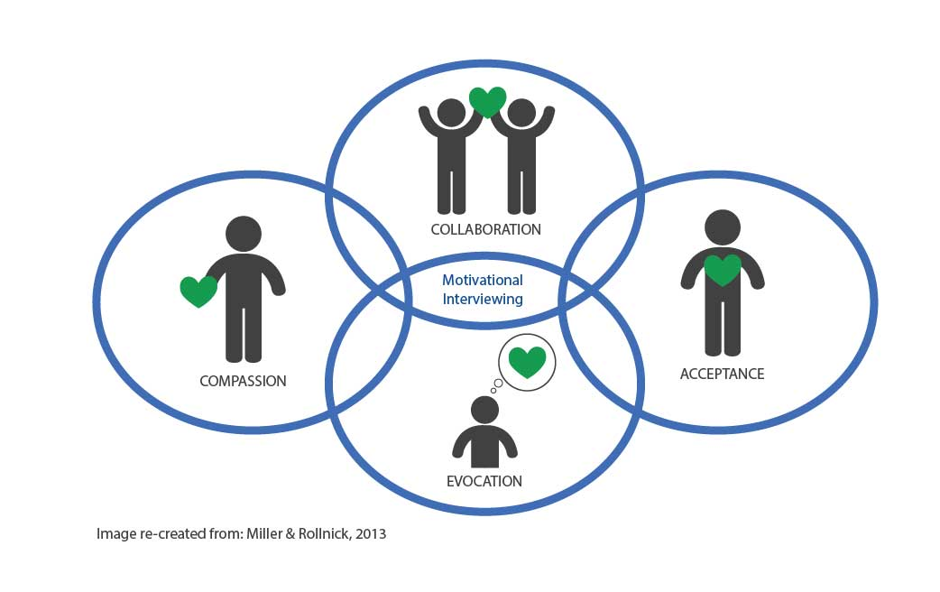

Imagine that you were trying to make a personally relevant change. You have tried a few times, made some progress, but failed to maintain consistency. How would you like to be treated by a coach? Would you prefer the coach to tell you exactly what to do or would you like to have a coach help you resolve your own personal barriers through empathetic listening? If you came up short, how would you like to be perceived: as lazy and less than competent or as a person who is trying their best? When engaging in client-centred coaching, always provide empathetic listening and never presume that the client is doing anything other than trying their best.

**Ambivalence**

A person experiences ambivalence when there are competing demands between desirable behaviours. For example, a client’s desire to improve their body composition by making home-cooked meals may compete with their desire to relax after a long day of work. A client may express ambivalence by saying:

“I want to start making healthy meals, but I don’t think I have the time.”

Ambivalence is a normal feature of the change process. In fact, if a client is voicing desires to change, this is a good thing. As a Nutrition Coach, it is your job to help the client move through this ambivalence. When a client is working through ambivalence, listen for change talk. Change talk may sound like this:

“I don’t want to have a heart attack like my father.”

“I’m sick of feeling low-energy all the time.”

Change talk expresses *what* the client wants or does not want. There is also a reason *why* the client wants this. The client’s *why* is rooted in their values and their goals. Change talk occurs when there is a discrepancy between the client’s values or goals and their actual behaviour.

Miller and Rollnick (2002) state: "Motivational interviewing involves assisting individuals to define their current and ideal selves, then pursue movement from the current self toward the ideal. Thus, a focus on values may help increase an individual’s sense of importance of change, as well as the direction of change."

When a client has identified a personal reason for change, the coach can help them understand the link between their behaviours and their values. It is important to always preserve a client's autonomy when doing this. For example, a client may say they want to lose weight because they want to successfully run a 5K.

Another example might be a client who wants to lose 40 pounds (18 kg) but they have remained stagnant. Behaviours can be categorised into those that help and those that hurt goal progress. Help the client understand that while their behaviour is entirely their choice, it is challenging to engage in harmful behaviours and still meet the goal. Is eating one piece of pizza instead of three worth it if it helps the client reach their goal? Is saying no to going out for drinks worth it if it helps the client reach their goal? Strengthen the link between behaviors and goals so that clients clearly understand prioritization

**Value and goal exploration**

Many chronic health problems, as well as mortality rates, are due to individual behaviours such as physical inactivity and poor diet (Ford, Zhao, Tsai, & Li, 2011). Human behaviour is regulated by the interaction of self-generated motivation and external influences. Think about when a client wants to cut down on snacking or eating unhealthy food (self-generated motivation), but their friends invite them out for pizza or their spouse always brings home ice cream (external influences). Urges and impulses are the tendency to act in a certain way in certain situations on specific occasions (Baumeister & Vohs, 2007) (Figure: Value and Goal Exploration).

When one internal process, often a counter-productive impulse, overrides another, this is self-regulation (Baumeister & Heatherton, 1996). Self-regulation is an individual’s ability to modify their behaviour (Baumeister & Vohs, 2007). Self-regulation skills help clients resist negative external influences and are necessary for goal-directed behaviour (Bandura, 1991). Focusing on and clarifying client values can help the client appreciate and prioritise behaviours that lead to outcomes that are more important than any goal incongruent behaviours.

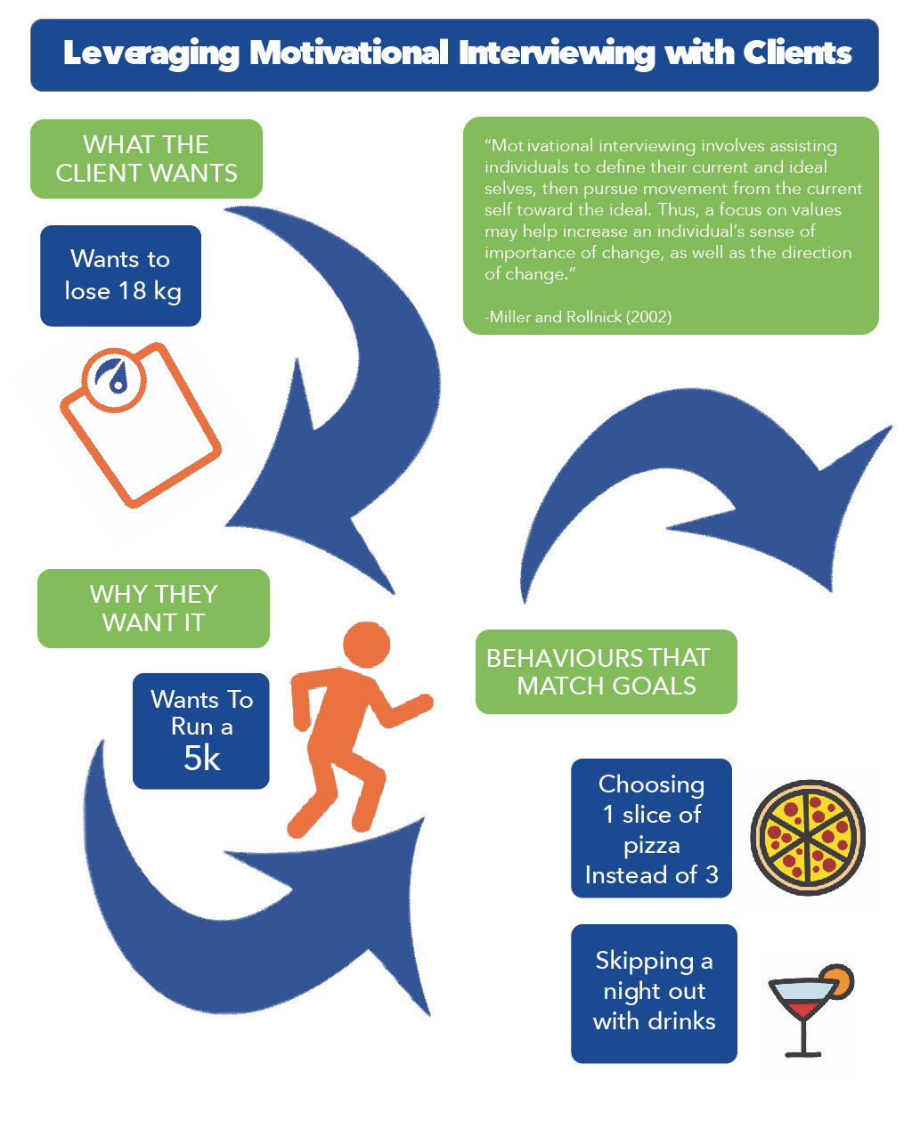

One technique used in MI is value exploration. Value exploration is a systematic examination of the relationship between life values and behaviour change or maintenance (Miller & Rollnick, 2002). Motivational interviewing uses client’s values to move toward a more satisfying lifestyle. Value prioritisation is linked to a person’s sense of identity (Hitlin & Piliavin, 2004). Personal goals that come from a value system enhance motivation by providing self-incentive and guidance for health habits (Bandura, 2004). It stands to reason that values are the root of the behavioural decision-making process (Rohan, 2000). Therefore, a focus on a client’s values can increase the importance of change and provide the direction for behavioral priorities.

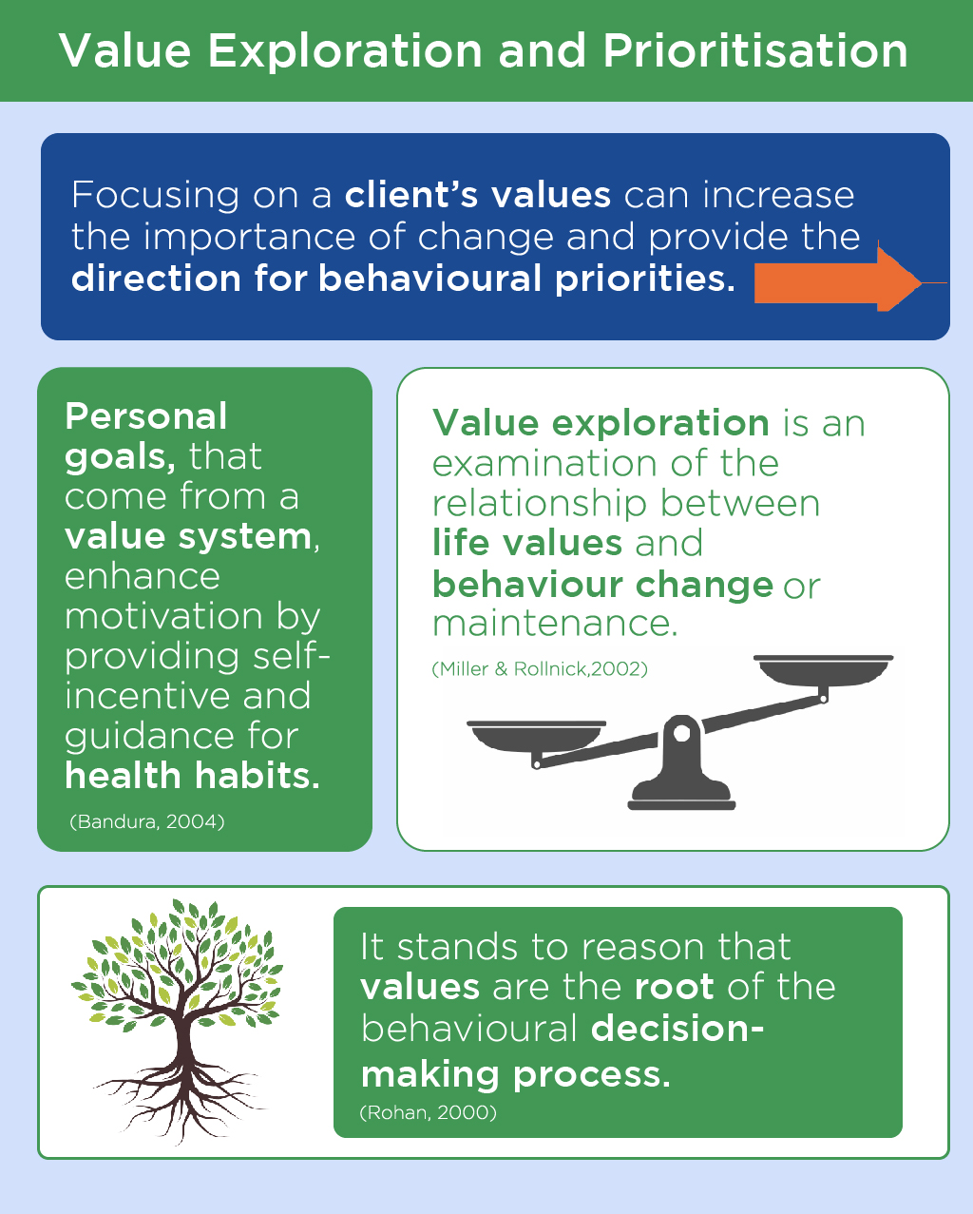

While attitudes and goals are subject to change, values are durable in serving as an ideal foundation for change efforts. Values inform goals, serve as motivation for behaviour and are the basis for an individual’s evaluation of their behaviour (Hitlin & Piliavin, 2004). Goals are end states that express values. For example, the client we mentioned earlier has a goal: to lose 20 pounds (9 kg). This goal expresses the values of health and family. Goals generated from values and goals necessitate specific behavioural changes. Value priorities then may be thought of as a guide to best possible living.

Value beliefs guide the judgment of behaviour as either good or not good. Clients are better equipped to achieve health-related goals when the behaviours necessary for success are congruent with their deeply held values or are intrinsically and or autonomously motivated compared to extrinsic and controlled. A person that values healthy living will identify a situation where this value is relevant (i.e. food temptation and the value of being healthy), create goals that are congruent with that value (i.e. lose or maintain weight) and perform behaviours that aid in living a value-based life (i.e. make home-cooked, healthy meals).

A value exploration gives meaning to behaviour. When a client eats spinach to lose weight, this may be perceived as a negative experience if it does not have meaning. But, ask the client why they want to lose weight. Maybe in college they were very fit and always saw that as a part of their identity. After they got a job, they gained 30 pounds (13.6 kg) in a year. Losing weight will help the client be the person that they truly see themselves as. When they make healthy decisions to replace unhealthy ones, they are living up to their values and the struggle of behaviour change now has meaning.

Consider this example: a client who values outdoor activity. Hiking, camping and kayaking are a part of their identity. But, in the last 3 years, this client has gained 30 pounds (13.6 kg), which interferes with the client’s identity and values. The client has the goal of losing 30 pounds (13.6 kg) so they can live up to their values. The goal of losing 30 pounds (13.6 kg) necessitates specific behaviours. If a goal is rooted only in some external outcome (i.e. weight loss only) and not based on autonomous motivation, then, once the goal is hit, the client may not continue with long-term maintenance (Teixeira, Patrick, & Mata, 2011). Values are important because they have a longer life span, meaning they can guide behaviour even after goals are met (Lillis, 2014).

If values can be made crystal-clear, even low-order behaviours, such as eating vegetables with dinner, can have meaning. While not diet-related, hall-of-fame pitcher Tom Seaver describes this perfectly as it related to his value of being the best pitcher: Pitching… determines what I eat, when I go to bed; what I do when I’m awake. It determines how I spend my life when I’m not pitching. If it means I have to come to Florida and can’t get tanned because I might get a burn that would keep me from throwing for a few days, then I never go shirtless in the sun… If it means I have to remind myself to pet dogs with my left hand or throw logs on the fire with my left hand, then I do that too. If it means in the winter I eat cottage cheese instead of chocolate chip cookies in order to keep my weight down, then I eat cottage cheese (Extracted from Grit by Angela Duckworth).

Values help a client define the best version of themselves. However, values are abstract and, therefore, not always at the forefront of an individual’s mind. They might also fail to see how their behaviours are connected to values. While every person has a value structure, they may not see how it relates to their health. Because values–behaviour relationships may not always be salient, it is important that the coach provides empathetic and reflective listening.

This client was able to open up and express their goal of losing 15 pounds (6.8 kg), which would help them feel more confident and healthier. Notice that the coach helped the client express their *why* through reflective listening. Achieving this goal would help them to become the ideal version of themselves. If it is possible to achieve and improve empathetic listening skills, it is possible to find out what a client’s unspoken values are.

Values represent the clients' *why*. The client who wants to lose 15 pounds (6.8 kg) wants to feel confident, safe and healthy. When making health changes, there are any number of ways to achieve the *why*. For example, to lose weight, a client may increase their exercise, decrease soda consumption or cut out late-night snacking. It is important to emphasise that they have autonomy (their own personal choice of what to do).

Reflective listening involves careful attention to what the client is saying and paraphrasing it back so that the client understands that the coach understands. Successful reflective listening occurs when a Nutrition Coach can find the true meaning behind what a client is saying. This can help encourage change talk and also confirms to the client that the coach understands them.

It is important to understand three different relationships between problematic behaviours and values (Miller & Rollnick, 2002):

* Self-oriented: The behaviour is good for the individual but bad for others.
* Short-sighted: The behaviour is good for the individual now but bad for the individual later.
* Inefficient: The behaviour satisfies some needs or values but prevents others.

For the most part, short-sighted and inefficient relationships with values and behaviours will be the ones that health-and-fitness professionals must help clients address. These two often go hand in hand. Take, for example, the client who wants to lose weight but fulfils the need to socialise and the value of friendship by drinking and going out for pizza every weekend with friends. These social bonds are built around behaviours that are incongruent with the client’s goals. The client's behaviour is fulfilling one need at the expense of the goal. The client’s value to be social is not negative but how the client is achieving the value is inefficient if they wish to be healthy. A good coach can help the client find ways to still fulfil a need without preventing the fulfilment of another. Find the client's values that are related to their goal. Find out what values negative behaviours fulfil and help the client find alternative ways to achieve their needs in goal-congruent ways.

**Autonomy support**

Imagine two coaches. A client has the goal of losing 20 pounds (9 kg). To do this, the client has intended to change their dietary behaviours. The first coach warns the client of the dangers of obesity, sedentary behaviour and a high-sugar, high-fat diet. The coach tells the client they *need* to follow their plan. On the other hand, the second coach is non-judgmental, listens to the client’s barriers, answers their concerns and helps them to become the architect of their own change plan. Social environments can facilitate the growth of a self-determined and autonomously motivated individual or they can reduce self-determined motivation.

In the self-determination theory, there are three basic psychological needs: competence, relatedness and autonomy. Whether or not they are met, these psychological needs are used to categorise environments as opposing or supporting of positive human functioning. For example, one coach in the example above went immediately to making recommendations for change and warned about the dangers of obesity; they removed the client’s autonomy. The other coach provided empathetic listening (relatedness) and asked the client what they wanted to do, thus, preserving autonomy. Individuals are attracted to situations where these needs are provided. One of these needs,autonomy, refers to being the perceived source of one's own behaviour, meaning the behaviour represents the individuals core self, values and interest (Ryan & Deci 2002).

How does autonomy fit into MI? Behaviours that are autonomous occur when the behaviour is valued and is personally important, congruent with a client’s identity or when it is in line with values, goals and needs. MI is client-centred coaching; this means acceptance of the client’s freedom to change or not to change. MI is also a collaboration with the client: by telling the client what to do without them specifically asking, the Nutrition Coach is robbing them of their autonomy. Still, there may be some instances where a client comes to their coach because someone else told them to. For example, imagine a client who meets with their Nutrition Coach because their doctor said that they needed to. You can still restore their autonomy with statements such as

“I know that the doctor sent you to me, but in the end, it’s up to you how you would like to respond to your doctor’s concern. What, if any, are some things you want to try?”

Typically, when people operate autonomously toward their goals, they tend to follow their plan longer and relapse less often than when they operate without autonomy.

## Motivational interviewing strategies

MI is a way of being with clients in addition to recognising that there are different motivational foundations for why people engage in behaviour. If healthy behaviours can be linked with values, the client may be more motivated to make changes. Coaching with MI also means respecting the client's autonomy. With this in mind, the health-and-fitness coach can use five general principles to practice MI (Figure: Five Strategies of Motivational Interviewing):

1. Express empathy through reflective listening.
2. Help clients identify discrepancies between their values or goals and their behaviour.
3. Support self-efficacy.
4. Avoid arguments.
5. Adjust to client resistance.

**Express empathy**

Accurate empathy occurs when the coach uses reflective listening that clarifies and expresses an understanding of a person's own experiences and goals and personal meaning for those goals. Reflective listening is the coach’s ability to accurately interpret the content of a client’s thoughts and feelings. This builds trust, which creates a foundation for honesty and acceptance. Clients should feel as if their own unique change experience is truly understood by the coach.

Nutrition Coaches will benefit from two concepts that relate to coaching with accurate empathy. The first concept is called the fundamental attribution error. This error occurs when a person's behaviour is attributed to 'the way they are' rather than to external factors. A coach who commits fundamental attribution error may believe that what people do reflects who they are. If they begin thinking the client is making poor health choices because they are 'lazy' or 'lack motivation', the spirit of collaboration between the coach and the client will be lost.



Reflective listening involves suspending the self and self-interest and being thoroughly immersed in what the client is saying. Coaches should think about their body language, too. Coaches are giving their client complete and undivided attention. After the client has expressed themselves, the coach may respond. A well-placed reflective statement can encourage a client to divulge more information that may be helpful in the change process. Reflective listening may have a certain format that includes (but is not limited to) starting with the following phrases:

* “It sounds like...”
* “You feel like...”
* “You want to do this but at the same time…”
* “Tell me more...”

Unconditional positive regard is the opposite of the fundamental attribution error. The coach needs to understand the client's feelings, as well as the meaning of their unhealthy behaviour, without blaming, judging or criticising them. When coaching with unconditional positive regard, Nutrition Coaches should believe that a client is trying their best in their situation. Accurate empathy is accomplished without imposing a view or agenda. With each client statement, the coach should be working to try to understand the underlying meaning (Center for Substance Abuse Treatment, 1999). Empathetic listening can be accomplished when the coach does the following:

* Respects and accepts the client
* Is non-judgmental
* Provides sincere compliments
* Provides unconditional support (Center for Substance Abuse Treatment, 1999).

**Identify discrepancies**

Think of the way discrepancies drive behaviour as part of a feedback loop. People have an ideal version of themselves, often called the *ideal comparator*. People take in information about their current self and, if a discrepancy is perceived between where they currently are and their ideal comparator, they perform behaviours to reduce this discrepancy. For example, if a person has an ideal weight of 180 pounds (81.7 kg) and they currently weigh 200 (90.7 kg) pounds, a discrepancy exists. Often a client will come to a health-and-fitness coach because they want to make a change. Because of this, many clients may already perceive a discrepancy between where they currently are and where they want to be.

Once the client’s situation is understood through accurate empathetic listening, they are freer to change. However, simply understanding a client’s situation by itself does not drive action. A goal of MI is to have clients voice their reasons for changing by helping them identify a discrepancy between their ideal comparator and their current status quo. To increase and make use of discrepancies, coaches can use several strategies. One of these strategies, a values exploration, may help a client see the differences in how they are behaving now with how they would like to perceive themselves. Discrepancies can also be created by having clients imagine possible futures that weigh the cost and benefits of changing.

Consider the following example conversation between a coach and a client. When a client looks forward they can examine possible futures. The results of this exercise exhibited in this video may help a client clarify their values.

Large discrepancies between current and ideal states may be demotivating to the client. If a client has an ideal body weight of 180 pounds (81.6 kg) but weighs 280 (90.7 kg) pounds, the gap between where they are and where they want to be may seem intimidating. The goal is important, but the client does not have the confidence that they can make it. The client may start with losing 20 pounds (9 kg). It is also vitally important to help improve a client’s sense of confidence and self-efficacy for challenging goals. Clients with strong self-efficacy can strive toward bigger goals with stronger commitment (Bandura, 2004).

**Supporting self-efficacy**

Self-efficacy is a person’s confidence that they can successfully execute behaviours required to produce outcomes. An individual's perception of their self-efficacy, in relation to the challenge of the behaviour, tells the client whether the pursuit of a goal is attainable or out of reach (Bandura, 1991). For example, a client might have confidence that they can eat vegetables one time per week (low-perceived challenge) but low confidence that they can eat two servings of vegetables every day (high-perceived challenge). A goal of motivational interviewing (MI) is to enhance the client's self-efficacy in their ability to overcome challenges and succeed.

Enhancing self-efficacy can be done using four methods: performance accomplishments, hearing of other's success in similar situations (vicarious experience), a coach’s encouragement (verbal persuasion), and even emotions such as stress (physiological states) (Bandura, 1977).

| **Source** | **Example** |
| --- | --- |
| Performance accomplishments | Provide a client with a chance to make an attainable change. For example, if the client typically eats out 4 nights per week, celebrate their success when they drop down to 1 night per week. |
| Vicarious experience | Provide examples of other clients who have been in the current client’s shoes. Give examples of what they did to achieve their goals. |
| Verbal persuasion | If a client is not sure that they have the ability to do a certain task, remind them of times in the past where they have successfully made changes. Maybe the client is not sure that they have time to do food preparation but they also said the same thing about fitting in exercise. Remind them that when they scheduled effectively they were able to exercise more. |
| Physiological states | Create a positive coaching relationship that mitigates nervousness and anxiety. If a client feels unsure about a certain behavior, either provide empathetic listening to help the client see a solution or suggest a different behavior that does not elicit negative emotions. |

Coach's Corner

Coaches can enhance self-efficacy for goal achievement and for specific behaviours that will lead to goal achievement by decreasing the difficulty of the task. For example, a client may have low self-efficacy for eating vegetables with every meal, but they believe they can start with having one meal per day with vegetables. In this instance, the coach offers a less-challenging option that the client can succeed at and, thus, provide a mastery experience.

One technique used in MI to support self-efficacy is affirmation. An affirmation is a positive statement about the client’s character that acknowledges their efforts. An affirmation might sound like this:

You did a great job making time to do food preparation this week. It looks like you really prioritised it!

Affirmations are not just about giving praise for a job done well; the articulation of why the coach believes the client is successful (prioritised) is impactful. They are not statements that insinuate that the coach’s approval is based on any specific behaviour (remember unconditional positive regard). Clifford & Curtis (2016) recommend that the coach avoid starting affirmations with 'I' because this draws focus toward the coach and away from the client. Affirmations can empower clients to believe in their abilities, improve self-confidence, support change, and decrease defensiveness while encouraging persistence (Clifford & Curtis, 2016). The coach can use open-ended questions to encourage the client to talk about behaviours they are confident they can do. Some of these questions might be the following:

"How might you cut down on soda?"

"You said you wanted to start eating more vegetables. What would be a good first step?"

Clients who have failed at their goals before may experience low self-efficacy. With continued failures, the expectation of future failures becomes more salient to the client. The goal becomes less desirable or feasible and effort is reduced. If a client is experiencing low confidence because of past failures, the term *failure* may need to be reframed.

If a client has decided that a new behaviour sounds like something they want to try, ask them how confident they are on a scale of 0 to 10, with 0 representing not-at-all confident and 10 representing extreme confidence. If the client picks a low number such as 3, ask them why they are at a 3 and not a 1 or 2. The coach may also ask a client what it would take to get them to attain a 4 or a 5. This will encourage the client to talk about why they do have confidence.

**Avoid arguments and adjust to client resistance**

A Nutrition Coach cannot succeed when arguing with a client. Arguments can make coaches defensive and defend the status quo.

The opposite of resistance is change talk. Change talk describes movement toward change, whereas resistance describes movement away. Resistance in the form of sustain talk presents an opportunity to hear the client’s perspective and potentially even elicit change talk. Reflections and/or open-ended questions can also diffuse resistance talk. One strategy with reflective listening is to sparingly amplify a client’s sustain talk (Clifford & Curtis, 2016). This may help them begin to state that certain behaviours might be problematic.

## Stages of change and motivational interviewing

If the client is ambivalent about change but the coach moves forward with action steps, there will be a disconnection in the coach–client relationship. Previously, motivational and planning phases of behaviour change were discussed. Plans will fail to benefit action if the client’s motivational foundation is not established. Everything up until the planning phase has been about exploring the client’s ambivalence, establishing value–behaviour relationships, building rapport and building motivation.

The Transtheoretical Model (TTM) of change, also known as the Stages of Change Model, describes a series of stages individuals go through as they change behaviour. In this model, change is a process rather than an event. The six stages of change in the TTM are precontemplation, contemplation, preparation, action, maintenance, and termination.



**Tailoring interventions to a client’s readiness**

Motivational interviewing can be used within other psychological frameworks. MI and TTM were developed separately. However, the stages of change in the TTM have provided a logical framework for the role of MI, while MI provides directions for how to move people along the stages of the change continuum. In essence, the TTM explains how and why people change and MI is a coaching style that helps people improve their motivation for change.

It is not necessary to assign people to specific stages of change as a part of motivational interviewing (Miller & Rollnick, 2009).

Critical!

Coaches should match the stage of readiness to change with the one the client is in. Making plans too quickly may only be met with resistance if the client is not ready. If a client has a weight-loss goal, take some time to determine why this goal is relevant to the client. Before moving into any planning phase, the coach must ensure that they and the client understand the personal importance of the change effort.

Try This

A client asks their coach for advice. In those instances, a coach can draw from the successes of other clients. For example, a coach might say the following:

1. “Well, another one of my clients who has a very busy schedule like you, started doing intermittent fasting and he has found that it works very well for him.”
2. “One of my clients made a drink rule for herself when she goes out. "For every drink she has, she also has a glass of water."

After you have presented a menu, it is important to ask if any of the options sound feasible to the client.

Consider the following example of a client who is in the precontemplation stage of change. The client is 50 pounds (22.6 kg) overweight and comes to their personal trainer for an exercise programme but is not interested in discussing their diet. However, they consume 8 to 10 drinks (14-18 UK units) every weekend with no intention of changing this habit. People in this stage are either unaware of their problem or are unwilling or discouraged to change. All problematic behaviours have a meaning and the Nutrition Coach can learn more about the client’s reason for being in the state they are in.

The Nutrition Coach can work to understand why the client likes doing this, avoid confrontation regarding the behaviour, provide some options that the client can choose from if interested (preserving autonomy) and encourage small changes. The coach may find out that this client drinks because they like to unwind and they like the social atmosphere of going out with friends. The appeal of drinking is not necessarily linked with the number of drinks or the type of drink the client has.

Rather than link the behaviour to weight, the coach may talk about drinking and exercise (the reason why the client came to the coach) and explain how it may impact the exercise results. Next, the coach can offer up a menu of options that other clients have tried and successfully completed and ask if any of these options sounds like something the client may want to try.

Getting Technical

Precontemplators and Resistance to Change

Precontemplator 1

* Reluctant precontemplators: These clients lack proper knowledge or think the goal is too far away. They may not recognise the consequences of their current behaviours. They may not want to risk the discomfort or challenge of changing.
* Action: Empathetic listening and providing sensitive feedback

Precontemplator 2

* Rebellious precontemplators: These clients have the information to know that their behaviours are problematic. They are, in fact, adamant about not changing.
* Action: Ensure the client that no one can force them to make any changes and that you have no intention of making them do anything they do not want to do. Provide them with a variety of options to see if one is appealing.

Precontemplator 3

* Resigned precontemplator: These clients may feel overwhelmed by the change process. Changing seems hopeless to them.
* Action: Instill hope and explore barriers to changing.

Precontemplator 4

* Rationalising precontemplator: These clients do not feel as if they are in personal risk from their behaviour.
* Action: Empathy and reflective listening – Let the client talk about the pros of their behaviour.

During the contemplation stage, the coach’s goal is to help the client get out of ambivalence by helping them see more pros of changing. They may provide personally relevant health information to the client. For example, they may ask the client to get blood work done or take their blood pressure. If personally relevant biomarkers show that the client is at risk that may help the client add another pro to the change process. The value exploration mentioned earlier may help the client move to the preparation stage.

If a client can see how changing will help them live up to their values, they may move from contemplation to preparation. The coach should also engage in careful listening, provide accurate feedback, affirm positive reasons for change and enhance the client’s self-efficacy for change.

Clients in the preparation phase need to create a plan that they feel will work for them. Once they make a plan, commitment toward following the plan needs to be enhanced. During this stage, the coach may present a menu of common barriers that clients may encounter. The client can pick the barriers that are personally relevant to them. The coach may then ask the client what they think they might do to overcome these barriers. The coach can provide options for what has worked with other clients and also help the current client fine-tune their plan.

During the action stage, coaches can help clients by teaching them how to make effective plans. For example, implementation intentions are specific plans that can enhance a client’s intentions to act. Implementation intentions are if–then plans that link situations with desired behaviours. This works by assigning control of a behaviour onto the environment (Gollwitzer, 1999). For example, if a client is trying to eat more fruit, they might create an implementation intention to do so. This might read as follows: “If my coffee is brewing in the morning, I will have an apple.” For a client to act, the coach should continue to promote self-efficacy, as well.

During the maintenance phase, it is imperative to identify relapses early. Encourage the client to accept a slip-up as just a slip-up. Accept that it happened and get back on track. Remind them that one bad meal or even one bad day does not undo everything they have worked toward. To minimise slip-ups, the client can also restructure their environment. For example, if they know that certain foods trigger them to overeat, they should avoid having them in the house. Alternatively, they can create planned cheat meals with a predetermined quantity of food.

| **Stage** | **Action** |
| --- | --- |
| Precontemplation | * Provide empathetic and reflective listening. * Do a value exploration to see how the client’s behaviors fit in with their values. * Build rapport. * Avoid arguments. * Begin with a small change and provide affirmation for each success. * Enhance self-efficacy. |
| Contemplation | * Help clients resolve ambivalence and encourage change. * Have clients get bloodwork done to examine biomarkers of health. Relevant health information may encourage change. * Use decisional balance sheets. * Provide affirmations. * Continue to enhance self-efficacy. |
| Preparation | * Assess strength of commitment to change. * Help clients develop feasible plans. * Help clients make specific action plans that dictate when, where, how, and with whom a behavior will occur. |
| Action | * Revise plans as needed. * Foster strong self-efficacy. * Harness social support. * Create and follow through on plans. |
| Maintenance | * Encourage clients to organize their environment so that temptations to relapse are minimal. * Strengthen commitment to the goal. * Identify relapses early. * Encourage clients to forgive relapses and return to their routine. * Harness social support. |

# Goal setting

At some time in their lives, many individuals try to change their eating patterns, eating choices and/or levels of physical activity to become healthier. To accomplish these new behaviours, it’s not uncommon for people to set goals. If many individuals are already setting goals, what need is there for information regarding goal setting? The short answer is that individuals generally do not set goals that maximise positive outcomes. In essence, the problem is getting people to set the right kind of goals—ones that provide direction and motivation. As most people will have learned from the New Year’s resolutions they have made, it is much easier to set a goal than to follow through on it. In fact, only 8% of people who set New Year’s resolutions achieve their goals (Diamond, 2018).

The setting of a goal does not guarantee its success. One reason for the low success rate is that goals to lose weight, change diet or exercise regularly are not set realistically in terms of the commitment, difficulty or evaluation of progress, and often do not include specific strategies for achieving the goals. Additionally, there are also a number of people who do not set goals and would benefit from doing so. In summary, individuals need to understand the goal-setting process, the different types of goals, goal-setting principles, why goals work and how to implement a goal-setting programme to maximise goal effectiveness.

The following are some typical goals that individuals might set in their attempts to lead healthier lifestyles:

* My New Year’s resolution is to work out 3 to 4 days per week.
* I want to eat healthier by consuming more fruits and vegetables.
* I want to lose 30 pounds (13.6 kg) in the next 6 months.
* I want to decrease my caloric intake from 3000 to 2000 calories per day.
* I want to limit my calories from added sugars and saturated fats and reduce sodium intake.
* I want to have a variety of protein foods in my diet, including seafood, poultry, lean meats, eggs, nuts, seeds and soy products.

At first, all of these goals seem reasonable (assuming they are realistic for the particular individual). However, research in different areas of exercise, diet, sport and commerce indicates that merely setting a goal does not guarantee changes in behaviour or increases in performance (Burton & Weiss, 2008; Locke & Latham, 2002; Silts, Horowitz & Townsend, 2004). In other words, just because a person says they are going to achieve something does not mean they will take the steps needed to get there.

Individuals must set the right kind of goals that enhance motivation, build confidence and inspire direct attention toward goal completion. Most people do not need to be convinced that goals are important. However, they may need to be instructed about the most effective types of goals and trained to develop a goal-setting programme that works. This lesson will cover some basic information about different goal-setting definitions along with different types of goals.

**Goal-setting definitions**

When defining goals, most researchers divide them into objective and subjective goals. Objective goals focus on “attaining a specific standard of proficiency on a task, usually within a specified time” (Locke & Latham, 2002). Attempting to attain a specified amount of weight loss (e.g., 25 pounds/11 kg) within 3 months, running for 30 minutes 4 times a week, consuming less than 10% of calories per day from saturated fats, and reducing caloric intake from 3,000 to 2,000 calories per day are all examples of objective goals. These are very specific and usually easy to measure.

Conversely, subjective goals are general statements (“I want to lead a healthier lifestyle”) that are vague and not easily measurable. But just because they are not easily measurable does not mean they cannot be measured. For example, if an individual’s goal was to lead a healthier lifestyle, then what would constitute a healthier lifestyle? That might be things like increasing levels of physical activity, decreasing servings per day from saturated fats and sodium, increasing the consumption of fruits and vegetables, and including a variety of protein foods in one’s diet. To improve on this, more general goals could be further broken down into specific objective goals like those noted previously (Table: Example Objective and Subjective Goals).

Food for Thought

Although most experts instruct people to set objective, measurable goals, subjective goals can also be effective if they are accompanied by specific behaviours that represent the subjective goal.

Example Objective and Subjective Goals

| Objective Goals | I want to lose 10 pounds (4.5 kilograms) in 8 weeks.  I want to reduce daily caloric intake by 500 calories. |
| --- | --- |
| Subjective Goals | I want to look and feel better.  I want to eat more vegetables. |

**Types of goals**

Goals can be divided into three different types. First are outcome goals, which are goals usually focused on the end result and oftentimes in relation to another person in the form of competition. For example, an overweight individual might have a goal to lose more weight than their best friend (who is similarly overweight) over the next 6 months. The key point is that the outcome is not really in their control as it, in part, depends on how well their competition does. The person setting the goal to beat their best friend might lose 40 pounds (18.1 kilograms - which would really be good in 6 months), but their friend could lose 50 pounds (22.6 kilograms). Thus, the person would not have met her goal, even though she lost a lot of weight. Because outcome goals are sometimes out of one’s control, both researchers and practitioners recommend generally staying away from setting outcome goals.

Second are performance goals, which are goals in relation to one’s own level of performance or behaviour. Examples would be reducing caloric intake from 3000 to 2000 calories per day, walking one hour five days a week, or increasing the intake of vegetables from two servings to three servings per day. These goals are mostly, or totally, under an individual's control and do not depend on comparing results to other individuals. People who set performance goals can focus on reaching their goals without concerns for what others are doing. This reduces perceived pressure and social comparison, allowing the focus to be on one’s own goals and accomplishments.

Coach's Corner

Outcome goals are fine, but they should not be the focus of a client’s goals. Rather, performance and process goals need to be set to provide the specific behaviours to reach the outcome goals.

Finally, there are process goals, which are goals focused on helping individuals reach their performance goal. For example, if an individual wanted to reduce her caloric intake from 3000 to 2000 calories, she might not buy temptation snack foods (e.g. cookies, crisps, cakes or chocolate bars) because, if they are at home, they will probably be eaten.

Similarly, if a goal was to exercise for 1 hour 5 days a week, a specific time would be blocked off in one’s calendar and treated like an unchangeable business meeting to make sure this time frame stays open for exercise 5 days a week. Table: Types of Goals provides examples of outcome, performance and process goals.

In terms of the relationship among these three types of goals, it appears most effective if individuals focus on performance and process goals and use outcome goals where appropriate (Filby, Maynard & Graydon, 1999).

Types of Goals

| **Goal Type** | **Examples** |
| --- | --- |
| Outcome Goal | 1. Win a weight loss competition among friends. 2. Place in top ten in a 5K race. |
| Performance Goal | 1. Reduce calorie intake from 3,000 to 2,000 calories. 2. Perform aerobic exercise for 1 hour per day 5 days per week. |
| Process Goal | 1. Avoid buying processed snack foods at the grocery store. 2. Schedule 1-hour workouts at 6:30 a.m. Monday–Friday. |

Outcome goals are fine if they are not used in isolation. Only focusing on the outcome (instead of the task at hand) can cause anxiety and distracting thoughts. Individuals should focus more on performance and process goals and use outcome goals to complement the efforts of the performance and process goals.

Although it may be effective to employ the three different types of goals, recent research (Lochbaum & Gottardy, 2015), using golf performance, found that setting mastery goals that are in a person’s control (i.e. performance or process goals) produced significantly better performance than employing outcome goals (i.e. winning the tournament). Focusing on the area of diet and nutrition, studies (Freund & Hennecke, 2012; 2015) found that focussing on the process of weight control (dietary behaviours) produced significantly more weight loss than focussing on the outcome (amount of weight loss). Therefore, nutrition coaches should have their clients focus on how to lose weight (e.g. changing dietary habits) instead of how much weight to lose.

Coach's Corner

To help set performance and process goals, fitness professionals should ask probing questions of clients to gain a better understanding of their dietary habits:

* Do you find yourself eating meals quickly and on the run? If so, how often?
* Do you tend to overeat and feel full and sluggish? If so, how often?
* How often do you find yourself eating in the car or in front of the television?
* How many servings of vegetables do you eat for breakfast, lunch and dinner?
* How much water do you tend to drink per day?

Questions like the ones mentioned above will help formulate new performance and process goals, which will ultimately lead to better outcomes: weight loss or improved health measures. Examples of process/performance goals could include the following:

* Eat slower and more mindfully, focussing on the taste, smell and texture of the food.
* Eat until only 80% full and save any leftovers for another time.
* Avoid eating in the car or in front of a television when possible.
* Aim to eat three servings (about 2 cups) of vegetables per day.
* Aim to drink eight glasses of water per day.

**Goal-setting effectiveness**

The effectiveness of goal-setting has been demonstrated in a variety of domains, although the largest body of evidence comes from the industrial/organisational literature. Specifically, more than 650 goal-setting studies (with over 50,000 participants using 90 different tasks across 10 different countries) have been conducted in industrial and organisational settings (Locke & Latham, 1990). These studies have tested different aspects of goal-setting such as goal specificity (do your best vs. specific goals), goal proximity (short vs. long-term goals), goal difficulty (hard, moderate and easy goals), goal commitment (how important it is to reach one’s goal) and goal type (outcome, performance and process goals). This body of literature indicates that specific and difficult goals lead to higher levels of task performance than easy goals, no goals or do-your-best goals (Locke & Latham, 1990; Locke & Latham, 2002; Locke, Shaw, Saari & Latham, 1981). For example, instead of a person saying she wants to lose 50 pounds (22.6 kg) by the end of the year (long-term goal), specific short-term goals (e.g. losing 6 pounds/2.7 kg per month) should be included. Similarly, having a goal to reduce caloric intake from 2500 to 2000 calories per day (moderately difficult) is better than saying “I will do my best to lose as much weight as possible this year”.

**Goal-setting research**

Goal setting in sport and exercise settings has also produced strong findings (although not as strong as the industrial/organisational literature) regarding the relationship between goals, performance and goals and behaviour change. Research regarding goal-setting effectiveness in sport began about 35 years ago and is now approaching approximately 100 studies. Reviews of literature (Burton & Weiss, 2008; Kyllo & Landers, 1995; Weinberg, 2010) have demonstrated moderate to strong effects in approximately 80% of the studies investigating the relationship between goals and performance. Specifically, the research indicates that individuals who set goals produce significantly better performance results than those who do not.

Critical!

One of the most consistent findings in all behavioural psychology is that specific goals produce significantly better performance than easy goals, no goals or do-your-best goals.

Most relevant to the needs of Nutrition Coaches is the research on goal setting and diet, nutrition, exercise and weight control. For example, Shilts, Horowitz and Townsend (2004) conducted a review of studies employing a goal-setting intervention to modify dietary or physical activity behaviours. Studies generally showed a positive relationship between goal setting and dietary and physical activity behaviours (although some studies found no relationship). In addition, caution should be applied when working with children and adolescents, as little research has been conducted with this population. Pearson (2011) conducted a review of studies using a goal-setting intervention to lose weight in overweight and obese populations. Results were again positive, especially when they were short-term, involved the individual in the creation of the goal and provided regular feedback. Furthermore, Cullen, Baranowski and Smith (2001) found that goal setting as a strategy to change dietary behaviours was most effective when a four-step goal-setting process was employed.

The process included recognising a need for change, establishing goals, adopting a goal-directed activity and self-monitoring it and self-rewarding goal attainment. Because goal-setting was shown to be helpful in promoting dietary change in their review, the authors recommend that registered dietitians and nutrition coaches use goal setting to enhance behavioural change in diet. In another study, Nothwehr and Yang (2007) found that individuals who more frequently set goals related to diet and nutrition used more appropriate behavioural strategies for weight management and diet and nutrition. In other words, this study found that those who frequently set goals tended to focus more on manipulating personal behaviours (e.g. exercising appropriate portion control).

Be careful before applying goal-setting principles regarding diet and nutrition to children and adolescents. For example, very-young children often lack the maturity and ability to accurately self-monitor their own behaviours.

In one of the more interesting studies investigating goal setting, dietary habits and weight control, Schnoll and Zimmerman (2001) randomly assigned students in an introductory nutrition class to one of four treatment conditions, including goal setting, self-monitoring, goal setting plus self-monitoring and a control group.

Participants in the goal-setting groups set both short-term and long-term goals regarding their fibre intake and wrote down their goals. The self-monitoring group recorded their fibre intake twice daily and submitted them to the experimenter twice a week. The goal-setting plus self-monitoring group simply combined the above two groups. Results revealed that participants who set goals consumed more fibre than the groups not setting goals, although the most fibre was consumed when goal setting was combined with self-monitoring.

Thus, for individuals trying to change their eating patterns (maybe increasing or decreasing consumption of certain types of foods), it appears that setting specific short- and long-term goals, writing down their exact intake and then self-monitoring is related to the most positive eating behaviours. Another study (Donaldson & Normand, 2009) also found that goal setting combined with self-monitoring and feedback from significant others greatly increased caloric expenditure (i.e., physical activity) for all participants.

Table: Examples of Specific vs. Vague Goals illustrates the difference between vague and specific goals. It is important for Nutrition Coaches to help clients set specific goals to maximise adherence to, and effectiveness of, the programme.

Examples of Specific vs. Vague Goals

| **Vague Goals** | **Specific Goals** |
| --- | --- |
| My goal is to decrease my caloric intake. | My goal is to reduce my caloric intake from 2,500 to 2,000 calories per day. |
| My goal is to increase the amount of fruits and vegetables I eat each day. | My goal is to increase my fruit and vegetable intake from one serving to two servings per day. |
| My goal is to increase my exercise frequency and intensity. | My goal is to exercise 4 days a week for 1 hour, which includes 10-minutes of stretching, 30 minutes of jogging, and 20 minutes of strength training. |

**Why goals work**

There is nothing magical about why goal setting works. Although different mechanisms have been proposed as to why and how goals work, the one that has received the most support is known as the mechanistic explanation (Locke et al., 1981; Locke & Latham, 1990). This approach suggests that goals influence performance in four distinct areas:

1. Directing attention and action
2. Mobilising effort
3. Enhancing persistence
4. Developing new learning strategies

Goals can influence behaviour and performance through directing an individual’s attention to the task and focussing on the relevant cues in the environment. In fact, research has indicated that the most important reason individuals set goals is to focus attention on the task at hand (Weinberg, Burton, Yukelson & Weigand, 2000). For example, if an individual had a goal to reduce their caloric intake by 500 calories per day, this would help them focus on this aspect of eating and remember that they need to be aware of how many calories they are consuming. Thus, when they go out to eat, instead of simply focusing on socialising with friends, they will also stay focussed on their caloric consumption. Similarly, an individual who sets a goal to exercise 30 minutes aerobically and 30 minutes lifting weights 3 days a week might put this on the mirror in their bathroom so they stay focussed to exercise regularly.

In addition to focusing attention, goals also increase effort and persistence. For instance, if a fitness professional was trying to help a sedentary person begin a walking programme, it is likely that a specific and relevant goal (e.g. walk for 10 minutes five times a week) would lead to greater adherence to said programme than just being asked to “do their best”. Under the goal-setting condition, an individual would likely devote more effort preparing for the walking regimen (e.g. clearing his schedule or telling others about the regimen) and persist in the face of inconvenience, boredom or other possible barriers. Similarly, losing 60 pounds (27 kg) might seem like an impossible task for an obese person who has been overweight much of their life. However, by setting a goal to lose 2 pounds a week and charting this subgoal accomplishment, the individual can stay motivated and persist with the weight-loss programme for the time required.

The final mechanism by which goals can influence performance is through the development of new learning strategies. An exerciser wanting to lose 20 pounds (9 kg) might decide that he must exercise early in the morning (new strategy) because in the past he would always get too busy later in the day and would not have time to exercise (a good excuse not to exercise). In addition, an individual who has a goal to cut down on eating snacks between meals, the habit that caused them to gain 30 pounds (13.6 kg) in a year, may decide on a new strategy: avoid buying these snacks, so they are not tempted to eat them while at home.

In the past, they might have taken the whole bag of these snacks (crisps, cookies or pretzels) with them to watch TV, only to wind up eating most of the pack. Their new strategy, then, would be to pre-portion a reasonable serving before sitting down to watch TV. Or, they may switch out the bag of snacks for a healthier, less-calorie-dense snack like a piece of fruit or some vegetables. If they want another snack, they will have to get up and get one and do this every time they want a snack. This will help them avoid mindless eating.

## Goal-setting principles

At the outset of the chapter, research was presented from the industrial/organisational, sport and nutritional areas, indicating that goal-setting can have a significant positive effect on behavioural change in different domains. As noted earlier, the industrial/organisation literature leads the way, with hundreds of studies noting the specific conditions under which goal setting effects are maximised. Different acronyms have been used to describe the goal-setting principles. Arguably one of the most common acronyms is SMART, which typically stands for: specific, measurable, attainable, realistic and timely.

An updated version is known as SMARTS goals. Looking at each letter, SMARTS goals principles are as follows:

* S - Specific
* M - Measurable
* A - Action-Oriented
* R - Realistic
* T - Timely
* S - Self-Determined

Helpful Hint

Set SMARTS goals to maximise goal effectiveness: Specific, Measurable, Action-Oriented, Realistic, Timely and Self-Determined.

Though these concepts do not encompass all the goal-setting principles, it is a good start. Other principles include short- and long-term goals, written goals, goal commitment, identifying goal barriers, providing feedback and individualising goals.

**Specific and Measurable goals**

When people are trying to achieve some level of performance or change in behaviour, they are often told to “do their best”. This seems reasonable but, in reality, how do individuals know they are doing their best? In addition, individuals never really fail, because they can always say they did their best and they cannot do any more than that. This do-your-best type of instruction can be motivating, but it is not as powerful in terms of enhancing motivation as encouraging individuals to achieve a specific goal (Locke & Latham, 1990; Weinberg & Butt, 2014). In fact, Locke and Latham (1990) found that 51 of 53 goal-specificity studies supported the idea that specific goals enhance performance significantly more than general goals or do-your-best goals. Goal specificity allows individuals to adequately and properly assess whether or not they are making progress toward achieving their goal. Telling an individual that their goal is to eat healthier is too general and does not provide useful information. A more-specific strategy is telling an individual is to increase their vegetable intake from one serving to two servings per day. In addition, Mento, Steel and Kaaren (1987) analysed 49 studies employing almost 6000 participants and found consistent evidence that setting specific goals translated into a 9% increase in task performance. Regarding goal specificity and dietary change, Shilts, Horowitz and Townsend (2004) found consistent support for the use of specific goals in positively changing dietary behaviours.

**Action plans**

People, in general, are not very systematic in developing and implementing plans to achieve their goals (Weinberg, Butt & Knight, 2001; Weinberg, Butt, Knight & Perritt, 2001). However, the mechanistic explanation for goal-setting effectiveness (noted earlier) suggests that one way in which setting goals enhances performance and changes in behaviour is through the development of relevant learning strategies. Unfortunately, this aspect of goal setting is often neglected as, oftentimes, goals are set with no strategies or action plans for achieving them.

Individuals who use action plans more often and more systematically achieve their goals significantly more often than individuals without action plans (Burton, Weinberg, Yukelson & Weigand, 1998). These action plans should focus on process goals; this helps guide individuals in doing what is necessary to achieve their goals.

For example, reducing caloric intake from 3000 to 2000 calories might involve strategies such as not buying any high-calorie snack foods (e.g. cookies or crisps) and making smaller portions of food to achieve a weight loss of 30 pounds (13 kilograms) in 6 months. Similarly, reducing the consumption of refined carbohydrates and added sugars (e.g. cookies, cakes, pastries, candy or ice cream) may involve strategies such as grocery shopping each weekend for predominately whole foods that are minimally processed (e.g. fruit, vegetables, legumes, poultry or seafood). Action plans also help overcome barriers that may get in the way of achieving a specific goal. For example, clients can pack their lunch each morning for the upcoming day and take it with them to work. This will minimise the temptation to eat at fast-food restaurants, especially when pressed for time.

**Realistic (but challenging) goals**

Setting realistic goals is a key component of an effective goal-setting strategy. Goals that are too easy do not present a challenge and lead individuals to be complacent and exert less than maximum effort. Conversely, if goals are too difficult, individuals tend to lose motivation, become frustrated and possibly give up when they consistently fall short of their goal (Burton & Weiss, 2008; Locke & Latham, 2002). For example, a morbidly-obese individual might want to set a goal to lose 120 pounds (45 kilograms) in a year. But, if a Nutrition Coach was working with this individual, he or she would know that losing 100 pounds (45 kilogrms) in a year is extremely unlikely and the client should set a more realistic goal of losing 60 pounds (27 kilograms). Focussing on caloric intake as a goal for someone trying to lose weight, a female might set a goal to reduce their calories from 2500 to 1000 per day. But a Nutrition Coach should know that this is an unrealistic goal because the U.S. Department of Health and Human Services (2010) recommends that women consume daily between 1600 (sedentary) to 2400 (active) calories. Therefore, the goal of 1000 calories per day would be too low, even for most sedentary individuals, unless under a doctor’s supervision.

So, how does one determine what is a realistic goal? Unfortunately, in most cases, there is not a specific standard that should be obtained; rather, individual differences and environmental factors need to be considered when setting realistic goals for a client. To illustrate, say there are two individuals (A and B) who both weigh 250 pounds (113 kilograms) and want to lose 50 pounds (22.6 kilograms) within 6 months. At a glance, this seems realistic, as that boils down to an average of roughly 2 pounds (0.9 kilograms) per week, which is the rate of weight loss recommended by most doctors and health professionals. To do this, they both decide to walk for 60 minutes, five times a week and reduce caloric intake to 2000 calories per day. Person A has a job that requires lots of travel, late nights and meals out. They are pressed for free time and, thus, have a difficult time meeting their goals of walking and limiting calories to 2000 per day. Conversely, Person B has a job with lots of flexibility, so they are able to get up and take breaks to walk at their discretion throughout the day. They eat at home each night and their family prepares healthy meals and smaller portions to help them consume no more than 2000 calories per day. Therefore, the goals set appear realistic for Person B but not for Person A.

**Timely goals**

All goals should have a specific timeframe in which they should be accomplished. Without a timeframe, individuals could always say they are still striving to meet their goal. Lack of a specific timeframe can undermine a person’s motivation. An important way to include the timeframe is to set short-term goals (e.g. daily or weekly) and long-term goals (e.g. monthly or yearly). Both short- and long-term goals are necessary to maximise performance and behavioural change (Locke & Latham, 1990; Vidic & Burton, 2010).

Long-term goals provide direction and set the stage for what a client is eventually trying to achieve. They keep the focus on where the client eventually wants to go. However, focussing only on long-term goals does not improve performance (Kyllo & Landers, 1995) as the destination may seem too far away and daunting.

Short-term goals are important because they help individuals focus on small improvements and provide continuous feedback concerning progress toward the long-term goal. Breaking up a long-term goal into bite-sized, manageable short-term goals can make the seemingly impossible become possible. The feedback from short-term goals can also serve a motivational function and allow adjustment of goals either upward or downward, depending on the situation.

A good way to envision the interaction of short-term and long-term goals is to think of a staircase with the long-term goal at the top, the present level of performance (behaviour) at the bottom, and a sequence of progressively linked short-term goals connecting the top and the bottom steps. Figure: Staircase Approach to Short- and Long-Term Goals provides a visual example of this staircase approach for increases in physical activity leading to improved health and fitness.

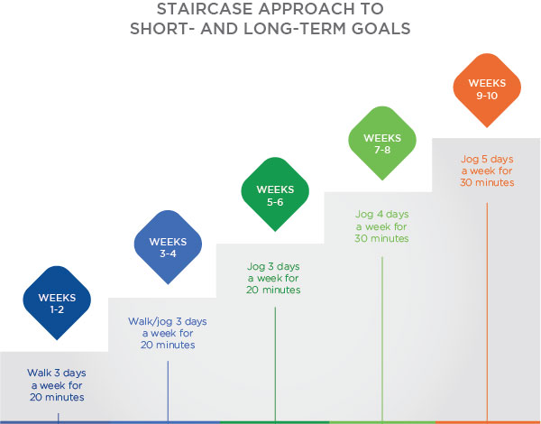

As seen in the figure, the starting place (current level of performance) is to walk 3 days per week for 20 minutes for Weeks 1 and 2. The next level is to walk/jog 3 days per week for 20 minutes for Weeks 3 and 4. These levels systematically increase and represent short-term goals. The amount of exercise increases until the individual reaches the goal of jogging 30 minutes 5 days per week, by Weeks 11 and 12. Achieving this long-term goal would represent the recommended 150 minutes of exercise per week by the U.S. Department of Health and Human Services (2008) "Physical Activity Guidelines for Americans".

**Self-determined goals**

There is no doubt that goal-setting works. There is much research that supports its effectiveness. Goal setting has been documented as a highly effective tool for assisting people in achieving results. However, goals, per se, are not effective by themselves. They are tools and they require that clients be committed to those goals. Without goal commitment, clients are not likely to put forth the required effort and persistence to achieve their goals, especially if they are challenging. However, challenging but realistic goals are the most effective goals.

One important way to enhance commitment is to have clients take an active part in setting their goals. Goals that are self-determined will provide longer-lasting intrinsic motivation (Ryan & Deci, 2002). Of course, if clients are not knowledgeable about dietary standards, they may have to rely on a Nutrition Coach to provide guidance. However, it is still important for clients to own and embrace their goals and be invested in achieving them.

When Nutrition Coaches are working with clients to set goals, they should elicit the client's opinion about realistic goals and provide rationales for specific goal choices. Nutrition Coaches can also present clients with different levels of goal difficulty and see their perceptions of what is realistic, easy or difficult. The key point is to make clients feel that they are involved in a meaningful way in setting their goals. For example, the Nutrition Coach could ask the client what is realistic in terms of food choices and caloric intake.

This is important because changing eating behaviour can be extremely difficult, especially consistently executing this behaviour for long periods of time (hopefully for a lifetime). Consider the following example of a client who wants to lose weight. Besides the normal difficulty in changing eating behaviours, barriers often get in the way of achieving these dietary goals, for instance, going on vacation (plentiful opportunities to indulge), travelling a great deal for work, eating out a lot (not having control of food portions and how food is prepared), working long hours (little time to prepare food) and family responsibilities. All of these things can impact a client’s ability to achieve their goals.

The Nutrition Coach should help clients identify potential barriers so strategies can be developed to cope with them. For example, a client is eating few fruits and vegetables because they eat lunch mostly at fast-food restaurants. The Nutrition Coach can identify this barrier and provide guidance on how to prepare healthy meals in advance.

**Reevaluate goals**

Goal setting is a starting place, not an ending place. There is often a lot of iteration, despite using all the principles of goal setting noted previously. Oftentimes, what was thought of as realistic and challenging goals (based on research and previous behaviour/performance) were either too easy or too difficult. This is where setting short-term goals helps because these are markers of how well the client is progressing toward their long-term goal. It is imperative that Nutrition Coaches periodically reevaluate their clients’ goals to make sure they are still realistic and relevant. Unfortunately, what often happens is that goals are set at the outset of setting up a nutrition program but these goals are not revisited in a systematic way to determine if they are still appropriate for the client. Nutrition Coaches need to make time for systematic meetings to evaluate the progress clients are making.

Getting Technical

In making decisions about goals, nutrition and weight loss, a process called the hot–cold empathy gap (Lowenstein, 2005) should be considered. Specifically, the hot–cold empathy gap emphasises the notion that people fail to realise how much their current emotional experiences bias perception. For example, if a male client has had a couple of bad weeks at work or in a relationship, he would more likely set easy goals because he is feeling depressed. In essence, his current feelings of depression (hot) flavour his perceptions of the difficulty of reaching goals (cold).

For example, say a client has set a goal of losing 45 pounds (20.4 kilograms) in 6 months by decreasing caloric intake to 1600 calories per day and increasing physical activity by walking for 60 minutes five times per week. At the end of 1 month, the client has lost only 3 pounds (1.3 kilograms), is averaging 2300 calories per day, and is walking for 60 minutes 5 days a week. On evaluation, it becomes obvious that they are reaching their exercise goal but falling short of their caloric intake goal and, thus, their weight-loss goal.

The first approach would be to ask the client what is getting in the way of achieving their goal and reevaluate whether the goal was ever feasible. Clients should rate their level of performance, identify barriers and report how confident they are on reaching their initial goal. If they report poor performance, identify barriers and/or report low confidence, then the goal needs to be reevaluated and revised.

At this point, the fitness professional should work with their client to modify the goal and provide helpful strategies. For example, the client’s new caloric intake goal could be raised to 2000 calories per day. In addition, the Nutrition Coach can encourage some new behaviours to meet the new goal: eating until only 80% full, eating at least three servings of vegetables per day, and drinking at least 8 cups (1.9 litres) of water per day. The point is that the goal is evaluated and that the changes that follow this evaluation are agreed upon by both parties.

**Goal feedback**

In addition to periodically reevaluating clients’ goals, it is also important to provide feedback on a regular basis regarding their progress. Of course, setting short-term goals, as mentioned earlier, will provide information regarding progress toward long-term goals. But feedback also includes general statements such as “You’re doing well”, “Keep up the good work”, “You need to spend more time on your goals” and “Hang in there”. These qualitative statements should be included along with more specific quantitative feedback such as “You have lost 20 pounds in 3 months” or “You are averaging 2 cups of fruit and vegetables per day”.

Combining goals with feedback appears to be extremely important in the achievement of goals. For instance, Locke and Latham (1990) found that in 17 of 18 studies focussing on goal setting and task motivation, the combination of goal setting and feedback produced significantly higher performance than setting goals alone. Furthermore, 21 of 22 studies found that the combination of goals and feedback was significantly better than feedback alone.

These consistent findings indicate that it is extremely important to combine feedback with goals when working with clients, as this produces the best performance. However, researchers argue that feedback needs to be viewed positively by clients for it to be helpful in performance or behavioural change. If clients view feedback negatively, this could lead to lower levels of confidence, effort and motivation. For example, if the Nutrition Coach tells a client that they need to work harder and exert more effort if they want to achieve their goals, this could be taken that they are perceived as lazy and not really committed to achieving their goals. Therefore, feedback needs to be positive and informational so that it can be integrated into strategies to continue moving toward goal achievement as well as enhance their intrinsic motivation and self-determination (Deci & Ryan, 2000). Finally, it is important to tailor the type of feedback to the individual. This involves being in tune with your client and noting individual preferences, as discussed in the next section.

**Individualise goals**

Probably the most important principle when implementing a goal-setting program applied to diet and nutrition is to make sure that Nutrition Coaches customise goals to the individual (Strecher et al., 1995). Even though psychology often focuses on group differences (e.g. moderately difficult goals produce better performance than easy goals, no goals or do-your-best goals), there also needs to be consideration of individual differences. Although most people prefer moderately difficult goals, some people prefer very difficult goals as that seems to bring out their best efforts. Along these lines, individuals with high self-motivation typically improve their performance when given extremely difficult goals, whereas individuals with low levels of self-motivation actually decrease their performance with difficult goals.

The health behaviours of diet and nutrition are highly complex and require careful planning to develop an appropriate goal-setting strategy. For example, rushing into a goal to reduce the amount of saturated fat in a client’s diet may be non-productive or even counterproductive as the Nutrition Coach needs to consider several factors before providing nutritional coaching and setting goals. More specifically, nutritional coaching generally involves a careful assessment of diet, identification of problem foods, discussion of environmental cues influencing the consumption of problem food and the creation of an action plan. Therefore, setting a goal - for example, to reduce a client’s fat intake by 20% - without careful attention to the behavioural factors associated with high-fat consumption is likely to fail. Alternatively, setting short-term goals based on specific behaviours, related to specific problem foods, will produce a greater likelihood of success.

Try This

Although following goal-setting principles is important for Nutrition Coaches, individual differences need to always be considered as clients are different based on their unique personalities.

To help individualise goals for clients, ask open-ended questions to more clearly understand their intrinsic motivation and barriers to new lifestyle habits. Some examples include the following:

* What are your biggest concerns about your health and eating habits?
* What work are you prepared to do to reach your goal?
* How motivated are you to reach your goal?
* What have you tried in the past to reach your weight-loss goal?
* Did it succeed? Why or why not?
* What has prevented you from reaching your goals in the past?
* Have you already started making changes to your dietary habits?

Similarly, there are specific guidelines for exercise behaviours, but these are guidelines and individuals start out at different places and under different conditions. An obese person might only be able to exercise at a very low-intensity level and sustain that exercise for just a few minutes. So, even though the recommendation is for 150 minutes of moderate to vigorous exercise per week, this might be far outside the capabilities of this individual. Another example involves commitment to goals. Specifically, it is recommended that to increase commitment, individuals post their goals in a public place to increase motivation and possibly peer pressure to achieve their goals. However, some clients are strongly opposed to visibly posting their goals because they feel their goals are personal and they do not want other people knowing about their goals. A situation like this makes it important to be sensitive to individual differences and not blindly adhere to all goal-setting principles. In fact, although understanding the general principles of goal-setting is extremely important, nutrition coaches should not implement these principles without considering each individual client’s needs, goals, personality, motivation and situation.

**Case study**

Now that the principles of goal-setting have been presented, along with the different types of goals and the effectiveness of setting goals, it is time to apply these principles to a case study with a fitness professional (Roger) and a client (Amy). At the encouragement of her husband and friends, Amy came to Roger with the goals to get in better cardiovascular shape, lose weight and eat healthier. However, Amy was not really motivated to make these changes. Knowing this, Roger had Amy complete a decision balance sheet (Hoyt & Janis, 1975; Prestwich, Lawton, & Conner, 2003) prior to their first meeting. It is often hard to start an exercise and diet programme and, to help people in this decision-making process, psychologists have developed a technique known as a decision balance sheet.

This technique can make clients more aware of the potential benefits and costs of an exercise/diet programme. In devising a decision balance sheet, individuals write down the anticipated consequences of exercise/diet participation in terms of gains to self, losses to self, gains to important others, losses to important others, approval of others and disapproval of others. A numerical value (1 to 5) is determined, rating the importance in their life of each entry. As can be seen in Table: Example Decision Balance Sheet, the gains to self and others outweigh (numerically) the losses to self and others and should provide Amy with more motivation to start her exercise and diet programme.

Example Decision Balance Sheet

| Gains to Self  5 - Better physical condition  5 - Better health  4 - Weight loss  3 - More energy | Losses to Self  5 - Less time with family  3 - Less time for hobbies |
| --- | --- |
| Gains to Important Others  5 - Healthy and longer life with spouse  4 - Healthier so I can play with my kids  3 - Become more attractive to my spouse | Losses to Important Others  4 - Less time to devote to parenting  3 - Less time to devote to work |
| Approval of Others  4 - My spouse would like me to live a healthier lifestyle.  3 - My children would like me to be more active. | Disapproval of Others  3 - My boss thinks it takes too much time away from work. |

At their first meeting, Roger took a detailed history of Amy’s eating, exercise patterns and background, along with what she wanted to achieve by working with a fitness professional. He also talked to Amy and provided her with some written information on different goal types and different goal-setting principles. After reviewing all this information, Roger developed some goals for her and he asked her to develop one goal for each of the three areas for improvement.

When they met for their second meeting, they compared their goals and negotiated to determine which goals were most important. However, since Amy was just starting a goal-setting programme, the first two goals were prioritised based on the following method (i.e. Amy rated how important each goal was to her and how confident she was in achieving it using a 1 to 10 scale.) The next two goals would kick in if she was successful with the first two goals.

Amy's Goals

| **First Set of Goals** | **Rating** |
| --- | --- |
| Walk 60 minutes per day, 5 days a week. | 7 |
| Eat three servings of vegetables and 2 servings of fruit each day and cut out snack/comfort foods to once per day. | 6 |
| **Second Set of Goals** | **Rating** |
| Lift weights 3 times per week to strengthen her upper and lower body. | 3 |
| Lose 30 pounds (13.6 kilograms) in 5 months (6 pounds/2.7 kilograms per month). | 5 |

Amy learned from Roger that losing 30 pounds (13.6 kg) is a performance goal, but her goals regarding diet, weightlifting and exercise are process goals. They should help her reach her performance goal. Roger also knows that to be most effective, Amy’s goals need to be specific and measurable as well as short-term and long-term, so he can see the progress she is making.

Amy exercises under Roger’s supervision three times a week and also works on her goals outside of her training sessions. After 4 weeks, everything is going well and Amy is on target. But, at the 6-week mark, some problems arise that continue to worsen by the 8-week mark. Specifically, her walking reduces to 30 minutes three times per week, she does not lose any weight during this time, and she does not eat her requisite fruits and vegetables, but goes back to eating more refined carbohydrates and processed foods. By this point, she has missed half of her individual sessions with Roger.

During their next workout session, Roger sat down with Amy and asked her why she was not making good progress on several of her goals. Amy said there were a couple of barriers that were getting in the way of reaching her goals and she was getting quite frustrated. Specifically, her boss at work has given her several labour-intensive tasks to do and she found herself working long hours. She also said that because she is stressed, she has gone back to eating more comfort foods. In addition, her husband and children seem to eat anything they want and do not gain weight, making it harder to eat healthy with more vegetables and fruits. Due to these factors, Amy does not think her goals are realistic anymore and has been losing motivation and confidence.

Roger develops an action plan that will help Amy get back on track and effectively address the barriers getting in the way of her reaching her goals. (It should be noted that another way to cope with barriers is early in the process. The fitness professional could ask the client to discuss and evaluate potential barriers with potential solutions. In this way, a relapse prevention action plan programme could be put in place earlier in the process, instead of waiting 6 weeks to identify barriers. By this point, it may be too late; the client might have already lost too much motivation).

1. Regarding her increased workload at her job affecting her walking, Roger and Amy decided that she could use her lunchtime at work to walk 30 minutes in addition to the time she already spent walking.
2. Roger knows the importance of writing down and tracking goals daily, so he asked Amy to systematically write down the progress she is making toward her goals daily to be reviewed every 2 weeks.
3. Amy asked her husband to limit any snack/comfort foods in the house so as not to tempt her into eating these high-caloric foods.
4. Roger had Amy re-evaluate her goals based on her current conditions, and she decided to cut back lifting weights from three to two times per week to save some time and change her weight-loss goal from 30 pounds in 6 months to 20 pounds in 6 months.

Roger and Amy both felt that these changes would make her goals more realistic given her barriers but still make positive changes toward a healthier lifestyle in terms of diet and exercise.

Nutrition Coaches should help their clients apply proven goal-setting principles, especially when setting short-term and long-term goals. However, merely setting a goal does not guarantee success and changes in behaviour. Consequently, clients must set the right kind of goals that enhance their motivation and build confidence. It is equally as important for clients and their Nutrition Coaches to continually evaluate the effectiveness of the goal(s) and adjust it accordingly. This requires appropriate feedback from the Nutrition Coach. In this chapter, you learned about:

* Different types of goals.
* The benefits of effective goal-setting.
* How to create SMARTS goals.
* Identifying methods for providing feedback and tracking client progress.
* Using goal worksheets and templates with clients.
* Identifying obstacles commonly encountered when setting goals.

# Dietary assessment and body composition testing

In the United States, the Department of Health and Human Services (HHS) and the United States Department of Agriculture (USDA) produce the *Dietary Guidelines for Americans* (HHS & USDA, 2015), a document that serves as a resource for health professionals and those involved in policy decisions involving nutrition.

One set of important recommendations within the DRIs are the Acceptable Macronutrient Distribution Ranges (AMDRs), which state the recommended percent of calories that adults should obtain from carbohydrates (45 to 65%), fat (20 to 35%), and protein (10 to 35%) (Figure: Acceptable Macronutrient Distribution Ranges).

**Principles of healthy eating patterns**

To support the five broad guidelines as well as the detailed recommendations discussed in this module,three principles of healthy eating patterns are provided by the *Dietary Guidelines for Americans.* These principles provide big-picture guidance for the diet without addressing specific nutrients

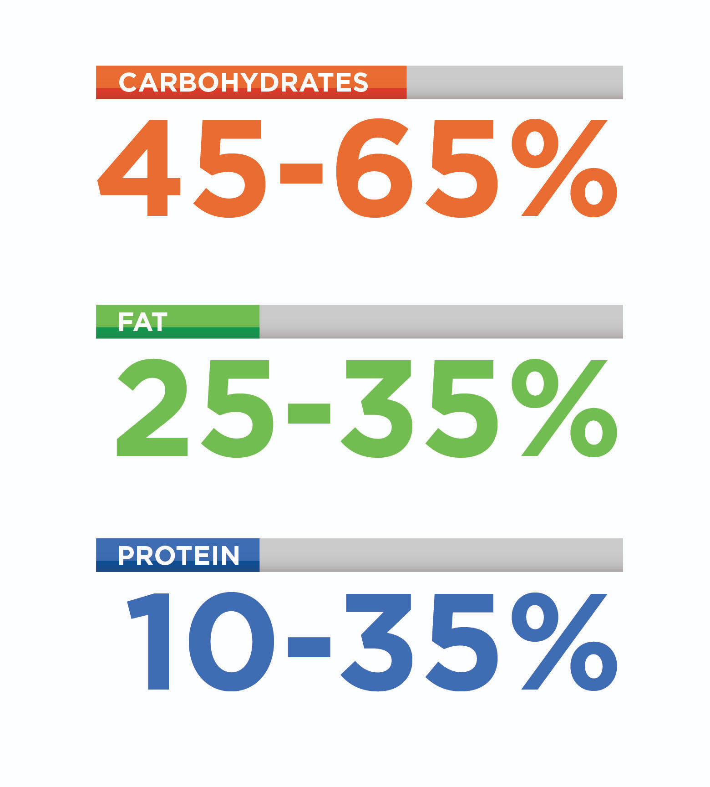

Oftentimes, clients will want to know which diet or eating pattern is *best*. This type of black-or-white thinking is reinforced by fad diets, sensational news headlines, and input from friends or family with limited understanding of nutrition. It is important to emphasize to your clients that there is more than one healthy way to eat and that their own preferences should play a role in determining how to implement a healthy eating pattern. It is better to encourage clients to make small sustainable changes to their eating pattern rather than recommend that they try to stick to an overly restrictive diet that they will probably not be able to follow long-term.

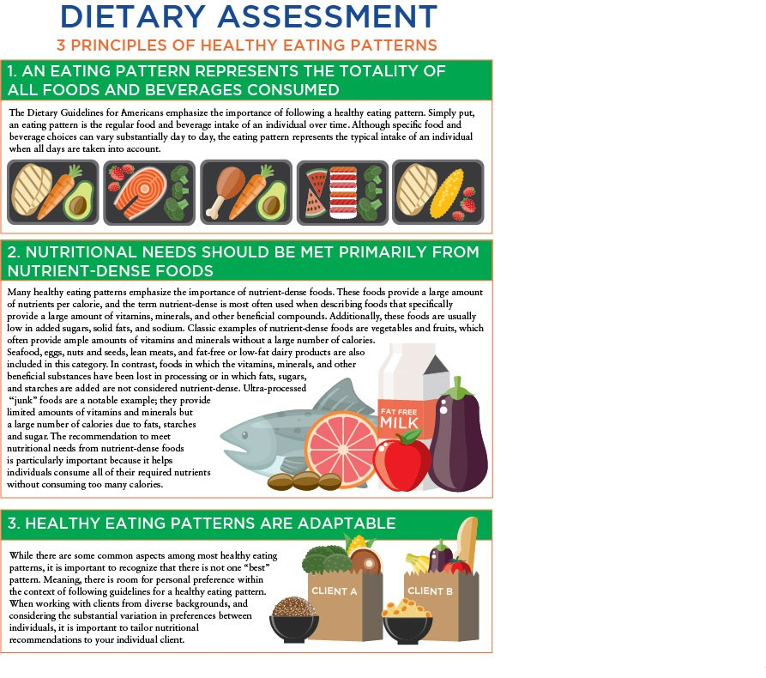

**Components of healthy eating patterns**

The *Dietary Guidelines for Americans* generally emphasize the importance of overall eating patterns rather than focusing on specific nutrient recommendations like the DRIs. Nonetheless, there are several food groups or nutrients that are specifically emphasized (such as vegetables and fruits) while several others are intentionally limited (such as added sugars and fats).

Additionally, the recommendations to include or exclude certain types of foods should be followed within the context of a diet that contains an appropriate number of calories (Table: Estimated Calorie Needs From the *2015–2020* *Dietary Guidelines for Americans*). The guidelines provide estimated daily calorie needs based on age, sex, and physical-activity level.

Estimated Calorie Needs From the 2015–2020 Dietary Guidelines for Americans

| **MALES** | | | | **FEMALES** | | | |
| --- | --- | --- | --- | --- | --- | --- | --- |
| **Age** | **Sedentary** | **Moderately Active** | **Active** | **Age** | **Sedentary** | **Moderately Active** | **Active** |
| 18 | 2400 | 2800 | 3200 | 18 | 1800 | 2000 | 2400 |
| 19–20 | 2600 | 2800 | 3000 | 19–20 | 2000 | 2200 | 2400 |
| 21–25 | 2400 | 2800 | 3000 | 21–25 | 2000 | 2200 | 2400 |
| 26–30 | 2400 | 2600 | 3000 | 26–30 | 1800 | 2000 | 2400 |
| 31–35 | 2400 | 2600 | 3000 | 31–35 | 1800 | 2000 | 2200 |
| 36–40 | 2400 | 2600 | 2800 | 36–40 | 1800 | 2000 | 2200 |
| 41–45 | 2200 | 2600 | 2800 | 41–45 | 1800 | 2000 | 2200 |
| 46–50 | 2200 | 2400 | 2800 | 46–50 | 1800 | 2000 | 2200 |
| 51–55 | 2200 | 2400 | 2800 | 51–55 | 1600 | 1800 | 2200 |
| 56–60 | 2200 | 2400 | 2800 | 56–60 | 1600 | 1800 | 2200 |
| 61–65 | 2000 | 2400 | 2600 | 61–65 | 1600 | 1800 | 2000 |
| 66–70 | 2000 | 2200 | 2600 | 66–70 | 1600 | 1800 | 2000 |
| 71–75 | 2000 | 2200 | 2600 | 71–75 | 1600 | 1800 | 2000 |
| 76 and up | 2000 | 2200 | 2400 | 76 and up | 1600 | 1800 | 2000 |

Critical!

Although generic calorie intake recommendations are provided in the *Dietary Guidelines for Americans*, these may not be applicable to many individual clients. Using the methods described in this module will allow you to tailor calorie intake recommendations to individual clients based on their body size and activity level.

Additionally, when working in Australia, Nutrition Coaches should consider this information for educational purposes only, and must always utilize the [ADG Eat for Health Calculator](https://www.eatforhealth.gov.au/eat-health-calculators) to determine caloric intake recommendations for clients.

The recommendations range from 1,600 to 2,400 calories/day for adult women and 2,000 to 3,000 calories/day for adult men (Figure: Recommended Calorie Range for Adult Men and Women). While the calorie limits may be useful to members of the general population, there are several reasons why these generic recommendations may not be best to use for individual clients, particularly active clients.

Firstly, the calorie intake recommendations do not take body size (e.g., height and weight) into account. Secondly, there are only three activity levels (sedentary, moderately active, and active) in the recommended calorie intakes. These activity levels do not distinguish between activity at work and activity during leisure time. Additionally, some very-active individuals and athletes will exceed the definition of *active* provided by the guidelines*,* which is “a lifestyle that includes physical activity equivalent to walking more than 3 miles per day at 3 to 4 miles per hour, in addition to activities of independent living.” For these reasons, it is recommended that individualized calorie intake recommendations be utilized with clients. These recommendations can be provided by laboratory testing or through the use of prediction equations.

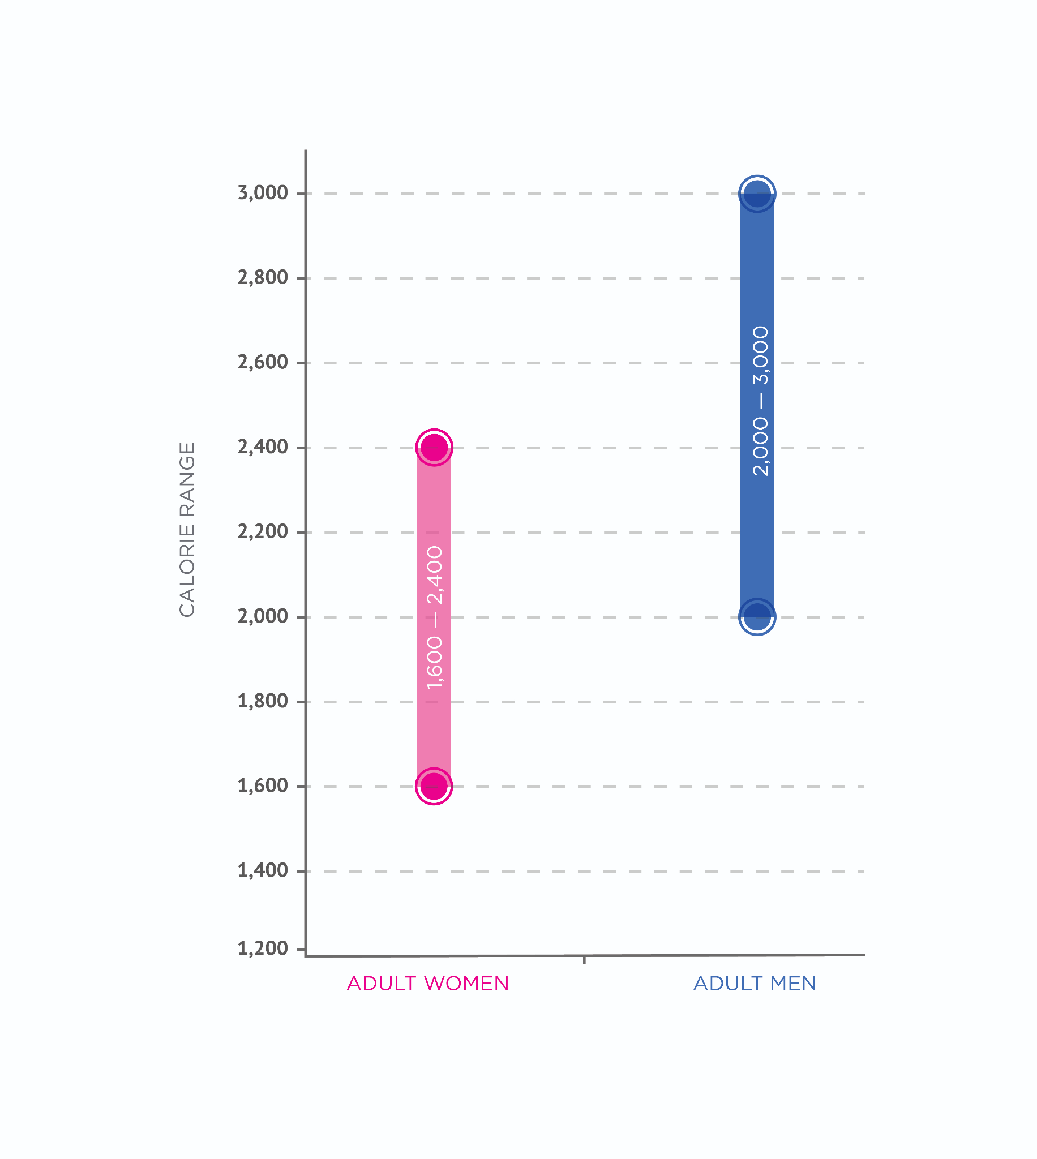

One frequently used method of estimating calorie intake is to estimate a client’s resting metabolic rate (RMR) and then multiply this number by an activity factor to get an estimate of the individual client’s daily calorie needs for weight maintenance. Then, calories can be added or subtracted from this daily calorie intake in order to promote weight gain or weight loss, respectively.

Try This

While the *Dietary Guidelines for Americans* provides generic calorie intake recommendations based on sex, age, and approximate activity level, these recommendations do not account for other relevant factors such as body weight and height. A variety of equations have been developed to estimate metabolic rate based on important characteristics of an individual. The following is an example of resting metabolic rate (RMR) estimation as well as how this information can be used to prescribe a client’s calorie intake.

Mifflin-St Jeor Equation

RMR (kcal / day) = (9.99 X weight (kg)) + (6.25 X height (cm)) - (4.92 X age (y)) + (166 X Sex Factor) - 161

Where body weight is in kilograms, height is in centimeters, and sex factor = 1 for males and 0 for females.

Example

You are estimating the RMR of a 175-pound man who is 6 feet tall and 35 years old.

Start by converting the weight and height to the required metric units.

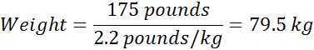

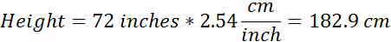

Now, you can complete the calculation:

RMR (kcal / day) = (9.99 X 79.5kg) + (6.25 X 182.9cm) - (4.92 X 35) + (166 X 1) - 161

RMR (kcal / day) = 1,770 kcal / day

The RMR represents an estimate of the calories that are used by this individual’s body simply to keep physiological processes running over the course of a day. Any physical activity or exercise would increase the number of calories used each day. A way to get a big picture of the physical-activity level of a participant is to multiply the RMR by an appropriate activity factor, as shown in the following table.

Physical Activity at Work/School and Physical Activity in Leisure Time* Activity Factor

Very Light – Sitting at a desk for most of the day

* Very Light 1.4
* Light 1.5
* Moderate 1.6
* Active 1.7
* Very Active 1.8

Light – Industrial work, sales, or office work that involves light activities

* Very Light 1.5
* Light 1.6
* Moderate 1.7
* Active 1.8
* Very Active 2.0

Moderate - Cleaning, kitchen staff, delivering mail on foot, etc.

* Very Light 1.6
* Light 1.7
* Moderate 1.8
* Active 1.9
* Very Active 2.0

Heavy - Heavy industrial work, construction work, or farming.

* Very Light 1.7
* Light 1.8
* Moderate 1.9
* Active 2.1
* Very Active 2.3

*\**Definitions: very light (almost no activity at all), light (walking, non-strenuous cycling or gardening approximately once a week), moderate (regular activity at least once a week, e.g., walking, bicycling or gardening), active (regular activities more than once a week, e.g., intense walking, bicycling or sports), very active (strenuous activities several times a week).

Try This

Practice calculating your own weight-maintenance energy needs. Use this method to compare your recommended weight-maintenance calorie needs to the generic recommendations shown in Estimated Calorie Needs from the prior *2015–2020 Dietary Guidelines for Americans* table.

**Foods to emphasize**

The *Dietary Guidelines for Americans* provides recommendations based on research demonstrating that certain food groups are associated with a reduced risk of chronic diseases and may help prevent some forms of cancer. Major food categories that are emphasized include vegetables, fruits, whole grains, low-fat or fat-free dairy, and protein foods. These recommendations can serve as a good starting point when evaluating the quality of clients’ diets and can help determine which practical recommendations to make to clients.

While some of these recommendations could lead to improvements in body weight or composition, it is important to remember that the goal of the *Dietary Guidelines for Americans* is to describe healthy diets that may help prevent diet-related chronic conditions.

Variety of vegetables

Vegetables are typically very nutrient-dense and are a critical part of a healthy-eating pattern. They provide many important nutrients, including fiber, water-soluble, and fat-soluble vitamins and minerals. Not only is vegetable consumption in general recommended, but it is advised that a variety of different types are consumed (Infographic: Vegetable Variety).

Eating vegetables from different categories will help ensure that an individual will obtain the full spectrum of beneficial nutrients found in this food category. Importantly, vegetables can be consumed in a variety of forms, including fresh, frozen, canned, dried, or cooked. However, lower-sodium forms of canned and frozen vegetables are recommended when fresh vegetables are not used.

It is important to limit the amount of butter or creamy sauces added to vegetables. Although the preparation of vegetables can increase their palatability, adding large number of calories from fat in order to make vegetables more appealing can be counterproductive to an individual’s overall health and wellness.

Fruits

Similar to vegetables, fruits provide fiber along with vitamins and minerals. While a variety of fruits can be part of a healthy eating pattern, it is recommended that at least half of fruit consumption comes from whole fruits rather than juices (Figure: Fruit vs. Juice). Although 100% fruit juice can contribute to meeting fruit intake goals, it does not provide the fiber found in whole fruits.

Many fruit juices may be less than 100% juice and contain large amounts of added sugars. Some dried fruit products also contain added sugar and may be easy to overeat due to their lower water content as compared to whole fruits. When canned fruit is chosen, the options with the lowest amount of added sugar should be chosen.

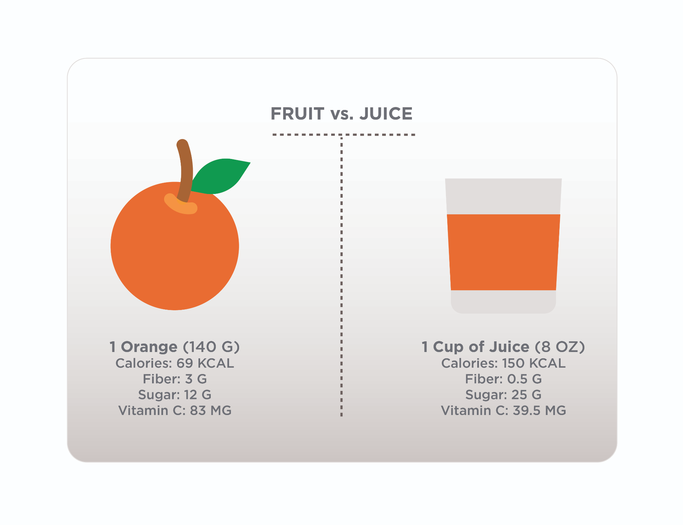

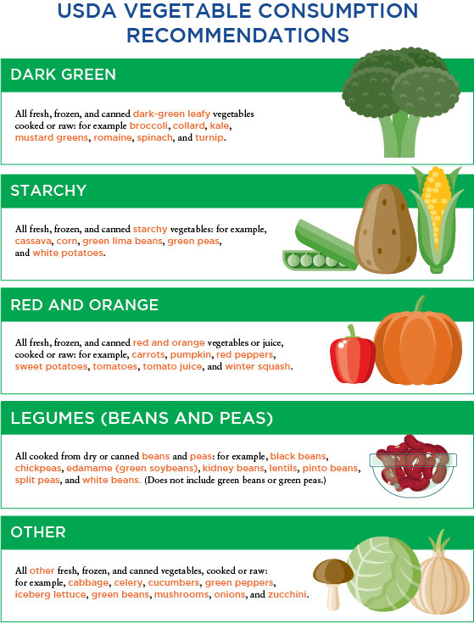

Grains

The *Dietary Guidelines for Americans* recommends that whole grains be included in a healthy eating pattern, while refined grains are limited. Whole-grain products include whole-wheat bread, whole-grain cereals and pastas, oatmeal, brown rice, and quinoa. Refined-grain products include most white breads, refined-grain cereals and pastas, and white rice. Refined-grain products are often enriched, meaning that nutrients that were lost during the refining of the grain are added back to the product (Figure: Whole, Refined, and Enriched Wheat). Often, B vitamins and iron are added to enriched products.

Some products contain whole grains but are not 100% whole grain. For example, a product label might state “made with whole grains,” even when the food only contains very-small amounts of whole grains. Some products will have stamps that specifically identify them as containing 100% whole grains or 50%+ whole grains. If the product does not have a stamp, looking for terms like “100% whole grain,” “whole wheat,” “brown rice,” or “oats” will give you an indication that it is a whole-grain product.

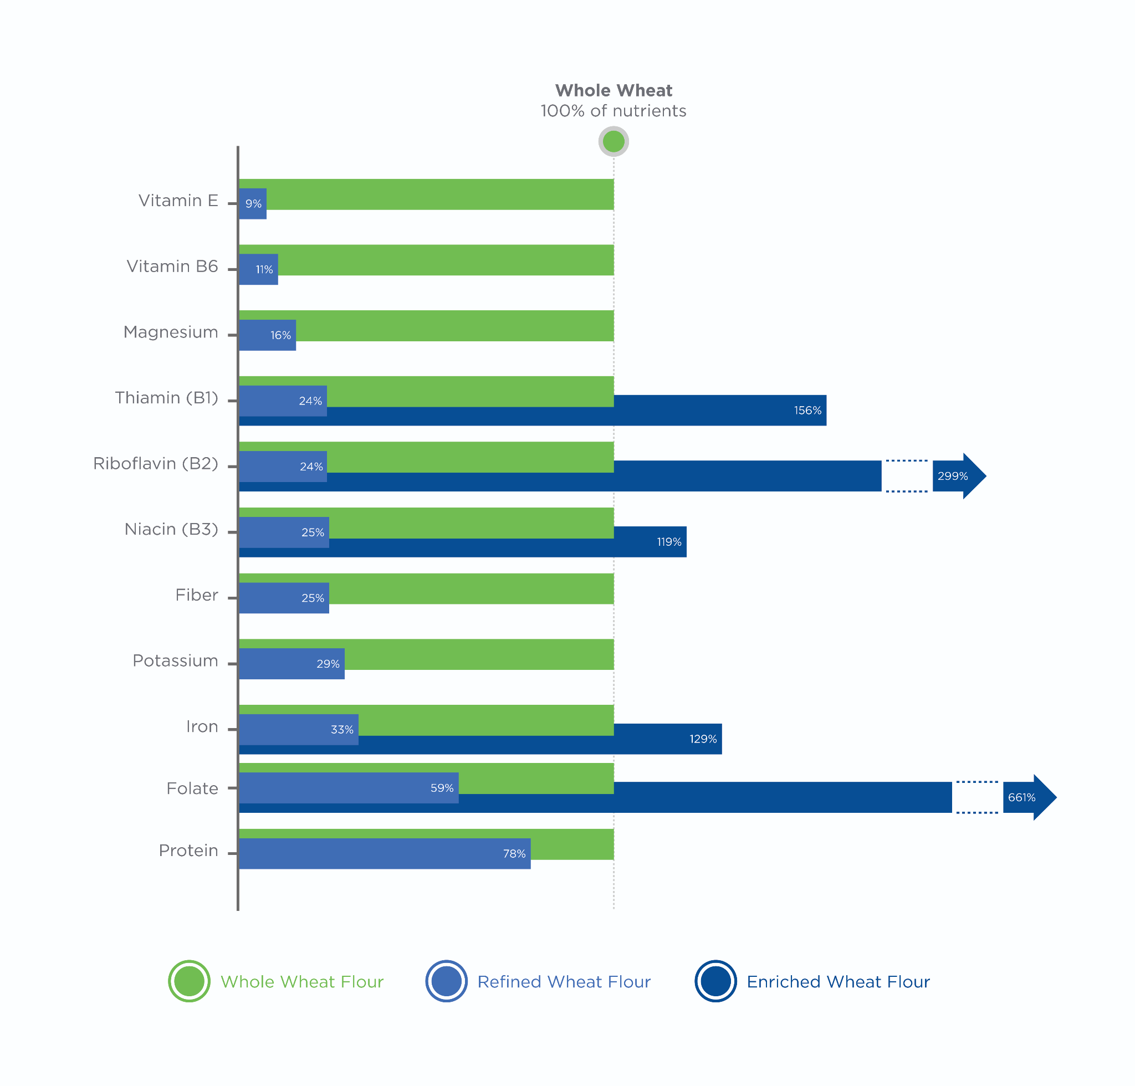

Dairy

Dairy products, such as milk, yogurt, and cheese, can help provide important nutrients. Dairy products are a good source of calcium, phosphorus, and a variety of other minerals. These minerals are essential for numerous aspects of physical well-being, notably bone health. Dairy proteins (i.e., whey and casein) are some of the highest-quality proteins in the food supply.

Many dairy products are also fortified with vitamin D because this vitamin enhances calcium absorption in the intestines. One potential downside to dairy is that frequently consuming full-fat dairy can potentially cause an individual to eat too many calories. For example, each 1-cup serving of full-fat (4 to 5%) Greek yogurt contains approximately 210 calories, including 11 grams of total fat and 8 grams of saturated fat. However, a 1-cup serving of fat-free Greek yogurt contains approximately 120 calories and no fat.

The guidelines recommend consuming low-fat or nonfat dairy to alleviate the concern of extra calories in full-fat dairy products. These products provide the beneficial nutrients found in dairy but are lower calorie per serving. Another important consideration when recommending dairy is that many within the population are lactose intolerant, meaning that they have insufficient quantities of the enzyme that breaks down lactose in the small intestine. When these individuals consume lactose, they typically feel bloated and uncomfortable and experience an upset stomach.

While some lactose-free dairy products and enzyme supplements are available, some individuals will choose to exclude dairy completely. In these cases, or for those who follow a plant-based diet, fortified soy products may be a suitable alternative due to their similar profile of nutrients. However, it is important to realize that some dairy substitutes do not possess all of the beneficial components of dairy.

For example, although soy milk provides a similar amount of protein when compared to dairy milk, almond milk provides substantially less protein. For clients who choose not to eat dairy, you can help them compare the nutrition of dairy-substitute products to actual dairy products in order to make the best substitutions.

Animal and plant protein sources

Both plant and animal proteins can contribute to overall protein intake. A wide range of protein sources are available: dairy, eggs, seafood, poultry, meat, soy products, nuts, seeds, and legumes. In addition to the protein they provide, these foods often contain good amounts of B vitamins and some minerals.

Consuming a variety of protein sources can be beneficial due to the different vitamins and minerals provided by each protein source. While all protein counts toward daily protein needs, animal proteins are typically higher-quality proteins than plant proteins.

Soy protein is the highest-quality, plant-based protein and exhibits a protein quality similar to many animal products. Protein quality is determined by a variety of factors, including the digestibility of the protein and how similar the pattern of amino acids in a protein source is to the pattern required by the human body

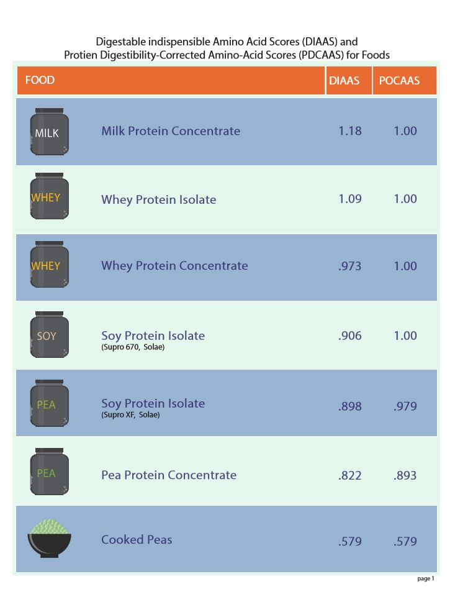

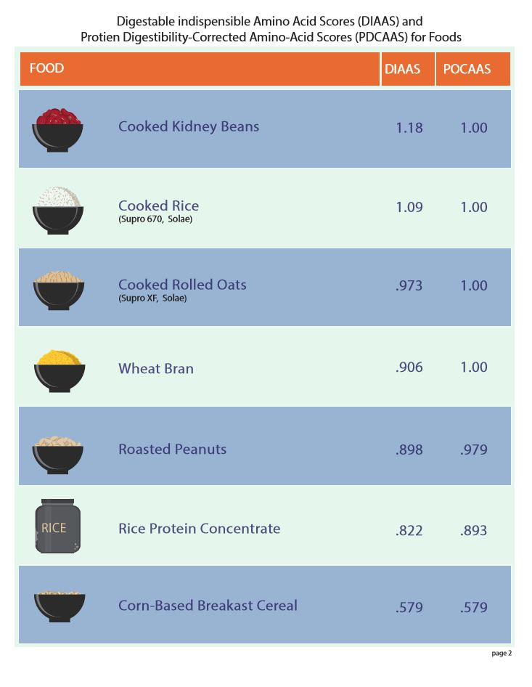

Saturated fats

Saturated fats are fats that contain a large proportion of saturated fatty acids (Figure: Fatty Acid Profiles of Common Fats and Oils). These fats are often solid at room temperature. Major sources of saturated fat include cheese, meat, and solid fats.

The guidelines recommend the intake of saturated fats to be less than 10% of the overall daily calorie intake and that saturated fats in the diet be replaced with unsaturated fats. The guidelinesalso state that the majority of Americans exceed this maximum recommended intake of saturated fats. Although saturated fats are used for some essential functions in the body, they can be produced within the body without consuming them in the diet.

The reason for the limitation of saturated fat intake is research demonstrating that replacing saturated fats with unsaturated fats lowers blood cholesterol and reduces risk of heart attacks and deaths related to heart disease (Hooper et al., 2015; Sacks et al., 2017). Because heart disease is the leading cause of death worldwide (World Health Organization), lifestyle changes that can reduce the risk of heart disease or death are of great public health importance. Overall, due to the widespread overconsumption of saturated fat and associations between overconsumption and heart disease, an evaluation of the saturated fat content of the diet may be appropriate for some clients.

Added sugar

Sugars, such as syrups and table sugar, are added to foods and drinks to increase their sweetness. However, added sugars typically do not provide additional nutrients. This means that foods with substantial amounts of added sugar often have low-nutrient density and high-energy density. Importantly, some sugars do occur naturally in nutrient-dense foods such as fruits and dairy.

The guidelinesemphasize the need to include these food groups while limiting foods in which sugar has been added in processing. This recommendation is due to the difference in nutrient density between foods like fruit or dairy and foods with added sugar (Infographic: Sugar Content Comparison – Processed Beverages). While fruits and dairy provide additional nutrients such as vitamins and minerals, foods with added sugars often have relatively low nutrient density. For this reason, the guidelines recommends consuming less than 10% of calories per day from added sugars as well as staying within recommended calorie limits.

As an example, a 16-ounce bottle of soda may have approximately 50 grams (200 calories) of added sugars. For someone who eats 2,000 calories per day, consuming this single bottle of soda accounts for 10% of daily calories and represents the maximal recommended quantity of added sugar for their intake level.

Foods with substantial amounts of added sugar are often very palatable, meaning that excessive quantities can be eaten very easily. Typically, individuals find it much easier to overeat foods with added sugars as compared to less-processed whole foods that contain sugar such as fruit. Because of this, it is important to increase the clients' awareness of whether they are susceptible to overindulging in foods with added sugars.

In addition to the likelihood that added sugars will contribute to excess calorie intake overall, the guidelines cite research demonstrating that eating patterns with high amounts of added sugar are associated with a greater risk of heart disease, obesity, diabetes, and some forms of cancer, which may be due to a cluster of unhealthy behaviors and increased adiposity due to increased caloric intake. For these reasons, increasing the clients’ awareness of their intake of added sugars can not only help with the goal of improving body composition but may also promote their long-term health and well-being.

Locate 10 different food items, either in your home or at the grocery store, and try to identify how much added sugar the products contain. The U.S. Food and Drug Administration (FDA) is now requiring that added sugars be included on nutrition facts labels. However, some companies have until the end of the year 2020 to comply with this regulation. Because of this, some food items may not explicitly state how much added sugar the product contains. In these cases, the total sugar content of the item can be examined alongside the ingredient list. Ingredients like sucrose, maltose, high fructose corn syrup, cane sugar, raw sugar, syrup, and honey indicate that sugar has been added to the product.

After evaluating your 10 food items, reflect on which items had more added sugar than you expected and which had less. Also consider what proportion of calories in each food item came from added sugars, keeping in mind that the *Dietary Guidelines for Americans* recommends that no more than 10% of total daily energy comes from added sugars.

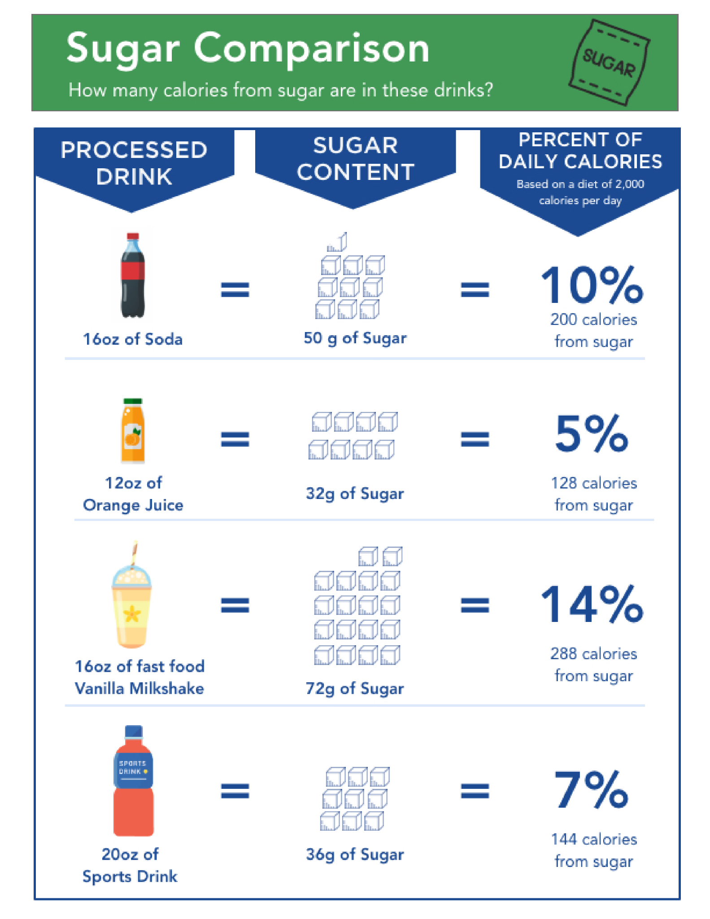

Sodium

Sodium is essential for many critical functions of the human body and is provided by many whole foods. However, the increased prevalence of processed foods has dramatically increased the sodium content of the food supply, primarily due to salt (sodium chloride) that is added to extend the shelf-life of processed foods and also to enhance their flavor. Higher intakes of sodium have been associated with increased blood pressure, one indicator of heart disease risk (Whelton et al., 2012; Institute of Medicine, 2014). However, there is some controversy regarding the effects of sodium intake on heart disease risk (Oparil, 2014).

Nonetheless, it is recommended that adults consume no more than 2,300 milligrams/day of sodium (Figure: Sodium in Table Salt). While the sodium content of specific foods varies, many items contain 1/3 to 1/2 of the recommended daily limit in a single serving. Foods like pizza (up to 1,000+ milligrams per slice), soup (about 700 milligrams/cup), deli sandwiches (about 1,000 milligrams per 6-inch sub), and dressings or sauces (up to about 1,000 milligrams per serving) are examples of foods that are high in sodium. However, there are also foods that may not seem particularly salty to a client but actually contain moderate amounts of sodium.

For example, a slice of bread may contain around 200 milligrams of sodium and condiments like ketchup may contain around 150 milligrams per tablespoon. If a client is trying to limit sodium intake, all foods and beverages should be carefully considered due to the prevalence of sodium in many different products.

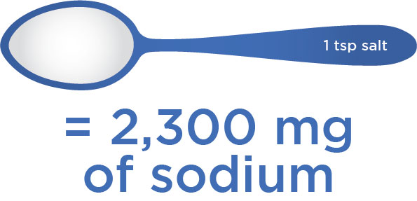

Sodium is often included in sports drinks to help replace sodium lost in sweat, although the amount of sodium lost via sweat can vary substantially between individuals. While this may not be a concern for moderately active individuals, those who regularly perform long bouts of exercise and sweat substantially could potentially benefit from consuming sodium surrounding long-duration exercise to maintain electrolyte and fluid balance.

This is an example of a time when nutrition recommendations for public health take a different perspective than those for athletic performance. In fact, the *Dietary Guidelines for Americans* includes a note indicating that the stated sodium intake value “does not apply to highly active individuals” due to their increased amount of sweating. Although it is generally believed that the sodium needs of the majority of active individuals are met due to the prevalence of sodium in the food supply, be aware that some clients could need higher sodium intake. In particular, those who perform long-duration exercise and sweat substantially may need additional dietary sodium to replace losses due to sweating.

**Disparities between guidelines and intake**

One of the five guidelines provided by the *Dietary Guidelines for American*sis to “shift to healthier food and beverage choices.” This recommendation implies that current food and beverage intake in the United States is not aligned with a research-supported healthy eating pattern. The guidelines present data on the typical intakes in the United States, which is provided by a national food survey called *What We Eat in America*. This survey is jointly conducted by the HHS and USDA and given as part of the National Health and Nutrition Examination Survey (NHANES) (Table: What We Eat in America Survey Results Summary).

What We Eat in America Survey Results Summary

| Based on recent data from this survey, the guidelinesemphasize the following concerns: |
| --- |
| 1) About 3/4 of the population has an eating pattern that is low in vegetables, fruits, dairy, and oils. |
| 2) More than half of the population is meeting or exceeding total grain and protein foods recommendations but are not meeting the recommendations for the subgroups (i.e., whole grains and seafood) within each of these food groups. |
| 3) Most Americans exceed the recommendations for added sugars, saturated fats, and sodium. |
| 4) The eating patterns of many are too high in calories, as demonstrated by the high percentage of the population that is overweight or obese. |

Coach's Corner

Being aware of the general population’s dietary intake patterns can help you understand some of your clients better. However, it is important to remember that each individual client may differ from the eating patterns observed in the whole population. Performing dietary assessment, as described later in this module, can help you determine which shifts in eating patterns may be beneficial for a particular client.

The guidelines recommend a number of simple substitutions or shifts in order to combat the discrepancies between dietary recommendations and the actual intake of the general population. These include exchanging high-calorie snacks for nutrient-dense snacks, trading fruit products with added sugar for real fruit, shifting from refined grains to whole grains, replacing added sugars with unsalted snacks, trading butter for oils, and consuming no-sugar-added beverages instead of those with added sugars.

Because much of the population does not consume the recommended variety of foods within each food group, it is recommended that individuals broaden their intakes. For example, seafood intake is low in men and women of all ages. In order to promote the intake of a diverse spectrum of protein-containing foods, it is recommended that seafood (such as salmon or tuna) is utilized as a main protein source twice per week. However, not all seafood is created equal. It is important to understand the nutritional differences between wild and farmed seafood when educating your client on choosing seafood as a main protein source

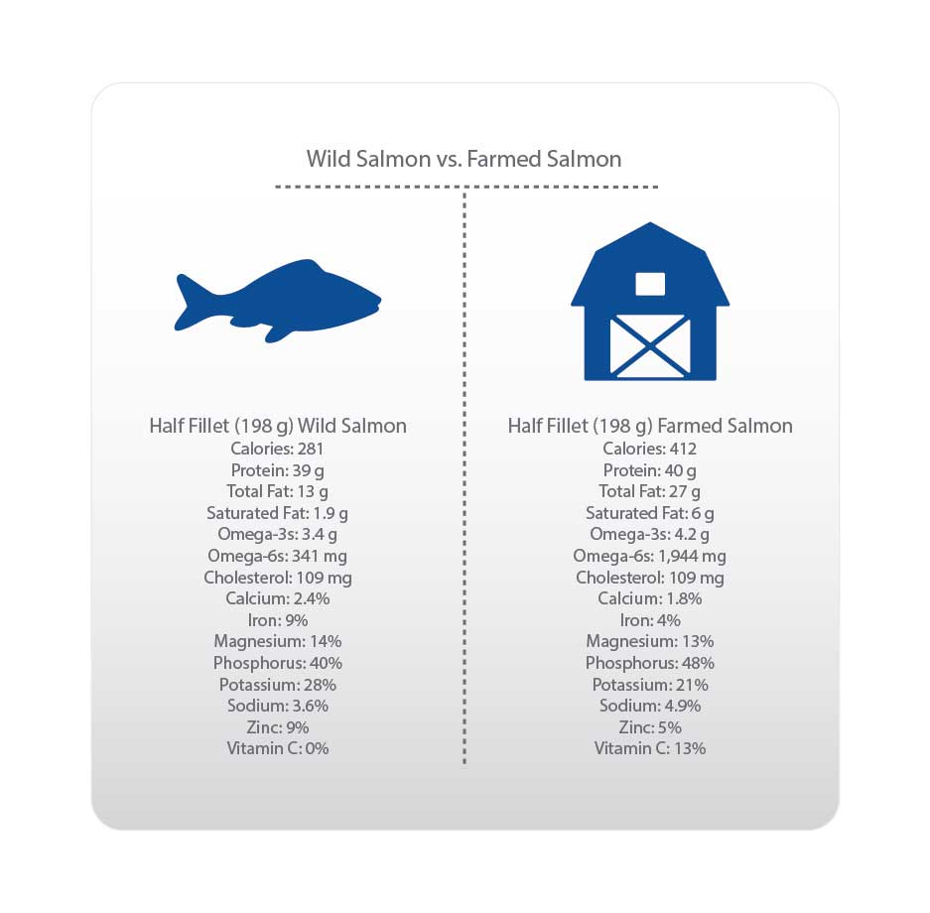

One of the reasons that seafood intake is generally low could be due to the fact that seafood is often more expensive that other protein sources like poultry or dairy. If your clients consume limited seafood due to price concerns, you could encourage your clients to look for sales on seafood items and then stock up, particularly when the seafood can be frozen and used later. However, it is important to realize that some clients may simply dislike seafood or may not be able to afford seafood on a regular basis. While recommendations provide goals to strive for, the importance of personal preferences and budget constraints should be considered.

**Questioning current guidelines**

It is important to recognize that the field of nutrition is relatively young and that much research is still needed to fully understand the impact of different eating patterns on health and well-being. Although the dietary recommendations presented by the *Dietary Guidelines for Americans* or other reputable sources are well-intentioned, they are not perfect and will likely change over time. Some recommendations have solid scientific backing but the evidence for other recommendations is limited.

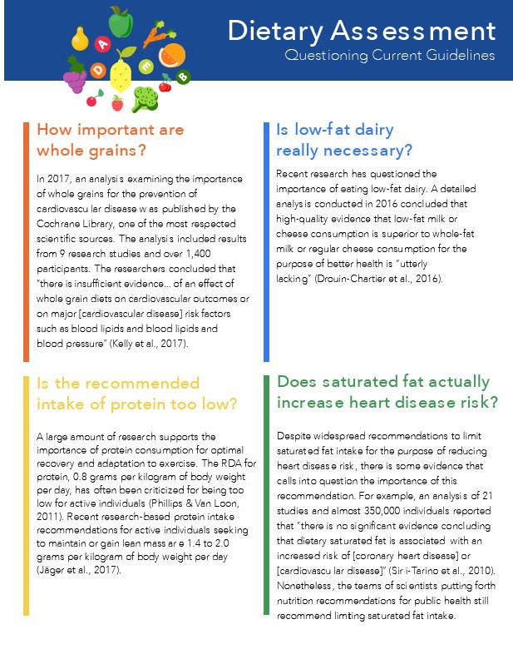

Infographic: Nutritional Guideline Controversies highlights a few examples of current questions and/or controversies that exist today surrounding nutritional guidelines.

There are multiple levels of scientific evidence. For example, expert opinion is viewed as a relatively weak level of evidence and research studies in animals are viewed as weaker evidence than well-conducted studies in humans. The highest levels of evidence are achieved when the results from multiple well-conducted studies are combined in order to allow for stronger conclusions to be made. In nutrition research, many studies examine the association or correlation between intake of a certain nutrient and some aspect of health. While this type of research is useful for establishing a relationship between the diet and long-term health, it does not allow for determination of cause-and-effect relationships. Nutrition guidelines are produced from the available research but it is important to realize that nutrition is a relatively young scientific discipline and it is complicated to study. Ultimately, some dietary recommendations have stronger scientific support than others, and much more research is needed in a wide variety of nutritional areas.

While it is important to base nutrition practice on the best-available evidence, there are many questions in nutrition that have not been definitively answered. Additionally, there are many questions that have been answered for particular contexts, such as specific populations or age groups, but that have not been answered for all contexts. Understanding that the scientific process, the human body, and nutrition are complex will help you understand why answers to many common questions are not black-or-white. As a Nutrition Coach, it is important to realize that the nutrition guidance you provide your clients should be based on existing evidence but that the collective body of nutrition knowledge will grow over time and that recommendations may change because of this.

While the Infographic: Nutritional Guideline Controversies on the previous page is certainly not exhaustive, it demonstrates the point that the science of nutrition is a young and evolving field and better answers are being found as science progresses. Part of the scientific process is questioning current recommendations. The field of nutrition science will continue to explore the dietary factors that are most important for health and wellness.

As a Nutrition Coach, realize that many nutrition issues are not clear-cut and that recommendations may change over time. While staying up-to-date with current research is certainly recommended, helping your clients improve their health and wellness does not require you to know every detail of the current controversies in nutrition. Focusing on eating patterns that are feasible for your client, while also helping them move toward their health-and-fitness goals should be your first priority. Remain aware that recommendations can change and try not to hold to your views on nutrition dogmatically.

With that said, it is important to remember that the current nutrition guidelines are established based on substantial amounts of research and the interpretation of research by committees of experts. These recommendations should not be discounted even though it is well-recognized that they may be revised as additional information becomes available.

**Assessing dietary intake**

Performing a dietary assessment with clients is an important step in identifying eating-pattern changes that may help them reach their goals more effectively. Getting a picture of the client’s typical eating behaviours and food choices will help with understanding them better. This is a critical step in promoting the success of the client, because there is not a one-size-fits-all nutritional programme that works for every individual.

Although there are broad recommendations to promote a healthy eating pattern, as discussed in this chapter, there are many specific ways to implement these recommendations. Tailoring recommendations to each client individually will increase the likelihood that they will be able to make lasting dietary changes.

Understand that a client may be unintentionally providing you with a diet record (or other dietary assessment) that is not fully reflective of their lifestyle. For example, a client may present you with a day of a diet record that they feel is a *normal* day. However, the reality may be that they eat this way a couple days per week, but slip up and make poorer food choices on the other days. It is possible that these slip-ups could be stalling the client’s progress even though they may be unnoticed by the client.

If you suspect that your client’s dietary assessment may not be fully reflective of their habitual diet, try asking your client for information about their weekly routine. For example, you could ask if a dietary record they provided is how they eat every single day of the week or if they eat differently when they have social events, go out to eat, etc. You could ask the client to try to think about specific types of days (e.g. weekends) or situations (e.g. snacking in front of the TV) that may happen periodically, but were not apparent from their dietary assessment.

The goal of these conversations is to help increase your client’s awareness of their complete lifestyle and how it affects what they eat. Increased awareness of times when it is easy to make poor dietary choices may help your clients be on their guard for when these situations undoubtedly arise.

Before assessing the client's dietary intake, it is important to realise that there are limitations to nearly every method of dietary assessment. For example, some methods rely on the ability of the client to accurately remember the specific foods, and quantities of food, they ate at an earlier date. Additionally, some clients may intentionally or unintentionally change the way they eat when they are tracking their food intake so that their diet appears healthier than it is on a normal day.

What is more, many individuals vary a lot in what and how much they eat. For example, some individuals follow a fairly healthy and predictable eating routine during the week, but overeat at social occasions or weekend outings. This type of behaviour can sabotage fitness progress, but may not be apparent from looking at a few days of dietary assessment. Additionally, some individuals may either intentionally or unintentionally fail to record some food items they eat when completing a diet record. The coach might infer that the client is eating an appropriate number of calories for weight loss, or perhaps even eating a diet that is too low in calories. However, when tracking the client’s body weight over the course of weeks or months, it may not change or could even increase. This may give some indication that the initial diet record was either inaccurate or did not fully reflect the eating patterns of the client.

In these cases, it is important to have a conversation with the client to ensure they understand the procedures of the dietary assessment method and the importance of getting an accurate picture of their habitual diet. Do not accuse the client of dishonesty, but rather try to identify whether the client has eating patterns that were not completely captured by the assessment method so that appropriate recommendations can be made in the future. Ultimately, for the reasons mentioned here, it is important to interpret the results of dietary assessments cautiously.

**Methods of dietary assessment**

There are several common methods of dietary assessment that can provide an overall picture of a client’s diet as well as identify specific patterns that may need to be modified. While these methods vary in their approaches, each attempt to provide information about the client’s typical nutritional habits. Unfortunately, all existing dietary assessment methods have limitations.

Attention to detail and practise in using these assessment methods will help the Nutrition Coach know what to look for, as they continually improve their ability to understand and utilise the information obtained from these methods. The overall goal of employing these methods is to be able to provide clients with constructive feedback that helps promote their long-term health and well-being.

24-hour recall

The 24-hour recall is a simple interview in which a client describes everything they have had to eat or drink the previous 24 hours. Often, several specific steps are followed in order to help a client remember all foods and drinks consumed during this period. For example, the following steps are adapted from the National Health and Nutrition Examination Survey (NHANES) *Dietary Interviewer Procedures Manual:*

1. Quick list: Obtain a simple list of all food and drink items eaten within a 24-hour period of time without focussing on specific details and amounts.

2. Forgotten foods: Ask the client about specific food categories that may have been forgotten, such as non-alcoholic or alcoholic beverages, sweets/desserts and snacks. This may be particularly important for those who *graze*.

3. Time and occasion: Ask the client to think about his or her schedule during the 24-hour recall period and state what time foods were consumed. Remembering the activities of the day may help the client remember additional items.

4. Describe the food: Now that the list of foods/drinks has been compiled, ask the client to provide the following information for each food item: where the food was obtained (home, restaurant, etc.), brand/restaurant associated with the food, preparation method, how the food/drink was served (e.g. served with anything else) and the quantity of the food/drink.

5. Final review/probe: Briefly review the 24-hour recall for completeness with the client and ask one final time if there are any items that could have been forgotten.

Use Handout: 24-Hour Recall Worksheet as a tool with clients.

During the recall interview, it is important to give the client time to think and respond. If the client is rushed through the interview, they may be more likely to forget items. Although this method is relatively easy to use, it does rely on an individual’s accurate recollection of their intake. This may be particularly difficult when estimating portion sizes. Even if a client remembers everything he or she ate in the last 24 hours, it may be difficult to accurately describe the portion size.

Another limitation of this method is that evaluating a single 24-hour period may not give an accurate representation of a client’s overall diet. Because of this, it may be better to perform several 24-hour recalls in order to obtain more information. It may also be beneficial to perform assessments for both weekdays and weekend days, because many individuals eat differently on weekends.

Usual intake

Evaluating an individual’s usual intake can provide a big-picture look at their eating habits. This method can be used alone if high precision is not needed, or it can be used as a complement to a 24-hour recall or diet record in order to help determine if the days being assessed are similar to the client’s normal eating patterns.

The usual intake assessment consists of simply asking the client about their typical eating routines. Starting with the beginning of the day, clients should provide the Nutrition Coach with information regarding the frequency of eating, which food items are typically consumed, and the approximate quantity of each food item. This method can be useful for those who follow a very-regular eating pattern, but may be less useful for those with unpredictable eating habits. If this method is used, inquire about normal weekdays and weekend days.

The usual intake dietary assessment is most appropriate for those who follow very-predictable eating patterns. For example, those who prepare and portion all their meals for the week may be good candidates for this method. However, even those who meticulously plan all their meals for the week may indulge on weekends or at social events. Because of this, it is important to ask a client how often they deviate from the usual intake they described.

The frequency of eating different than their usual intake is only one potential concern. Another is how much they deviate from their usual intake. For example, if an individual indulges in two cookies once per week but otherwise follows a very predictable eating pattern, she or he may still be able to be assessed relatively accurately using the usual intake method. However, if an individual has one cheat day each weekend, in which they eat much differently than the usual intake they describe, this could be enough to make this assessment method inaccurate for this individual.

In these cases, another option would be to complete two usual intake assessments: one for a normal weekday and one for a normal weekend day. Ultimately, the usual intake method will not be suited for many clients, including those whose intakes vary considerably from day to day.

Diet record

Diet records are a common method of dietary assessment, particularly with the wide availability of mobile diet record apps. Diet records are essentially a list of all food items eaten within a specific period of time. The end result of a diet record may be relatively similar to a 24-hour recall, but the food items are added as the client consumes them. While this method was traditionally completed on paper, mobile apps provide a way to keep a digital diet record while also integrating dietary intake goals.

To increase the accuracy of a diet record, instruct the client to write down each food as soon as they prepare or eat it. Waiting until the end of the day and then trying to remember everything that was eaten, as well as the quantity eaten, will likely increase the error of this method.

Try This

Locate and download three different mobile diet-record apps. Use each one for a few days and identify what you like and dislike about each one. This will allow you to provide recommendations to your clients who may benefit from using this method.

Diet records have the potential to provide precise information on a client’s intake; however, similar to other methods, there can be substantial errors in diet records when a client either forgets to record items or is unable to accurately describe the type and amount of food eaten. One method that may increase the accuracy of a diet record is to have the client use a food scale.

Food scales can be purchased online inexpensively and they can help reduce errors in estimating quantities of food. When using diet records, a common recommendation is to have the client track 3 days (2 weekdays and 1 weekend day) over the course of a week in order to get a more complete picture of their intake. As in other methods of assessment, a challenge for obtaining accurate diet records is the client’s desire to appear healthy and avoid being criticised.

While this is not always the case, clients who feel this way may either consciously or unconsciously eat differently on days when they are tracking their diet, because they do not want to record bad foods that their fitness professional will see. Although this scenario may not be completely avoidable, encourage the clients to eat as normally as possible when tracking their diet so there is an accurate representation of their habitual patterns. Remind them that the purpose of this assessment is to help them and that having accurate information will help facilitate effective coaching.

Some mobile diet-record apps allow users to grant other individuals access to their digital-diet records. If your client uses one of these apps and is comfortable granting you access, this may be an easy way to periodically check in on their diet records. Some clients find it helpful to track food every day, but you can spot check the diet records so that you do not have to analyse every single day of their intake. Even knowing that their trainer/nutritionist can access their diet record at any time may help some individuals stay on track.

When encouraging clients to be open and honest when recording their diet, emphasise that your goal is to help them in a nonjudgmental way. Even if they know their diet needs to change, encourage them not to feel any pressure to make their diet appear *healthier* than it actually is. Remind them that the best way you can help them is if they provide you with the most accurate information they can.

Food Frequency Questionnaire

Food frequency questionnaires are designed to provide a big-picture view of the diet and allow for identification of intakes of particular food groups. These questionnaires often consist of a series of multiple choice questions designed to identify the frequency of consumption of major categories of food (i.e. grain products, vegetables, fruits, meats, poultry, seafood, dairy, fats/oils, sweets, etc.).

The Food Frequency Questionnaire used by the National Health and Nutrition Examination Survey (NHANES) is available [online](http://www.cdc.gov/nchs/data/nhanes/nhanes_03_04/tq_fpq_c.pdf). While this questionnaire contains 139 questions and may be more detailed than needed, reviewing this document may provide coaches with ideas for how to provide a simple food frequency questionnaire for their clients. Coaches can also complete this food frequency questionnaire themselves to gain a better understanding of this dietary assessment method.

Results from a food frequency questionnaire can be used to evaluate the similarity of a client’s intake of certain food groups and subgroups as compared to recommendations, such as those provided earlier in this module. Similar to assessing usual intake, the food frequency questionnaire can give a big-picture look at some dietary patterns, but will not provide precise information regarding the intake of particular nutrients.

# **Monitoring Body Composition**

Body composition refers to all the separate compartments making up the human body. The composition of the body is one of several important factors to consider when evaluating an individual’s health and wellness. Poor body composition has been associated with a number of diseases, and monitoring body composition provides information about nutritional status in health and disease (Heymsfield, Lohman, Wang & Going, 2005).

What is more, improving body composition is one of the most common health-related goals. Aspirations of fat loss or muscle gain are frequently expressed by clients working with health and fitness professionals.

Coach's Corner

Periodically assessing body composition can help evaluate the effectiveness of the nutrition and exercise interventions designed to promote these changes. Performing a baseline assessment of your clients when they first start working with you will allow you to track their progress and obtain an objective evaluation of whether your programme is producing the desired effects. Of course, body composition is only one factor and others should be considered. These may include physical performance (strength, endurance, flexibility, etc.) or more subjective factors like confidence, energy levels and overall well-being.

## Methods of assessing body composition

As with assessing dietary intake, it is important to understand that accurately evaluating body composition can be difficult. Every available method of body composition assessment provides only an *estimation* of an individual’s *real* body composition. There is no method that is available that provides the *exact* composition of the body. With that said, some methods provide more accurate estimations than others.

All methods of body composition attempt to divide the body into separate parts that have importance for the health and proper functioning of the body. Each of these methods attempts to provide more detailed information than a simple body weight measurement. This is because body weight simply groups every component of the body together. That is, it does not distinguish between fat, muscle, bone, etc. Because of this, body weight is not the ideal assessment of an individual’s body.

It is not uncommon for exercising individuals to have a healthy change in body composition, but no change in body weight. Body mass index (BMI), which is calculated as an individual’s weight in kilograms divided by their height in meters squared, is another commonly used metric that considers all body weight equal (Table: Body Mass Index Categories).

Body Mass Index Categories

| **BMI (kg/m2)** | **Weight Category** |
| --- | --- |
| Below 18.5 | Underweight |
| 18.5–24.9 | Normal weight |
| 25.0–29.9 | Pre-obesity |
| 30.0–34.9 | Obesity class I |
| 35.–39.9 | Obesity class II |
| Above 40 | Obesity class III |

Instead of a single compartment, like body weight and BMI, most common methods of body composition divide the body into two compartments: fat mass and fat-free mass. In these 2-compartment models, everything that is not fat is grouped together. This fat-free mass includes water, protein, bone, glycogen stores, etc. If a method further divides fat-free mass into two compartments, it is termed a 3-compartment model because body weight is now split into three separate compartments.

Source: National Heart, Lung and Blood Institute (n.d.). Classification of Overweight and Obesity by BMI, Waist Circumference and Associated Disease Risks. Retrieved from [National Heart Blood and Lung Institute.](https://protect-us.mimecast.com/s/I7LFC73MlMhEPOyRf8kSiL?domain=nhlbi.nih.gov)

In addition to the fat compartment, these models typically include water and residual (a term referring to everything else in the body). In order to produce a 3-compartment model, it is typically necessary to conduct multiple assessments on an individual and mathematically combine the results.

If yet another body compartment is considered, a 4-compartment model can be produced. Separates body weight into fat mass, water, bone and residual These models are often viewed as a true gold-standard estimation of body composition. In order to obtain a 4-compartment model, measurements of body weight, body volume, water and bone content are needed. Each of these items can be obtained by some of the individual techniques described next.

Getting Technical

Although you will probably not assess your clients using a 4-compartment model, this gold standard method is often used to determine the accuracy of more common assessment methods. In order to obtain a 4-compartment model, measurements of body weight, body volume, water and bone content are needed. Body volume can be obtained by underwater weighing or Air Displacement Plethysmography (ADP); water can be estimated by Bioelectrical Impedance Analysis (BIA); and bone can be estimated using Dual-Energy X-Ray Absorptiometry (DXA).

While the 4-compartment model boasts impressive accuracy, it is typically unavailable outside of research environments. As discussed later, the most accurate techniques are not always the best choice to use with your clients. Several factors, including ease of use and availability, should be considered as you think about how to assess the body composition of your clients.

**Bioelectrical Impedance Analysis (BIA)**

Bioelectrical impedance analysis(BIA) is a technology that estimates body composition by calculating the fluid content of an individual’s body using small currents of electricity (Figure: Bioelectrical Impedance Devices). Although specific devices vary, all have electrodes that are placed into contact with an individual’s skin, typically on the hands and/or feet. A harmless current then travels through the body by some of the electrodes, while others receive the signal. The BIA device automatically performs calculations to determine how easily the current travels through the body, and produces a 2-compartment model to split the body into fat mass and fat-free mass.

Many clients may have been exposed to BIA previously due to the many inexpensive devices that are available. Body weight scales that also provide body-fat percentage estimates often have electrodes on the scale surface and utilise BIA technology. Handheld BIA devices with electrodes are also very common. While some advanced BIA devices can demonstrate good accuracy, most of the cheap models available to the general population are not very accurate.

Although BIA is most common, there are several other technologies that evaluate the body’s response to electrical currents in order to estimate body composition. These include Bioelectrical Impedance Spectroscopy (BIS) and Electrical Impedance Myography (EIM). While these devices have traditionally not been commonly available to the general population, some affordable devices are now being produced and marketed to individual consumers.

The skinfold method is based on estimating the thickness of the fat layer under an individual’s skin. Using calipers, the skin and fat are pinched at certain locations on the body to determine their thickness (Figure: Skinfold Callipers). Common assessment sites on the body are shown in Handout: Skinfold Measurement Worksheet. The thickness of fat under the skin at these locations is entered into an equation that estimates the overall body density. The specific number of sites entered into the equation varies and many different equations are available.

The density of the body obtained from these equations is used to predict the body fat of an individual using a 2-compartment model. Additionally, measuring the thickness of the fat layer at specific locations can be used to get a general idea of whether body-fat loss is occurring at a particular location. Although the skinfold method has the advantage of being portable and cheap, the experience and skill of the health professional performing the assessments can greatly impact the accuracy of body-composition estimates.

**Ultrasound**

Ultrasound technology uses high-frequency sound waves emitted by a probe to visualise different parts of the body (Figure: Ultrasound). In the body-composition assessment, ultrasound can be used to determine the size or quality of a muscle as well as the thickness of the fat layer under the skin. By assessing the thickness of the fat layer under the skin, ultrasound can function as a more advanced version of skinfold callipers.

While skinfold callipers rely on some educated guesswork regarding the location of the fat layer as compared to the underlying muscle tissue, ultrasound has the ability to actually *see* where the fat layer is located. Ultrasound assessments of fat thickness can be performed at the same sites as a skinfold assessment, and prediction equations can be used to estimate the overall body composition using a 2-compartment model. Additionally, the fat-thickness measurement at particular sites can be used to determine if a client is gaining or losing fat at these locations.

Some clients will have region-specific body-composition goals such as a desire to lose body fat from the arms or waist. While genetically-influenced body fat distribution will play a major role in where body fat is lost, evaluating the fat thickness at certain locations may better inform clients with information regarding whether they are indeed losing body fat at the desired locations.

Although ultrasounds are most common in medical and research settings, some portable ultrasound transducers are becoming more affordable. As such, this method may become more available at health and fitness facilities in coming years. However, as with many medical devices, there may be requirements for purchasing and operating the equipment that vary from region to region. Additionally, methods like ultrasound require appropriate expertise, training and practise in order to ensure reliable results.

**Circumferences**

Body shape varies between people, and the shape of an individual’s body can provide some information about the distribution of fat and muscle. A simple way to obtain some information about body shape is to measure the circumference of certain body segments. For example, waist circumference is correlated with visceral fat and associated with several diseases, including heart disease and diabetes (Camhi et al., 2011; Siren et al., 2012).

While this method may not be as accurate as some more advanced techniques, it may be a good choice when resources and equipment are limited. Similar to the measurements of fat thickness from skinfolds or ultrasound, the individual circumference measurements may be a useful indicator of whether body composition changes are occurring at certain locations.

Of course, simply seeing a change in circumference does not definitively tell whether fat or muscle is being gained or lost. While the specific circumferences measured may vary by client, some potentially useful sites include the waist, hips, chest, upper thigh and upper arm.

When measuring circumferences, it is important to be consistent in how you measure. Here are a few tips:

1. Use the same flexible measuring tape each time you perform a measurement.
2. The measuring tape should be placed perpendicular to the long axis of the body part you are measuring (for example, perpendicular to the torso and parallel to the floor for a waist circumference).
3. Measurements should be taken at a landmark that you can identify easily. For example, waist circumference can be taken at the umbilicus (belly button) or upper-arm circumference can be taken at the distance halfway between the shoulder and the elbow.
4. Measurements should be taken on the bare skin or over minimal form-fitting clothing. Measurements should not be taken over loose clothing unless necessary for the comfort and privacy of the client.
5. For waist circumference, you should measure the waist after the client exhales normally and with the arms hanging relaxed at the client’s sides.
6. You could consider taking two to three measurements of the same location and averaging the results to help reduce the error of your measurements.
7. In every aspect of the measurement, try to measure your clients the exact same way each time.

**Underwater Weighing**

Underwater weighing, also known as hydrodensitometry or hydrostatic weighing, is a 2-compartment method that predicts body composition based on the overall density of the body. This method involves the estimation of the 3-dimensional volume of the body through the measurement of an individual’s body weight while they are completely submerged under water. The body volume is usually corrected for the volume of air found in the lungs during the test.

When the individual’s body weight is divided by their body’s volume, the body density can be found. This is then used to predict body composition using prediction equations, as in skinfold measurement, using a 2-compartment model. While underwater weighing used to be a common technique, it has largely been replaced by newer technologies that do not require the participants to be submerged under water. Nonetheless, it is possible that some clients may have access to testing via this method or could be familiar with this method due to its relatively long history of use.

**Air Displacement Plethysmography**

The technique of air displacement plethysmography (ADP) exhibits similarities to underwater weighing without the necessity for a client to be submerged. Instead of the displacement of water, the displacement of air is evaluated. As in underwater weighing, this allows for the estimation of body volume, body density and body composition. The primary ADP device used today is an egg-shaped chamber attached to a computer system and body weight scale. During the assessment, the client sits inside the chamber while the device produces small changes in air pressure within the chamber. Based on the relationship between pressure and volume, the body volume of an individual is estimated.

Similar to underwater weighing, the amount of air in the lungs is either estimated or measured so that it can be accounted for. Body composition information is then available using a 2-compartment model. The Bod Pod® is available at many health and fitness facilities and tests can often be purchased. For clients who want a more accurate assessment than methods like skinfolds or circumferences, this could be a good option.

**Dual-Energy X-Ray Absorptiometry**

Dual-Energy X-Ray absorptiometry(DXA) uses X-rays of two different energies to estimate several aspects of body composition (Figure: Dual-Energy X-Ray Absorptiometry). During an assessment, the individual being evaluated lies on a DXA scanning table for less than 10 minutes while X-rays are passed through the body. The amount of radiation from a DXA scan is very low and is estimated to be about the same amount received during 3 hours of a normal life.

DXA evaluates differences in the X-rays when they were administered on one side of the body and when they are received by the device on the opposite side of the body. Performing these comparisons allows DXA to produce two different 2-compartment model comparisons: bone vs. non-bone; and non-bone lean mass vs. fat mass. Because of these two comparisons, DXA ultimately provides three body compartments (bone, fat and non-bone lean mass) and is viewed by some as a 3-compartment model.

A major advantage of DXA is that it provides detailed information about the bone, lean mass and fat in separate body regions (e.g. arms, legs and torso). This can allow for determining the distribution of an individual’s body fat, which can impact disease risk, as well as evaluating where body composition changes are occurring within the body. DXA is typically only available in medical and research settings, although some companies that provide health and wellness testing may offer DXA. Due to the substantial cost of the scanner, the charges for a DXA scan are often high.

DXA exhibits greater accuracy and precision than many assessment methods. However, it is not perfect. Although it is often called the gold standard of body composition, it has limitations. When compared to a 4-compartment model, there are errors in DXA body composition estimates that may be related to differences in the water content of the body (Toombs, Ducher, Shepherd & De Souza, 2012).

Water is the most prevalent substance in the body. A 4-compartment model is more accurate than DXA, because it specifically includes water as one of its compartments whereas DXA does not assess water. If a client receives a DXA scan, caution them that although DXA is a valid method of assessment, there can be errors in an individual person’s results, which may be partially due to the amount of water in their body.

Clients who do receive DXA scans are often surprised by their body-fat percentage being higher than expected. Part of this could be due to lack of awareness of what their actual body-fat percentage is, but DXA may also overestimate body fat in lean, muscular individuals (Graybeal et al., 2018).

**Infrared 3-Dimensional Scanning**

An assessment method with increasing popularity is infrared 3-dimensional scanning (Heymsfield et al., 2018). Several such devices are commercially available and each operates using similar principles. Using infrared light sensors, a 3-dimensional model of an individual’s body can be produced. This model can be used to automatically determine the circumferences and volumes of various body segments. This means that these methods can potentially be used in multiple ways: they can represent an automated method of obtaining circumference estimates to use in body-fat equations (as in traditional circumference methods), or the volume of the body could potentially be used to predict body composition (as in underwater weighing and air displacement plethysmography).

While the use of these methods for health and fitness assessments is relatively new, several models of scanners are commercially available. In fact, several are marketed specifically to gyms and fitness facilities, and it is likely that their usage will become more widespread. One potential advantage of these methods is the ability for a client to see a 3-dimensional avatar of their body over time in order to visualise the changes taking place. For some, this may be more meaningful than a particular body-fat percentage.

**Other methods**

Several other methods can be used to assess body composition but are not frequently used due to cost, availability or other factors. The following are examples of these methods:

* Computed tomography (CT)
* Magnetic resonance imaging (MRI)
* Hydrometry
* Near-infrared interactance (NIR)

Coach's Corner

Having a general awareness of the many techniques available to assess body composition, as well as knowing which are most practical for you and your clients, will help you be a well-informed practitioner.

It is unlikely the Nutrition Coach will encounter most of these methods being used. However, it is important to realise that there will continually be advances in body-composition assessment throughout the career of a Nutrition Coach.

Body Composition Assessment Method Comparison

| **Method(s)** | **Accuracy\*** | **Pros** | **Cons** |
| --- | --- | --- | --- |
| Bioelectrical impedance analysis (BIA), bioimpedance spectroscopy (BIS), and electrical impedance myography (EIM) | 3–4 (depends on model) | Simple and quick  Affordable (some models)  Portable (some models) | Limited availability (some devices)  Variable accuracy |
| Skinfolds | 3–4 (depends on assessor) | Affordable  Fairly simple and quick  Portable  Provides regional information | Less accurate  Unpleasant for some individuals |
| Ultrasound | 3 | Fairly simple and quick  Provides regional information | Limited availability |
| Circumferences | 4 | Affordable  Simple and quick  Portable  Provides limited regional information | Less accurate |
| Underwater weighing (hydrodensitometry) | 2 | Accuracy | Limited availability  Expensive  Not portable  Unpleasant for some individuals |
| Air displacement plethysmography | 2 | Accuracy  Fairly simple | Limited availability  Expensive  Not portable |
| Dual-energy X-ray absorptiometry | 1 | Accuracy  Quick  Provides regional information  Provides bone density | Very-limited availability  Expensive  Not portable  Small amount of radiation |
| Infrared 3-dimensional scanning | N/A | Simple and quick  Visualization of body shape | Not portable  Limited information on accuracy |

## Choosing the best methods for your clients

Each health professional will have to consider whether it is feasible to conduct body composition assessments with clients, and how to best implement the methods discussed in this module. Several important questions have been outlined in this section to facilitate the decision-making process when choosing the best method for the client. Additionally, information is provided regarding how to interpret and communicate about changes in the client's body composition.

**Which method(s) should you use?**

When considering all the factors involved in choosing and implementing a method of body composition assessment with clients, realise that there is not one best option. It is tempting to say that the most accurate method is the best, but the cost or availability of advanced methods may make them impractical for many coaches or clients.

In the end, the best method varies based on the fitness professional, client and available resources. Some clients may have access to advanced testing equipment and are willing to pay for more accurate testing. For other clients, it may be best to implement a relatively simple method that is able to give a general idea of whether a program is successful. When trying to decide which method of body composition assessment to use, there are a few questions that may help you decide

Both health professionals and clients can be tempted to discount simple methods of body composition assessment. However, there is nothing wrong with simply measuring your clients’ body weight and the circumferences of certain body parts as a basic way to track changes in the body. While the results of all methods should be interpreted cautiously, simple methods like body weight and circumferences can provide some indication of what changes are occurring in your client’s body.

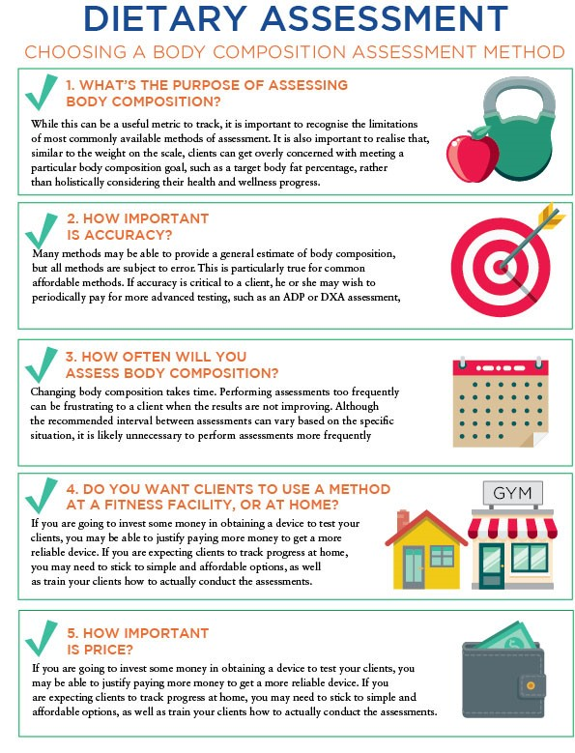

## Interpreting Changes in body composition and tracking progress

Once information is collected about how the client’s body is changing over time, interpret these values and communicate the information to the client. This will allow both parties to understand more about the effects the client’s nutrition and exercise habits are having on his or her body. There are a few critically important points to consider when tracking and interpreting changes in the client’s body composition.

First, realise that each method has some inherent level of error. Body composition estimates from even the most advanced techniques should be interpreted with some caution, particularly when they are being used with individual clients. Some of these methods are very accurate when measuring *groups* of people, but are often less accurate when measuring one person at a time. When assessing groups of individuals, such as in research studies, the body fat of some individuals may be overestimated while the body fat of other individuals may be underestimated. However, the overestimations and underestimations often help cancel each other out when considering changes in body fat for the entire group. The error present for every body composition assessment method also means that it is difficult to know whether a small change in body composition is real or not.

Critical!

Caution needs to be used when interpreting apparent changes in body composition. For example, it is difficult to know if a 0.5% decrease in body fat is real, or whether the client’s body fat appeared slightly lower due to an error of the technique or random day-to-day variation. Generally, you can be more confident in larger body composition changes seen over longer periods of time.

You should communicate to your client that each method of assessment has limitations. Additionally, it may be best not to perform body composition assessments too frequently. If performing a body composition assessment each week, it is unlikely that large enough changes will have occurred for you to determine whether a real change took place. Instead, it may be best to perform assessments no more frequently than every 1 to 2 months.

In addition to interpreting results with caution, it is important for the client’s body composition to be assessed the exact same way each time. This is true both for the body composition assessment technique being used, as well as how the client prepares for the assessment. In terms of the assessment method, do not compare results from different devices as the body composition results of the client will vary based on the device used.

It is not critical that the most technologically advanced method is used. However, it is critical that the same method is used consistently over time and that the implementation of that method is administered in the exact same way each time. In terms of pre-measurement activities, several factors that should be standardised are prior food and fluid intake, and recent exercise or physical activity. When feasible, it is ideal to perform any body composition assessment after an overnight period of fasting and resting. That is, it is desirable for the client to have not had anything to eat or drink in the previous 8+ hours, as well as having performed no exercise or physical activity other than daily activities.

Additionally, having the client empty his or her bladder prior to the assessment may be helpful for several assessment methods. While assessment methods vary in terms of how important these standardisation procedures are, employing this overnight fasting-and-resting period can help reduce the variability in the client’s body prior to the assessment. With that said, there are still factors that could impact the client’s body weight or body composition estimates even after an overnight fast. These include intestinal content from the previous day(s), the relative amount of stored glycogen and water in the body, and the client’s overall hydration status. Changes in these factors may be responsible for some day-to-day variations in body weight. For these reasons, it is important to cautiously interpret body composition changes, even when using the procedures recommended here.

Due to the inherent errors in each method of body assessment, it may be beneficial to perform several different simple techniques (Figure: Body-Composition Assessment Techniques).

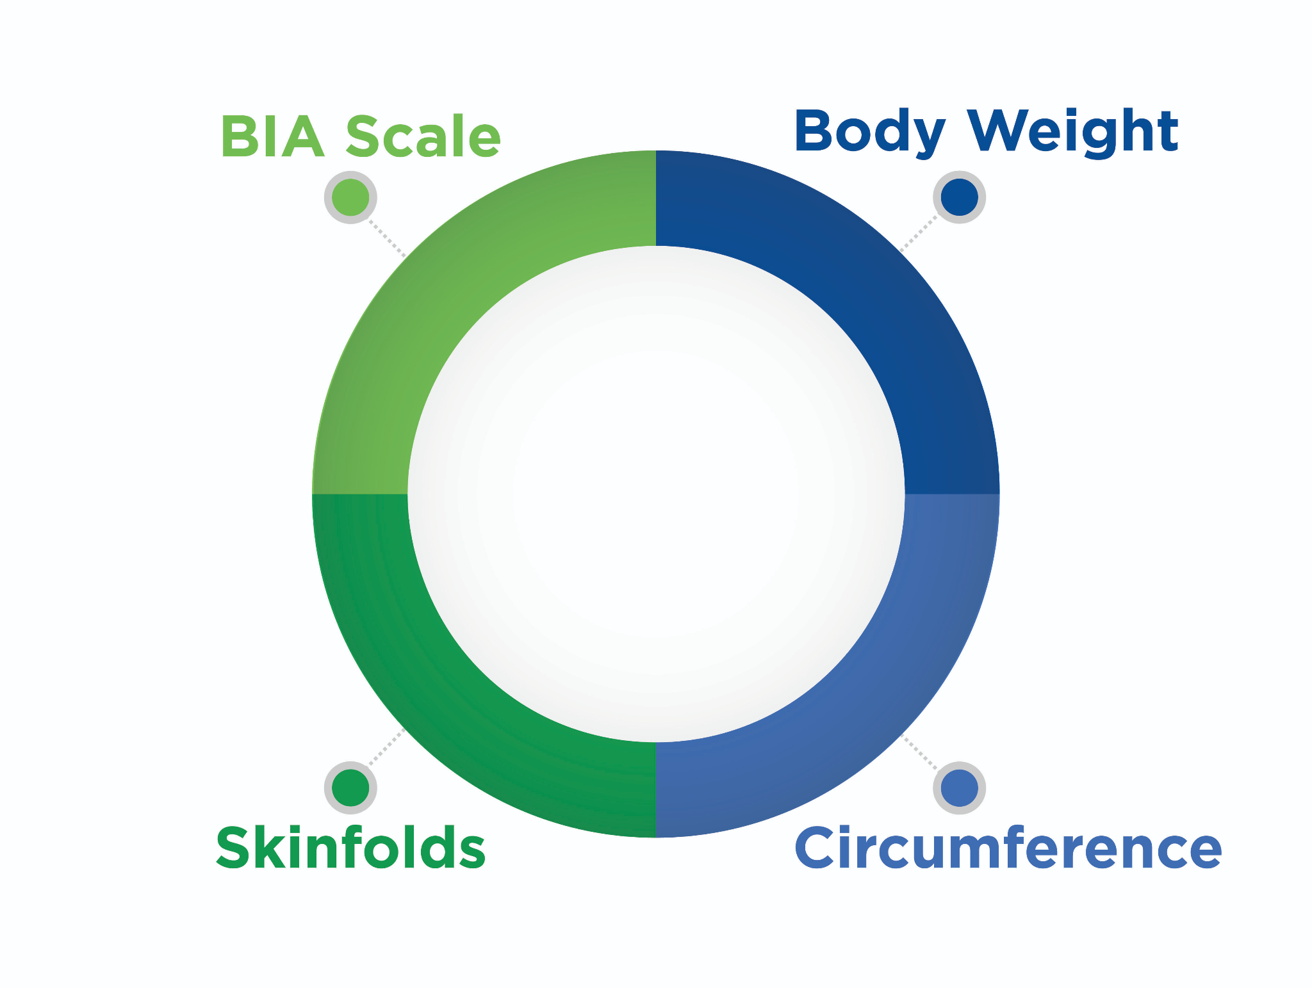

In addition to the methods discussed here, some clients find it useful to take periodic progress pictures to visualise their progress. Whether or not a client shares them, this can be a way to record the results of the mirror test.

The Nutrition Coach should keep organised records of any dietary and body composition information collected for a particular client. This will allow for the ability to provide the client with feedback regarding their dietary changes or body composition. One recommendation is to use a digital spreadsheet to keep dietary intake and body composition information organised for each client. Of course, it is critical to respect the privacy of the client and not share identifiable information about them without permission. This is particularly important in the age of social media. While some clients may feel pride and encouragement when highlighting their success on social media, others will not want this. Be sure to communicate clearly with the client. It is best to err on the side of protecting the client’s privacy. Overall, the consistency of which assessment is used, how it is used, and how the client prepares before assessments are some of the most-critical factors when assessing body composition.

Regardless of the amount of time or resources available, being as consistent as possible will increase the confidence in the body composition information obtained from clients. It is always important to remember that each method has errors, and that results should be interpreted cautiously even when best practices are used. Explaining these points to clients may also help them to have an appropriate context in which to interpret changes in the results of their body composition testing over time.

**Communication and sensitivity**

A final consideration when working with clients is to think about 'how to say' and 'what to say'. That is, the communication strategies used with clients about their dietary patterns and body composition may make a large impact on promoting a relationship built on trust. For example, an initial assessment of a new client indicates that they have relatively poor dietary habits and an unhealthy body composition. The way in which this is communicated is important when starting the relationship off on the right foot. Belittling the client or making derogatory comments about his or her diet or body composition is never appropriate.

While the Nutrition Coach has the responsibility to guide clients toward a healthier lifestyle, this should be done with sensitivity. Some clients will be ready and willing to change habits in order to work toward their health goals, but others may be more resistant. The Nutrition Coach will need to develop the expertise and knowledge of clients to be able to determine how much each individual client can handle at once, and how to communicate the recommended changes. Demonstrating kindness and sensitivity to the fact that lifestyle changes are difficult will help create a more-comfortable environment for the client, and can ultimately establish a relationship built on trust and respect.

It is important to recognise that some individuals may feel somewhat uncomfortable with having their body composition assessed and discussed. As a Nutrition Coach, it is important to identify this. Again, exhibiting kindness and sensitivity when communicating can go a long way in making clients more comfortable. It is also critical to respect the privacy of the clients, both in terms of the information collected and when or where the assessments are performed. For example, many clients may not like the idea of someone pinching their fat via skinfolds or measuring their waist circumference. Performing the assessments in a more private setting may lessen this discomfort.

# Food labels and portion sizes

Most packaged food items are required by the FDA to display a label that identifies the name of the product, the quantity of product in the package, the name and address of the manufacturer, the ingredient list, the nutrition facts label and a statement on any common allergens in the food. The name and net quantity of the product are usually the first pieces of information that consumers look at when selecting a product. They are generally displayed on the front of the packaging, known as the Primary Display Panel (PDP). While it is becoming more common for abbreviated nutritional information to be displayed on the front of packaging for quick reference, the full nutrition facts label, ingredients list and allergen statements are most often listed on the back or side panels of packaged foods. Furthermore, products that make specific health or nutrient claims have additional FDA labelling guidelines (FDA, 2018).

The nutrition facts label and the ingredient list are two important tools in determining the nutritional value of a product in an individual’s diet; yet, they are often overlooked by many individuals when purchasing packaged food items. In recent surveys on the use of the nutrition facts label, it was discovered that only 1/3 of surveyed participants frequently used it (Christoph et al., 2018).

**The Nutrition Facts Label: a brief history**

The standard nutrition facts label, as it appears on most packaged food products, was finalized in 1993 after passage of the Nutrition Labeling and Education Act (NLEA) in 1990 (Figure: Food Labeling in the United States). Prior to the NLEA, there was no regulation that *required* manufacturers to list nutritional information on packaged foods, or a standardised format for presenting this information. The NLEA specified exactly which nutrients were required to be listed on nutrition labels, the order of listing and the exact terminology to be used. The label remained mostly unchanged until 20 May 2016, when the FDA announced plans for a new version of the label to reflect updates in scientific research on diet and health. The new label, which is designed to be easier for consumers to read and understand, also reflects updated servings sizes for many foods.

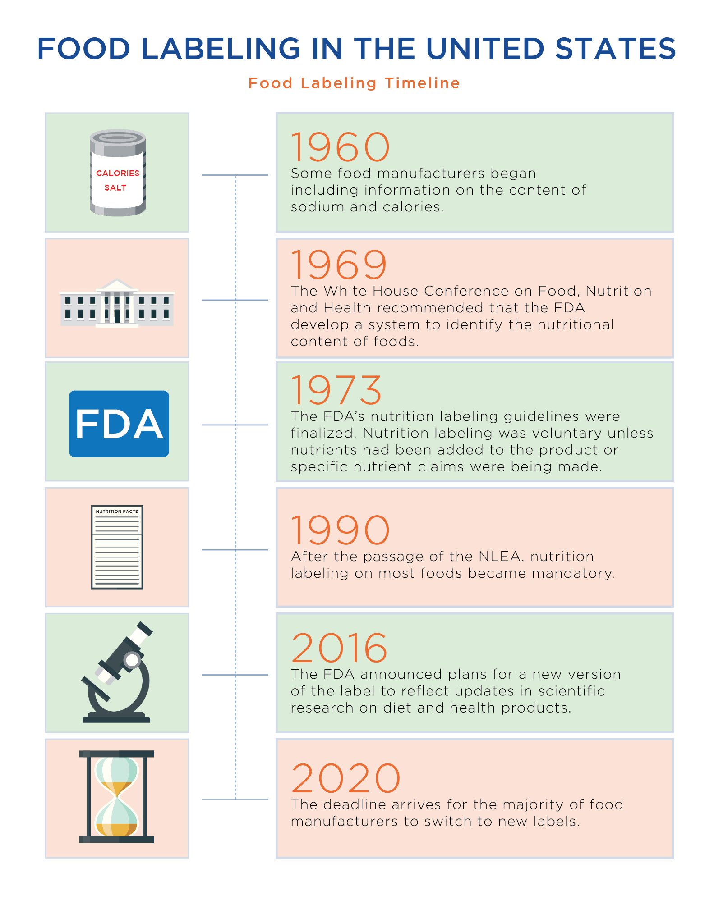

The new nutrition facts label is becoming more common, but consumers will likely see both the old and new label until the beginning of 2020, which is the compliance deadline for the majority of food manufacturers. The following are the key differences between the standard and revised nutrition facts labels (Figures: Standard/Original Nutrition Fact Label and Revised/New Nutrition Fact Label):

* The revised nutrition facts label displays the calorie information in larger and bolder font.
* Calories from fat are no longer required on the revised label.
* The revised label includes both total and added sugars.
* Vitamins A and C are no longer required on the revised label.
* Potassium and vitamin D have been added to the new label.

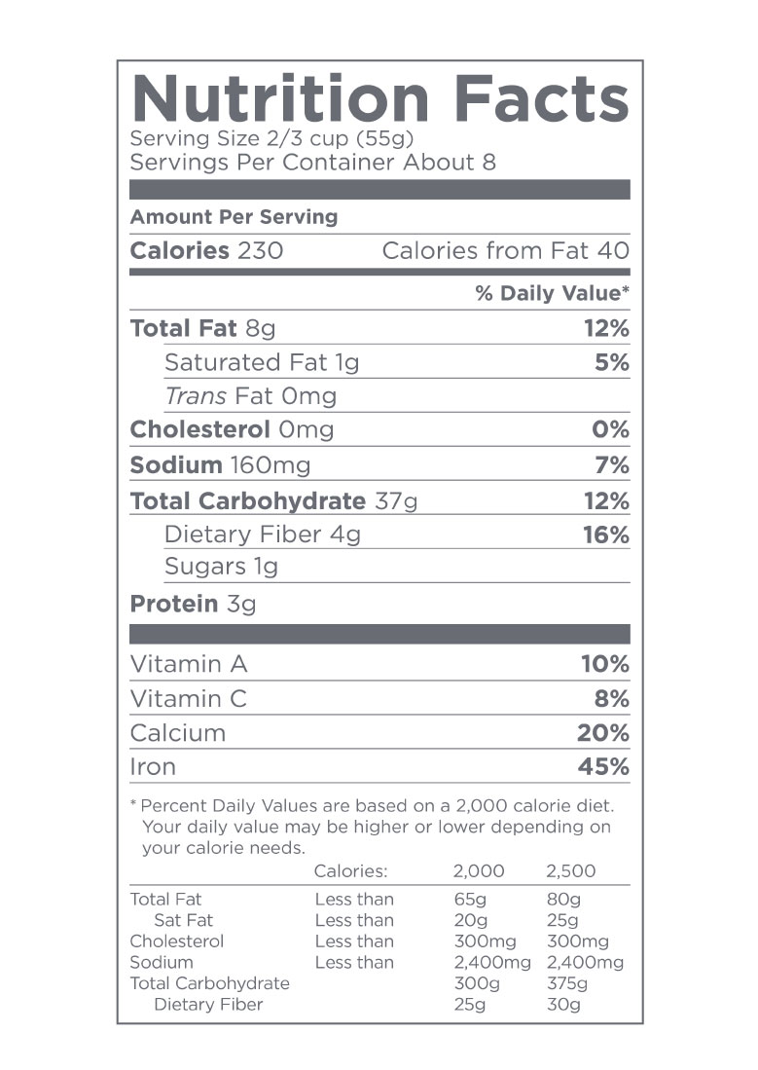

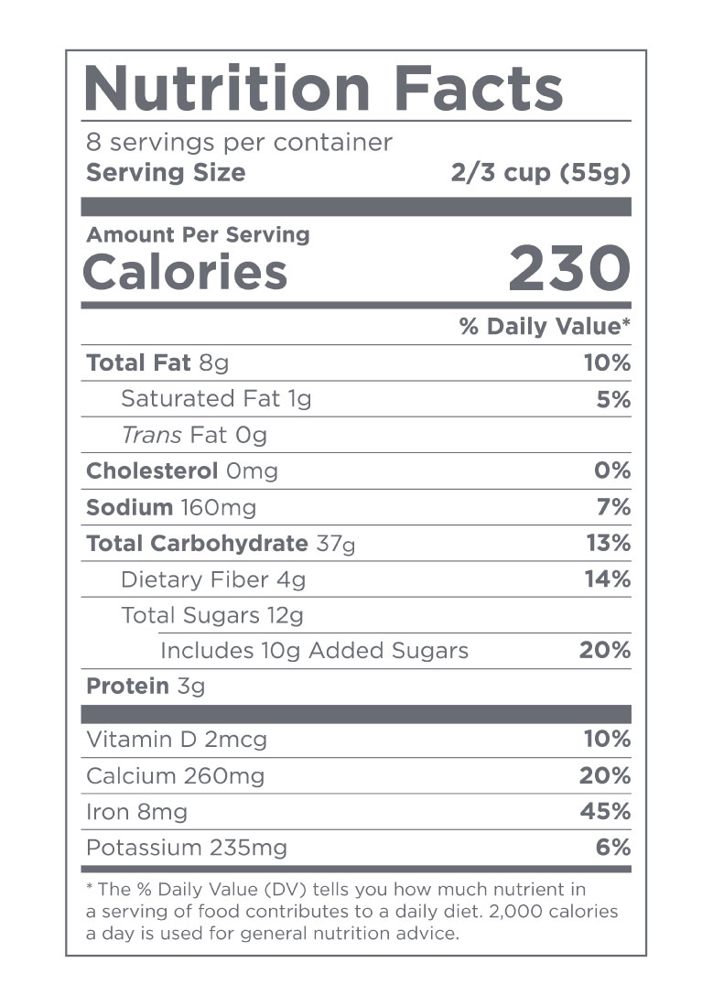

The nutrition facts label is required to display the following information:

* The number of servings per container
* Serving size
* Total calories per serving
* Amount of total fat per serving (in grams), saturated fat (in grams) and trans fat (in grams)
* Cholesterol (in milligrams)
* Sodium (in milligrams)
* Total carbohydrates (in grams)
* Dietary fibre (in grams)
* Total sugars and added sugars (in grams)
* Protein (in grams)
* Amounts and the Percent Daily Value for the following vitamins and minerals: vitamin D (in micrograms), calcium (in milligrams), iron (in milligrams) and potassium (in milligrams)

The prior/standard nutrition facts label required vitamins A and C to be listed, but these are no longer required on the new version of the label (FDA, 2018). Manufacturers may choose to display the amounts of additional vitamins and minerals in the product, but these are not required unless they were specifically added to the product (IOM, 2010).

**Reading the Nutrition Facts Label**

Two key features to look at first on a nutrition label are Servings per Container and Serving Size. The information presented on the nutrition facts label is for the specified serving size of the product, not the entire container, unless explicitly stated as such. Servings per container identifies how many servings of the product are being provided in the package based on the specified serving size. So, if a nutrition label states four servings per container and an individual chooses to consume the entire container, then the information on the nutrition facts label must be multiplied by four to get an accurate representation of what was actually consumed.

Under the revised guidelines for nutrition labelling, food products that contain more than one but less than or equal to three servings must also list the nutritional information for the entire container. This new requirement is designed to allow for the fact that food products with three servings or less *may* be consumed in one sitting. Therefore, providing consumers with information on the nutritional value of the entire container may promote more awareness of the nutritional impact of their choices. On products that have one to three servings, a dual-column label may be displayed.

**Serving size**

The serving size listed on the nutrition facts label is based on the amount of food that individuals are *typically* thought to eat during one sitting. It is *not* a recommended or suggested serving size of the product. Serving sizes for the nutrition facts label were recently updated by the FDA to more accurately reflect what individuals eat in one sitting. These amounts, known as Reference Amounts Customarily Consumed (RACCs), can be found on the FDA website and are intended to serve as reference amounts for food manufacturers to list on the nutrition label.

The serving size on the nutrition facts label is for *information purposes only;* it is not necessarily a recommendation of what an individual *should* be eating. An individual’s portion is what they choose to serve, and this may be *more or less than the serving size* listed on the nutrition facts label. Portion Size will also depend on several factors such as an individual’s calorie needs or activity level and on the type of meal being consumed (breakfast, lunch, dinner or a snack).

Coach's Corner

When reviewing the nutrition facts label with clients, emphasise that the serving size listed is for information purposes only. Individual needs vary, and the client’s portion size may be more or less than the serving size listed.



**Using the Percent Daily Value**

Percent daily values are, essentially, tools to indicate if a product is particularly *high* or *low* in a listed nutrient. They allow a person to figure out if the product is a *good source* of any listed nutrients. The Academy of Nutrition and Dietetics (AND) recommends that consumers generally choose products that provide 5% or less of total fat, saturated fat, cholesterol and sodium, and 20% or more for fibre, vitamins and minerals (AND, 2017). Percent daily values are provided for all listed nutrients on the nutrition facts panel except trans fat, total sugar and protein, as the FDA has not defined recommended daily amounts for these nutrients.

Getting Technical

Current dietary guidelines recommend limiting the amount of trans fat as much as possible; therefore, there are no recommended daily values established for trans fats. There are also no established recommendations for the amount of total sugar to eat in a day; hence, there is no daily value or percent daily value for total sugar. Percent daily values are provided for added sugar, as the current guidelines recommend limiting added sugar to no more than 10% of daily calories.

Because most American adults are not considered to be at risk for low protein intake, a percent daily value for protein is not required on the nutrition facts label unless the product is intended for use by infants and children under the age of 4, or if a specific claim about protein is made on the product (e.g. 'Good Source of Protein').

Try This

Generally, a percent daily value of 5 or less means that the product is low in that particular nutrient, and a value of 20 or more means that it is high in that nutrient. Consumers can therefore use the *5 and 20 rule* to compare products and select those that meet their specific dietary needs and health goals.

Look at the nutrition facts label for a product you regularly use, and review the percent daily value noted for each of the macro- and micronutrients. Using the 5 and 20 rule, determine if the percent daily values are high or low.

**Calories and Macronutrients**

After servings per container and serving size, consumers should look at the total calories provided and the macronutrient composition of the product, which includes the total amount of fat, carbohydrates and grams of protein provided in a serving. The new nutrition facts label displays total calories in much larger font than the old/standard version of the label. This is designed to make it easier for consumers to notice the total calorie content for a serving of the product. As noted earlier, information provided for total calories and each of the listed nutrients is for one serving of the product, unless otherwise specified.

Try This

When looking at a nutrition facts label, there are a number of questions that should be considered when determining if a food is a good choice or not. Consider the following questions each time you look at a label:

Total Calories per Serving– Do these appear excessively high? How many servings would an individual typically eat? Does this support nutritional goals?

Total Carbohydrate per Serving– Is this product high or low in carbohydrates? How many servings would a person typically eat?

Fibre– How many grams of fibre are in a serving? Is this product high or low in fibre?

Total and Added Sugars– How many grams of sugar and added sugar are in the product? Is this product high or low in added sugar? How does this align with nutritional goals?

Protein– How many grams of protein are in one serving of the product? How would this product contribute to protein requirements?

Total Fat and Saturated Fat per Serving– Does this support nutritional goals? Are any other types of fat listed (e.g. trans fat)? Does this product seem high in fat?

Dietary fibre

The nutrition facts label also lists the amount of dietary fibre provided in the specified serving of a product. Some products may additionally distinguish between soluble and insoluble fibre, but this distinction is not required unless a specific claim is made in reference to the fibre content in the product (e.g. “Good Source of Soluble Fibre”).

Total Sugars and Added Sugars

The new nutrition facts label lists both Total Sugars and the amount of Added Sugar provided in a product. As noted earlier, this is a change from the standard nutrition label that just lists total sugars. This distinction allows consumers to identify which products have a large amount of sugar *added in,* and which products contain naturally occurring sugar. Added sugars are those that have been added to the product in the form of sucrose (table sugar), corn syrup, high-fructose corn syrup, maltodextrin or other derivatives. Foods such as dairy and fruit contain *natural sugar* in the form of lactose and fructose; these are naturally present in the food, and have not been added to the product. Added sugars may be found in many products, some of which may seem quite unexpected or surprising. For example, bread, pasta sauce, salsa, flavoured yoghurt and salad dressing all contain some form of added sugar; yet, these are not products that are typically thought of as being sweetened.

Protein

Protein needs for individuals vary based on their calorie needs, activity levels, training volume and intensity and overall health. For this reason, the nutrition facts label does not specify a percent daily value for protein. Once individuals have calculated their protein needs, they can use the nutrition facts label to determine if a particular product provides adequate amounts to meet their goals.

Micronutrients

The main micronutrients required on the nutrition facts label include sodium, potassium, calcium, iron and vitamin D. Some food products may include nutritional information on additional vitamins and minerals. If the food has been fortified with any nutrients, or if the food product makes a claim about any nutrient(s), then they are required to be listed on the nutrition facts label. For all the listed micronutrients, both the amount in milligrams (micrograms for vitamin D) per serving and the percent daily value are provided.

Sodium

Packaged and processed food products often contain large amounts of sodium, because it serves as both a preservative and a flavour enhancer. Most individuals in the United States already consume large amounts of sodium, and excess intake can exacerbate high blood pressure in individuals who are sensitive to sodium. Therefore, paying attention to the sodium content in a food can help individuals make better purchasing choices and monitor how much of a mineral they are consuming.

Vitamin D, Calcium, Iron and Potassium

The new nutrition facts label includes nutrient listings for the amount of vitamin D, calcium, iron and potassium provided in one serving of a food product. The previous/standard nutrition label included information for vitamins A and C, but these are no longer required unless they have been added to a product. The FDA added vitamin D and potassium to the nutrition facts label because many American adults do not always consume adequate amounts of these nutrients in their diet (FDA, 2018). These four micronutrients are required to be listed on the nutrition label as they are considered to be the ones for which most American adults fail to consume the recommended amounts.

Cholesterol

Cholesterol is still listed on the nutrition facts label, but its relevance to an individual’s nutrition requirements and overall health goals may be limited as there is no consistent or direct correlation between dietary cholesterol intake and heart disease (Fernandez, 2012; Ravnskov et al., 2016). Cholesterol is generally found in foods of animal origin, including eggs and dairy products. Thus, most products derived from plant sources (grains, fruits, vegetables, etc.) will likely have minimal to no cholesterol in them, unless an animal product was added to the ingredients.

**Food Labels Outside the United States**

Food labels in other countries, for example, in the United Kingdom (UK) and countries of the European Union (EU), may differ in a few ways from the United States. However, they still provide valuable nutrition information on the energy density and the macro- and micronutrient content of a food product. One of the differences between the nutrition facts label between the United States and the UK/EU is that the US label displays nutrition information for a *specified serving size* of the food product, whereas in the UK and EU, it is provided for a standard 100 grams of a dry product or 100 or 200 millilitres of a liquid product. For comparison, a hundred grams of a dry food product and a hundred millilitres of liquid are both approximately 3 1/2 ounces.

Similar to the United States, the nutrition facts label in the UK and EU lists information for the total amount of energy (calories), total fat, saturated fat, carbohydrates, sugar, fibre, protein and salt in the food product (per 100 grams). In the UK and EU, however, the total energy content is listed in calories and kilojoules and the amounts of fat, saturated fat, sugar, etc., are listed in grams. Of note is that instead of sodium, the UK and EU list the amount of salt in 100 grams of a product (Figure: UK Nutrition Facts Label). As in the United States, any vitamins that have been added to a food product must be listed on the nutrition facts label along with the amount provided in 100 grams of the product.

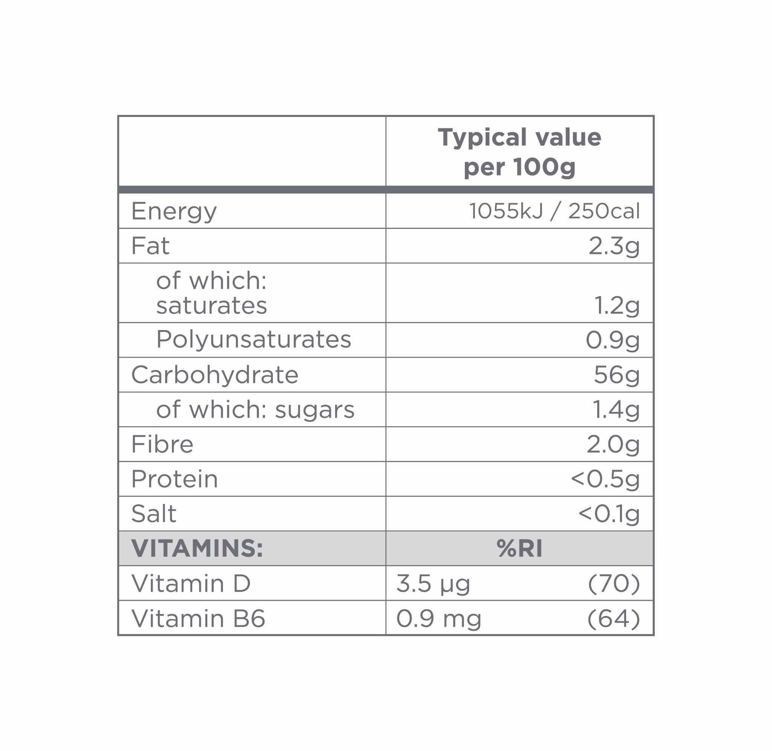

Reference Intakes vs Daily Values

In the EU, nutrition labels will also provide a percent Reference Intake (%RI) on the nutrition facts label, which serves a similar purpose as the percent daily values on a U.S. nutrition facts label (Figure: EU Nutrition Label). The reference intake values are determined by the European Legislation and provide reference recommended amounts for healthy individuals. As with the US percent daily values (%DV), the %RI allows consumers to see how much of a particular nutrient is provided in 100 grams of a product toward the reference intake amount for that nutrient. The goal in providing both the %RI and %DV on labels is to provide consumers with more information on the nutritional value of products, and how they contribute to meeting the recommendations for various nutrients in a diet.

Colour Coding on UK and EU Food Labels

Food Labels in the UK and EU may also provide a color-coded label with information on the amount of fat, saturated fat, sugar, and salt in a product to indicate if it is high or low in these nutrients.

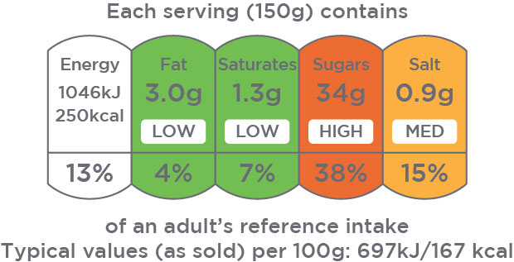

The colour-coded panels are displayed on the front of packages and reference the colours of traffic lights as indicators to *stop*, *go* and *proceed with caution*. A green highlight indicates that the product is low in the nutrient, amber indicates it is a medium source of the nutrient, and red indicates that it is high in the nutrient. This simple system of visual cues can immediately indicate whether a product is generally healthy, or if it is high in nutrients that should be limited or eaten in moderation.

**The Ingredients List**

The ingredient list may perhaps be one of the most important components of a nutrition label; however, it is often also the least used. In the United States, EU and UK, food manufacturers are required to list all ingredients in a packaged food product in *decreasing order of prevalence,* which means that the first ingredient listed is present in the largest amount. Manufacturers are also required to identify common allergens that are in or that may have contaminated the ingredients in the product (FDA, 2013; Gov.UK, n.d.). In the EU and UK, manufacturers are also required to list the percentage of an ingredient in a product if it is mentioned in the name of the product, highlighted or noted on the food label, and/or an ingredient that is typically associated with the product (Gov.UK, n.d.). So, for example, a fruit tart in the EU or UK that is labelled 'Mixed Fruit Tart' would be required to list the percentage of fruit in the product in the ingredient list.

These features make the ingredient list a particularly important tool for evaluating the nutritional value and the contribution of a particular food or food product to an individual’s diet. Without even looking at the nutrition facts panel, the ingredients list can indicate if a product is a whole-food product, a minimally processed product, or one that is highly refined and comprised of multiple ingredients, additives and preservatives.

The following are some questions to ask when looking at the ingredients list:

* What is the primary cause of exertional rhabdomyolysis?
* Which item is listed first?
* Does this correspond with what the product actually claims to be providing?

Coach's Corner

Encourage clients to look at the ingredient list for products they buy, and to select foods with five or less ingredients (not including added vitamins and minerals) and ingredients that they recognise.

Additives in Ingredients Lists

In the United States, the FDA requires manufacturers to list food additives by their common names so that consumers may easily recognise them. For example, the additives sodium benzoate and calcium sorbate would be listed as such in the ingredients list. In the EU and UK, however, additives are assigned an E number using a three- or four-digit code (e.g., E469) and these versus the additive's name are listed in the ingredient list. Even though consumers in the EU and UK may not know which additive an E number corresponds to, they can still identify that a product has additives in it. In the United States, consumers may not be familiar with the names of some additives but, as noted previously, they can still aim to select products with *short, identifiable* ingredient lists, and thus avoid buying products with many additives and processed ingredients.

**Nutrient claims**

Some products may include various nutrition terms on the label to signify that the product is a 'good source of' a particular nutrient or 'low' in another nutrient. The FDA maintains strict guidelines on the use of these nutrient terms. If consumers see these on food products, they may be assured that the product meets the regulatory standards for the term in use. These nutrient terms are typically displayed on the Primary Display Panel (PDP) of a food label. The more-common nutrient terms and their meanings are provided in Table: Product Nutrition Claims.

Product Nutrition Claims

| **Nutrient Term** | **Definition** |
| --- | --- |
| Low Calorie | Contains 40 calories or less per serving |
| Calorie Free | Contains less than 5 calories per serving |
| Low Cholesterol | Contains 20 milligrams or less per serving and 2 grams or less of saturated fat per serving |
| Cholesterol Free | Contains less than 2 milligrams of cholesterol per serving |
| Low Fat | Contains less than 3 grams of fat per serving |
| Reduced Fat | Contains at least 25% less fat per serving than the regular product (for a similar serving size) |
| Low Saturated Fat | Contains 1 gram or less of saturated fat per serving and no more than 15% of calories from saturated fat |
| Saturated Fat-Free | Contains less than 0.5 grams of saturated fat per serving and no greater than 0.5 grams of trans fat per serving |
| Fat Free | Contains less than ½ gram of total fat per serving |
| % Fat Free | Contains X% non-fat macronutrients by weight (e.g., 98% fat-free) |
| No Trans Fat | Contains less than 0.5 grams of trans fat per serving (does not mean completely free of trans fats) |
| No Sugar | Contains less than ½ a gram of sugar per serving |
| No Added Sugar | Contains no added sources of sugar (but may still contain a large amount of natural sugar, e.g., dried fruit) |
| Low Sodium | Contains less than 140 milligrams of sodium per serving |
| Very Low Sodium | Contains less than 35 milligrams of sodium per serving |
| No Salt Added | Contains no added salt (may still contain sodium if naturally in the food) and must state that it is not sodium free |
| Sodium Free | Contains less than 5 milligrams of sodium per serving |
| Light/Lite | Contains 50% less fat or sodium or 1/3 fewer calories than the regular product (for an equal serving size) |
| Gluten Free | Contains less than 20 parts per million (ppm) of gluten* |
| Certified Gluten Free | Certified by an independent organization to contain less than 10 ppm of gluten per serving |
| *The FDA allows products to be labeled Gluten-Free if they are inherently free of gluten, meaning they do not contain wheat, rye, barley, or any hybrids of these grains. Gluten-free products may still contain less than 20 ppm of gluten (AND, 2017; Celiac Disease Foundation, n.d.). | |

Guidelines in the EU and UK also provide reference ranges for nutrition claims (based on 100 gram serving sizes), to indicate whether a product is low or high in certain nutrients. Table: Reference Amounts in the UK lists some of the common reference amounts to determine if a product is high or low in fat, saturated fat, sugar and salt.

Reference Amounts in the UK

| **Nutrient** | **Reference Ranges** |
| --- | --- |
| Total Fat | Low in Fat: Contains 3 grams fat or less per 100-gram serving  High in Fat: Contains more than 17.5 grams of fat per 100-gram serving |
| Saturated Fat | Low in Saturated Fat: Contains 1.5 grams or less of saturated fat in 100-gram serving  High in Saturated Fat: Contains more than 5 grams of saturated fat per 100-gram serving |
| Sugar | Low in Sugar: Contains 5 grams or less of total sugars per 100-gram serving  High in Sugar: Contains more than 22.5 grams of total sugar per 100-gram serving |
| Salt | Low in Salt: Contains 0.3 grams or less of salt per 100-gram serving  High in Salt: Contains more than 1.5 grams of salt per 100-gram serving |

Health Claims on Nutrition Labels

Some food labels may include a health claim, which states that consumption of the product or its components may help in reducing the risk of a certain disease or health issue. For example, many oatmeal packages display the health claim that “as part of a healthy diet, soluble fibre from foods such as oatmeal may help reduce the risk of heart disease.” These types of health claims are reviewed by the FDA and are only allowed on food labels if there is Significant Scientific Agreement (SSA) to support their use (FDA, 2006) or if they are considered to be a Qualified Health Claim, which requires specific language and terminology in order to be approved for use on food labels. Approved Health Claims include statements related to the following:

* Calcium and vitamin D intake and a reduced risk of osteoporosis
* Dietary fats and cancer
* Fruits and vegetables and cancer
* Folic acid and a reduced risk of neural tube defects
* Sodium and hypertension (high blood pressure)
* Soluble fibre and a reduced risk of heart disease.

After reviewing the nutrition facts label and the ingredients list, take a look at some of the products you have at home. Are there any products that you might have reconsidered purchasing after reviewing the nutrition label and ingredients?

**Additional Nutrition Terms seen on Food Labels**

Food labels may also contain various other popular terms that may influence a consumer’s purchasing decisions. Terms such as *Natural*, *Non-GMO*, *Cage-Free*, *Organic* or *Certified Organic* on a food label may encourage consumers to select a particular product. However, it is important to note that not all of these terms are necessarily meaningful. Of the terms listed above, organic and *certified organic* are the most meaningful in conveying verifiable standards to the consumer. Use of the term *organic* is regulated by the US Department of Agriculture (USDA), which defines three categories for organic labelling:

* 100% Organic: The product contains only organic ingredients, i.e., those produced using organic standards (not including water and salt).
* Organic: The product contains at least 95% organic ingredients (not including water and salt).
* Made with Organic Ingredients: The product contains at least 70% organic ingredients. The remaining 30% are still subject to various standards, including the use of non-genetically modified organism (Non-GMO) ingredients.

Various other terms, such as *natural,* may also be displayed on food labels and can make a food item appear to seem healthy or nutritionally superior to its counterparts. However, most of these terms are not regulated by the FDA and have no clearly defined standards. For example, the term *natural* is often found on many food labels (natural ice cream, natural yoghurt, natural flavouring, etc.), but it is notoriously misleading as it has no real meaning. Yet, it can lead consumers into buying products by making them seem healthier than those that are not labelled as such. Table: Additional Popular Food Label Terms provides a listing of other popular terms that may influence consumer purchasing decisions.

Additional Popular Food Label Terms

| **Term** | **Meaning** |
| --- | --- |
| Cage-Free (on poultry products) | Chickens had access to roam outside the cage; there is no guarantee that they did. |
| Grass-Fed (on beef products) | Fed grass versus grain or corn for primary source of food, no government standards or regulation. |
| Natural | No true definition, meat and poultry cannot contain artificial ingredients, colors, or preservatives. |
| Pasture Raised | Spent time on pasture or outdoors for a period of time, no clear indication of how much time, and no government standards or regulation. |

## Supplement Facts Labels

Dietary supplements include any products that contain a dietary ingredient. They are taken by mouth to supplement an individual’s diet. This includes vitamins, minerals, amino acids, protein powders, herbs, enzymes and other botanical products (FDA, 2015). The nutrition label for dietary supplements is called a supplement facts label, and it differs in a few ways from the nutrition facts label applied to foods and food products. The use of dietary supplements has grown tremendously since the 1970s (Bender et al., qtd. in IOM, 2005) and, with the growth in both the industry and consumer use of dietary supplementation, there was a need for clear labelling and a defined role for the FDA in its regulation. The Dietary Supplement and Health Education Act (DSHEA) of 1994 addressed this need. It also marked an important moment in defining dietary supplements and outlining the FDA’s role in regulating them.

**Supplement Label Requirements**

By law, as defined in the DSHEA, dietary supplement labels must display the name of the supplement, the net quantity (amount) of the supplement, the nutrition labelling (supplement facts label), the ingredient list, and the name and place of business of the manufacturer or distributor (FDA, 2005). The supplement facts panel differs slightly from the nutrition facts label in a few ways. As with the nutrition facts label, the supplement facts label must include the serving size and servings per container. However, servings per container may be omitted if it is the same as the total (net) quantity provided in the container.

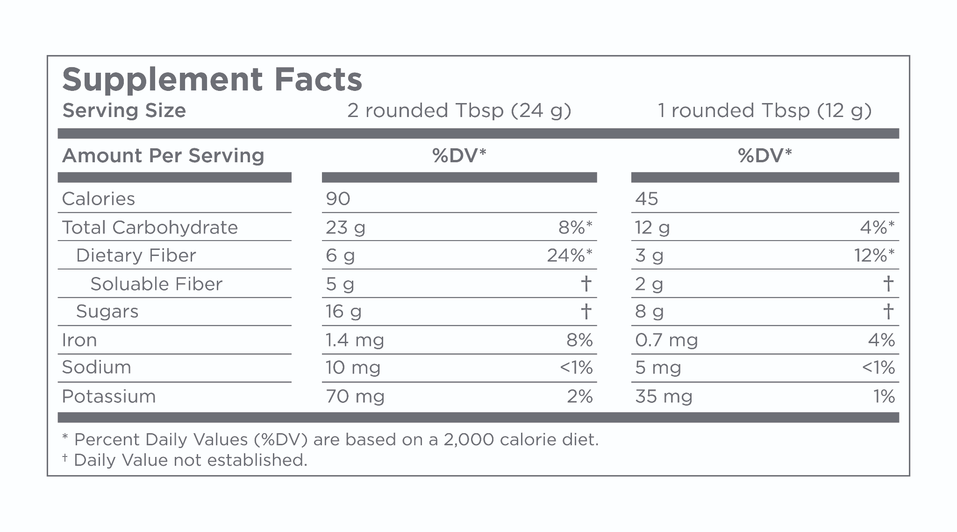

For example, if the serving size for a supplement is one capsule and there are 100 capsules in the container, then the servings per container is also 100 and does not need to be specified on the supplement container (FDA, 2005). (This differs from the nutrition facts label where servings per container is required in all cases.) As with the nutrition facts label, the nutrient information provided on the supplement facts label is for the specified serving size. In cases where multiple serving sizes may be recommended (for example, at different times of the day), nutrient information may be provided for each specified serving size.

**Nutrient Listing on Supplement Labels**

As on the nutrition facts label, the supplement facts label must list information on the following values/nutrients when they are present in measurable amounts (any amount greater than zero). If these nutrients are *not* present in any measurable amount in the supplement, they may be omitted from the supplement facts label.

* Total Calories
* Calories from Fat
* Total Fat
* Saturated Fat
* Cholesterol
* Sodium
* Carbohydrates
* Dietary Fibre
* Sugar
* Protein
* Vitamins A and C
* Calcium and Iron

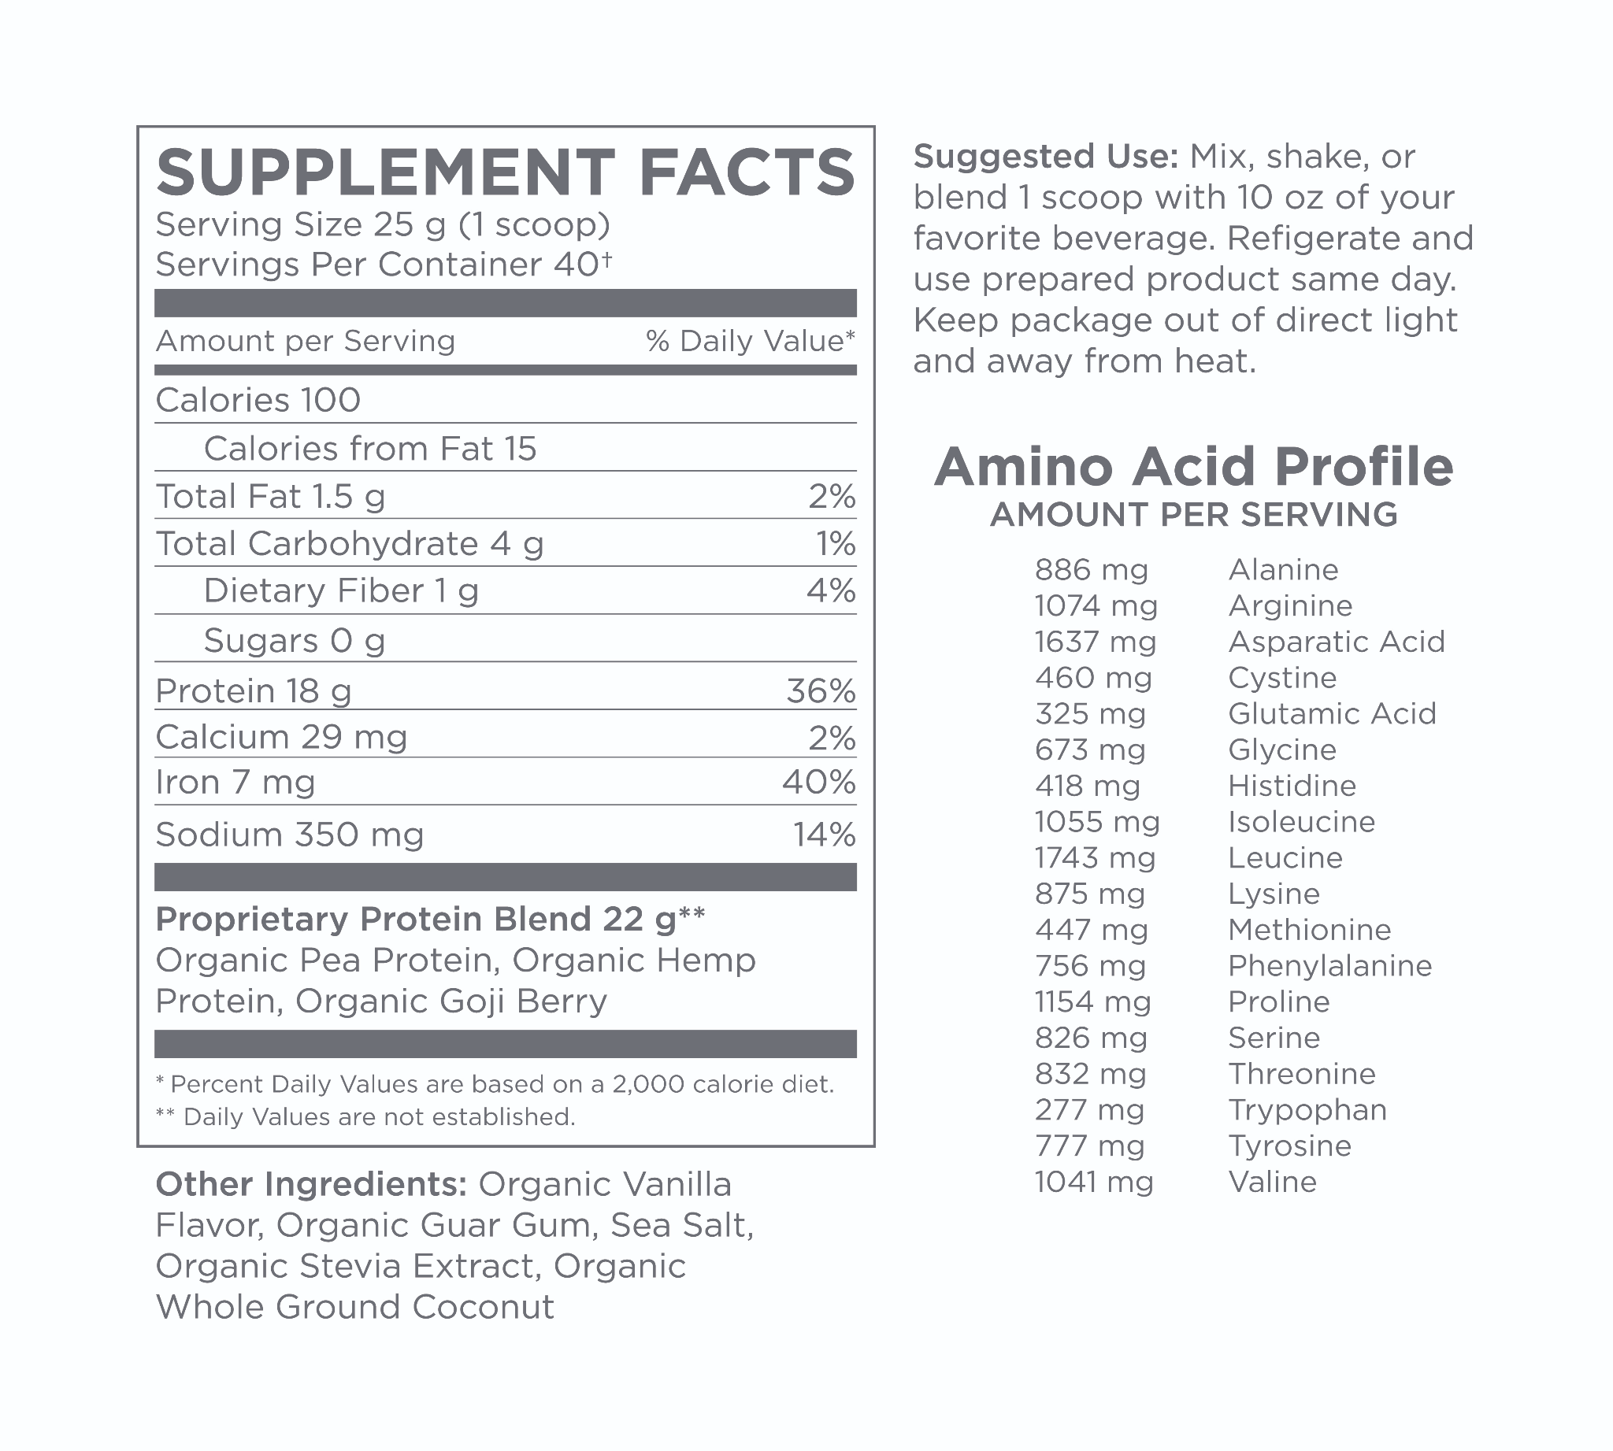

Amounts for other vitamins and minerals *must* be listed if they are specifically added to the supplement or if a claim is made about them on the dietary supplement label. Similarly, information on calories from saturated fat and information on any other nutrients such as polyunsaturated fat, monounsaturated fat, soluble fibre, insoluble fibre, sugar alcohols, etc., must be listed *if* the supplement includes any claims about them, or if they were *added* to the product.

Supplement fact labels can also differ slightly depending on the *supplement type*. For example, Figure: Protein Supplement Label is a supplement facts label from a brand of protein powder. Note the serving size, servings per container and the amounts provided for each nutrient listed: calories, calories from fat, total fat, total carbohydrates, dietary fibre, sugars, protein, calcium, iron and sodium. Amounts for vitamins A and C are not listed, because they are not present in any measurable amount. Because the supplement is a protein blend and claims to provide all the essential amino acids, it must also list all the amino acids provided on the supplement label.

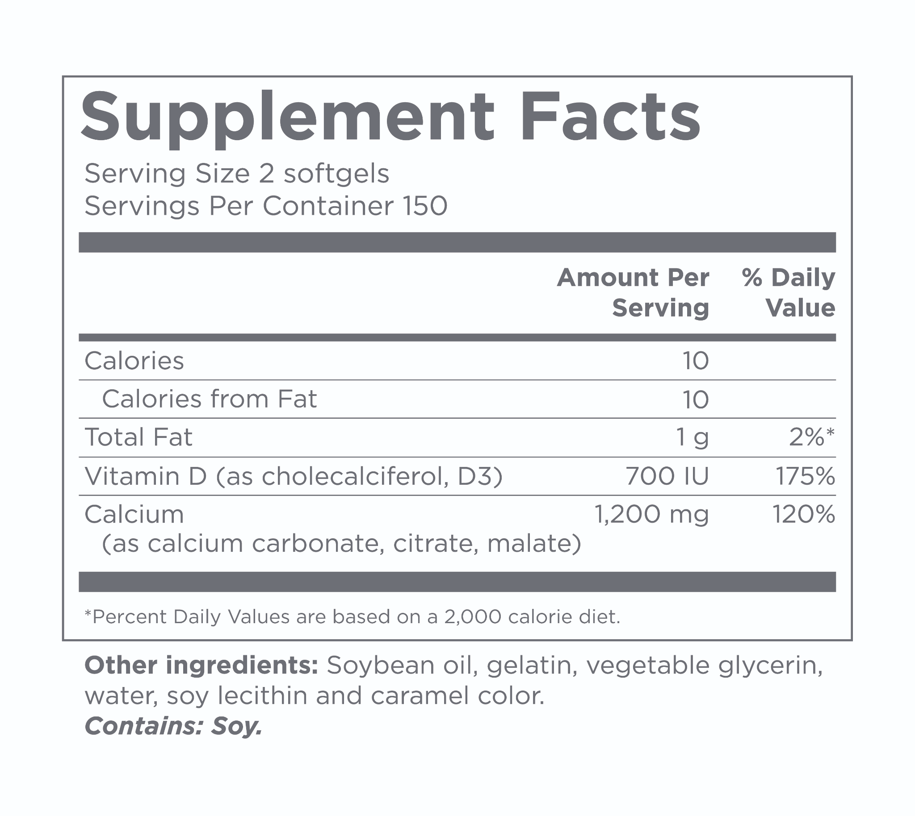

In contrast, Figure: Calcium Supplement Label is a supplement label for a calcium and vitamin D supplement and it only lists information for calories, calories from fat, and the amounts of vitamin D and calcium provided in one serving. Carbohydrates, sugar, fibre, protein and vitamins A and C have been omitted due to an insignificant amount of each being present.

As with the nutrition facts label, serving size should be one of the first areas of focus when reviewing a supplement facts label, as the information presented applies to the specified serving. Consumers may choose to use more or less of the serving listed based on their individual needs, but understanding the information presented will remain crucial in making an informed decision. With all supplements, consumers should assess the nutritional value of the product, and the amount of the nutrient(s) provided per serving in relation to their particular needs and the context in which they are using the supplement.

Look at the supplement facts label for a protein shake and answer the following questions:

* What is the serving size?
* How many grams of protein are provided in one serving?
* How does this amount compare to your daily needs for protein?
* How does this compare to your client’s daily needs for protein?
* In what context are you or your client using the supplement?
* Does the serving size provide an appropriate amount for you or your client’s needs within that context?

It is important to review the serving size for any vitamin, mineral or herbal supplement, as the information presented is for only the serving size listed and not necessarily for one full unit/dose of the supplement. Failure to read the supplement facts and note the serving size can lead to incorrect dosing and inadequate or excess consumption of the supplement.

**Percent Daily Value**

The supplement facts label also indicates the percent daily value (%DV) for all ingredients for which the FDA has defined a daily value (with the exception of protein). The percent daily value is omitted for certain nutrients (total fat, saturated fat, cholesterol, carbohydrates, fibre and various vitamins and minerals) if the supplement is intended for use by children under 4 years of age or by pregnant or lactating women (FDA). As on the nutrition facts label, the percent daily value provides an indication of how much of a particular nutrient is provided in one serving of the supplement toward the recommended daily value of that nutrient (based on a 2000 calorie diet).

If the percent daily value for a nutrient has not been established, then a symbol and note stating 'Daily Value Not Established' is listed in the %DV column for that nutrient. The percent daily value column should be interpreted in a similar manner as the %DV column on a nutrition facts label. Some dietary supplements will provide "well over 100% of the Daily Value" for one or more nutrients, which may or may not be appropriate for an individual’s needs.

Many supplements will provide well over 100% of the daily value for a nutrient. These should be reviewed in the context of an individual’s diet and nutritional needs, as well as for how the body processes each nutrient.

For example, vitamin D supplements typically provide well over 100% of the %DV. This is because the absorption of vitamin D supplements by the body is highly inefficient. Even though a pill may have over 1000% of the average person’s vitamin D needs, nowhere near that amount will actually be absorbed into the bloodstream when taken orally. For that reason, medical professionals often recommend supplementing vitamin D in much higher quantities than other nutrients. However, remember that this should only be done under doctor’s orders when a deficiency is identified.

For other supplements, high dosages may be inappropriate, unnecessary and sometimes even dangerous. Always consider the context and the need for a supplement in an individual’s diet, and work with clients’ physicians to understand what nutrients they may be deficient in.

**Supplement Labels outside the United States**

Supplement labels in the EU and UK are fairly similar to those in the United States. However, supplements in the EU (and some other countries) that contain any vitamins and minerals will list the percent nutrient reference value (%NRV) instead of using the term %DV (Figure: Nutrient Reference Values). Values for the NRV and RDA are essentially the same; the change in nomenclature from RDA to NRV in the EU/UK is for EU labelling guidelines. Similar to the %DV in the United States, the %NRV indicates what percentage of the recommended amount of a vitamin or mineral is provided in the specified serving (and/or 100 grams) of a dietary supplement. Consumers can use the %NRV to evaluate a dietary supplement and see how it contributes to their daily needs for a vitamin or mineral, and how it may fit into the context of their diet.

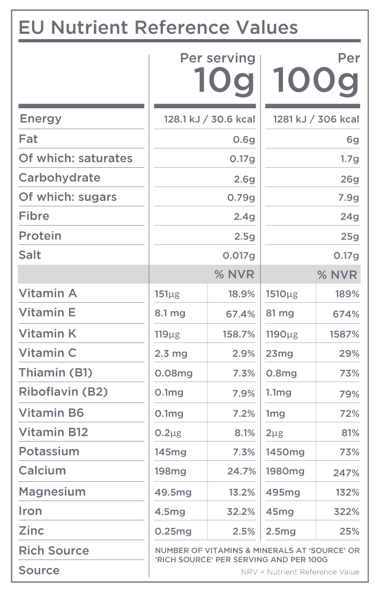

## Portion sizes

Over the years, portion sizes have been steadily increasing. What used to be a large-sized drink or side dish at restaurants is now often a medium or small-sized order on modern menus. We live in a time with unprecedented access to food with advertisers trying to convince everyone to eat their company’s products on billboards, TV and online constantly, throughout each day. In this environment, it can be quite difficult to control food intake with so many temptations and mixed messages coming from every angle. To help better understand this often-overlooked subject, methods for healthy portion size control will be discussed.

**Serving size vs portion size**

As noted previously in reviewing the nutrition facts label, the terms *serving size* and *portion size* may appear synonymous to many consumers. However, they actually have two different meanings.

The *serving size* for a food or food product is typically a specific quantity that serves as a reference amount for the nutrition content and value of that food. It is not necessarily the amount of food that an individual *should* eat in one sitting, as the latter depends on multiple factors such as an individual’s needs, activity level, current weight status and goals, health status and any medical issues.

A *portion* is the amount of food or food product that an individual chooses to put on their plate or consume in a sitting. An individual’s portion *may be more or less than the standard serving size* for a food item, depending on various factors such as their needs, the type of food being consumed, the eating occasion and other components of the meal in question.

**Portion distortion**

As mentioned before, portion sizes of commonly consumed foods have increased significantly, and this phenomenon has been partly implicated in the rise in obesity rates since the 1970s and 80s (Trust For Americas Health, 2018; Busko, 2017; Ledikwe, 2005; Young, 2002). These rising portion sizes may have contributed to an increase in average caloric consumption for each individual, likely due to the fact that when presented with larger amounts of food, people tend to eat more. (Rolls, 2014; Zlatevska et al., 2014; Ledikwe et al., 2005).

Larger portion sizes have also likely distorted what many individuals now consider to be a normal portion of food (NHLBI, 2013). For example, consider that 20 years ago, a regular bagel was 3 inches across in diameter and a regular hamburger was approximately 4 1/2 ounces by weight; whereas currently, a normal bagel is 6 inches across in diameter and a regular hamburger at a restaurant is 6 to 8 ounces by weight (NHLBI, 2013).

Restaurant portions have also increased significantly over the past few decades (NHLBI, 2013). Figure: Changes in Portion Size highlights the changes and the increase in normal portion sizes for popular foods over the past few decades. Therefore, providing consumers with guidelines on appropriate portion sizes of foods and meals may help with addressing the problem of portion distortion and excess caloric consumption.

**Portion distortion in social media**

Social media platforms are another area in which food portions may be exaggerated. Images of oatmeal and smoothie bowls, toast slathered with peanut butter, pancake stacks with drizzles of syrup, and salads garnished with multiple toppings can all *appear* to be healthy and appetising. However, in many cases, the portions and garnishes are exaggerated for photographic purposes and are not necessarily reflective of appropriate portions for an individual. In many cases, the image may appear to feature one serving of a food item, but it may be large enough for two or three servings. Being aware of serving sizes and appropriate portion sizes, and being able to estimate servings and portions with common visual cues can be effective tools for individuals seeking to manage their diet and weight. A Nutrition Coach can help clients learn about appropriate servings and portion sizes, and how to estimate these at mealtimes or when dining out.

Ask clients to provide an estimation of their own portions at meals. Are their portions balanced or exaggerated for any food groups? Discuss the concepts of portion distortion and portion control with clients in relation to their health and weight-management goals.

**Weight management and portion control**

Portion control plays a significant role in weight management. Weight management is a complex area but studies have shown that portion control, along with managing overall diet quality and the energy density of foods consumed, can play an important role in managing weight (Kling et al., 2016; Rolls, 2014; Melanson et al., 2012; Pedersson et al., 2007). For individuals seeking to manage their weight, one effective strategy is to manage portion sizes at meals and snacks, especially of higher calorie and energy-dense foods.

When it comes to managing the quantity of food eaten, there are many different approaches to managing portions. One approach promoted by the USDA and supported by the Academy of Nutrition and Dietetics (AND), as well as various educational organisations, is to use the USDA MyPlate guide.

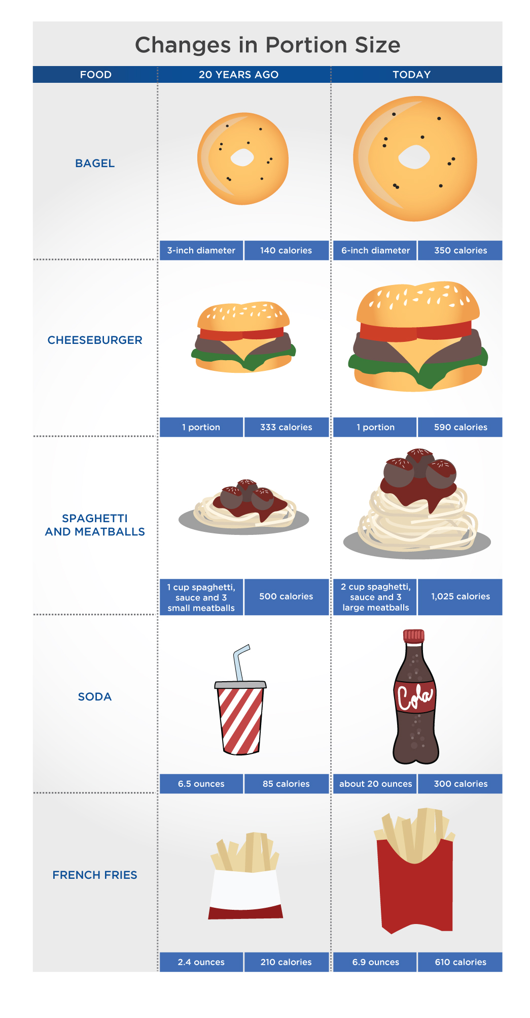

The USDA MyPlate provides a visual guideline to appropriate portion sizes for the food groups protein, grains, vegetables and fruit, by indicating how each group should ideally be structured on a plate. MyPlate recommends that grains and vegetables comprise just over a quarter of a plate each, and fruits and protein foods each take up just under a quarter of the plate. Put differently, fruits and vegetables should make up half a plate at meals, and protein and grains/starch should make up a quarter each. The Harvard School of Public Health has a similar version called the Healthy Eating Plate.

Similar to the USDA’s MyPlate, the Harvard Healthy Eating Plate uses the image of a plate to convey appropriate portion sizes for the different food groups, but it differs in a few important ways. The Harvard Healthy Eating Plate recommends a larger portion for vegetables and a slightly larger portion for protein compared to the USDA MyPlate.

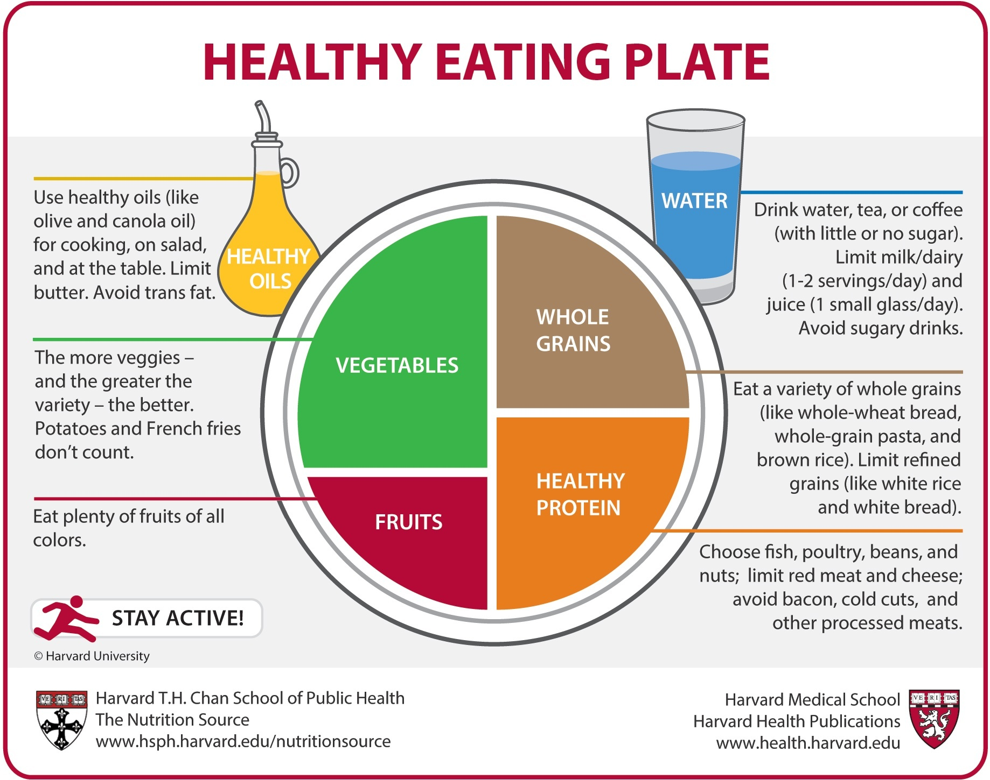

The Harvard Healthy Eating Plate also provides more specific nutrition guidelines for each food group. For example, the grains group is labelled Whole Grains to reinforce the recommendation for consuming mostly whole grain products. The protein group is labelled Healthy Protein to denote healthier sources of protein versus more processed and fattier sources. Each food group also has an associated paragraph that outlines the types of foods that are recommended within each category. In addition, the Harvard plate includes recommendations to include healthy oils, water and physical activity as part of an overall healthy eating plan.

Both images do not indicate a *specific* portion size for foods within each group, so there is no specified amount in ounces or grams for protein, grains, fruit, vegetables or oils on either plate. However, both images still demonstrate the concepts of portion control and portion management through the relative spaces according to each food group on a plate. They simply simplify the process of managing relative portions of food on a plate without the need to measure food in ounces or grams. For some consumers, this simplified plate image may be easier to follow than having to approximate quantities for each food item.

**Plate size**

The USDA MyPlate and the Harvard Healthy Eating Plate may not be helpful for portion control if plate sizes are very large. Research has shown that plate size can affect the amount of food individuals consume at a sitting (Holden et al., 2016). People tend to serve themselves and consume larger portions from bigger plates and bowls than from smaller dishes. One solution to help with overall portion control is to use smaller plates at meals. Using a 7- or 9-inch plate instead of one that is 11 or 12 inches in diameter will limit the total amount of food that can be placed on the plate, and may also make food portions appear larger, creating the illusion of a larger serving size.

This may be an effective strategy with individuals who want to control portions, but also have a tendency to fill their plate at meals. Another solution for managing portions is to learn how to approximate appropriate portion sizes of foods using common visual cues such as the palm of a hand, a fist, a tennis ball, etc. This strategy can be used to estimate portion sizes regardless of the plate size.

**Portion Control Guide**

Portion sizes will, of course, depend on the size, gender and activity level of each individual. Smaller, less-active individuals will require smaller portions at meals, and larger or more-active individuals may need larger portions of some or all of the food groups. While portion sizes depend on an individual’s needs, it is useful to be able to approximate *common* serving and portion sizes using popular visual cues, and then adjust for individual requirements as needed. One of the easiest props to use for portion control is an individual’s own hand. Infographic: Common Portion Sizes provides easy visual approximations for common portion sizes in each of the food groups. Serving and portion sizes for many commonly eaten foods can also be estimated using other visual cues such as objects around the house

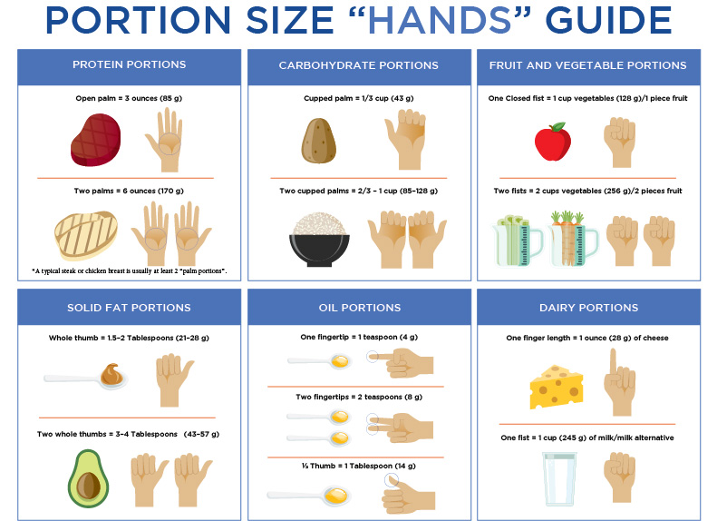

**Measuring servings and portions**

Some individuals may choose to use specific utensils, such as measuring cups and spoons, to estimate serving and portion sizes of foods. This is certainly an option, but attention must be paid to how the utensil is filled. For example, a heaping tablespoon of peanut butter has approximately twice the fat and calories as a level tablespoon of peanut butter. Similarly, a heaping 1/2 cup of rice may have double the calories of a level 1/2 cup. When food portions are measured out using cups and spoons, it is generally recommended to use level amounts. The exception to this is if the measurements are being made for a recipe that specifies the use of *heaping* spoons or cups of an ingredient.



## Portion sizing in the UK and EU

In the UK and EU, portion recommendations are typically provided in grams and millilitres, but also in common food-serving sizes (e.g., tablespoons or food amounts), and may differ slightly from the United States. The British Dietetic Association’s (BDA) website provides a comprehensive list of portion sizes of various foods. Some of the more-common foods in each of the food groups and appropriate portion sizes are provided in Table: Portion Recommendations in the UK. Again, these are *reference* portion sizes for the average healthy adult in the UK based on a 2000 calorie diet. Individual needs may vary depending on the age, gender, health and activity level of a person. In some sense, the term *portion* as used in the UK recommendations may be more synonymous with US *serving sizes,* as the actual amount/portion of food an individual serves themselves *may be more or less than the amounts* listed below and will depend on an individual’s specific needs.

Portion Recommendations in the UK

| **Food Group / Food** | **Portion Size (Visual Approximation)** |
| --- | --- |
| Protein  Meat/Poultry  Fish  Eggs  Beans/Lentils/Chickpeas  Soy Protein (Tofu/Tempeh)  Nuts/Nut Butter | 60–90 grams (size of a deck of cards)  140 grams (palm of hand)  2 eggs  150 grams (4 tablespoons)  100 grams (4 tablespoons)  30 grams (1 tablespoon) |
| Carbohydrates  Bread  Pasta/Rice (Cooked)  Potatoes (Cooked)  Cold Cereal  Hot Cereal (Uncooked) | 1 medium slice  2–3 tablespoons  1 medium baked potato or 2 egg-sized new potatoes (boiled)  3 tablespoons  3 tablespoons |
| Vegetables  Peas/Carrots/Mixed Vegetables/Corn  Tomatos/Peppers | 80 grams (3 heaping tablespoons)  80 grams (1/2 pepper or whole tomato) |
| Fruit  Berries/Grapes  Apples/Pears/Bananas/Oranges  Small Fruit (Kiwis/Plums/Apricots) | 80 grams (small handful or 10–12 grapes)  80 grams (1 medium-sized fruit)  80 grams (2 pieces of fruit) |
| Dairy  Milk (or Non-Dairy Alternate)  Yogurt  Cheese (Hard) | 200 milliliters (1 glass)  125 grams (3 tablespoons)  30 grams (matchbox- or chess-piece size) |
| Oils/Fats  Oil  Solid Fat (Butter/Spreadable Butter) | 3 grams (1 teaspoon)  5 grams (1 teaspoon) |

he Nutrition Facts label and the ingredients list on packaged foods are important tools in enabling consumers to make healthy food choices. They provide consumers with key information about the nutrient content and the components in a food item, and also allow consumers to compare different products and choose the most appropriate one for their needs and goals. Similarly, the Supplement Facts label on dietary supplements provides information on the nutrient content and composition of these products, and enables consumers to make informed decisions regarding supplementation.

Portion control remains an important aspect of maintaining a healthy diet and weight, but it is also an area that is a challenge for many individuals. Portion guidelines, either in the form of a healthy plate template or visual cues to approximate appropriate portion sizes, can help individuals maintain a well-balanced diet, meet their nutrient needs, and manage their weight goals. Remember when reading nutrition labels and managing food portions that *serving size* and *portion* refer to two different things. The serving size for a food item is a specific quantity that serves as a reference amount for the nutrition content and value of that food, while a portion is what an individual chooses to serve him or herself. Portions will depend on various factors such as age, gender, activity level, health status and hunger levels during the day.

Providing clients with the knowledge of how to read nutrition and supplements facts labels is an important step in helping them make healthier choices about their food and supplement purchases, and helping them to choose the most appropriate products for their health and fitness goals. Helping clients understand how to determine appropriate portion sizes for different food groups can help them take control of their own diet and manage their own portions at meals.

In this chapter, you learned about:

* Accurately reading and interpreting Nutrition Facts and Supplement Facts labels.
* Percent Daily Value (%DV) and other standard Nutrition Facts label terms.
* Health claim rules and regulations for food product labels.
* Interpreting ingredients lists.
* Government-determined portion size standards.
* Estimating portion sizes based on parts of the hand and common household items.

# Helping clients navigate the real world

Navigating the real-world food environment can be overwhelming for several reasons — from the variety of food products that are available today, to busy lifestyles, hectic schedules, social settings and media promotions of new products on the market. This material can be intimidating, but it does not have to be. With some planning and preparation, clients can learn how to navigate a variety of social, work and household settings, to make healthy eating a priority and seamlessly work it into their lifestyle. Some situations that can be challenging when it comes to making healthy food choices include the following:

* Navigating the grocery store
* Dining out
* Holidays, parties and social events
* Food/meal preparation
* Travel
* Snacking.

One of the most important strategies to practice is to *plan and prepare* ahead of time. This strategy can apply to any scenario that poses a challenge to making healthy food choices — from the grocery store, to dining out, travel or social events. Planning ahead, whether this involves creating a shopping list prior to a grocery trip, selecting recipes for the week ahead, or looking at a restaurant menu ahead of time, can help individuals maintain some control over their food choices. Planning ahead of time can help individuals set themselves up for success.

This autonomy and sense of ownership can be a powerful motivator and tool for ensuring continued success. Table: Plan-Ahead Strategies for Healthy Eating in Various Scenarios lists some of the ways in which clients can plan ahead for various situations that may be challenging when it comes to eating healthy. The following sections in this chapter go into greater detail on each of these situations, and the strategies that clients can employ in each case.

Plan-Ahead Strategies for Healthy Eating in Various Scenarios

| **Scenario / Situation** | **Plan-Ahead Strategies** |
| --- | --- |
| Grocery Shopping | * Select recipes/meals and foods in advance. * Write a grocery list. * Avoid shopping at busy times. * Avoid shopping when hungry. |
| Dining Out | * Look at the menu ahead of time. * Call in advance to request accommodations. * Request substitutions or alternates at the restaurant. * Have an idea of what to order ahead of time. |
| Parties/Holiday Events | * Let the host know in advance of any dietary restrictions. * Offer to bring a healthy dish. * Have a light snack prior to the event. * Set a drink limit ahead of time. |
| Travel | * Pack heathy, non-perishable snacks for the journey. * Research some restaurants at the destination ahead of time. * Write out a list of healthy meals to stick to at restaurants. * Look up one or two local grocery stores at your destination. * Write a list of healthy foods to obtain at the local store and stock up on arrival. |
| Between-Meal Snacks | * Write out a list of healthy snacks to stick to: both sweet and savory. * Prepare and pack snacks ahead of time for the week. * Keep a healthy snack (non-perishable) at your desk or in your bag for hunger emergencies. |

**Grocery shopping**

With the growth of the food industry over the last few decades, grocery stores have expanded to become food meccas. While navigating through aisles with innumerable food options making healthy food choices can be overwhelming. Consumers also have different habits when it comes to grocery shopping. Some consumers may have a clearly defined list of what they want to buy and do not stray from their list, while other consumers may not have a list or may have a general idea of what they want but then succumb to impulse purchases based on 'what looks good'.

In addition, other factors such as time constraints, hunger signals, and the grocery store’s placement of products on shelves and point-of-display areas can influence consumer purchasing decisions (Breugelmans et al., 2005). All of these factors play a role in what consumers decide to put in their shopping trolleys, purchase and consume.

Coach's Corner

Ask clients how they navigate grocery store aisles. Do they use a shopping list or buy products that are convenient or look appealing? Do they ever shop when they are hungry? Does this lead to impulse purchases? How many of the scenarios listed above sound familiar at the grocery store?

The following are two important strategies in navigating a grocery store and making healthy food choices:

* Recognising and avoiding common pitfalls
* Planning ahead

Planning ahead for the grocery store can be as simple as making a shopping list and scheduling a day and time to make the trip. Scheduling and planning for a grocery trip can help consumers avoid multiple trips to the store, and can also help to avoid the risks associated with shopping while hungry.

Shopping while hungry has been associated with an increased likelihood of impulse purchases of high-calorie foods, especially high-calorie snacks (Nederkoorn et al., 2009). Shopping lists can serve several purposes: visual reminders of items that need to be purchased, organisation, staying within a budget, and avoiding impulse or last-minute purchases. Using a shopping list at grocery stores is associated with better diet quality, an increased likelihood of meeting recommendations for important nutrients and maintaining a healthy weight (Dubowitz et al., 2015; Crawford et al., 2007; Perez-Cueto et al., 2010; Qi et al., 2000, qtd. in Dubowitz et al.)

A shopping list can also be an effective tool in planning *navigation* around a grocery store and minimising the amount of time spent backtracking across the store.

**Grocery store navigation**

In general, grocery stores tend to place fresh produce and whole, minimally processed items along the perimeter of the store, and place more processed, packaged products in the centre aisles. While not all packaged foods are unhealthy, many items (such as sugary breakfast cereals and granola bars, crisps, cookies, snack crackers and sweets) can be calorie dense and can contain excess amounts of added sugar and/or sodium.

While the occasional consumption of these foods may fit into an individual’s diet, excess consumption of these high-calorie foods *could* contribute to undesirable weight gain if it places an individual in a caloric surplus. Many processed foods (such as granola bars, cookies, candy, etc.) can also be easy to overeat due to generally lower fibre content. In addition, many items contain few nutrients apart from added sugar and carbohydrates (unless they have been fortified with vitamins and minerals). A diet that is based on large amounts of calorie-dense, processed foods and that contains few whole foods such as fruits, vegetables and lean proteins could be high in excess calories and also low in many micronutrients.

Centring a shopping trip primarily along the perimeter of the store can help consumers stay focused on buying whole, unprocessed foods as the mainstay of their diet. It may also help them avoid the temptation to pick up excess amounts of refined and snack-food items, which tend to be located in the centre aisles. One way to plan for this is to write a grocery list that focuses on whole food items located along the perimeter of a store, and to list any products located in centre aisles toward the bottom of the list.

**Shopping list by recipe**

Another way in which to organise a grocery list is by recipe and then by food category. This is a two-step process that may be helpful for individuals who like to use recipes and/or plan specific meals for the week ahead of time. With this approach, individuals may select two or three recipes for the week ahead and note the specific ingredients required for each. These ingredients are then grouped together in one list that is organised by food categories (as in the Sample Grocery List Template). Listing similar items together in specific food categories, such as produce, dairy, seafood, etc., can help streamline the shopping experience and make it more efficient.

A haphazard or disorganized list (or lack of a list) can lead to back-tracking across a grocery store for forgotten items. This is not only inefficient but can also expose consumers to more products in the store (as they backtrack through it) and increase the amount of time that they spend in the store. Both of these behaviours, in-store travel distance and length of time in the store, have been associated with an increased likelihood of making unplanned purchases (Hui et al., 2013; Bell et al., 2011).

Try This

Grocery lists can be organizsd in several different ways, depending on individual preferences. One way is to organise it by ingredients needed for recipes that are planned for the week. Another way is to list foods by category and write down staple items that need to be purchased in each (e.g. dairy, meat, seafood, vegetables, fruit, etc.).

Try creating a grocery list for the week ahead. Do you prefer creating a list of staple foods that you eat frequently and need to stock up on, or do you prefer to use recipes and shop by ingredients needed?

Try creating a list both ways. Do you prefer one method over the other, or a combination of both ways?

**Recognising and avoiding pitfalls at the grocery store**

Even with a shopping list, various factors can still influence an individual’s choice of food products, and some factors can turn into pitfalls that lead to unhealthy food choices. One of these factors is hunger. Grocery shopping while hungry can increase the likelihood of impulse purchases and the likelihood of buying higher-calorie food items (Nederkoorn et al., 2009). This is because hunger plays a role in food choices, and the physiological need for food may overpower an individual’s initial goal of choosing healthy foods.

Satisfying internal hunger signals prior to shopping may help to reduce the risk of impulse and unhealthy food purchases made purely out of the physical need for food. Another strategy to avoid impulse purchases while hungry is to adhere to a prepared grocery list. Clients who find themselves shopping while hungry could also ask themselves if the product they are purchasing is one that they would buy on a regular basis, or if it is something that they just picked up because they are hungry. Being able to distinguish between *regular* versus *impulse* *purchases* may help clients monitor their own behaviour and avoid buying unhealthy items out of pure hunger.

**Product placement at the grocery store**

One pitfall that consumers may encounter is being influenced by product placement and marketing at a grocery store. As noted earlier, grocery stores tend to place packaged, processed foods and snack items in the centre aisles. Some studies on consumer purchasing decisions also show that people tend to buy products that are placed at eye-level and those that are easily accessible on shelves (Breugelmans et al., 2005). In reality, these may not necessarily always be the most nutritious items.

Consumers should review the nutrition information of products that they select and compare different brands to select the item that best meets their needs. Items that are located on higher or lower shelves *may* end up being better choices than those that are easily accessible. Taking the time to review the nutrition information for these products will be key in making a healthy choice.

Many stores may also highlight particular products at a point-of-display area in order to encourage consumers to buy these items, often placing smaller, snack foods such as sweets, chocolate and crisps at the checkout. These marketing strategies draw attention to popular food items, and are typically aimed at promoting product purchases. Not all stores feature product displays, but being aware of such marketing strategies in advance can help consumers remain cognisant during a trip to the store and avoid being swayed by heavily promoted junk foods and/or impulse buys. As noted earlier, an effective strategy to avoid being distracted and influenced by product promotions is to create a shopping list and stick to it (refer back to the Sample Grocery List Template).

**Shopping in bulk at warehouse stores**

Many individuals may opt to shop at large warehouse stores for major food items and staples, and then supplement any minor needs from a local store during the week. Buying items in bulk can be a cost-saving strategy, especially for families, and many large warehouse stores offer a wide variety of healthy food choices (such as produce, lean proteins, starches and whole grains) for lower prices than local food stores. However, it is also easy to buy bulk quantities of food items that may not fit in a nutrition plan (such as junk foods, sugary beverages, cookies, sweets, crisps, etc.).

Buying large quantities of unhealthy foods has the effect of making them easily accessible and available at home, and the increased availability of unhealthy snack foods at home has been associated with an increased intake of these items (Campbell et al., 2007, qtd. in Pearson et al., 2012; Bogart et al., 2017). A smarter strategy is to buy bulk quantities of healthier food items: produce, lean proteins (including frozen options), whole grains and dairy, and buy small packages of any processed snack food items (such as sweets, crisps, etc.), *if necessary*, from a local grocery store.

**Dining out**

Dining out can present many challenges when it comes to making healthy food choices, and this may be an area that presents the most difficulty for many individuals. Dining out can encompass a variety of situations. This section highlights several different dining out scenarios, identifies the challenges presented by each, and provides simple yet tangible strategies that consumers can employ in each situation to help them make healthy food choices.

Dining frequency and occasion

Eating at a restaurant can add several hundred extra calories to an individual’s day for a variety of reasons. Restaurant portions are sometimes large and can lead to excess intake. Meals may be prepared with extra sauces, fats and rich gravies that can add extra calories; also, dishes may be coated in butter prior to serving (both for flavour and improved presentation). This can also add extra calories and fat to a meal. For example, one tablespoon of butter or oil has 100 to 120 calories and 12 to 14 grams of fat. A study by researchers at the Johns Hopkins Bloomberg School of Public Health suggested that, in general, consumers tend to eat fewer calories when they cook at home versus dining out (Wolfson, 2015). Research also indicates that since the 1980s and 90s, there has been a rise in the number of meals that adults and children eat away from home and that this may be associated with less-desirable nutritional outcomes (Kant, 2004; Glanz, 2007).

Other studies suggest that the increase in dining away from home may be one of the contributors to the rise in childhood obesity rates (Nicklas et al., 2001). Thus, dining out frequently *can* lead to the consumption of excess calories; however, this does not mean that dining out is off limits to anyone who wants to eat healthy. It does mean that clients may need to be more mindful of their portions and selections of food and drinks when dining out.

There are two main considerations for dining out: the frequency of dining out and the dining occasion (Figure: Considerations for Dining Out). Eating outside of the home on a frequent basis is a risk factor for a higher intake of calories and fat, and a lower intake of micronutrients (Lachat et al., 2011). Therefore, if individuals dine out on a very frequent basis, they may wish to be more diligent about planning ahead and paying attention to choosing healthier food options. In contrast, individuals who rarely eat out and only do so on special occasions, may wish to indulge and enjoy themselves without being excessively concerned about making healthy choices at the meal. An occasional splurge or treat will not necessarily derail an otherwise healthy diet and can, in fact, be a very healthy, mental break from a structured eating plan.

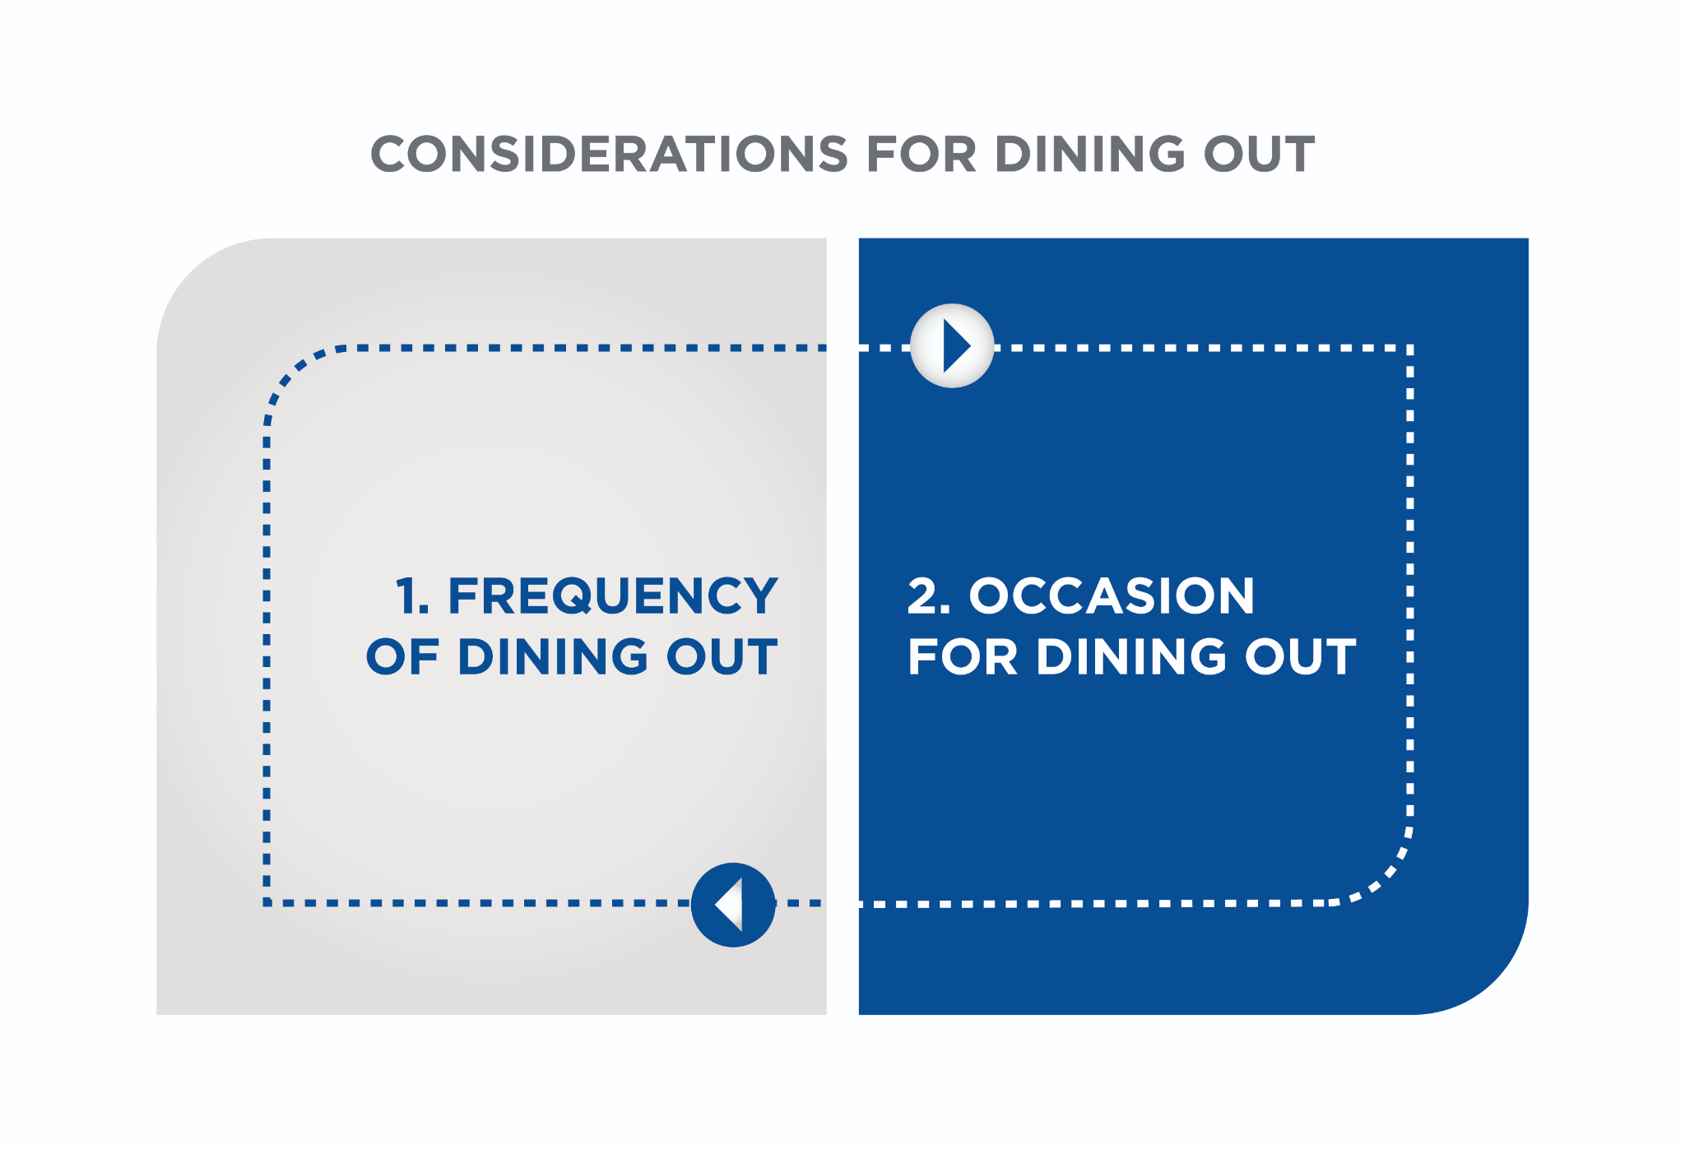

The occasion should also be considered when dining out. Every dining out occasion does not *need* to be an indulgence, but some special occasions may very well deserve to be enjoyed without an excessive concern over healthy food choices. For example, major life events like one’s own wedding, the wedding of a close friend or family member, an important birthday, a Bar Mitzvah or a graduation are all special occasions that mostly happen once in a lifetime. As such, these events need to be weighed in the full context of the nutrition plan, as a smart nutrition plan should allow for these life events.

(Note that individuals who may be monitoring their weight and wish to maintain healthy food choices regardless of the occasion can still follow the strategies outlined in subsequent sections of this chapter.)

**Dining at restaurants**

Despite the fact that restaurant meals can be more calorie dense than home cooked ones, it *is* still possible to make healthy food choices and avoid excess calories at restaurants. The following are some simple tips and strategies that can make this possible.

When possible, look at the menu ahead of time

Most restaurants have their menus posted online, either on their website or on an external site that features customer reviews. Reviewing the menu in advance can allow an individual to plan ahead and select a few options that fit within their nutrition plan. This can help them to avoid the pressure of having to make a quick decision at the restaurant, and reduce the risk of being influenced by the choices of others at the table. It also gives an individual a greater sense of control over their food choices for the meal.

Avoid arriving at the restaurant excessively hungry as this may increase the risk of overeating. If the meal is scheduled for late in the evening, a light protein and fibre-based snack (such as some sliced low-sodium deli meat with vegetables or tuna on whole grain crackers) may help to stave off excess hunger prior to dinner. Protein, in particular, can help to promote satiety (Westerterp-Plantenga et al., 2012; Ortineau et al., 2014) and so a protein-based snack may be optimal for delaying hunger.

Look for key words on the menu that indicate how a dish is prepared

In general, the healthiest preparation methods will be those that minimize added oils and fats and avoid charring the food (meats and poultry) (Table: Cooking Methods).

Thus, the options on a menu that are the lowest in calories and added fats are generally dishes that are poached, steamed, roasted or broiled (without added fats).Grilled foods are generally lower in calories and added fats than fried foods, but restaurants may slather extra fat on grilled, broiled or roasted meats and fish to keep them moist. Similarly, baked dishes may sound healthy but they can be baked in heavy sauces or in a pastry crust, both of which are calorically dense. One of the best ways in which to avoid extra fats or oils from being added to dishes is simply to request that the dish be prepared *dry,* or with *no added oil or butter*.

Cooking Methods

| **Cooking Method/Preparation** | **Description** |
| --- | --- |
| Braised | Food is sautéed first and then cooked at a lower temperature in liquid. |
| Broiled | Food is cooked by exposing it to a source of radiant heat at a high temperature (higher than for roasting). The heat source may be a grill, oven with a broiler feature, or live coals. The heat source is typically above the food, though not always, and the food is turned during cooking. |
| Baked | Food is cooked using convection heat in an oven. It may be precooked and finished in the oven or prepared entirely in the oven. Food may be baked dry or in a liquid/casserole and may or may not include a sauce. |
| Battered | Food is coated in batter and then deep-fried at a high temperature. |
| Creamed | The food has been prepared by simmering or poaching it in milk or a cream-based liquid. |
| Crispy | Typically refers to food that has been fried – It may or may not be coated in a batter. Some crispy foods may be baked rather than fried but this may not always be stated. |
| Fried | Food is deep-fried in oil. |
| Grilled | Food has been cooked using dry, radiant heat directly applied to the surface of the food (e.g., on a grill pan or on a grill over coals). Fat may be added to the food during the process. |
| Oven-Baked/Roasted | Food is baked dry or roasted in the oven. |
| Pan-Fried | Food has been fried in a small amount of oil or other fat in a pan. |
| Poached | Food has been cooked in liquid (either water or wine) at a lower temperature than used for simmering and with no added fat. |
| Sautéed | Food is cooked at high heat in a small amount of fat in a shallow pan. |
| Simmered | Food has been cooked in hot liquid at a temperature below the boiling point of water. |
| Smoked | Food (usually meat) has been cooked by exposing it to smoke from a burning or smoldering substance (usually wood). |
| Smothered | Food (usually meat) is browned on the stove and then cooked at low heat covered in gravy in a covered pan. |
| Steamed | Food has been cooked in steam, possibly in a small amount of water, with no added fat. |
| Stir-Fried | Food is cut into small pieces and then cooked in a small amount of hot oil in a wok while being stirred continuously. |
| Tempura | Food that is battered and deep-fried. |

Getting Technical

Charring is a method of cooking that creates a burnt or blackened crust on the outer surface of a food. Most foods (such as meats and vegetables) can be charred by cooking them over an open flame or at a high temperature on a stove. Charring meats, fish and poultry can lead to the production of substances called heterocyclic amines (HAs) and polycyclic aromatic hydrocarbons (PAHs). Both of these are chemicals that have been associated with DNA changes (NIH, 2017).

In studies done on lab rats, both HAs and PAHs were associated with the development of breast, colon and prostate cancers (Sigumar et al., 2004). However, the doses fed to the rats were extremely high and much larger than the amounts an individual would typically consume through their diet (NIH, 2017). Some studies have found that the increased consumption of well-done meats was associated with an increased risk of colon cancer (Cross et al., 2010; Chiavarini et al., 2017), but other studies have found no such association (Bylsma et al., 2015; Le et al., 2016). Nevertheless, it may still be optimal to avoid excess intake of charred meats, poultry and fish to avoid the excess consumption of HAs and PAHs.

Ask for sauces, dressing and/or cheese on the side

Many seemingly healthy dishes, such as salads and stir-fries, can be smothered in a high-calorie dressing or sauce and/or be loaded with several hundred calories worth of cheese. With these types of dishes, requesting the dressing, sauce and/or cheese on the side allows a consumer to control how much of the high-calorie condiment they want to use. In many instances, a small amount of dressing, sauce or a flavourful cheese is enough to add flavour to a dish, and it is usually not necessary to add the entire amount that is provided.

Use a plate for shared appetisers

Appetisers like nachos, wings and tortilla chips that are presented on a large plate or platter can be easy to overeat before the arrival of the main courses. Using an appetiser plate and portioning out an individual serving of these foods can help individuals keep track of how much they are eating.

Avoid the bread basket or limit to one piece

Many restaurants provide a complimentary bread basket at the table. The bread can be a great accompaniment to the meal, but it is also easy to mindlessly eat multiple servings of this item, adding a few hundred calories to the meal even before the main dish arrives. As with shared appetisers, using a plate and limiting the bread to one piece or portion can help individuals manage their intake. If the main dish already contains a starch, then it may be preferable to avoid the bread basket completely.

Balance calories from alcohol and dessert

Calories from alcohol and dessert can add up very quickly, particularly if multiple drinks are consumed during the course of and prior to dinner, and if a higher-calorie dessert is selected. Many desserts can be very high in calories, depending on the amount and type of ingredients used. For example, desserts like chocolate mousse, chocolate cake, tiramisu and cheesecake are made with cream, sugar, butter, eggs, etc., all high-calorie ingredients; therefore, one serving can contain several hundred calories.

With these higher-calorie items, clients may want to consider whether they want both alcohol and dessert and, if so, moderate their portions. One option might be to select *either* alcohol or dessert with the meal, but not both. Another option may be to share the dessert with other individuals at the table. In either case, being mindful of the higher-caloric contribution of alcohol and dessert can help individuals make informed choices, while still enjoying the experience of dining out.

Set a limit on alcohol

Alcohol calories can add up quickly when dining out. For example, one 5-ounce (150 ml) glass of white wine has 121 calories, a 1.5-ounce (45 ml) glass of rum has approximately 97 calories, and 12 ounces (350 ml) of light beer has around 110 calories. These are among the lightest drinks to have, but calories in mixed drinks and cocktails are typically much higher due to the addition of juice, mixers, syrups and garnishes (such as sugar rims and sweetened fruit).

Setting a limit of one to two drinks *before* arriving at the restaurant can help individuals plan ahead, and thus, stay in control of their own healthy eating goals. Consider the serving size of the drinks, as well as the calorie information. For some drinks, such as a daiquiri, the calories may not appear to be very high. However, the calories noted for one in Table: Calorie Counts of Popular Alcoholic Drinks are for only 3.5 ounces (100 ml). A daiquiri (and many other drinks) served at a bar may be much larger and contain several times the calories.

Calorie Counts of Popular Alcoholic Drinks

| **Beverage** | **Size** | **Calories** |
| --- | --- | --- |
| Light Beer | 12 oz. (355ml) | 110 |
| Regular Beer | 12 oz. (355ml) | 145 |
| Craft Cider | 12 oz. (355ml) | 150 |
| Gin or Vodka | 1.5 oz. (45ml) | 96 |
| Rum | 1.5 oz. (45ml) | 97 |
| Coffee Liqueur | 1.5 oz. (45ml) | 137 |
| White Wine | 5 oz. (145ml) | 121 |
| Red Wine | 5 oz. (145ml) | 125 |
| Dry Dessert Wine | 3.5 oz (90ml) | 157 |
| Red Dessert Wine | 3.5 oz (90ml) | 165 |
| Bloody Mary | 4.6 oz (136ml) | 120 |
| Daiquiri | 3.5 oz (104ml) | 229 |
| Margarita | 3.5 oz (104ml) | 254 |
| Mimosa | 4 oz. (120ml) | 75 |
| Mint Julep | 4.5 oz (135ml) | 165 |
| Mojito | 3.5 oz (104ml) | 169 |
| Pina Colada | 3.5 oz (104ml) | 242 |
| Rum and Coke | 8 oz (235ml) | 173 |
| Rum and Diet Coke | 8 oz (235ml) | 100 |
| Tequila Sunrise | 6.8 oz (200ml) | 232 |
| Gin and Tonic | 8 oz (235ml) | 161 |
| White Russian | 8 oz (235ml) | 568 |

Enjoy the company

Dining out can seem to be all about the food (and at times it may be), but it is also important to enjoy other non-food related aspects of the meal: the atmosphere, the ambiance and the opportunity to socialise with your dining companions. Slowing down and enjoying the occasion and the company can also enhance the experience of the meal, and can help individuals avoid eating too quickly and potentially too much.

**Meeting friends at the bar**

The bar scene can make it difficult to choose options that fit into a nutrition plan. However, it is still possible to maintain healthy eating habits in these situations by following a few simple rules and tips:

1. Set a drink limit: As with dining out, decide on the number of drinks planned for consumption *before* arriving at the bar. Setting a limit of one or two drinks ahead of time can help individuals stay in control of their diet and their goals.
2. Start with water or a non-alcoholic drink: Starting off with water or a non-alcoholic drink such as sparkling water serves a dual function: it enables individuals to hydrate before having any alcohol and also allows them to feel that they are engaging with the rest of the company without *having* to get an alcoholic beverage straight away.
3. Avoid drinking on an empty stomach or if hungry: Alcohol is absorbed more quickly on an empty stomach than if there is some food present. Drinking on an empty stomach can contribute to feeling ill/drunk much quicker, and may also impair an individual’s ability to make good decisions regarding healthy food choices. It is preferable to eat a meal or a protein and carbohydrate-based snack *prior* to having a drink.
4. Choose protein-based and vegetable appetizers at the bar: Bar food can be calorie dense, particularly when it comes to fried and breaded options such as wings, French fries, chips, mozzarella sticks, nachos, etc. However, there are usually some lower-calorie options listed on the menu or available on request (Figure: The Healthiest and Least Healthy Bar Foods to Order). Many protein-based appetisers that are not fried (such as chicken tenders, chicken satay/skewers, sliders and prawn cocktail) are lower in calories than their fried and breaded counterparts, and can be healthier choices. Bars will usually also offer crudités (for example, with wings) or a vegetable platter with a dip (such as hummus, a bean dip or dressing); both are lower-calorie options. Another alternative is to request a side salad with a protein such as grilled chicken or prawns. Many bars will happily accommodate simple requests if asked. The following figure provides a list of some of the healthiest bar foods to order, and also which items to avoid.

**Choosing healthy lunch options**

Packing lunch for work is usually easier to fit into a nutrition plan (and cheaper) than buying lunch, but with busy schedules, it often becomes necessary to buy lunch during the work week. Most of the time, it is useful to keep things simple and consider if the meal includes healthy options for the three macronutrients: protein, carbohydrates, and fat.

Table: How to Choose a Healthy Meal provides a step-wise workflow through the process of choosing a healthy meal whether it is breakfast, lunch, or dinner.

How to Choose a Healthy Meal

| **Process** | **Questions to Consider** |
| --- | --- |
| 1. Pick a protein. | * Is it lean? * If not, is there a leaner version that is cooked differently? (Is it grilled or poached versus fried?) * Is it an appropriate portion size? If not, can you request a smaller portion or save a portion for later? * Is there adequate protein? If not, can you request a slightly larger portion? |
| 2. Pick at least two vegetables. | * Are vegetables available with the lunch option? Are they included in the meal? * Can you request additional vegetables either on the side or to be added to the meal? * How are the vegetables prepared? Are they raw or cooked? If cooked, are they prepared in a healthy manner: grilled or roasted versus fried? * Are the vegetables breaded or covered in a sauce? Can you request sauce on the side? |
| 3. Pick a healthy, high-fiber starch. | * What are the starch options available for the meal? * If grain-based, is it a whole grain or a refined grain? * How much starch does the meal provide? * Is it an appropriate portion? If in excess, can you request a smaller portion or save some for a later time? * Is starch prepared in a healthy manner? Does it contain added fat (oil, butter, or cheese)? |
| 4. Pick a healthy fat. | * Is fat included in the preparation of the meal? * Is a healthy fat part of the meal? * If not, what options are available–olive oil, avocado, nuts, seeds? * Is the amount a healthy portion? If not, can you request less or request it on the side? |

As with dinner, when selecting lunch options it is important to consider how a food is prepared, the portion provided, and the addition of extra calories through sauces, dressings, cheese and other higher-calorie additions, such as croutons, wontons and tortilla strips. Many individuals choose a salad as a lower-calorie lunch option, but then either do not add any protein or nutritious fat source to complete the meal *or* add too many high-calorie items (such as cheese, cream, nuts, seeds, dressings, dried fruit, etc.), and end up with more calories than if they had ordered a cheeseburger.

Adding protein to meals not only increases meal satisfaction but also prolongs satiety (Ortineau et al., 2014; Westerterp-Plantenga et al., 2012). Healthy fats such as olives, olive oil, avocados (all good sources of mono-unsaturated fats) and nuts (such as almonds and walnuts) can enhance the flavour of meals and aid in the absorption of fat-soluble vitamins. They are also associated with a reduced risk of cardiovascular health (when combined with overall healthy food choices) (Willett, 2006; Kris-Etherton et al., 2008). However, they are higher-calorie items and portion control remains important. Appropriate portions of these healthy fats may be five to six olives, 1 to 2 teaspoons of olive oil (as a dressing), and 1/5 to 1/4 of an avocado.

Another important consideration is the nutrient density and nutrient quality of the meal. Does it include an *adequate amount* and a *variety* of nutrients through the inclusion of vegetables, protein and healthy fats, or is it a predominantly carbohydrate and fat-rich meal?

Getting Technical

Nutrient Density and Nutrient Quality seem very similar, but actually refer to two slightly different concepts.

Nutrient Density refers to the amount of nutrients provided by a food or meal relative to the total calories in the meal. A meal or a food item that is nutrient dense provides a large amount of nutrients for fewer calories. Examples of nutrient dense foods are most fruits and vegetables, which contain many vitamins, minerals and phytonutrients, and are fairly low in calories. A nutrient-poor food might be soda or sweets; both are high in calories, but provide very few nutrients.

Nutrient Quality refers to the amount and variety of nutrients provided in a food or meal. A meal or food that provides a variety of nutrients in large amounts can be considered to be of high nutrient quality. For example, a large salad that includes a variety of greens, colourful vegetables, a lean protein source, a whole grain and one or two sources of healthy fats (such as olive oil and/or avocado) is both nutrient dense and of high nutrient quality. A cupcake is calorie dense, but is of low nutrient density and low-nutrient quality, because the primary nutrients it provides are carbohydrates and fat.

Coach's Corner

Ask clients how often they eat lunch out and what options are available to them. How do they select their lunch (and dinner) options?

Do they buy lunch and other meals depending on what they feel like eating, on what is available, or for other reasons?

Do they consider the nutrient density and/or quality of their meals?

**Social eating**

Holidays, family events and parties are wonderful occasions to socialise and connect with family and friends, which is also an important aspect of staying healthy and happy. They can, however, present various challenges with making healthy food choices, and this can be overwhelming for individuals who are trying to manage their weight or have specific health or fitness goals.

As noted earlier, special occasions *should* be enjoyed without excess anxiety over making healthy food choices. However, multiple social events and parties during the holiday season can lead to excess caloric intake for many individuals and increase the risk of weight gain. This section provides some tangible and practical guidelines on how to navigate social events and parties, and still make healthy food choices in each circumstance.

**Holidays and parties**

One of the best ways in which to stay on track with healthy eating during the holidays and at social events is to plan ahead.

Contact the host ahead of time and let them know of any dietary restrictions or allergies.

Offer to bring a dish if it is a potluck. Some options include a salad, a fruit platter or vegetable tray, or a healthy side dish. By offering to bring a dish, this guarantees that there will be at least one healthy option from which to choose. This may also be helpful for other guests who may be seeking a healthier alternative too.

Eat lightly (but do *not* starve) on the day of the party or event. Many individuals often think that if they have a big event or party scheduled for the evening, they should starve themselves or avoid eating anything for the entire day to 'stay within their calories' or because they know they will be 'overdoing it' later. This is NOT the best strategy, as undereating or starving over the course of the day can increase the likelihood of overeating out of excess hunger at the event or party.

A more practical strategy is to eat lightly, but to have nourishing and nutrient-dense meals earlier in the day to avoid excess hunger later on. These should ideally be based on some lean protein and high-fibre carbohydrates to be filling and provide some satiety. As noted earlier, protein in particular seems to promote greater levels of satiety and may, therefore, be an optimal choice for a snack (Ortinau et al., 2014).

Examples of some protein-based snacks are plain, low-fat Greek yoghurt or cottage cheese, low-sodium deli meat, tuna or a hard-boiled egg. If hungry prior to an event, having a small protein-based snack may help individuals avoid arriving at the event hungry and risk overeating. Some examples of light but nutrient-dense meals include the following:

Light and Nutrient-Dense Meal Examples

| **Meal** | **Light / Nutrient-Dense Examples** |
| --- | --- |
| Breakfast | * Whole-grain toast with eggs and fruit * Protein-rich smoothie with nuts and fruit * Greek yogurt or cottage cheese with fruit and nuts * Lox, whole-grain toast, and fruit |
| Lunch | * Salad with a lean protein (tuna, turkey, or grilled chicken) or eggs, lentils, or beans * Whole-grain wrap or half a wrap with lean protein and vegetables * Soup with whole-grain crackers and a side salad * Small sandwich or half a large sub or sandwich with lean protein, vegetables, and a small piece of fruit |

Set a drink limit ahead of time. This is similar to planning ahead for dining out. Establishing a drink limit ahead of time can help individuals stay in control of their choices and avoid consuming excess calories from alcohol at events. Starting off with a non-alcoholic and lower-calorie beverage can also help individuals maintain their drink limit, while still remaining social and enjoying a drink with other guests.

Monitor portions. Monitoring portions of calorie-dense foods can help individuals stay on track with a healthy diet, while still enjoying some treats and indulgent foods at holidays and parties. One approach is to focus on vegetables and lean proteins for appetisers, and then structure the main meal using the guidelines of the USDA My Plate or a Healthy Eating Template.

Focus on lean protein and vegetables as the main base of the meal, and try small amounts of two or three higher-calorie items as toppings rather than full-size portions. This approach also allows individuals to try a few higher-calorie and indulgent items, but to base the main portion of the meal on lighter vegetables and lean proteins.

Prioritise Foods. Holidays and parties often include foods that are eaten on rare occasions (i.e. turkey, stuffing, pumpkin pie, etc.). Rather than indulging in every single item at a party or event, a healthier approach may be to select two or three dishes that seem particularly appealing and to enjoy moderate portions of those. With this approach, individuals can still enjoy some foods that they may not regularly eat but avoid eating excess calories by sampling every single item that is available. For example, foods that can be eaten on any occasion (such as bread, pasta or rice) may be worth skipping in favour of trying a moderate portion of a more indulgent dish at a party or event. By making choices and compromises, individuals can still enjoy themselves, maintain overall healthy choices and avoid going overboard on calories at holidays and events.

Planning ahead for any occasion (from dining out to holiday events and parties) can help individuals stay on track with their health and fitness goals. Setting a drink limit ahead of time, contributing a healthy dish, and having an idea of what foods and splurges they may want to have at an event can help individuals stay in control of their diet and choices, and avoid feeling overwhelmed.

**Travel**

Travel can also present many challenges with making healthy food choices. However, planning in advance can help individuals maintain their health and fitness goals and continue to eat healthy foods.

Prior to travelling

Make a list of healthy, mostly non-perishable food items to pack such as nuts, fruit and nut protein bars, nut butters and whole-grain crackers for snacks. If possible, pack the meals for the journey. Food options at airports have expanded in recent years but it may still be better (and cheaper) to pack a small meal for the journey rather than relying on the options available at the airport and en route if traveling by car (Infographic: Healthy Eating at the Airport).

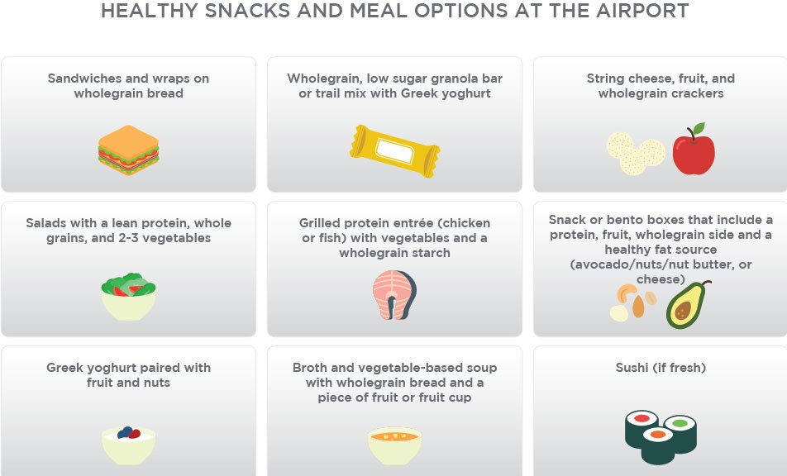

Before the next time you travel, research a few healthy restaurants and grocery stores at your destination. Having an idea of where to eat and shop on arrival can ease some of the pressure and anxiety over being able to make healthy choices while travelling.

On arrival, visit a local grocery store to purchase fruit, breakfast options and a few snacks (nuts, fruit and nut protein bars or whole-grain crackers) to ensure that there are some foods available for the trip that fit your plan. If the residence has a refrigerator available, buying perishable items such as Greek yoghurt, cheese, cottage cheese and even a few vegetables is another great strategy. Having foods readily available, especially when hungry, makes it easier to stay on track and make healthy choices even when travelling.

Ask clients what challenges they face when travelling. Do they travel with healthy snacks, or eat whatever is available at the airport or on the road? Do they still try to choose healthy options when travelling, or wait until they return home to focus on healthy eating again?

Ask clients what foods they choose at the airport or on a road trip. How do they make their choices?

What type of foods/snacks (if any) do they pack when travelling?

**Dining at home**

Dining at home today can include several different options: cooking at home, ordering a takeout from a restaurant or food delivery service, and/or using a meal-prep service that provides all the ingredients and recipes for a fee, and allows individuals to prepare a gourmet meal at home. Each of these scenarios requires some decisions on which foods/meals to prepare, order or buy, and at times, the sheer variety of options can make it seem difficult or confusing to select healthy options. However, a few guidelines can help individuals make healthy choices in any of these situations.

Meal prep

Meal prep can sound overwhelming, but it is not as labour-intensive, time-consuming or complicated as it initially seems. Meal prep can be kept fairly simple, depending on an individual’s preferences and lifestyle. The basic idea behind meal prep is to prepare some or all meals or meal components in advance, in order to save time and energy during a busy week. Some additional benefits of meal prep include the following:

* Having meals already prepared or ready-to-prepare, thereby reducing the chance of ordering out or making less-healthy food choices
* Not having to worry about what to eat or prepare on multiple days of the week because the preparation has been done beforehand
* Having additional time to engage in other activities (such as exercise, time with family, etc.) during the week

Meal prep does not mean making every single meal ahead of time (unless an individual wants to). Furthermore, meal prep may not be for everyone. Some individuals prefer the flexibility and spontaneity of choosing what and/or where to eat without preparing ahead, especially if they prefer ordering or eating out. However, meal prep can be a great way to maintain health and fitness goals, as it grants the individual greater control over their meal choices and the way in which they are prepared. The following guidelines provide some tangible and practical strategies for making meal prep easy and efficient for novices, and for those who may already be preparing meals ahead of time.

## **Meal Prep Guidelines**

Decide what type of meal prep best suits the client's lifestyle and preferences.

The following are some questions to consider:

* Do you want to prepare full meals ahead of time, or just prepare the ingredients to make cooking easier on weeknights?
* Do you like to try new recipes or do you prefer making a few staple dishes that are tried-and-true favourites?
* Do you like variety, or are you happy eating similar meals on a daily basis and then changing the options for the following week?
* Do you want to prepare for a full week, or only for a few days and leave some flexibility for dinners out?
* Do you want to prepare for dinner only or all three meals?

Budget and schedule time for meal prep. Complete this once a decision on the type of meal prep has been made. An individual who prefers to make most meals ahead of time may need to budget more time than someone who simply wants to prep ingredients ahead of time.

Invest in the right equipment and tools for meal prep. There is a huge selection of food gadgets and cooking appliances, but not all are needed to be able to meal prep. Investing in a few key tools and time-saving devices can make this an easier and efficient task. The following table provides a list of basic kitchen tools and appliances to invest in for meal prep, and some time-saving appliances that can make the process even more efficient.

Kitchen Tools and Appliances for Meal Prep

| **Food Preparation Tools** | **Food Processing & Cooking Appliances** | **Time-Saving Appliances & Tools** |
| --- | --- | --- |
| Knives: chef’s knife, bread knife, paring knife, or small chopping knife | Food processor (small and large) | Slow cooker |
| Ladles/spoons | Blender (traditional or high-powered) | Pressure cooker |
| Peeler, grater, or spiralizer (hand-held works) | Saucepans (1 small, 1 large) | Microwave |
| Mixing bowls | Skillet or frying pan (1 small, 1 large) | Air fryer |
| Food storage containers (many) | Steamer basket | Toaster ovens with broilers |
| Mason jars | Oven |  |
| Sandwich and freezer bags | Baking sheets |  |
| Aluminum foil or plastic wrap |  |  |

Stock the pantry with cooking staples. Preparing meals requires the right ingredients, and some staples are used in many different dishes. Key ingredients to keep stocked are listed in the following table.Having these ingredients available at any time can make meal prep easier, and so many of these ingredients are used over and over again.

Pantry and Refrigerator Staples for Meal Prep

| **Dry Goods** | **Perishable / Refrigerated Items** |
| --- | --- |
| Olive oil: virgin and extra virgin  Coconut oil for higher heat cooking  Dried or canned lentils and beans  Boxed or canned low-sodium soups  Dried pasta  Whole-grain and white rice  Rolled oats  Vinegars: balsamic and red wine vinegar  Salt: both iodized and a finishing or kosher salt  Black pepper  Spices: dried basil, oregano, dill, thyme, rosemary, paprika, chili pepper, garlic powder, cumin, or mixed seasonings (such as five spice) | Eggs, preferably organic  Grass-fed butter  Milk: dairy or non-dairy  Nut butters: peanut, almond, cashew, or sunflower seed  Grainy or Dijon mustard  Mayonnaise  Teriyaki sauce  Barbeque sauce |

Decide on the menu for the week (and/or on staple foods to prepare) and write a list of the fresh ingredients that will be required. This step will depend on the meal-prep style of the individual, as noted earlier. Some individuals prefer to follow recipes and make larger quantities of complete meals. Others may prefer to make batches of staples, such as two or three proteins, starches and vegetables, and then mix and match to make meals during the week. Both approaches require writing out a list of fresh ingredients that are needed.

The frequency of grocery shopping can also vary depending on individual preferences. Many individuals may find it efficient to plan and shop once a week for the bulk of their grocery needs for the week ahead, especially if they meal prep. Other individuals may prefer to shop once a month at a large warehouse store for major food items and staples, and then supplement any minor needs from a local store during the week. Either approach may work, based on an individual’s lifestyle and preferences. Planning meals and grocery purchases ahead of time can also help to minimise time spent on grocery shopping and help save money. By planning ahead, individuals can avoid the need for multiple trips to the store and focus their purchases on specific meals rather than buying foods haphazardly.

Schedule a few hours on a designated day to meal prep and time it. Setting a time limit on meal prep can help to improve efficiency and prevent it from consuming an entire day (which may be one of the reasons why meal prep seems daunting to many people). Minimise other distractions and make it enjoyable; play music or listen to a podcast while prepping.

Deciding on what to prepare

Deciding on the meal prep menu can be daunting, and may be one of the reasons why the idea of meal prepping can seem intimidating. However, planning out what to prep does not necessarily require a detailed menu for the week; this is left to the individual. The following is a basic guide for determining what to prepare:

If using or trying new recipes, limit to two or three. Trying several new recipes as part of meal prep can become complicated due to the time commitment and the need for all the ingredients. Two or three recipes, however, are manageable.

Identify the main sources of the macronutrients for meals during the week. This involves deciding on which protein sources, carbohydrates (vegetables and grains) and healthy fats will form the base of most meals during the week. These first two steps essentially define the items that will be on your grocery list for the week.

**Food Safety Guidelines**

Proper storage of food is always important, and particularly so when preparing meals in advance. The improper handling and storage of food can increase the risk of foodborne illnesses, which can be unpleasant (in some cases quite dangerous or even deadly). Basic food safety guidelines with the preparation of food are highlighted below. However, food storage is equally important. The [CDC website](https://www.cdc.gov/foodsafety/keep-food-safe.html) provides important guidelines on food safety protocols for food preparation and storage (Table: Safe Internal Cooking Temperatures for Meat and Poultry).

Safe Internal Cooking Temperatures for Meat and Poultry

| **Meat and Poultry** | **Minimum Internal Cooking Temperature** |
| --- | --- |
| Whole cuts of beef, pork, or lamb | 145°F (Rest for 3 minutes before carving.) = 62 ºC |
| Fin Fish | 145°F (Flesh must be opaque) = 62 ºC |
| Raw, fresh ham | 145°F = 62 ºC |
| Ground meats (beef and pork) | 160°F = 71 ºC |
| All poultry (including ground chicken and turkey) | 165°F = 74 ºC |
| Casseroles and heating leftovers | 165°F = 74 ºC |

**Basic Food Safety Guidelines**

Safe handling of food during meal preparation is critically important to prevent the risk of foodborne illnesses, which can be very serious. The Centers for Disease Control (CDC) in the United States estimates that approximately 48 million people fall ill from a foodborne illness each year, of which approximately 3000 die and 128,000 are hospitalised (CDC, 2018). That is a phenomenal number. Many foodborne illnesses can be prevented through the practice of good hygiene, and the prevention of cross-contact between raw meats and fish and ready-to-eat items.

The CDC outlines four basic steps for maintaining food safety: Clean, Separate, Cook and Chill (CDC, 2018).

**Meal delivery services**

Using a meal prep or delivery service can help some individuals streamline the process of preparing meals while being able to try new recipes. Meal prep or delivery services provide preportioned ingredients and detailed instructions for the preparation of selected recipes, and deliver these to consumers’ homes. Meal preparation, then, just involves reading the instructions and preparing the delivered meals.

Meal delivery services can be a great option for individuals who are busy and may not want to or have time to meal prep for the week ahead. However, not all of the recipes provided by such services are low-calorie and the portions may not always be adequate or appropriate for every individual. Most services will provide the nutritional information for the recipes on their website, and consumers should review this information to see if the nutritional value of the recipe is in line with their health goals.

One way in which to increase the nutritional value of the meals is to add extra vegetables during preparation or on the side. This strategy not only adds additional vitamins, minerals and fibre to the meal, but adds more volume if a portion appears to be small. It also helps consumers to maintain the habit of making half their plate consist of vegetables, as per general healthy guidelines.

## Healthy snacking

Is snacking healthy? This is a question that many individuals ask and the answer is that it depends. Snacking can be healthy if the food choices for snacks fit into the overall caloric and nutrient needs for an individual. However, the excessive consumption of energy-dense, nutrient-poor snack foods beyond an individual’s caloric needs can contribute to undesirable weight gain.

**Snacking and weight**

Some studies suggest that snacking between meals and increased eating frequency is associated with weight gain (Mathes, 2014). However, other studies show that snacking between meals does *not* necessarily lead to weight gain (Feld et al., 2004; Kant, 2014; Raynor et al., 2014). The literature on snacking between meals and body weight shows varying results (Swinburn et al., 2004), and part of the reason may be that there are several factors that must be considered with regard to snacking: the overall caloric intake over the course of the day; the size, caloric density and composition of the snacks eaten; and the frequency of eating.

**Pros and Cons of snacking**

For many individuals, snacks serve as a buffer between meals to help control hunger, but they can also help meet nutrient needs if they are planned effectively. For example, a mid-morning or afternoon snack of fruit, nuts and plain Greek yoghurt can provide a healthy dose of vitamins, minerals, healthy fats, protein and calcium. For individuals who may not have time for large or balanced meals, snacks can serve to fill in the 'nutrient gaps'.

However, snacks can contribute to weight gain if they add to an individual’s caloric intake beyond their energy needs. This can happen for a variety of reasons:

1. Snacking excessively on energy-dense foods
2. Mindless and excessive snacking due to boredom or other emotions
3. Late-night snacking on high-calorie foods

Snacks should, ideally, serve a *purpose* in an individual’s diet. And, as with meals, they should be planned out and/or planned *for* within the context of an overall healthy eating pattern.

Snacks should be within an appropriate caloric range for an individual, and should be considered in relation to their nutrient composition and contribution to the individual’s diet. The size of the snack will depend on the overall calorie needs of the individual and their preference of meal frequency.

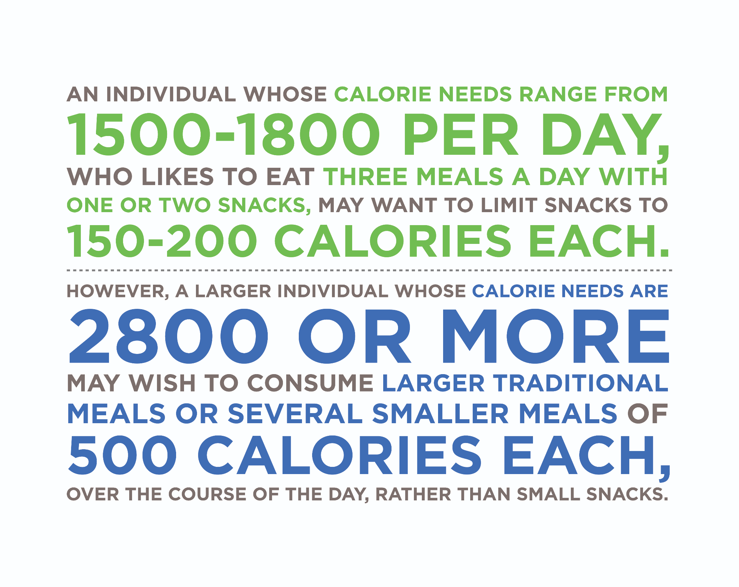

Ask clients about their snacking habits. The following are some questions to consider:

1. Do they snack between meals and, if so, why? Is it due to hunger or boredom?
2. What types of foods do they choose for snacks? Do they prepare these ahead of time, or rely on what may be available at work or at events?
3. Do they consider the nutritional value and composition of snacks?
4. Do they feel that snacking is affecting their weight? Or do the snacks help control their appetite and hunger?

**Healthy snacks**

An ideal snack may be a combination of a high-fibre carbohydrate and a lean source of protein to promote satiety (Ortinau et al., 2014). A small portion of nuts may also be an acceptable snack. Despite being calorie-dense, nut consumption is not associated with significant weight gain and may even be associated with a reduced risk of weight gain (Bes-Rastrollo et al., 2012). However, portion control with high-calorie snacks such as nuts remains important.

Food for Thought

A 1-ounce serving of nuts can contain between 160 to 200 calories, depending on the type of nut selected (Cleveland Clinic). Almonds and pistachios are on the lower end of this calorie range, whereas macadamias, pecans and walnuts are at the high end. A 1-ounce portion of nuts is approximately ¼ cup, but the number of nuts can be very different. For example, 1 ounce of almonds is approximately 23 nuts and 1 ounce of pistachios is 49 pieces. In contrast, 1 ounce of walnuts is 14 halves and 1 ounce of macadamia nuts is only 11 nuts.

To keep portions in check, it may be helpful for clients to measure or weigh out 1 ounce of nuts to see what it actually looks like, and then keep that amount in mind when selecting nuts as a snack.

Infographic: Healthy Snack Examples provides examples of healthy snacks that range from 150 to 200 calories and feature two or more macronutrients. Individuals who have higher calorie needs and/or who prefer eating mini-meals throughout the day may benefit from larger portions of the foods listed or small versions of meals.

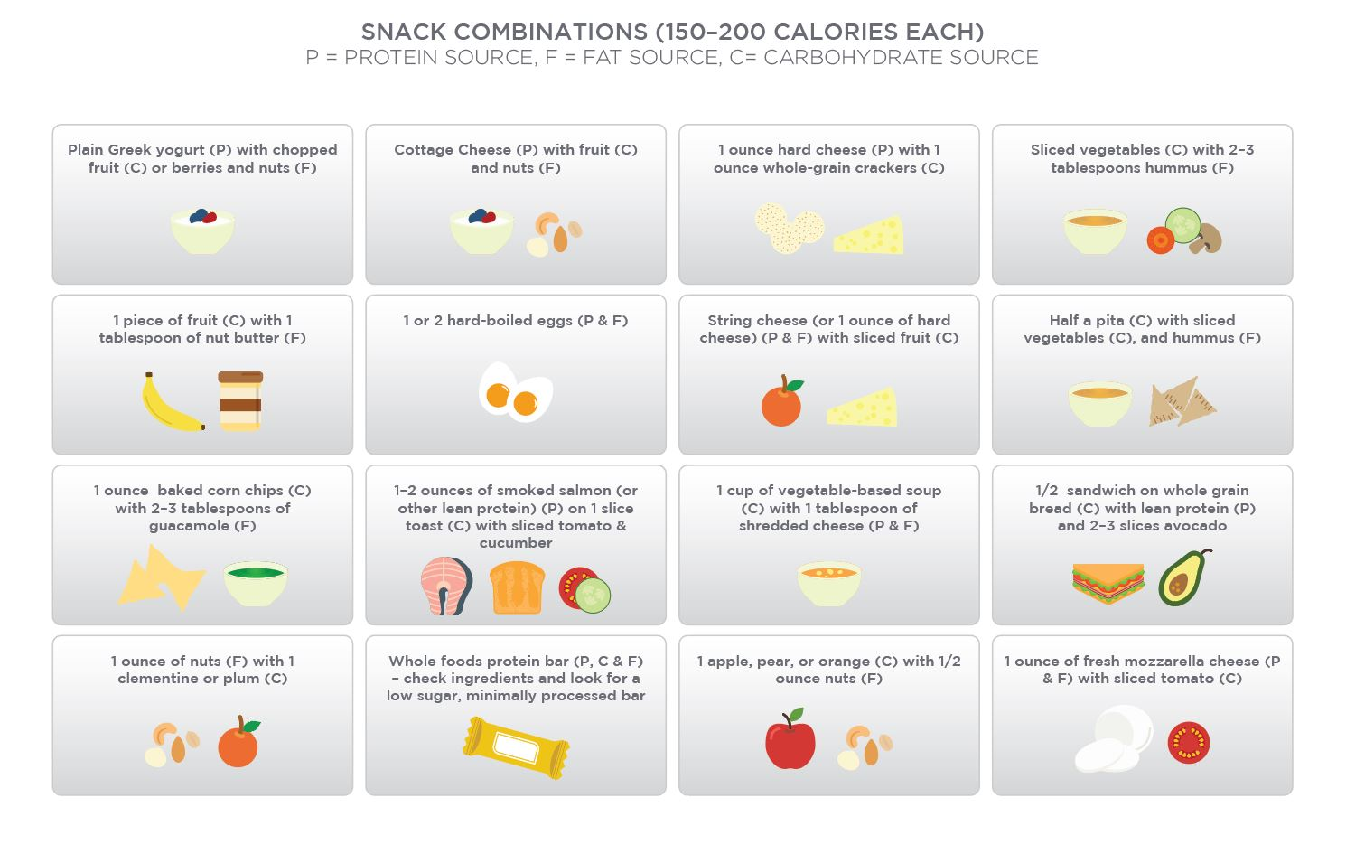

The examples provided are not an exhaustive list, but are intended to provide an example of how whole foods may be combined to provide a satisfying and satiating snack that includes two or more macronutrients. One of the keys to snacking is planning them in advance. This may be most appropriate for individuals who have long work days and/or long commutes, and like to have a healthy snack in between meals. Planning out and preparing some healthy snacks ahead of time, for example, during meal prep on the weekend, can help to ensure the availability of healthy food choices when hunger strikes.

Use the Handout: Healthy Snack Options Template to educate clients when choosing healthy snack foods. It is divided into three columns to help clients identify the source of protein, carbohydrates and fat in their snacks of choice. Identifying the source of macronutrients in a snack can also help clients choose primarily healthy, whole-food items versus opting for processed and convenience foods.

The third factor in healthy snacking is to identify if the snack is being consumed due to hunger and/or to stave off hunger, or if it is something that is being used to satisfy an emotional need or being consumed out of boredom. Snacking due to boredom and/or mindless snacking can contribute to weight gain if it leads to an excess consumption of calories beyond an individual’s energy needs over a prolonged period of time. Snacking due to boredom can occur in various situations: at work on a slow day, in the evening after dinner, or on a weekend afternoon at home. If clients express that they are snacking out of boredom, then coaches should explore other healthy habits that may be substituted in place of food. These may include the following:

* Taking a short walk break from work: Even a 10-minute walk can be refreshing and energising, and can take the focus away from food.
* Calling a friend or family member: This can be emotionally uplifting and provide a chance to reconnect with friends and family. Maintaining social and family connections is also an important part of an overall healthy lifestyle.
* Engaging in a new hobby: This may be most appropriate for individuals who find that they are bored in the evenings after dinner or on weekend afternoons. Picking up a new hobby like painting, craft work, joining a book club or learning a new sport can have several benefits. It not only serves to relieve boredom, but also provides a healthy outlet to exercise creative skills, engage in a healthy activity and/or create social connections.
* Reading and/or research: Reading a book, fiction or non-fiction, or researching a new topic are also healthy activities that not only take the focus away from food as a pastime but actively serve to engage and cultivate an individual’s mind. Clients may find that once they pick up a new hobby or activity, they are less likely to reach for food out of boredom.

**Mindless eating**

Mindless eating can be described as eating that occurs without paying attention to the food being consumed (WeightWatchers, 2018). It typically occurs when an individual consumes food while preoccupied or engaged with other activities, and can contribute to weight gain if it leads to excess consumption of calories over a sustained period of time. One reason is that inattention to the food being consumed *may* lead individuals to consume larger amounts (Robinson et al., 2013). Another reason that appears to play a larger role is that mindless or distracted eating may lead to a poor recollection of the meal eaten and this may lead to overeating at subsequent meals/eating episodes (Robinson et al., 2013; Higgs, 2002; Lillis, 2014). In contrast, mindful eating has been shown to have positive effects in weight and health management (Daubenmier et al., 2011; Timmerman et al., 2012; Harris, 2013). The following are some situations in which mindless eating may occur:

* Eating while watching television in the afternoon or evening
* Eating while driving
* Snacking or eating a meal while working at a computer
* Snacking while at the movie theatre
* Picking at snack foods and appetisers at a social event or party.

Try to track when and how many times you snack during the day.

* Is it predominantly in the morning, afternoon or evening?
* Do you snack while at work or only when bored?
* Do you find yourself eating mindlessly at times? When does this happen?
* What types of foods do you reach for when you snack? Do you assess your hunger levels when snacking?
* What might you suggest to clients after monitoring your own snacking habits?
* What are some recommendations you have for clients to help them monitor their own snacking habits?

Mindless eating may not be a behaviour that can be changed overnight. However, there are some practical tips and guidelines that may help clients who report eating mindlessly in certain situations, especially when bored (Table: Tips for Managing Mindless Eating).

Tips for Managing Mindless Eating

| Find an alternative activity or hobby to help deter mindless eating that stems from boredom. |
| --- |
| 2. Ask clients to pause before reaching for food and ask themselves if they are truly hungry or just bored. |
| 3. Take a screen break for lunch. Many individuals will eat lunch at their desks or in front of a computer screen without paying attention to their food or their hunger and satiety levels. Taking a short break (even 20 minutes, to pause and enjoy lunch) can help to enhance satiety and promote a greater sense of enjoyment of the meal. |
| 4. Make it difficult to eat mindlessly. This may be a helpful strategy for individuals who reach for snacks when they are stressed and have easy access to junk foods. At work, this may mean removing all junk-food items from your desk and storing all foods and snacks in the office refrigerator. At home, this may mean storing snack foods in a hard–to-reach cupboard or at the back of the freezer. In all these cases, it requires effort to go and retrieve the food item and the time and effort required may be sufficient to cause a client to pause and consider if they are truly hungry or just reaching for a snack out of habit, stress, or boredom. |

**Creating healthy habits**

B.J. Fogg, who is a professor at Stanford University and a researcher on behaviour change and behaviour design, has put forward a study on human behaviour called *Behaviour Design*, which provides a set of models for explaining and understanding how human behaviour works. His approach, called the B.J. Fogg Behaviour Model, proposes that in order for a particular behaviour to occur, three elements have to come together: there has to be motivation, the ability to perform the behaviour and a prompt (previously referred to as a trigger) (Fogg, 2018).

BJ Fogg's Behaviour Model

With regard to creating healthier eating habits, an individual must first be *motivated* to make a change. A Nutrition Coach may be able to increase a client’s motivation to eat healthier by highlighting the benefits of doing so. These benefits may include increased energy, improved nutrition status and health profile, and improved body weight and body composition. Clients must also feel confident that they have the *ability* to engage in healthier behaviour. Ability is a factor that can be changed with education, tools and resources, and this is another area in which a Nutrition Coach may be able to help clients.

For example, if a client does not know how to cook, a coach can direct them to cooking resources, classes and sources for healthy recipes. If a client is unsure of how to begin meal prepping, a coach can review some guidelines to meal prepping and help them identify the resources they need. For clients who do not know how to select healthy options at restaurants, a coach can guide them on how to select meals and point out keywords to look for on the menu.

The third element of B.J. Fogg’s model, *prompt*, refers to a trigger or a call to action. It is essentially a cue that will set off a behaviour given that the other two factors, *motivation* and *ability*, are in place. A prompt could be a simple note that reminds an individual to perform an activity (for example, a note on a computer reminding an individual to get up and take a 5-minute walk break every hour). It may also be an existing behaviour; turning on the television may be a prompt for some individuals to reach for a snack. Using Fogg’s approach, associating a healthy habit with an existing behaviour may help to create a prompt for that healthy habit to start occurring on a more consistent basis. Using the example of the television, if turning it on is associated with reaching for a snack, a healthy habit to interject may be to reach for a glass of water prior to reaching for a snack. Another option would be to reach for a *healthy* snack, such as sliced vegetables or fruit, versus an energy-dense and/or high-sugar snack.

Small steps to success

Fogg also argues for making *simple*, easy changes so that they fall within the scope of an individual’s ability (Fogg, 2009). In many circumstances, individuals will try to make too many changes at once. If their motivation is high and they have the ability to successfully implement the changes, then they may be able to sustain them. However, there is a chance that if the changes are drastic deviations from their previous habits, they may not be able to sustain them, either through decreased motivation over time or the lack of success in one or more areas of change. Making changes simple and easy to implement can therefore enhance the likelihood of success and make the change easier to sustain over a longer period of time.

Food for Thought

Consider the example of a client who does not meal prep or eat any vegetables at meals. They may find it difficult to successfully implement and sustain both changes at the same time. A more sustainable approach may be to pick one of the two goals, break it down into small steps, identify when exactly a specific behaviour or change will take place, and then implement and repeat it so that it becomes a habit. In this example, a realistic goal for the client may be to start with the addition of a vegetable to dinner on at least 3 days of the week. Once this change has become a habit (and he/she is eating a vegetable with dinner on 3 days of the week), it can be extended to having a vegetable *daily* at dinner until this too becomes a habit.

In the context of eating, the amount and types of changes needed will vary from client to client. The job of a Nutrition Coach may be to help a client identify the changes that they want to make, and develop a realistic plan for implementing small changes that will lead to a larger change in eating habits.

Coach's Corner

When working with clients, it may be helpful to use a step-wise process to help them achieve their goals:

1. Ask clients to list their ultimate or end goal. This may be a general goal (such as eating healthier, losing weight or start exercising).
2. Ask them to be more specific about their goals. If the goal is to 'eat healthier', ask them to be specific about what changes they want to make. The more specific the goal, the greater the likelihood a client can define the steps needed to achieve it and a timeline for making the changes.
3. Encourage clients to pick a simple change and identify a specific time or condition when they will implement the change. For example, a client whose goal is to eat more vegetables should identify exactly when and how they will implement this change.
4. Use the concept of setting SMART goals (Specific, Measurable, Achievable, Relevant and Time-Bound)to help clients make small, measurable changes that they can achieve and sustain over the long-term.

Fogg (2013) also highlights the ideas of celebrating small successes, both to maintain motivation and to reinforce a sense of self-efficacy as an individual 'who can succeed'. A coach can contribute to this celebration by congratulating a client for accomplishing a goal or a healthy habit, no matter how large or small. For some clients, the change may be as simple as adding a vegetable at dinner 3 days a week. A client’s success with implementing this change should be celebrated.

**Designing for behaviours that lead to a goal**

Fogg’s (2013) behaviour model also emphasises the idea of 'designing for behaviours that lead to an outcome'. The idea behind this approach is to make small, simple changes that will eventually result in the realisation of the end goal. For example, a client’s end goal may be to lose a certain amount of weight. Rather than focussing solely on the end goal itself, Fogg’s approach looks at making small behaviour changes and establishing healthy habits that will eventually result in the desired weight loss. The types of changes needed will, of course, vary for different individuals and depend on their goals and their current habits.

**Creating healthy habits**

Another recommendation in Fogg’s (2013) behaviour model is that small changes should be tied to existing behaviours, so that the latter serve as prompts for the new behaviour to occur. Over time, the new behaviour also becomes a habit and a part of an individual’s lifestyle, but the change occurs seamlessly, without the need for overt effort. An example of this may be a client who wants to incorporate more fruit and vegetables into their diet. An initial small change may be for the client to add a piece of fruit with breakfast every day.

Because the new behaviour (having fruit) is associated with an existing behaviour (having breakfast), the latter serves as a prompt for the new behaviour to happen. Over time, having fruit with breakfast becomes a habit and becomes a seamless part of the client’s lifestyle. After a couple of weeks of maintaining this initial change, the client may progress to incorporating another change, adding a fruit to their afternoon coffee break every day. Again, because there is an existing behaviour in place (having a coffee break), there is a prompt for the new behaviour to occur.

The success of these small changes eventually leads to the client accomplishing their goal of adding more fruit and vegetables to their diet. In this example, the end goal came about naturally as a result of implementing small changes that were tied to existing behaviours and that eventually turned into healthy habits.

Navigating the real world and food choices that fit in with a nutrition plan amidst the vast array of foods that are available today can seem overwhelming for many individuals. Grocery shopping, dining out, travel, social events and parties all present their own challenges. Grocery shopping can seem overwhelming, due to the variety of food products that are available. Dining out and eating healthily may seem difficult due to the higher-caloric and fat content of many restaurant dishes, and social events and parties can appear difficult to navigate when trying to eat healthy.

However, with some planning, it is possible and fairly easy to make healthy choices in all of these situations and more. Planning out a grocery trip, meal prepping for a busy week, knowing how to select meals when dining out, and being prepared with healthy foods and snacks ahead of time when working and travelling can make healthy eating fairly easy. Identifying which areas present the greatest challenges and helping clients to develop strategies to address these *first* may be a more-efficient and effective strategy for a Nutrition Coach.

Creating healthy eating habits takes time and a step-wise, gradual approach may help clients sustain healthy changes in the long term. A Nutrition Coach can serve an important role in helping clients identify their goals and break them down into small, sustainable habits that will eventually lead to the desired outcome. A key point to remember is that change of any kind takes repetition, practice and perseverance.

# Navigating diets

Nutrition Coaches should be aware of the wide ranges of dietary approaches that exist, in addition to having an appreciation of the scientific consensus on their effectiveness. This gives the Nutrition Coach a number of tools they can use with individual clients, rather than applying a generic one-size-fits-all approach to everyone. Clients will often come to the Nutrition Coach with questions about popular diets or fad diets. The Nutrition Coach should be able to accurately and objectively discuss the merits of these approaches, leaving the client more informed and less susceptible to falling for non-evidence based approaches.

Dietary approaches can vary based on several factors, including but not limited to the following:

* Energy (calorie) control, e.g. calorie counting, points-based commercial diets or specific meal plans
* Macronutrient composition, e.g. low-carb, low-fat, ketogenic or protein-sparing modified fast
* Food type/group choices and/or restriction, e.g. gluten-free, vegan, vegetarian, paleo, clean eating or Mediterranean
* Time-based restriction, e.g. fasting, time-restricted feeding or cut-off times for meals/nutrients
* Degree of flexibility or rigidity of the dietary restraint.

The aim of this chapter is to give an objective overview of where the current evidence base lies in relation to several prominent dietary strategies. Before assessing the specific dietary strategies, it is worth considering a broader overview concept of dietary principles versus dietary methods.

Coach's Corner

It should be noted that in addition to a suitable diet, successful weight loss will also likely include other behaviours, notably physical activity and behaviour training such as self-monitoring (Ramage et al., 2014).

Critical!

Remember to always refer clients to a Registered Dietitian Nutritionist (RDN) or medical doctor if they want specific, personalised diet guidance and recommendations.

**Principles vs Methods**

As a Nutrition Coach, one can expect to be asked the question “What is the best diet?” from time to time. The primary problem is that it assumes there is a single best method. To accurately assess the potential effectiveness of a diet for a client, one must understand the principles by which diets in general influence health and body composition, rather than relying on any given dietary method. For example, almost *all* diets will have research and/or anecdotes proving that the method can cause weight loss. So, rather than asking which one is best, a better question is to ask is “By what principles do all these diets work?”.

If a calorie deficit is not in place, then fat loss will not occur, regardless of the method.

Weight loss is predicated on a few key principles that are common to all successful diets, regardless of the specific method used. The primary principle, in this case, is overall energy balance (Katz, 2005; Yumuk, 2015). Any diet where the person successfully loses body fat will be due to the fact that the individual was in a net calorie deficit (negative energy balance) over a sufficient period of time. If a calorie deficit is not in place, fat loss will not occur, regardless of the method.

Other core principles of a successful diet include macronutrient intake, micronutrient intake, overall food quality and adherence to the diet. To assess the potential usefulness of an individual diet method, one can ask the following questions:

1. Does this approach lead to superior fat loss compared to other approaches?
2. Does this approach lead to superior muscle mass gain (or retention) compared to other approaches?
3. Is this approach likely to lead to any micronutrient deficiencies?
4. Is the client likely to be able to adhere to this approach?
5. Does this approach align with the client’s food preference and tolerances?
6. Is there potential for this approach to cause negative health outcomes (e.g. worsening of blood lipids, insulin sensitivity or other health markers)?
7. Is this approach an evidence-based dietary approach?

Critical!

There is no one diet method that is best in all situations and contexts. Rather, a core set of principles should guide the Nutrition Coach’s decision-making process when deciding what approach will be most effective in any given situation with an individual client. However, there are some overarching evidence-based guidelines that should be adhered to.

**Diet approaches based on macronutrient composition**

Several diets are based on the restriction or promotion of certain macronutrients. With foods being comprised of the three macronutrients (protein, carbohydrate and fat) and dietary fibre, modifying the amounts of one or more of these in the diet will have an impact on food choices. This section will examine whether diets of a specific macronutrient composition hold a physiological and/or practical advantage over other diets.

Low-energy diets (low-calorie diets)

Low-energy diets (LED) are those that contain a low amount of total calories. Typically, low-energy diets will be of about 800 to 1200 kilocalories per day (kcal/d). Those less than 800 kcal/d would be classed as very low-energy diets (VLED) (Leeds, 2014). The obvious advantage of utilising an LED or VLED is that weight loss will occur at a much faster rate than other diets (Ryttig et al., 1997). Therefore, such diets may be particularly useful in situations where rapid weight loss can have profound health benefits (e.g. in obese patients).

Research has consistently shown clear improvements in health markers when overweight or obese patients lose body fat, even when those losses are moderate (Ryan & Yockey, 2017). While rapid fat loss can be achieved through low- and very-low-calorie dieting, there are both physiological and practical disadvantages to such diets

Negative Effects of Low-Calorie Dieting and Rapid Weight Loss

| Increased risk of lean body mass loss, particularly in those who are already relatively lean |
| --- |
| Decreased athletic performance |
| Lowered ability to recover from exercise |
| Increased hunger versus more moderate calorie reduction (although not always the case) |
| Decreased food options |
| Difficulty in consuming sufficient amount of micronutrients |

Critical!

Very low-energy diets (VLED) should be followed only under the supervision of a medical professional. It is beyond the scope of practice for Nutrition Coaches to recommend or oversee the implementation of VLED for clients. A VLED is a doctor-supervised diet that typically uses commercially prepared formulas, such as liquid shakes or bars, to promote rapid weight loss in patients who are obese. VLED formulas are not the same as the meal replacements sold at grocery stores or pharmacies, which are meant to substitute for one or two meals a day.

For non-obese clients, an LED may still be appropriate depending on the duration and composition of the diet in addition to the goals, preferences and suitability of the individual. Losses in lean body mass (e.g. muscle) can be largely or almost entirely mitigated through the inclusion of high protein intake and resistance training (Cava et al., 2017). Endurance exercise may also help mitigate losses in lean body mass, although the research is mixed on this and the magnitude of the benefit is less clear.

Table: Protein Intakes While Dieting provides protein recommendations while dieting. It is advisable to push toward the higher end of the ranges the larger the calorie deficit, especially in already lean individuals (Helms et al., 2014). One fear with low-calorie diets is that they will cause a larger rebound or weight gain than diets of a more moderate calorie reduction. However, research on overweight and obese people shows that faster initial weight loss can lead to better results even in long-term follow ups, suggesting that not only do they not regain weight faster, but that the faster initial rate of weight loss is a long-term benefit (Heilbronn et al., 2006; Nackers et al., 2010).

Protein Intakes While Dieting

| **Suggested Intake (g/kg)** | **Suggested Intake (g/lb)** | **Reference** |
| --- | --- | --- |
| 1.2 to 1.6 g/kg body weight | 0.5 to 0.7 g/lb body weight | Leidy et al., 2015 |
| 1.6 to 2.4 g/kg body weight | 0.7 to 1.1 g/lb body weight | Hector & Phillips, 2018 |
| 2.3 to 3.1 g/kg fat-free mass | 1.0 -to 1.4 g/lb fat-free mass | Helms et al., 2014 |

When the diet is overseen by an appropriate professional, it is likely that an LED and VLED can be very effective in achieving weight loss and, thus, health improvements in overweight and obese individuals. Where an LED or VLED diet is used, great attention should be paid to the plan of action for the time period after the diet finishes or once a goal weight is achieved.

Low-Fat Diets (LFD)

While there is no exact definition of a low-fat diet (LFD), it typically describes a diet where fat intake is 20 to 35% of total calories (Trumbo et al., 2002). The advice to decrease dietary fat intake to 20 to 35% of total calories has been given for many decades at a public health level. Diets below that lower cut-off of 20% of total calories are often referred to as very low-fat diets (VLFD). There are some potential downsides to extremely low-fat intakes.

Potential Negative Impacts of Extremely Low-Fat Intakes

| Can limit inclusion of foods with positive health impacts (e.g., nuts, seeds, olive oil, etc.) |
| --- |
| Can make the diet more difficult to adhere to due to food restrictions |
| May lead to decreases in sex hormones such as testosterone (Hämäläinen et al., 1983) |
| Can lead to increases in triglyceride levels in the blood in the short-term (Lichtenstein & Van Horn, 1998) |
| Theoretically, can increase the risk of an essential fatty acid deficiency at consistent extremely low-fat intakes (<10% of total calories) |

lthough the overall effect is quite modest, randomised controlled trials (RCT) have consistently shown reductions in body weight, body fat and waist measurement when the amount of dietary fat in the diet was reduced compared to the normal intake (Hooper et al., 2015). As alluded to earlier, the loss of body fat on any diet (including a low-fat diet) is a function of decreased calorie intake. Therefore, a low-fat diet that leads to reduced caloric intake (and in turn negative energy balance) will lead to weight loss.

The following are some of the primary explanations for reduced calorie intake on a low-fat diet:

1. Reduction in calorie-dense foods: As dietary fat contains 9 calories per gram, compared to 4 calories per gram for carbohydrates, for example, foods high in dietary fat tend to be more calorically dense. That is, for the volume they take up, there are a high number of calories in that portion (e.g. oils, nut butter and cream). Therefore, limiting these foods or the portion size of these foods can help reduce total calorie intake.
2. Reduction in hyperpalatable foods: Hyperpalatable foods are those that appeal to our senses (and brain) much more than whole, minimally-processed foods. A hyperpalatable food is often a combination of fat, sugar, salt, and other flavours or sensory stimuli. Hyperpalatable foods are very easy to overeat because of that extremely enjoyable sensory experience combined with high-calorie density and low-satiety impact (due to low protein and fibre amounts). Limiting fat intake in the diet will automatically limit the amount of hyperpalatable foods that can be consumed, therefore, likely causing a decrease in calories.

Overall, diets with a fat intake of 20 to 35% appear to be positively associated with health, and can potentially help achieve a calorie deficit in cases where weight loss is desired. However, very low-fat intakes carry some risk. Many foods high in dietary fat can have a positive benefit on health and should be promoted for inclusion in one’s diet (Table: Positive Impacts of Dietary Fat). While it is highly likely that there is great individual variation in optimal fat intakes and disease risk, it seems prudent to advise basing most of dietary fat intake on plant-based fats, particularly those high in monounsaturated fatty acids, as well omega-3 sources, such as fatty fish. In addition, animal foods such as eggs and dairy can confer health benefits and should not be avoided due to their fat content.

Positive Impacts of Dietary Fat

| Humans cannot make essential fatty acids, so they must be obtained via the diet. |
| --- |
| Fat allows us to absorb fat-soluble vitamins: A, D, E, and K. |
| Cell walls contain fat. |
| Fats are involved in hormone production. |
| Helps avoid problems with low-fat diets |

Low-Carbohydrate (LC) Diets

Similar to low-fat diets, there is no agreed definition of a low-carbohydrate diet, with its classification varying wildly from study to study (Ajala, English & Pinkney, 2013). Studies typically classify a diet as low-carbohydrate if the carbohydrate content is 40% or less of the total calories. However, many have argued that for a diet to be defined as truly low-carbohydrate, then the carbohydrate intake should be much lower, e.g. 50 to 150 g/d (Westman et al., 2007) or < 20% of total calories (Gulbrand et al., 2014).

Low-carbohydrate diets have been shown to be beneficial for body-weight and fat reduction in both short and long-term studies (Hashimoto et al., 2016; Gardner et al., 2018). However, when compared to diets of a higher carbohydrate amount, but matched for calories, meta-analyses have indicated that LC diets do not seem to be superior for fat loss (Naude et al., 2014; Johnston et al., 2014). In the short-term, metabolic ward studies have shown that when both calories and protein intake are matched between diets, there is not a superior fat-loss benefit to reducing calories via carbohydrate restriction over fat restriction (Hall et al., 2015). Longer-term trials have shown similar changes in body composition in low-carbohydrate and low-fat diets, including over 12 months (Gardner et al., 2018) and 24 months (Foster et al., 2010).

Despite the current lack of convincing evidence that a low-carbohydrate diet can lead to greater fat loss than a diet matched for calories and protein, there may be a practical benefit to low-carbohydrate diets for some people. When people adopt a low-carbohydrate diet, there can be an unintentional increase in the protein content of the diet (Brehm et al., 2003). As higher protein intakes lead to greater satiety (i.e. feeling of fullness), this may lead to a decrease in calorie intake. Also, hyperpalatable foods can often be high in carbohydrates, so a low-carbohydrate diet will mean the avoidance of many of the highly processed, hyperpalatable foods that people tend to overeat (Leigh et al., 2018).

Overall, low-carbohydrate diets can be safely used as a dietary approach to decrease body fat. However, there is no fat-loss advantage over other dietary approaches of equivalent calorie and protein intake. A low-carbohydrate diet is most likely a sub-optimal approach for many competitive athletes, particularly in sports with considerable energy contribution from the anaerobic system (Burke, 2015; Burke et al., 2017). A low-carbohydrate diet can be safely used as part of a healthy lifestyle; however, its health impact is dependent on the foods selected and not merely the macronutrient composition.

Ketogenic diets

The ketogenic diet has been around since the 1920s, as a diet plan to reduce seizures for patients with epilepsy (Barañano et al., 2008). It involves consuming a large percentage of calories from fat, a moderate percentage of protein and very little carbohydrates. It is a combination that leads to the physiological state of (nutritional) ketosis. Ketosis is a natural metabolic state that occurs when the body starts producing ketones (ketone bodies) from fat. The body can use these ketones as a fuel (substrate) source to generate energy in place of glucose (which is now scarce).

*Starvation ketosis* occurs in response to a lack of incoming energy (insufficient caloric consumption). *Nutritional ketosis* can be achieved without extremely low-caloric intake through the restriction of carbohydrates, although this can still occur within the context of a calorie deficit. A ketogenic diet typically requires carbohydrates to be restricted to less than 50 grams per day (or 5% of total calories), protein intake to be moderate (20 to 30% of calories), and the remaining calories to be made up from dietary fat (usually 65 to 75% of calories).

Long-term ketogenic diets are capable of leading to greater weight loss than traditional low-fat diets (Bueno et al., 2013) or other control diets (Hashimoto et al., 2016). However, when calories and protein are matched between diets, a ketogenic diet does not lead to more fat loss than a non-ketogenic or higher-carbohydrate diet (Johnston et al., 2006; Meckling et al., 2004). While it is entirely possible to increase muscle mass on a ketogenic diet, the increases in muscle may be inferior to a higher-carbohydrate diet (Vargas et al., 2018).

Hypothetically, a ketogenic diet may lead to a spontaneous decrease in average calorie intake for some of the same reasons as described previously for low-carbohydrate diets (i.e. preference for such foods, increased protein intake and avoidance of hyperpalatable foods). However, there is also a hypothesis that the presence of ketones can lead to increased satiety, and thus, a reduced-calorie intake and/or decreased hunger while dieting; therefore, there is likely increased adherence to the diet (Gershuni et al., 2018; Gibson et al., 2015). It has also been found that ketosis can lead to the suppression of ghrelin, a potent appetite hormone (Sumithran et al., 2013). More research needs to be done in order to investigate whether small changes in satiety hormones related to ketogenic diets actually lead to changes in food intake in the long term. At the moment, the exact relationship between ketones, satiety and food intake over the long term has not been definitively established.

A well-formulated ketogenic diet may be safe to consume for many people, with the presumption that the diet is comprised of mostly whole, minimally-processed foods and is providing adequate micronutrients and fibre. However, those embarking on the diet should be aware that unwanted side effects have been reported on the initiation of the diet such as nausea, headaches, vomiting and dizziness (Goday et al., 2016). Ketogenic diets have shown to lead to improvements in cardiovascular disease risk in certain people, notably, decreases in blood triglycerides and increases in high-density lipoprotein cholesterol (Paoli et al., 2013). However, the extent to which this happens beyond that of other dietary approaches is still debated. Also, even in cases where fat mass is decreased, a ketogenic diet can lead to increases in LDL cholesterol (Kephart et al., 2018). Increases in LDL cholesterol in response to a ketogenic diet should be of concern and may warrant reducing fat intake in those susceptible individuals. It should be noted that there is a large individual genetic variation in response to high-fat diets.

It is recommended that regular blood tests are done and consultations with a doctor/physician are carried out to ensure blood markers remain in a healthy range.

High-protein diet

A high-protein diet is typically defined as one containing more than 25% of total calories from protein, or above 1.2 grams of protein per kilogram of body weight (g/kg) or 0.54 g/lb. The recommended daily allowance (RDA) for protein is currently set at 0.8 g/kg (0.36 g/lb). However, there is strong evidence showing multiple health and body composition benefits to consuming higher amounts, especially in the range of 1.2 to 1.6 g/kg (0.54 to 0.73 g/lb).

Much of these benefits are based on the ability for high-protein diets to preserve or increase fat-free mass (FFM), increase satiety and increase the thermic effect of feeding (TEF). They show more body-fat reduction per unit of body weight loss when compared to low-protein diets. For clients trying to build muscle mass, it seems that a protein intake of 1.6 g/kg (0.73 g/lb) will likely maximise the muscle gain that occurs in response to resistance training (Morton et al., 2018). However, some people may benefit from going up to 2.4 g/kg (1.1 g/lb). Lean individuals in a calorie deficit will likely benefit from higher intakes. For lean, resistance training people who are in a caloric deficit, a protein target of 2.3 to 3.1 g/kg of fat-free mass (1.0 to 1.4 g/lb of fat-free mass) has been suggested (Helms et al., 2014).

Getting Technical

This per-meal dose of protein intake seems to be about 0.25 g/kg, with a higher dose of 0.4 g/kg needed in older adults (Moore et al., 2015). In order to account for all individuals who fall outside of the average response, a higher dose of 0.4 g/kg per meal may be recommended, particularly if there is a high priority to maximise muscle mass (Phillips, 2013). As an example, for a 75-kilogram (165-pound) client, a per-meal protein dose of 30 grams would equate to a 0.4 g/kg serving.

So, in absolute terms, a broad general recommendation would be to advise clients to consume 20 to 40 grams of protein in three to four meals across the day. Current evidence shows that consuming protein in a more evenly distributed fashion, rather than in a skewed manner, is likely beneficial (Mamerow et al., 2014; Churchward-Venne et al., 2013). By way of example, consider a daily protein intake of 120 grams across four meals; an evenly distributed intake would be meals of approximately 30 grams of protein at each meal (e.g. 8 a.m., 12 p.m., 4 p.m. and 8 p.m.). A skewed intake might look something like a protein dose of 10 grams, 15 grams, 80 grams and 15 grams, at Meals 1, 2, 3 and 4, respectively.

While previously some have voiced concern about the potential for very high-protein intakes to be harmful to health (usually in relation to kidney or liver health), recent evidence suggests that even intakes of 2.5 to 3.3 g/kg over a 6-month period resulted in no harmful effects on blood lipids or markers of liver and kidney function (Antonio et al., 2016). So, while it is well-recognised that high-protein diets can be detrimental to those with existing kidney disorders, there is no strong evidence that high-protein diets are dangerous for healthy individuals (Cuenca-Sanchez et al., 2015). Evidence indicates that high-protein diets are safe for healthy individuals and lead to improved body composition. Due to their increased satiety, they may also be useful for reducing calorie intake. However, the quality of the protein sources is important to consider for health. For example, research consistently shows associations between processed meat consumption and cancer risk, particularly colon cancer risk. Protein should mainly come from minimally-processed foods such as lean cuts of meat, eggs, dairy, and vegetable sources like legumes and pulses.

Nutrition Coaches should refer all clients with chronic kidney disease to a medical professional prior to providing nutrition advice.

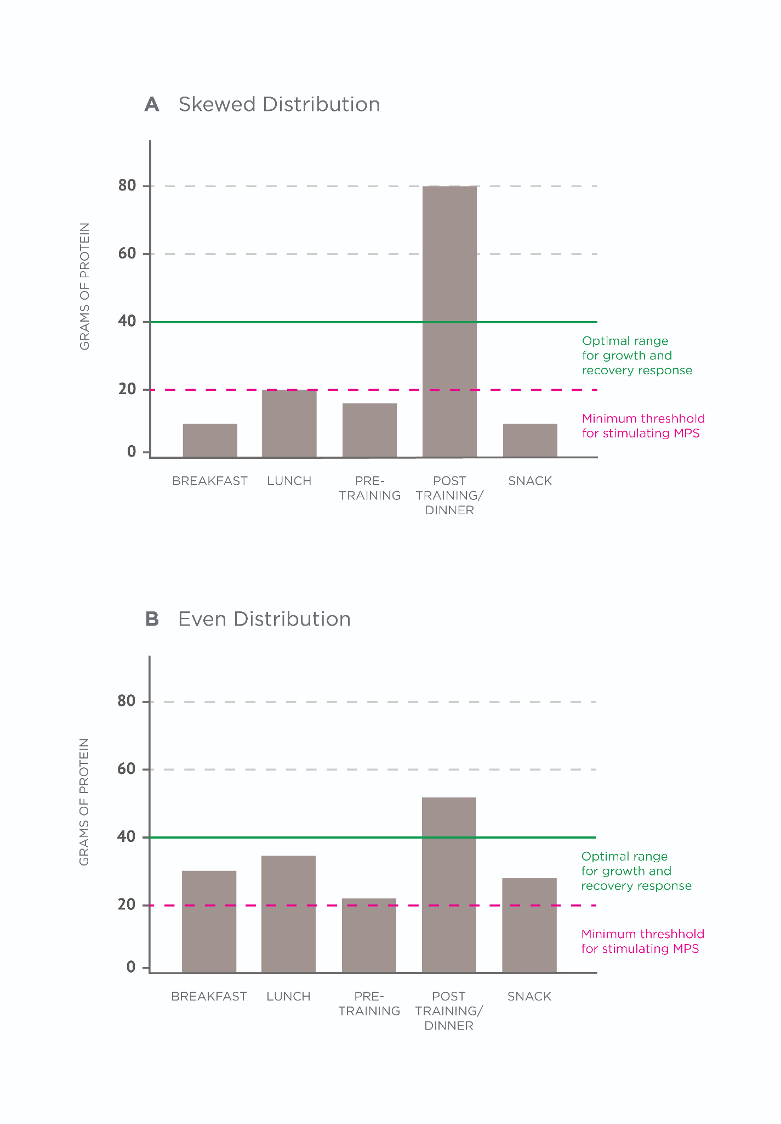

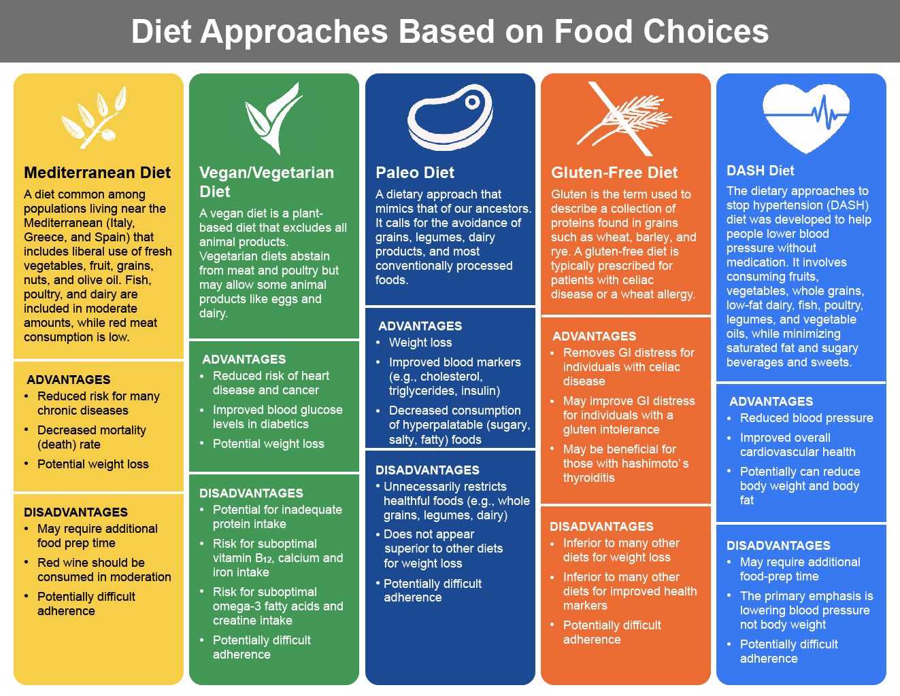

**Diet approaches based on food choices and/or restrictions**

Some dietary approaches are based on certain food choices and/or restrictions they impose. This can take the form of advising specific foods or food groups from which to base the diet on, or naming specific foods or food groups that should be avoided outright. This section will examine some of the most common approaches of this type.

Mediterranean diet

The Mediterranean diet was originally conceived based on observations of the good health experienced by populations living by the Mediterranean (predominantly Greece, Italy and Spain). Plant foods such as fresh vegetables, fruit, grains and nuts make up the basis of the diet, in addition to liberal use of olive oil. Fish, poultry, and dairy products like cheese and yoghurt are included in moderate amounts, while red meat consumption is low. However, the Mediterranean diet extends beyond food choices as it also accounts for social and cultural aspects such as communal mealtimes, resting after eating, and regular physical activity (Renzella et al., 2018).

The Mediterranean diet approach has evidence supporting its role in reducing the risk of several chronic diseases (Filippatos et al., 2016; Sofi et al., 2010). When adherence to the diet is sufficiently high, it is also associated with decreased mortality (Sofi et al., 2014). A meta-analysis of trials looking at the diet’s effect on weight loss found that the Mediterranean diet did better than control diets (Eposito et al., 2011). Current evidence strongly supports the Mediterranean diet as a health-promoting diet. Because of the food emphasised in the diet, it will likely positively impact cardiovascular disease markers (e.g. triglycerides, cholesterol and blood glucose).

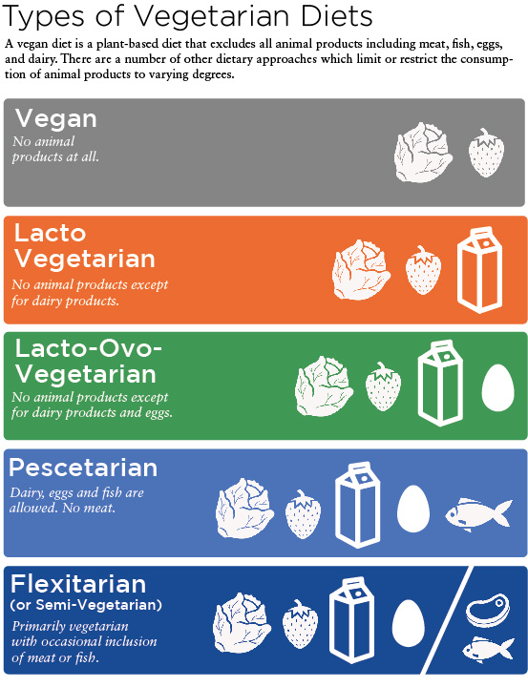

As with other diets, adherence is the key to its effectiveness, so attention should be paid to the individual’s foods preferences and likelihood of sticking to an eating strategy. Additionally, ensuring that an appropriate amount of total energy is consumed relative to the individual’s goal is crucial for body composition changes.

Vegan diet and vegetarian variations

A vegan diet is a plant-based diet that excludes all animal products, including meat, fish, eggs and dairy. There are a number of other dietary approaches that limit or restrict the consumption of animal products to varying degrees.

An examination of observational research suggests that vegans and vegetarians have a reduced risk of heart disease and cancer, but there is no difference in all-cause mortality (Dinu et al., 2017). Research consistently shows associations between processed meat consumption and cancer risk, particularly colon cancer risk (Zhao et al., 2017). However, the health effects of consuming processed meat products (e.g, sausage, salami, etc.) and consuming unprocessed meat (e.g. cuts of fresh meat available at a butchers) are likely very different due to the increased presence of potentially carcinogenic compounds (Jeyakumar et al., 2017).

Vegetarian diets can improve blood glucose levels in diabetics, but they are not superior to other dietary approaches and are potentially inferior to other options such as the Mediterranean diet (Schwingshackl et al., 2018). The improvements in blood glucose, therefore, are likely down to the impact of weight loss, which is clearly the dietary component that most strongly improves health in Type 2 diabetics (Guess, 2018). For the Nutrition Coach working with a client who is eating a vegan or vegetarian diet, there are some potential pitfalls of such diets that should be accounted for and mitigated. These include the following:

1. Protein Intake – Due to the absence of meat, fish, eggs and dairy in the vegan diet, an individual may struggle to eat optimal amounts of protein, especially if their goals are to increase/maintain muscle mass and/or recover from exercise. Therefore, attention should be paid to plant sources of protein in the diet and, if necessary, a vegan-friendly protein supplement (e.g. pea protein powder) can be used.
2. Protein Quality – When it comes to maximising the muscle protein synthesis (repair/growth) response to a meal, plant-based proteins are inferior to animal-based protein sources due to their poorer amino acid profile (van Vliet, Burd & van Loon, 2015). Therefore, to maximise the anabolic response to feeding, one may consider increasing the protein dose from plant-based sources, supplementing with additional amino acids such as leucine, or using a combination of plant-based sources in a meal to provide a more favourable amino acid profile for maximising muscle protein synthesis.
3. Vitamin B12 – The absence of meat in the diet also puts the individual at risk for suboptimal vitamin B12 intake and/or outright deficiency (Allen, 2008). Therefore, it is advisable to supplement with vitamin B12.
4. Omega 3 Fatty Acids – The essential omega-3 fat is called alpha-linoleic acid (ALA), which can be converted into eicosapentaenoic acid (EPA) and docosahexaenoic acid (DHA) in the body. It is EPA and DHA that have the most potent health benefits. These are the omega-3 fatty acids that are present in fatty fish like salmon and mackerel. Omega-3 fatty acids in plant foods (e.g. hemp seeds, walnuts and chia seeds) are in the ALA form. And while ALA can be converted into EPA and DHA, this conversion is poor in humans (Williams & Burdge, 2006). Therefore, in diets that do not include fatty fish, it may be advisable to supplement with an EPA + DHA supplement. Vegan-friendly EPA/DHA supplements are available with the fats extracted from microalgae.
5. Calcium – In diets that do not contain dairy, a common source of dietary calcium is absent. Therefore, special attention should be paid to food sources to ensure sufficient calcium is consumed. Vegans can obtain calcium from several sources, with leafy green vegetables being a particularly good source.
6. Iron – The absence of meat in the diet removes a good source of iron. In addition, the iron found in plant-based foods is non-heme iron as opposed to the heme iron found in animal products. Non-heme iron has a much lower bioavailability than heme iron, meaning vegan clients may require even higher iron intakes to maintain an adequate iron status. The Institute of Medicine recommends an intake of 1.8 times that of non-vegetarians (Position of the American Dietetic Association, 2009).
7. Creatine – Red meat, poultry and fish are the best sources of creatine within the diet. Therefore, vegan and vegetarian clients may tend to have lower muscle creatine stores (Rogerson, 2017). Creatine has demonstrated clear and consistent benefits for exercise performance (Kreider et al., 2017) and emerging research has suggested it can have benefits on health, including mitigating age-related loss of muscle mass and strength, and reducing the risk of neurological disorders such as traumatic brain injury and Parkinson’s disease (Riesberg et al., 2016).

Overall, vegan and vegetarian diets are predominantly associated with positive health outcomes, especially when compared to control or the Western Diet. As discussed with other diets, the healthfulness will be dependent on the food choices. For example, a vegan diet comprised of lots of whole foods like vegetables, fruits, legume, and nuts will be superior to a vegan diet that is made up of lots of processed foods, but simply eliminates animal-based foods. However, the nutrition coach should be aware of the suboptimal micronutrient intakes that can arise and account for these through dietary and supplementation recommendations.

Paleo diet (Paleolithic diet)

The paleo diet is a dietary approach that focuses on selecting foods that proponents of the diet claim humans were exposed to for most of our evolutionary history: meat, fish, vegetables, fruit, nuts and seeds. In its strictest form, it calls for the avoidance of grains, legumes, dairy products and most conventionally processed foods. However, this commonly represented list of foods is not in concordance with the current evidence of what our ancestors likely consumed.

Short-term trials in healthy people have shown that embarking on a paleo diet can lead to weight loss (Osterdahl et al., 2008) and improvements in blood markers such as cholesterol, triglycerides and insulin (Frassetto et al., 2009; Manheimer et al., 2016). However, it is reasonable to assume that any fat loss benefit from the dietary change is simply due to decreased caloric intake (via decreases in the consumption of energy-dense, hyperpalatable foods, and increases in protein and vegetable intake).

The primary objection to recommending a paleo diet is that it unnecessarily restricts foods and/or food groups that have strong evidence to support beneficial impacts on health. Most evidence very strongly supports the promotion of whole grains, legumes, and dairy consumption for human health. They provide sources of fibre, micronutrients, and phytochemicals that all impart health benefits. And large-scale epidemiological research has consistently shown associations with improved health and better long-term outcomes. So, for most people, it would seem a paleo diet is unnecessarily restrictive. However, it should also be clear that some individuals do not tolerate one or more of those food groups for a variety of reasons. Therefore, such individuals may experience improvement in symptoms via the adoption of a diet that eliminates the problematic foods. It should be noted that there is little evidence to suggest that a paleo diet is superior for fat loss and/or health compared to other types of dietary approaches based on minimally processed foods that contain appropriate calorie and macronutrient amounts.

Gluten-free diet

Gluten is the term used to describe a collection of proteins found in grains. In wheat, gluten covers two related proteins: gliadin and glutenin. Other gluten-containing grains include (but are not limited to) barley and rye. Naturally gluten-free grains include (but are not limited to) corn and rice. For a long time, a gluten-free diet has been prescribed in clinical practice for the management of patients with coeliac disease as well as a wheat allergy. In coeliac patients, the body amounts a severe immune response to the gluten proteins. This causes severe damage to the gut lining and patients exhibit several symptoms, including gastrointestinal distress, diarrhoea, pain, rapid weight loss and severe fatigue. It is treated with a gluten-free diet for life.

More recently, it has been increasingly accepted that a certain number of people, who do not have coeliac disease or a wheat allergy, may also experience negative symptoms based on the consumption of gluten-containing foods. In such cases, a diagnosis of non-coeliac gluten sensitivity (NCGS) may be given. Currently, the diagnosis is made based on exclusion: if a patient demonstrates symptoms when consuming gluten but a biopsy has shown they do not have coeliac disease or a wheat allergy (Mansueto et al., 2014). There is currently not a validated blood (or other) test universally accepted to confirm a diagnosis of NCGS, making it difficult to accurately assess prevalence rates within the population. Although most estimates for the prevalence of gluten-related disorders globally commonly report a figure of about 5% (Elli et al., 2015). Regardless of the uncertainty, it is suggested that the Nutrition Coach assumes a certain minority of the non-coeliac population may benefit from a gluten-free diet (Caio et al., 2014). Therefore, advising a gluten-free diet to a majority of clients is not an evidence-based position and should be avoided.

It has also been hypothesised that people with other autoimmune disorders other than coeliac disease (e.g. Hashimoto’s thyroiditis) can benefit from a gluten-free diet. Indeed, there are links between autoimmune disorders; having one increases your risk of developing another (Lundin & Wijmenga, 2015). However, there is still much debate within clinical nutrition about in what contexts a gluten-free diet should be prescribed, if at all. Such a decision falls outside of the Nutrition Coach’s scope of practice. There is currently little to no good evidence to suggest that a gluten-free diet in those who do not suffer with a gluten-related disorder will lead to better body composition, cognitive function or health, in comparison to gluten-containing whole-food based diets.

MyPlate

MyPlate is the most current attempt from the USDA to represent guidelines for healthy eating through a visual representation with supporting recommendations. MyPlate is the latest in a long line of such representations by the USDA, including the 2005 MyPyramid and the 1992 Food Guide Pyramid (A Brief History of USDA Food Guides, 2017).

The MyPlate recommendations are based on four primary goals (What is MyPlate?, 2018):

1. Focus on variety, amount and nutrition.
2. Choose foods and beverages with less saturated fat, sodium and added sugars.
3. Start with small changes to build healthier eating styles.
4. Support healthy eating for everyone.

Despite increasing knowledge of healthy eating guidelines, as with virtually all diets, adherence to these dietary guidelines still seems to be a problem, at least at a population level (Haack et al., 2014).

**DASH (Dietary Approaches to Stop Hypertension) diet**

The dietary approaches to stop hypertension (DASH) diet was originally developed to help people lower blood pressure without medication. The DASH diet is based around a small number of very simple recommendations (Table: DASH Diet Recommendations (courtesy of the National Heart, Lung and Blood Institute).

Recent meta-analyses and systematic reviews have found the DASH diet to have benefits for reducing blood pressure (Saneei et al., 2014), improving cardiovascular risk factors (Siervo et al., 2015), and reducing body weight, fat mass and BMI compared to controls (Soltani et al., 2016). However, there may be issues with achieving compliance with the diet (Kwan et al., 2013). Overall, the DASH diet promotes the inclusion of many health-promoting foods and would be a healthy eating approach if adhered to. As is a running theme with all the diets discussed so far, the benefits of the diet for health and body composition are simply a function of eating primarily minimally processed foods and consuming appropriate energy intake.

DASH Diet Recommendations (courtesy of the National Heart, Lung and Blood Institute)

| Eating vegetables, fruits, and whole grains |
| --- |
| Including fat-free or low-fat dairy products, fish, poultry, beans, nuts, and vegetable oils |
| Limiting foods that are high in saturated fat such as fatty meats, full-fat dairy products, and tropical oils such as coconut, palm kernel, and palm oils |
| Limiting sugar-sweetened beverages and sweets |



**Diet approaches based on time restrictions and/or fasting**

Some dietary approaches are predominantly based on the timing of meals and/or nutrients, more so than on food selection or macronutrient composition. Many of these approaches include some form of fasting where meals are consumed within a specific window of time. Other timing restraints may include restricting intake on certain days, avoiding eating at certain times of the day, or alternating between phases of undereating and ad libitum dieting. This section will examine some of these approaches.

Fasting and time-restricted feeding

Fasting is achieved by consuming zero to minimal amounts of calories (via food and caloric beverages) for periods that can range from 12 hours to 3 weeks (Longo & Mattson, 2014).

There are various distinct iterations of a dietary approach based on intermittent fasting:

1. Alternate Day Fasting
2. 5:2 Diet
3. Time-Restricted Feeding (TRF)
4. Prolonged Fast (several days of fasting done every several months)

Relevant to the Nutrition Coach, a fasting protocol that requires fasts of longer than 24 hours (and particularly those lasting 3 or more days) should be done under the supervision of a physician/doctor (Longo & Mattson, 2014).

Alternate Day Fasting

Alternate day fasting is a protocol that is just as its name implies; the individual alternates between a day of fasting and a day of feeding (typically ad libitum dieting). While the fasting day can indeed be a complete fast, it often allows a small amount of calories such as 25% of normal maintenance intake or 500 kcal. Not only is a large calorie deficit created on fasting days, but trials seem to indicate that although as much can be consumed on feast days as desired, the amount eaten is not large enough to negate the large caloric deficit created the day before while fasting, thus leading to significant fat loss (Varady et al., 2013). However, this seems to also depend on the individual, as big eaters (an ability to overeat or eat large amounts of food) may eat enough on feeding days to prevent weight loss (Heilbronn et al., 2005).

5:2 diet

The 5:2 diet derives its name from a description of the protocol: 2 fasting days and 5 feeding days per week. Calories can be consumed on the fasting days with a maximum of typically 500 kcal set for women and 600 kcal for men. The diet has been shown to be capable of inducing fat loss, despite only 2 of every 7 days being purposely hypocaloric (Carter et al., 2018). This can be explained by considering the impact on energy balance across the 7-day period. If the 2 fasting days create a significant caloric deficit and there is not a large overcompensation for this on feeding days to completely mitigate the large deficit created on the 2 fasting days, over the 7-day period there is a net caloric deficit, and thus, weight loss.

Coach's Corner

When an individual is considering embarking on a fasting strategy for the first time, the Nutrition Coach should make them aware that some people will experience certain physiological (e.g. dizziness) and psychological (e.g. irritability) changes. Such symptoms can vary in their intensity and will often diminish in time.

Additionally, where an alternate-day fasting model (or 5:2 diet) is used, food quality should still be emphasised to clients. Feast days are not a free for all. Food choices should be good, eating should be mindful, and the client should eat until satiated but not beyond. On fasting days, given the low number of calories allowed, foods high in fibre and protein should be emphasised (e.g. lots of fibrous vegetables with some lean meat).

Time-restricted feeding

Time-restricted feeding is a term that has appeared in research to describe an eating approach where there are specific eating and fasting windows across the day. As an example, a common variant of intermittent fasting is a 16:8 fasting:feeding approach, As the name suggests, in such a set-up the individual would fast for 16 hours in every 24-hour period, leaving a feeding window of eight hours (e.g., eating the first meal of the day at 1 p.m., having the final meal at 9 p.m. and then fasting until 1 p.m. the next day). Recent research has suggested such a 16:8 time-restricted feeding pattern may improve health markers and decrease body fat (Moro et al., 2016). However, it is worth noting that the time-restricted feeding group ate fewer calories in the study. Indeed, time-restricted feeding may help people achieve a calorie deficit without counting/tracking calories or food intake (Tinsley et al., 2017).

Nutrition Coaches should never recommend a specific fasting strategy to clients. This information is only intended to educate clients who have expressed an interest in fasting so that they may make the best choice for themselves.

Systematic reviews and meta-analyses suggest that forms of intermittent caloric restriction produce similar effects to continuous calorie restriction in calorie-matched conditions (Harris et al., 2018; Seimon et al., 2015). Therefore, it is probably best to view intermittent fasting protocols as neither being better nor worse when it comes to changes in body composition when compared to non-fasting diets of the same food, calories and macronutrients. However, the Nutrition Coach should be aware that on an individual basis, a diet that is based on fasting (or any other method for that matter) may confer a benefit if it increases dietary adherence.

**Diet psychology and impact on client adherence**

A deep discussion of diet psychology and behavioural change is beyond the scope of this chapter. However, any discussion of the effectiveness of different dietary approaches should pay attention to some of the psychological and behavioral issues that can be influenced by the type of diet used, and the mindset with which the individual faces their dietary choices. Success in improving health and/or body composition is going to be directly tied to the ability to adhere to the planned dietary approach. Therefore, any dietary decisions that will make adherence to the key dietary principles more/less difficult should be highlighted.

A wide variety of different dietary approaches can lead to improvements in health and body composition. Rather than asking 'Which diet/method is best?' it is more important for the Nutrition Coach to understand the principles that underlie a healthy diet and/or a diet that alters body composition.

In fact, all dietary approaches or methods will be successful for the same reasons. For example, for body fat loss to occur, it is advisable that the diet has an energy (calorie) content that places the dieter in a caloric deficit, contains an adequately high amount of protein and is based on predominantly minimally-processed foods. Clearly, the diet could be set up in many ways to achieve such principles.

Some dietary approaches have much stronger evidence behind their efficacy than others. For example, the Mediterranean diet and the DASH diet have an extensive amount of peer-reviewed literature behind them, with the vast majority showing clear benefits for health. Other diets do not have extensive, high-quality long-term research supporting their use.

When diets are matched for calorie and protein content, there seems to be no fat-loss advantage for either low-carbohydrate or low-fat diets. Therefore, it is advisable to use amounts of carbohydrates and dietary fat in the diet that fit the individual’s preferences and goals. Similarly, current evidence suggests that in diets matched for calories and protein, the impact on body composition will be similar between diets of differing meal timings and meal frequencies.

Dietary restraint is required for successful outcomes, particularly in relation to weight loss. However, it is likely that a flexible control of diet behaviours is superior to a rigid control, as it leads to less overeating and negative psychological outcomes. For most individuals, foods and/or food groups should not be unnecessarily restricted.

No matter the exact approach, current evidence indicates that a healthy diet is one based on vegetables, fruit, whole grains, lean meats, fish, eggs, nuts, seeds, dairy and legumes. For body composition specifically, calorie intake and macronutrient intake will be the main drivers of change. Food type/quality has a very minor role in impacting body composition from a physiological perspective. However, in practice, a diet of predominantly whole, minimally-processed foods will lead to better outcomes indirectly, due to the increased probability of controlling calories on such a diet.

In this chapter, you learned about:

* Body composition and health claims related to a range of diet types.
* Comparisons between low-fat and low-carbohydrate diets.
* The features of MyPlate and the Mediterranean and DASH diets.
* The characteristics of the ketogenic and paleolithic diets.
* The science and efficacy of intermittent fasting protocols.
* The difference between low-energy and very low-energy diets.

# Nutrition hot topics and controversies

The modern nutritional landscape is vast and ever-changing. This is expected as science is based on continuous development, building on previous foundations as novel information emerges.

An unfortunate side effect of having an abundance of nutritional data available to anyone with an Internet connection is that the world has become rife with misinformation. Unless someone has a solid grasp on nutritional science, it can be difficult to tease fact from fiction.

Learning the different nutrition hot topics and controversies will help provide the Nutrition Coach with evidence-based conclusions on a variety of popular nutrition topics they will encounter with clients. Rather than address common myths directly, this chapter will discuss the topics in general to provide the information necessary to address any potential questions and concerns that clients may have.

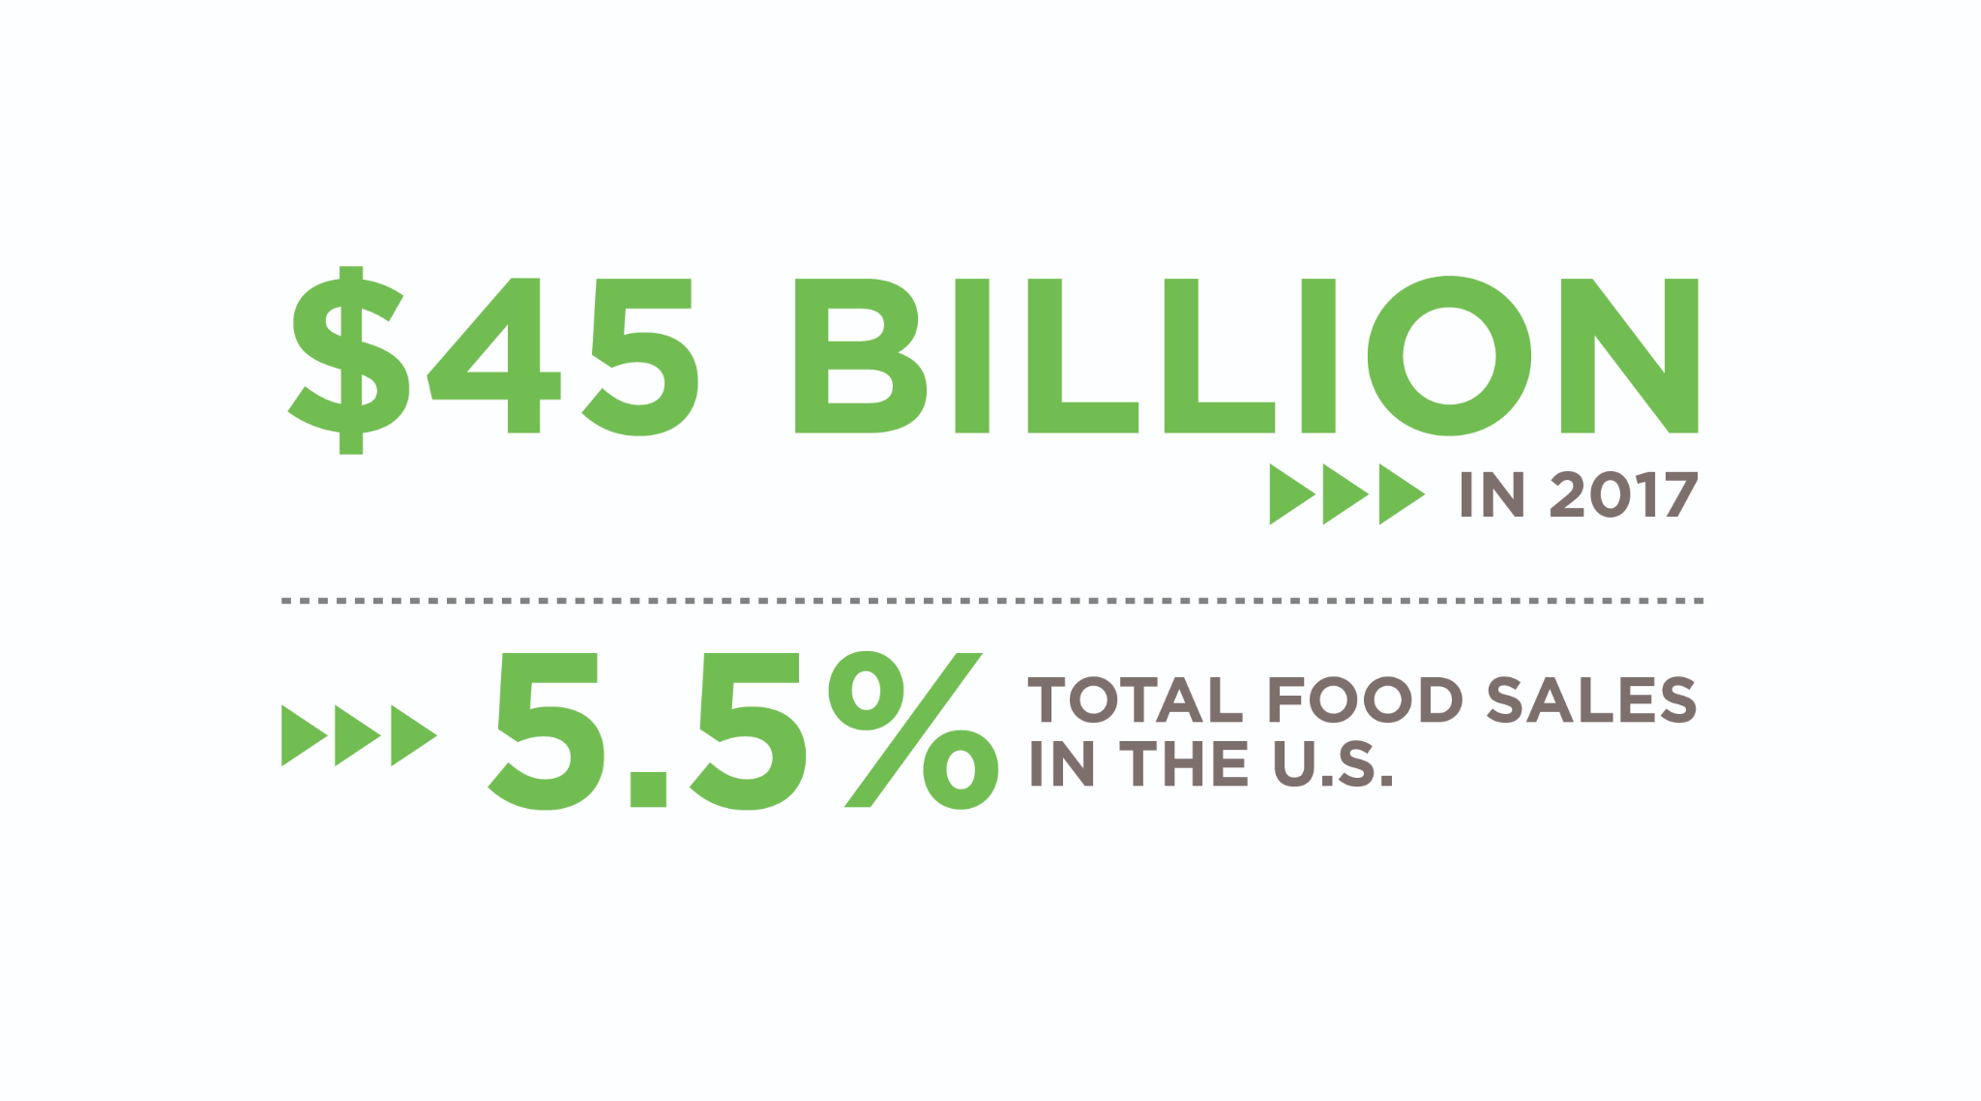

**Organic vs Conventional**

The organic market has seen substantial increases over the past decade, bringing in over $45 billion in 2017 and accounting for 5.5% of total food sales in the U.S. (Figures: Organic Sales Increase and U.S. Organic Food Sales) (McNeil, 2018). These sales are driven, in part, by consumer perceptions that organic foods are healthier than conventional foods, which seem to be of greater concern to people than the environmental, social, and economic sustainability of organic foods (Annunziata & Angela, 2017; Baudry et al., 2017).

Whether organic foods are healthier than conventional foods has been evaluated in numerous studies over the past 20 years and there is ample scientific evidence to help shape our thoughts on the topic. As a Nutrition Coach, it is important to understand the nutritional impact of eating organic foods compared with conventional to help clients navigate the supermarket and obtain the highest nutritional value for their dollar.

Importantly, *conventional* refers to the predominant type of intensive agriculture and animal husbandry methods in the United States where the use of pesticides and concentrate feed are common. *Organic* refers to practices that adhere to the USDA’s certified organic criteria.

The USDA maintains a comprehensive website about organic certification and related data and research: <https://www.usda.gov/topics/organic>

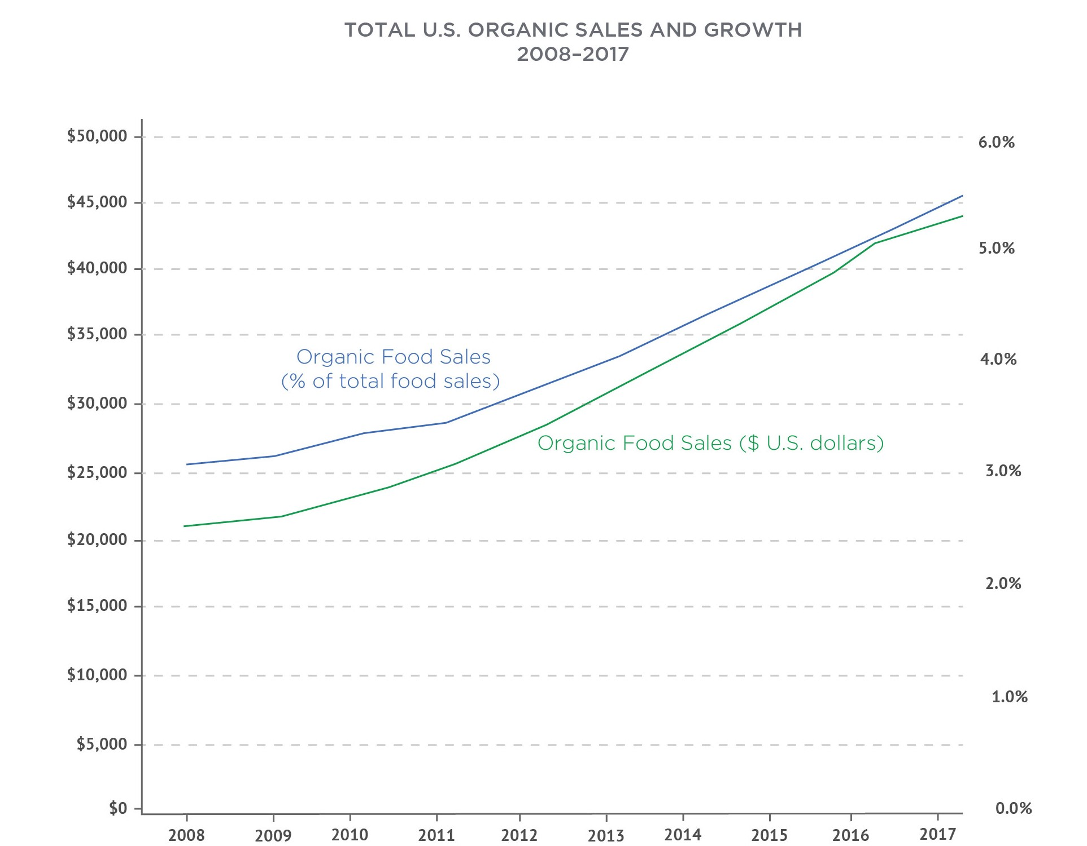

**Agriculture**

The primary difference between conventional and organic agriculture is the reliance of conventional agriculture on synthetic pesticides. Although some pesticides are approved for use in organic farming systems, organic farming generally relies on crop rotation, biological control through employing natural enemies of pests, and hygiene practices (van Bruggen, Gamliel, & Finckh, 2016). Of the pesticides that are used, most have lower toxilogical concerns than their synthetic counterparts because they are part of the human diet (e.g., sulfur, potassium bicarbonate, and coconut soap) or are used in pest traps rather than being applied to the crop [(](https://paperpile.com/c/Cv3Z5O/wPdM)van Bruggen et al., 2016[)](https://paperpile.com/c/Cv3Z5O/wPdM).

Many synthetic pesticides have been linked to cancer (Goodson, et al., 2015), hormone disruption (Vandenberg et al., 2012[)](https://paperpile.com/c/Cv3Z5O/flkX), and neurological disorders (Burns, McIntosh, Mink, Jurek, & Li, 2013). Organic produce has four-fold lower levels of pesticide residues than conventional produce (Barański et al., 2014; Smith-Spangler et al., 2012). A lower pesticide exposure through eating organic produce can be considered a health benefit, especially for pregnant women, infants, and children who are in developmental stages where pesticide exposure can have profound developmental effects (Burke et al., 2017; Voorhees, Rohlman, Lein, & Pieper, 2016).

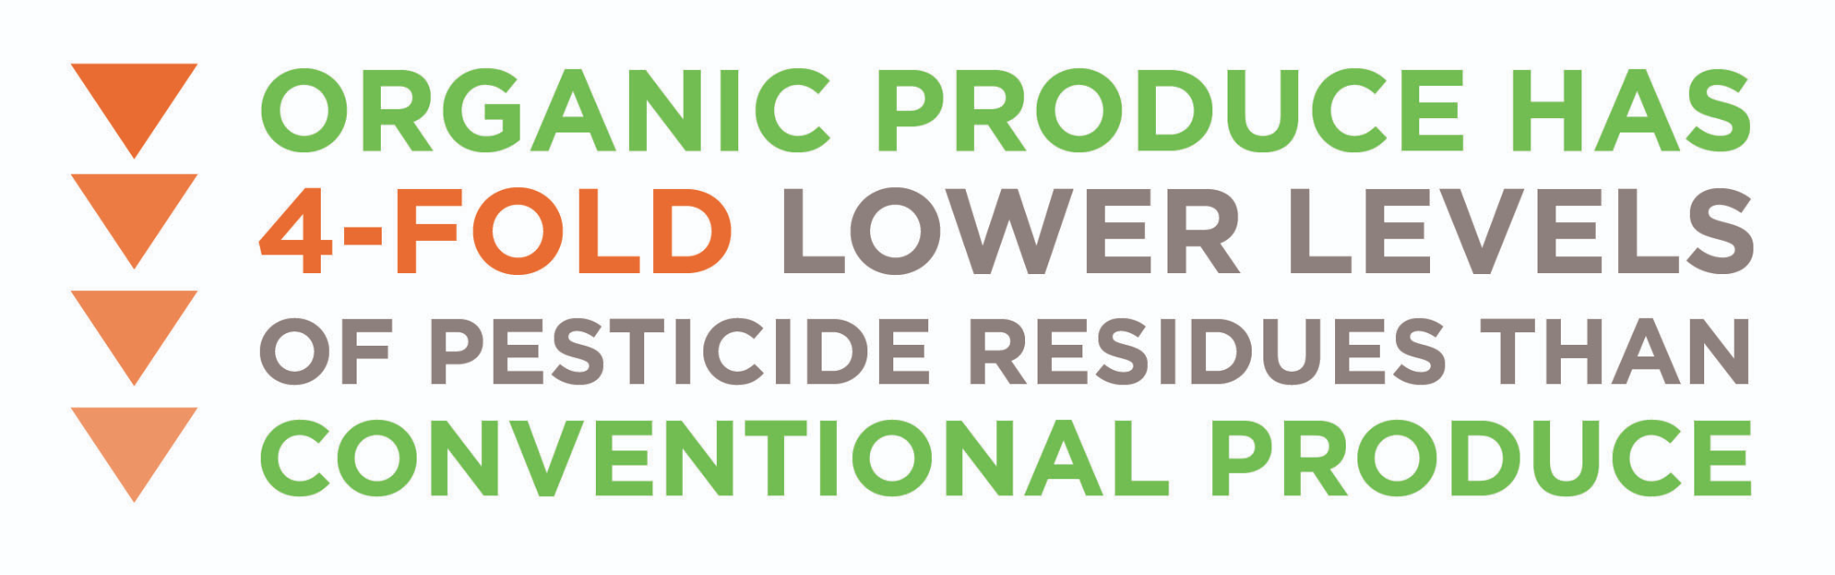 

Importantly, controlled trials have demonstrated that switching from conventional to organic produce significantly reduces biomarkers of pesticide exposure in as little as 5 to 7 days in adults and children (Lu et al., 2006; Oates, Cohen, Braun, Schembri, & Taskova, 2014). Over the course of a year, pesticide exposure significantly correlates with fresh fruit and vegetable consumption, further supporting the notion that eating conventional produce is a significant source of pesticide exposure.

Some researchers have challenged the notion that pesticide exposure from produce is a concern due to the overall exposure levels being well-below established safety limits [(Winter & Katz, 2011)](https://paperpile.com/c/Cv3Z5O/njzS). However, current toxicology practices to determine the safe exposure limit to chemicals assume that all dose-response relationships are monotonic (linear) and that there is always a threshold dose below which no adverse effects of a chemical occur.

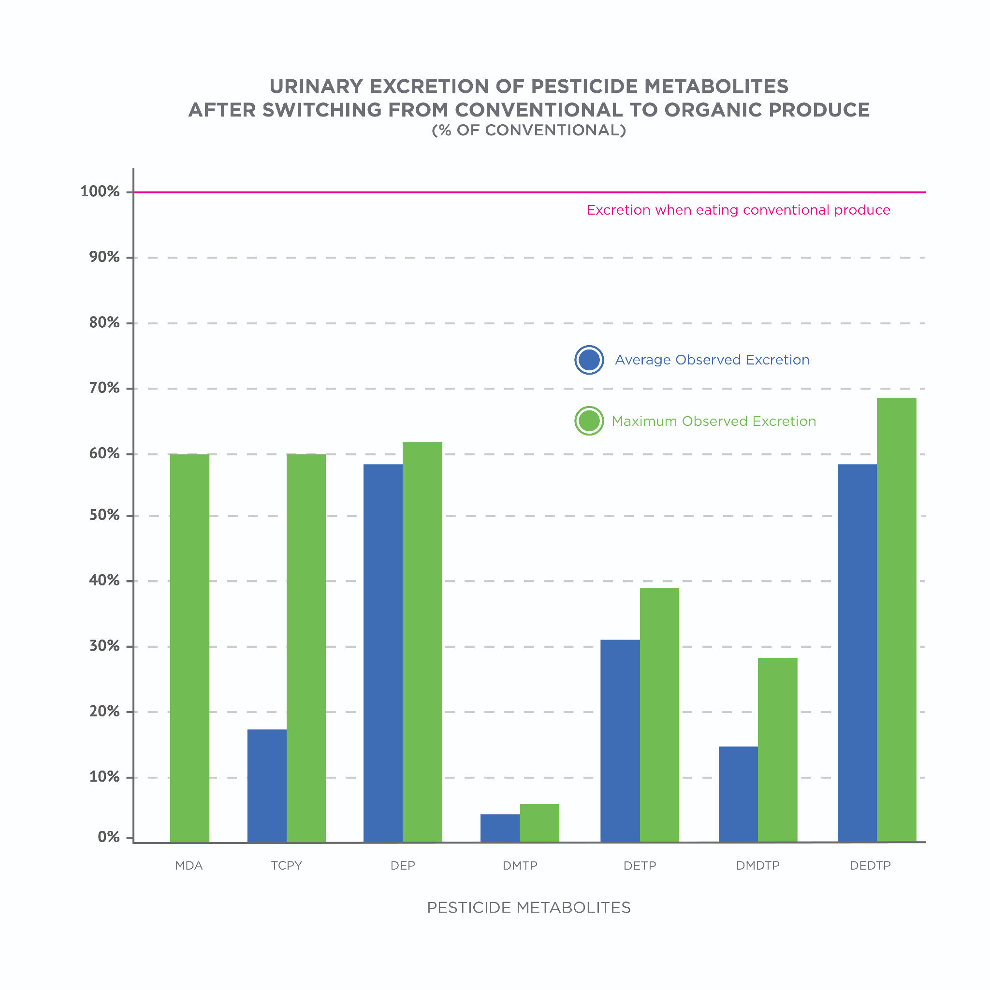

This monotonic relationship is captured by the following colloquialism: the dose makes the poison. It is an appealing concept because even water can kill if enough is consumed within a short timeframe (Gardner, 2002). Yet, the assumption that most chemicals are monotonic in toxicology research has been heavily criticized as being dogma from the 16th century (Myers, Zoeller, & vom Saal, 2009; White et al., 2009).

Rather, numerous experiments with hormones, drugs, and other chemicals that act via hormonal mechanisms have shown that it is very common for the dose-response curve to be non-monotonic and form one or more U-shaped curves (Vandenberg et al., 2012).

When discussing the issue of toxicology with a client, visuals are worth 1,000 words. Figure: Monotonic vs. Non-Monotonic can help illustrate that idea of assumed and realistic dose-response relationships. The end-goal is to help the client understand that many chemicals are toxic at high and low doses with a less-toxic middle ground between these extremes. Yet, most research is not conducted at the lower doses to determine what toxic effects occur at these doses, therefore, making it difficult to establish a lower-limit exposure level at which harm could be expected. It is a counter-intuitive concept: that some exposure may be safer than too little exposure.

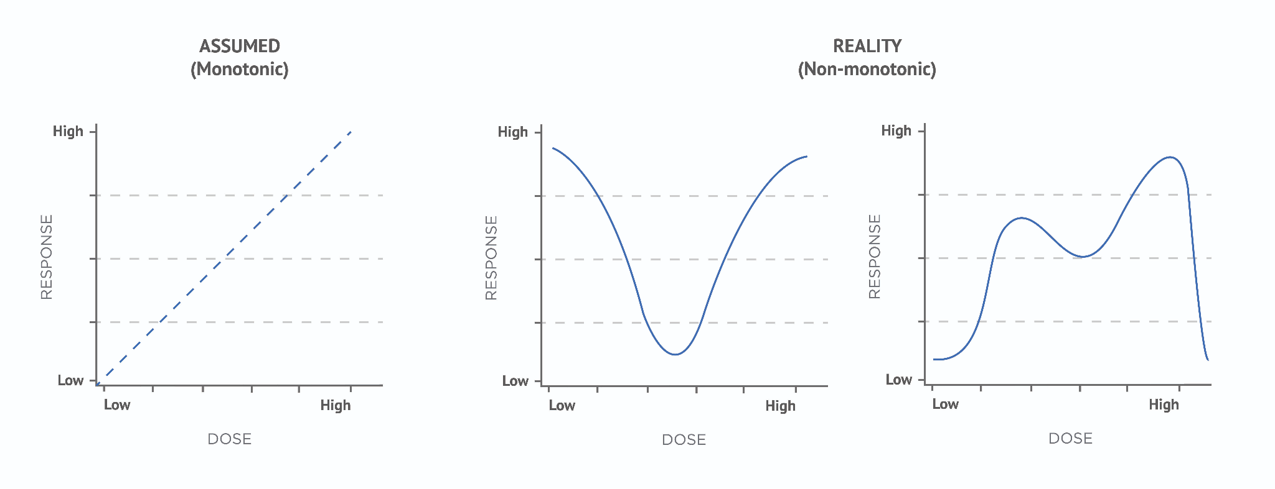

Accordingly, toxicological testing of various synthetic pesticides may not accurately capture the true risk of exposure. This has been the case with one of the most widely used pesticides on corn, soybeans, and wheat: glyphosate (the active ingredient in Roundup) is carcinogenic at low doses untested in traditional toxicology studies (Davoren & Schiestl, 2018[)](https://paperpile.com/c/Cv3Z5O/PPoh).

Of course, pesticide use varies by crop. Several consumer-advocacy organizations, such as the Environmental Working Group and the Pesticide Action Network, provide assessments of pesticide residues on conventional and organic produce. If your clients are interested in reducing pesticide exposure, the data provided by these organizations can help them make changes that will have the greatest return on investment.

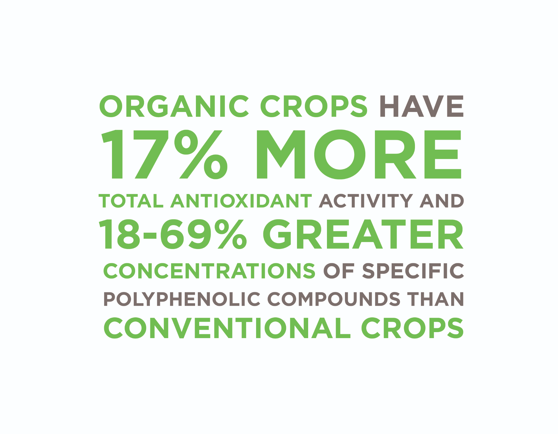

Nutritionally, there are not many meaningful differences between organic and conventional produce in terms of macronutrients, vitamins, or minerals (Barański et al., 2014; Smith-Spangler et al., 2012). However, organic produce does beat out conventional when it comes to secondary metabolites.

Plant polyphenols are believed to be one of the reasons eating a diet rich in plants is associated with numerous health benefits such as beneficial effects on the brain, cancer, inflammation, and the cardiovascular system (Infographic: Benefits of Polyphenols) (Del Rio, 2013). Switching from conventional to organic foods would increase polyphenol intake by the equivalent of one to two servings of fruits and vegetables without any change in actual food or energy intake (Barański, et al., 2014[)](https://paperpile.com/c/Cv3Z5O/RJhn).

When it comes to produce, organic varieties are likely to be the better option due to lower levels and safer types of pesticides as well as higher concentrations of secondary metabolites. Not all crops are grown the same way, however, and resources discussed can help the Nutrition Coach and client determine which foods pose the greatest health risk from pesticide exposure.

The higher concentration of polyphenols with organic farming is likely the result of greater stress on the plant (wounding, pest attacks, disease, etc.) that signal it to produce more polyphenols: a known defense mechanism of plants that benefits survival (Zaynab et al., 2018). Less pesticide and fertilizer use with organic farming means a greater stress exposure to organic crops.

**Meats, milk, and eggs**

Organic meats, milk, and eggs must come from livestock that are raised on certified organic land, meeting all organic criteria for agriculture; fed 100% organic feed without animal byproducts and synthetic preservatives; raised without antibiotics, growth hormones, or animal byproducts; and allowed year-round access to the outdoors (National Organic Program, 2013).

The USDA has several fact sheets available on their website. Take a look at the [Organic Livestock Requirements fact sheet](https://www.ams.usda.gov/publications/content/organic-livestock-requirements) to see the regulations in place for meat, milk, and eggs.

There are clear ethical considerations with livestock welfare and people who opt for organic meats expect that animal welfare standards are higher for organic than conventional livestock (Hughner, McDonagh, Prothero, Shultz, & Stanton, 2007[)](https://paperpile.com/c/Cv3Z5O/kXre). Roughly 3/4 of Americans are concerned with the welfare of livestock and believe there should be an objective third party evaluating livestock welfare and that livestock are generally raised under conditions in-line with organic criteria [(](https://paperpile.com/c/Cv3Z5O/UfOy)Spain, Freund, Mohan-Gibbons, Meadow, & Beacham, 2018).

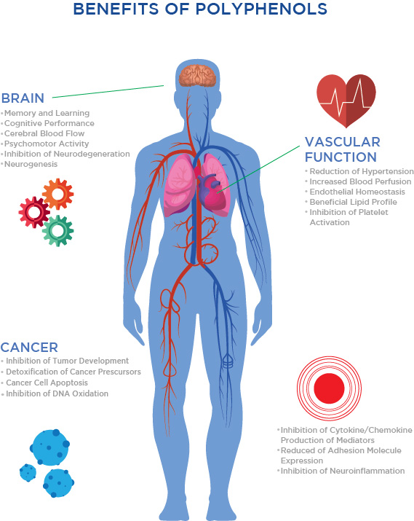

There are clear ethical considerations with livestock welfare and people who opt for organic meats expect that animal welfare standards are higher for organic than conventional livestock (Hughner, McDonagh, Prothero, Shultz, & Stanton, 2007[)](https://paperpile.com/c/Cv3Z5O/kXre). Roughly 3/4 of Americans are concerned with the welfare of livestock and believe there should be an objective third party evaluating livestock welfare and that livestock are generally raised under conditions in-line with organic criteria [(](https://paperpile.com/c/Cv3Z5O/UfOy)Spain, Freund, Mohan-Gibbons, Meadow, & Beacham, 2018).

Due to differences in livestock living conditions and feed, organic livestock will have less exposure to environmental toxicants such as pesticides and other persistent organic pollutants (POPs) (Domingo & Nadal, 2016). The lipid solubility of these toxins means that they accumulate primarily in fat, be it meat fat, milk fat, or egg yolks.

Exposure to these toxicants through meat consumption has been minimally investigated. What data is available suggests that it is a health concern, albeit one less than exposure to toxicants from conventional agriculture or air pollution (Domingo, 2017). However, there is little to no research investigating differences between organic and conventional meats for pesticides, mycotoxins, and other contaminants (Średnicka-Tober et al., 2016).

Most research comparing organic and conventional meats, dairy, and eggs focuses on differences in nutrition content with particular focus on the fatty acid profile. The colloquialism, *you are what you eat*, applies to livestock with the animal’s diet known to modify the fatty acid profile of its meat, milk, or eggs.

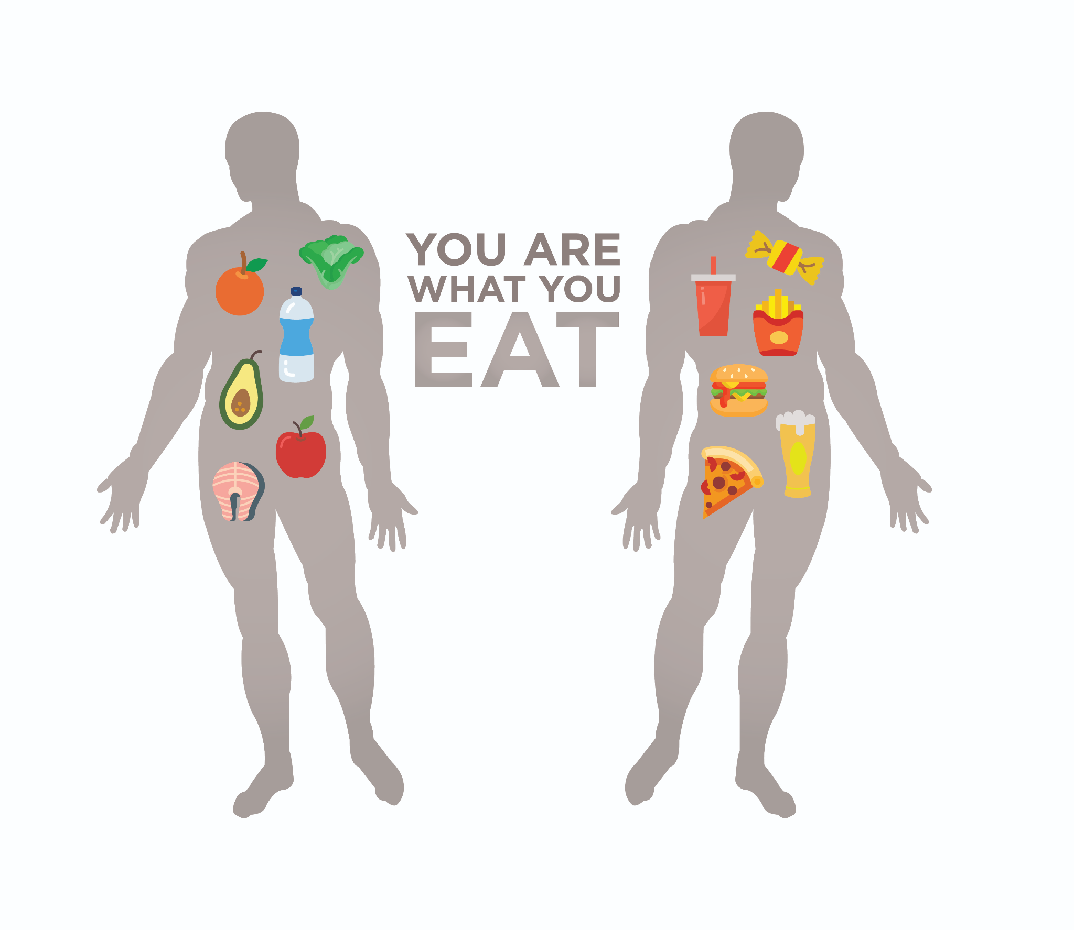

When discussing conventional meat with clients, two points need to be emphasized: the accumulation of POPs in animals is an established occurrence but there is little investigation into POP concentrations in conventional and organic meats. If this issue concerns clients and they have barriers toward purchasing organic meats, opting for low-fat meats can help reduce POP exposure due to their accumulation primarily within fat tissue.

Although these relative increases are large, the absolute amounts of omega-3 fatty acids in meat and milk are so low that the real-world implication of these findings is low. Using the 47% increase in meat as an example, the absolute omega-3 content would increase by 280 or 470 milligrams per 100 grams (900 calories) of beef tallow or chicken fat, respectively.

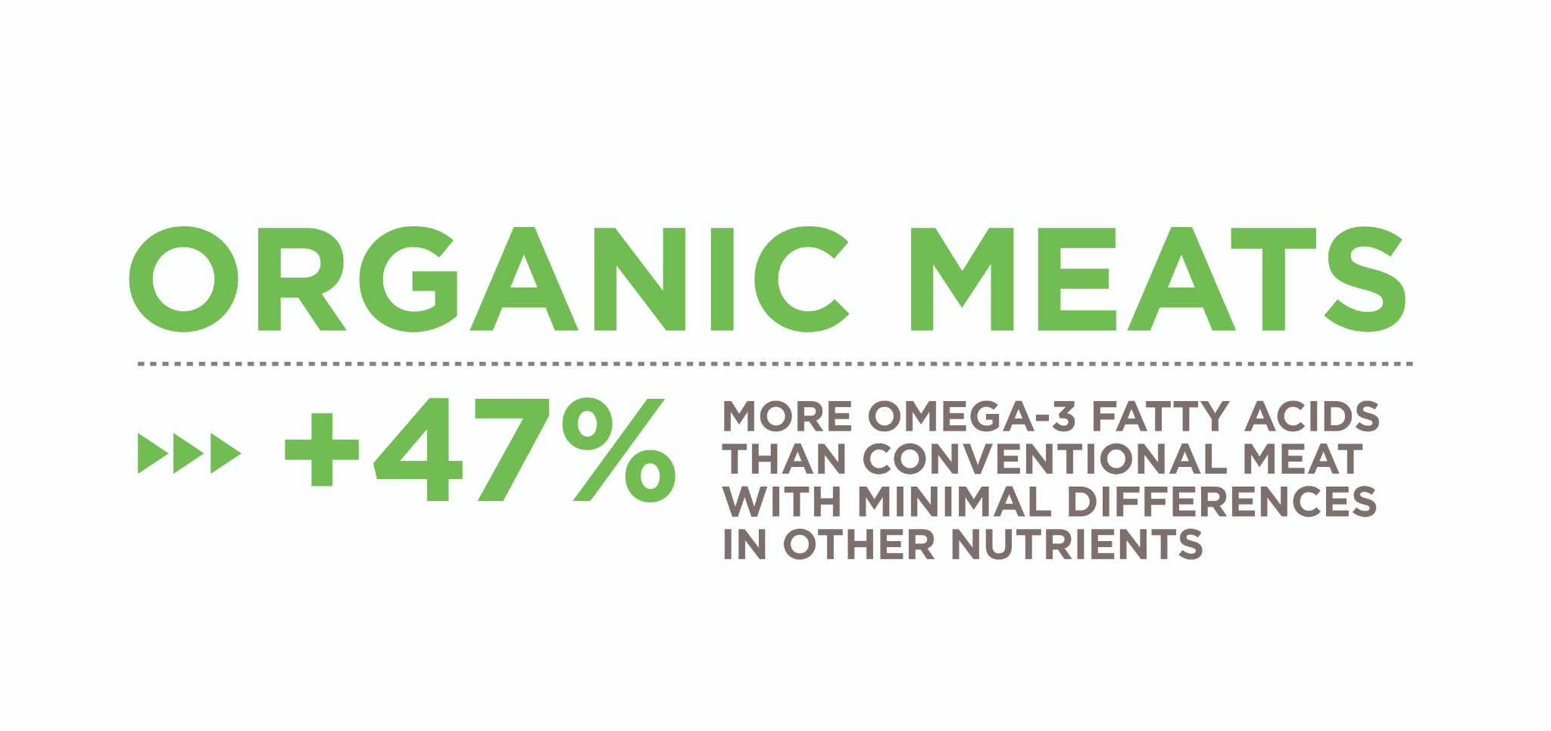

Importantly, this increase comes almost entirely from alpha-linolenic acid (ALA), which is not readily converted into the long-chain omega-3 fatty acids associated with the health benefits: EPA and DHA (Gerster, 1998; Średnicka-Tober et al., 2016).

No systematic reviews or meta-analyses have been conducted for eggs. However, individual studies suggest that, while differences in fatty acids, vitamins, and minerals do exist, they are too small to be of real-world significance (Filipiak-Florkiewicz et al., 2017). There are also little to no differences in concentrations of bioactive compounds like polyphenols (Mugnai et al., 2014).

In summary, organic livestock live healthier and more humane lives than conventional livestock but this translates into minimal nutritional differences in their meat, milk, and eggs. There is a theoretical concern with POP accumulation being greater in conventional livestock and the foods we obtain from them but there has not been any direct investigation into the actual amounts, their health effects, or the differences in either between organic and conventional.

**Grass-fed and pasture-raised**

Many consumers are now searching for grass-fed and finished animals raised on pasture throughout the lifespan, thus, replicating the animal’s natural environment and ensuring they are always consuming an ecologically appropriate diet. Similar to organic, these food choices are driven by perceptions of increased animal welfare and healthfulness of their meat, milk, and eggs.

Meats

Although organic standards are a step in the right direction toward increased animal welfare compared to conventional livestock conditions, there are nuances that some people take issue with. For example, certifying cattle as organic requires that the cattle be grazed on certified organic pasture throughout the entire grazing season for the geographic region but, because this time-frame is variable, the overall requirement for grass in the diet is a minimum of 30% (National Organic Program, 2013). Moreover, these rules apply only up until the final 120 days of the cattle’s lives, during which time they can be finished on grain feed (albeit certified organic).

This grain-feeding period is long enough to have a substantial impact on the quality of the meat, primarily by increasing its fat content anywhere from two- to four-fold and altering the fatty acid profile to be higher in monounsaturated fatty acids, lower in polyunsaturated fatty acids, and higher in the ratio of omega-6 to omega-3 fatty acids (Duckett, Wagner, Yates, Dolezal, & May, 1993).

These findings are consistent across numerous studies comparing beef from grass-fed and finished cattle to that of grain-fed cattle. That is, beef from grass-fed and finished cattle is leaner, contains more omega-3 fatty acids, including EPA and DHA, and vitamins A and E (Daley, Abbott, Doyle, Nader, & Larson, 2010; Van Elswyk & McNeill, 2014). The extent of the differences are variable, however, because the nutritional content of beef depends heavily on the type of forage crops that are eaten by the animal, the animal’s age and breed, and the season (Figure: Grass-Fed Beef Nutrition Benefits).

Overall, opting for grass-fed and finished cattle will have the greatest nutritional impact if your client does not regularly consume seafood or regularly eat high-fat cuts of meat because the nutritional differences are largely confined to the meat’s fat content.

For individuals who do not like eating seafood rich in EPA and DHA, beef from grass-fed and finished cattle can help boost their intake. Swapping out 690 grams per week (about 24 ounces or 1.5 pounds) of red meat from conventional cattle for red meat from grass-fed cattle and lamb has been shown to significantly increase serum concentrations of total omega-3 fatty acids, including DHA, and reduce the serum omega-6 to omega-3 ratio (McAfee et al., 2011).

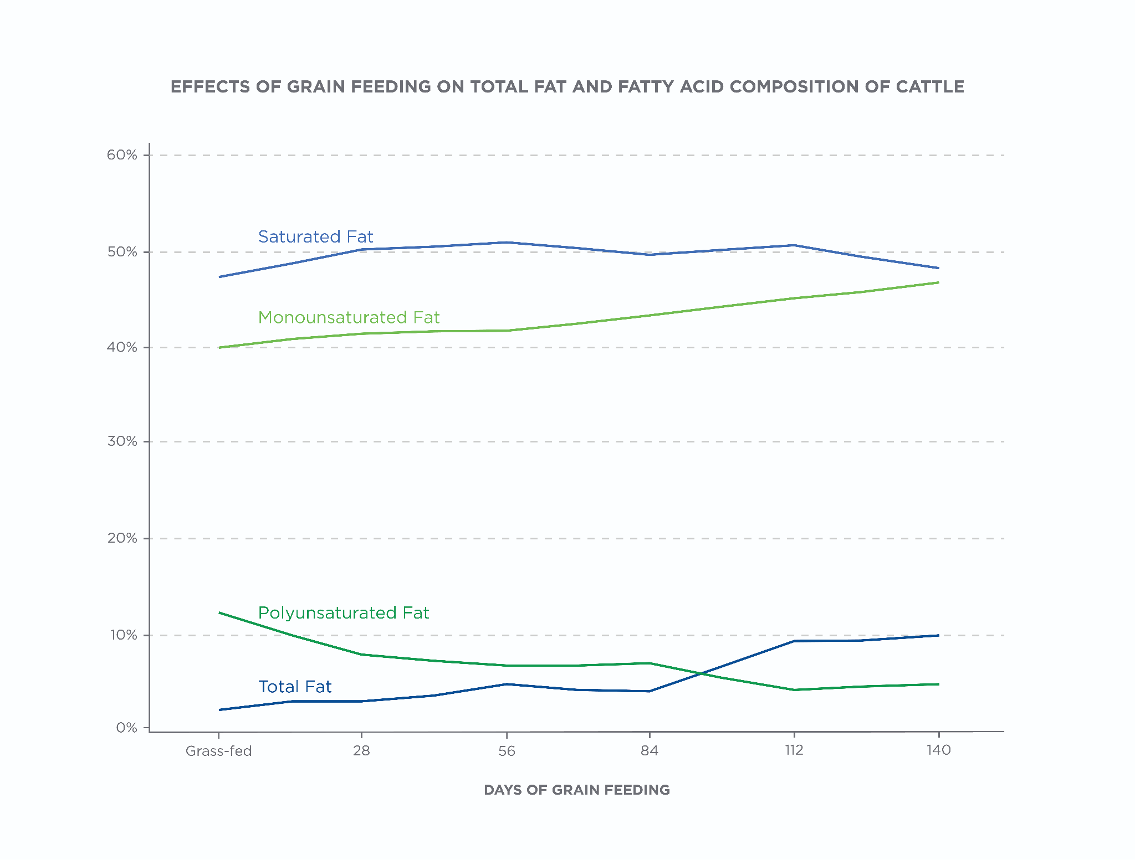

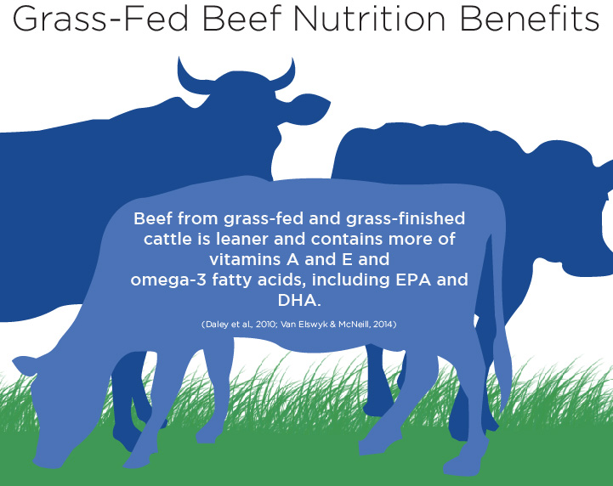

Milk and eggs

As with the meat itself, the milk and eggs produced by livestock are influenced by the animals’ diet. For example, feeding dairy cows an increasing amount of grass in the diet leads to directly proportional decreases in saturated fat and increases in mono- and polyunsaturated fats, including conjugated linoleic acid (CLA) and ALA (Couvreur, Hurtaud, Lopez, Delaby, & Peyraud, 2006). Other studies have reported similar observations (Hebeisen, Hoeflin, Reusch, Junker, & Lauterburg, 1993).

Importantly, however, the real-world relevance of these chances is questionable. The increase in omega-3 content is limited primarily to an increase in ALA from 0.22 grams per 100 grams of milkfat in conventional dairy to 0.7 grams per 100 grams of fat in 100% grass-fed dairy (Couvreur et al., 2006). These increases are incredibly small and likely to have little to no effect on health.

Similarly, the increase in CLA from conventional to 100% grass-fed was 0.48 to 1.65 grams per 100 grams of milkfat (Couvreur et al., 2006). In a controlled trial having participants supplement their diet with 2.2 to 2.7 grams of CLA per day for several weeks, no significant effects were seen on blood lipids or lipoproteins other than a marginal reduction in triglycerides (Gebauer, Destaillats, Dionisi, Krauss, & Baer, 2015).

Even with 100% grass-fed milk, the level of intake, which had no notable health benefits in this controlled trial, would have required consuming at least 133 grams of pure milkfat or about 1,200 calories. Accordingly, the changes in the CLA content of milk from grass-fed cows are not of any real-world significance because overall CLA levels remain low.

As with meat and milk, the diet of chickens influences the nutrient content of their eggs. Pastured hens lay eggs with significantly more omega-3 fatty acids, including a notable increase in DHA, less omega-6 fatty acids, and a lower omega-3 to omega-6 ratio than their conventional or organic counterparts (Lopez-Bote et al., 1998; Mugnai et al., 2014). Additionally, eggs from pastured hens contain significantly more vitamin E and bioactive compounds, including lutein and zeaxanthin (Lopez-Bote et al., 1998; Mugnai et al., 2014)

Some of the differences in nutritional content of eggs from pastured and conventional hens are of real-world significance. For example, lutein is the primary antioxidant within the brain and retina (Erdman et al., 2015); consuming just one conventional egg per day has been shown to increase serum lutein of adults by 21 to 26% (Blesso, Andersen, Bolling, & Fernandez, 2013; Goodrow et al., 2006). Yet, pastured eggs had two to three times as much lutein as conventional (Mugnai et al., 2014), suggesting that their consumption would have a notably larger effect on lutein status.

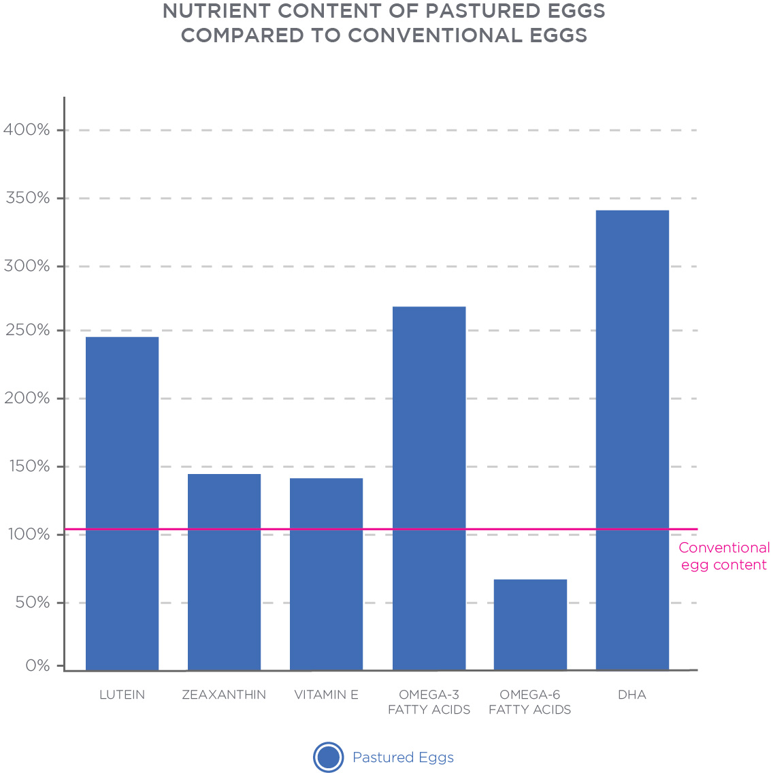

Importantly, the chicken feed appears to be the most important factor of egg-nutrient composition. There are minimal differences between eggs of chickens that received the same feeding regimen but who were raised either in cages or free-range (Anderson, 2011). Similarly, supplementation of the chicken’s diet with vitamin D leads to notable doses of 100 to 400 IU of vitamin D per egg (Browning & Cowieson, 2014), but free-range chickens that have regular access to sunlight also produce eggs with minimally higher vitamin D concentrations (Kühn, Schutkowski, Kluge, Hirche, & Stangl, 2014).

Grass-fed livestock produce meat, milk, and eggs that are more nutritious than their conventional counterparts, although the extent of the differences depends largely on the specific practices and environment of the grass-fed farms. Generally speaking, nutritional differences are small and not of real-world value

## Genetically Modified Organisms

Genetically modified organisms (GMOs) are defined by the World Health Organization (2014) as “organisms (i.e. plants, animals or microorganisms) in which the genetic material (DNA) has been altered in a way that does not occur naturally by mating and/or natural recombination.” Since their entrance into the world market in the 1990s, there has been considerable debate in the scientific and consumer communities over the perceived benefits and risks that would result from the widespread adoption of GMOs (National Academies of Sciences, Engineering, and Medicine, 2017)

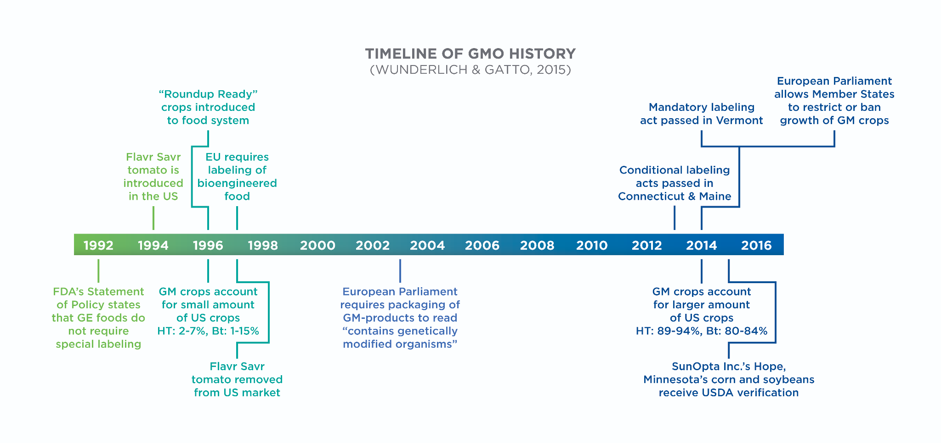

In consumer circles, the debate revolves primarily around transparency and GMO labeling requirements. While Europe requires that GMOs are labelled as such, the United States and Canada do not. Yet, depending on cultural worldview, 53 to 83% of Americans believe that the federal government should require mandatory GMO labeling (Kemper, Popp, Nayga, & Kerr, 2018). Consumers are willing to pay an extra 29 to 45% more to avoid purchasing GMOs (Wunderlich & Gatto, 2015). As a response to consumer demand, many companies now voluntarily advertise if their products do not contain GMOs such as through the Non-GMO Project verification seal.

Additionally, certified organic foods in the United States are not allowed to contain GMOs. Overall knowledge about GMOs is low among the general population with most people obtaining information from the Internet, television or radio, or friends and family (Wunderlich & Gatto, 2015). Yet, consumer perceptions about GMOs depend on GMO knowledge as well as trust in the scientific, private, and public institutions related to the GMO industry (Öz, Unsal, & Movassaghi, 2018). Americans are most trusting of information from nonprofit consumer advocacy groups and universities, relatively neutral toward the private sector as a whole (but untrusting of food manufacturers), and strongly untrustworthy of the media and government (Kemper et al., 2018).

GMOs are a passionate topic for some clients and discussion should revolve around finding a happy middle-ground. Depending on what the client is looking for, a discussion of the possible benefits and risks of GMOs can help maintain a neutral, evidence-based atmosphere. Keep in mind that there is no dietary requirement for GMOs. So, when talking with clients who are against their consumption, the Nutrition Coach can focus primarily on how best to avoid them.

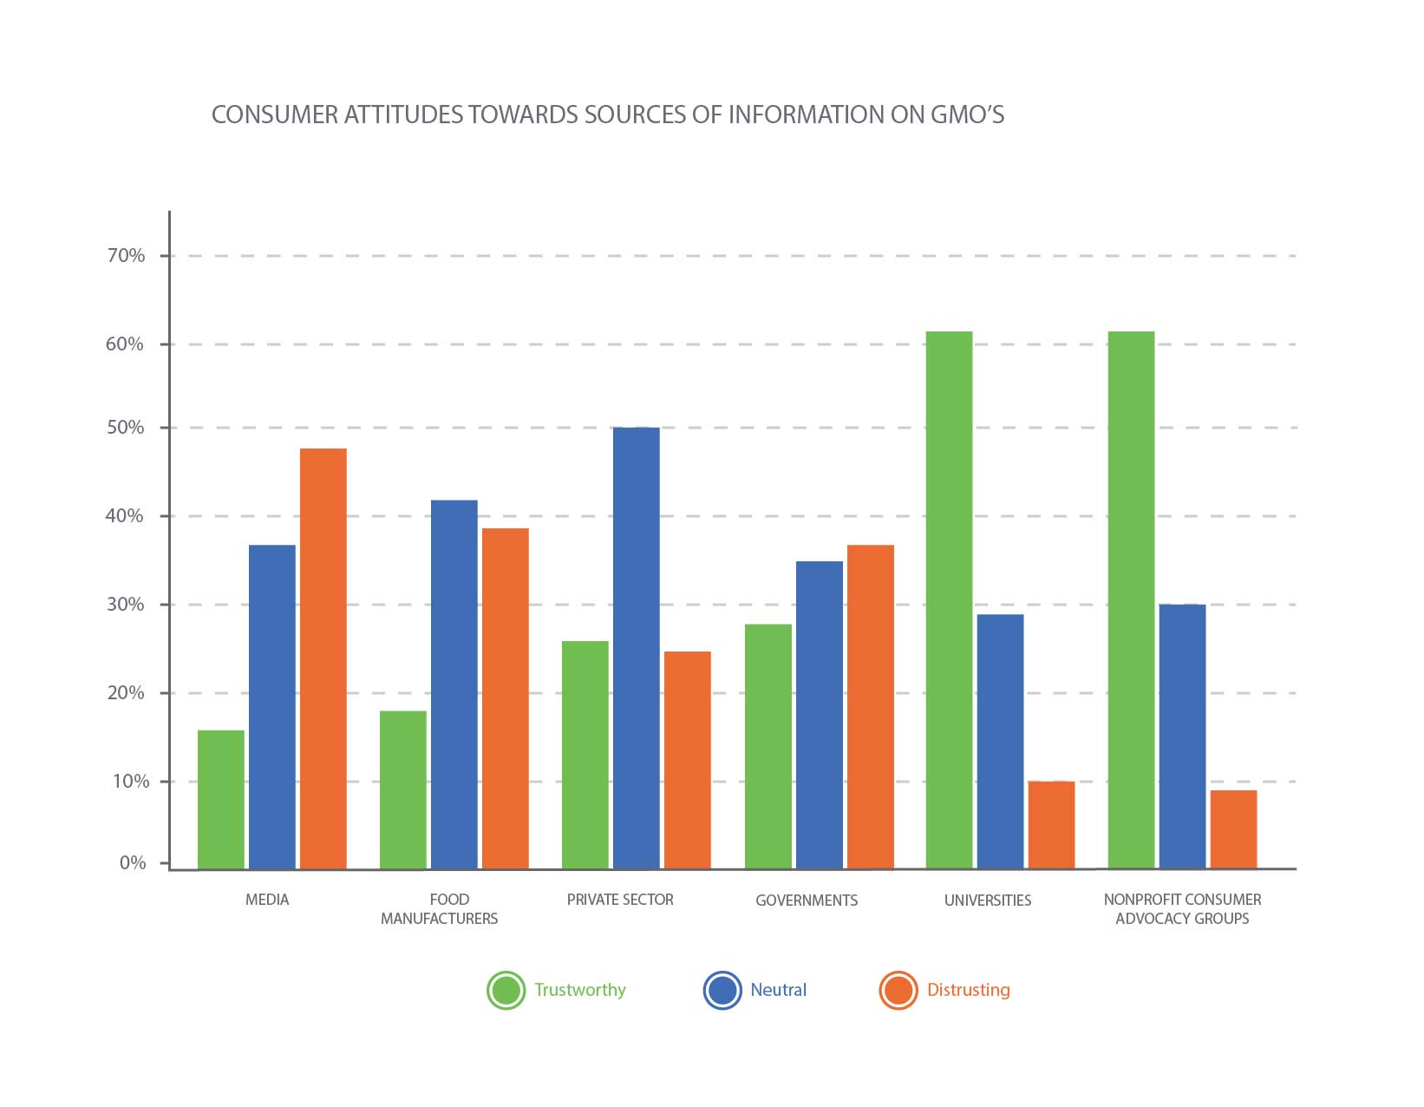

**Arguments in favour of GMOs**

Several arguments have been put forth in favor of genetically modified crops, including increased crop yields, increased nutritional value, and improvement in food processing (Zhang, Wohlhueter, & Zhang, 2016).

Improved nutritional value and food processing capabilities are more subjective with benefits being largely context-dependent. For instance, the genetic engineering of rice to have higher beta-carotene (called Golden Rice) has the specific goal of reducing vitamin A deficiency in developing nations where rice is a staple component of the diet (Tang, Qin, Dolnikowski, Russell, & Grusak, 2009). In developed nations where vitamin A deficiency is not of as great a concern, the increased nutritional value of Golden Rice is arguably not as great a benefit of GMOs.

Similarly, a genetically modified potato was created so as to reduce acrylamide formation when cooked at high temperatures such as when potatoes are processed into French fries or potato chips (Rommens, Yan, Swords, Richael, & Ye, 2008[)](https://paperpile.com/c/Cv3Z5O/v6ST). The health benefits, of course, depend on the client’s diet and how much they eat fried potatoes (if at all).



The benefits of GMOs are highly context-specific. When discussing these advantages with clients, it is important to emphasize that they may not apply to the client directly.

**Potential risks of GMOs**

The potential benefits must be weighed against potential risks, which can be grouped into direct and indirect effects (Zhang et al., 2016). Direct effects are best demonstrated by the ways in which genetic modification expresses itself, not always in ways that can be anticipated.

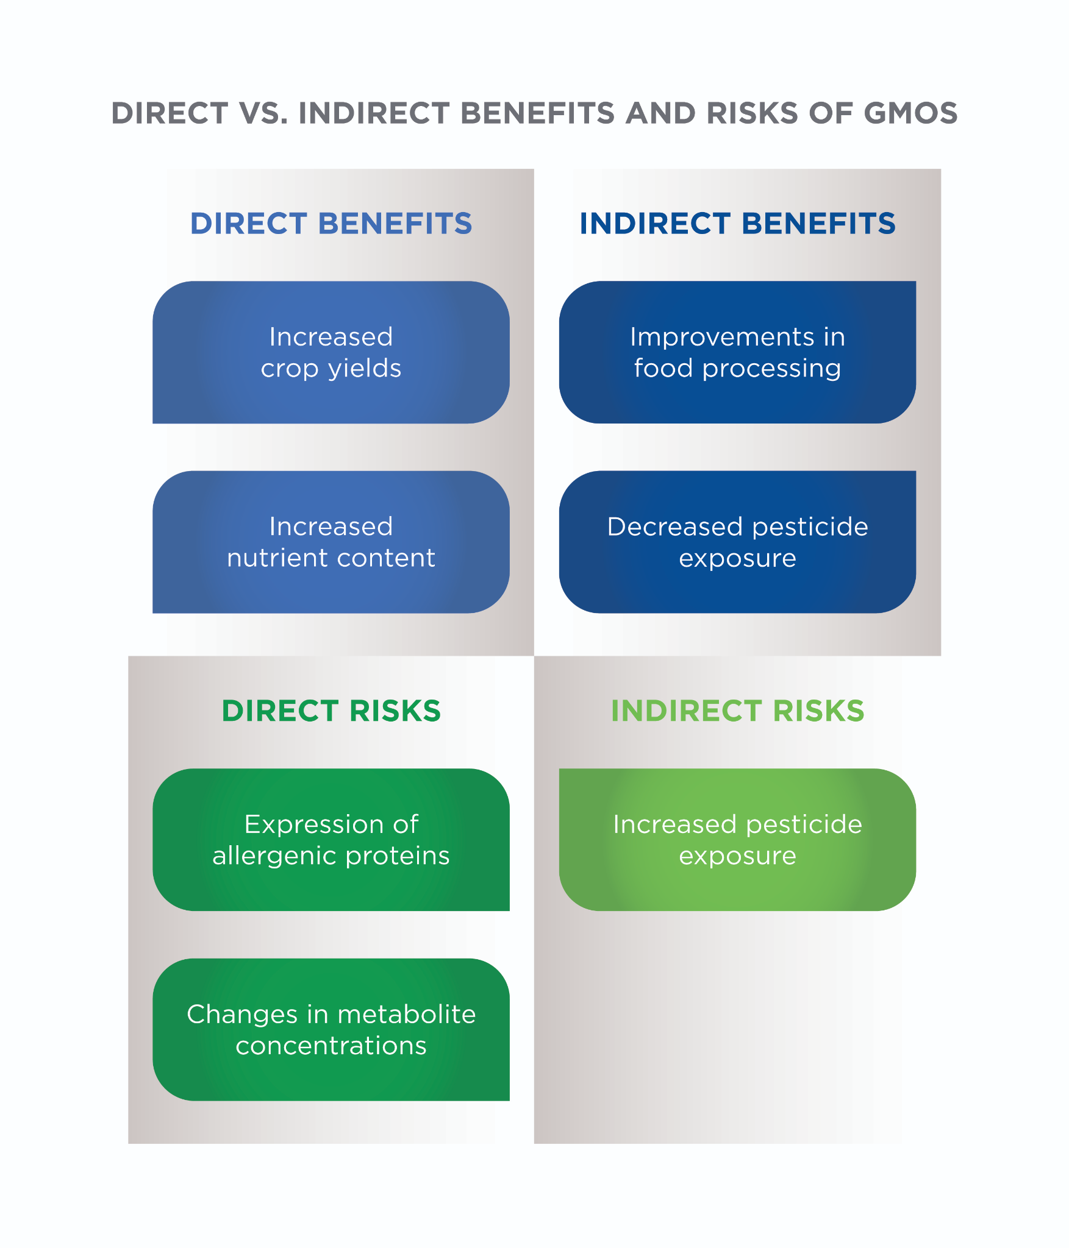

Examples include the expression of allergenic proteins and changes in metabolite concentrations, including toxic ones, that result from poorly understood regulatory pathways in plants in response to genetic modification (Bawa & Anilakumar, 2013[)](https://paperpile.com/c/Cv3Z5O/UXIy). For example, soybeans have been shown to provoke Brazil nut allergies after having a protein from Brazil nuts genetically modified into the soybean to increase its nutritional value (Nordlee et al, 1996).

Indirect effects come from how GMOs are used in agricultural practices. Currently, most genetically modified crops are aimed at providing the plant with inborn resistance to either pests or pesticides or both. One example is *Bacillus thuringiensis (Bt)* crops, which have genes from the Bt bacterium inserted into their DNA to have them produce their own pesticides. They, therefore, require less pesticide application from farmers (Koch et al., 2015).

On the other hand, crops like Roundup Ready soybeans are genetically modified to resist the effects of the pesticide glyphosate, so spraying can be done more frequently without the risk of hurting the soybean crop (Funke, Han, Healy-Fried, Fischer, & Schönbrunn, 2006). Other Roundup Ready crops include soy, corn, canola, alfalfa, cotton, and sorghum, with wheat under development.

There is still much work to be done on determining the short- and long-term effects of widespread GMO acceptance. Many of the risks of GMOs are speculative, but they are scientifically plausible. Whether they are healthy or harmful is not a black-and-white issue and is not amenable to a simple yes or no. Until the debate is settled, the client can actively avoid GMO products by looking for foods certified to be non-GMO or certified organic.

GMOs are a controversial topic with no clear-cut answer as to whether they are safe or harmful. GMOs remain an area of ongoing investigation with several currently known benefits and risks.

Context is an important consideration when determining whether GMOs should be included in the diet because many of the health effects (good or bad) depend on the person who is considering eating them.

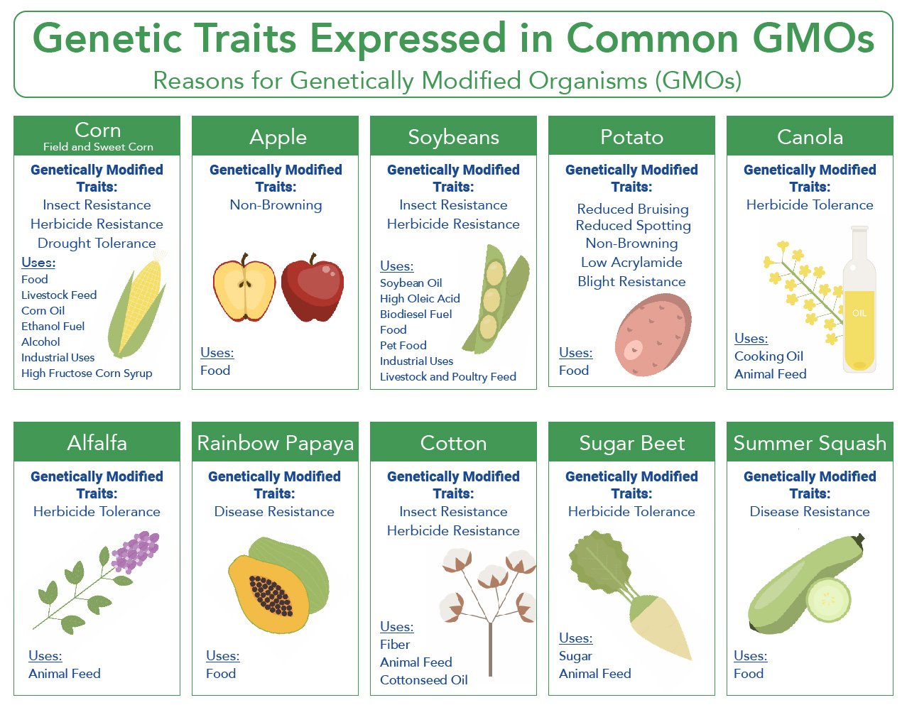

**Gluten-free diets**

Wheat entered the human diet just under 10,000 years ago as humans transitioned to relying more on agriculture and less on hunting and gathering (Heun, 1997[)](https://paperpile.com/c/Cv3Z5O/7Uuu). It quickly became a worldwide staple with global wheat production being over 750 million tons (Food and Agriculture Organization of the United Nations, 2018). The average U.S. adult eats roughly 132 pounds of wheat per year (USDA, 2016[)](https://paperpile.com/c/Cv3Z5O/yWyl).

Some people, however, cannot tolerate wheat: those who have a wheat allergy (allergic reaction), those who have celiac disease (an autoimmune condition), and those who have non-celiac gluten sensitivity (NCGS, a food sensitivity) (Sapone et al., 2012). For these individuals, a wheat-free or gluten-free diet is mandatory to enjoy optimal health. See Figure: Wheat Consumption and Infographic: Gluten and Gluten-Free Grains for a list of grains that include and do not include gluten.

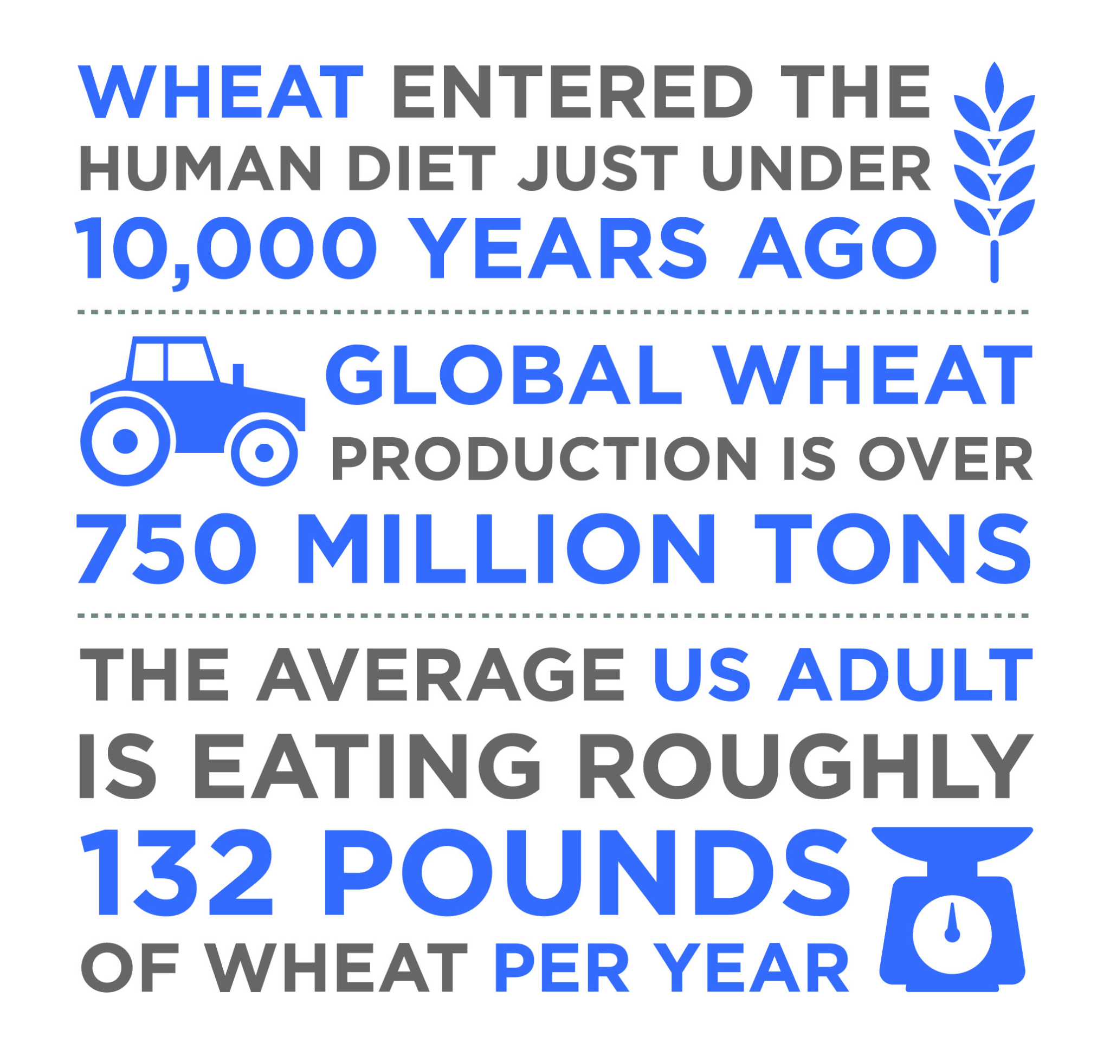

The effects of consuming wheat and gluten in people with celiac disease and wheat allergies are well-established, in most cases, leading to a diagnosis early in life (Sapone et al., 2012). Comparatively, NCGS lacks rigorous diagnostic criteria and remains more elusive than other gluten-related conditions despite up to 13% believed to have it (Fasano, Sapone, Zevallos, & Schuppan, 2015; Molina-Infante, Santolaria, Sanders, & Fernández-Bañares, 2015). One reason for the difficulty in diagnosing NCGS is because many of the symptoms associated with NCGS are nonspecific such as fatigue, headache, anxiety, and an overall lack of well-being (Volta et al., 2014[)](https://paperpile.com/c/Cv3Z5O/40xk).

Moreover, there is overlap with general intestinal distress from fermentable, poorly absorbed, short-chain carbohydrates: fermentable, oligo-, di-, monosaccharides, and polyols (FODMAPs) (Biesiekierski et al., 2013). Some research has suggested that NCGS is owed to a combination of FODMAP and gluten sensitivity because following both FODMAP-free and gluten-free diets lead to symptomatic improvement in people with NCGS (Dieterich et al., 2018[)](https://paperpile.com/c/Cv3Z5O/qvWf).

Importantly, gluten does cause an increase in intestinal permeability (leaky gut) in people without celiac disease (Drago et al., 2006[)](https://paperpile.com/c/Cv3Z5O/B8iZ), an effect mediated by gluten’s interaction with zonulin, the protein that regulates the integrity of tight junctions within the intestinal tract (Fasano, 2012). It is currently believed that people with NCGS elicit an immune response toward microbial products such as lipopolysaccharides (LPS) that inappropriately enter the bloodstream as a result of gluten-induced intestinal permeability (Brenchley & Douek, 2012; Uhde et al., 2016).

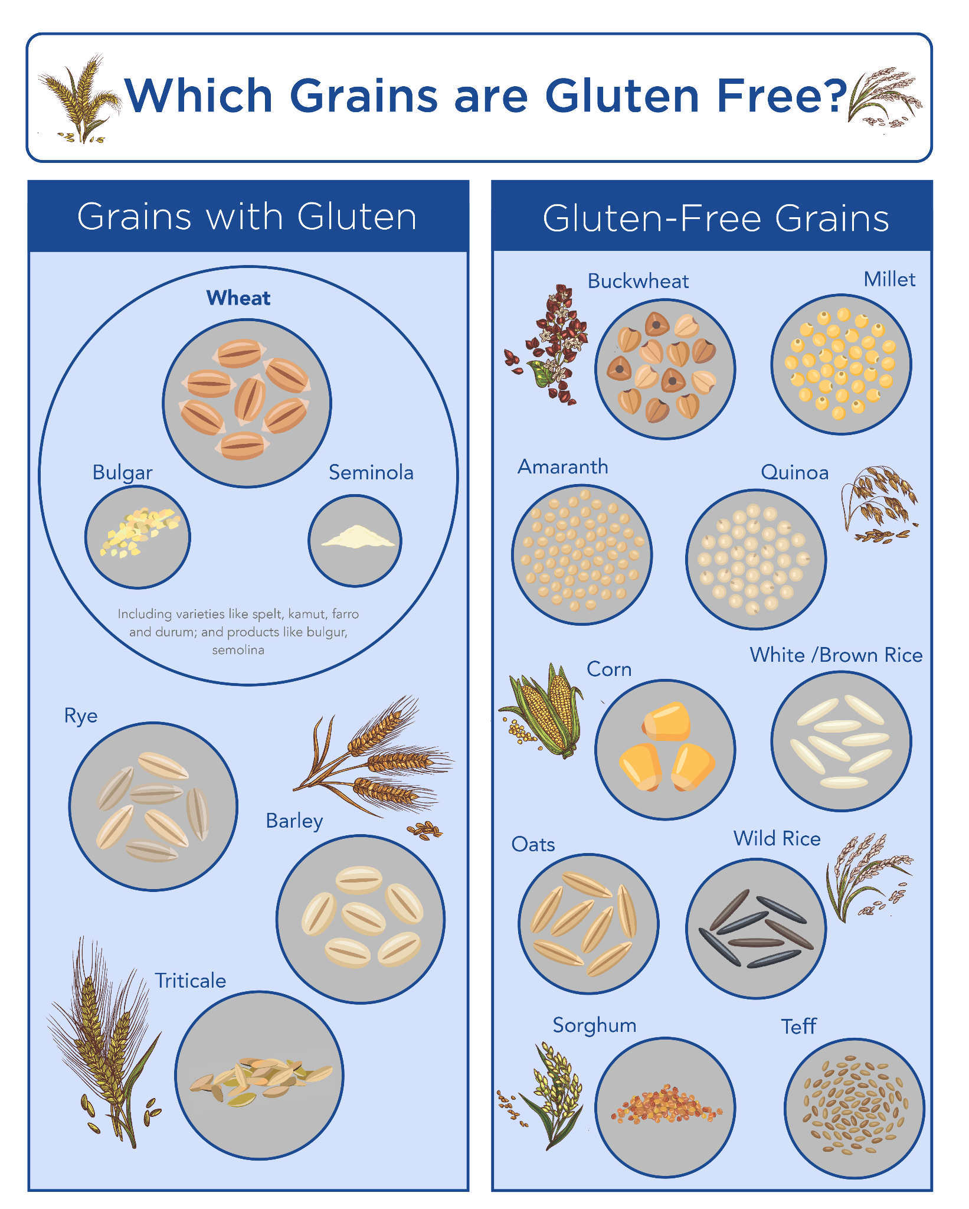

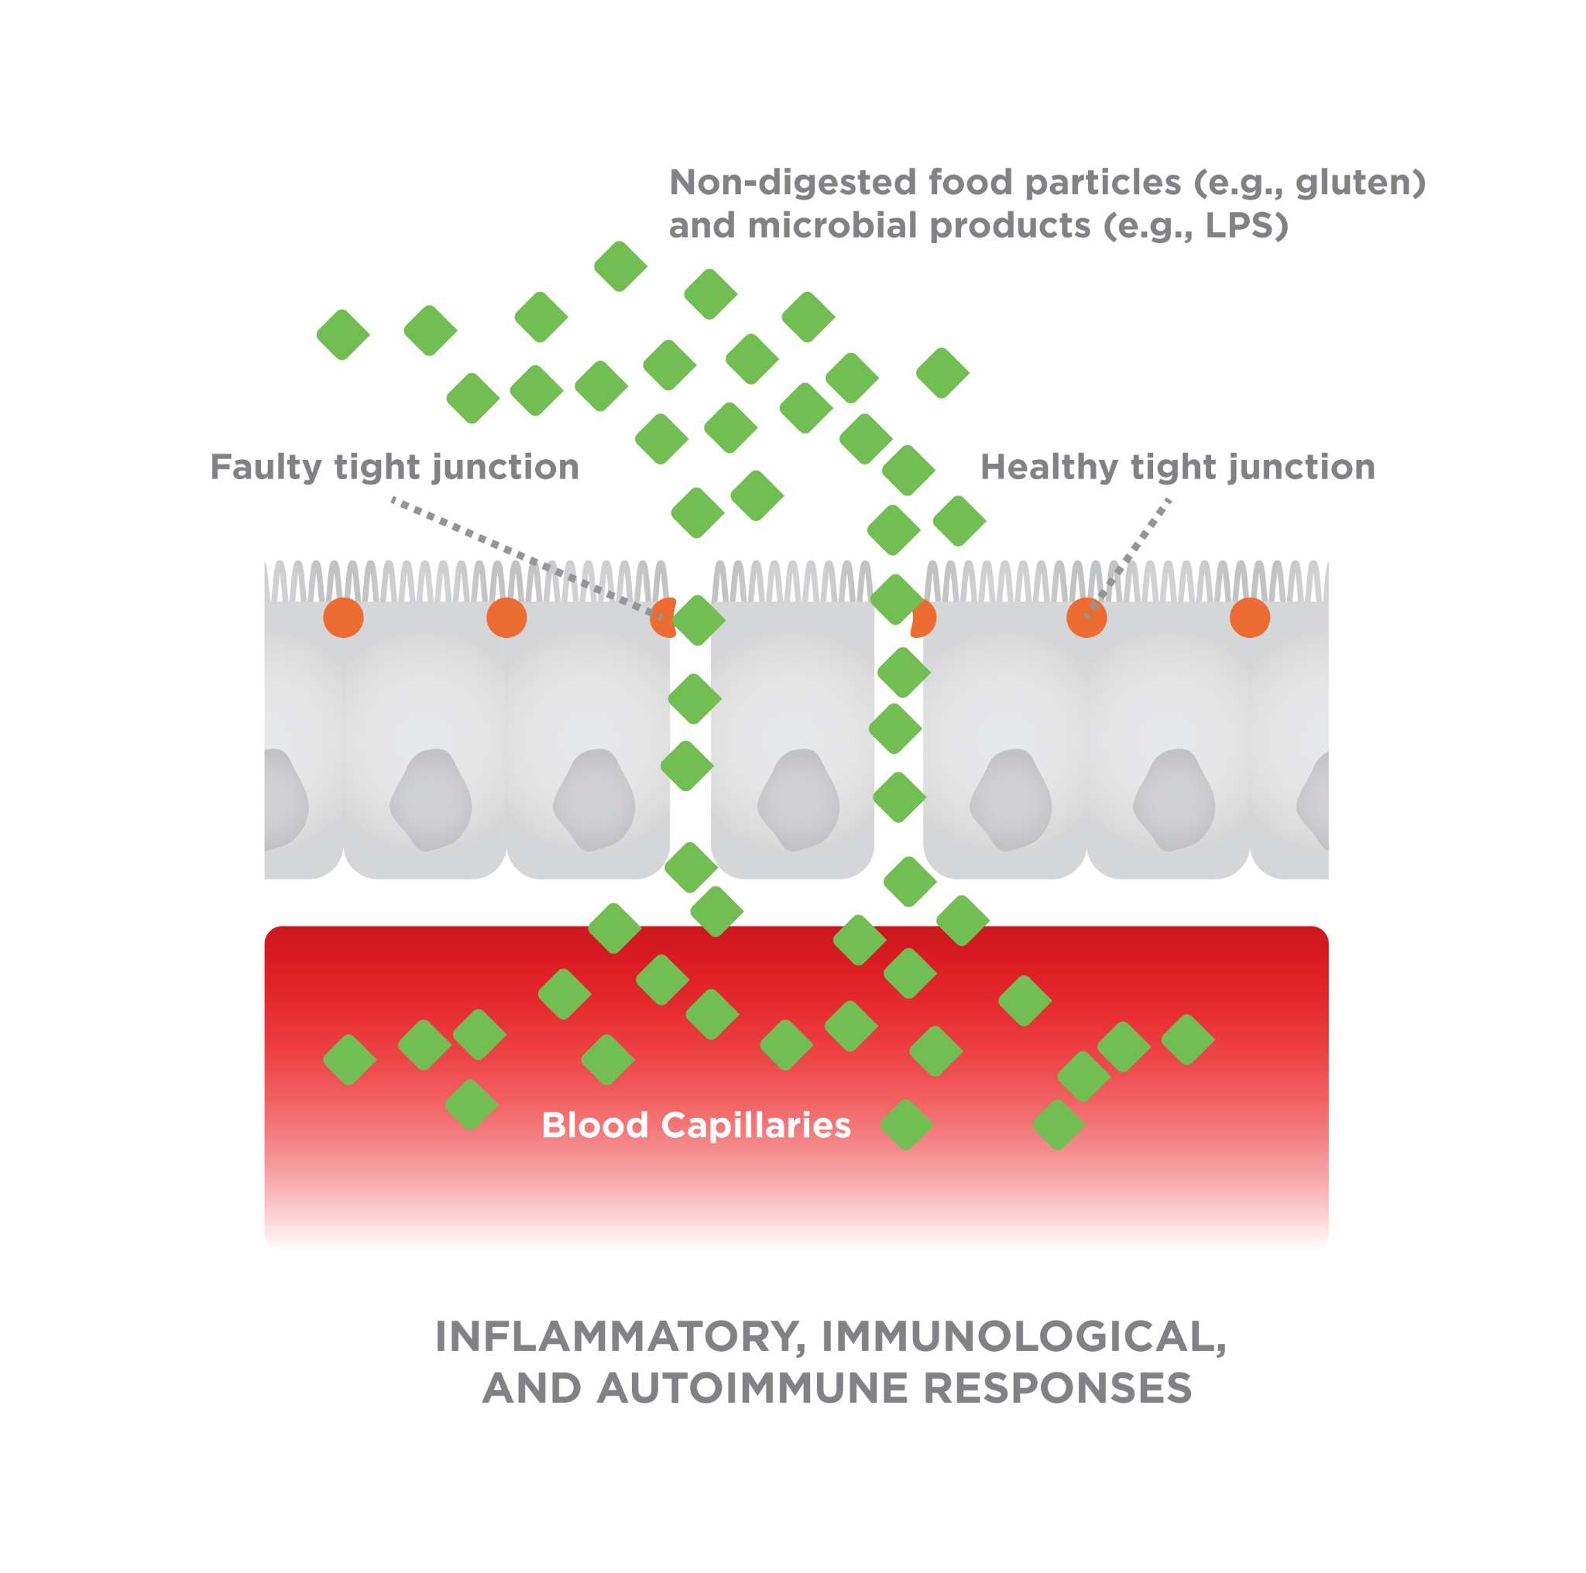

When working with clients following a gluten-free diet, it is important to determine whether they feel best following a low-FODMAP diet, a gluten-free diet, or a combination of the two. If they are adamant about having negative symptoms when eating gluten-containing foods, then it is best to have them work with their gastroenterologist to attempt and diagnose NCGS (Sapone et al., 2012[)](https://paperpile.com/c/Cv3Z5O/AbGS).

FODMAPs may be a possible concern for clients who present with gastrointestinal issues. Like gluten, not all people are sensitive to them and a simple elimination diet excluding common food sources of FODMAPs can help determine if this is a cause of the GI discomfort. Importantly, FODMAP intolerances are unlike other conditions that have a unique cause and a simple fix. They can affect everyone differently and, therefore, require an individualized treatment approach. Clients interested in eliminating FODMAPs from the diet should consult with an experienced dietitian who specializes in teaching the low-FODMAP diet.

Going gluten-free

The gluten-free food industry has exploded to nearly $8 billion in 2017 with 2/3 of Americans believing that gluten-free foods are healthier than their gluten-containing counterparts and 1/4 going gluten-free to aid in weight loss (Jones, 2017). A survey of 910 athletes without celiac disease found that 56% had *self-diagnosed* gluten-sensitivity and 41% followed a gluten-free diet 50 to 100% of the time (Lis, Stellingwerff, Shing, Ahuja, & Fell, 2015). Of course, there is nothing special about a gluten-free diet that would help someone lose weight (Marcason, 2011[)](https://paperpile.com/c/Cv3Z5O/VEaI), nor are there performance benefits of going gluten-free (Figures: Gluten-Free Beliefs and Athletes With Gluten Sensitivity) (Lis, Stellingwerff, Kitic, Ahuja, & Fell, 2015).

Whether someone embarks on a gluten-free diet by necessity or choice, it is important to understand potential pitfalls of a gluten-free diet to best help clients navigate this decision. Thankfully, there is no requirement for wheat or gluten in the human diet, so avoidance should not pose a theoretical concern.

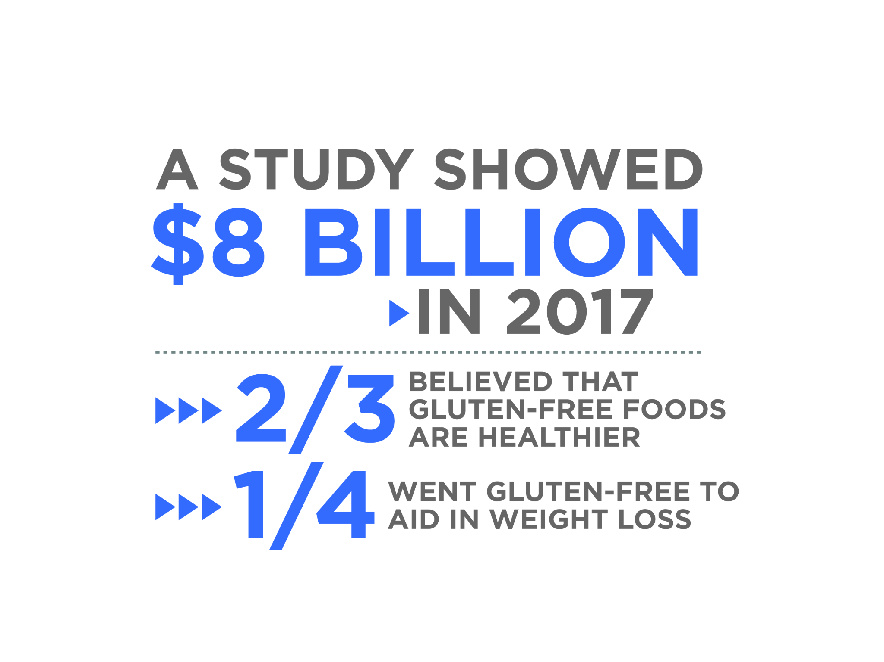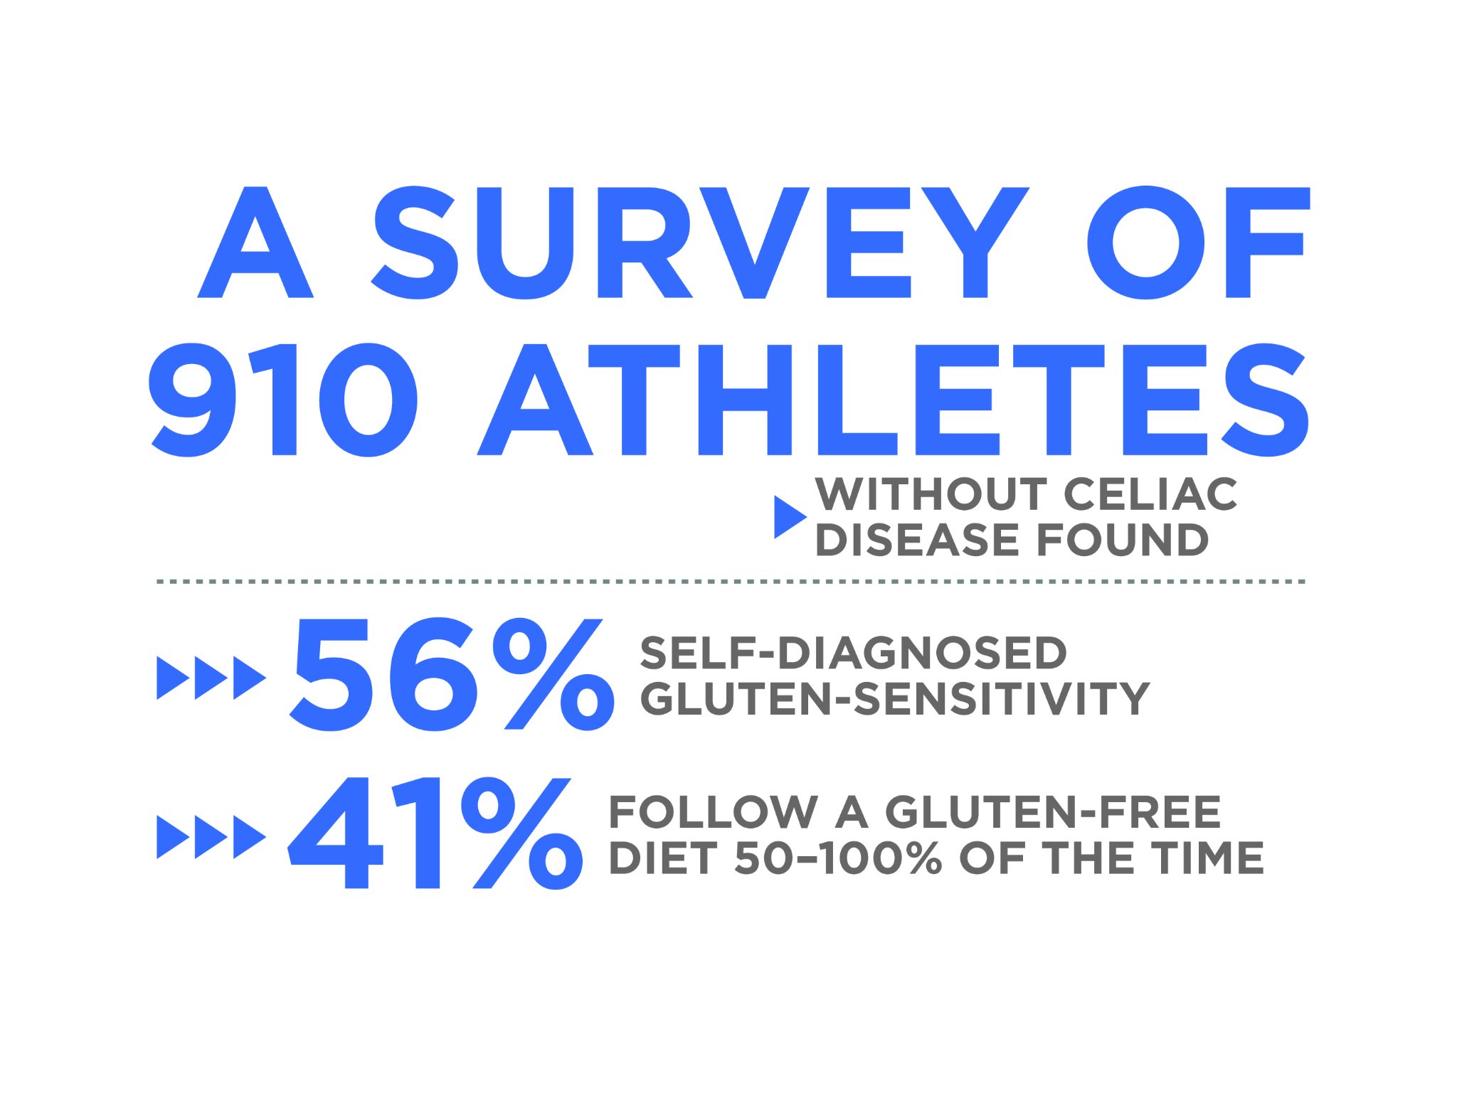

When working with clients who have self-diagnosed themselves with gluten sensitivity, the first step should be to have them consult with their healthcare provider to determine whether this sensitivity is a more severe issue like a wheat allergy or celiac disease. If not, recommend that the client work with their healthcare provider to determine if they have NCGS. Regardless of why a client has chosen to follow a gluten-free diet, working with them to minimize processed foods and emphasize whole-meal gluten-free grains, vegetables, fruits, and legumes is important for ensuring nutrient adequacy.

Surveys comparing gluten-free to gluten-containing products have reported minimal nutritional differences other than a lower protein content of gluten-free foods (Missbach et al., 2015; Wu et al., 2015). The product in question matters, though, with gluten-free bread and flour products usually having more fat and sugar while gluten-free crackers generally have less (Fry, Madden, & Fallaize, 2018). Regardless, gluten-free products are consistently more expensive (Fry et al., 2018; Missbach et al., 2015).

Any differences need not play out in real life. Whether gluten-free or not, working with the client to select whole-meal grains and pseudograins, which are higher in fiber and several vitamins and minerals, is important for nutrient adequacy (Missbach et al., 2015; Pellegrini & Agostoni, 2015). The problem is that people do not do this; they ditch gluten but continue to eat refined flours (e.g., rice flours, etc.) and have diets poor in fiber, folate, iron, zinc, magnesium, and calcium (Vici, Belli, Biondi, & Polzonetti, 2016).

In summary, gluten-containing grains, such as wheat, can be problematic for some individuals. There is no dietary requirement for gluten, so eating a gluten-free diet should pose no theoretical concern. However, simply eliminating gluten does not ensure that the client will eat a nutritious diet as many gluten-free foods are no better than their gluten-containing counterparts. Care should be taken to work with them to eat more fibrous vegetables, whole-meal gluten-free grains, legumes, and fruits.

The following tips are several practical ways to encourage people on a gluten-free diet to ensure it is nutritionally adequate (Jones, 2017).

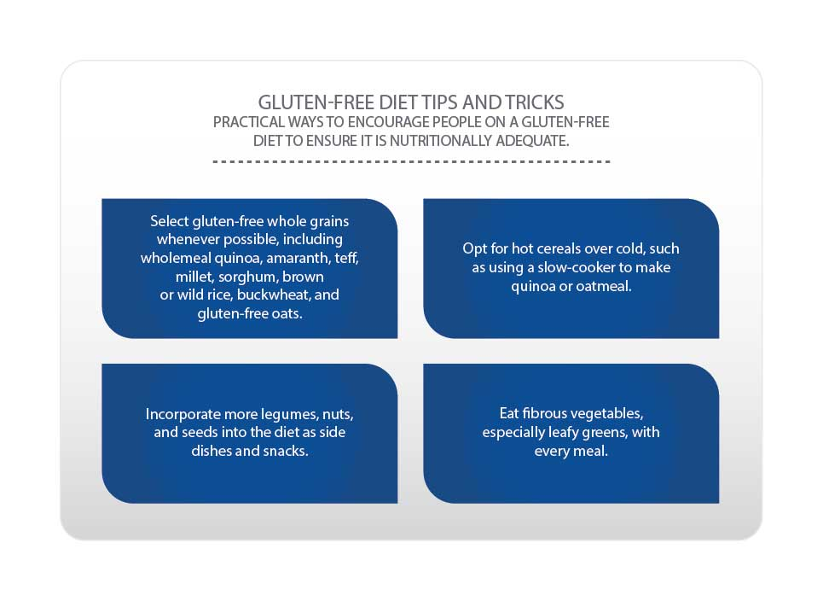

Clients embarking on gluten-free diets may simply swap out processed foods for other processed foods (that do not contain gluten). This can be particularly problematic if the client believes that these foods are healthier due to a lack of gluten because that belief might encourage overconsumption (e.g., they are not as bad for me, so I can eat more). It is important to work with clients to ensure nutrient adequacy and minimize the consumption of refined grains and processed foods regardless of whether they contain gluten.

**High-fructose corn syrup**

High-fructose corn syrup (HFCS) is a sweetener made from the enzymatic conversion of corn starch into glucose and fructose. It is one of the most widely used replacements for sucrose (table sugar) in the United States, due to its lower cost and comparable sweetness.

From a biochemical standpoint, the difference between sucrose and HFCS is subtle. Both are a combination of glucose and fructose. Whereas sucrose is half glucose and half fructose, with the two molecules bonded to each other, HFCS is 55 to 65% fructose and the molecules exist as free glucose and fructose in solution

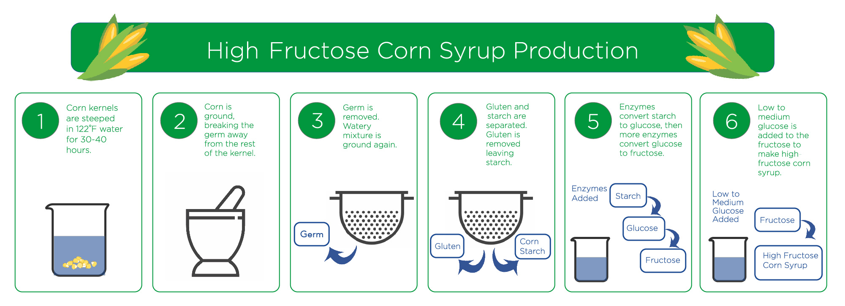

There is certainly a reason to minimise the consumption of added sugars in the diet, especially those from sugar-sweetened beverages. Authoritative bodies around the world have recommended limiting added sugar intake, with goals as low as less than 5% of energy intake. Added sugar consumption in the United States has been on the decline (Rippe, et al., 2017). Numerous observational and intervention studies have demonstrated that consuming added sugars are associated with cardiovascular diseases and Type 2 diabetes, secondary to promoting excessive energy intake and obesity (Stanhope, 2016).

Coach's Corner

Some health authorities recommend that no more than 5% of energy intake comes from added sugars. For a standard 2000-kcal diet, this amounts to about 25 grams of added sugar or roughly ½ of a can of soft drink. That is not a lot, and speaks volumes on how quickly these hidden sugars can add up.

There are many hyperbolic thoughts and comments about HFCS, even in the scientific literature, where it has been called a "weapon of mass destruction" (Basaranoglu, Basaranoglu & Bugianesi, 2015). Of course, these hyperbolic positions and the fructose hypothesis are not without pushback from other researchers (White, 2013).

The arguments against fructose stem from the fact that, unlike glucose, fructose is metabolised primarily within the liver and bypasses a critical rate-limited step (phosphofructokinase) in glycolysis. This means that fructose will continue to be oxidised for energy even when the body does not need any, whereas oxidation of glucose would be minimised.

If the body does not need energy, then the excess produced from fructose will be stored as fat via de novo lipogenesis (DNL), which is greater in response to fructose than glucose (Parks, Skokan, Timlin & Dingfelder, 2008). However, DNL is not the main fate of fructose; isotopic tracer studies have shown that 50% of ingested fructose is converted into glucose, 25% into lactate, at least 15% into liver glycogen, and only 10% oxidised directly or converted to fatty acids (Sun & Empie, 2012). Also, it is important not to overlook the dosage being tested, as most studies are conducted with unrealistic amounts of pure fructose (White, 2013).

A meta-analysis of 80 controlled trials and over 1400 participants evaluating the association between fructose and cardiometabolic risk found that in trials where fructose was exchanged for other carbohydrates in the diet, the dose averaged 100 grams per day, and in trials where fructose was added on top of the habitual diet, the average dose was 187 grams per day (Choo & Sievenpiper, 2015). Comparatively, the average American consumes about 49 grams of fructose per day, and 95% consume less than 87 grams (Marriott, Cole & Lee, 2009).

Overall, the fructose hypothesis has been heavily criticised for a reliance on unrealistic and circumstantial evidence derived primarily from animal studies using extraordinary doses of fructose (Rippe & Angelopoulos, 2013; Tappy & Mittendorfer, 2012; van Buul, Tappy & Brouns, 2014; White, 2013). Even with these unrealistically high doses of fructose, numerous meta-analyses have reported that fructose does not differentially affect body weight (Sievenpiper et al., 2012), blood lipids (Chiavaroli et al., 2015; Wang et al., 2014), or the development of fatty liver (Chiu et al., 2014) from other forms of carbohydrates when the two are matched for energy and may, in fact, reduce blood pressure (Ha et al., 2012) and benefit glycaemic control (Cozma et al., 2012; Evans, Frese, Romero, Cunningham & Mills, 2017a, 2017b; Sievenpiper et al., 2012).

On the other hand, when fructose is added into the habitual diet and evaluated under conditions of energy excess, it shows harmful effects on all these outcomes. This is not an issue with fructose per se; it is an issue with overeating. As already mentioned, though, sugar-sweetened beverages promote overeating and consequential weight gain (Stanhope, 2016).

When discussing this topic with clients, it is important to emphasise that added sugars can be included in a healthy diet, so long as they do not promote overeating. Unless the client is consistently tracking their food intake, however, research suggests that added sugars will not be fully compensated for, making overeating more likely. As a general rule of thumb, minimising added sugars in favour of nutrient-dense whole foods is prudent.

In terms of high fructose corn syrup, research suggests that it is not much different from regular table sugar. Encouraging clients to read food labels and look at the sugar content can be an easy way to minimise added sugars in the diet. Ideally, they would not be reading many food labels due to eating mostly fresh plants and animals, but that is not always the case. As such, getting in the habit of reading food labels can be an easy way to identify foods high in sugar that may not immediately appear to be.

**Non-nutritive sweeteners**

Non-nutritive sweeteners (NNS) are food additives that offer all the joy of sugar without the calories or metabolic effects of sugars (like increasing blood glucose and insulin after eating them). They can be made naturally, usually extracted from plants, or synthetically. The synthetic NNS are colloquially referred to as artificial sweeteners.

There are currently six artificial NNS and two natural NNS that are approved by the FDA for use in the food industry. They are shown in Table: Non-Nutritive Sweeteners on the Market along with their relative sweetness to table sugar (sucrose) and acceptable safe daily intake levels (FDA, 2018).

Non-Nutritive Sweeteners on the Market

|  | | **Sweetness relative to sucrose** | **FDA safe intake level (mg/kg body weight)** | **Safe intake level as tabletop sweetener packets (for a 132-pound adult)** |
| --- | --- | --- | --- | --- |
| Artificial NNS Sweeteners | Acesulfame  Potassium (Ace-K) | 200 x | 15 | 23 |
| Advantame | 20,000 x | 32.8 | 4920 |
| Aspartame | 200 x | 50 | 75 |
| Neotame | 10,000 x | 0.3 | 23 |
| Saccharin | 400 x | 15 | 45 |
| Sucralose | 600 x | 5 | 23 |
| Natural NNS Sweeteners | Steviol glycosides (Stevia extract) | 300 x | 4 | 9 |
| Monk fruit extract (Luo Han Guo) | 175 x | Unknown | Unknown |

Source: US Food and Drug Administration (2018). Additional Information about High-Intensity Sweeteners Permitted for Use in Food in the United States. Retrieved from https://www.fda.gov/food/ingredientspackaginglabeling/foodadditivesingredients/ucm397725.htm

The use of NNS has increased as more and more people are trying to lose weight or avoid sugar while satisfying their sweet tooth. A 12-ounce (354 ml) can of soft drink delivers about 40 grams of sugar and 160 calories. Drink diet soft drinks and get zero of both. It seems like a no-brainer, right?

At the same time, the use of NNS remains a point of controversy among many, due to beliefs that they may actually cause weight gain and associated metabolic diseases like Type 2 diabetes. Although a discussion of the toxicology of each NNS is beyond the scope of this chapter, it is important to take a look at the role of NNS in common health conditions you may encounter with your clients.

**Obesity and weight loss**

As the name indicates, NNS has zero calories, whereas sugar has 4 calories per gram or 16 calories per teaspoon. Logically, for people trying to lose weight, ditching sugar-sweetened beverages and using NNS can help slash calorie intake and contribute to weight loss.

A meta-analysis of 15 randomised controlled trials reported that substituting NNS for sugar modestly reduced body weight, fat mass and waist circumference among people who were overweight and obese (Miller & Perez, 2014). Subsequent interventions have found that drinking 24 ounces of diet soda per day leads to significantly greater weight loss and less hunger over a 12-week period than drinking 24 ounces of water (Peters et al., 2014) and resulted in maintaining greater weight loss over a year-long follow-up (Peters et al., 2016).

A meta-analysis of 15 randomised controlled trials reported that substituting NNS for sugar modestly reduced body weight, fat mass and waist circumference among people who were overweight and obese (Miller & Perez, 2014). Subsequent interventions have found that drinking 24 ounces (710 ml) of diet soft drinks per day leads to significantly greater weight loss and less hunger over a 12-week period than drinking 24 ounces (710 ml) of water (Peters et al., 2014) and resulted in maintaining greater weight loss over a year-long follow-up (Peters et al., 2016).

So, should we recommend diet soft drinks over water? Certainly not, but these studies show that it is definitely an improvement over sugar-sweetened beverages and definitely does not hinder weight loss.

Unsurprisingly, the NNS-obesity link originated from observational studies that simply look at the dietary habits and health of different groups of people (Ruanpeng, Thongprayoon, Cheungpasitporn & Harindhanavudhi, 2017). Although it is possible that consuming more NNS leads to weight gain and obesity, the intervention studies demonstrate this is not the case. Rather, it appears that the link between obesity and NNS use is explained by reverse causality, or that people become obese and then begin to consume more NNS.

This hypothesis is supported by data showing that people with obesity consume more NNS (Bleich, Wolfson, Vine & Wang, 2014) as do people with anorexia and bulimia nervosa (Brown & Keel, 2013). The use of NNS is associated with self-reported intent to lose weight (Drewnowski & Rehm, 2016). Similarly, the consumption of NNS is associated with a less-healthy lifestyle habits such as being less active (Winther, Aasbrenn & Farup, 2017). These observations alongside the intervention studies explain why NNS are associated with obesity, and provide evidence against the notion that they cause weight gain.

Accordingly, clients can enjoy diet drinks and NNS without worrying about unintentionally hindering their weight loss, at least as long as they do not compensate for using NNS by eating more of other food.

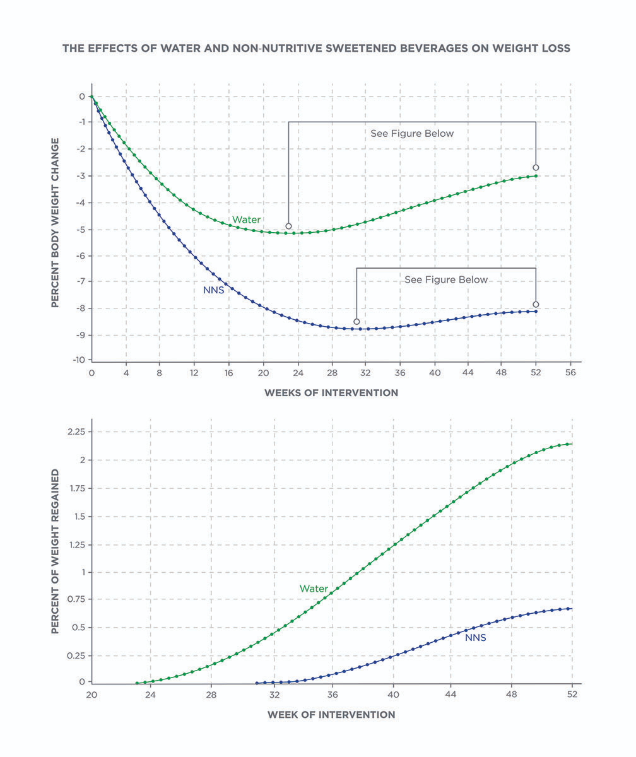

**Appetite**

The health halo effect describes a psychological phenomenon whereby people eat more of something they perceive as being healthy (Sundar & Kardes, 2015). It is unconscious sabotage to dieters and can definitely mask any benefit of replacing sugar with NNS. For example, a common example is someone eating large fast-food meals alongside a diet soda (as if getting a diet soda allows for eating more of other calorie-dense foods) (Infographic: The Health Halo Effect).

Another possible issue with NNS is the belief that they cause people to be hungrier and eat more because of the dissociation between sweet taste and lack of calories (Swithers, 2013). This may be true of some people but not most, especially regular consumers of NNS who have altered activation patterns in certain pathways of the brain involved in food reward (Green & Murphy, 2012). These neuroimaging findings suggest that regular use of NNS can train the brain to dissociate a sweet nutritive taste from a sweet non-nutritive taste.

Overall, however, the effects of NNS on hunger appear relatively benign. Only 10 of 60 studies investigating how NNS use affects short-term appetite and food intake have reported increases (Lohner, Toews & Meerpohl, 2017). The other 50 studies reported either no effects (n=39) or reductions in appetite and food intake (n=11).

Many clients might opine that NNS make them hungrier and that can be the case. However, research shows that this is in the minority, with most people experiencing no change in appetite and an equivalent amount experiencing reductions in appetite. When working with clients, it is important to understand their individual response to NNS consumption.

**Type 2 diabetes and Glycaemic control**

As with obesity, observational research links the use of NNS to the development of Type 2 diabetes (Romo-Romo et al., 2016). Unlike with obesity, the effects of NNS on glycaemic control are complicated.

NNS do not generally affect blood glucose or insulin like sugars do after consuming them (Romo-Romo et al., 2016). However, emerging research is linking chronic use of NNS to worse glycaemic control, which could provide an explanation for their link to Type 2 diabetes. For example, two recent interventions have shown that regular consumption of sucralose reduces insulin sensitivity in healthy adults after as little as 2 weeks (Lertrit et al., 2018; Romo-Romo, Aguilar-Salinas, Brito-Córdova, Gómez-Díaz & Almeda-Valdes, 2018). The dosages of sucralose were realistic, too: 168 to 200 mg/d or about 15 packets of Splenda.

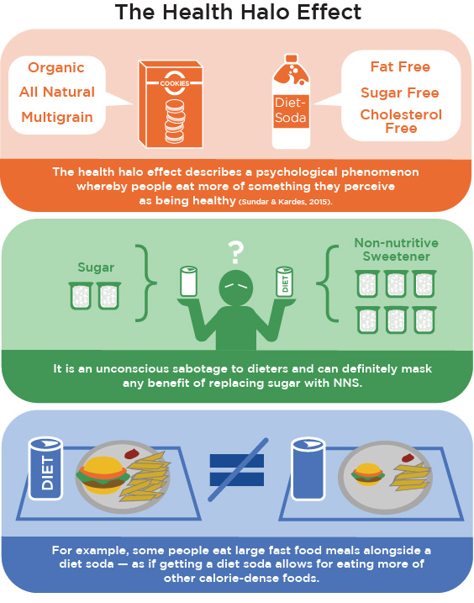

Whether these effects would occur with other NNS remains to be determined. Also, the timing of consumption may be an important mediating variable, as the negative effects on glycaemic control are believed to be mediated in part by effects on the microbiome, meaning that consuming NNS in the fasted state would have a more pronounced effect on the gut (Nakajima, Iwane & Higuchi, 2017).

On the other hand, the acute ingestion of sucralose 10 minutes before a glucose-tolerance test has been shown to potentiate the glucose-stimulated rise in blood glucose and insulin levels (Pepino, Tiemann, Patterson, Wice & Klein, 2013).

Some clients may believe that NNS affect blood glucose and insulin like glucose and other carbohydrates. This is a misconception. When consumed in isolation, NNS do not affect either in the short-term. However, emerging data does suggest a potential worsening of glycaemic control with chronic consumption of very-high levels of sucralose. Whether this occurs with other NNS is not known.

What is still unclear is to what extent these potential negative effects play out in people who are most likely to benefit from using NNS: those with obesity and those attempting to lose weight. After all, weight loss is an established method of reducing the risk of Type 2 diabetes and improving insulin sensitivity (Al-Goblan, Al-Alfi & Khan, 2014).

**Detoxes and cleanses**

Usually, a combination of highly restrictive dieting and expensive supplementation for no more than a couple weeks, detox and cleansing programmes claim to purify the body of ill-defined toxins that are sapping people’s health.

While the notion of detoxifying the body has some scientific backing, the many detox programs on the market are gimmicks focussed on draining the wallet with unnecessary protocols and supplements. In fact, in 2009, an investigative report of 15 different detox programs found that none used the same definition of *detox,* and none could offer evidence backing up their detoxification claims (Tuff & Ball, 2009).

There will be many clients that have already devoted time and money to detox programmes. Asking them about their experiences on these programmes and their reasons for using them can provide insight into the beliefs and desires of the client, while also opening them up for discussion about the reality of detox programmes and their lack of defined parameters.

There is little to no research on detox programmes, with their perceived benefits being the simple result of extreme calorie restriction (Klein & Kiat, 2015; Obert, Pearlman, Obert & Chapin, 2017). Most programmes have gone untested, and case reports have documented people suffering kidney damage and liver failure from following detox programs and using their supplements (Kesavarapu, Kang, Shin & Rothstein, 2017; Makkapati, D’Agati & Balsam, 2018).

There is also the issue of popular media and celebrities highlighting how amazing various detox programmes are without any data to support those claims. The words of these celebrities can be convincing to some clients and may provide them with an expectation to benefit, so the mind makes it so.

Detoxification done right

The human body has the natural ability to detoxify. It does it on a daily basis to stay alive and healthy. Most toxins and toxicants are metabolised by Phase I and Phase II pathways within the liver, and then excreted via bile or the kidneys. So, the notion of detoxing is not something of fiction

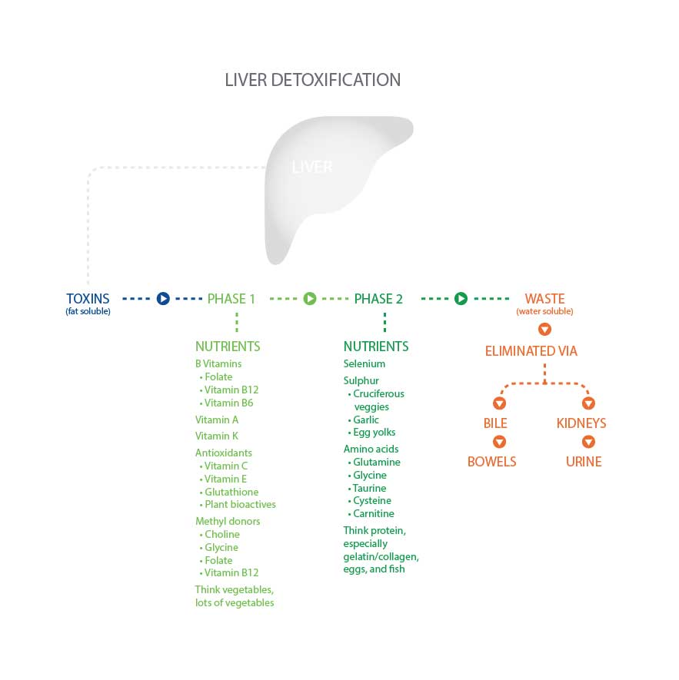

When discussing detoxification with the client, emphasis should be placed on supporting the body’s natural ability to detoxify itself, which can be done by eating nutrient-dense foods rich in the vitamins, minerals and amino acids that the liver requires to accomplish this goal. The over-arching message should be that detox is real, but people do not need restrictive dieting and supplements to accomplish it. They simply need a healthy diet and lifestyle.

The body's natural detoxification systems are affected by our nutritional status and lifestyle. With daily food choices, the body has the ability to affect the toxin (created by plants and animals) and toxicant (man-made poisons) loads, as well as the effectiveness of the body's detox pathways [(](https://paperpile.com/c/Cv3Z5O/Xrgy)Cline, 2015).

While weight loss ultimately benefits the health of many people who are overweight or obese, some negative effects may be realised during the weight-loss process itself as toxins and toxicants are released from fat cells (Cheikh Rouhou, Karelis, St-Pierre & Lamontagne, 2016). People with obesity have two to three times more pollutants in their body than normal-weight folk, and their release during weight loss does increase the toxic load burden on the liver (Kim et al., 2011). Rapid weight loss seems to cause the greatest toxic burden (Cheikh Rouhou et al., 2016).

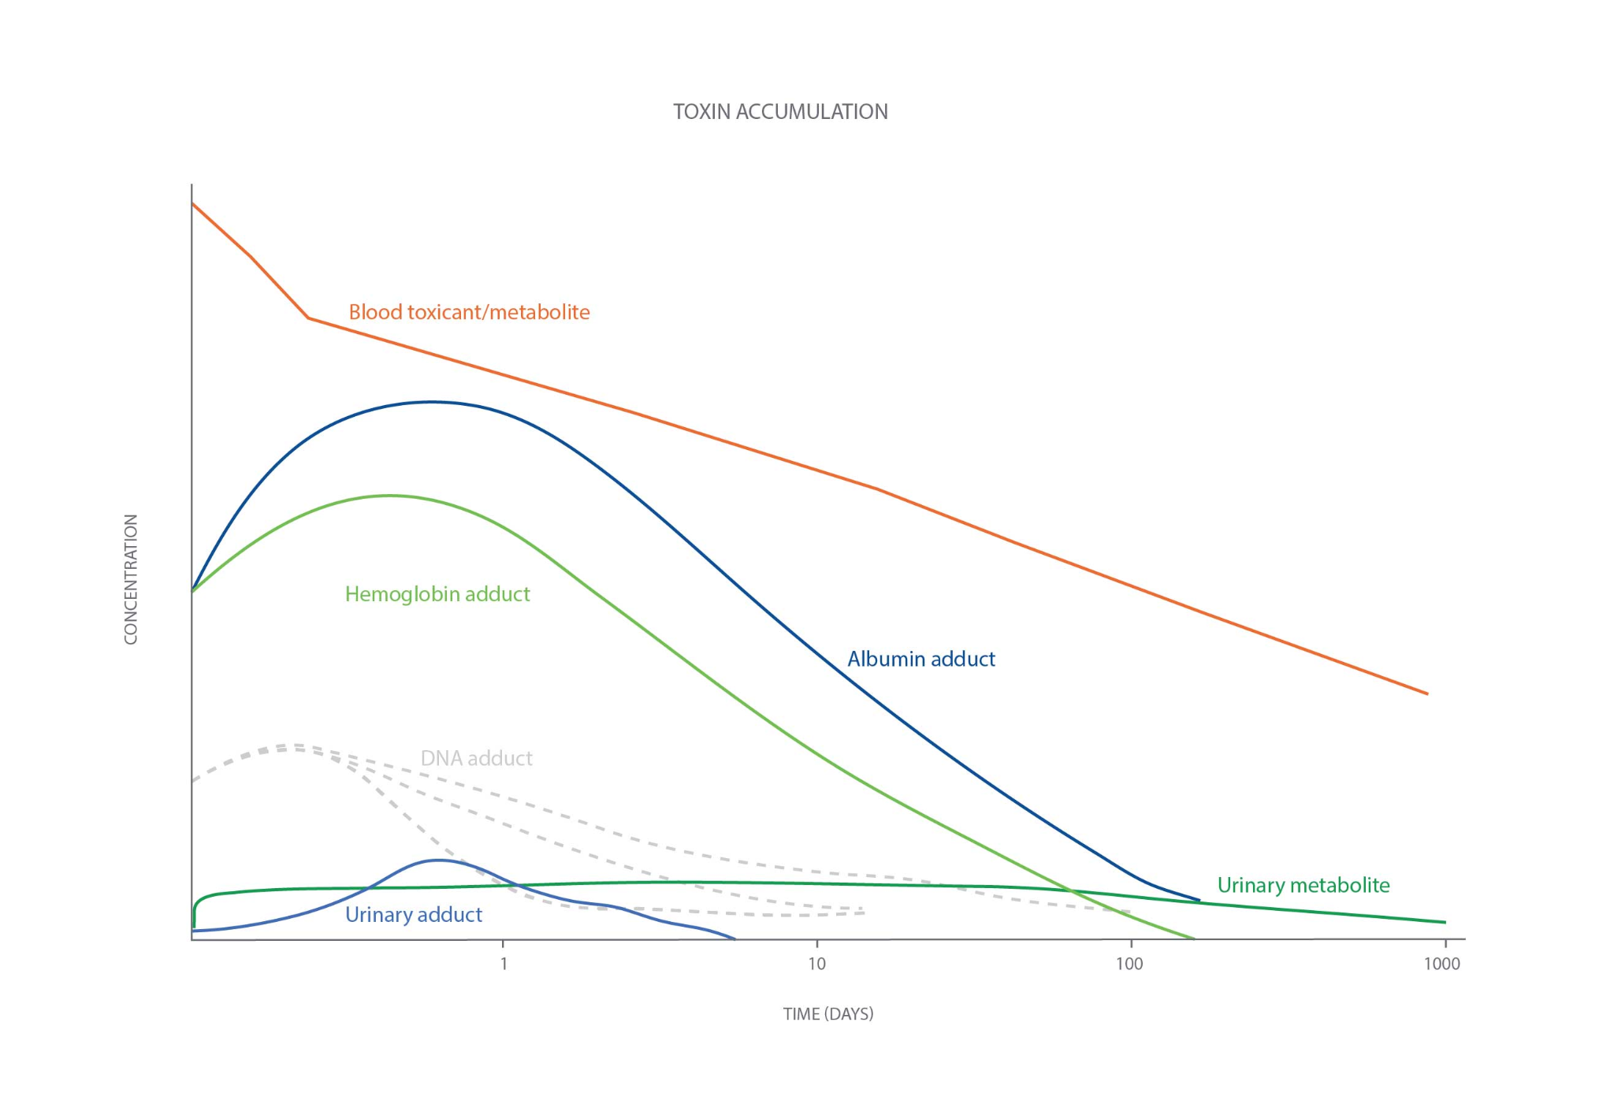

Many clients may be impatient and want to lose weight rapidly. This can be motivating for them, but it can also reduce adherence to the weight-loss plan if the toxic load released from fat cells is overwhelming. An individualised approach is necessary, and slower weight loss occurring alongside the establishment of new diet and lifestyle habits that will sustain weight loss in the long-term seems to be a prudent default approach to working with clients.

Detox programs are ill-defined restrictive diets. The real detox is happening daily within our body, and is best supported by eating a nutrient-dense diet and maintaining a healthy lifestyle. This is all the more important for clients who are attempting to lose weight, because toxicants are stored in fat tissue and released during weight loss.

Juicing

Juicing is a popular activity by many health enthusiasts and dieters that involves extracting the juice from fresh fruits or vegetables. Juicing can be a part of someone’s regular diet or a form of juice-cleanse detox programme, where nothing but juice is consumed for 1 to 2 weeks.

Juices retain many of the nutrients from the whole food but not all of them, missing out on the fibre (pulp) and some phytochemicals (Pyo, Jin & Hwang, 2014; Uckoo, Jayaprakasha, Balasubramaniam & Patil, 2012). Of course, the solution is rather simple: add the pulp back into the juice and drink it down. Alternatively, one could opt for blending fruits and vegetables rather than juicing them, so as to retain the entire food. Either way, turning foods into beverages can be an easy way to increase the consumption of fruits and vegetables that would not otherwise be eaten.

Nutrition Coaches also need to be mindful of what is being juiced. Fruit juices taste great and are rich in phytochemicals, but they are also rich in sugars and calories (Clemens, Drewnowski, Ferruzzi, Toner & Welland, 2015). Vegetables are more nutrient-dense and lower in sugars, but they also contain more anti-nutrients that become concentrated in the juice. For example, some people have given themselves kidney disease by consuming oxalate-rich juices (Getting, Gregoire, Phul & Kasten, 2013).

Does the client enjoy eating vegetables and fruits? If not, then juicing or blending them into a smoothie can be a simple approach to increasing intake. See if this is something the client would be able to adhere to and enjoy doing. Just be cautious about what is being juiced and about buying premade juices, because they can be very high in calories and added sugars.

Getting Technical

Oxalate-rich foods include beets, chard, collards, leek, parsley and spinach, all of which may be juiced due to their perceived healthfulness. People who have suffered kidney disease from frequently consuming these juiced foods consume at least 10 times as much oxalate as the average American, or about 1200 to 1500 milligrams per day.

Finally, juicing should be incorporated into a whole-foods diet, not used a substitute for it. It can help increase the client’s intake of vegetables and herbs that are rich in nutrients to support health, such as by reducing blood pressure and improving the blood lipid profile (Zheng et al., 2017). However, there are many nutrients juicing does not offer, such as protein, which may reduce the accumulation of toxicants in the body (Myrmel et al., 2016).

Explored in this chapter have been several hot topics in nutritional science that are considered a source of controversy among both the layperson and the professional. NASM has purposely not addressed the myths and misconceptions directly, instead opting to provide an overview of the available literature for each topic that provides the Nutrition Coach with the information necessary to answer client questions and engage in an evidence-based discussion. Remember, there are always two sides to every coin and multiple legitimate perspectives on many issues.

In this chapter, you learned about:

* Organic versus conventional foods.
* Grass-fed and pasture-raised meat.
* Genetically modified organisms.
* Gluten containing and gluten-free foods.
* High-fructose corn syrup and non-nutritive sweeteners.
* Misconceptions about detoxes and cleanses.

# Managing weight loss plateaus and maintaining weight loss

Successful weight loss is a challenging endeavour for many. There are numerous obstacles to success; these barriers include physiological, psychological and environmental factors. Two major challenges that people face include weight-loss plateaus and preventing weight regain. In fact, keeping the weight off long-term is so challenging that very few are successful. Only 17% of adults in the United States sustain a 10% weight loss after 1 year (Kraschnewski et al., 2010).

Only 17% of adults in the United States sustain a 10% weight loss after 1 year.

Similar or worse results have been observed in countries like Germany (de Zwaan et al., 2008) and Finland (Sarlio-Lahteenkorva, Rissanen & Kaprio, 2000). Addressing these challenges means understanding the reasons behind plateaus and poor maintenance statistics. It also means knowing strategies to overcome these challenges.

**Weight-loss plateaus**

Almost everyone experiences weight-loss plateaus in the quest to lose weight. A weight-loss plateau can be defined as a period of stalled progress of 1 month or longer (Figure: Weight-Loss Plateau).

Weight change is a function of energy balance. When people consume fewer calories than they expend, they establish an energy deficit and lose weight. If weight loss stops, it means there is no longer a deficit. Energy consumption has reached a new equilibrium with energy expenditure.

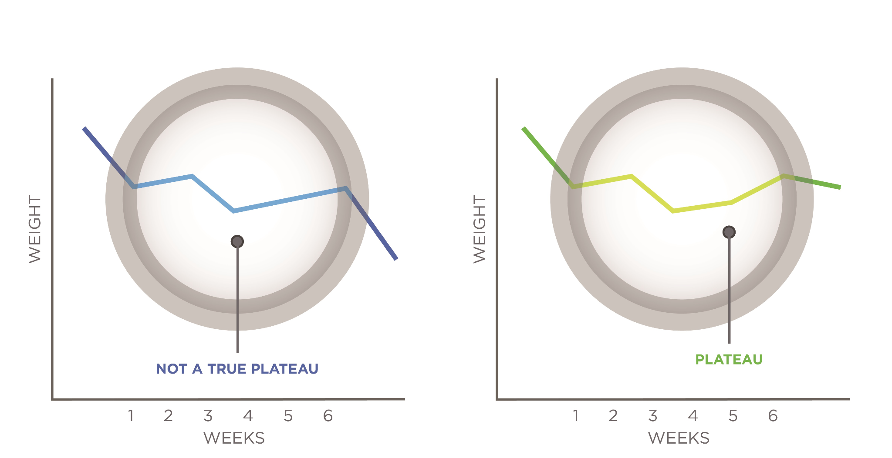

**Lapses in dietary adherence**

An increase in energy intake so that energy intake matches energy expenditure is the main reason for a weight-loss plateau. Weight-loss success is strongly related to dietary adherence rather than diet type or macronutrient composition.

Dietary adherence also predicts weight regain after weight loss; in fact, people with low dietary adherence show greater weight regain at 1 to 2 years compared to people with high adherence.

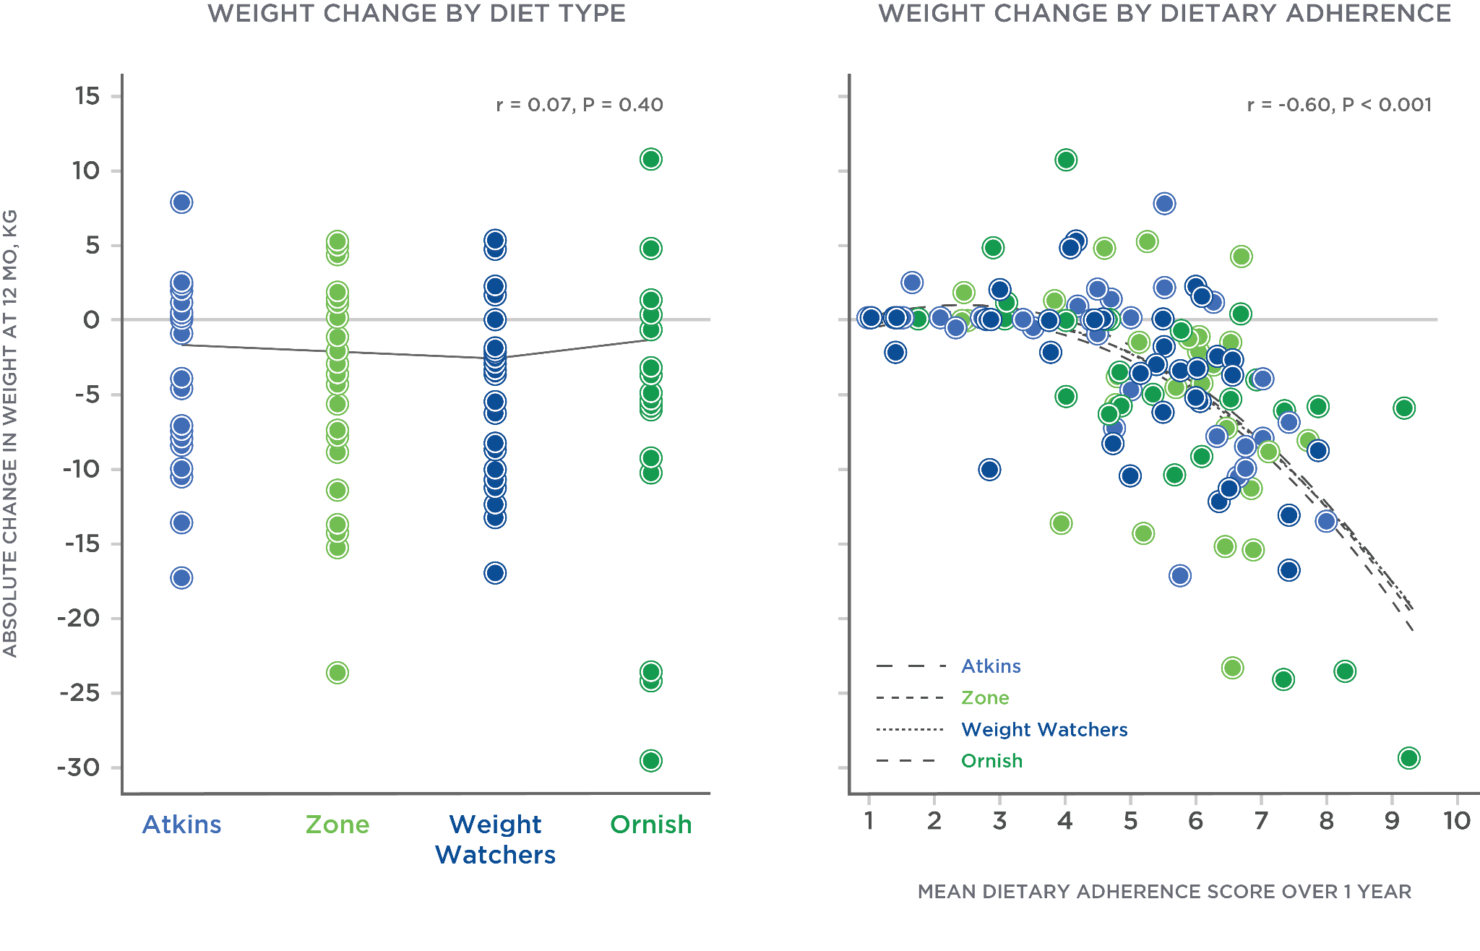

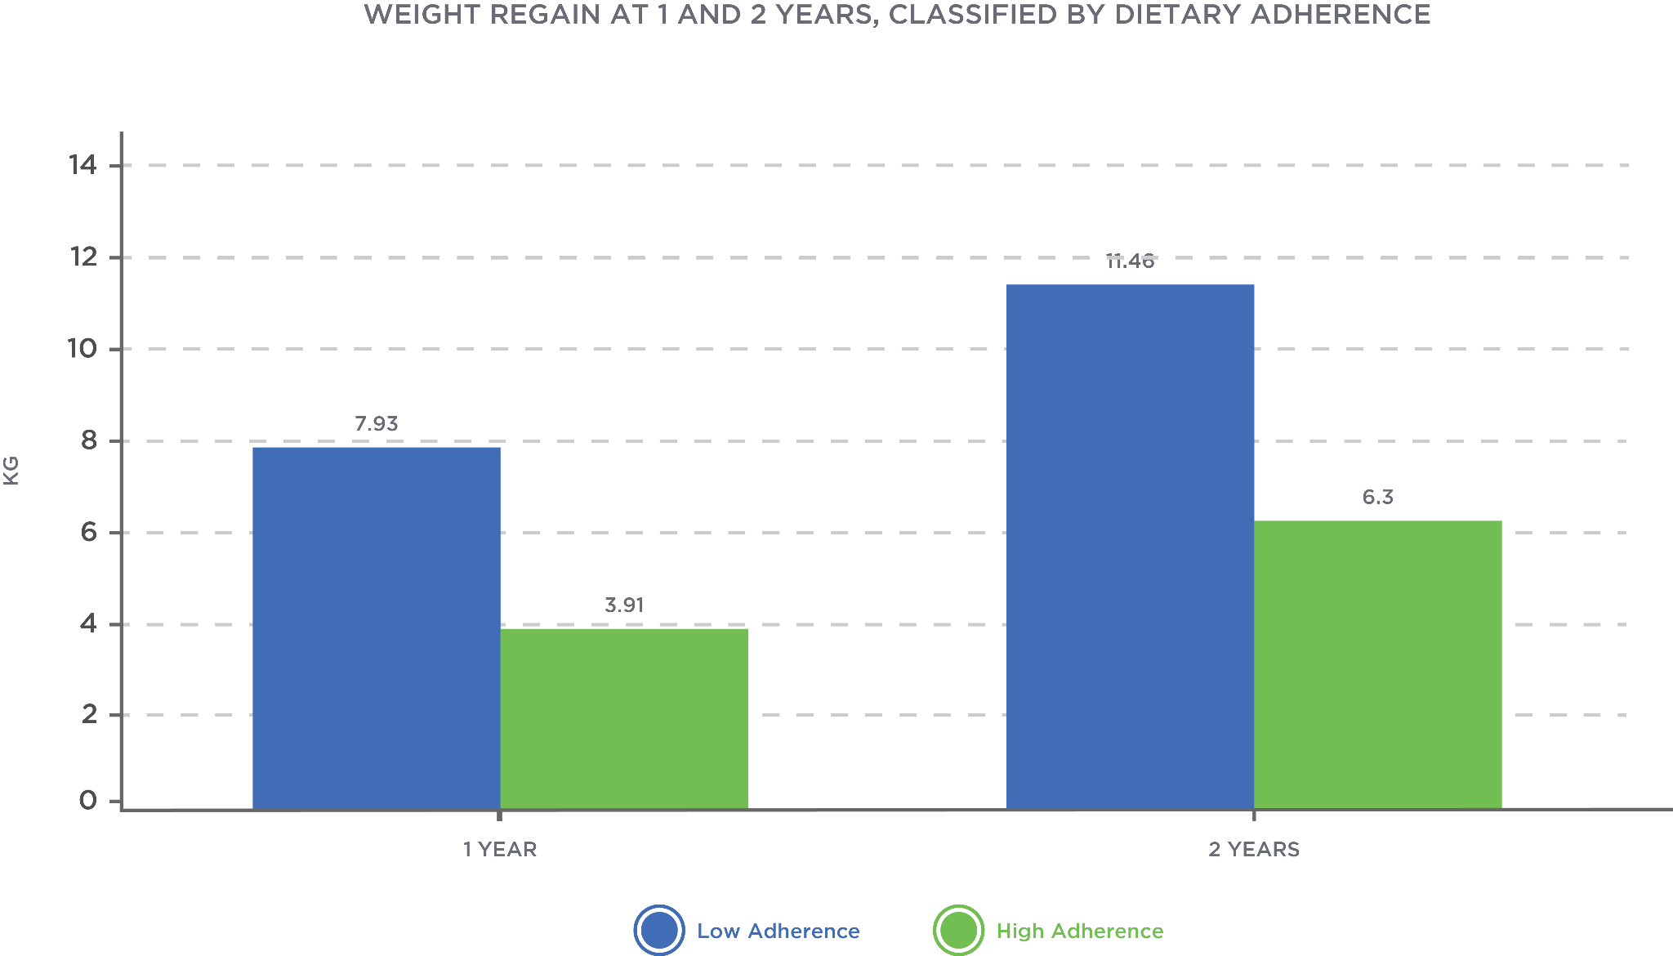

This indicates that dietary adherence reigns supreme over other factors (e.g. macronutrient composition). This highlights the importance of tailoring a dietary strategy to the needs and preferences of an individual. If a dietary strategy does not fit the needs of an individual, adherence and results may suffer. Dietary adherence is also a key factor behind lack of weight loss. Mathematical models show that energy expenditure adaptations (decreases in metabolism and physical activity) are not a major factor in weight-loss plateaus.

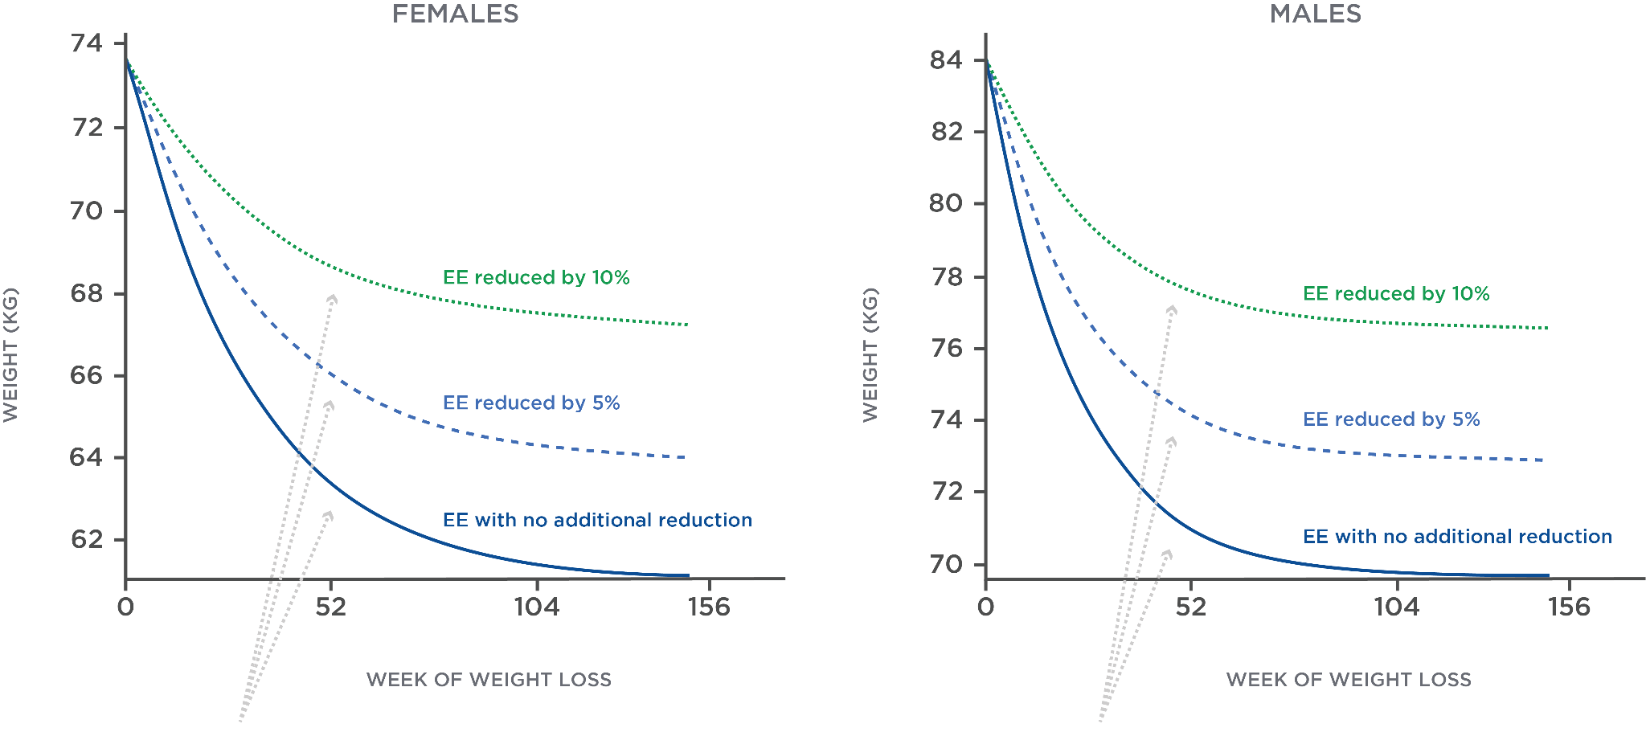

However, mathematical models of dietary lapses closely match actual weight loss (Thomas et al., 2014) (Figure: Models With Dietary Adherence Lapses). The best result for weight loss was observed in the mathematical model with 100% dietary compliance. These all show that lapses in dietary adherence are the primary reason for less-than-expected weight loss.

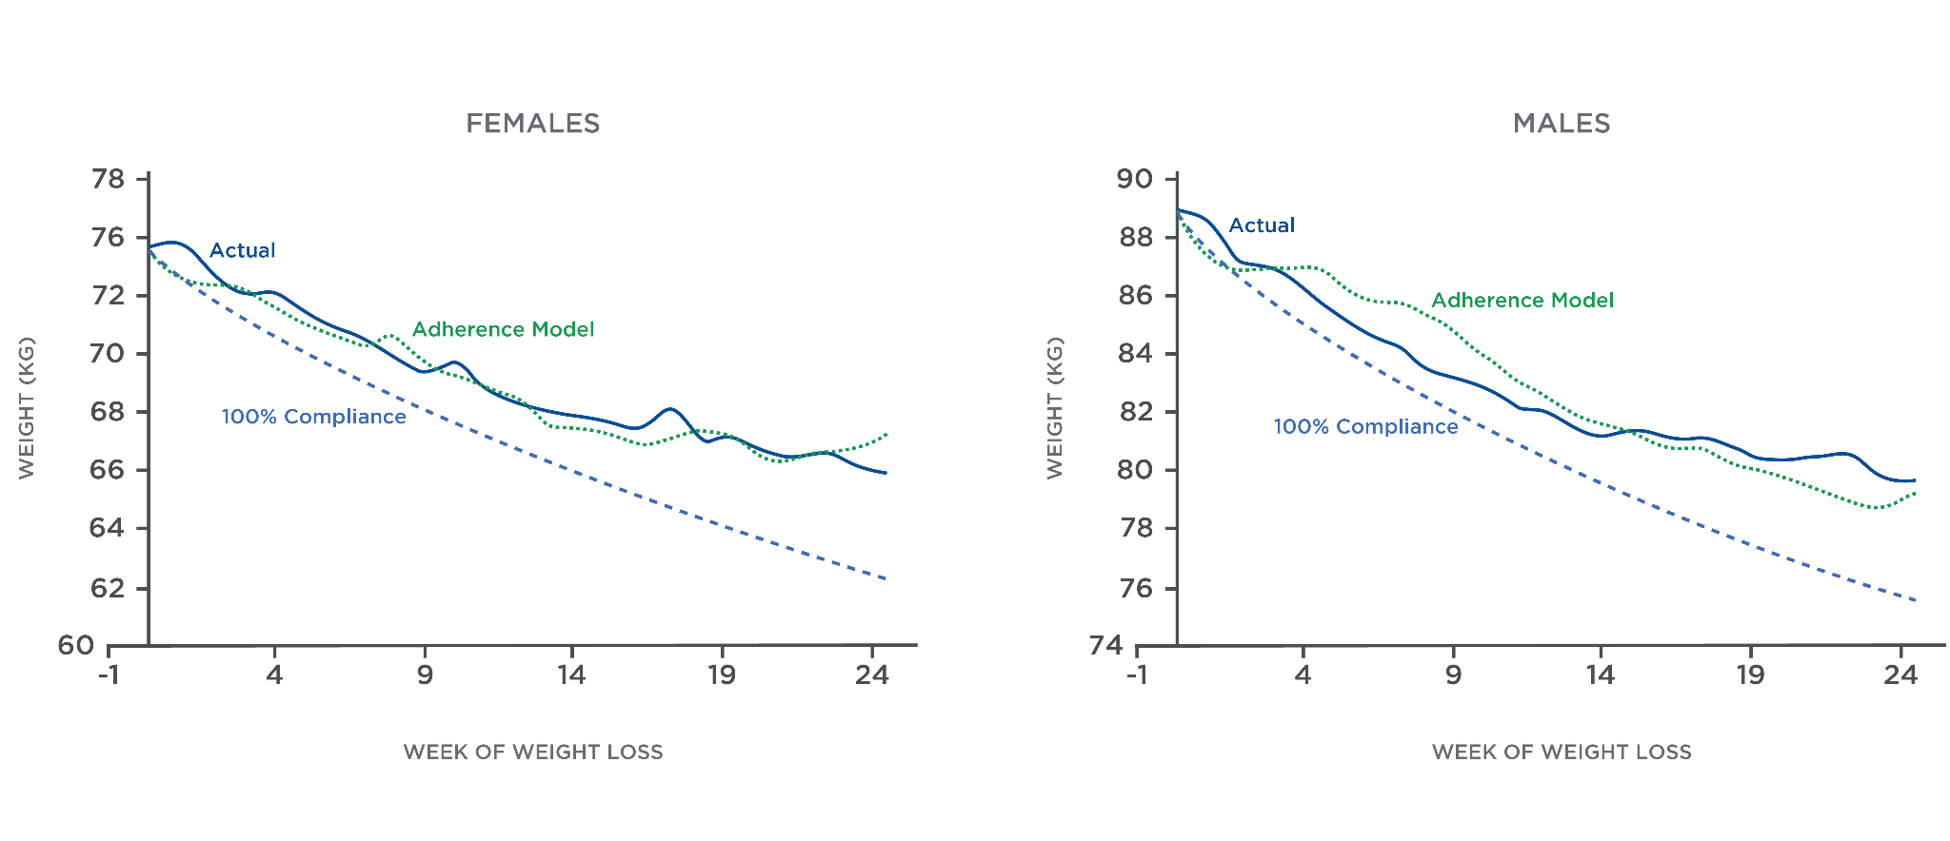

If a client has hit a plateau, the most likely reason (according to the scientific research) is a loss of dietary adherence. This means the most effective way to address plateaus is to address adherence. To improve dietary adherence, it is important to understand the causes of adherence lapses.

Coach's Corner

Tracking actual weight loss versus projected weight loss can be a useful way to assess client adherence. If actual weight loss is much less than predicted, then there is a high probability that a client is having adherence problems. There are online tools that can help give projected weight loss. One good tool is the [National Institute of Diabetes and Digestive and Kidney Diseases Body Weight Planner](https://www.niddk.nih.gov/bwp). When it is run in expert mode, it will give a simulation of projected weight loss over time.

**Causes of dietary adherence lapses**

There are numerous reasons why dietary adherence is difficult. Reasons for non-adherence can range from purposeful to unintentional. These reasons can be placed into at least one of three categories:

* Physiological
* Psychological
* Environmental.

Physiological

When the body is placed in an energy deficit, there are strong signals to try to bring the body back into energy balance. One of these signals is an increase in appetite. For example, reduced obese people (i.e., obese people who have lost significant weight) do not experience a decrease in hunger during overfeeding (Cornier, Grunwald, Johnson, & Bessesen, 2004) (Figure: Physiological Factors).

This contrasts with thin individuals, who experience a decrease in hunger (Cornier, Grunwald, Johnson, & Bessesen, 2004) (Figure: Hunger and Overfeeding). This indicates that people who have lost weight will not naturally detect if they are eating too much. They can end up inadvertently overeating, hitting a weight plateau, or regaining weight. This is a natural response from the body to try regain the lost weight.

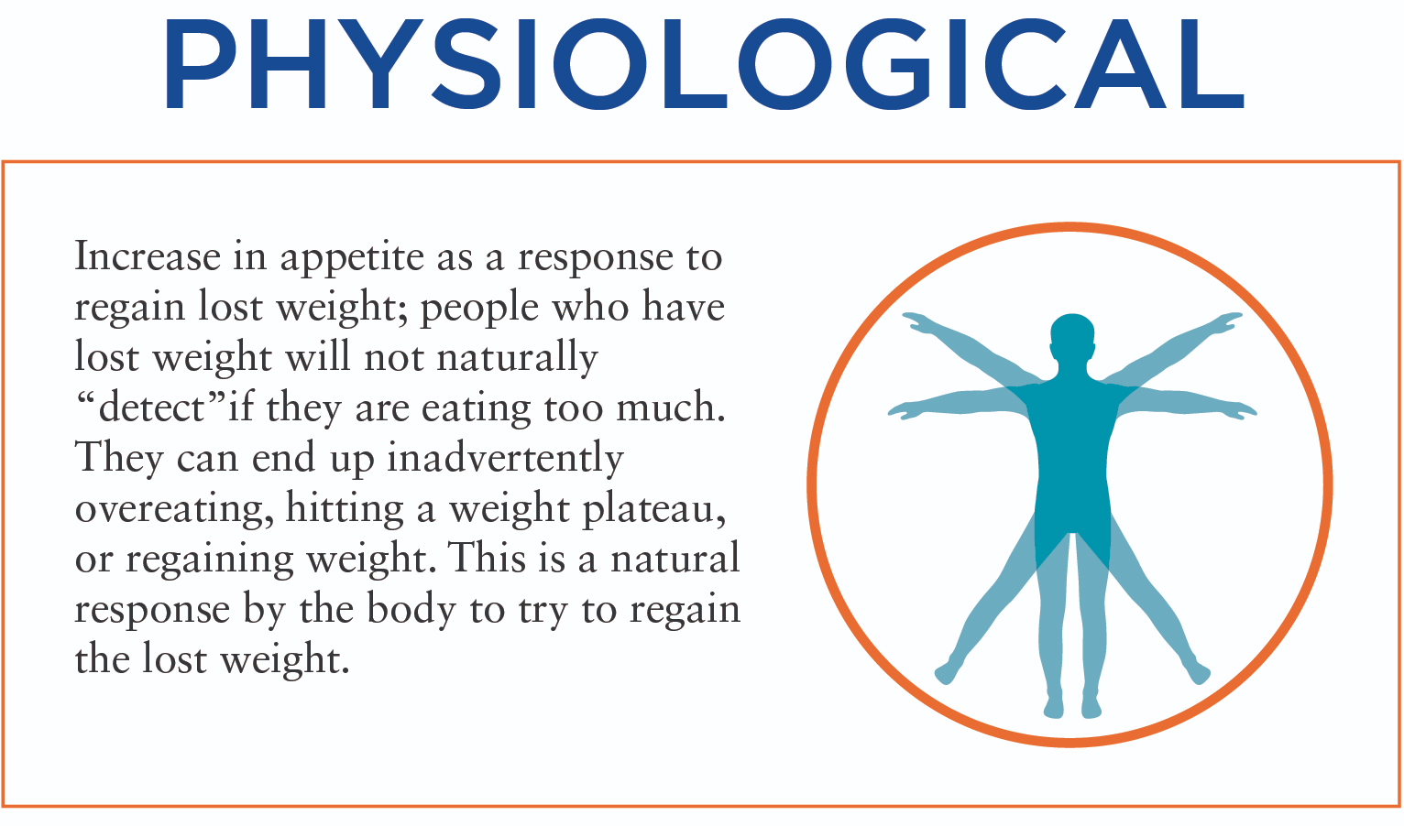

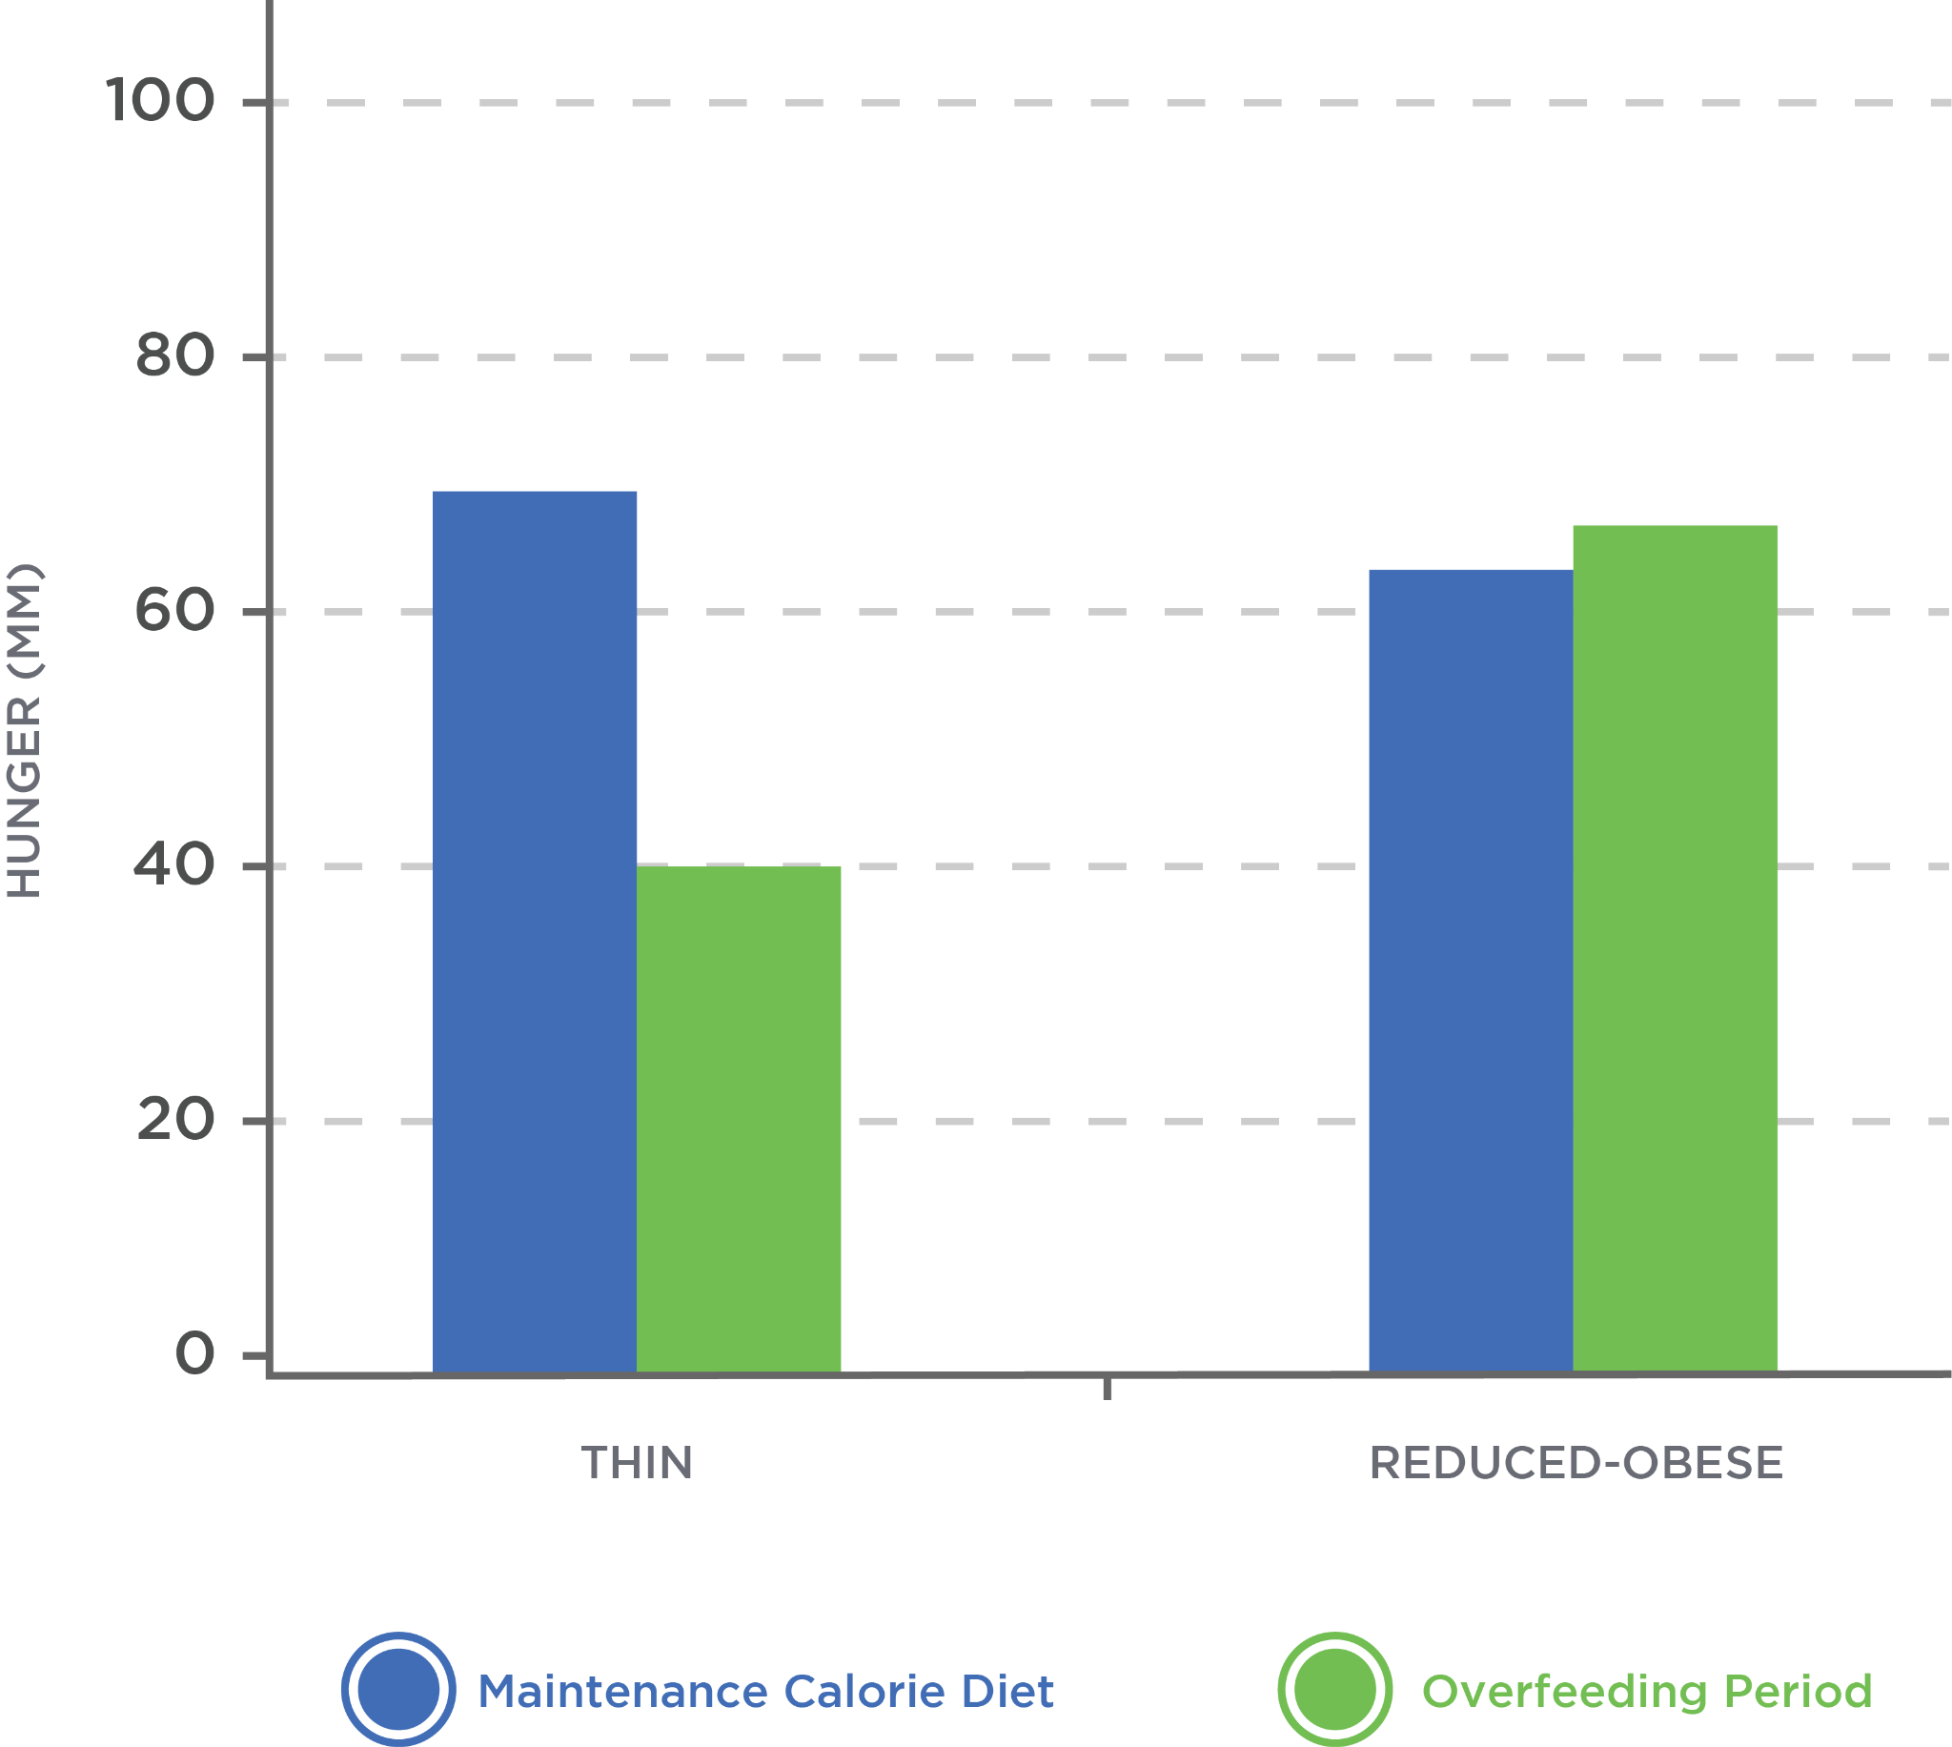

The physiological increase in appetite is strong. Self-reported hunger increases as more weight is lost (Gilbert, Drapeau, Astrup & Tremblay, 2009). There is a biological drive to increase calorie intake by approximately 100 calories for every kilogram of weight loss (Polidori, Sanghvi, Seeley & Hall, 2016). This increase in the drive to eat is much stronger than any metabolic adaptation. This lends further support to adherence loss as the primary reason for weight-loss plateaus. In fact, the drive to overeat persists 2 years after starting the diet (Polidori, Sanghvi, Seeley & Hall, 2016).

It is important for practitioners to understand how these strong hunger signals persist for long periods. The constant hunger signals can override a client’s willpower and lead to adherence lapses. Thus, it is important to help clients structure their plan to maximise satiety and adherence. It is also important to empathise with clients during lapses and understand how they might be feeling.

The following charts show changes in appetite, energy expenditure and energy intake in relation to body-weight change over 2 years (Polidori, Sanghvi, Seeley & Hall, 2016). The initial decrease in calorie intake and body weight is met by a strong increase in appetite (Figure: Changes in Appetite, Energy Expenditure and Energy Intake). This results in energy intake beginning to increase. After 2 years, energy intake has returned to baseline and appetite remains elevated. This coincides with a gradual increase in body weight. This visually demonstrates how plateaus and weight regain occur.

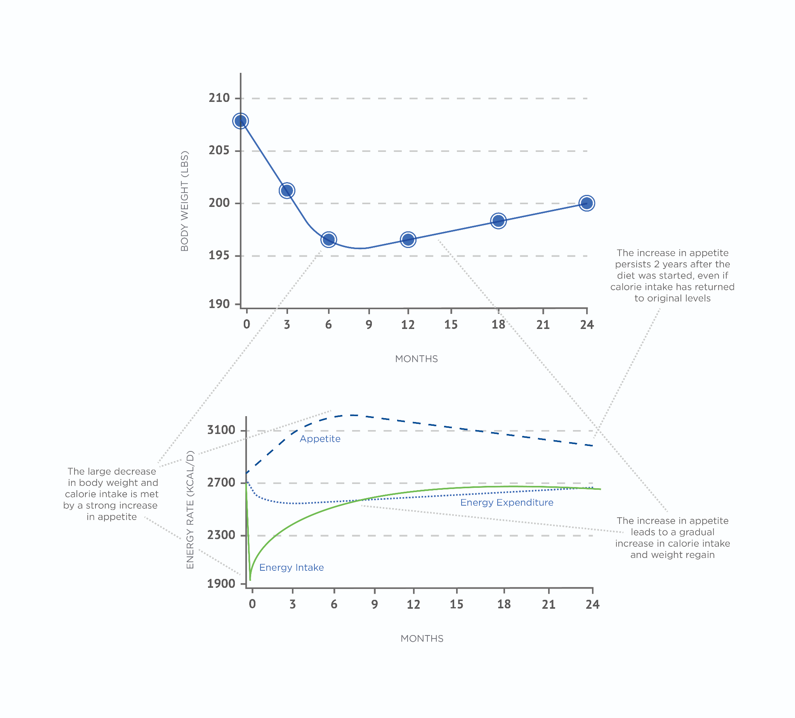

Psychological

There are numerous psychological barriers to dietary adherence (Halali, Mahdavi, Mobasseri, Asghari Jafarabadi & Karimi Avval, 2016). These barriers represent a challenge for both the client and the coach as they can be constantly present, and can vary from one person to the next or one situation to the next. Given the wide variety of psychological barriers to adherence, there is no one-size-fits-all approach to managing them. They require an individualized, client-centered approach, strategizing and working with the client to achieve solutions.

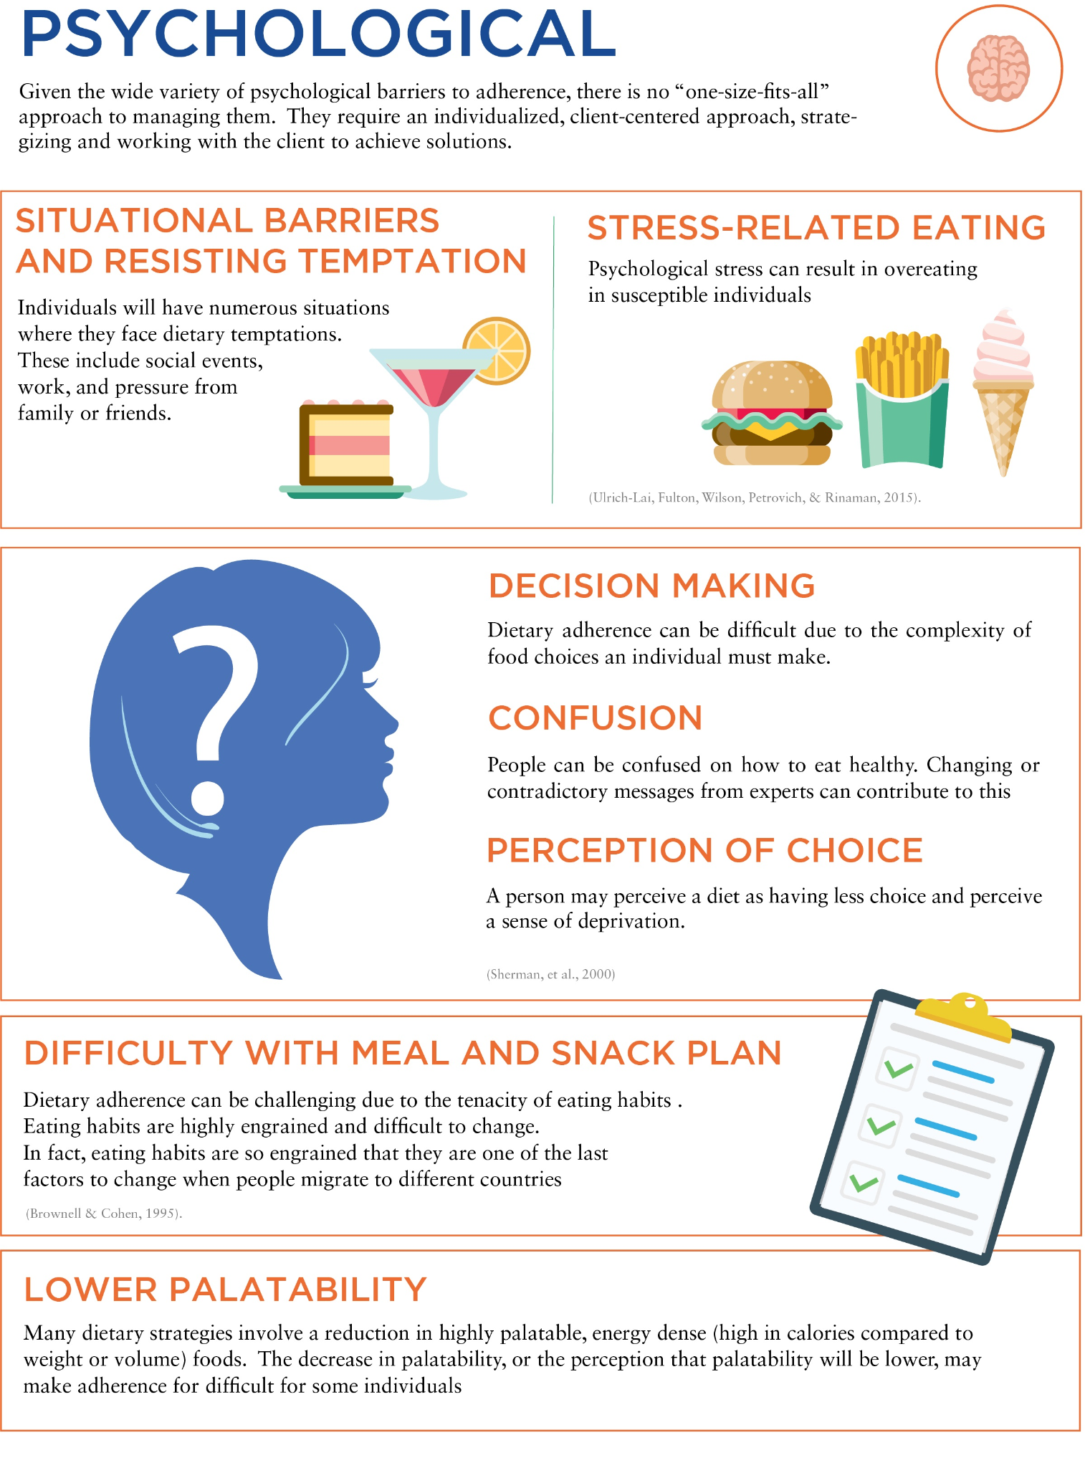

Environmental

The food environment has a powerful effect on how much people eat. The abundance of hyperpalatable, energy-dense foods has a significant role in the obesity epidemic (Morris, Beilharz, Maniam, Reichelt & Westbrook, 2015). The role of the environment is so powerful that people will spontaneously overeat when surrounded with highly palatable food. For example, people surrounded with vending machines full of familiar, palatable foods will spontaneously overeat by up to 54% above their maintenance calories (Larson, Rising, Ferraro & Ravussin, 1995). This implies that a client’s food environment will play a strong role in success. It is important to teach clients how to construct their food environment so that highly palatable, energy-dense foods are not readily available. This can range from keeping problem foods locked away and out of sight to keeping energy-dense foods out of the house or personal environment.

**Cognitive reframing: breaking through weight-loss plateaus**

To help a client break through a weight-loss plateau, it is important to build the proper mindset from the outset. With most clients, it is not a matter of *if* a plateau occurs but *when*. It is important to educate the client about the near-certainty of plateaus and that they are a normal part of the weight-loss journey.

A positive spin can be put on the plateaus by viewing them as landings en route to the bottom of a larger staircase (Infographic: Plateaus Stair Step Progression). The steps (progress) decrease while the size of the landings increases. In fact, plateaus can be viewed as successful weight-loss maintenance at a lower body weight. They can be considered maintenance practice or opportunities to test program sustainability. This is important because long-term weight-loss maintenance can be challenging for many (Kraschnewski et al., 2010).

**Re-establishing an energy deficit**

Because a plateau is due to energy intake matching energy expenditure, the way to break a plateau is to re-establish a deficit. This can be done by reducing energy intake, increasing energy expenditure, or by both. Decreasing energy intake can be done in at least one of three ways:

* Reduction in energy density of food choices (i.e., food with similar volume but less calories)
* Reduction in portion size
* Reduction in frequency of intake.

When considering a reduction in energy intake, it is important to assess the individual’s ability or preference to reduce calorie intake. If the self-reported calorie intake is already low (such as 1,000 to 1,200 calories per day), further lowering calorie intake may not be an option. Underreporting also presents a challenge. People often underreport how much they really eat, sometimes by significant amounts (Hill & Davies, 2001). In fact, when self-professed small eaters are given amounts of food equal to what they claim to be eating, they lose weight (Clark et al., 1994). Dealing with underreporting can be challenging for a coach.

In some cases, an increase in prescribed calorie intake may be useful, as it may improve adherence (Frost et al., 2007). This may particularly be the case when reported calorie intake is very low (1,000 to 1,200 calories per day or less). In other cases, the use of meal-replacement powders or ready-to-eat low-calorie meals for a short period of time can be useful. This allows for tighter control of calorie intake. If the person begins to lose weight, it can help instruct the person as to their previous inaccuracies in tracking. Other methods to reduce underreporting can range from instruction on portion sizes to demonstration of common errors in measuring food intake. For example, a client’s assessment of a tablespoon of peanut butter may be equivalent to three tablespoons if it were measured on a scale.

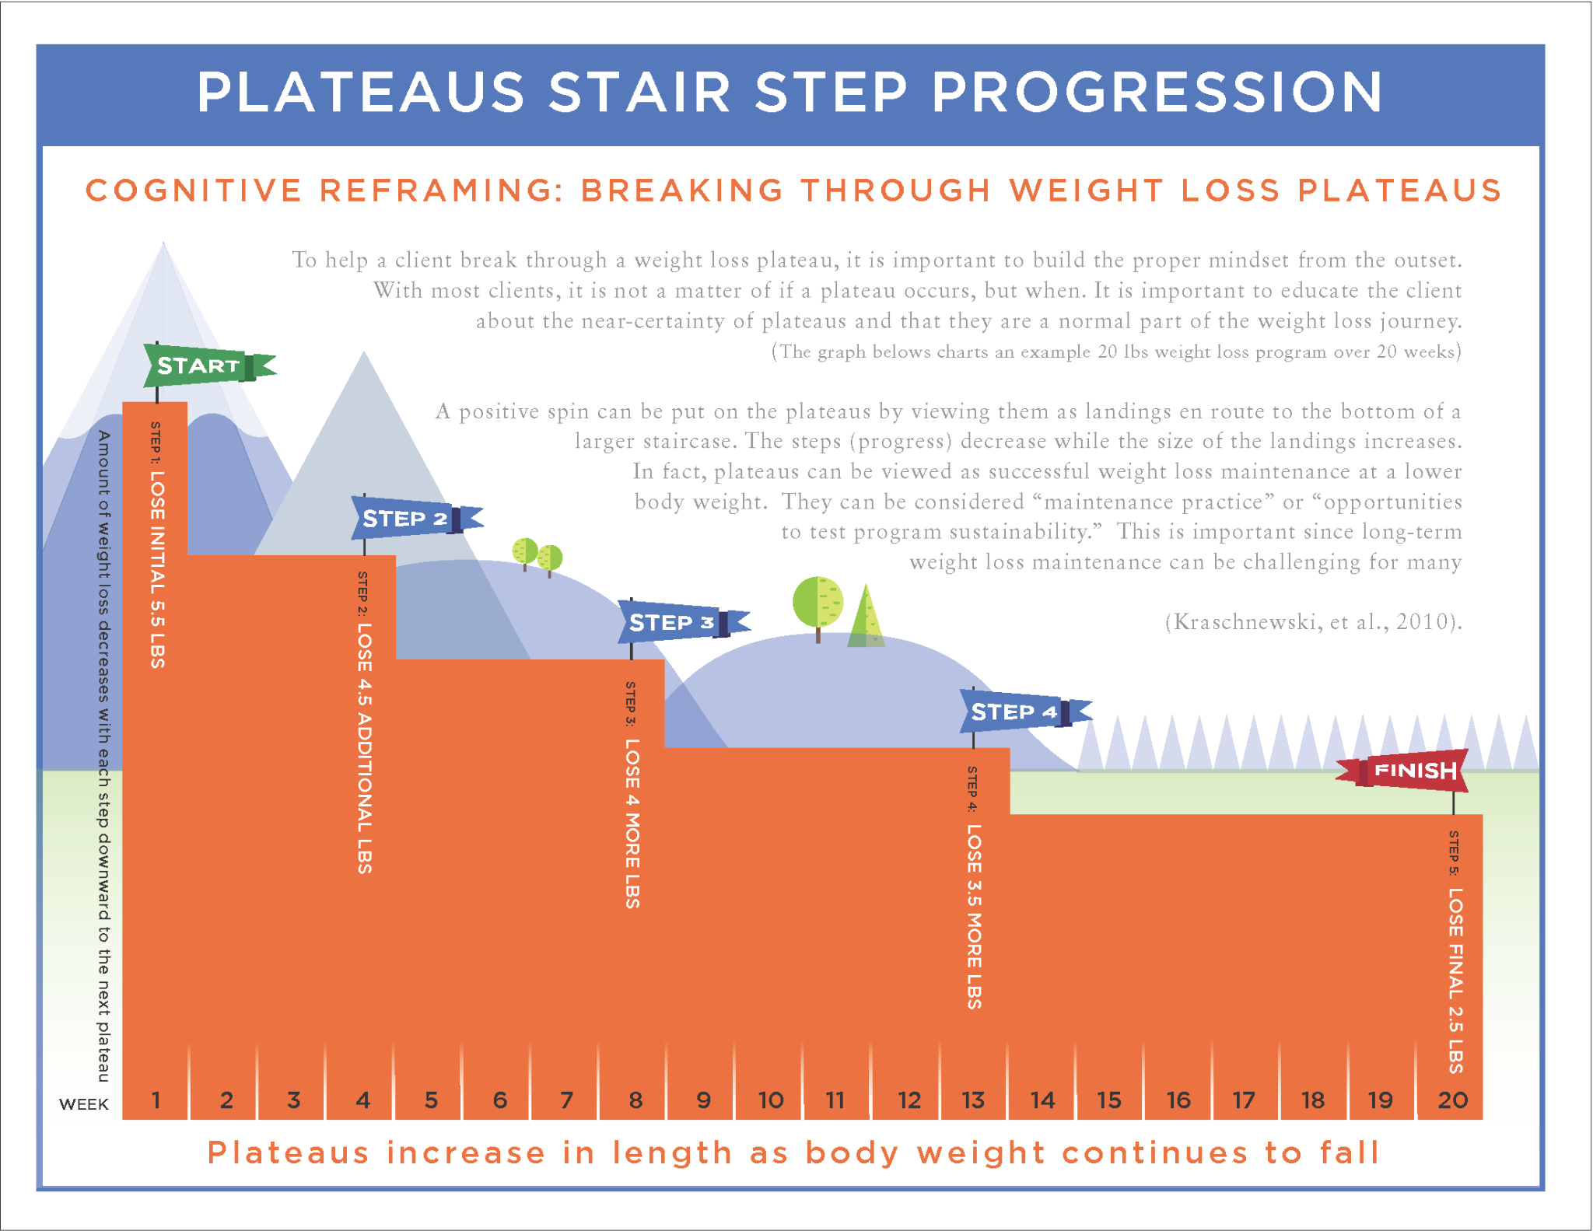

Increasing energy expenditure is another tool to help break plateaus. Increasing energy expenditure can be done in one of three ways:

* Increasing formal exercise volume
* Increasing nonexercise physical activity
* Increasing recreational physical activity.

Increasing exercise volume can mean increasing the duration or frequency of exercise sessions. Increasing nonexercise physical activity includes things such as parking further from destinations, doing dishes by hand rather than using a dishwasher, using a push rather than riding lawnmower, etc. As with a reduction in energy intake, it is important to assess the individual’s ability or preference for increasing energy expenditure. For example, perhaps the person may not have room to perform additional exercise sessions but may have the ability to take frequent 5-minute walk breaks through the day to accumulate nonexercise physical activity (Swartz, Squires, & Strath, 2011).

Coach's Corner

Determining whether a client needs to decrease calorie intake, increase energy expenditure, or do both will depend on the client’s preferences and situation. The following are some guidelines on how to choose:

1. If there is room to decrease calorie intake and a client’s self-reported hunger levels are not too high, then reducing calorie intake may be the best method.
2. If there is room to decrease calorie intake but hunger levels are high, then an increase in activity may be a better option.
3. If calorie intake is already low and the client is reporting accurately, then an increase in activity is preferable.
4. If calorie intake is low but underreporting is suspected, then an increase in calorie intake (to improve adherence) or efforts to improve self-reporting accuracy combined with an increase in activity may be best.
5. If there is not much room to increase formal exercise in the client’s daily schedule, then efforts to improve recreational activity or nonexercise activity (particularly in short bouts throughout the day) may work best.

**Improving dietary adherence**

Because lapses in dietary adherence are often the primary reason for plateaus, improving dietary adherence is an important strategy to help break plateaus. This means finding ways to overcome the physiological, psychological, and environmental barriers to adherence.

Try This

There are many available tools to help with self-monitoring. These include online diet trackers, online weight trackers (many online diet trackers also include the capability to track body weight), and activity-monitoring devices (like a pedometer or fitness band). Encourage a client to use such tools to help provide them with feedback and improve adherence.

Physiological

Dieting results in strong increases in hunger and feelings of hunger are associated with lapses in adherence (Forman et al., 2017). Thus, manipulation of dietary components to improve satiety may help adherence. One component that can be manipulated is the size of the energy deficit. While larger deficits may result in greater weight loss and possibly create more buy-in, they do so at the expense of greater hunger and possibly lower adherence. For example, people who try to adhere to a 30% deficit do no better than people who are prescribed a 10% deficit (Das et al., 2009). Higher deficits can result in greater hunger levels and less satisfaction with the overall amount of food consumed (Das et al., 2009). Actual weight loss is sometimes greater with smaller deficits, likely due to better adherence (Table: Frost Study Results) (Frost et al., 2007).

Frost Study Results

|  | **Group 1** | **Group 2** | **Group 3** |
| --- | --- | --- | --- |
| Energy prescribed (kcal) | 1100 | 1600 | 1700 |
| Estimated energy requirement (kcal) | 2600 | 2500 | 2400 |
| Estimated energy deficit (kcal) | 1500 | 900 | 700 |
| Projected 12-week weight loss (lbs) | 39 | 23 | 19 |
| Actual 12-week weight loss (lbs) | 6.4 | 7.3 | 11 |

Getting Technical

Some have thought that the lack of weight loss with very-low reported calorie intake is due to starvation mode and metabolic adaptation. However, the degree of metabolic adaptation at a very-low calorie intake (such as < 1,200 calories per day) is usually insufficient to stop weight loss. The loss of adherence with very-low calorie intakes is a better explanation. Therefore, increasing the prescribed calorie intake can help improve weight loss. The client is given a more achievable target and becomes more adherent.

The quality and composition of the diet can also be modified to improve satiety, which would promote better adherence. Lower energy density, higher protein, and higher fiber intakes are all associated with greater satiety (Holt, Brand Miller, & Petocz, 1996). Reducing food variety and palatability can also help improve satiety, but this must be balanced with the person’s individual preferences and ability to adhere. Higher physical activity levels are associated with better adherence (Downer et al., 2016), perhaps due to lower brain responses to food cues (Luo, O'Connor, Belcher, & Page, 2018) and better appetite regulation (Dorling et al., 2018). Finally, modified foods (such as artificially sweetened foods) can enhance adherence through the substitution of lower-calorie versions of a person’s preferred foods (Sherman et al., 2000).

Food for Thought

The buffet effect refers to the tendency of people to eat more when there is a large variety of food. This is why decreasing variety may help with satiety and adherence. However, this must be weighed against a client’s preferences. If variety is too low, it may increase feelings of deprivation. This could lead to a loss of adherence.

Environmental

The food environment can have a strong influence on adherence (Forman et al., 2017). For example, the availability of high-reward, highly palatable foods is associated with lapses in adherence (Forman et al., 2017). Thus, modifying the environment can help improve adherence. Steps to modify the food environment include the following:

* Reduce food cues and visibility (Guyenet, 2017): Food-cue exposure is associated with increased eating and weight gain (Boswell & Kober, 2016). Overweight individuals may be more sensitive to food cues (Watson, Wiers, Hommel, Gerdes, & de Wit, 2017). Thus, reducing those cues may help people manage their calorie intake. Keep foods out of sight to reduce temptation and spontaneous snacking. In food-storage areas, reduce visibility of less-healthy options by burying them behind or beneath more healthy options. Avoid watching commercials that are filled with food advertisements.
* Create effort barriers (Guyenet, 2017): Altering the food environment to increase availability of healthier choices and decrease the availability of less-healthy choices may improve eating behavior (Roy, Kelly, Rangan, & Allman-Farinelli, 2015). Making it more difficult to obtain a high-calorie, energy-dense food may make it less likely a person will consume that food. This includes the following:
  + Keep less-healthy food in a locked cabinet.
  + Keep foods in a less-prepared form (e.g., whole oranges versus sliced oranges).
  + Only keep foods in the house that need to be prepared or cooked (not premade or prepackaged).
  + Keep energy-dense and problem foods out of the personal environment.

Getting Technical

Optimal Foraging Theory (OFT) refers to how human brains assign value to food. OFT is defined by the calories gained from a food relative to how much energy and time is needed to obtain it. Energy-dense foods provide a lot of calories and are easy to obtain and, thus, provide high value to the brain. Making such foods difficult to obtain (like keeping them out of the house) reduces the value of these foods.

Psychological

There are numerous psychological factors that can help promote dietary adherence. These include the following:

* Education: It is important to understand the rationale for required dietary changes. However, a rationale for change is not a sufficient condition for change (Sherman et al., 2000). The most important component of education is teaching people how to change their behaviors. In general, behavioral education will help promote dietary adherence more than nutrition education (Steptoe, Perkins-Porras, Rink, Hilton, & Cappuccio, 2004).
* Motivation: Sustained motivation is important for long-term success. Motivation can be improved by increasing awareness of the benefits of progressing toward and achieving goals. By regularly working toward and achieving goals, a sense of personal control and self-efficacy (a perceived ability to make change) are developed. Developing an appreciation of the benefits of maintaining long-term weight loss can also help. Motivation can also be enhanced by increasing the perceived benefits of goal achievement and weight loss while decreasing the perceived costs (Sherman et al., 2000).
* Awareness of a plan and goals associated with that plan: While motivation can be important, it can fluctuate; thus, it is important to maintain behavioral changes even when motivation decreases. Motivation alone does not translate to behavior change or compliance. However, individuals who set out very-specific plans to engage in a particular behavior are more likely to carry it out (Milne, Orbell, & Sherran, 2002). For example, people are more likely to engage in exercise at least once per week if they form a very-specific plan regarding when and where they would exercise (Figure: Motivation and Awareness of Plan Results) (Milne, Orbell, & Sherran, 2002). This is in contrast to individuals who just receive information on the benefits of exercise (Milne, Orbell, & Sherran, 2002).
* Active self-regulation and self-monitoring: Self-monitoring (such as dietary tracking or regular self-weighing) is also associated with better dietary adherence (Tinker et al., 2007). Teaching people the behavioral skills to navigate obstacles and temptations is also important. The more obstacles that are present, the worse adherence tends to be (Kwasnicka, Dombrowski, White, & Sniehotta, 2017). For example, if a client is extremely busy and food preparation is a challenge, then the use of meal-replacements or healthy meal-delivery services can help a client navigate this obstacle. Teaching a client to prepare food ahead of time (like prepping food for the entire week on a Sunday) is another potential solution. Additionally, an example of how a client might navigate temptation is where the client consumes a high-protein snack before going to a social event. Thus, the client is not hungry and as tempted by the food that might be available.
* Social support: Support from family or friends is important to help maintain dietary adherence. Support groups can also help. Within the context of social support, encouragement (doing or saying things to help promote better dietary choices) tends to work better than warnings (doing or saying things to warn of the consequences of eating an unhealthy diet) (Stephens, Rook, Franks, Khan, & Lida, 2010).
* Cognitive and behavioral skills: These include skills to both prevent lapses in adherence and cope with temporary lapses in dietary adherence. Skills to prevent lapses in dietary adherence include recognizing situations that involve a high risk of lapses and then learning to modify or avoid those situations. Skills to cope with lapses include cognitive reframing of lapses as temporary setbacks rather than failures.
* Flexible over rigid approaches: Flexible approaches to dieting allow for occasional divergence from plans and for flexibility in food choices. Flexible approaches are associated with lower-calorie intakes and better weight loss (Westenhoefer et al., 2013).
* Managing feelings of deprivation: Feelings of deprivation are associated with low dietary adherence (Forman et al., 2017). Feelings of deprivation can be managed through a variety of techniques, including modest deficits, flexible dieting approaches, and avoidance of dichotomous thinking around food and diets (i.e., avoiding thoughts that a person is on or off a diet or that a food is good or bad).
* Tailoring dietary characteristics to the individual: Several dietary-programming elements should be individualized to a person’s preferences, tolerances, and goals. These include macronutrient distribution, food choices, and the continuity of the diet (i.e., continuous dieting or intermittent approaches). For example, if a person prefers a lower-carbohydrate approach compared to a higher-carbohydrate approach, this should be factored into the dietary programming to help adherence.

**Long-term weight maintenance**

Weight-loss plateaus are not the only challenge faced by people trying to lose weight. Maintaining weight loss long-term is one of the most difficult aspects of weight management. While statistics vary by study, the overall long-term success rates are low (Kraschnewski et al., 2010). Reasons for low success rates include impaired satiety signals (Cornier, Grunwald, Johnson & Bessesen, 2004), increased biological drive to regain weight (Polidori, Sanghvi, Seeley & Hall, 2016), hyperpalatable food environment, constant food cues and easy access (Morris, Beilharz, Maniam, Reichelt & Westbrook, 2015), long-term reductions in physical activity energy expenditure (Rosenbaum, Hirsch, Gallagher & Leibel, 2008), and experiences of a higher burden because maintaining weight loss requires much more effort compared to lean people (Kruseman, Schmutz & Carrard, 2017).

**Factors associated with maintenance**

While long-term weight maintenance is challenging, it is not impossible. Numerous people have successfully maintained long-term weight loss. Scientists have identified numerous factors that play a role in maintaining long-term weight loss

Helpful Hint

If clients are tracking well on weekdays but not weekends, and if they are not losing weight, it is likely due to a loss of adherence and high-calorie intakes on the weekends.

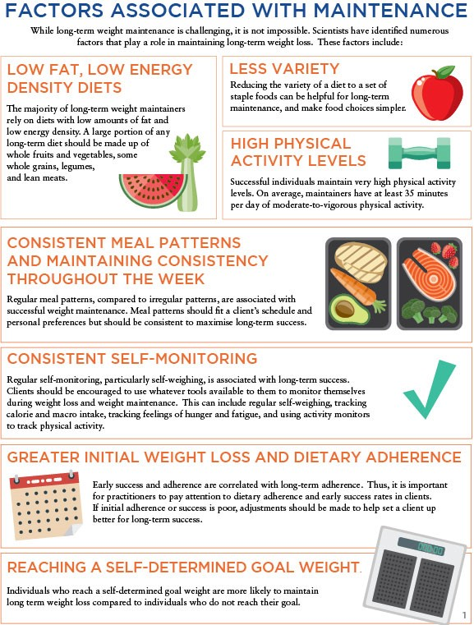

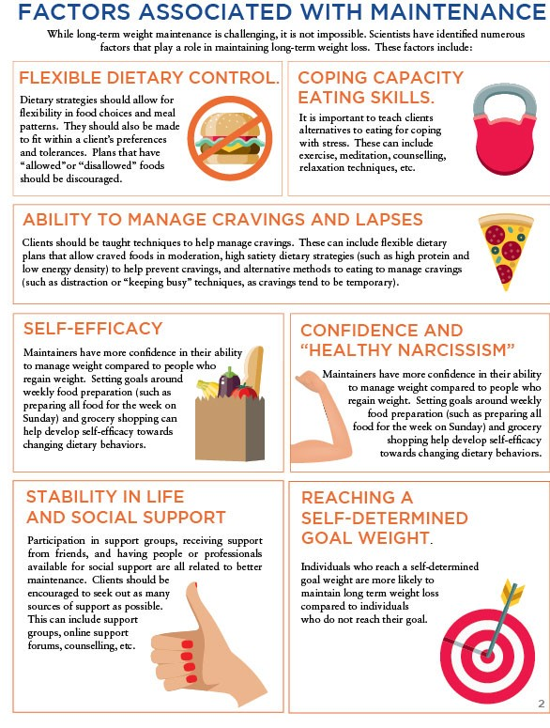

Helpful Hint

'If you’re going to fail, fail fast' is a common phrase in the business world. This applies to dietary adherence. If it is obvious that a client is struggling with adherence early in a programme, it is important to make rapid adjustments.

Coach's Corner

A useful concept is to set boundaries as triggers for action. For example, a red-light number can be a body weight at which, if a client exceeds it, they should seek professional help to make sure no further regain occurs. Say a client loses 30 pounds (13.6 kg). The client might set a red-light number at a 10-pound (4.5 kg) regain.

**Factors associated with regain**

There are a few factors associated with an increased risk of weight regain. Some of these are the opposite of the factors associated with maintenance.

* Sedentary lifestyle: Randomised controlled trials (RCTs) show that weight regain is more likely when physical activity energy expenditure is low (1000 calories per week) (Tate, Jeffery, Sherwood & Wing, 2007). Low leisure time is likely to lead to weight regain (Elfhag & Rossner, 2005). Perceived barriers for carrying out physical activity are also associated with weight regain (Elfhag & Rossner, 2005). The use of activity monitors like accelerometers and pedometers can be useful in providing feedback on overall daily physical activity levels.

Food for Thought

Exercise, particularly resistance training, helps preserve fat-free mass. This may be one of the mechanisms behind how exercise helps with long-term weight maintenance.

* Disinhibited eating: People that tend to have no restraint regarding their eating habits are more likely to regain weight (Elfhag & Rossner, 2005). While long-term maintenance allows for more flexibility than a weight-loss phase, some restraint is still necessary. Thus, continuing to practise some of the same restrained eating habits during maintenance as those practised during active weight loss can be helpful.
* Dichotomous view of foods and a rigid approach to dieting: Rigid approaches are an all-or-nothing approach to dieting and allow for very little flexibility. They tend to label foods as *good* or *bad,* or *allowed* or *disallowed*. Rigid approaches are associated with a pre-occupation with food (Westenhoefer et al., 2013). Rigid, all-or-nothing approaches are a risk factor for periods of overeating (Linardon, 2018). Rigid control of eating behaviour can increase feelings of deprivation and cravings (Meule, Westenhofer & Kubler, 2011). Clients should avoid labelling foods in a dichotomous fashion, and quality should be viewed on a continuum with some foods higher in quality (like fruits and vegetables) and some foods lower in quality (like energy-dense desserts).
* Binge eating: Binge eating includes the consumption of large quantities of food while feeling a lack of control over eating. It is associated with increased risk of weight regain and people who binge eat experience distress about their episodes (Elfhag & Rossner, 2005). If a client has issues with binge eating, seeking out professional counselling from someone with expertise in binge eating can be helpful.
* Emotional eating, psychosocial stress, and low coping capacity: People who regain weight often have poor coping strategies and tend to eat in response to stressful events and emotions (Elfhag & Rossner, 2005). They may use escape-avoidance ways to cope that include eating and passively wish the problems would vanish (Elfhag & Rossner, 2005). Clients should be encouraged to find alternatives to eating for coping with stress. Clients should also be encouraged to actively problem solve when faced with challenging situations.
* Lack of social support: Lack of social support or negative involvement from family, spouses or friends are associated with regain (Elfhag & Rossner, 2005). Clients should be encouraged to seek out support wherever they can. If support from family or friends is lacking, then support groups or Internet groups may be useful alternatives.
* Psychopathology: Depression or other psychiatric diagnoses may be associated with regain risk, although the research findings have not been consistent (Elfhag & Rossner, 2005). Clients should seek professional help in cases where psychopathology may be a risk factor.
* Medication-induced appetite elevation: Some medications may increase appetite and lead to weight regain. For example, glucocorticoid medications can increase appetite and food reward, leading to abdominal weight gain (Serfling, Buades-Rotger, Harbeck, Kramer & Brabant, 2018). Clients should discuss their medications and potential alternatives with their physicians.
* Excessive loss of fat-free mass: The percentage of weight loss from fat-free mass during a diet is a predictor of subsequent weight regain (Vink, Roumans, Arkenbosch, Mariman & van Baak, 2016). Exercise can be an important tool to help prevent the loss of fat-free mass.
* Diet burnout: Long-term weight maintenance takes increased effort (Kruseman, Schmutz & Carrard, 2017). The constant required effort may lead to psychological burnout, particularly if the diet is disliked, there is a lack of flexibility and/or there is no break from the diet. Thus, it is important to ensure a diet fits a client’s preferences and has adequate flexibility to help prevent burnout. Prescription of maintenance breaks can also be useful.

Factors Associated With Weight Loss Plateaus, Weight Maintenance, and Weight Regain

|  | **Plateau** | **Maintenance** | **Regain** |
| --- | --- | --- | --- |
| Elevated appetite | ↑ | ↓ | ↑ |
| Hyperpalatable, energy-dense food environment | ↑ | ↓ | ↑ |
| Dietary adherence | ↓ | ↑ | ↓ |
| Low-energy density and/or low-fat diets |  | ↑ | ↓ |
| Less dietary variety |  | ↑ | ↓ |
| Consistent meal patterns throughout the week |  | ↑ | ↓ |
| High physical activity |  | ↑ | ↓ |
| Self-monitoring | ↓ | ↑ | ↓ |
| Greater initial weight loss |  | ↑ | ↓ |
| Reaching self-determined goal weight |  | ↑ | ↓ |
| Flexible dietary control | ↓ | ↑ | ↓ |
| Intuitive eating |  | ↑ | ↓ |
| Coping skills and overcoming situational barriers | ↓ | ↑ | ↓ |
| Ability to manage cravings, temptation, and lapses | ↓ | ↑ | ↓ |
| Self-efficacy |  | ↑ | ↓ |
| Confidence and healthy narcissism |  | ↑ | ↓ |
| Life stability |  | ↑ | ↓ |
| Social support | ↓ | ↑ | ↓ |
| Disinhibited eating (no restraint) |  | ↓ | ↑ |
| Dichotomous view of foods and rigid dietary control | ↑ | ↓ | ↑ |
| Psychopathology |  | ↓ | ↑ |
| Medication-induced appetite elevation |  | ↓ | ↑ |
| Binge eating |  | ↓ | ↑ |
| Emotional and stress-related eating | ↑ | ↓ | ↑ |
| Excessive loss of fat-free mass |  | ↓ | ↑ |
| Diet burnout |  | ↓ | ↑ |
| Weight-cycling history |  | ↓ | ↑ |

Weight-cycling history

A previous history of weight cycling is associated with increased risk of weight regain (Elfhag & Rossner, 2005). Previous failed attempts to maintain weight loss may alter a person’s confidence to be able to achieve long-term success. For individuals who have a history of weight cycling, it is important to learn the history of their previous efforts. The practitioner should learn what has or has not worked for the person in the past. This can help guide future efforts and provide the client with better methods to approach weight loss and maintenance.

For example, if a person has used extreme, rigid diets in the past, it is critical to teach the individual about more moderate, flexible approaches. It is also important to determine whether it is the appropriate time to attempt weight loss. For example, during periods of major stressful life events (e.g. divorce, severe illness, etc.), it may be unrealistic to attempt weight loss. It may be better to attempt weight loss at a future time when things settle down for the client, and perhaps focus more on maintenance or general healthy behaviours.

Diet breaks as an adherence tool

The increased biological drive to regain weight combined with the hyperpalatable, easy-to-access food environment can make long-term adherence difficult. Willpower is generally insufficient to overcome these challenges. The physiological, psychological and environmental factors can be overwhelming. Thus, an appropriate dietary strategy for a client is one that makes adherence as easy as possible, while minimising any suffering. Intermittent dietary strategies can be a useful tool to help enhance long-term adherence. The maintenance periods can act as a psychological break from the rigors of dieting without negatively affecting long-term success. In fact, there are no differences in weight or fat loss when intermittent approaches are compared with continuous approaches (Roman et al., 2018). This suggests that intermittent approaches can be used for individuals that may need them without negatively impacting success.

Weight-loss plateaus are an inevitable part of the weight-loss journey. They are caused by energy intake matching energy expenditure, usually due to a loss of dietary adherence. Drivers behind losses of dietary adherence include increased hunger and appetite, psychological barriers and the prevalence of energy-dense, highly palatable food in the environment. Breaking through weight-loss plateaus involves re-establishing an energy deficit by decreasing energy intake, increasing energy expenditure, or doing both. Improving dietary adherence can be one of the most effective ways to decrease energy intake. This can be achieved through dietary manipulation, controlling the food environment, and attending to psychological factors that impact adherence.

Long-term success rates for weight-loss maintenance are low. A variety of dietary, behavioural and psychological factors are associated with successful maintenance or weight regain. It is important for practitioners to understand the factors that can impact maintenance and take the appropriate steps to maximise the probability that a client will be successful. This includes understanding a client’s weight history and using a variety of tools (like diet breaks) to help a client succeed.

In this chapter, you learned about:

* Defining a weight-loss plateau.
* The causes and purpose of plateaus.
* The importance of dietary adherence for weight-loss success.
* The impact hunger has on dietary adherence.
* How to identify a true weight-loss plateau.
* The negative impact of emotional eating and possible solutions.
* The current research findings on weight-loss plateaus.
* Factors that promote dietary adherence and prevention of weight regain.
* Appropriate communication strategies for clients experiencing a weight-loss plateau.

# Programming: putting it all together

Programming is formally defined as the action or process of scheduling something. In the context of nutrition coaching, programming can be defined as the process or scheduling of a nutrition plan in which the plan is set into motion to achieve a specific goal. Programming, then, is essentially the practical application in which a nutrition coach summarizes the scientific principles of nutrition.

Applying these principles can be achieved by employing seven defined, but integrated steps:

1. Set a goal.
2. Determine the total daily energy requirements adjusted for the goal.
3. Set the protein macronutrient target.
4. Set the fat macronutrient target.
5. Set the carbohydrate macronutrient target.
6. Individualize and convert numbers to food and habits.
7. Monitor, evaluate, and adjust.

This seven-step process clearly defines a logical order of progression as well as a hierarchy of what to prioritize. This concept can be explained through an analogy about cake. The cake represents the total daily energy intake as defined by both macronutrition as well as micronutrition (Aragon et al., 2017). The icing represents smaller, but sometimes important, things such as nutrient timing or the distribution of macro- and micronutrient intake throughout the day. The sprinkles or other toppings represent things like supplements or sugar varieties (e.g., glucose versus fructose) that might help athletes gain a small but helpful competitive advantage.

This chapter will cover programming in a practical and client-centered nature. At the end of this chapter, the Nutrition Coach will be able to determine appropriate nutritional recommendations aligned to the client’s self-directed goals or needs; align client goals and expectations with achievable results given their capacity and circumstances; individualize dietary recommendations according to personal preference, tolerance, and exercise training demands; and monitor and evaluate a dietary approach and recommend strategies based on the client’s outcome.

Critical!

For Nutrition Coaches in Australia, the information in this chapter is for personal educational purposes only. When working with clients, Australian Nutrition Coaches must always refer to the [Australian Dietary Guidelines](https://fitness.org.au/articles/policies-guidelines/nutrition-advice-within-scope-of-practice-for-ausreps/4/1356/20) and utilize the [ADG Eat for Health Calculators](https://www.eatforhealth.gov.au/eat-health-calculators).

**Set a goal**

The first step in the programming process is to define the end outcome for the program. In the context of nutrition coaching, the outcome, in most cases, will be a body composition or exercise-related goal. The goals can be categorized into one of the following types: weight (fat) loss, weight (muscle) gain, a combination of fat loss and muscle gain (body recomposition), or improved exercise (sport) performance. While these goals share similar structures, there are key things that differentiate them and how they should be set.

Weight (fat) loss

A large percentage of clients who seek out nutrition coaching have weight (fat) loss as their primary goal or a part of their primary goal. While this seems to be a nebulous goal, there are some criteria the Nutrition Coach can use as guidelines to help someone define a weight- (fat-) loss goal as well as some process goals and milestones.

While some people may set weight-loss goals based on previous body weight or an arbitrary number, a Nutrition Coach must understand what thresholds and targets can improve client health while still being feasible to achieve.

According to most research in people who are overweight or obese, weight loss of 10% can substantially improve an individual’s health and reduce their risk of many chronic diseases (e.g., diabetes and cardiovascular disease).

In fact, there is some data to show that even a 1-kilogram (2.2-pound) reduction in weight can reduce the relative risk of developing diabetes by 16% (Hamman et al., 2006). Given this, losing 10% of one’s starting body weight within the first 6 months of a smartly programmed nutrition program is a reasonable goal (Hamman et al., 2006; National Heart, Lung, and Blood Institute, 2003).

In addition to outcome goals ranging from 5 to 10% of weight loss from starting body weight, there are well-researched rates of weight loss that are realistic and backed by science. For example, for most people who are overweight or obese, roughly 0.5 to 1% of total body weight loss per week are realistic and feasible goals for initial weight-loss periods that likely will not comprise an individual’s adherence to the recommended nutrition program. In most people, this translates to roughly 1 to 2 pounds (0.4 to 0.9 kilogram) of weight loss per week.

Setting deficits for weight (fat) loss

Weight loss can follow many different paths and use many different approaches, all of which can be successful. Which approach gets implemented often depends on the situation, end goal, and weighing the pros and cons of each approach. There are two main things to consider when setting a calorie deficit for an individual: the total amount of weight loss desired and the time frame. In most cases, these go hand-in-hand and must be considered together. The greater the desired weight loss and the shorter the time frame, the larger the calorie deficit needs to be. The smaller the desired weight loss and the longer the time frame, the smaller the calorie deficit needs to be.

Examples can be helpful in illuminating this and highlighting various approaches. Consider a 200-pound woman (90.7 kilograms) who wants to lose 50 pounds (22.6 kilograms). Assume the rule of thumb indicating that around a 3,500-kcal deficit results in a pound (0.45 kilograms) of weight loss. This means that there needs to be a 175,000 cumulative-calorie deficit to reach this goal (3,500 × 50 = 175,000).

Next, determine the time frame for the weight loss. It is helpful to calculate the necessary cumulative calorie deficit first as it helps frame what a reasonable time frame is for this goal. For example, if this person wants to lose 50 pounds (22.6 kilograms) in 60 days, that would require the individual to have a daily calorie deficit of about 2,917 (175,000 / 60 = 2,917). Conversely, if the person wanted to lose 50 pounds (22.6 kilograms) in a year (365 days), that would require them to have a daily calorie deficit of about 480 calories per day (175,000 / 365 = 479). This concept can be broken down graphically to show how long it takes to reach this cumulative deficit at varied levels of caloric deficit.

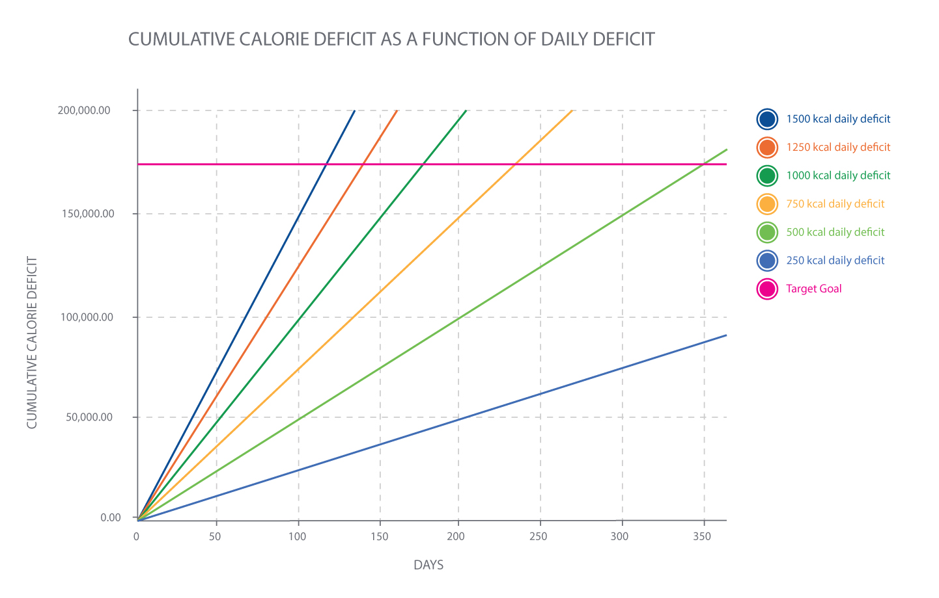

The Figure: Cumulative-Calorie Deficit as a Function of Daily Deficit highlights one of the phenomena that is observed both mathematically, in the scientific literature, and in the real world: larger deficits compound quickly and lead to better results than very-small deficits. However, there are limits to the size of a daily deficit that is feasible and there are biological consequences of extremely large deficits that need to be considered. One can think about this as a traditional U-curve (Figure: U-Curve) in which very-small deficits do not provide enough of a deficit to accumulate and result in meaningful change while very-large deficits are unsustainable or often lead to poor adherence and are not more effective than moderate deficits (Tsai and Wadden, 2006).

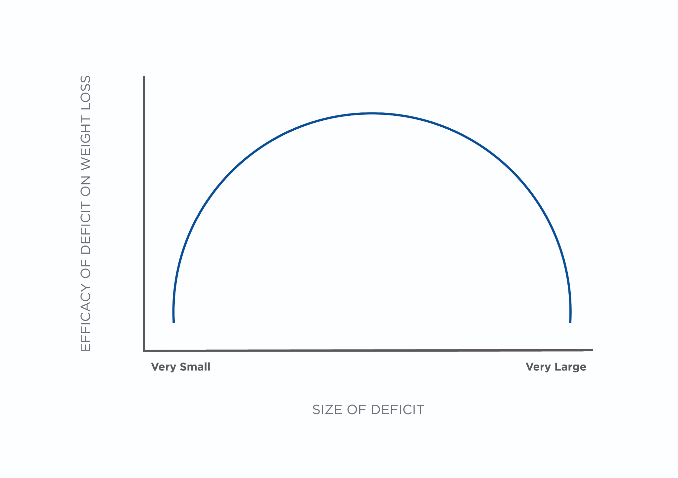

Now that there is a foundational understanding of the total weight loss, the time frame, and how different daily calorie deficits function together, there are some tools and guidelines that can be used to help determine appropriate and safe calorie deficits.

As mentioned earlier, weight-loss goals should fall in the range of 1 to 2 pounds (0.4 to 0.9 kilogram) per week or 0.5% to 1.0% of body weight per week. Using previous examples, simple math can determine ranges of calorie deficits for both absolute pounds (or kilograms) per week as a goal or based on a percent of body weight.

* 1 lb (0.45 kg) per week = 3,500 kcal per week deficit / 7 days = 500 kcals deficit per day
* 2 lbs (0.9 kg) per week = 7,000 kcal per week deficit / 7 days = 1,000 kcals deficit per day

For setting deficits based on body weight, the relative deficit changes substantially. This might be a more realistic way to calculate deficits. Take two very different examples: a 130-pound (58.96-kilogram) person who is aiming to lose roughly 10 pounds (4.53-kilograms) and a 325-pound (147.41-kilogram) person who is aiming to lose 125 pounds (56.69 kilograms).

Case 1: 130-pound (58.96-kilogram) woman losing 1% body weight per week

* Weekly weight loss: 130 x 1% = 1.3 lb (.58 kg)
* Weekly deficit required: 1.3 lb x 3,500 kcal/lb = 4,550-kcal deficit
* Daily deficit required: 4,550 / 7 days = 650-calorie-per-day deficit

Case 2: 325-pound (147.41-kilogram) woman losing 1% body weight per week

* Weekly weight loss: 325 x 1% = 3.25 lbs (1.47 kg)
* Weekly deficit required: 3.25 pounds x 3,500 kcal/lb = 11,375-kcal deficit
* Daily deficit required: 11,375 / 7 days = 1,625-calorie-per-day deficit.

Each approach leads to slightly different daily calorie deficits and each one can be used fairly effectively depending on the goals of the client. There are some boundaries that can be helpful when setting daily calorie intakes, especially when discussing options with a client. An upper threshold of 1% weight loss per week should be set for almost all clients. This means that the maximal calorie deficit set for Case 1 and Case 2 discussed previously would be 650 and 1,625, respectively. There should also be a minimal threshold, as well. Currently, there is no guideline to use as an anchor for a minimum threshold, but calorie reductions smaller than about 250 kcals per day are not very effective. At this small of a reduction, it takes a long time (about 2 weeks) to see 1 pound (0.45 kg) of weight loss, which, when coupled with natural daily fluctuations in weight, can take 4 to 6 weeks to observe 1 true pound of weight loss. Furthermore, at deficits this small, minor deviations from a nutrition plan can result in a loss of the deficit, making it more difficult to achieve meaningful results.

At this point, a Nutrition Coach has the tools to effectively set a calorie deficit based on the overall goal, timeframe of that goal, and the parameters in which a safe yet effective deficit can be set. Remember that this deficit is relative to a person’s total daily energy expenditure (TDEE), which anchors what the deficit is relative too. TDEE will be discussed at length later in this chapter.

“An upper threshold of 1% weight loss per week should be set for almost all clients.”

Weight (muscle) gain

Nutrition coaches will also encounter clients who are aiming to increase their muscle mass and, as a result, increase their body weight. While weight gain can be achieved quite rapidly through a caloric surplus, for individuals whose goal is to gain lean body mass (e.g., muscle tissue) while minimizing increases in fat mass, there are rates of weight gain that have been established that help maximize the lean-mass to fat-mass ratio. In untrained or novice resistance trainees, a realistic increase in body weight should be roughly 0.5 to 1.0% per month. In most people, this translates to roughly 1 to 2 pounds (0.45 to 0.9 kg) of weight gain per month. In more advanced trainees, this rate of gain is cut in half with a 0.25 to 0.5% increase in total body weight serving as a target. This translates to roughly 0.5 to 1 pound (0.2 to 0.4 kg) per month.

Simultaneous fat loss and muscle gain

Losing body fat while concurrently increasing lean mass is a goal that is often referred to as body recomposition. While this goal is possible, it works best with people who have minimal training history and who are obese or overweight. This is also possible in deconditioned people who were formally fit.

Coach’s Corner

Nutrition Coaches should encourage weight-loss clients to begin or maintain an appropriate resistance-training regimen to help preserve lean body mass (i.e., muscle) while in a negative energy balance.

Given that weight loss is best achieved with a substantial caloric deficit whereas robust increases in lean body mass, specifically skeletal muscle, require calorie surpluses, it can be very inefficient to try and tackle both goals at once. For most people, it is best to focus on one goal at a time, prioritizing which one is the most important for the client at the time. Individuals with weight- (fat-) loss goals require a negative energy balance to lose weight. However, it is still possible for these clients to lose fat and preserve or gain some muscle simultaneously. To do so simply requires adequate protein intake, resistance training, and a *moderate* calorie deficit. But it is important to note, the rate of muscle gain while in a negative energy balance will be slower than if the client was in a calorie surplus.

Improve exercise performance

Many clients will not have goals related to scale weight or increasing muscle mass. Some, especially many athletes, will have goals of improving their exercise performance or performance in their athletic event of choice. Athletes usually have goals that can be categorized as increasing strength, power, endurance, and/or skill development. While all of these goals can be placed into a coherent training program through thoughtful periodization, they often have interfering effects on one another. For this reason, they are usually set as independent goals for specific blocks of time.

It is important to understand the performance goals for each athlete at any given moment as programming nutritionally for improving power often has different total daily energy requirements than training for endurance. Briefly, athletes who are aiming to increase power and strength will perform high-intensity training sessions but will, overall, have a low-to-moderate amount of training volume and energy expenditure. The goal for these athletes is to maximize lean-mass gains and increases in force production while minimizing fat-mass accumulation. This contrasts with endurance athletes who will engage in low-, moderate-, and high-intensity training sessions and have high training volumes. The goal of these athletes is to fuel a high training load while minimizing lean-mass loss. As such, total energy needs as well as carbohydrate, fat, and protein requirements will differ based on their goals.

Coach’s Corner

An athlete that primarily relies on speed and power may experience detrimental effects if he or she largely focuses on endurance-training protocols (Rhea et al., 2008). As such, exercise training programs must be tailored to the athlete’s needs, goals, and abilities.

The Table: Macronutrient Recommendations by Performance Goals provides a brief description of varying energy and nutrient needs across exercise-performance goals.

Macronutrient Recommendations by Performance Goals

| **Goal** | **Protein** | **Carbohydrates** | **Fats** |
| --- | --- | --- | --- |
| Endurance | 1.2 to 1.6 g/kg/day (0.5 to 0.7 g/lb/day) | 3 to 5 g/kg/day (1.3 to 2.2 g/lbs/day) for the general population and athletes who partake in low-volume training or mostly skill-based training  5 to 8 g/kg/day (2.2 to 3.6 g/lbs/day) for athletes who partake in moderate-volume, high-intensity training – This can be defined as athletes engaging in 2 to 3 hours of training per day for 5 to 7 days per week.  8 to 10 g/kg/day (3.6 to 4.5 g/lbs/day) for athletes who partake in high-volume, endurance-based training – This can be defined as athletes engaging in 3 to 6 hours of training per day for 5 to 7 days per week.  About 12 g/kg/day (5.4 g/lbs/day) for athletes who partake in very-high-volume, endurance-based training – This can be defined as athletes engaging in > 6 hours of training per day for 5 to 7 days per week. | 1 g/kg/day (0.4 g/lb/day) |
| Strength/Power | 1.6 to 2.2 g/kg/day (0.7 to 1.0 g/lbs/day) | Approximately 5 to 6 g/kg/day (2.2 to 2.7 g/lbs/day) | About 30% of total daily calories (about 1 g/kg/day or 0.4 g/lb/day) |

**Seven steps for nutrition programming**

Clients seek the services of a Nutrition Coach for many reasons. Subsequently, the Nutrition Coach must be well-armed to help a variety of clients, each who have unique goals and circumstances. To help facilitate this process, coaches should follow a systematic and easy-to-follow approach for helping their clients. As previously discussed, the first step in the programming process is to determine the client’s goal. Goals are typically categorized into weight (fat) loss, weight (muscle) gain, a combination of fat loss and muscle gain (body recomposition), or improved exercise (sport) performance. After determining a client’s goal, the next step in the process is to calculate the client’s calorie and macronutrient needs. Use the following worksheet to help simplify this process.

**Determine total daily energy expenditure**

Whether someone wants to lose body fat, gain muscle, or improve their exercise performance, the next important step is understanding an individual's Total Daily Energy Expenditure. An individual’s TDEE, the total amount of calories expended in a given day, is comprised of three main components: Basal Metabolic Rate (BMR), Thermic Effect of Activity (TEA), and the Thermic Effect of Food (TEF). Note that Nonexercise Activity Thermogenesis (NEAT), or random acts of movement throughout the day besides structured exercise (e.g., fidgeting, taking a shower, or walking to a parked car), is considered an aspect of TEA

Getting Technical

Resting metabolic rate (RMR) differs slightly from basal metabolic rate (BMR). BMR is the metabolic rate that is achieved at *steady state* while RMR is simply measured at rest and can be altered by different conditions. “BMR measurements must meet total physiological equilibrium whereas RMR conditions of measurement can be altered and defined by the contextual limitations” (Ravussin et al., 1982).

The first step to determining an individual’s energy (calorie) needs is to calculate their BMR (Table: Equations for Determining Basal Metabolic Rate).

Equations for Determining Basal Metabolic Rate

| **Formula Name** | **Equation** | **Pros** | **Cons** |
| --- | --- | --- | --- |
| Harris–Benedict Equation | Women: BMR = 447.593 + (9.247 × weight) + (3.098 × height) – (4.330 × age)  Men: BMR = 88.362 + (13.397 × weight) + (4.799 × height) – (5.677 × age)  *Note:* Weight is in kilograms, height is in centimeters, and age is in years. | This equation is simple and easy to use. It does not require data on body composition. | It is the least accurate of the listed equations. It does not account for body composition. |
| Mifflin–St. Jeor Equation | Women: BMR = 9.99 x weight + 6.25 x height – 4.92 x age – 161  Men: BMR = 9.99 x weight + 6.25 x height – 4.92 x age + 5  *Note:* Weight is in kilograms, height is in centimeters, and age is in years. | This equation is simple and easy to use. It does not require data on body composition. | It does not account for body composition. It is not as accurate as the Katch–McArdle equation. |
| Katch–McArdle Equation | BMR = 370 + (21.6 × Lean Body Mass (kg))  Step 1: Weight (kg) × Body fat% = fat mass  Step 2: Weight (kg) – fat mass = lean body mass | This equation accounts for body composition. It is more accurate than the Harris–Benedict and Mifflin–St. Jeor equations. | It requires precise body-composition tests and data. It does not provide substantially more accurate data for real-world application. |
| Cunningham Equation | BMR = 500 + (22 x Lean Body Mass)  To calculate lean body mass:  Step 1: Weight (kg) × Body fat% = fat mass  Step 2: Weight (kg) – fat mass = lean body mass | This equation accounts for body composition. It is more accurate than the Harris–Benedict and Mifflin–St. Jeor equations. | It requires precise body-composition tests and data. It does not provide substantially more accurate data for real-world application. It is more likely to overestimate than the Katch–McArdle equation. |

Once basal metabolic rate is determined, the next step is to multiply it by an activity factor (Table: Activity Factor Adjustments) (Frankenfield, Roth-Yousey, and Compher, 2005; Rao et al., 2012). Put simply, TDEE can be calculated by the following:

TDEE = Basal Metabolic Rate × Activity Factor

Activity Factor Adjustments

| **Level of Activity** | **Description of Activity** | **Activity Factor Adjustment** |
| --- | --- | --- |
| Sedentary | Little or no exercise and a desk job | 1.2 |
| Lightly Active | Light exercise 1 to 3 days per week | 1.375 |
| Moderately Active | Moderate exercise 3 to 5 days per week | 1.55 |
| Very Active | Heavy exercise 6 to 7 days per week | 1.725 |
| Extremely Active | Very heavy exercise or a physical job or training twice per day | 1.9 |

Coach's Corner

Peter is a busy 40-year-old business executive. He weighs 100 kilograms (220 pounds) and is 6 feet tall (182 centimeters). He is moderately active, exercising about 4 days per week for 1 hour each session (an activity factor of 1.55). He wants to lose some weight and is willing to be on a 500-calorie deficit per day.

Calculate Peter’s TDEE using the Mifflin–St. Jeor equation:

* BMR = Male: 9.99 × weight (kg) + 6.25 x height (cm) – 4.92 × age + 5

Answer:

BMR = 9.99 × 100 (kg) + 6.25 × 182 cm – 4.92 × 40 + 5 = 1,944 calories

1,944 × 1.55 = 3,014 calories

3,014 calories = TDEE

Based on these assumptions, Peter should consume about 2,514 calories per day (3,014 – 500) to help him lose weight. He will round this down to 2,500 to keep things simple.

In addition to these calculations, there are some robust tools that are available through the National Institutes of Health. Specifically, the Body Weight Planner developed by the National Institute of Digestive and Diabetes and Kidney Diseases, which has been derived from decades of research, using precise and robust mathematical models to help determine calorie needs and how to adjust calorie needs as a person progresses through weight loss and weight gain.

Try This!

Calculate your own BMR using each of the four equations. Look at the difference between each one (if you do not know your exact fat-free mass, just estimate). Then, calculate your TDEE for each of the different levels of the activity factor and compare the difference. This will highlight how important it is to get an accurate level of daily physical activity compared to the precise BMR calculation used.

### [Body weight planner](https://www.niddk.nih.gov/bwp)

**Set the protein target**

Dietary protein can be used to leverage a nutritional program. Protein is critical in maintaining lean body mass, regulating hunger, and maintaining overall calorie intake. Daily protein targets should be set between 1.2 grams/kilogram and 2.2 grams/kilogram (0.54 to 1.0 gram/pound). For clients who fall into the *general population* category, protein targets of 1.2 to 1.6 grams/kilogram (0.54 to 0.7 grams/pound) are appropriate. For athletes or individuals looking to maximize muscle growth and training adaptations, protein targets of 1.6 to 2.2 grams/kilograms (0.7 to 1.0 gram/pound) are appropriate. While protein targets can be set higher than this at 2.3 to 3.1 grams/kilograms to preserve muscle during periods of caloric restriction, these levels of protein do not augment muscle growth above 1.6 to 2.2 grams/kilograms.

Coach's Corner

Peter, the 40-year-old business executive, needs to determine how many grams of protein to eat each day. He weighs 100 kilograms (220 pounds). His protein intake has been set at 1.6 gram/kilogram. How much protein should he eat per day?

Answer:

100 × 1.6 = 160 grams of protein per day

160 × 4 calories per gram = 640 calories of protein per day

While there is still much debate about exactly how much protein should be consumed at each meal, there is evidence that breaking it into multiple servings a day is better than a single giant serving of protein (Areta et al., 2013). Currently, most data indicate that consuming roughly 0.4 to 0.55 grams per kilogram (.18 to .25 gram/pound) in 4 servings per day is optimal for maximizing muscle growth. This equates to approximately 27 to 37.5 grams per meal for a 68-kilogram (150-pound) person. For simplicity and practical purposes, aiming for 20 to 40 grams of protein per meal seems logical for most average-sized adults.

For example, in studies comparing consuming large amounts of protein twice a day to evenly spaced moderate doses and to many small servings, the evenly spaced, moderate doses showed the greatest anabolic response (Areta et al., 2013). However, for individuals who are not concerned with muscle growth, the distribution throughout the day is not overly critical. If daily protein needs are met, there is no need to worry about how to optimally dose protein throughout the day.

Try This!

Use yourself as a test case and calculate your protein requirements as if you were a *general population* client. Then, calculate your protein needs as if you were an athlete. Next, build a meal plan for yourself that would hit protein targets for each. This will help you understand how different clients’ daily food intake might look.

Critical!

When working in Australia, Nutrition Coaches should consider this information for educational purposes only, and must always utilize the [ADG Eat for Health Calculators](https://www.eatforhealth.gov.au/eat-health-calculators) to determine macronutrient recommendations for clients.

**Set the fat target**

Setting a daily fat target differs from protein in that it should be based on total calorie intake. The Acceptable Macronutrient Distribution Range (AMDR) for adults is 20 to 35%. [Read *Dietary Reference Intakes for Energy, Carbohydrate, Fiber, Fat, Fatty Acids, Cholesterol, Protein, and Amino Acids* (2005) at NAP.edu.] As there is no defined level at which adverse effects from fat intake are known, this recommendation is subjective and not expressed in total grams, making it different from protein guidelines. These percentage guidelines should be considered flexible and a place to start but not as hard boundaries. Fat intake can increase above 35% if there is adequate fiber, micronutrient, and carbohydrate intake to allow for the appropriate level of workload for the client. Athletes will often fall lower in the range due to their daily requirement of carbohydrates while general-population clients can fall into the higher range even sometimes up to 50% of calories coming from dietary fat.

Coach's Corner

Peter, the business executive, has already determined his calorie and protein intake. His next step is to determine how many calories for fat he should eat. His Nutrition Coach recommends a modest fat intake of 30% based on Peter’s food preferences. Peter is sticking with a 2,500-calorie diet to help lose some weight. How many calories should he consume from fat each day?

Answer:

2,500 × 0.30 = 750 calories from fat per day

750 / 9 calories per gram = 83 grams of fat per day

Critical!

When working in Australia, Nutrition Coaches should consider this information for educational purposes only, and must always utilize the [ADG Eat for Health Calculators](https://www.eatforhealth.gov.au/eat-health-calculators) to determine macronutrient recommendations for clients.

**Set the carbohydrate target**

Carbohydrate targets can be set based on the remaining calories left after protein and fat targets are established. The formula would look like this:

Carbohydrate target calories = total daily calories – protein calories – fat calories

Remember that carbohydrate needs will increase as training volume and intensity increase and that total daily fat calories as a percent will decrease concurrently. In other words, carbohydrate intake is the macronutrient most affected by an individual’s training volume. For example, here are rough guidelines for carbohydrate recommendations for competitive athletes of different training volumes and intensities:

* 3 to 5 g/kg/day (1.3 to 2.2 g/lbs/day) for general population and athletes who partake in low-volume training or mostly skill-based training
* 5 to 8 g/kg/day (2.2 to 3.6 g/lbs/day) for athletes who partake in moderate-volume, high-intensity training – This can be defined as athletes engaging in 2 to 3 hours of training per day for 5 to 7 days per week.
* 8 to 10 g/kg/day (3.6 to 4.5 g/lbs/day) for athletes who partake in high-volume, endurance-based training – This can be defined as athletes engaging in 3 to 6 hours of training per day for 5 to 7 days per week.
* About 12 g/kg/day (5.4 g/lbs/day) for athletes who partake in very-high-volume, endurance-based training – This can be defined as athletes engaging in > 6 hours of training per day for 5 to 7 days per week.

Coach's Corner

Peter has already determined his total daily calories (2,500), protein (640 calories), and fat intake (750 calories). His next step is to determine how many calories from carbohydrates he should eat. Peter is sticking with a 2,500-calorie diet to help lose some weight. How many calories of carbohydrate should he consume?

Answer:

Carbohydrate target calories = total daily calories – protein calories – fat calories

Carbohydrate target calories = 2,500 – 640 (protein) – 750 (fat) = 1,110

Carbohydrate target = 1,110 calories

Carbohydrates in grams = 1,110 calories / 4 calories per gram = 278 grams of carbohydrate per day

Try This!

Calculate the carbohydrate needs for yourself across the different levels of activity. Then, translate that amount to varying amounts of food. Next, build a daily meal plan that meets the requirements across all the different levels. This will allow you to understand how different diets will look for clients with drastically different nutrient needs.

Critical!

When working in Australia, Nutrition Coaches should consider this information for educational purposes only, and must always utilize the [ADG Eat for Health Calculators](https://www.eatforhealth.gov.au/eat-health-calculators) to determine macronutrient recommendations for clients.

**Translate numbers to food and habits**

Once calorie needs are determined and the macronutrients (i.e. protein, fats and carbohydrates) are set, the next step is individualising the approach and translating the calorie and macronutrient numbers into foods and habits. The individualisation of the approach can be achieved through an initial assessment and discussion to help determine a client’s behavioural style, food preferences, current habits, barriers and goals, and discover their current level of nutrition/food competency.

There are myriad ways to monitor, track and evaluate a client’s food habits. One way to think about the varied approach is to visualise it on a continuum of highly quantitative methods (e.g. measure and weigh everything you eat and keep meticulous notes) to highly qualitative methods (e.g. consume mostly whole foods or “eat the rainbow”).

Both approaches have been shown to be successful and the different approaches should fit the client’s individual needs and preferences to maximize adherence to the recommended plan.

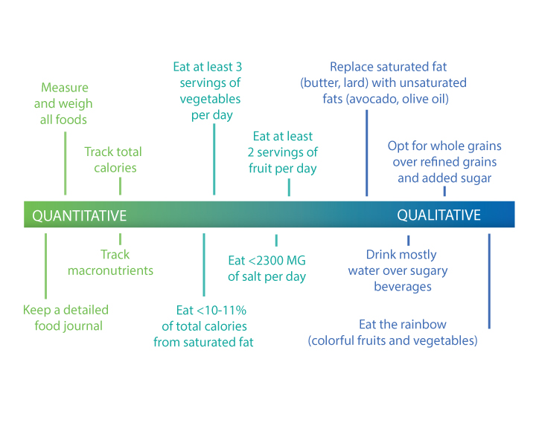

Within the continuum of highly quantitative to highly qualitative approaches to monitoring, tracking and evaluating food intake, there exists another continuum: the level of management (i.e. precision). One can take a high-level approach (macromanagement) or a detailed, fine-tuned approach (micromanagement). Some individuals do extremely well with broader guidelines to follow while others thrive with incredibly precise instructions for measuring, tracking and monitoring their food intake.

Regardless of the exact approach used (highly quantitative vs highly qualitative) and the precise level of managing intake (macromanagement vs micromanagement), the Nutrition Coach should guide the client toward a sustainable approach. This begins at the initial assessment through a discussion of the clients’ current approaches to tracking, monitoring and evaluating food intake, and a discussion of what has worked in the past and what has not worked. Many times, clients will take an all-or-nothing approach to monitor their intake. However, approaches that do not fall at the extreme edges of the spectrum and provide a flexible and somewhat intuitive approach to eating appear to provide the best long-term results. For example, encouraging a client who is detail-oriented to track their food very closely at the outset may increase their adherence and success, and teach them a lot about what macro- and micronutrients they are consuming. However, over time, teaching them the skills to monitor their food intake without carrying a food scale around and how to be more intuitive by relying on habits is likely to ensure longer-term success.

The next step, once the overall approach is set, is to translate the numbers (calories and macronutrients) into food and habits (based on the advice previously discussed). Translating a numeric programme into foods and habits is essential to getting a client to follow a programme, because it provides them with tools and a tangible approach to get started. It is important for Nutrition Coaches to engage clients in this process to ensure the nutrition plan is tailored to their needs and preferences. This also increases the likelihood that any recommendations will be adopted and sustained. For example, a Nutrition Coach can work closely with a client and develop a list of foods that the client would like to include in their nutrition plan from each of the food categories: fruits, vegetables, grains, dairy and protein. Exceptions can be made for individuals with food restrictions (e.g. removing dairy for people who are lactose intolerant). Next, the Nutrition Coach can use a nutrition database (e.g. the USDA Nutrition Database) and create a list of food options that meet the daily nutrition needs for their client. This information can be shown to clients to help them build their own meals and snacks that fit within their daily life.

[**Food Data Central**](https://fdc.nal.usda.gov/)

Try This!

Treat yourself as a client and calculate the calorie and macronutrient needs for yourself. Then, make a list of foods that you would like to include in your nutrition plan under each of the food categories (fruits, vegetables, dairy and protein). Next, use a nutrition database to build a daily food plan and then turn that into a nutrition programme that includes meals and, if applicable, snacks. Document this process and use it with your next nutrition client.

**Monitor and evaluate**

The last step in the process of programming is to monitor and evaluate. In this context, monitoring is observing a client and collecting data on the process and execution of the program. Evaluation is the objective assessment of what is being monitored. Understand that the monitoring and evaluation step is iterative wherein it is a continual, ongoing process aimed at gradual, systematic improvement.

Monitoring involves collecting data from the Nutrition Coach, as well as the client. For example, clients may record their food in a journal or in a food-logging software. They might also submit weekly reports about food choices and behaviours to their Nutrition Coach. When monitoring a client, the focus should be on the process; identify the areas of the process that are working and which ones are not. For example, if a client is asked to keep a food journal and they journal Monday through Friday but do not on the weekend, identify this as a potential barrier that can be discussed with the client to understand what might be getting in their way. Furthermore, there are some aspects of nutrition behaviours to be monitored that are more difficult to measure objectively and require a discussion with clients. Examples of these things might be food beliefs, moods, feelings and quality of life. Thus, the Nutrition Coach should take a holistic view of monitoring nutrition habits with a client to better understand the factors that can either support or get in the way of being consistent.

Evaluation is a combination of assessing the process and specific outcomes. For example, evaluation can include assessment of how effective a food journal is for a client (process), how a meal plan is being implemented (process), or if the client has reached a weight-loss goal by a specific time frame (outcome).

Monitoring and evaluating a client can be broken down into the following steps:

1. Conduct a baseline readiness assessment.
2. Develop a set of data to monitor and outcomes to evaluate.
3. Set guidelines for collecting data and monitoring.
4. Set intervals for check-ins and evaluations.
5. Gather data and analyse results.
6. Evaluate the results with the client.
7. Work together to form a plan for the next iteration.

Step 1: conduct a baseline readiness assessment

All progress should be measured relative to an individual's starting point. A baseline assessment can define a client’s starting point and provide valuable information regarding next steps. For example, some clients may not understand the concept of calories or the importance of micronutrients. Consequently, these individuals would have a much different starting point than clients who consistently track their calories and food quality. A baseline nutrition assessment can be performed using a wide range of tools, including things such as food frequency questionnaires and food diaries.

Coach's Corner

Reflect on what you have learned in previous chapters and make a list of the skills and tools you have learned. Use these to develop your personal baseline toolkit.

Person-centred interviewing techniques, such as motivational interviewing, can also help the Nutrition Coach understand a client’s food beliefs, identify their current level of readiness and motivation to change and identify the barriers that might get in the way of adhering to the nutrition plan. There is no singular best approach for baseline nutrition assessments; each Nutrition Coach should work to develop their own baseline assessment tools that allow them to best identify the status of their client.

Step 2: monitor data and evaluate outcomes

After completing a baseline assessment, the next step is to identify the scope for the first round of monitoring and evaluation. In other words, create a simple list of goals and behaviours to track. The scope should be appropriate for the client’s starting point. For example, if a client has never tracked food before, the first round of monitoring should not involve an overly meticulous calorie-counting and macronutrient tracking plan. Instead, it should begin with a basic recording of eating habits.

Coach's Corner

Once you determine the scope for monitoring a client, have them rate their confidence to carry out this behaviour on a 1-to-10 scale. If the client gives you a number less than 7, it means you need to help the client reevaluate how realistic the monitoring plan is for their daily life and make the necessary adjustments.

In addition to collecting, monitoring and evaluating *hard data* (e.g. calories, macronutrients or foods eaten), it is important to do the same for more *soft data*. These can be based on food habits such as how quickly one eats or how full they feel when they stop eating. These habit-based goals are particularly appropriate for clients who prefer a qualitative coaching approach versus a quantitative approach. See Table: Example Habit-Based Goals for a list of habits and soft skills that can be implemented at regular intervals (e.g. putting a new habit in place each week).

Example Habit-Based Goals

| Eat more slowly – put the fork down in between bites. Focus on the food: its taste, texture, and smells. |
| --- |
| Eat until your approximately 80% full. Once you are about 80% full, stop your meal and allow your body time to adjust to feeling satiated. |
| Drink at least 8 cups of water per day and aim to stay hydrated throughout the whole day. |
| Set a new sleeping schedule. Aim for 8 hours each night. |
| Substitute saturated or trans fats (whole cream, butter, or lard) for unsaturated fats (avocado or olive oil). |
| Eat at least one serving of lean protein with each meal (e.g., seafood, white-meat poultry, eggs, lean beef, or soy). |
| Fill half your plate with colorful fruits and vegetables each meal. |
| Drink primarily calorie-free drinks (e.g., water, black coffee, unflavored iced tea, etc.). Minimize calorie-dense drinks (e.g., soda, juice, or energy drinks). |
| Take a 5-minute break; avoid sitting for more than 3 hours at a time. |
| Aim for 150 minutes of moderate aerobic activity per week such as walking or brisk jogging. |
| Practice destressing techniques (e.g., meditate, unplug from technology for an hour, go for a walk, listen to music, or focus on a fun hobby). |
| Celebrate your wins and revisit any of these habits you are still having trouble maintaining. |
| Anticipate high-risk situations, identify triggers, and develop coping/problem-solving strategies for lapses. |
| Develop a social support network. |
| Replace negative self-talk (especially during weight-loss plateaus) with constructive and positive outlets (e.g., write down and acknowledge your own accomplishments). |

Once the general scope is set, the client and the Nutrition Coach should work together to determine what data will be monitored and what outcomes will be evaluated. This step is important, as it is critical that the client and the Nutrition Coach are aligned with the responsibilities of both parties. This serves as the foundation for the next step: setting guidelines for collecting data and monitoring.

Step 3: set guidelines for collecting data and monitoring

It is important to set guidelines for collecting data and monitoring. These guidelines include what data is to be recorded, how often it is to be recorded, which party is responsible for collecting what, and how it is to be recorded (notebook, e-mail, spreadsheets, mobile apps, etc.). There should be very clear instructions so that the client and the Nutrition Coach have a good understanding of expectations. A behavioural contract that is created and signed by both the Nutrition Coach and client can serve as positive reinforcement for the guidelines and expectations set and can be referred to in later sessions when reviewing client progress.

Step 4: set intervals for check-ins and evaluations

Setting intervals for check-ins and evaluations is important for keeping continuity and holding the client and the Nutrition Coach accountable for maintaining a monitoring and evaluation process. Check-ins also help to decrease the likelihood that clients will revert to old behaviours by identifying any setbacks early in the process. By regularly checking in with the client, the Nutrition Coach can help the client overcome challenges that may arise between check-ins. There is no guideline for how often check-ins should occur. Some circumstances require daily check-ins, while other circumstances require weekly, biweekly, monthly or even longer periods between check-ins. The length of these intervals should be determined through a conversation between the client and the Nutrition Coach, based on how much support is needed to stay on track.

Step 5: gather, organise and analyse data

At each interval, the Nutrition Coach should gather all the available data that is being monitored, organise that data and analyse it. The data analysis should be simple and focus on the most important aspects such as average daily and weekly calorie intake, average daily and weekly calorie surpluses and deficits, and adherence (or lack thereof) to habit-based goals. At this point, the Nutrition Coach should also take the analysed data and package it together in a format that the client can easily understand. This may take the form of pictures, graphs, charts or written reviews. When presenting data, eliminate technical jargon and overly complicated topics. The evaluation should provide a mix of professionalism with appropriate levels of intimacy.

Getting Technical

Conveying data to a client is a critical step in the communication process. Numbers can be overwhelming to some people, but there are a few key strategies that can improve communicating data.

* Keep the numbers simple. Round to the nearest whole number (e.g., round 156.7 grams to 157 grams, or even 160 grams)
* Use familiar metrics (e.g. Metric versus Imperial).
* Use verbal qualifiers (e.g. small or great).
* Place numbers in context so they are relevant, relatable and understandable.
* Order matters: the first and last numbers presented are most likely to be remembered.

Step 6: evaluate the results with the client

Once the data is organised, analysed and drafted into a form that the client can understand, the client and the Nutrition Coach should evaluate the results together, with equal participation from both parties. This is an excellent opportunity to go over key findings, ask questions to understand how the findings relate to the client’s overall goals, receive questions from the client, highlight areas of success as well as areas that can be improved, assess the feasibility of the current plan and identify changes that can be made in the next iteration. The teach-back method is an evidence-based technique that the Nutrition Coach can use when discussing key findings to increase the client’s comprehension of new information, promote accurate retention of the key findings once the session has ended and improve adherence to the recommended plan (Agency for Healthcare Research and Quality, 2015). The teach-back method is not a test of the client’s knowledge; rather, it uses a sequential process to ensure that the Nutrition Coach has clearly explained key findings by having the client state in their own words what they have learned and need to do.

Getting Technical

Studies have shown that 40 to 80% of information people are told is forgotten immediately, and nearly half of the information retained is incorrect (Kessels, 2003).

Step 7: work together to form a plan for the next iteration

After the results are discussed and the Nutrition Coach and the client have identified areas of success and opportunities for improvement and assessed progress toward outcomes, plan for the next iteration in the monitoring and evaluation process. At this point, the client and the Nutrition Coach should repeat this process beginning at Step 1; perform another assessment (it may be abbreviated this time), and then the process begins again.

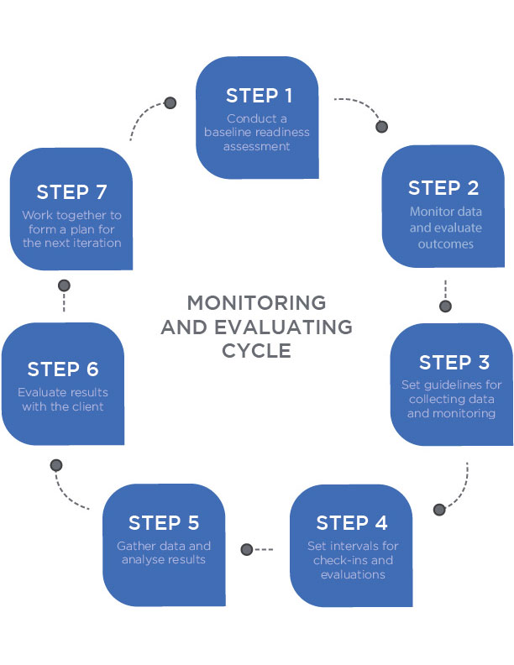

**Case studies**

The steps outlined in this chapter help the Nutrition Coach to provide individualized coaching across a wide variety of clients. To put these steps into practice, three example case studies are provided.

Case study 1: Billy

Billy is a 30-year-old, 5’ 7” former Division 1 college wrestler who has gained 30 pounds (13.6 kilograms) over the last 10 years and currently weighs 200 pounds (90.7 kilograms). He currently weight trains intensely in the gym with metabolic workouts four to five times a week. He also runs three times per week (2 to 3 miles per run) but rewards himself with food. He wants to lose 30 pounds (9.0 to 13.6 kilograms) as quickly as possible by starting a high-protein diet because he has read on the Internet that this diet is superior for weight loss. Follow Steps 1 through 6 from this chapter to set the initial plan.

Set Billy's caloric goals: Billy has a primary goal of weight loss. He wants to lose quite a bit of body weight, about 30 pounds (9.0 to 13.6 kilograms), in the shortest time frame possible. To give him an appropriate time frame to hit his goal, set his rate of weight loss close to 1% of total body weight loss per week. Setting his goals, timeline, and calorie deficit can be achieved by following these steps:  
Determine total calorie deficit

* 30 lbs × 3,500 kcals/lb = 105,000 kcals

Set weekly calorie deficit

* 200 lbs × 1% body weight loss per week = 2 lbs/week (0.9 kg)

Calculate weekly and daily calorie deficit

* 2 lbs/week × 3,500 kcals/lb = 7,000 kcals deficit per week
* 7,000 kcals per week / 7 days per week = 1,000 kcals deficient per day

Set timeline for achieving goal

* 105,000 kcal cumulative deficit / 1,000 kcal per day = 105 days.

Determine Billy's total daily energy: Now that the calorie deficit is set at 1,000 kcals per day, determine Billy’s total daily energy expenditure and then subtract the required deficit. Given there is no body composition data for Billy, the best way to estimate his basal metabolic rate will be to use the Mifflin–St. Jeor equation and use an appropriate activity factor. Determine basal metabolic rate

* Men: BMR = (9.99 x Weight in kg) + (6.25 x Height in cm) – (4.92 x age) + 5
* BMR = 9.99 × (200 lbs/ 2.2 kg per lb) + 6.25 × (67 inches × 2.54 cm per inch) - (4.92 × 30) + 5
* (9.99 x 90.7kg) + (6.25 x 170cm) - (4.92 x 30) +5
* 906.1 + 147.6 +5
* BMR = 1,826 kcal/day

Determine total daily energy expenditure (TDEE)

* TDEE = BMR × Activity factor
* TDEE = 1,826 × 1.725 (Very Active)
* TDEE = 3,150 kcals per day

Determine total daily energy intake based on deficit

* Total daily energy intake = TDEE – Target Deficit
* Total daily energy intake = 3,150 kcals per day – 1,000 kcals per day
* Total daily energy intake = 2,150 kcals per day

*Note:* An online calculator such as NASM's Body Weight Planner (see below) can be used instead of hand calculations to determine a client’s calorie needs.

Coach's Corner

Setting the activity factor can have a substantial impact on determining a client’s TDEE and their subsequent calorie and macronutrient intakes. Often, the activity factor is over- or underestimated and getting it correct the first time is difficult. For many clients, it is more beneficial to slightly overestimate the activity factor than it is to underestimate the activity factor. There are two main reasons for this:

1. When overestimating you have room to lower a client’s calories and macronutrients if weight loss is stagnant; if underestimating, you do not have room to lower it.
2. It may serve as a *mental anchor* for a client and encourage them to reach for a slightly higher level of physical activity. For example, if you set their activity factor as moderately active and they are stagnant in their progress but do not want to lower calories further, they can increase their activity to actually meet the moderately active criteria.

Set Billy's protein target: Protein targets can be set over a flexible window with ranges between 1.2 to 2.2 grams/kilograms (0.5 to 1.0 gram/pound/day) and with the higher end of the range allowing for minimal muscle-mass loss during periods of caloric restriction. Due to the intense nature of his workouts and desire for a high-protein diet, his protein target is 1.0 g/lb.

* 1.0 g/lb = 200 lbs × 1.0 g/lb = 200 grams per day
* 200 grams × 4 calories per gram = 800 kcals per day

Set Billy's fat target: Fat macronutrient intake can be set at varying ranges but a good rule to follow for most people is setting it at roughly 30% of total daily calorie intake.

* 2,150 kcals per day × 30% of total daily kcals = 645 kcals per day
* 645 kcals per day / 9 calories per gram of fat = 71 grams per day

Set Billy's carbohydrate target: Carbohydrate macronutrient targets can be based on the remaining calories left after protein and fat targets are established. In essence, carbohydrate target calories = total daily calories – protein calories – fat calories.

* Carbohydrate target calories = 2,150 kcals – 800 kcals – 645 kcals
* Carbohydrate target calories = 705 kcals
* 705 kcals per day / 4 kcals per gram of carbohydrate = 176 grams per day

Billy's total results: Table: Billy’s Total Results lists Billy’s goals, calories, and macronutrient needs based on the previous calculations.

Billy's Total Results

| **Overview** | **Calories** | **Protein** | **Fat** | **Carbohydrates** |
| --- | --- | --- | --- | --- |
| Goal: Lose 30 lbs  Time frame: 105 days | 2,150 kcals per day | 200 grams  800 kcals | 71 grams  645 kcals | 176 grams  705 kcals |

Convert numbers to food and habits: Billy’s numbers can be adjusted either slightly increasing or decreasing to best fit his dietary preferences as well as his exercise workload and adherence to the program. Billy mentioned he desires a high-protein diet. As a Nutrition Coach, the next step is to discuss in greater detail his food preferences, current dietary habits, barriers, and goals; discover his current level of nutrition/food competency; and have a discussion to ensure that his preferences and his goals can be aligned.

For example, a conversation between the client and the Nutrition Coach might look something like this:

Billy: Thank you for getting this plan put together for me. I see that you have put my protein at 200 grams a day. I was thinking that high protein would be closer to 400 grams per day. Can you explain this to me?

Nutrition Coach: You are welcome Billy and that is a great question. I am really glad you asked. We set your protein intake at 1 gram per pound, which falls into the higher range of protein intake and covers all your protein needs. If we were to increase your protein intake to 400 grams, your calorie intake from protein would be 1,600 calories and we would not be able to get enough energy from carbohydrates and fats to fuel the training you enjoy doing. This would mean we would not get the desired results and all the work you do in the gym would likely be compromised. Does that make sense? Or, do you have any more questions about this?

Billy: Okay, that makes sense and I understand the goals and why they are set the way they are. If I find that that 200 grams is either not enough or too much, will we be able to change them?

Nutrition Coach: Of course, the 200 grams is a great starting place and benchmark we are going to aim for as we get started. As you lose body weight, we can adjust protein based on how you are feeling and how your training changes. We will always discuss and make sure that we are both on the same page matching your needs, wants, and goals for the program.

Billy: Okay, great. I feel really good about this plan. Thank you for talking that through with me and letting me know I have some autonomy in this process.

Gathering this information, allowing for dialogue, and working to customize approaches with each client will help establish their daily habits and eating patterns.

Monitor, evaluate, and adjust: Lastly, the Nutrition Coach should perform a baseline assessment and implement a method for monitoring and evaluating Billy’s progress (or setbacks). This can be completed in the form of food diaries, journals, weekly check-ins, or any combination thereof.

Case study 2: Janet

Janet is a 44-year-old, 5’ 10” woman who has lost and regained 30 pounds (13.6 kilograms) multiple times. She currently weighs 180 pounds (81.6 kilograms). Working with a Nutrition Coach remotely, she is willing to walk for 20 minutes two times per week but she does not enjoy structured exercise. Janet gets overwhelmed when she must track all her calories but she is looking to lose the weight and keep it off this time.

Follow Steps 1 through 6 from this chapter to set the initial plan.

Set Janet’s caloric goals: Janet has a primary goal of weight loss. She wants to lose a substantial amount of weight but does not have a strict timeline and wants to ensure that it is sustainable. Her biggest concern is regaining the weight because she has experienced this phenomenon too many times in her past. This presents a wide range of options regarding Janet’s daily calorie needs and time frame for weight loss. Janet and her Nutrition Coach need to explore a few options.

The first step is to determine the requirements needed to successfully hit her 30-pound weight-loss goal. This can be accomplished by setting parameters for the shortest time frame (with the most aggressive calorie deficit) and the longest time frame (with the least aggressive calorie deficit).

Determine total calorie deficit: 30 lbs × 3,500 kcals/lb = 105,000 kcals

Set maximal weekly calorie deficit (1% of body weight)

* 180 lbs × 1% body weight loss per week = 1.8 lbs (0.81 kg) per week
* 1.8 lbs per week × 3,500 kcals/lb = 6,300 kcals deficit per week
* 6,300 kcals per week / 7 days per week = 900 kcals deficit per day

Set minimal weekly calorie deficit (250 kcals per day)

* 250 kcals per day × 7 days per week = 1,750 kcal deficit per week
* 1,750 kcal per week deficit / 3,500 kcals/lb = 0.5 lb deficit per week

Set minimal and maximal timeline for achieving goal

* 105,000 kcal cumulative deficit / 900 kcal per day = about 117 days
* 105,000 kcal cumulative deficit / 250 kcal per day = about 420 days

After reviewing these numbers, Janet decides she wants to fall in the middle and take 9 months to reach her 30-pound (13.6-kilogram) weight-loss goal. To calculate Janet’s daily calorie deficit use the following approach: 105,000 kcal cumulative deficit / 270 days = about 390-kcal deficit per day.

Determine Janet’s total daily energy: Janet’s goal is to lose 30 pounds (13.6 kilograms) in 9 months (270 days). Her calorie deficit is set at 390 kcals per day. Next, determine Janet’s total daily energy expenditure and then subtract the required deficit. There is no body composition data for Janet; therefore, the best way to estimate her basal metabolic rate will be to use the Mifflin–St. Jeor equation and use an appropriate activity factor.

Determine basal metabolic rate

* Women: BMR = 9.99 x weight + 6.25 x height – 4.92 x age – 161
* BMR = 9.99 × (180 lbs / 2.2 kg per lb) + 6.25 X (70 inches × 2.54 cm per inch) – 4.92 × 44 – 161
* BMR = 1,551 kcal/day

Determine total daily energy expenditure (TDEE)

* TDEE = BMR × Activity factor
* TDEE = 1,551 × 1.2 (Sedentary)
* TDEE = 1,861 kcals per day

Determine total daily energy intake based on deficit

* Total daily energy intake = 1,861 – Target Deficit
* Total daily energy intake = 1,861 kcals per day – 390 kcals per day
* Total daily energy intake = 1,471 kcals per day

*Note:* An online calculator such as NASM's Body Weight Planner (see below) can be used instead of hand calculations to determine a client’s calorie needs.

Set Janet’s protein target: Protein targets can vary and range between 1.2 to 2.2 grams/kilograms (0.5 to 1.0 gram/pound/day) with the higher end of the range allowing for minimal muscle-mass loss during periods of caloric restriction. In this instance, it can be helpful to set three protein options and then discuss with Janet as to which target is best.  
Offer three different options for protein target

* 0.5 g/lb = 180 lbs × 0.5 g/lb = 90 grams per day = 360 kcals per day
* 0.7 g/lb = 180 lbs × 0.7 g/lb = 126 grams per day = 504 kcals per day
* 1.0 g/lb = 180 lbs × 1.0 g/lb = 180 grams per day = 720 kcals per day

Janet decides that 0.7 gram/pound is an ideal range as it provides a substantial amount of protein yet it still enables her to eat adequate carbohydrates and fat. This sets her protein intake at 126 grams and 504 kcals per day.

Set Janet’s fat target: Fat macronutrient intake can be set at varying ranges but a good rule to follow for most people is setting it at roughly 30% of total daily calorie intake.

* 1,471 kcals per day × 30% of total daily kcals = 441 kcals per day from dietary fat
* 441 kcals per day / 9 calories per gram of fat = 49 grams of fat.

Set Janet’s carbohydrate target: The last macronutrient to calculate for Janet is carbohydrates. Carbohydrate targets can be based on the remaining calories left after protein and fat targets are established. In essence, carbohydrate target calories = total daily calories – protein calories – fat calories.

* Carbohydrate target calories = 1,471 kcals – 504 kcals – 441 kcals
* Carbohydrate target calories = 526 kcals
* Carbohydrate intake in grams = 526 kcals / 4 kcals per gram of carbohydrate = 132 grams

Janet’s total results: Table: Janet’s Total Results lists Janet’s goals, calories, and macronutrient needs based on the previous calculations.

Janet’s Total Results

| **Overview** | **Calories** | **Protein** | **Fat** | **Carbohydrates** |
| --- | --- | --- | --- | --- |
| Goal: Lose 30 lbs  Time frame: 270 days | 1,471 kcals per day | 126 grams  504 kcals | 49 grams  441 kcals | 132 grams  526 kcals |

Convert numbers to food and habits: The next step is to discuss in greater detail Janet’s food preferences, current dietary habits, barriers, and goals and discover her current level of nutrition/food competency. Gathering this information will help establish her daily habits and eating patterns.

For example, Janet mentioned she wants to avoid meticulous tracking of her calories or macronutrients. As such, her Nutrition Coach should teach predominately qualitative approaches to eating to maximize adherence to her recommended plan while simultaneously using the numbers previously calculated to serve as an overall dietary guide. For example, Janet’s Nutrition coach can work with her to create a list of foods that she would like to include in her nutrition plan from each of the major food groups: protein, fruits, vegetables, grains, and dairy. Next, Janet’s coach should demonstrate example meals that fall within her plan. These example meals will give her a better idea of appropriate portion sizes that fit her calorie and macronutrient needs. Over time, Janet will become a more intuitive eater and should be able to build her own meals that fit within her calorie and macronutrient goals.

In addition to creating example meals, providing a list of easy-to-follow dietary habits can also be useful. The Nutrition Coach can introduce a new habit during each check-in. This will help Janet adhere to the program while also taking the guesswork out of eating. The following are some examples:

* Eat more slowly; focus on the food: its taste, texture, and smells.
* Eat until 80% full.
* Drink at least 8 cups of water per day.
* Eat at least one serving of lean protein with each meal.
* Fill half your plate with colorful fruits and vegetables with each meal.

Monitor, evaluate, and adjust: Janet’s numbers can be adjusted slightly with macronutrients increasing or decreasing slightly to best fit her dietary preferences. For Janet, who has a low training volume, she can adjust her protein, carbohydrate, and fat macros slightly (+/– 10%) and still achieve virtually identical results. This sets her protein range at 110 grams to 140 grams, fat intake at 45 grams to 55 grams, and carbohydrate intake at 115 grams to 145 grams per day.

Given the flexibility of her dietary program, the Nutrition Coach must monitor and track her progress. It will be equally important to notate any setbacks and adjust her plan accordingly to minimize a relapse and subsequent weight gain.

Case study 3: Leon

Leon is a 36-year-old, 6’ 4” man and has been 250 pounds (113.3 kilograms) since turning 18. He is getting married on the beach in 3 months and wants to look his best by losing 30 pounds. He joined a gym, is new to exercise, and is working with you for both exercise and nutrition plans. He says he will do whatever you ask to help him reach this goal

.

Set a goal: Leon has a primary goal of losing 30 pounds. He has a wedding coming up with a very-short timeline: 3 months away. This requires an aggressive approach: a weight loss of 1% body weight each week. Consequently, clear communication with his Nutrition Coach is vitally important to ensure that adherence and compliance to his nutrition plan remain intact.

Set Leon's caloric goals: The first step is to determine Leon’s calorie deficit within the truncated time frame of 3 months. Determine total calorie deficit: 30 lbs × 3,500 kcals/lb = 105,000 kcals

Set weekly and daily calorie deficit

* 250 lbs × 1% body weight loss per week = 2.5 lbs per week
* 2.5 lbs per week × 3,500 kcals/lb = 8,750 kcals deficit per week
* 8,750 kcals per week / 7 days per week = 1250 kcals deficit per day

Set timeline for achieving goal: 105,000 kcal cumulative deficit / 1250 kcal per day = about 84 days.

Determine Leon’s total daily energy: The next step is to determine Leon’s total daily energy expenditure and then subtract the required deficit. Given that we do not have Leon’s body composition data, the best way to estimate his basal metabolic rate will be to use the Mifflin–St. Jeor equation and use an appropriate activity factor.

Determine basal metabolic rate

* Men: BMR = 9.99 × weight in kg + 6.25 × height in cm - 4.92 × age + 5
* BMR = 9.99 × (250 lbs / 2.2 kg per lb) + 6.25 × (76 inches × 2.54 cm per inch) – 4.92 × 36 + 5
* BMR = 2,170 kcal/day

Determine total daily energy expenditure (TDEE)

* TDEE = BMR × Activity factor
* TDEE = 2,170 × 1.55 (Moderately Active)
* TDEE = 3,364 kcals per day

Determine total daily energy intake based on deficit

* Total daily energy intake = 3,364 – Target Deficit
* Total daily energy intake = 3,364 kcals per day – 1,250 kcals per day
* Total daily energy intake = 2,114 kcals per day

*Note:* An online calculator such as NASM's Body Weight Planner (see below) can be used instead of hand calculations to determine a client’s calorie needs.

Set Leon’s protein target: Protein targets can be set over a fairly flexible window with ranges between 1.2 to 2.2 grams/kilograms (0.5 to 1.0 gram/pound/day) and with the higher end of the range allowing for minimal muscle-mass loss during periods of caloric restriction. It can be helpful to set three protein intake levels for a client and then discuss with them as to which target is best. Offer three different options for protein target

* 0.5 g/lb = 250 lbs × 0.5 g/lb = 125 grams per day = 500 kcals per day
* 0.7 g/lb = 250 lbs × 0.7 g/lb = 175 grams per day = 700 kcals per day
* 1.0 g/lb = 250 lbs × 1.0 g/lb = 250 grams per day = 1,000 kcals per day

For Leon, it is likely that 0.7 gram/pound is an ideal range as it provides a substantial amount of protein but allows ample room for adequate carbohydrates and fats as well.

Set Leon’s fat target: Fat intake can be set at varying ranges but a good rule to follow for most people is setting it at roughly 30% of total daily calorie intake.

* 2,114 kcals per day × 30% of total daily kcals = 634 kcals per day
* 634 kcals per day / 9 calories per gram of fat = 70 grams of fat

Set Leon’s carbohydrate target: Carbohydrate targets can be based on the remaining calories left after protein and fat targets are established. In essence, carbohydrate target calories = total daily calories – protein calories – fat calories.

* Carbohydrate target calories = 2,114 kcals – 700 kcals – 634 kcals
* Carbohydrate target calories = 780 kcals
* Carbohydrate intake in grams = 780 kcals / 4 kcals per gram of carbohydrate = 195 grams

Leon’s total results: Table: Leon’s Total Results lists Leon’s goals, calories, and macronutrient needs based the previous calculations.

Leon's Total Results

| **Overview** | **Calories** | **Protein** | **Fat** | **Carbohydrates** |
| --- | --- | --- | --- | --- |
| Goal: Lose 30 lbs  Time frame: 88 days | 2,114 kcals per day | 175 grams  700 kcals | 70 grams  634 kcals | 195 grams  780 kcals |

Convert numbers to food and habits: Leon has an aggressive goal to lose 30 pounds in 88 days. As such, adherence to his dietary program is critically important. As Leon’s nutrition coach, the next step is to discuss in greater detail his food preferences, current dietary habits, barriers, and goals and discover his current level of nutrition/food competency. Gathering this information will help establish his daily habits and eating patterns.

Monitor, evaluate, and adjust: Given the aggressiveness of Leon’s goal, the Nutrition Coach must monitor and track his progress. It will be equally important to notate any setback and adjust his plan accordingly. Check-ins should be scheduled for a minimum of once a week.

Programming is the practical application of the scientific principles of nutrition through a systematic process that allows clients to reach their goals. While the fine details of programming are nuanced and can be considered an artform in many cases, there are some well-developed processes that should be used as a template. Follow these steps:

1. Set a goal with the client.
2. Determine the total daily energy requirement.
3. Set the protein macronutrient target.
4. Set the fat macronutrient target.
5. Set the carbohydrate macronutrient target.
6. Individualise and convert numbers to food and habits.
7. Monitor, evaluate and adjust.

In this chapter, you learned about:

* A seven-step process for nutritional programming.
* A realistic rate of weight loss per week.
* Calculating daily energy intake and macronutrient targets for clients.
* Aligning nutritional recommendations to a client’s self-directed goals.
* Monitoring, evaluating and readjusting a client’s nutrition programme based on their progress.